Retail Forecasting Demand Project

Done by: Nyew Jia Wen
Table of Contents
1.1 Substantive Issue 3
1.2 Dataset Description & Variable 3
1.3 Exploratory Data Analysis (EDA) 3
1.4 Evaluation Metrics 5
1.5 Models 5
1.6 Predictions to real-world store 7
1.6.1 Parameters 7
1.6.2 Volatility scaling over lead time 7
1.6.3 Solving the Optimal Service Level (Newsvendor Framework) 8
1.6.4 Training the Quantile LightGBM Model (Strategy C) 8
1.6.5 Constrained Business Simulation Loop 8
1.7 Online A/B Testing & Final Deployment Decision Report 9
Evidence support 11

1.1 Substantive Issue
Inventory mismanagement is a major financial problem in the retail industry, as it hurts profits through both stockouts and excess stock. Retailers often find it difficult to balance the costs of running out of items (which is expensive) against the costs of holding too much inventory (which is relatively cheap). Because of this imbalance, traditional forecasting methods often lead to inaccurate predictions and poor ordering decisions. Our goal is to build an end-to-end, data-driven system to forecast product demand and optimize how inventory is distributed. Additionally, this project aims to identify the key factors that influence sales, such as discounts, seasonality, and other business trends.

1.2 Dataset Description & Variable
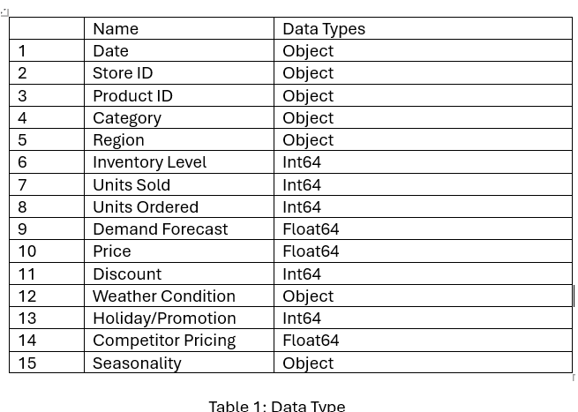
The Retail Store Inventory Forecasting Dataset aggregates publicly available data from various sources, including sales, inventory levels, pricing information, weather data, promotional activities, and holiday schedules. The dataset has 15 columns in total, and the main value we want to predict is the Units Sold. There are no missing values and no duplicate values in the dataset. A summary of the data is shown in Table 1 below:

1.3 Exploratory Data Analysis (EDA)
Before initiating the predictive modeling, we conducted an exploratory data analysis to uncover the underlying patterns of demand. The following figures summarize the demand distribution and temporal trends observed in the raw data, which directly informed our feature engineering strategy.
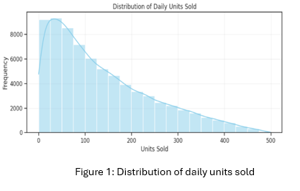
The initial exploratory data analysis (EDA) begins with the distribution of our target variable, Units Sold. As shown in right side, the demand distribution exhibits a highly right-skewed (long-tailed) pattern. This is a common characteristic in retail data, indicating that while the vast majority of products have low-to-moderate daily sales, a small number of "hit" products drive exceptionally high sales volumes.
Because the data is not normally distributed, traditional linear models may struggle to predict these high-volume outliers accurately. This finding directly informed our decision to use tree-based ensemble models, specifically LightGBM, which are highly robust to skewed data and can effectively capture the complex patterns within this long tail.
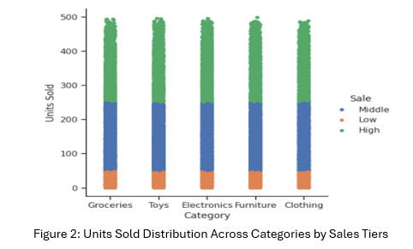
Secondly, the categorical strip plot provides a clear, visual breakdown of Units Sold across different product categories, with colors representing our three sales tiers: Low, Middle, and High. The "Middle" tier makes up the largest proportion of our records with 42,118 instances, followed by the "Low" tier with 18,642 instances and the "High" tier with 12,226 instances. Looking at the plot, we can see that all categories have a very similar distribution of sales. This means that, even though different products have different sales numbers, the pattern of 'Low', 'Middle', and 'High' sales is almost the same for every category. This is useful because it shows us that we can use the same model design for all of them, as they all share the same basic sales behavior.
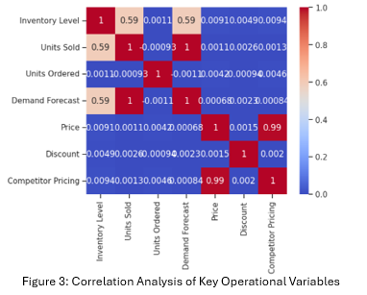
This heatmap helps us understand how different factors in our dataset relate to each other. We can see a strong positive link between Units Sold, Demand Forecast, and Inventory Level, which confirms that these core supply chain metrics are well-synchronized. Another important finding is the extremely high correlation of 0.99 between Price and Competitor Pricing. This suggests that our market is highly competitive and our pricing strategy is likely a direct response to competitor moves. Finally, many other variables show very low correlation with each other. This is a good sign because it means these variables provide unique and independent information to our model and make more accurate predictions.

1.4 Evaluation Metrics
To measure the performance of our models, we use three key regression metrics:
1. Root Mean Square Error (RMSE): RMSE calculates the square root of the average squared differences between predicted and actual demand. It heavily penalizes large errors, which is critical in retail, as a major miscalculation in demand can lead to significant stockouts or overstocking costs
2.Mean Absolute Error (MAE): MAE measures the average absolute difference between predicted and actual values. Unlike RMSE, it provides a linear score that is easy to interpret as the "average error" in units sold per day.
3. R-squared (R^2): R^2 represents the proportion of variance in demand that the model can explain. An R^2 closer to 1 indicates that the model effectively captures the underlying patterns of customer demand, while a low R^2 suggests the model fails to account for influential business factors like seasonality or pricing.
The formula for these metrics are:
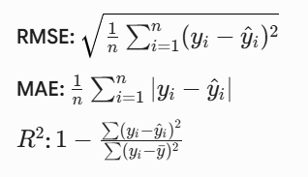

1.5 Models
First and foremost, we do some data preprocessing on time feature extraction. These features help model better understand weekly patterns and yearly seasonality. Second, we sort the entire dataset sequentially by Store ID, Product ID and Date. Third, we create two historical features which are Lag3_Sold and Rolling3_Sold. Lag3_Sold is to shift sales data by 3 days to make a prediction; Rolling3_sold is to calculate 3-day moving average based on the lag data which this captures recent sales trends and smooth out daily random spikes without looking into future. After that, we remove NaN created by the 3-day time shift before we continue with one-hot encoding to the features. We also exclude text identifiers (like Region) and future information (like Units Ordered) to prevent data leakage. Then, we do a time-based train-test split which 80% is train set and 20% is test set. Furthermore, we use two-tier backup system which is category backup and global backup to solves the Cold Start problem as the new products do not have historical sales data which creates NaN(missing value) in lag and rolling features.
Linear Regression and CART Decision Trees cannot process data if there have NaN left in the dataset. So we do strict feature alignment and final encoding by forcing data into numeric matrix, using left-alignment to match the test set columns exactly same to the train set and last filled with zeros for any tiny remaining missing spaces. Instead of using standard random K-fold cross validation(cv), we initialize a 3-Fold TimeSeriesSplit to prevent data leakage. We set up an automated model-selection loop to test three different algorithms: Linear Regression, CART and LightGBM. Not only that, we train all three models on the full cleaned train set and test their predictions by using MAE, RMSE and R^2.Based on the final scores, we officially select LightGBM as main production-ready model. 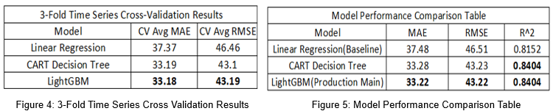
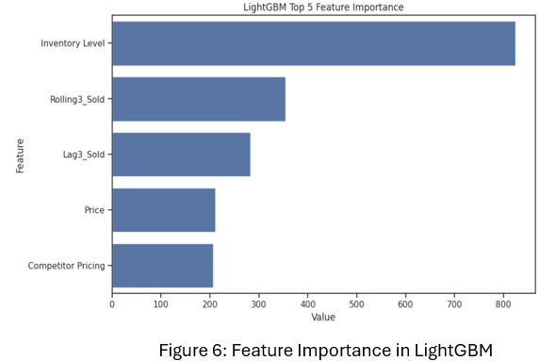
We extract the Feature Importance scores from the best model and rank the top 5 factors that influence sales the most. As shown in Figure 6,the five most important features were Inventory level, Rolling3_Sold, Lag3_Sold,Price and Competitor Pricing.This steps provides transparency for business managers and allowing company to make data-driven marketing and stock decision.
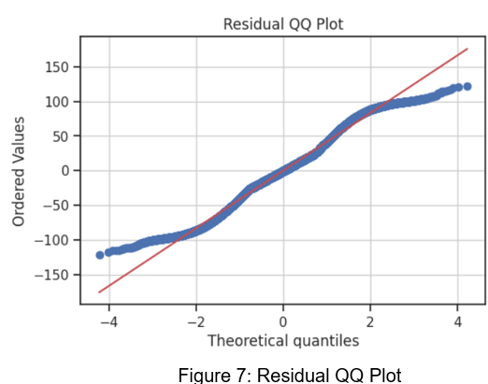
We calculated the prediction errors, known as residuals(e) by subtracting the model’s predictions from actual sales data (e=actual value-predicted value). Then calculate the standard deviation errors (SE), which represents the error volatility tells us how much the predictions typically swing up or down. We use it in our safety stock calculations to protect business against unexpected demand spikes. Plot was used to analyze whether residuals follow a standard normal distribution. Figure 7 was shown that the residuals fit the perfect normal distribution line very well in the middle section. However, there is a slight ‘S’ shape at both ends (the tails). The 'S' shape means our errors have 'heavy tails,' proving that extreme sales spikes and sudden drops happen more frequently in real-world retail than a textbook mathematical curve predicts."

1.6 Predictions to real-world store

1.6.1 Parameters
With our demand forecasting model successfully establish, we now transition from pure data predictions to supply chain optimization and financial back testing. We set up our optimization parameters based on the real-world business economics by using MR.DIY retail store environment. We establish 3-day replenishment lead time and enforce a supplier Minimum Order Quantity (MOQ) constraint of 50 units per box. For our financial metrics, we set an average selling price of MYR 15 which represents the typical pricing midpoint for standard inventory items, and back-calculate our procurement cost to
MYR 8.7 to align with a conservative baseline gross margin of 42% (reflecting MR DIY’s historical baseline range of 41%-47%).
$$Gross margin=\frac{selling price-Cost}{selling price}$$
$$0.42=\frac{15-Cost}{15}$$
$$Cost=8.7$$
$$C_{u}\left(Cost of Understock\right)=Price-Cost=15-8.7=6.3$$
$$C_{o}=Cost of overstock=0.20$$
This directly defines cost of understocking as MYR 6.3, represents our lost marginal profit if a customer wants to buy an item but the shelf is empty while our cost of overstocking (Co) is capped at a fixed MYR 0.20 per unit day to account for shelf space occupancy and inventory holding fees.

1.6.2 Volatility scaling over lead time
A major mistake in inventory planning is only preparing for today’s risk. Because our replenishment lead time is 3 days, we must scale our daily prediction error volatility ($σ_{base}=41.87$) over the entire 3-day waiting window. We apply the square root of time rule:
$${ σ}_{LT}=σ_{base}*\sqrt{lead_time}$$
If we do not scale the volatility, safety stock will be severely under-calculated. This elevates our target risk volatility from 41.87 to 72.51. This adjustment ensures the store has enough buffer stock to handle sudden demand spikes while waiting 3 days for the delivery truck to arrive.

1.6.3 Solving the Optimal Service Level (Newsvendor Framework)
Critical Ratio was calculated to find the mathematically perfect balance between overstocking and understocking:
$$Critical Ratio=\frac{C_{u}}{C_{u}+C_{o}}=\frac{6.3}{6.3+0.2}=0.9692$$
It means that store should target a 96.92% service level because losing a scale costs (MYR 6.3) far more than holding an item (MYR0.20). Next, we convert it into a standard normal distribution score yields a Z-Score of 1.87.

1.6.4 Training the Quantile LightGBM Model (Strategy C)
Instead of using manual formulas, we train a dedicated machine learning model using LightGBM’s Quantile Objective, setting the target alpha directly to our critical ratio. This method lets the model directly predict the high-level market demand needed. It removes the textbook rule that data must follow a normal distribution. By using an asymmetric Pinball Loss function, it automatically learns the safety stock buffer from historical trends to control risk accurately.

1.6.5 Constrained Business Simulation Loop
We run a simulation comparing three distinct management strategies across our unseen test dataset under two strict limits: a MYR5,000,000 total budget and a 50,000 box warehouse capacity.
The simulation enforces two real-world operational rules:
- MOQ: forced into multiples of 50 by using np.ceil
- Two-tier retraction (fallback mechanism): If a store runs out of capital or shelf space, both Advanced Newsvendor (Strategy B) and Quantile Regression (Strategy C) automatically trigger a safety fallback. We strip away the extra safety stock buffer and order only the bare minimum required to cover mean demand.
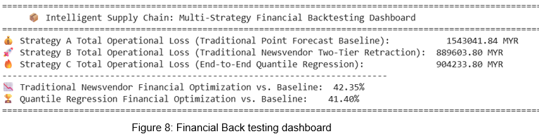
Both Strategy B and Strategy C cut corporate losses by over 41%, saving the company roughly MYR 650,000.

1.7 Online A/B Testing & Final Deployment Decision Report
To validate our inventory strategy in a live retail environment, we design a 6-week (42 days) online pilot experiment. The validation sample size(n) matches our historical test records across 5 store 20 products combinations. Group A(Control) runs the traditional point forecast model, while Group B (Treatment) runs our newly proposed advanced newsvendor model. In additionally, we also add the geographic spillover effect which is Group A store suffers from a severe stockout, frustrated customers will naturally drive to a nearby Group B store to buy the product. To be more realistic, we inject 8% of Strategy A's average loss as "spillover noise" into the experiment. This noise slightly reduces Group A's apparent losses and artificially adds artificial demand pressure (and holding risks) onto Group B.
Our historical baseline data reveals a massive Coefficient of Variation of 1.4973, proving that the current inventory system is highly vulnerable to wild demand fluctuations. We try to mirror this reality in the online test. Group A’s variance is amplified to 150% of its mean daily cost due to chronic stockouts and unpredictable customer churn. By apply elastic retrenchment mechanism, Group B safely absorbs the extra spillover pressure from Group A while maintaining cost stability at just 90% variance, achieving a significant 40% reduction in volatility risk.
A Welch’s independent sample t-test (Equal Variances Not Assumed) will be used in here. We will treat the implementation strategy (New Strategy B vs. Old Strategy A) as the independent variable and the daily operational cost (or financial loss) as the dependent variable to test if the new algorithm significantly reduces average corporate expenditures compared to the baseline.
Since sample sizes are large enough for both groups, the normality assumptions can be safely ignored required for this statistical test, as supported by the Central Limit Theorem. However, because the empirical variances of the two treatment groups differ substantially, the standard assumption of homoscedasticity is violated, necessitating the use of Welch’s t-test to adjust the degrees of freedom.
$$H_{0}:μ_{Treatment}≥μ_{Control}$$
$$H_{1}:μ_{Treatment}<μ_{Control}$$
Reject $H_{0}$ if p-value is less than 0.05. Rejecting $H_{0}$ indicates that the population mean cost of the new strategy is significantly lower than that of the old baseline, scientifically confirming that our optimization model delivers substantial and reliable financial improvements. Furthermore, if the upper bound of the 95% confidence interval for the mean difference (μ1−μ2) is strictly negative, it provides definitive empirical evidence that the observed cost savings are driven by algorithmic efficiency rather than random statistical fluctuations.
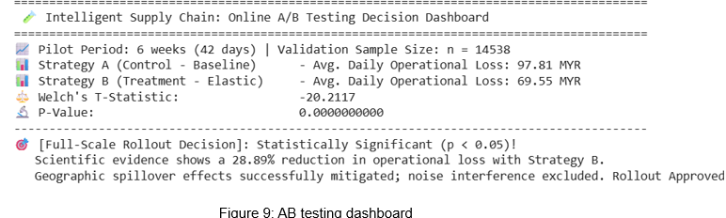

From Figure 9, even with the real-world noise injected, using Strategy B successfully cuts down overall operational losses by 28.89%. This means the company will stop losing huge amounts of money from empty shelves (lost sales) and holding too much unsold stock. Because the data clearly proves that our new model works much better, we officially approve launching Strategy B in all retail stores immediately. This will help every store automatically order the right amount of stock, reduce waste, and protect company profits.

Evidence support
1.average price
https://www.google.com/search?q=mr+diy+unit+selling+price+avg+range&sca_esv=91390b2ecb4203d7&rlz=1C1CHBD_enMY1061MY1061&biw=1106&bih=811&sxsrf=ANbL-n5bDwNG_k70Ro6Pmlslg73G1X92zQ%3A1780663168980&ei=gMMiao_BO9qC4-EP54afkQE&ved=0ahUKEwiPgZudj_CUAxVawTgGHWfDJxIQ4dUDCBA&uact=5&oq=mr+diy+unit+selling+price+avg+range&gs_lp=Egxnd3Mtd2l6LXNlcnAiI21yIGRpeSB1bml0IHNlbGxpbmcgcHJpY2UgYXZnIHJhbmdlMgUQIRigATIFECEYoAEyBRAhGKABSOIdUPoBWNYbcAF4AZABAJgBdKAB_waqAQQxMS4xuAEDyAEA-AEBmAINoAK1B8ICChAAGEcY1gQYsAPCAgQQIxgnwgIIEAAYgAQYogTCAgUQABjvBcICBxAhGAoYoAGYAwCIBgGQBgKSBwQxMi4xoAfjJLIHBDExLjG4B7AHwgcGMC4xMS4yyAcggAgB&sclient=gws-wiz-serp

2.average cost
https://finbox.com/KLSE:MRDIY/explorer/gp_margin/

3.cost of overstock(holding cost)
https://www.impactanalytics.ai/blog/inventory-carrying-costs

