Data:

* SFDC- All CW from EXTs from 4/30/2018 to 10/19/2018
* Gabe’s Roster- EXTs with start & end date

Findings

All reps: WoW median CW per rep per city

* San Francisco and Vancouver peaked week 6
  + SF had median CW of 3; Vancouver had median CW of 4
* NYC: Unexplained spike week 4; median CW of 8

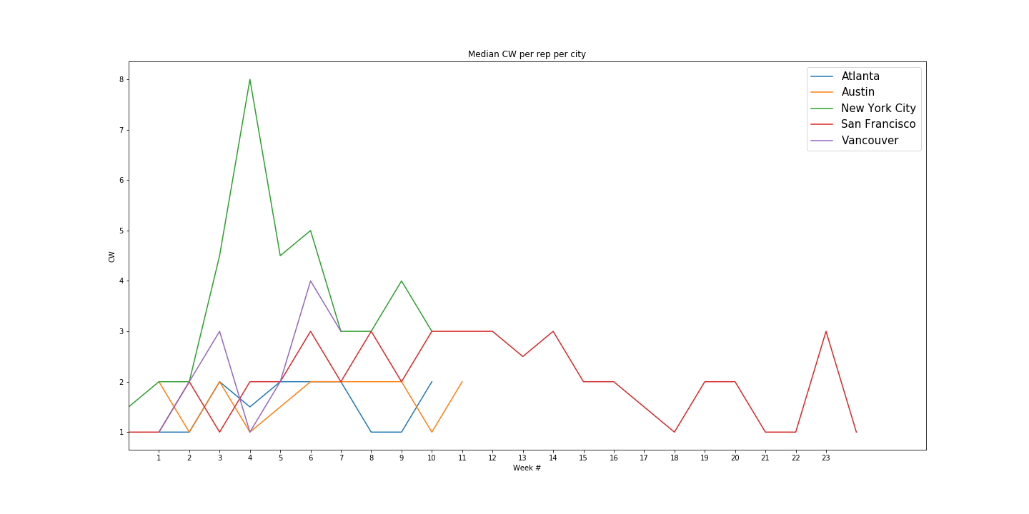

All reps: WoW median CW per rep

* Weeks 0-1: median = 1 CW
* Weeks 2-10: median = 2 CW, with steady increase throughout
  + Interquartile range remains roughly the same
* After week 10, data not helpful because only based off San Francisco/Austin – should ignore weeks 11 and onward

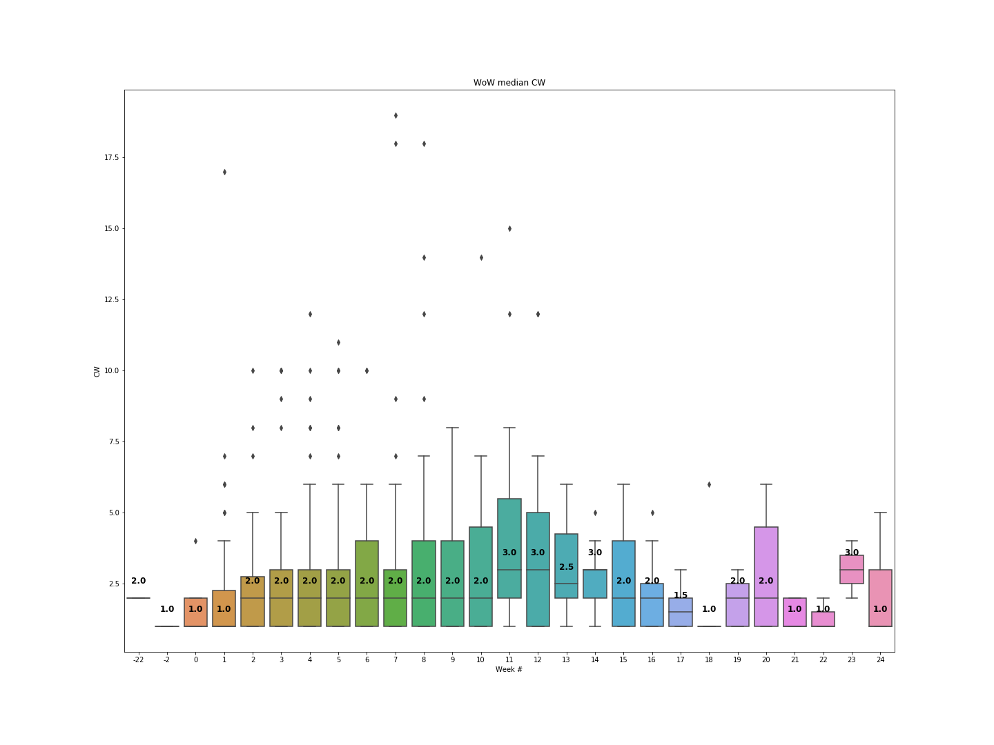

Only Active Reps, excluding Inbounds:

* Weeks 0-4: median = 1 CW
* Weeks 5-10: median = 2 CW except week 7 with 1.5 CW
* Either inbounds seem easier to achieve or active reps are better, or both. Reps don’t reach median CW of 2 until week 5 (versus week 2 in the scenario above).

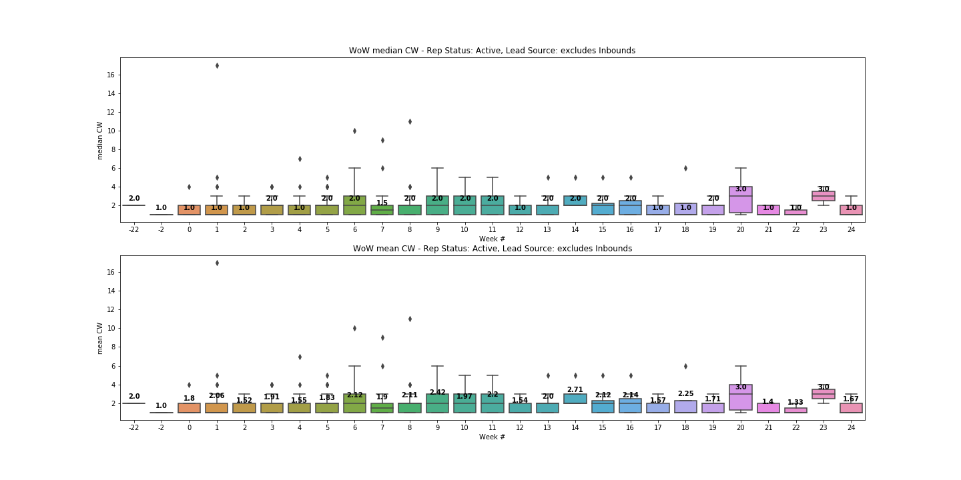

“Points” Analysis: assign 0.8 point for Inbound vs 1.0 point for Outbound

Only Active Reps, excluding nan, Cold, Referral leads

* Seller “points” steadily increase WoW from weeks 0 to 10

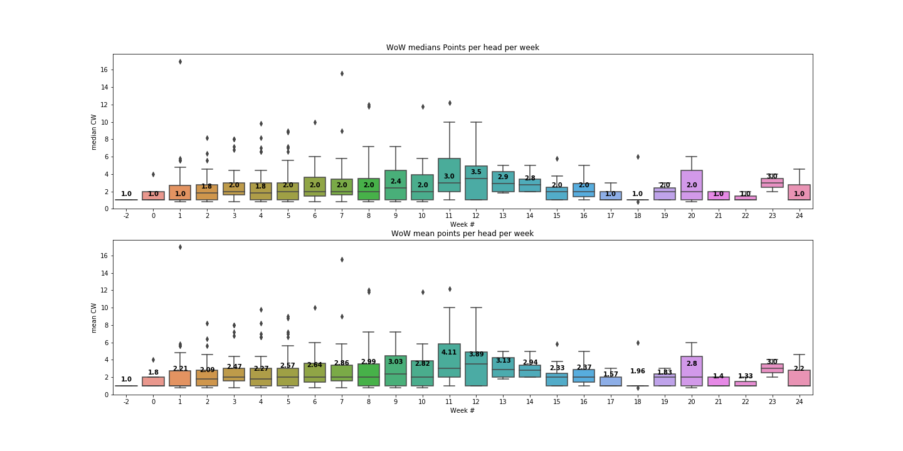

Takeaways

* WoW median CW: the bottom 50th percentile consistently achieves no more than 2.0 CW per week. The subset of reps above the 50th percentile achieve more and more CWs during ramp (see weeks 6-10), thus expanding the area between median and third quartile.
* Whether performance after week 10 continues to increase or stabilizes is hard to determine, since we are only looking at 10 weeks of data. However, we can expect:
  + We can expect outliers to continue to increase
  + We can expect better performance between median and Q3/outer fence
  + it’s entirely possible that median CW doesn’t ever increase past 2.0, even in the best case scenario

Recommendations

* Set attainment goal based on point system OR based off of median CW achieved WoW

|  |  |  |  |  |
| --- | --- | --- | --- | --- |
| Week | Mean CW (actual) | Mean Points (actual) | Proposed Attainment (%) | Proposed Attainment (CW) |
| 0 | 1.0 | 1.8 | 0% | 0.0 |
| 1 | 1.0 | 2.21 | 0% | 0.0 |
| 2 | 2.0 | 2.09 | 30% | 0.6 |
| 3 | 2.0 | 2.47 | 30% | 0.6 |
| 4 | 2.0 | 2.27 | 40% | 0.8 |
| 5 | 2.0 | 2.57 | 50% | 1.0 |
| 6 | 2.0 | 2.64 | 60% | 1.2 |
| 7 | 2.0 | 2.86 | 70% | 1.4 |
| 8 | 2.0 | 2.99 | 80% | 1.6 |
| 9 | 2.0 | 3.03 | 90% | 1.8 |
| 10 | 2.0 | 2.82 | 100% | 2.0 |

* Proposal:
  + Ideally, we would reward any achievement above the median for any given week, but EXTs are paid hourly.
  + Since it’s entirely possible that median CW doesn’t ever increase past 2.0, even in the best case scenario, the bare minimum requirement should be no greater than the median for that week, and should never exceed 2.0 for any week between weeks 1 and 10.
  + The proposed attainment percentages do NOT reflect likelihood of achieving median but rather the “buffer” / “grace” that we give to new sellers who are learning and practicing new material