**Depth is an important driver of nearshore benthic fish communities in the Salish Sea**

Jill Campbell, Fiona Francis, Sharon Jeffery, Francis Juanes, Sarah Dudas

**Brief Introduction Context Paragraph**

Protecting marine biodiversity is key to ensuring the stability and resilience of our oceans and in maintaining the ecosystem services humans depend on. However, collecting widespread marine biodiversity data necessary to support effective management or conservation efforts is not always feasible due to the challenging and time-intensive methods of collecting subtidal species richness and abundance data. Since biotic data are often difficult to obtain, abiotic variables that appear to influence specific species or communities can be used to inform species distributions. Information on species distributions can be helpful in determining areas of habitat suitable for commercially valuable or endangered species or areas that support increased biodiversity or ecosystem services. These abiotic variables, or surrogates, are especially useful in remote areas, or in identifying potential areas for protection. Here, surrogates are defined as “an attribute of an ecosystem that is used as a proxy for another aspect of biodiversity of interest” (Sato et al. 2015). Here, we explore the use of depth, tidal current speed, percent cover of rock, and benthic slope as abiotic surrogates for fish species diversity and abundance in the Salish Sea.

**Introduction Objective Paragraph**

This project aims to determine if abiotic variables can act as proxies for nearshore fish biodiversity and explores this through three objectives. First, we will use linear mixed effect models to determine how fish species richness, abundance, and biomass vary with four abiotic variables: tidal current speed, depth, percent rock cover, and benthic slope. Second, using the variable of primary importance identified from our first objective, we will explore how community composition varies with that variable using a non-metric multidimensional scaling plot (nMDS). Third, we will use individual fish lengths in a partial pooling mixed effect model analysis to predict how the variable of primary importance influences species length.

**Analysis Methods, Results, and Figures**

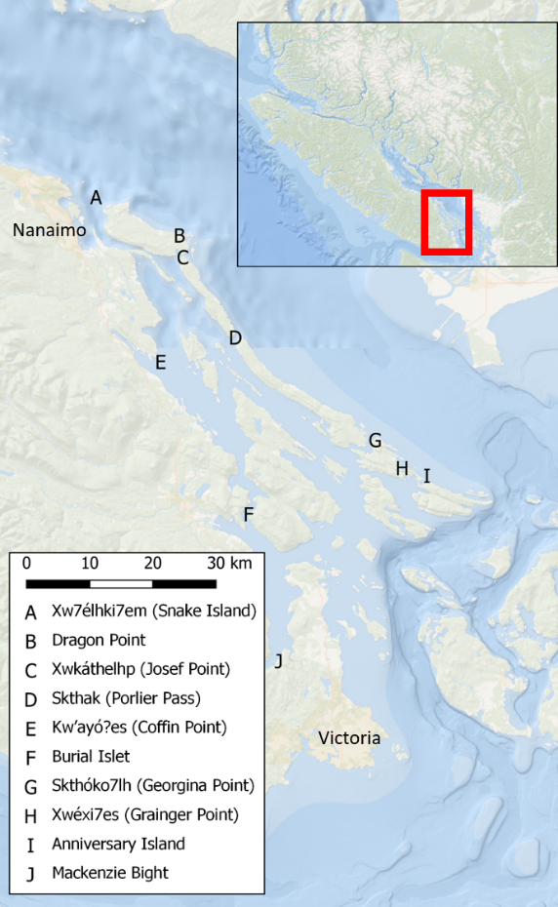

Figure 1: Map of survey sites within the Southern Gulf Islands BC Canada. High current sites are coloured red, low current sites are coloured blue. Current speed categories were defined by using the inflection point of all daily maximum current speeds at all sites. Hul’q’umin’um’ site names are used when they could be found in the literature.

**Abiotic data analysis**

**Analysis Methods:**

Daily maximum current speeds were extracted for each site by determining the maximum recorded current speed over each 24-hour period.

**Results:**

Daily maximum tidal current speeds measured at 10 meter depth over the 41-day collection period (16 December 2019 to 26 January 2020) ranged from 1.81 cm/sec to 118.50 cm/sec over the 10 sites (Figure 2). The Tilt Current Meters can only record speeds up to 120 cm/sec but for them to reach this maximum speed they need to become completely horizontal, which is unlikely to occur since they are positively buoyant. We believe that current speeds at Skthak (Porlier Pass), Xwéxi7es (Grainger Point), and Burial Islet repeatedly exceeded this speed and therefore, the true values are actually higher.

**Figure:**

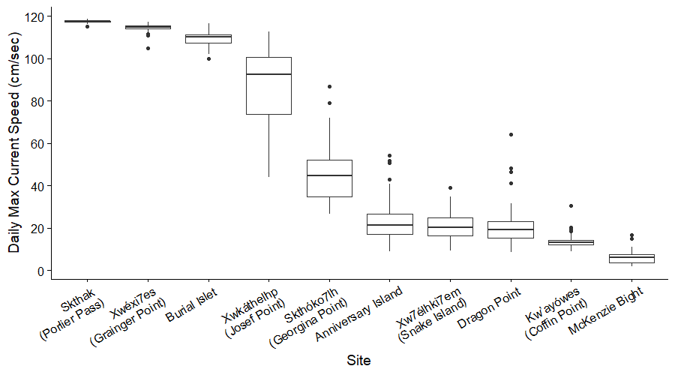

Figure 2: Daily maximum current speeds at each site presented as boxplots, indicating the median and quartiles with whiskers extending to 1.5 times the interquartile range.

**Fish species richness, abundance, and biomass analyses**

**Analysis Methods:**

Fish lengths were converted into biomass estimates using the power formula,

|  |  |
| --- | --- |
| $$Weight=a x {Length}^{b}$$ | (Equation 1) |

with *a* and *b* coefficient values coming from multiple sources (Washington et al. 1978; Lea et al. 1999; Haggarty and King 2004; Froese et al. 2014).

**Results:**

Across all sites and depths a total of 1,653 fish from 25 species were observed, resulting in a biomass of 210.7 kg. Six species were only observed on 3 meter depth transects and seven species were only observed on 15 meter depth transects (Appendix Table A1).

A total of 69 transects were completed and the number of replicate transects at each site and depth were not consistent due to logistical limitations (e.g., poor weather, currents, and/or visibility, or personnel and/or boat availability). Individual transect species richness, abundance, and biomass are displayed in Figure 3.

**Figure:**

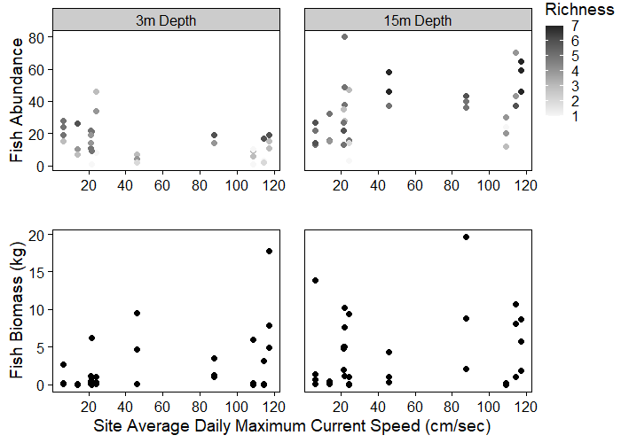

Figure 3: Individual transect fish abundance and biomass at each site average daily maximum current speed. Grey shaded circles in the abundance plot (top) represent the transect species richness (via shade) and abundance (via vertical position), black circles in the biomass plot (bottom) represent transect biomass. The number of replicate transects at each site and depth were inconsistent due to site sampling logistic limitations.

**Model results**

**Analysis Methods:**

We considered 15 candidate linear mixed effect models for each of the three fish biodiversity metrics (richness, abundance, and biomass) using all combinations of the four abiotic variables (depth, current speed, percent cover of rock, and benthic slope) as fixed effects, including the null model. All models included survey site as a random effect to account for the replicate transects at each site over the study period. Linear mixed effect models were fit using the lme function in the nlme package in R (nlme package in R, Pinheiro et al, 202). We used Akaike’s Information Criterion corrected for small sample sizes (AICc; bblme package in R, Bolker and R Development Core Team, 2020) to identify the model that best explained the observed differences in fish species richness, abundance, and biomass.

**Results:**

**Figures:**

**Fish community results**

**Analysis Methods:**

Since transect depth was the primary explanatory variable identified during the linear mixed effect modeling analysis, fish community compositions were compared between the two transect depths using non-metric multi-dimensional scaling of Gower distance measures (nMDS; reshape2 package in R, Wickham, 2007; vegan package in R, Oksanen et al, 2019). Data included abundance values for each species at each site and depth, resulting in a zero-inflated data set with 72% of the abundance observations being zeros. To account for this in the nMDS analysis, data were Wisconsin double standardized and square root transformed. In a Wisconsin double standardization, each abundance value is divided by its column maximum and then divided by the row total. The Gower dissimilarity index was calculated to provide the best fit to the data and was used in the nMDS analysis.

**Results:**

The fish community compositions between the 3 meter and 15 meter depths were compared using a non-metric multi-dimensional scaling (nMDS) plot (Figure 11). The transect depth communities do not overlap and the analysis of similarity (ANOSIM) test results indicate there are significant differences between the depth communities (*p*-value = 0.001, *R* statistic = 0.082); an *R* statistic close to 0 indicates community similarity and a value close to 1 indicates community dissimilarity, with the *p*-value measuring how likely that result is over 999 permutations.

**Figure:**

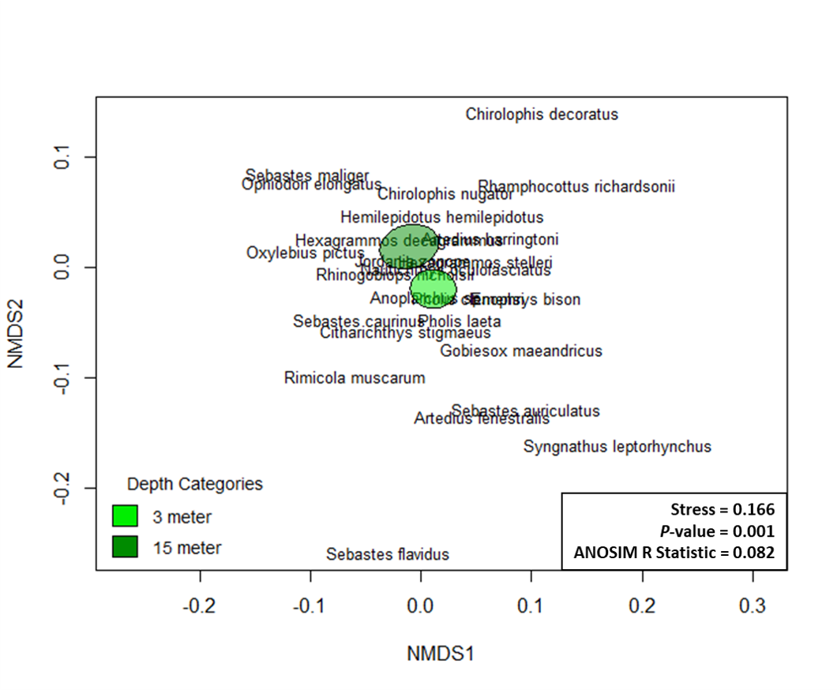

Figure 11: Non-metric multi-dimensional scaling (nMDS) plot of the Gower dissimilarity measure of fish community dissimilarities for the 3m and 15m depth transects. The coloured shapes represent the 95% confidence interval for the community centroids.

**Fish length analyses**

**Analysis Methods:**

**Results:**

**Figure:**

**Appendix**

Table A1: Species observed and their total recorded abundances, observed minimum and maximum lengths, and maximum lengths as indicated on FishBase.org for comparison. Species are grouped based on which transect depths they were observed on and ordered from most to least abundant.

|  |  |  |  |  |
| --- | --- | --- | --- | --- |
|  |  | Observed | | FishBase |
| Species Name | Total Abundance | Minimum Length (cm) | Maximum Length (cm) | Maximum Length (cm) |
| Species observed at both depths | | | | |
| *Rhinogobiops nicholsii* | 776 | 2 | 11 | 15 |
| *Artedius harringtoni* | 459 | 1 | 10 | 10 |
| *Jordania zonope* | 153 | 2 | 14 | 15 |
| *Sebastes caurinus* | 86 | 4 | 65 | 58 |
| *Hexagrammos decagrammus* | 68 | 7 | 52 | 61 |
| *Oxylebius pictus* | 37 | 9 | 14 | 25 |
| *Chirolophis nugator* | 7 | 6 | 7 | 15 |
| *Pholis laeta* | 7 | 5 | 13 | 25 |
| *Hemilepidotus hemilepidotus* | 7 | 8 | 22 | 51 |
| *Anoplarchus sp.* | 6 | 6 | 11 | 20 |
| *Nautichthys oculofasciatus* | 6 | 5 | 13 | 20 |
| *Sebastes auriculatus* | 3 | 5 | 24 | 56 |
|  |  |  |  |  |
| Only at 3 meter depths | | | | |
| *Artedius lateralis* | 8 | 3 | 10 | 14 |
| *Hexagrammos stelleri* | 6 | 8 | 16 | 48 |
| *Gobiesox maeandricus* | 5 | 4 | 10 | 16 |
| *Enophrys bison* | 1 | - | 23 | 37 |
| *Rimicola muscarum* | 1 | - | 3 | 7 |
| *Syngnathus leptorhynchus* | 1 | - | 10 | 33 |
|  |  |  |  |  |
| Only at 15 meter depths | | | | |
| *Sebastes maliger* | 12 | 6 | 23 | 61 |
| *Ophiodon elongatus* | 9 | 25 | 75 | 152 |
| *Rhamphocottus richardsonii* | 4 | 2 | 7 | 9 |
| *Citharichthys stigmaeus* | 3 | 2 | 9 | 17 |
| *Sebastes flavidus* | 3 | 17 | 24 | 66 |
| *Chirolophis decoratus* | 2 | 12 | 13 | 42 |
| *Pholis clemensi* | 1 | - | 5 | 13 |

**Suggestions for Journals**

**Ecological Applications**

*Ecological Applications is concerned broadly with* ***the applications of ecological science to environmental problems****. It publishes papers that develop scientific principles to* ***support environmental decision-making****, as well as papers that discuss the application of ecological concepts to environmental issues, policy, and management. Papers may report on experimental tests, actual applications, scientific decision support techniques, economic analyses, social implications of environmental issues, or other relevant topics. Statistical or experimental methods papers that support research and applications are welcome. Papers submitted to Ecological Applications should be accessible to both scholars and practitioners.*

Impact factor: 4.25

Online only (no print copy of the journal)

No limit on number of figures – colour figures incur no additional publication charges

Data must be made publicly available

$75/pdf page

**Ecological Indicators**

*The ultimate aim of* Ecological Indicators *is to* ***integrate the monitoring*** *and* ***assessment*** *of* ***ecological*** *and* ***environmental indicators******with management practices****. The journal provides a forum for the discussion of the applied scientific development and review of traditional indicator applications as well as for theoretical, modelling and quantitative approaches such as index development.*

Impact factor: 4.96

Online only

~ 7,000 words, max 10,000 words

No limit on the number of figures

$2500 flat fee

**CPS Fish and Aquat Sci**

*The* Canadian Journal of Fisheries and Aquatic Sciences*is the primary publishing vehicle for the multidisciplinary field of aquatic sciences. The journal publishes perspectives (syntheses, critiques, and re-evaluations), discussions (comments and replies), articles, and rapid communications, relating to* ***current research on*** *-omics, cells, organisms, populations,* ***ecosystems, or processes that affect aquatic systems****. The journal seeks to amplify, modify, question, or redirect accumulated knowledge in the field of fisheries and aquatic science.*

Impact factor 2.85

Max 10,000 words

No limit on the number of figures

No mandatory fees, $1500 to publish open access w/ DFO discount, $250/colour figure

**AFS – Marine and Coastal Fisheries**

*Marine and Coastal Fisheries: Dynamics, Management, and Ecosystem Science publishes original and innovative research that synthesizes information* ***on biological organization across spatial and temporal scales*** *to promote ecologically sound fisheries science and management. This Gold Open Access journal provides an international venue for studies of marine, coastal, and estuarine fisheries, with emphasis on species' performance and responses to perturbations in their environment, and promotes the development of* ***ecosystem-based fisheries science and management****. The journal encourages contributors to identify and address challenges in population dynamics, assessment techniques and management approaches, human dimensions and socioeconomics, and ecosystem metrics to improve fisheries science in general and make informed predictions and decisions.*

Impact factor: 1.74

150 page max

No additional charges for colour figures

$1,980 flat fee

For context, my master’s thesis chapter was 8800 words, 24 pages, had 16 figures, 2 tables, and 1 appendix table.