# Depth is an important driver of nearshore benthic fish communities in the Salish Sea

## Abstract

In this study, deeper, rocky habitats were found to support increased fish species richness and abundance in the Southern Gulf Islands of BC Canada; however, tidal current speed did not have a significant effect on fish biodiversity. High and low current sites were surveyed at two depths (3 and 15 meters below chart datum) by SCUBA divers from October 2019 to March 2020 in the Southern Gulf Islands. Fish biodiversity was characterized by fish species richness, abundance, biomass, and community composition. Current, temperature, salinity, and primary substrate type were collected to investigate relationships between these metrics and fish biodiversity. Non-parametric statistics, nMDS plots, analysis of similarity tests, and linear mixed effect models were used to determine differences in fish biodiversity between high and low current sites and survey depths. Results from these analyses indicate that univariate measures such as fish species richness and abundance differ significantly between survey depths but not by current speed. Additionally, multivariate analyses of fish biodiversity indicated a significant effect of depth, but not current speed, on fish abundance. The most abundant species observed were *Artedius harringtoni,* *Hexagrammos decagrammus,* *Jordania zonope*, *Rhinogobiops nicolsii*, and *Sebastes caurinus*, and there were significant differences in abundances /or lengths of four of these five species across current categories and/or survey depths. This is the first study to explore how depth and tidal current influence fish communities in the Salish Sea.

## Introduction

Protecting marine biodiversity is key to ensuring the stability and resilience of our oceans and in maintaining the ecosystem services humans depend on (Holmlund and Hammer 1999; Covich et al. 2004; Sala and Knowlton 2006; Worm et al. 2006; Palumbi et al. 2008). However, collecting widespread marine biodiversity data necessary to support effective management or conservation efforts is not always feasible due to the challenging and time-intensive methods of collecting subtidal species richness and abundance data. Biological data are often collected via scuba surveys which are depth and time limited, via hydroacoustic data collection or ROV surveys which require extensive post-survey annotation, or via destructive or damaging seining, trawling, or fishing surveys. Since biotic data are often difficult to obtain, abiotic variables that appear to influence specific species or communities can be used to inform species distributions. Information on species distributions can be helpful in determining areas of habitat suitable for commercially valuable or endangered species or areas that support increased biodiversity or ecosystem services. These abiotic variables, or surrogates, are especially useful in remote areas, or in identifying potential areas for protection (Ward et al, 1999; Rodrigues and Brooks 2007, Mellin et al. 2011; Rees et al. 2014; McHenry et al. 2017). Here, surrogates are defined as “an attribute of an ecosystem that is used as a proxy for another aspect of biodiversity of interest” (Sato et al. 2015). Abiotic surrogates have been identified as physical characteristics such as habitat, depth, temperature, salinity (McHenry et al. 2017), or current (Baynes and Szmant 1989; McHenry et al. 2017, Haak et al. 2019, Rubidge et al. 2020).

Here, we explore the use of tidal current and depth as abiotic surrogates for fish species diversity and abundance in the Salish Sea. This study contributes data to a relatively data-poor region of the BC coast where no studies have explored how tidal current influences nearshore fish diversity, and few or no studies exist on some of the species we observed. Human demands for space and resources within the Salish Sea are increasing and the information provided here can help inform marine spatial planning efforts by providing more information on fish species in the region and more broadly by evaluating the use of tidal current and depth as abiotic surrogates for fish biodiversity.

Tidal currents often result in areas of higher productivity and invertebrate and fish biodiversity (Baynes and Szmant 1989; Palardy and Witman 2011; Embling et al. 2012; Pitcher et al. 2012; Fenberg et al. 2015; Kregting et al. 2016; Rubidge et al. 2020; Nephin et al. 2020). Previous studies show currents promote water mixing that brings nutrient-rich water to the surface (Thomson 1981; Leonard et al. 1998) and has been linked to increased abundances of phytoplankton and zooplankton (Batten and Crawford 2009; Ueno et al. 2010; Moser et al, 2017; Blauw et al. 2012). Bottom-up processes have been shown to drive trends in biodiversity (Leonard et al. 1998; Ware and Thomson 2005; Watson et al. 2011; Fenberg et al. 2015) and this increase in abundance of low trophic level species results in increased fish biomass. In addition to influencing food webs, currents have also been shown to connect communities by circulating reproductive propagules (Siegel et al. 2008; Palardy and Witman 2011; Watson et al. 2011).

Depth has also been shown to influence fish communities, but several other physical factors are correlated with depth, such as light, temperature, or pressure. Light availability results in increased seaweed abundance at shallow depths, providing habitat structure and food for lower trophic level fish prey species. These shallower waters also experience more variability in temperature, salinity, and surface wave motion (Stefansdottir et al. 2010) which may be difficult for some species to tolerate. Depth preferences may also vary with life-stage, with recently settled juveniles preferring shallower habitats for some species (Love et al. 2009; Sobocinski et al. 2018).

This project has three objectives. First, we will determine how fish species richness, abundance, and biomass vary with tidal current speed and depth using linear mixed effect models. Based on previous studies we expect to see increased fish species richness, abundance, and biomass (Baynes and Szmant 1989; Gibson et al. 1996; Pitcher et al. 2012). Second, we will explore how community composition varies with tidal current speed and depth using principle component analysis (PCA). Fish species flourish at different optimal current speeds (Robinson et al. 2007; Robinson et al. 2013; Markel et al. 2017; Haak et al. 2019), and these species-specific differences in current speed preference may dominate community-level trends (Gibson et al. 1996; Tolimieri et al. 2009; Díaz-Astudillo et al. 2017; Viehman and Zydlewski 2017). Therefore, we predict there will be community level differences in species composition with tidal current speed and depth. Third, we will explore how the lengths and abundances of species with 20 or more observations differ with tidal current speed and depth. For these analyses, individual fish lengths were used rather than transect-level overall fish biomass as we are interested in understanding the life history uses of individual species. We predict we will see fewer recently settled juvenile fish in areas of higher current and deeper depths (Love et al. 2009; Sobocinski et al. 2018; Haak et al. 2019).

Studies examining fish community compositions in high tidal current areas or by depth have not been tested in the Southern Gulf Islands of BC, and few studies have been done on the nearshore benthic fish communities in this heavily developed region. To support marine spatial planning efforts in the region, we endeavor to understand how abiotic factors can be used to determine biodiversity hotspots which can be marked for protection or further consideration in oil spill response planning. Here, we collected abiotic and biotic data at 10 locations in the Southern Gulf Islands of BC to evaluate how tidal current speed and depth influence fish communities and individual species.

## Methods

*Site selection*

Ten sites were selected for this study in the Southern Gulf Islands, BC (Figure 1, generated using the PBSmapping package in R (Schnute et al, 2019; R Core Team, 2020)). This group of islands is located within the Strait of Georgia, a relatively shallow, near estuarine basin, greatly affected by seasonally driven, freshwater run-off from the Fraser River (Thomson, 1981). Water circulation pattens are driven by oceanic in and outflows through the Juan de Fuca Strait and from Fraser River outflows (especially in the southern region of the Strait of Georgia) (Thomson, 1981). The subtidal habitat in the Strait is dominated by soft substrates, with rock substrate contributing to only 25.7% of the area from the intertidal down to 20 meters subtidal (Thomson, 1981).Sites with either high or low current speeds were identified for this study based on local knowledge, site scouting, and tidal current modeling from Fisheries and Oceans Canada, and were refined by current speed data collected during the study. Sites were selected to include locations over rocky substrate (bedrock, boulder, or cobble) to a depth of 15 meters below chart datum.

The sites chosen are within Snuneymuxw, Stz'uminus, Hul’qumi’num Treaty Group, W̱SÁNEĆ, and scəẃaθən məsteyəxʷ territories; we used Hul’q’umin’um’ site names when they could be found in the literature alongside the English names in the figures (Rozen, 1985; Abramczyk, 2017).

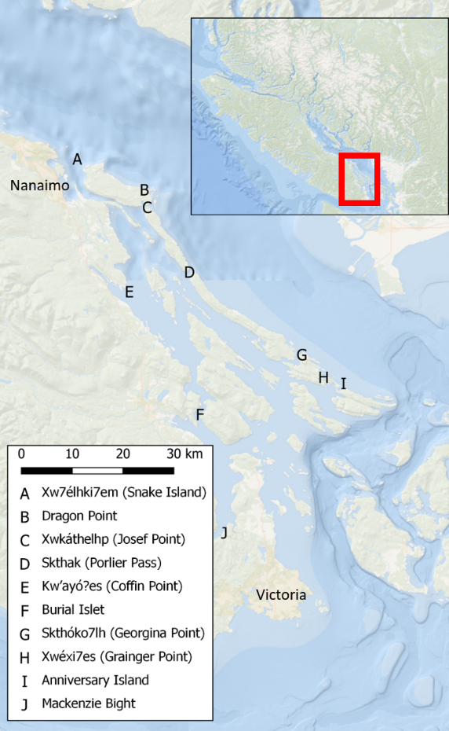

Figure 1: Map of survey sites within the Southern Gulf Islands BC Canada. High current sites are coloured red, low current sites are coloured blue. Current speed categories were defined by using the inflection point of all daily maximum current speeds at all sites. Hul’q’umin’um’ site names are used when they could be found in the literature.

*Current data collection and analysis*

Tilt Current Meters (Lowell Instruments, LLC.) were configured to record the current speed for a 15 second duration each minute at a burst rate of 8 Hz. The burst rate determines the rate at which observations are recorded in order to account for small oscillations of the current meter due to water movement, and the rate used here was recommended by Lowell Instruments, LLC. Recording current speeds using a 15 second duration with 8 Hz burst rate allows increased battery life as compared to continuous current speed recording. The recorded speeds were averaged over the 15 second duration to produce one current speed value per minute. The maximum recording speed of the Tilt Current Meters is 120 cm/sec.

Tilt Current Meters were placed at 10 meters depth below chart datum in areas close to where the fish and substrate surveys were conducted. The main challenge with placing the Tilt Current Meters is the large, flat area free of any rock or kelp necessary for them to move in 360° to accurately record current observations. At many sites, it was challenging to find such locations, therefore the location of the current meter was not always directly between where the 3 and 15 meter fish and substrate transects were conducted. Current speeds were recorded at all sites for 41 days, from 16 December 2019 to 26 January 2020.

Daily maximum current speeds were extracted for each site by determining the maximum recorded current speed over each 24-hour period. Other studies have also used maximum current speeds in their studies (Haak et al. 2019; Rubidge et al. 2020). Maximum current speeds were used as these extreme conditions may represent abiotic thresholds for certain species (Liao 2007). Once a threshold is reached or exceeded it may become difficult for individuals of certain species to thrive under those conditions and the risk increases of being outcompeted by species who have higher thresholds, which may result in community level change.

*Fish and substrate data collection*

All fish in the study were surveyed using non-destructive, observational techniques with animal ethics approval from the University of Victoria Animal Care Committee (2019-020 (1)). The fish and substrate data collection protocols were adapted from Partnership for Interdisciplinary Studies of Coastal Oceans (http://www.piscoweb.org/kelp-forest-sampling-protocols), Reef Life (https://reeflifesurvey.com/methods/), and Reef Check (https://reefcheck.org/PDFs/RCCAmanual9thedition.pdf). Transect lengths, depths, and observational windows were altered to account for the typically reduced visibility in the northeastern Pacific as compared to the tropics or California where these protocols were created.

Fish and substrate surveys were conducted from 17 October 2019 to 7 March 2020. Each site was visited as often as currents, weather, and personnel availability allowed over the survey period resulting in three or four replicate surveys at each site. High current sites were surveyed during slack current to ensure diver safety. Transects were 20-meters long and were conducted along 3 and 15 meter depth contours (below chart datum) at each site using SCUBA (Figure 2). The 3 meter depth allowed for the fish community residing in the kelp/seaweed habitat to be surveyed. The 15 meter depth is typically deeper than most kelps and seaweed grow and experiences less variability in temperature, salinity, and water motion from waves and boat traffic. This depth was also the deepest depth that could be surveyed while following Canadian Association of Underwater Scientist Level 1 standards. At each visit, transects were conducted at similar GPS coordinates, but the starting point of these replicate transects varied. The intention was to observe variation at the site level, while capturing representative conditions at each site within the confines of logistical limitations.

Two passes were conducted over each transect. On the first pass at each depth the transect tape was deployed while swimming at least 1 m above the substrate to avoid disturbing benthic fishes. During this first pass, all larger fish situated within a 1 m swath along the length of the transect path and up to 1 m above the substrate were recorded, along with their lengths (to the nearest cm) to avoid losing that information if the fish moved away prior to being recorded on the second pass. On the second pass back along the transect tape, all fish species, their abundances, and estimated lengths (to the nearest cm) were recorded within a 1 m width along the entire length of the transect path, which included fish located in all cracks and crevices and up to 1 m above the substrate. The fish recorded on the first pass were not counted again if they were encountered on the second pass. These two passes were treated as one single transect unit in all analyses. The same diver collected all the fish data to reduce variability. They determined the lengths of the fish by measuring the fish against known lengths along their hand, arm, or dive slate. When fish could not be approached closely enough to determine lengths directly, the diver noted the position of the fish’s snout and tail relative to the surrounding rock, then measured that distance after the fish had moved. The second diver recorded primary and secondary substrate type over the same area where the fish were observed in 1 m2 quadrats along the transect tape every 2 m (10 quadrats along each 20 m transect). Primary and secondary substrate types were based on the Wentworth Class (Wentworth 1922) and were limited to bedrock (> 1 m), boulders (1 – 0.25 m), cobble (0.25 – 0.06 m), gravel/sand/silt/mud (< 0.06 m), and shell hash.

Species from the family Embiotocidae were not included in the statistical analyses, although they were recorded. These included four Surf perch species (*Brachyistius frenatus, Cymatogaster aggregate, Embiotoca lateralis, and Rhacochilus vacca*) which are highly mobile, less territorial than other species, and may move into and out of sites based on current speeds or directions (Simard et al. 2002), or only move into high current sites when the current is slow enough for them to maneuver. Since these species may be more transient at the site level, the analyses were conducted without them to better capture the effect of current on the resident fish community.

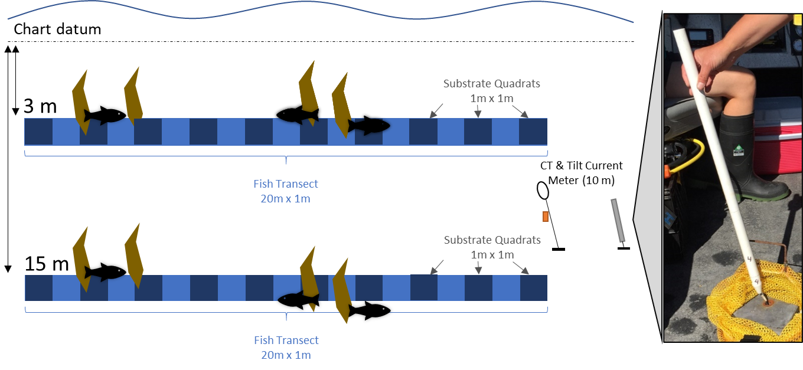

Figure 2: Schematic of fish and benthic data collection protocol. Fish and benthic characteristics were measured at 3 meter and 15 meter depth contours (below chart datum) at each of the 10 sites. Fish were counted and measured in a 1 meter width along the 20 meter long transect (light blue rectangle). Substrate characteristics were recorded in 1 m2 quadrats every 2 meters (10 quadrats per 20 meter long transect, dark blue squares). Sites were surveyed multiple times from October 2019 to March 2020 resulting in replicate transects at each depth. Current, temperature, and salinity data were continuously recorded at 10 meter depth from 16 December 2019 to 26 January 2020 using Tilt Current Meters from Lowell Instruments, LLC and conductivity and temperature loggers from Star Oddi.

Fish lengths were converted into biomass estimates using the power formula,

(Equation 1)

with *a* and *b* coefficient values coming from multiple sources (Washington et al. 1978; Lea et al. 1999; Haggarty and King 2004; Froese et al. 2014). The same person conducted all fish surveys to reduce sampling variability, however substrate data were collected by nine individuals over the survey period with each given consistent top-side training.

*Fish and substrate data analysis*

To ensure surveys were conducted over similar habitats, the primary substrate observation in each quadrat were summed over each transect. These transect level values were then compared between current categories and transect depths. While secondary substrate type data were collected, only 49% of the quadrats had a secondary substrate type, therefore these data were not explored.

Fish biodiversity metrics - species richness, abundance, and biomass - were modeled using linear mixed effect models for two reasons. First, while sites were categorized as either high or low current, we observed a continuum of current among sites that could not be captured in the non-parametric analyses using the categorical current data. Second, the random effect in the mixed effect models can better account for site variation, rather than averaging the replicate transects at each site as was done in the non-parametric analyses to avoid pseudoreplication. We considered four candidate models for each of the three fish biodiversity metrics: a null model (~ (1|Site)), a mean daily maximum current speed model, referred to hereafter as max current (~ Max Current + (1|Site)), a transect depth model (~ Transect Depth + (1|Site)), and a max current + transect depth model (~ Max Current + Transect Depth + (1|Site)). All models included survey site as a random effect to account for the replicate transects at each site over the study period. Linear mixed effect models were fit using the lme function in the nlme package in R (nlme package in R, Pinheiro et al, 202). We used Akaike’s information criterion (*AIC*), (bblme package in R, Bolker and R Development Core Team, 2020) to identify the best model to test for differences in fish abundance between the selected explanatory variables. We determined the best-supported model as that with the lowest AIC value (Burnham and Anderson 2002).

Fish community composition was compared among the current and depth categories using non-metric multi-dimensional scaling of Gower distance measures (nMDS; reshape2 package in R, Wickham, 2007; vegan package in R, Oksanen et al, 2019) to visualize the relative dissimilarities of the transects between current category or transect depth communities. Data included abundance values for each species at each site and depth. This resulted in a zero-inflated data set with 72% of the abundance observations being zeros. ~~To account for this in the nMDS analysis, data were Wisconsin double standardized and square root transformed. In a Wisconsin double standardization, each abundance value is divided by its column maximum and then divided by the row total. The Gower dissimilarity index was calculated to provide the best fit to the data and was used in the nMDS analysis.~~

Statistical analyses were conducted in R version 3.6.2 (R Core Team, 2020).

## Results

*Abiotic data analysis*

Daily maximum tidal current speeds measured at 10 meter depth over the 41-day collection period (16 December 2019 to 26 January 2020) ranged from 1.81 cm/sec to 118.50 cm/sec over the 10 sites (Figure 3). The Tilt Current Meters can only record speeds up to 120 cm/sec but for them to reach this maximum speed they need to become completely horizontal, which is unlikely to occur since they are positively buoyant. We believe that current speeds at Skthak (Porlier Pass), Xwéxi7es (Grainger Point), and Burial Islet repeatedly exceeded this speed and therefore, the true values are actually higher.

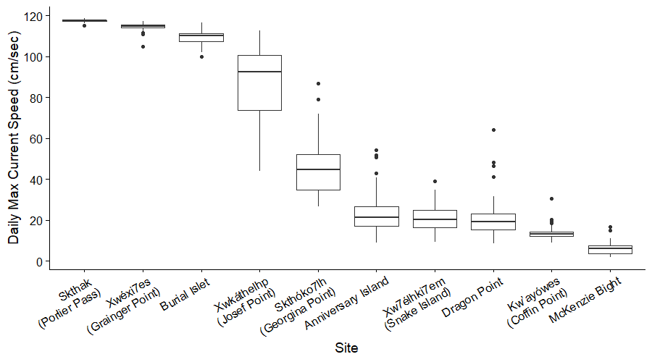

Figure 3: Daily maximum current speeds at each site presented as boxplots, indicating the median and quartiles with whiskers extending to 1.5 times the interquartile range.

Temperature and salinity data were also collected and analysed, but there were no biologically significant differences in these variables among sites. ~~The primary substrate observation in each quadrat were summed by transect.~~ Primary substrate type was similar over all sites and depths with rock substrates (bedrock, boulder, and cobble) comprising 89 - 97% of the transects. Gravel, sand, silt, mud, and shell hash substrates comprised the remaining 3-11% of transect primary substrate types.

*Fish species richness, abundance, and biomass analyses*

Across all sites and depths a total of 1,653 fish from 25 species were observed, resulting in a biomass of 210.7 kg. Six species were only observed on 3 meter depth transects and seven species were only observed on 15 meter depth transects (Appendix T1).

A total of 69 transects were completed and the number of replicate transects at each site and depth were not consistent due to logistical limitations (e.g., poor weather, currents, and/or visibility, or personnel and/or boat availability). Individual transect species richness, abundance, and biomass are displayed in Figure 4.

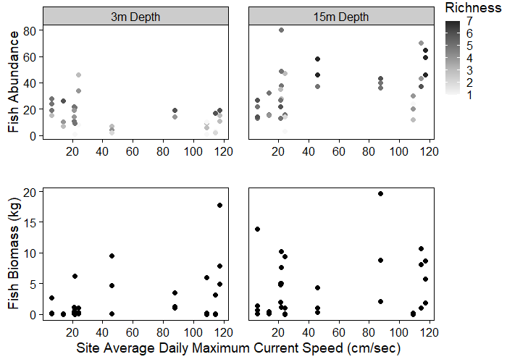

Figure 4: Individual transect fish abundance and biomass at each site average daily maximum current speed. Grey shaded circles in the abundance plot (top) represent the transect species richness (via colour) and abundance (via vertical position), black circles in the biomass plot (bottom) represent transect biomass. The number of replicate transects at each site and depth were inconsistent due to site sampling logistic limitations.

Fish abundance and biomass values for each transect do not necessarily exhibit a positive relationship since the species driving the abundance differences (*Rhinogobiops nicholsii, Artedius harringtoni* and *Jordania zonope)* have a maximum length of 15 cm or less*,* whereas the species driving the biomass differences can reach lengths up to 61 cm for *Hexagrammos decagrammus* or 152 cm for *Ophiodon elongatus*.

*Fish biodiversity models*

The two explanatory variables tested in the linear mixed effect models to estimate fish abundance were Max Current (mean daily maximum current speed) and Transect Depth. The raw abundance data were plotted against these two variables to observe how fish abundance varied with these explanatory variables (Figure 14).

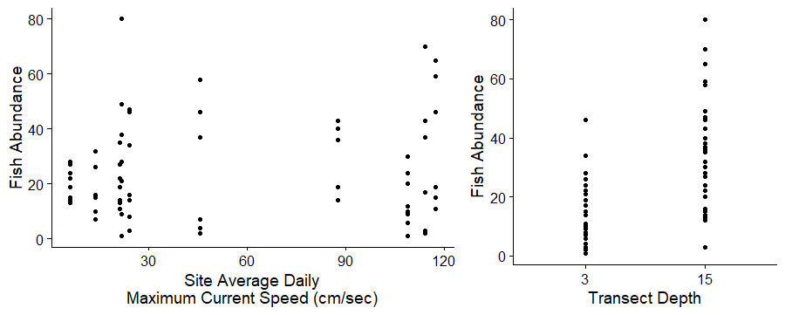

Figure 14: Fish abundance on each transect as compared to site average daily maximum current speed (left panel) and transect depth (right panel).

The top linear mixed effect model for estimating fish abundance was the Transect Depth model (Equation 2; Table 2) as indicated by the low AIC score. The three other models tested had AIC scores of between 5.4 to 33.8 points higher. The model residuals showed some positive skew as demonstrated by a Pearson residuals vs fitted plot and a Q-Q plot (Figure 15), indicating that the model may be overpredicting fish abundance on the 15 meter depth transects. Mean fish abundance was more than twice as high (19.64 fish on average) at 15 meter depth transects than the 3 meter depth transects (3 meter mean fish abundance: 14.10 ± 5.4 fish; 15 meter mean fish abundance: 33.74 ± 6.9 fish, Figure 16).

(Equation 2)

Table 2: Results of model selection for four candidate models of fish abundance.

|  |  |  |  |  |  |
| --- | --- | --- | --- | --- | --- |
|  | Model Parameters | logLikelihood | *AIC* | Δ*AIC* | Weight |
| Transect Depth | 4 | -278.8 | 565.6 | 0.0 | 0.936 |
| Transect Depth + Max Current | 5 | -280.5 | 571.0 | 5.4 | 0.064 |
| Null Model | 3 | -293.9 | 593.9 | 28.3 | <0.001 |
| Max Current | 4 | -295.7 | 599.5 | 33.8 | <0.001 |

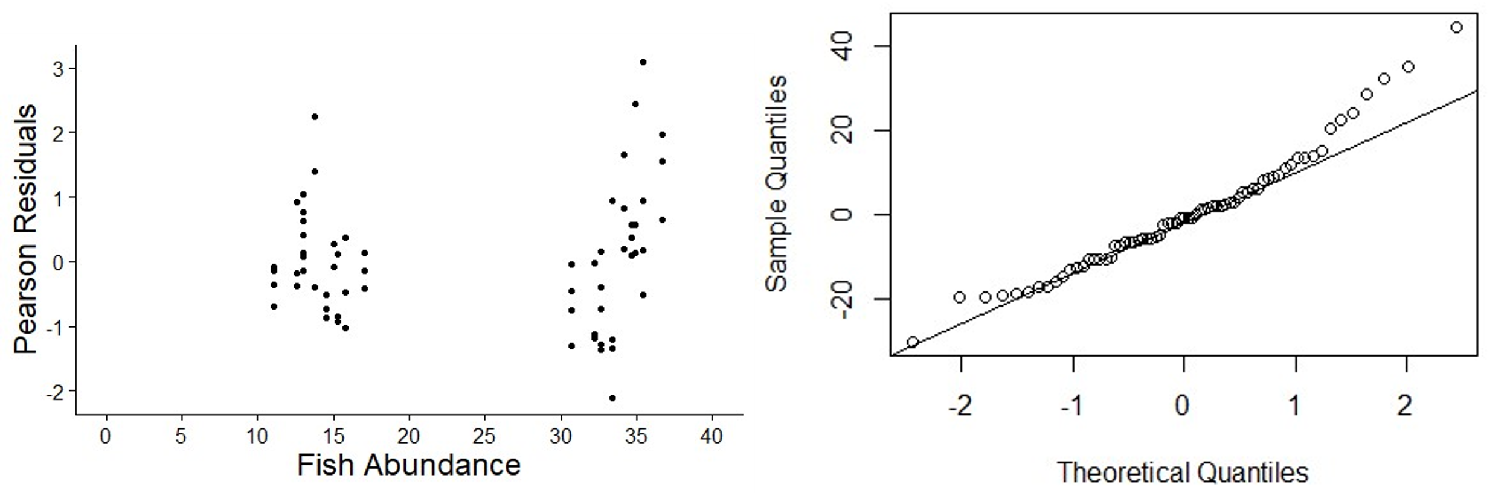

Figure 15: Plots showing model fit. Pearson residuals versus fitted abundance data plot (left) showing fish abundance estimates at 3 meter (cluster of black dots on left of plot) and 15 meter (cluster on right of plot) depths. Quantile-quantile plot (right) showing right skew.

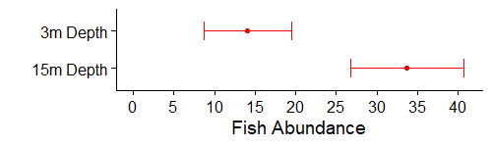

Figure 16: Predicted mean fish abundance at 3 meter and 15 meter depths from a linear mixed effects model with transect depth as the fixed effect and site as the random effect. Red dots indicate predicted mean abundance, horizontal lines represent 95% confidence intervals.

Fish abundances at 3 meter and 15 meter depths were similar under the linear mixed effect model estimates and non-parametric median values. The 3 meter depth median value was 14.7 fish and the linear mixed effect model abundance estimate was 14.10 ± 5.4 fish. The 15 meter depth median value was 32.0 fish and the linear mixed effect model abundance estimate was 33.74 ± 6.9 fish. The similarities of these two methods in determining fish abundances provides added confidence in the model results.

*Fish community results*

~~The fish community composition at different current speeds and depths were compared using non-metric multi-dimensional scaling (nMDS) plots (Figure 11). The current category and transect depth communities overlap, but the high stress value (0.243) of the nMDS plot indicates the dissimilarities between replicate transects are not well represented by the 2-dimensional plot. The analysis of similarity (ANOSIM) test results indicate there is no differences between current (~~*~~p~~*~~-value = 0.051,~~ *~~R~~* ~~statistic = 0.142) or depth (~~*~~p~~*~~-value = 0.046,~~ *~~R~~* ~~statistic = 0.097) communities; an~~ *~~R~~* ~~statistic close to 0 indicates community similarity and a value close to 1 indicates community dissimilarity, with the~~ *~~p~~*~~-value measuring how likely that result is over 999 permutations.~~

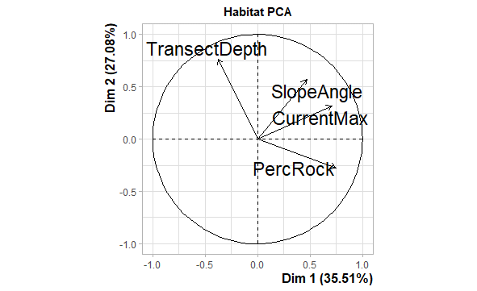

~~Figure 11:~~ ~~Non-metric multi-dimensional scaling (nMDS) plot of the Gower dissimilarity measure of fish community dissimilarities for current category or depth transects. Each symbol represents a replicate transect. The shape represents the transect depth (circle for 3 meter depth and triangle for 15 meter depth) and colour represents current category (blue for low current and red for high current).~~

## Discussion

Transect depth was determined to be an important driver of fish abundance in our study in both the non-parametric analyses and the linear mixed effect models, demonstrating the importance of depth for the nearshore fish species observed. Both statistical methods predicted similar fish abundances for both depths. However, tidal current did not have a significant effect on fish species richness, abundance, or biomass in either the non-parametric analyses or the linear mixed effect models. Tidal current also did not have a statistically significant effect on fish communities as determined by the nMDS plot and analysis of similarity test. However, current speed and depth did result in species specific differences. The five most abundant species observed during this study were *Artedius harringtoni, Hexagrammos decagrammus, Jordania zonope,* *Rhinogobiops nicholsii,* and *Sebastes caurinus*. At high current sites, *A. harringtoni* were significantly more abundant and smaller and *S. caurinus* were significantly longer than at low current sites. At 15 meter depths *J. zonope* were significantly more abundant and *H. decagrammus* were significantly longer than at 3 meter depths.The results of this study suggest that depth may be a useful abiotic surrogate for fish species richness and abundance in the Southern Gulf Islands of BC, however, tidal current was not shown to be a suitable surrogate for fish biodiversity but may be useful for species-specific studies.

There were significant differences between high and low current sites in daily average temperature and salinity values. High current sites were on average 0.22 °C cooler and 1.61 psu fresher than the low current sites. Thomson (1981) indicates that temperatures and salinities are often lower in areas with tidal mixing.However, the temperature and salinity differences observed here are not likely to be biologically meaningful as temperature and salinity values vary more annually than over the period recorded here (Thomson, 1981; Burd et al. 2008). Additionally, most of the species encountered here range from California to Alaska and therefore can tolerate a broader range of temperature and salinity values than those recorded in this study. Rock substrate (comprised of bedrock, boulder, and cobble substrates) was the primary substrate identified in 89-97% or more of the transect quadrats at each current regime or transect depth, confirming that surveys were conducted over similar substrates and therefore substrate type may not be confounding fish community results.

The current categorization that resulted from using the Tilt Current Meter readings and inflection point speed differed from our a priori assumptions of the sites. We had initially thought Skthóko7lh (Georgina Point) would be a high current site, yet through the analysis conducted here, was categorized as a low current site. Current speeds are dampened along shorelines as the friction between the water and substrate reduces the speed of the water. At Skthóko7lh (Georgina Point), the substrate has a very shallow slope, resulting in a wide area between the shoreline and where the Tilt Current Meter was placed over which the water may be slowed. This may be why the current speeds observed here were much slower than what we had initially assumed. Additionally, the Tilt Current Meters require an area approximately 1.5 m2 to be able to move freely, which, at many locations, was a challenge to find since the substrate is quite complex. This was especially evident at Xwkáthelhp (Josef Point) where the only area large enough to place the Tilt Current Meter at 10 meters below chart datum was also surrounded by tall boulders, which may have created a back eddy, thus limiting the ability of the Tilt Current Meter to detect the true current speed at the site. Therefore, the current speeds at both Skthóko7lh (Georgina Point) and Xwkáthelhp (Josef Point) may be higher than those observed in this study.

Transect depth was a strong indicator of increased fish species richness and abundance, similar to results found by others (Gibson et al. 1996; Love et al. 2009; Sobocinski et al. 2018). These studies examined fish biodiversity over much shallower depth ranges (0.5-5 m, Gibson et al. 1996) or much deeper depth ranges (19-365 m, Love et al. 2009; 30-100 m, Sobocinski et al. 2018) and this study fills in the knowledge gap between these depth ranges. While Gibson et al. generally found increased species richness, abundance, and weight at 5 meter depths versus 0.5 meters, both Love et al. and Sobocinski et al. found increased species richness and abundance at the shallower depths in their range. Those results, coupled with the results from this study may indicate that species richness and abundance are highest between 5 and 19 meter depths. All three studies also found higher abundances of juvenile fish in the shallower depth ranges, which may also be the case here for *H. decagrammus.* Here, the lower fish species richness and abundance in the 3 meter depth communities may be a result of exposure to variability in temperature or salinity or from unpredictable wave and surge motion from wind and boat traffic, particularly at sites along high traffic boat and ferry routes or near marinas (all survey sites with the possible exception of Xwéxi7es (Grainger Point) and Anniversary Island). This stress may result in fish occupying calmer, more stable conditions at depth (Liao 2007; Young and Carr 2015). As well, increased kelp cover and reduced visibility along many 3 meter depth transects may have reduced our ability to detect all fish present, or since the 3 meter transects were conducted after the 15 meter depth transects, surveyors were sometimes constrained by the increasing current speeds at sites with narrow slack current windows or by limited air reserves. Here, two species were found to have significant differences in either abundance or length between transect depths. *J. zonope* had 1.7 more fish and *H. decagrammus* were 10.0 cm longer on the 15m depth transects, suggesting perhaps distinct depth preference for *J. zonope*, and life stage movements for *H. decagrammus*.

Vieham and Zydlewski (2017) also did not find any correlation between fish abundance and current speed, but other studies have linked tidal phase to fish abundance (Kingsford and Suthers 1996; Embling et al. 2012; Haak et al. 2019; Robinson et al. 2007; Vieham and Zydlewski 2017). Unfortunately, this research was not able to take tidal phase into account as the high current sites could not safely be dove during maximum flood or ebb.

While we did not detect any community level differences between the current regimes, it does appear that certain species abundances and lengths are influences by current speed. There were significant differences in *A. harringtoni* abundance and length differences between current or depth communities. *A. harringtoni* were more abundant in high current communities at both depths but were larger in low current communities. *A. harringtoni* prefers rock habitat free from shell hash or silt (Norton 1991) and prefers giant acorn barnacles (*Balanus nubilus*) which provide cover for ambush attacks on their prey and protection from predators (Demetropoulos et al. 1990). The high current sites had 7% fewer quadrats with sand, silt, or mud or shell hash substrate types and had dense aggregations of giant acorn barnacles, providing optimum habitat compared to low current sites. *S. caurinus* were 1.7 time smaller at low current sites than high current sites. Multiple young-of-year (recently settled juveniles) *S. caurinus* were routinely observed at the low current site McKenzie Bight, which may have influenced the results. Just over half (52.5%) of the quadrats on the 3 meter depth transects had understory kelp as the dominant algae type which is optimal habitat for this life stage (Hayden-Spear 2006).

If there are differences in fish biodiversity between current categories, and we did not detect them, it could be due to a number of factors such as: the range of current speeds observed here was too narrow, the dives were conducted during slack current and may be misrepresenting the high current communities, the six-month sampling period introduced seasonal effects which obscure the trends, or the within site variation obscured the between current category variation. The sites included in this study represent the strongest tidal currents in the area and were observed over some of the largest tidal exchanges of the year. However, to address these concerns, future studies should sample over a much shorter time frame and sample more sites, rather than a few sites multiple times. Additionally, factors outside of the study design, such as the presence of sea lions and harbour seals, anthropogenic stressors such as boat traffic or fishing, or pollution from nearby towns or the Fraser River plume may have influenced our ability to determine the effectiveness of tidal current as a suitable abiotic surrogate. Sea lions and harbour seals were observed on the surface at each site at almost every visit and sea lions were also observed during some of the transect surveys, which may have altered fish behaviour. As well, boat traffic is a very common occurrence at many of the sites.

Since these surveys were conducted during slack current to ensure the safety of the dive team, the fish communities that are active during the high flow times were not observed, which might alter the inferred effect of current on fish communities. Further studies using cameras secured to the substrate (Bond et al. 2018) or hydroacoustic data (Viehman and Zydlewski 2017) that capture the communities present during the highest current flow periods may yield more complete results. Additionally, we did not take temporal (seasonal or interannual) effects into consideration as surveys were only conducted during the winter months of 2019-2020. Fish species diversity may vary during the spring when many species breed and nest and when plankton abundances are highest (Vieham and Zydlewski 2017). As well, many rockfish species are thought to hide more over the winter months (Carlson and Barr 1977), which may have biased the abundances and biomass estimates observed here. However, this study provides much needed data on many of these locations and species and provides valuable baseline data.

The depths surveyed here are quite shallow for both the sites studied and the region in general; the average depth of the Strait of Georgia is 155 m (Thomson, 1981). Fish communities deeper than those surveyed here may yield different results. However, within the study area, hard substrate habitat is rare deeper than 10 meters and was a limiting factor in site selection. Supplementary studies could be conducted in additional areas to determine if the trends observed here are widespread or a phenomenon localized to the Southern Gulf Islands of BC. Other studies on benthic fish have found additional drivers of biodiversity, including: substrate type (Dean et al. 2000; Laidig et al. 2009; Mcarthur et al. 2010; Easton et al. 2015; Kregting et al. 2016; Bond et al. 2018; Le Bris and Wroblewski 2018; Carrasquilla-Henao et al. 2019), habitat rugosity (Andrews and Anderson 2004; Love and York 2006; Mcarthur et al. 2010; Young and Carr 2015; McHenry et al. 2017; Frid et al. 2018), biogenic habitat (Dean et al. 2000; Zalmon et al. 2011; Young and Carr 2015; Le Bris and Wroblewski 2018; Paes Gomes et al. 2018), slope (Dean et al. 2000; Easton et al. 2015; Carrasquilla-Henao et al. 2019), and wave velocity (Young and Carr 2015). Only one of these studies was conducted in the Strait of Georgia (Carrasquilla-Henao et al. 2019) and more work is needed to determine if the previously mentioned biodiversity drivers are important for nearshore benthic fish in this area.

In conclusion, the results presented here indicate that depth may be a useful abiotic surrogate for fish species richness and abundance over rocky habitat in the Southern Gulf Islands of BC. These results were determined via two statistical methods, non-parametric Mann-Whitney U tests and linear mixed effect models. While tidal current speed did not influence the fish community, it was an important driver of *A. harringtoni* abundance and length differences and *S. caurinus* length differences. As well, transect depth was an important driver of *J. zonope* abundance and *H. decagrammus* length differences. Additionally, some fish species appear to prefer certain depth or tidal current habitats and may require additional consideration to ensure they are adequately protected. These results can be of use for marine spatial planning, nearshore fish conservation efforts, and species distribution modeling, as areas with a range of depths should be considered to protect fish biodiversity and species-specific preferences for current may need to be taken into account.

## Acknowledgments

This research was conducted on the traditional territories of Snuneymuxw, Stz'uminus, Hul’qumi’num Treaty Group, W̱SÁNEĆ, and scəẃaθən məsteyəxʷ. We would like to offer our gratitude to the 3,272 fish that contributed directly to this research. We are grateful for field work support from the Malahat First Nation, Shepherd Charters, captains Steve White and Nick Bohlender, and divers Meghan Abele, Del Heal, Em Lim, Charlotte Matthews, Dominique Maucieri, Matt Miller, Héloïse Frouin-Mouy, Desmond Roessingh, Sam Starko, and Emie Woodburn. The authors would also like to acknowledge Sharon Jeffery who assisted with study design and provided valuable feedback on a previous version of this manuscript and to Nick Brown and Fiona Francis for assistance with the data analysis. JC was funded by a Canadian Federation of University Women 1989 École Polytechnique Commemorative Award and by DFO.

## References

Abramczyk U (2017) Hul’qumi’num Peoples in the Gulf Islands: Re-Storying the Coast Salish Landscape. Masters thesis, University of Victoria, Victoria

Andrews KS, Anderson TW (2004) Habitat-dependent recruitment of two temperate reef fishes at multiple spatial scales. Mar Ecol Prog Ser 277:231–244.

Batten SD, Crawford WR (2005) The influence of coastal origin eddies on oceanic plankton distributions in the eastern Gulf of Alaska. Deep Res Part II Top Stud Oceanogr 52:991–1009.

Baynes TW, Szmant AM (1989) Effect of current on the sessile benthic community structure of an artificial reef. Bull Mar Sci 44:545–566.

Blauw AN, Benincà E, Laane RWPM, Greenwood N, Huisman J (2012) Dancing with the tides: fluctuations of coastal phytoplankton orchestrated by different oscillatory modes of the tidal cycle. PLoS One 7: e49319.

Bolker B, R Development Core Team (2020) bbmle: Tools for General Maximum Likelihood Estimation. R package version 1.0.23.1, https://CRAN.R-project.org/package=bbmle

Bond T, Partridge JC, Taylor MD, Cooper TF, Mclean DL (2018) The influence of depth and a subsea pipeline on fish assemblages and commercially fished species. PLoS One 13:e0207703.

Burd BJ, Barnes PAG, Wright CA, Thomson RE (2008) A review of subtidal benthic habitats and invertebrate biota of the Strait of Georgia, British Columbia. Mar Environ Res 66 Suppl: S3-S38.

Burnham KP, Anderson DR (2001) Model Selection and Inference: A Practical Information-Theoretic Approach, 2nd ed. Springer-Verlag, New York.

Carlson HR, Barr L (1977) Seasonal changes in spatial distribution and activity of two species of Pacific rockfishes, *Sebastes flavidus* and *S. ciliatus*, in Lynn Canal, southeastern Alaska. Mar Fish Rev 39:23–24.

Carrasquilla-Henao M, Yamanaka KL, Haggarty D, Juanes F (2019) Predicting important rockfish ( Sebastes spp.) habitat from large-scale longline surveys for southern British Columbia, Canada. Can J Fish Aquat Sci 76:682–694.

Christopoulos, DT (2019) inflection: Finds the Inflection Point of a Curve. R package version 1.3.5. https://CRAN.R-project.org/package=inflection

Covich AP, Austen MC, Bärlocher F, Chauvet E, Cardinale BJ, Biles CL, Inchausti P, Dangles O, Solan M, Gessner MO, Statzner B, Moss B (2004) The role of biodiversity in the functioning of freshwater and marine benthic ecosystems. Bioscience 54:767–775.

Dean TA, Haldorson L, Laur DR, Jewett SC, Blanchard A (2000) The distribution of nearshore fishes in kelp and eelgrass communities in Prince William Sound, Alaska: Associations with vegetation and physical habitat characteristics. Environ Biol Fishes 57:271–287.

Demetropoulos CL, Braithwaite LF, Maurer BA, Whiting D (1990) Foraging and dietary strategies of two sublittoral cottids, *Jordania zonope* and *Artedius harringtoni*. J Fish Biol 37:19–32.

Díaz-Astudillo M, Castillo MI, Cáceres MA, Plaza G, Landaeta MF (2017) Oceanographic and lunar forcing affects nearshore larval fish assemblages from temperate rocky reefs. Mar Biol Res 13:1015–1026.

Easton RR, Heppell SS, Hannah RW, Ryan Easton ÓR (2015) Quantification of Habitat and Community Relationships among Nearshore Temperate Fishes Through Analysis of Drop Camera Video. Mar Coast Fish Dyn Manag Ecosyst Sci 7:87–102.

Eggertsen L, Hammar L, Gullström M (2016) Effects of tidal current-induced flow on reef fish behaviour and function on a subtropical rocky reef. Mar Ecol Prog Ser 559:175–192.

Embling CB, Illian J, Armstrong E, van der Kooij J, Sharples J, Camphuysen KCJ, Scott BE (2012) Investigating fine-scale spatio-temporal predator-prey patterns in dynamic marine ecosystems: A functional data analysis approach. J Appl Ecol 49:481–492.

Fenberg PB, Menge BA, Raimondi PT, Rivadeneira MM (2015) Biogeographic structure of the northeastern Pacific rocky intertidal: The role of upwelling and dispersal to drive patterns. Ecography 38:83–95.

Frid A, McGreer M, Gale KS, Rubidge E, Blaine T, Reid M, Olson A, Hankewich S, Mason E, Rolston D, Tallio E (2018) The area–heterogeneity tradeoff applied to spatial protection of rockfish (Sebastes spp.) species richness. Conserv Lett 11:e12589.

Froese R, Thorson JT, Reyes RB (2014) A Bayesian approach for estimating length-weight relationships in fishes. J Appl Ichthyol 30:78–85.

Gibson RN, Robb L, Burrows MT, Ansell AD (1996) Tidal, diel and longer term changes in the distribution of fishes on a Scottish sandy beach. Mar Ecol Prog Ser 130:1–17.

Haak CR, Cowles GW, Danylchuk AJ (2019) Wave and tide-driven flow act on multiple scales to shape the distribution of a juvenile fish (*Albula vulpes*) in shallow nearshore habitats. Limnol Oceanogr 64:597–615.

Hayden-Spear J (2006) Nearshore habitat associations of young-of-year copper (Sebastes caurinus) and quillback (S. maliger) rockfish in the San Juan Channel, Washington. Master’s thesis, University of Washington, Seattle.

Haggarty DR, King JR (2004) Hook and line survey of Lingcod (*Ophiodon elongatus*) and Rockfish (*Sebastes spp*.) in northern Strait of Georgia (statistical areas 18 and 19) October 2003. Can Tech Rep Fish Aquat Sci 2533:1–39.

Holmlund CM, Hammer M (1999) Ecosystem services generated by fish populations. Ecol Econ 29:253–268.

Hothorn T, Hornik K, van de Wiel MA, Zeileis A (2008) Implementing a class of permutation tests: The coin package. J Stat Softw 28(8):1-23.

Kingsford MJ, Suthers IM (1996) The influence of tidal phase on patterns of ichthyoplankton abundance in the vicinity of an estuarine front, Botany Bay, Australia. Estuar Coast Shelf Sci 43:33–54.

Kregting L, Elsaesser B, Kennedy R, Smyth D, O’Carroll J, Savidge G (2016) Do changes in current flow as a result of arrays of tidal turbines have an effect on benthic communities? PLoS One 11: e0161279.

Laidig TE, Watters DL, Yoklavich MM (2009) Demersal fish and habitat associations from visual surveys on the central California shelf. Estuar Coast Shelf Sci 83:629–637.

Lea RN, McAllister RD, VenTresca DA (1999) Biological aspects of nearshore rockfishes of the genus Sebastes from central California: with notes on ecologically related sport fishes. Dep Fish Game, Fish Bull 177:112 p.

Le Bris A, Wroblewski JS (2018) Species composition and habitat preferences of the nearshore fish fauna of Bonne Bay, Newfoundland. Mar Biodivers Rec 11:1–17.

Leonard GH, Levine JM, Schmidt PR, Bertness MD (1998) Flow-driven variation in intertidal community structure in a Maine estuary. Ecology 79:1395–1411.

Liao JC (2007) A review of fish swimming mechanics and behaviour in altered flows. Philos Trans R Soc B Biol Sci 362:1973–1993.

Love MS, Yoklavich M, Schroeder DM (2009) Demersal fish assemblages in the Southern California Bight based on visual surveys in deep water. Env Biol Fish 84:55–68.

Love MS, York A (2006) The relationships between fish assemblages and the amount of bottom horizontal beam exposed at California oil platforms: Fish habitat preferences at man-made platforms and (by inference) at natural reefs. Fish Bull 104:542–549.

Markel RW, Lotterhos KE, Robinson CLK (2017) Temporal variability in the environmental and geographic predictors of spatial-recruitment in nearshore rockfishes. Mar Ecol Prog Ser 574:97–111.

Mcarthur MA, Brooke BP, Przeslawski R, Ryan DA, Lucieer VL, Nichol S, Mccallum AW, Mellin C, Cresswell ID, Radke LC (2010) On the use of abiotic surrogates to describe marine benthic biodiversity. Estuar Coast Shelf Sci 88:21–32.

McHenry J, Steneck RS, Brady DC (2017) Abiotic proxies for predictive mapping of nearshore benthic assemblages: Implications for marine spatial planning: Implications. Ecol Appl 27:603–618.

Mellin C, Delean S, Caley J, Edgar G, Meekan M, Pitcher R, Przeslawski R, Williams A, Bradshaw C (2011) Effectiveness of biological surrogates for predicting patterns of marine biodiversity: A global meta-analysis. PLoS One 6: e20141.

Moser GAO, Piedras FR, Oaquim ABJ, Souza DS, Leles SG, de Lima DT, Ramos ABA, Farias C de O, Fernandes AM (2017) Tidal effects on phytoplankton assemblages in a near-pristine estuary: a trait-based approach for the case of a shallow tropical ecosystem in Brazil. Mar Ecol 38:1–18.

Nephin J, Jeffery S, Thiess M, Archer S, Boschen-Rose J, Dudas S (2020) Methods and results from remotely operated vehicle ( ROV ) survey PAC2017-030 : Exploring high and low current areas in the Salish Sea. Can Tech Rep Fish Aquat Sci 3405:vi + 39.

Norton SF (1991) Habitat Use and Community Structure in an Assemblage of Cottid Fishes. Ecology 72:2181–2192.

Oksanen J, Blanchet FG, Friendly M, Kindt R, Legendre P, McGlinn D, Minchin PR, O'Hara RB, Simpson GL, Solymos P, Stevens MHH, Szoecs E, Wagner H (2019) vegan: Community Ecology Package. R package version 2.5-6. https://CRAN.R-project.org/package=vegan

Paes Gomes M, Queiroz De Albuquerque C, Andrades R, Martins AS, Robinson LA, Spencer M (2018) Influence of detached macroalgae on fish size and condition in nearshore habitats. Estuar Coast Shelf Sci 211:227–237.

Palardy JE, Witman JD (2011) Water flow drives biodiversity by mediating rarity in marine benthic communities. Ecol Lett 14:63–68.

Palumbi SR, McLeod KL, Grünbaum D (2008) Ecosystems in action: Lessons from marine ecology about recovery, resistance, and reversibility. Bioscience 58:33–42.

Pinheiro J, Bates D, DebRoy S, Sarkar D, R Core Team (2020) nlme: Linear and Nonlinear Mixed Effects Models. R package version 3.1-148, https://CRAN.R-project.org/package=nlme

Pitcher CR, Lawton P, Ellis N, Smith SJ, Incze LS, Wei CL, Greenlaw ME, Wolff NH, Sameoto JA, Snelgrove PVR (2012) Exploring the role of environmental variables in shaping patterns of seabed biodiversity composition in regional-scale ecosystems. J Appl Ecol 49:670–679.

R Core Team (2020). R: A language and Environment for Statistical Computing. R Foundation for Statistical Computing, Vienna, Austria. https://www.R-project.org/

Rees MJ, Jordan A, Price OF, Coleman MA, Davis AR (2014) Abiotic surrogates for temperate rocky reef biodiversity: Implications for marine protected areas. Divers Distrib 20:284–296.

Robinson CJ, Gómez-Aguirre S, Gómez-Gutiérrez J (2007) Pacific sardine behaviour related to tidal current dynamics in Bahía Magdalena, México. J Fish Biol 71:200–218.

Robinson CLK, Hrynyk D, Barrie JV, Schweigert J (2013) Identifying subtidal burying habitat of Pacific Sand Lance (*Ammodytes hexapterus*) in the Strait of Georgia, British Columbia, Canada. Prog Oceanogr 115:119–128.

Rodrigues ASL, Brooks TM (2007) Shortcuts for biodiversity conservation planning: The effectiveness of surrogates. Annu Rev Ecol Evol Syst 38:713–737.

Rozen DL (1985) Place-Names of the Island Halkomelem Indian People. Masters thesis, University of British Columbia, Vancouver, BC

Rubidge E, Jeffery S, Gregr EJ, Gale KSP, Frid A (2020) Assessment of nearshore features in the Northern Shelf Bioregion against criteria for determining Ecologically and Biologically Significant Areas (EBSAs). DFO Can Sci Advis Sec Res Doc 63 p.

Sala E, Knowlton N (2006) Global marine biodiversity trends. Annu Rev Environ Resour 31:93–122.

Sato CF, Westgate MJ, Barton PS, Foster CN, O’Loughlin LS, Pierson JC, Balmer J, Chapman J, Catt G, Detto T, Hawcroft A, Kavanagh RP, Marshall D, McKay M, Moseby K, Perry M, Robinson D, Schroder M, Tuft K, Lindenmayer DB (2019) The use and utility of surrogates in biodiversity monitoring programmes. J Appl Ecol 56:1304–1310.

Schnute JT, Boers N, Haigh R (2019) PBSmapping: Mapping Fisheries Data and Spatial Analysis Tools. R package version 2.72.1. https://CRAN.R-project.org/package=PBSmapping

Siegel DA, Mitarai S, Costello CJ, Gaines SD, Kendall BE, Warner RR, Winters KB (2008) The stochastic nature of larval connectivity among nearshore marine populations. Proc Natl Acad Sci U S A 105:8974–8979.

Simard Y, Lavoie D, Saucier FJ (2002) Channel head dynamics: Capelin (*Mallotus villosus*) aggregation in the tidally driven upwelling system of the Saguenay - St. Lawrence marine park’s whale feeding ground. Can J Fish Aquat Sci 59:197–210.

Sobocinski KL, Ciannelli L, Wakefield WW, Yergey ME, Johnson-Colegrove A (2018) Distribution and abundance of juvenile demersal fishes in relation to summer hypoxia and other environmental variables in coastal Oregon, USA. Estuar Coast Shelf Sci 205:75–90.

Stefansdottir L, Solmundsson J, Marteinsdottir G, Kristinsson K, Jonasson JP (2010) Groundfish species diversity and assemblage structure in Icelandic waters during recent years of warming. Fish Oceanogr 19:42–62.

Thomson RE (1981) Oceanography of the British Columbia Coast. Can Spec Publ Fish Aquat Sci 56:291 p.

Tolimieri N, Andrews K, Williams G, Katz S, Levin PS (2009) Home range size and patterns of space use by lingcod, copper rockfish and quillback rockfish in relation to diel and tidal cycles. Mar Ecol Prog Ser 380:229–243.

Ueno H, Crawford WR, Onishi H (2010) Impact of Alaskan Stream Eddies on Chlorophyll Distribution in the North Pacific. J Oceanogr 66:319–328.

Viehman HA, Zydlewski GB (2017) Multi-scale temporal patterns in fish presence in a high velocity tidal channel. PLoS One 12: e0176405.

Ward TJ, Vanderklift MA, Nicholls AO, Kenchington RA (1999) Selecting marine reserves using habitats and species assemblages as surrogates for biological diversity. Ecol Appl 9:691–698.

Ware DM, Thomson RE (2005) Bottom-up ecosystem trophic dynamics determine fish production in the Northeast. Science (80) 308:1280–1284.

Washington PM, Gowan R, Ito DH (1978) A biological report on eight species of Rockfish (*Sebastes spp*.) from Puget Sound, Washington. National Marine Fisheries Services, Seattle, Washington.

Watson JR, Hays CG, Raimondi PT, Mitarai S, Dong C, McWilliams JC, Blanchette CA, Caselle JE, Siegel DA (2011) Currents connecting communities: nearshore community similarity and ocean circulation. Ecology 92:1193–1200.

Wentworth CK (1922) A scale of grade and class terms for clastic sediments. J Geol 30:377–392.

Wickham H (2007) Reshaping Data with the reshape Package. J Stat Softw 21(12):1-20.

Worm B, Barbier EB, Beaumont N, Duffy JE, Folke C, Halpern BS, Jackson JBC, Lotze HK, Micheli F, Palumbi SR, Sala E, Selkoe KA, Stachowicz JJ, Watson R (2006) Impacts of biodiversity loss on ocean ecosystem services. Science 314:787–790.

Young M, Carr MH (2015) Application of species distribution models to explain and predict the distribution, abundance and assemblage structure of nearshore temperate reef fishes. Diversity and Distributions 21(12):1 428–1440. https://doi.org/10.1111/ddi.12378

Zalmon IR, Mccrea M, Love MS (2011) Abundance, size and habitat relation of reef fish on biogenic structures (structure-forming invertebrates) at Anacapa Island, southern California. J Mar Biol Assoc United Kingdom 91:1295–1305.

## Appendix

A1: Species observed and their total recorded abundances. Species are grouped based on which transect depths they were observed on.

|  |  |  |  |  |
| --- | --- | --- | --- | --- |
|  |  | Observed | | FishBase |
| Species Name | Total Abundance | Minimum Length (cm) | Maximum Length (cm) | Maximum Length (cm) |
| Species observed at both depths | |  |  |  |
| *Rhinogobiops nicholsii* | 776 | 2 | 11 | 15 |
| *Artedius harringtoni* | 459 | 1 | 10 | 10 |
| *Jordania zonope* | 153 | 2 | 14 | 15 |
| *Sebastes caurinus* | 86 | 4 | 65 | 58 |
| *Hexagrammos decagrammus* | 68 | 7 | 52 | 61 |
| *Oxylebius pictus* | 37 | 9 | 14 | 25 |
| *Chirolophis nugator* | 7 | 6 | 7 | 15 |
| *Pholis laeta* | 7 | 5 | 13 | 25 |
| *Hemilepidotus hemilepidotus* | 7 | 8 | 22 | 51 |
| *Anoplarchus sp.* | 6 | 6 | 11 | 20 |
| *Nautichthys oculofasciatus* | 6 | 5 | 13 | 20 |
| *Sebastes auriculatus* | 3 | 5 | 24 | 56 |
|  |  |  |  |  |
| Only at 3 meter depths | |  |  |  |
| *Artedius lateralis* | 8 | 3 | 10 | 14 |
| *Hexagrammos stelleri* | 6 | 8 | 16 | 48 |
| *Gobiesox maeandricus* | 5 | 4 | 10 | 16 |
| *Enophrys bison* | 1 | - | 23 | 37 |
| *Rimicola muscarum* | 1 | - | 3 | 7 |
| *Syngnathus leptorhynchus* | 1 | - | 10 | 33 |
|  |  |  |  |  |
| Only at 15 meter depths | |  |  |  |
| *Sebastes maliger* | 12 | 6 | 23 | 61 |
| *Ophiodon elongatus* | 9 | 25 | 75 | 152 |
| *Rhamphocottus richardsonii* | 4 | 2 | 7 | 9 |
| *Citharichthys stigmaeus* | 3 | 2 | 9 | 17 |
| *Sebastes flavidus* | 3 | 17 | 24 | 66 |
| *Chirolophis decoratus* | 2 | 12 | 13 | 42 |
| *Pholis clemensi* | 1 | - | 5 | 13 |