**Software Engineering II Project**

**Digital Cookbook**

Group 2

Member 1

Jiang Chenwei

Member n

Bao Yuning, Wang Shuzheng, Chen Xinyu

**Content**

1. Specification 3
   1. Description 3
   2. Product functions 3
   3. User characteristics 4
   4. Data 4
   5. Functional requirements 4
   6. Non-functional requirements 5
2. UML Specification 6
   1. Diagram 6
3. GUI Design 7
   1. Structure/MVC 7
   2. Screenshots 8
4. Evaluation 9
   1. Group Work 9
   2. Task Responsibilities 9

# **Specification**

# **Description**

Learning to cook is a very important skill to many people and it enriches their daily life. However, many people may have difficulty in cooking due to various factors, including the tight schedule and ignorance of cooking skills. Therefore, we develop a digital cookbook for those who need to learn cooking skills.

This digital cookbook provides adequate recipes for users. Usersdo not need to register. The app relates to a MySQL database (DB) where detailed information of the recipes is saved. Besides, they can also create or update their own recipes. Searching for the recipes, by inputting the name, ingredients, and both two key words, is also allowed.

By analyzing the user characteristics and drawing the class diagram and use case diagram, we came up with ideas about the design pattern of the application. It is clearly structured with a MVC pattern and easy to use. The well-designed GUI satisfies users’ aesthetic needs.

The cookbook is coded in java with the joint effort of all the group members. After several times of necessary tests, it could function well and satisfies basic and practical needs for users. But it may still have some small problems and its function could be extended better.

# **Product functions**

Good functions contribute a lot to the good usability. Therefore, during the development period, we paid a lot of attention to them.

It can store recipes with a picture. By searching the recipes in GUI, users can easily get the stored results when the app calls corresponded programs. We add an extension function here: User can not only search for a recipe by name but also by one or more ingredients.

Since a user may encounter different situations such as the change of served people’s number, we set the serve amount changeable so that the app can calculate ingredient numbers according to users’ behavior. And all parts of a recipe can be changed by the user. User can create, read, update, and delete recipe. All the quantity in the ingredients list seen by the user is only for one person if he or she does not operate it.

# **User characteristics**

The target user for this APP is those who would like to learn some new recipes and share recipes with others. The audience of this APP is not limited by the gender and occupation, but neither the extremely young nor the elder are the most suitable since they may not understand the content or not know how to use it.

This APP is quite useful for people who would like to try some new recipes, which could not only save time but also ensure the quality. For instance, people could just follow the recipe to buy ingredients and cook by following the instructions. In addition, those who are willing to share the recipes with others are also quite suitable to use this APP. They could create and update the recipes and if they are not willing to show this recipe anymore, they could just delete it.

# **Data**

The data in this digital cookbook are all stored in a database. These data include the data related to users, recipes and ingredients.

For users, the database will store the information of author and the recipes. For recipes, the database should store the basic information of recipes including name, ID, preparation time, cook time, instruction, picture, amount of serve, author and the ingredients. The ingredients include the ingredient unit, ingredient name, quantity and recipeID.  
 And the data base controller will also provide serves such as create, search and update and delete.

# **Functional requirements**

The Digital Cookbook is a software that every user is greeted with a random recipe. Recipe search is based on either recipe names or ingredient names, and the result will be displayed as a table. It is possible to create, update, delete recipes for users. The change of the recipes will be saved in a database.

For the recipe, it shows all the details, including the name, serve amount, prepare time, cook time, ingredients, and concise instructions. The users can change the serve amount which results in adapting the ingredient amounts.

# **Non-functional requirements**

The Digital Cookbook should be memorable, acceptable, and easy to use and the calculation of ingredients’ amount should be concise. All software associated with Digital Cookbook will be written in Java with Javadoc provided. The conventions should be obeyed, and MVC design pattern is chosen for this project. The database will be implemented by JDBC.

# **UML Specification**

# **Diagram**

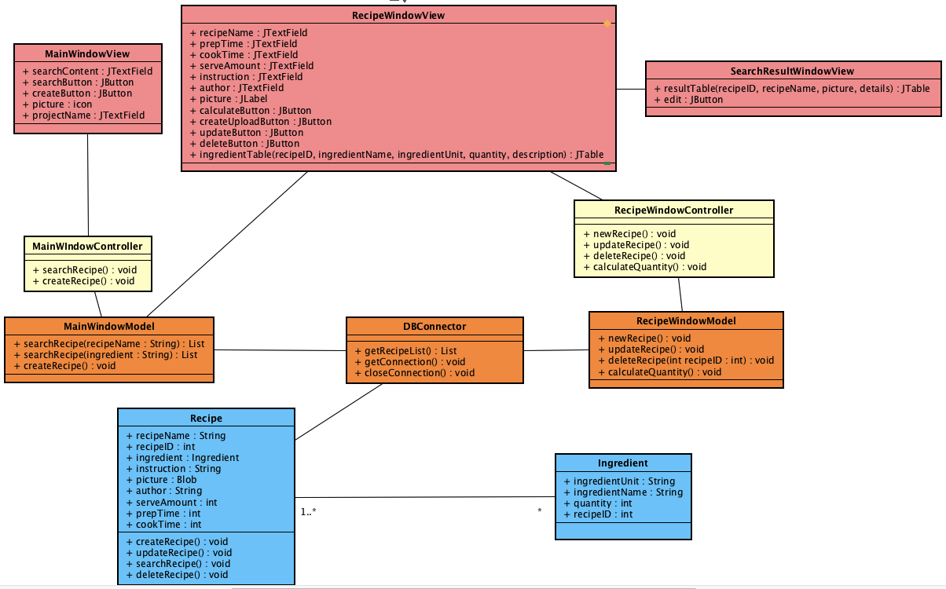

# **GUI Design**

# **Structure/MVC**

For the GUI design, we have conducted three windows: the MainWindowView, RecipeWindowView and SearchResultWindow.

1.The MainWindowView is the frame can pop out when initializing the program.

a. When click the ‘create’ button, it will call the MainWindowController to generate a new RecipeWindowView with default values (mostly null) for the user to fill in.

b. When click the ‘search’ button, the content of the SearchTextField will be read and passed into database to select the name or the ingredient of the recipe, thus popping out the SearchResultWindow.

2. The RecipeWindowView is the window concerns all the information of the recipe itself. It can be called by ‘create’ button in MainWindowView and ‘edit’ button of the SearchResultWindow.

a. When click the ‘create’ button in MainWindowView, it is used to confirm of the creation of a certain new recipe (make sure every element is added).

b. You can change the IngredientQuantity by changing the serveAmount and then press the ‘calculate’ button, then the corresponding data will be changed according to your input. The quantity stored and showed in the Jtable is only for one person and can easily be changed when user changes the serveAmount and click ‘calculate’.

c. You can upload the picture of the recipe by pressing the ‘picture’ button.

d. ‘update’ button is used to change the certain element of the recipe while the perquisite is that the recipe you want to update should be stored in the database already. This button is invisible if you are creating a new recipe.

e. ‘delete’ button is to delete the recipe which should existed already. This button is invisible if you are creating a new recipe.

3. The SearchResultWindow is the window demonstrating the search result. It is shown in the form of a JTable which enables user to see the multiple results clearly.

a. When click the ‘edit’ button, the relevant RecipeWindowView will pop out and you can do the operation of the RecipeWindowView.

# **Screenshots**

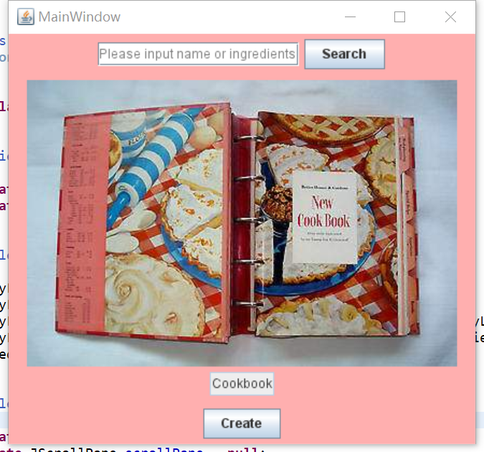

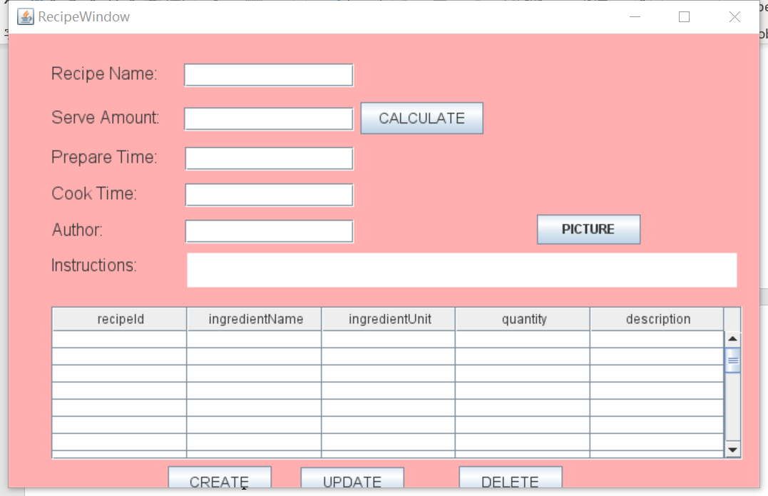

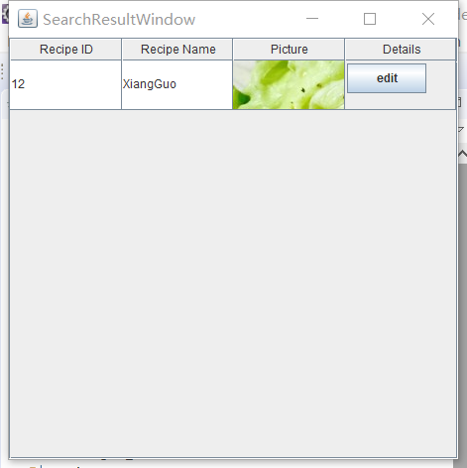

# **Evaluation**

# **Group Work**

Our group have finished this project and the report together. When this project began, we had a face-to-face conference to design the draft of GUI of digital cookbook and finished the UML Diagram.

After that, we communicated and shared our ideas through WeChat-group. Everyone sent their code to the group when he/she finished his/her work. Then one person (usually done by Chen Xinyu) is responsible for integrating our code and sent it to others.

During the last week, the bugs came into appear as the more code was integrated. Thus, we decided to have online conferences in almost every day at 8 o’clock. We used the BBB conference room to share screen and revise our code together. It was very difficult at first since everyone had his/her opinion and code-patterns, but after three days, the prototype of the whole program was finished.

At last, we refactored our code separately in order to make it reader-friendly and well-structured.

# **Task Responsibilities**

Jiang Chenwei: The UML Diagram, the implementation of model-view-controller and code of GUI parts, the basic structure of classes and packages, the organizer of conference and the refactor of code.

Bao Yuning: Design of GUI, the UML Diagram, the implementation of model-view-controller and code of GUI parts, the basic structure of classes and packages and the refactor of code.

Chen Xinyu: The connection establishment between Database and Java Program, the Integration of every one’s code, debug of code, method implement for the operation between Java and Database such as update, delete and query.

Wang Shuzheng: Design of GUI, the connection establishment between Database and Java Program, method implement for the operation between Java and Database such as update, delete and query.