# Innovations

Contents

Innovations 1

GitHub Link 1

SCSS Styling 2

Strong API Result Typing 3

Add Vehicle Page 4

## GitHub Link

GitHub Link to public repository:

<https://github.com/fionntmcc/Advanced-Data-Centric-Web-App>

## SCSS Styling

Styled the application using SCSS to achieve a professional and modern look.

Figure 1: ‘/vehicles’ route

Figure 2: ‘/vehicleDetails/09-G-992’ route

## Strong API Result Typing

Implemented strong client-side typing for API response objects. This is industry-standard best practice to ensure consistency in RESTful applications and leverages the advantages of typing in TypeScript. These were auto-generated using the “JSON to TS” extension for Visual Studio Code.

Figure 3: API result interfaces

## Add Vehicle Page

Add page with error handling and validation for posting vehicles to the database.

Figure 4: Add Vehicle Page

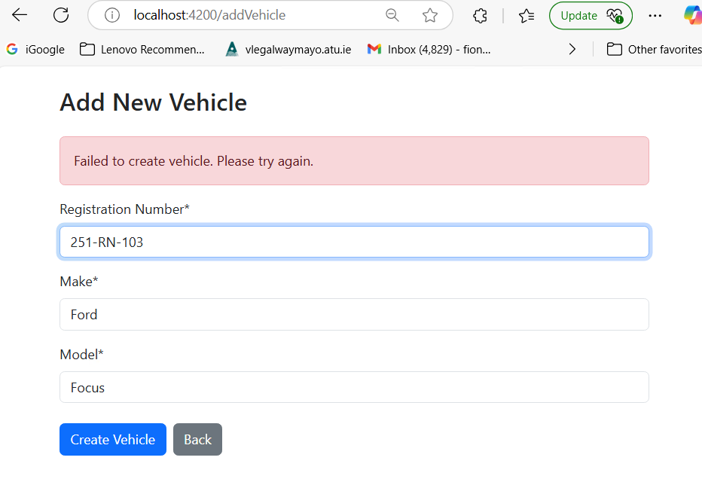

Figure 5: Validation, no duplicate registrations

This page ensure that all fields are filled out and registration is not duplicated.

Figure 6: Added Vehicles will show up in table

Figure 7: Added Vehicles can be assigned to a mechanic