Regime-Dependent Tail Risk and Regime-Switching Predictive Distributions
Evidence from MS-GARCH with Explicit Tail Shift Quantification

1. Problem and Contribution
Standard rolling Student-t GARCH(1,1) models produce one-step-ahead VaR forecasts using predicted volatility and fixed heavy-tailed innovations (Angelidis, Benos and Degiannakis, 2004). In low-volatility periods, coverage is close to nominal levels. However, in high-volatility regimes, systematic under-coverage emerges: VaR95 violations rise to 11.84% under this baseline model (vs 5% nominal), and VaR99 violations reach 3.67% (vs 1%). Coverage remains near nominal in calm regimes, indicating that model failure is state-dependent rather than uniform over time.
The baseline model already implies persistent and heavy-tailed dynamics (α + β ≈ 0.993; ν ≈ 6–7). Yet substantial under-coverage persists in stress periods. This suggests that the breakdown cannot be explained by volatility persistence or fixed heavy tails alone. The central hypothesis of this project is that high-volatility regimes involve structural tail thickening—i.e., a shift in tail shape beyond simple variance scaling.
This project contributes three sections. First, it implements regime-conditional out-of-sample back testing to document state-dependent VaR failure. Then it quantifies regime-specific tail shifts using a Peaks-over-Threshold (POT) Generalized Pareto framework with bootstrap inference. At last, it incorporates regime dependence directly into the predictive distribution via a Markov-switching mixture density, allowing tail shape to vary with filtered regime probabilities.
The results show that stress regimes exhibit tail shifts beyond variance scaling, and that regime-weighted predictive distributions improve risk calibration relative to single-state models, particularly at the 95% level. Specifically, Bootstrap inference confirms that tail indices differ significantly across regimes, with tail-event frequencies increasing multiple-fold in stress states. Incorporating this regime dependence into a Markov-switching predictive mixture reduces high-regime VaR95 violations (from 11.84% to 10.68%), though extreme 99% tails remain challenging. of regime-dependent tail structure is therefore necessary for realistic risk measurement. The results are consistent with the view that single-state models may be insufficient to capture regime-contingent tail behaviour.

2. Data and Regime Definitions

2.1 Data
The dataset combines U.S. equity, volatility, and interest-rate data from 1 January 1996 to 31 December 2025.
- Equity returns: daily adjusted close prices of SPY (SPDR S&P 500 ETF), downloaded via Yahoo Finance. Log returns are computed from adjusted prices.
- Volatility proxy: daily VIX index levels (^VIX), also from Yahoo Finance.
- Interest rates: daily 3-month Treasury yield (DGS3MO) and 10-year Treasury yield (DGS10) obtained from FRED. Missing rate observations are forward-filled to maintain alignment.
After merging and removing missing values, the final aligned dataset contains 6,268 daily observations used for estimation and out-of-sample analysis. All models are estimated using rolling windows with one-step-ahead forecasts to ensure forward-looking evaluation.
The SPY return series exhibits standard features of equity markets: volatility clustering and occasional large negative jumps. Across the full sample, extreme left-tail events (defined using a fixed standardized threshold) occur infrequently, with an unconditional frequency below 1%. However, their incidence is not time-homogeneous and varies systematically across volatility states.

2.2 Regime Definitions
To study regime dependence, market states was defined using three complementary approaches: exogenous volatility regimes, endogenous latent states, and policy-shock indicators.

(i) Exogenous volatility regimes (VIX quantiles)
Market regimes are first defined using VIX quantiles. The sample is partitioned into low-, mid-, and high-volatility states. This classification yields 3,528 low-volatility days, 1,320 mid-volatility days, and 1,420 high-volatility days, ensuring adequate representation of stress periods.
Extreme losses are substantially more frequent in VIX-high regimes than in VIX-low regimes. The probability of an extreme negative return increases several-fold when moving from low to high volatility states. This establishes a basic stylized fact: stress regimes are characterized not only by higher variance but also by a higher concentration of tail events.

(ii) Endogenous regimes: MS-GARCH filtered states
In addition to the VIX classification, a two-state Markov-switching GARCH model was used. The latent state is inferred via maximum likelihood filtering and represents low- and high-volatility regimes.
The filtered high-volatility state isolates periods of persistent volatility elevation. Conditioning on this endogenous state yields an even sharper separation of calm and stress periods than the VIX-based partition. In particular, extreme losses concentrate disproportionately in the high-volatility latent state, consistent with regime-dependent distributional shifts.
This endogenous classification captures latent volatility dynamics that may not be fully reflected in contemporaneous VIX levels.

(iii) Policy-shock indicator
As a complementary conditioning variable, a monetary-policy shock indicator was constructed using standardized (z-scored) 3-month interest-rate changes. Episodes are classified into tightening, easing, or neutral periods based on statistically significant deviations.
The sample contains 887 tightening and 797 easing episodes, with neutral periods dominating. While policy shocks capture large macro-financial movements, they are treated as supplementary regime information rather than primary volatility states.

2.3 Stylized Facts Across Regimes
Across both exogenous (VIX) and endogenous (MS-GARCH) classifications, extreme negative returns are disproportionately concentrated in stress regimes. Event-study evidence around low→high transitions shows that volatility shifts upward discretely and remains elevated for several days, while extreme losses cluster tightly around transition dates. This pattern suggests that large shocks often coincide with regime entry, but regime persistence sustains elevated risk afterward.
Overall, the data exhibit clear regime dependence: stress states are associated with both higher conditional scale and a greater density of extreme outcomes. This motivates explicit modelling of regime-dependent tail behavior in subsequent sections.

2.4 Notation Table
Symbol | Meaning
r_t | log return
σ_t | conditional volatility
ν | degrees of freedom
ξ | GPD tail index
p_t | filtered high-state probability

3. Methods

3.1 Baseline Risk Model and Backtesting Framework

Rolling Student-t GARCH
The baseline model follows the GARCH framework of Engle (1982) and Bollerslev (1986), extended to Student-t innovations as in Bollerslev (1987).
At each time $t$, parameters are estimated using a fixed rolling window of past returns. The model produces:
- Conditional mean ${\hat{μ}}_{t+1∣t}$
- Conditional volatility ${\hat{σ}}_{t+1∣t}$
- Degrees of freedom parameter $ν$
One-step-ahead VaR at level $α$is computed as:
$${\text{VaR}}_{α,t+1}={\hat{μ}}_{t+1∣t}+{\hat{σ}}_{t+1∣t} q_{α}^{\left(t_{ν}\right)}$$
where $q_{α}^{\left(t_{ν}\right)}$is the α-quantile of the Student-t distribution.
Out-of-sample (OOS) evaluation is conducted on 5,008 aligned trading days. All competing VaR series are fully aligned with no missing forecast dates.

Backtesting Statistics
VaR calibration is evaluated using:
Kupiec Unconditional Coverage (UC) (1995):
$$LR_{UC}=-2log⁡\frac{\left(1 − α)^{T-N}α^{N}\right.}{\left(1 − \hat{p})^{T-N}{\hat{p}}^{N}\right.}\text{where }\hat{p}=\frac{N}{T}$$
Christoffersen Conditional Coverage (CC) (1998):
Adds an independence component to test violation clustering.
Both tests are implemented under identical OOS samples across models to ensure like-for-like comparison.

Standardized Residuals for Tail Diagnostics
Standardized returns are constructed as:
$$z_{t}=\frac{r_{t}-{\hat{μ}}_{t∣t-1}}{{\hat{σ}}_{t∣t-1}}$$
When OOS volatility forecasts are unavailable (primarily outside the rolling window), the closest available conditional volatility estimate is used to preserve continuity of tail-rate construction.

3.2 Two-State MS-GARCH Model
A two-state Markov-switching GARCH model is estimated with Student-t innovations (Hamilton, 1989).
State $S_{t}∈\{1,2\}$follows a first-order Markov chain with transition matrix:
$$P=\left(\begin{matrix}p_{11} & 1-p_{11} \\ 1-p_{22} & p_{22}\end{matrix}\right)$$
Conditional return dynamics:
$$r_{t}=μ_{S_{t}}+σ_{S_{t},t}ε_{t},ε_{t}∼t_{ν_{S_{t}}}$$
Each regime has its own GARCH parameters and degrees of freedom The regime-switching GARCH extension follows Klaassen (2002).

Estimation Procedure
Estimation proceeds in two stages:
- Gaussian MS-GARCH warm start
- Student-t refinement via maximum likelihood
Multiple randomized initializations are used to mitigate local maxima.
Post-estimation relabeling ensures that state 2 corresponds to higher unconditional volatility.
Filtered regime probabilities are computed using the Hamilton filter:
$$p_{t}=P(S_{t}=2∣F_{t})$$
These probabilities parameterize regime-dependent quantities and predictive densities.

3.3 Tail-Shift Quantification: POT-GPD

Exceedance Definition
Tail thickness is estimated using a Peaks-over-Threshold (POT) approach applied to standardized residuals $z_{t}$, grounded in extreme value theory (Pickands, 1975; Embrechts et al., 1997).
For exceedances below threshold $u$:
$$y_{t}=u-z_{t}\text{for }z_{t}<u$$
Exceedances are modeled using the Generalized Pareto Distribution (GPD):
$$G(y)=1-{\left(1 + ξ\frac{y}{β}\right)}^{-1/ξ}$$
where:
- $ξ$= tail index
- $β$= scale parameter
$ξ>0$implies heavy (Pareto-type) tails.

Regime Conditioning
POT estimation is conducted:
- By exogenous volatility regime (e.g., VIX quantiles)
- By endogenous MS state classification
- By filtered probability partitions
This allows tail-shape comparison across regimes.

Bootstrap Inference
Regime-specific tail indices are estimated via maximum likelihood.
Statistical inference is conducted using bootstrap resampling to obtain confidence intervals for:
$$Δξ=ξ_{\text{high}}-ξ_{\text{low}}$$
Equality of tail indices across regimes is tested using bootstrap-based two-sided p-values.

3.4 Regime-Weighted Predictive Mixture Density

The predictive density follows a regime-weighted mixture representation as in Gray (1996).
$$f(r_{t+1}∣F_{t})=(1-p_{t})f_{1}(r_{t+1})+p_{t}f_{2}(r_{t+1})$$
where:
- $p_{t}=P(S_{t}=2∣F_{t})$
- $f_{1},f_{2}$are regime-specific conditional Student-t densities
VaR and Expected Shortfall (ES) are computed directly from the mixture distribution via numerical integration or quantile inversion, consistent with the coherent risk measure framework of Artzner et al. (1999). This specification produces a probabilistic regime-switching forecast without hard state classification or ad hoc volatility scaling.

4. Results

4.1 VaR failure under stress (regime-conditional miscalibration)
Rolling Student-t GARCH(1,1) produces nominally calibrated VaR in low-volatility periods but fails sharply in stress regimes. Grouping out-of-sample violations by exogenous VIX quantiles shows strong regime dependence: in VIX-high periods, VaR95 violation rates rise to 11.84% under the baseline model (vs 5% nominal), and VaR99 violations rise to 3.67% (vs 1% nominal). In contrast, low-VIX periods are close to nominal coverage. Standard UC/CC backtests reject correct coverage primarily because of the stress-regime under-coverage, rather than uniform miscalibration across time.
Importantly, the baseline model already incorporates substantial volatility persistence (α+β≈0.993) and heavy-tailed innovations (ν≈6–8). Since scale dynamics and constant tail thickness are already embedded, the residual miscalibration in stress periods cannot be attributed to volatility clustering alone. The evidence is therefore consistent with regime-dependent shifts in tail behaviour rather than simple variance amplification.
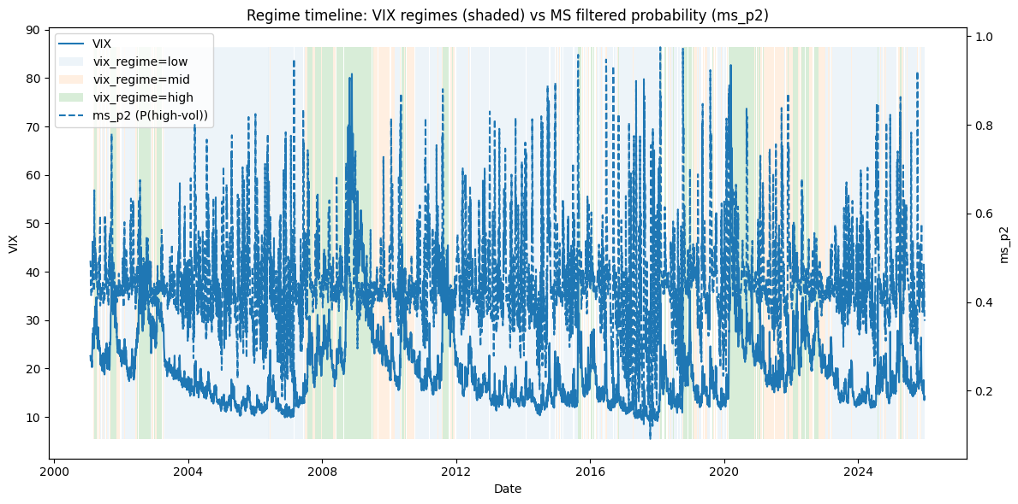
Figure1: Regime Timeline (VIX background + ms_p2). Background shading shows VIX-quantile regimes (low/mid/high), while the dashed curve reports the MS-GARCH filtered probability of the high-volatility state ($ms_p2$). Co-movement validates the stress proxy, while mismatches highlight that the latent Markov state is inferred from return dynamics rather than directly mirroring VIX.
VIX-based regimes co-move strongly with the MS-GARCH filtered high-volatility probability $p_{t}$, validating the economic interpretation of the latent state. However, the series are not identical: $p_{t}$is inferred from return dynamics and reflects persistence/clustering beyond what is mechanically implied by VIX.
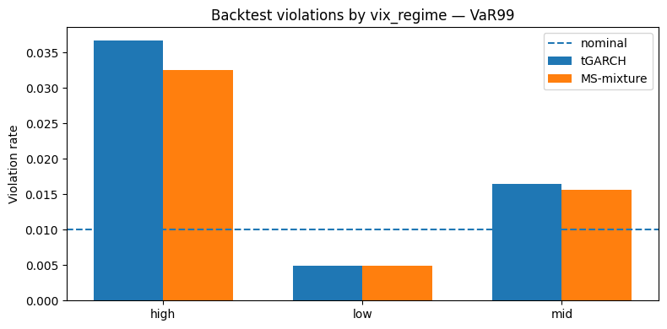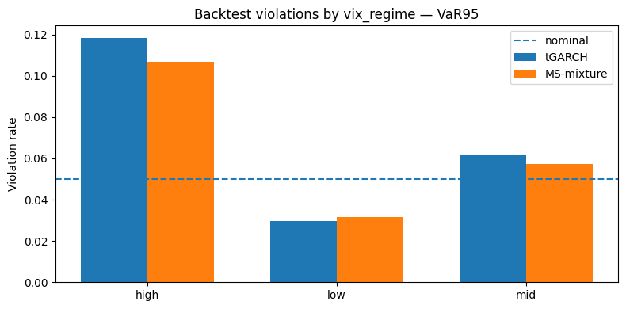

figure 2: Backtest Violations by VIX Regime. The bars summarizes the core backtest result: violation rates are near nominal in low/mid regimes and markedly above nominal in high regimes, confirming that VaR failure is concentrated in stress states.

Sepecifically, in high regimes, violation rates far exceed nominal levels (VaR95 ≈ 10–12% vs 5%; VaR99 ≈ 3%+ vs 1%). The MS-mixture reduces violations relative to baseline but does not fully restore nominal coverage. Backtests show severe under-coverage in high-volatility regimes; regime-switching mixtures reduce but do not eliminate this under-coverage.

4.2 Evidence of tail shift (POT–GPD)
To assess whether stress miscalibration reflects structural tail changes, tail thickness is estimated using a Peaks-over-Threshold (POT) framework applied to standardised losses.
Extreme-event frequencies increase markedly with stress intensity. Under VIX regimes, the probability of a standardised loss exceeding −3 rises from 0.28% in VIX-low to 1.90% in VIX-high regimes (approximately 6.7× higher). Conditioning on endogenous MS states yields even sharper separation. Sorting observations by filtered regime probability produces a monotonic gradient in tail frequency, with the highest quartile exhibiting substantially elevated extreme risk.
Beyond frequency amplification, GPD tail-index estimates differ significantly across regimes. The estimated difference Δξ between high- and low-volatility states is statistically significant under bootstrap inference, supporting economically meaningful tail thickening in stress periods. While tranquil-state estimates are imprecise due to limited exceedances, inference based on regime differences remains statistically supported.
Taken together, these findings indicate that stress regimes are associated not only with higher conditional scale, but with structural changes in tail curvature.

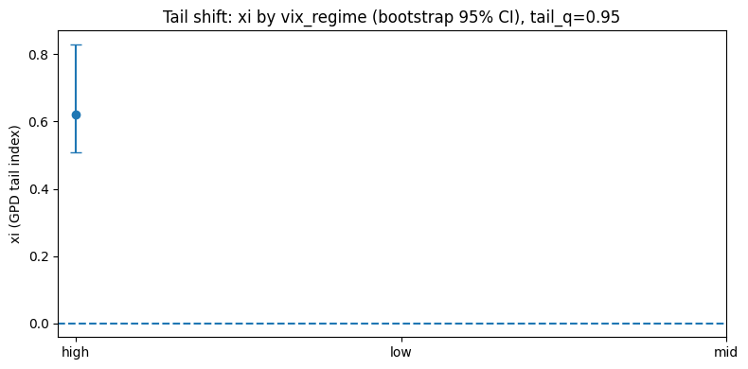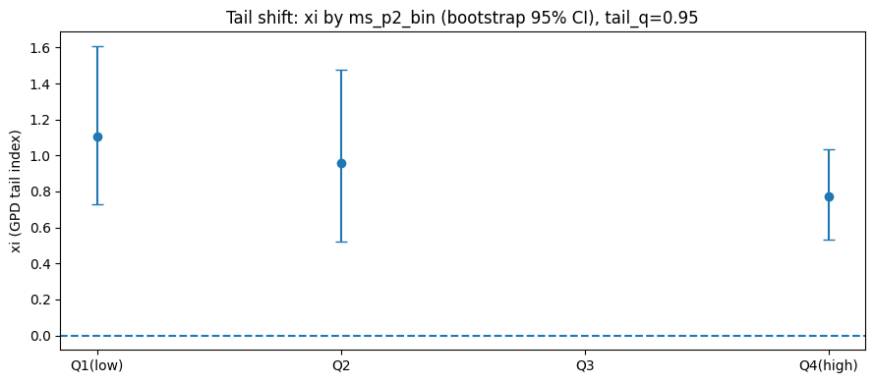

Figure 3 Tail Shift (xi by regime). Figure reports bootstrap confidence intervals for the GPD tail index across VIX regimes and across MS-state probability bins. Under high VIX regimes, the estimated tail index is significantly positive (ξ ≈ 0.62, 95% CI [0.51, 0.83]), confirming economically meaningful heavy-tail behavior during stress. Mid regimes exhibit similar though slightly lower tail thickness. ms_p2 quartile results serve as robustness checks; wide confidence intervals reflect small-sample uncertainty in POT estimation.

4.3 Regime-mixture improves calibration (but extreme quantiles remain hard)

To incorporate regime dependence directly into the predictive distribution, a probabilistic mixture density is constructed using filtered state probabilities:

$$f\left(r_{t+1} ∣ F_{t}\right)=\left(1-p_{t}\right)f_{1}\left(r\right)+p_{t}f_{2}\left(r\right),$$
This specification alters the full predictive shape rather than applying a mechanical volatility multiplier.
In VIX-high periods, VaR95 violations decline from 11.84% to 10.68% under the mixture specification, with a smaller reduction at the 99% level (3.67% to 3.25%). Improvements are more pronounced at moderate quantiles than in the far tail. These results suggest that regime-weighted predictive densities capture part of the stress-regime tail amplification but do not fully eliminate extreme under-coverage.
Residual miscalibration at the 99% level likely reflects data sparsity in the far tail and possible sub-regime dynamics within stress periods.

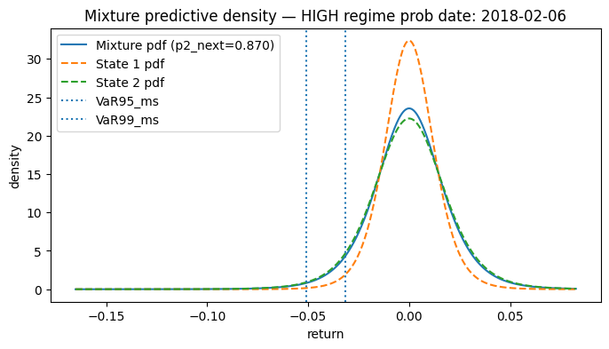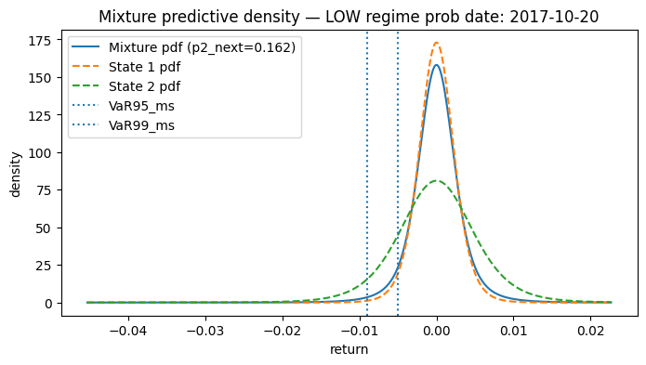
Figure 4. Regime-switching predictive densities under high and low regime probabilities.
The figure plots the MS-GARCH mixture predictive density where $p_{t}$is the filtered probability of the high-volatility state. The dashed curves denote the state-specific conditional densities, and vertical lines mark the implied VaR${}_{95}$ and VaR${}_{99}$ thresholds. The top panel corresponds to a high regime-probability date ($p_{t}≈0.87$); the bottom panel to a low regime-probability date ($p_{t}≈0.16$).
When the high-volatility state probability is elevated, the predictive distribution becomes wider and more left-skewed, with visibly thicker tails and lower peak density. VaR thresholds shift further into the left tail, indicating materially greater downside risk. When the high-volatility probability is low, the distribution concentrates around zero, tail mass declines, and VaR thresholds move closer to the center.
The figure illustrates that regime probabilities reshape the entire predictive distribution rather than merely scaling conditional variance. State-contingent VaR and ES emerge endogenously from probabilistic weighting of distinct regime densities, providing a structural mechanism for improved calibration during stress periods without uniformly inflating risk measures in tranquil states.

4.4 Transition dynamics (event study evidence)
Event-study analysis of low-to-high regime transitions reveals two distinct dynamics. Across both STRICT (n=19) and RELAXED (n=25) definitions, predicted volatility exhibits an immediate upward level shift at τ=0 (mean σ rising from approximately 0.007–0.008 pre-event to 0.012–0.014 post-event) and remains elevated for several days. In contrast, extreme losses spike sharply at τ=0 (≈0.28–0.32) before reverting quickly.
Logistic regression confirms that volatility regime is the dominant predictor of next-period extreme events: relative to VIX-low, VIX-high increases the odds by approximately 6.9× (OR 6.92, 95% CI [3.17, 15.14]). Policy-shock indicators are not statistically significant. Static classification models perform poorly due to severe class
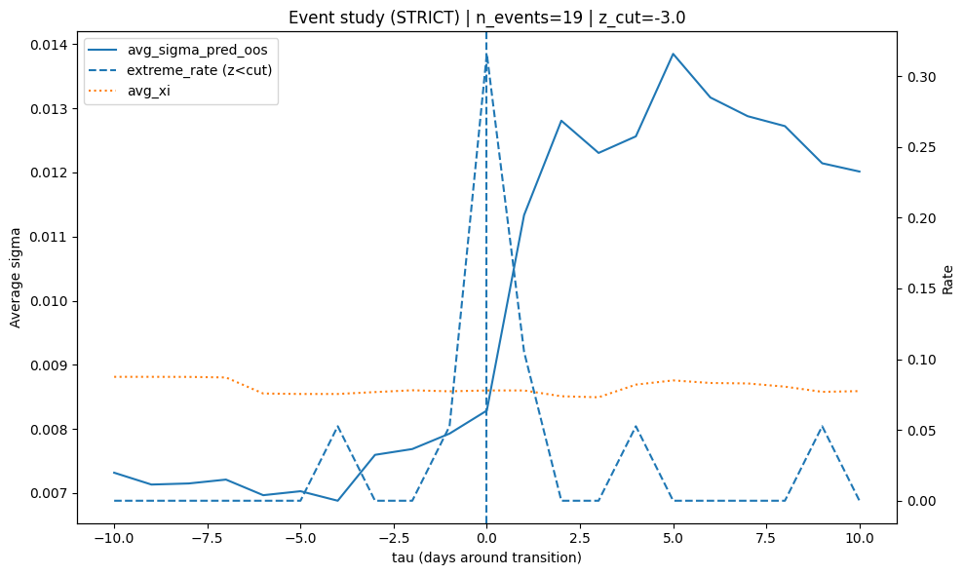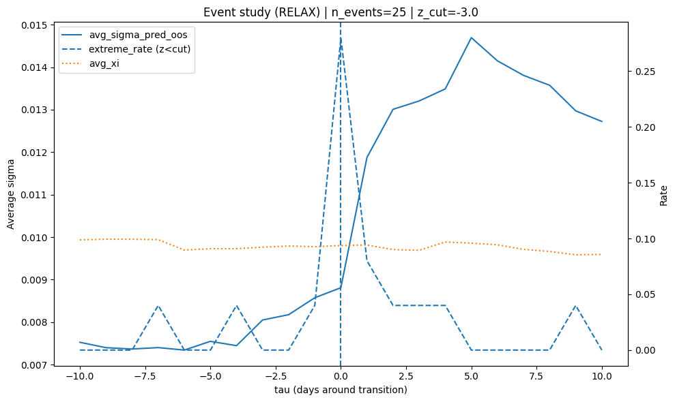
Figure 5. Event study of low-to-high volatility regime transitions under STRICT (n=19) and RELAXED (n=25) definitions. Event time τ ∈ [−10, +10] trading days is centered at the transition date (τ = 0). The solid line shows average out-of-sample predicted volatility, the dashed line the frequency of extreme standardized returns (z < −3), and the dotted line the average POT–GPD tail index ξ.
Extreme negative returns are sharply concentrated at τ = 0, with the exceedance frequency spiking at the transition and reverting rapidly thereafter. In contrast, predicted volatility increases at the transition and remains elevated for several subsequent days, indicating that regime entry reflects a persistent shift in conditional variance rather than a transitory shock. The tail index ξ does not exhibit a comparable discontinuity within the short event window, consistent either with gradual tail adjustment or limited precision of short-horizon POT estimation. The same qualitative pattern holds under both STRICT and RELAXED definitions, supporting the interpretation of low-to-high switches as structural volatility regime changes rather than isolated extreme events.

5. Discussion and Limitations

5.1 Interpretation
The results collectively point toward a regime-dependent distributional mechanism. Although the baseline Student-t GARCH model incorporates volatility persistence and heavy tails, stress-regime miscalibration persists, indicating that constant tail thickness is insufficient.
Diagnostic evidence shows that exceedances relative to predicted volatility increase systematically in high-volatility states, even after controlling for scale effects. This supports a distributional interpretation: stress regimes involve shifts in tail curvature rather than merely higher conditional variance.
A single-state specification imposes constant tail shape across market conditions. When the underlying data-generating process exhibits regime-dependent curvature in the survival function, no single Student-t distribution can simultaneously match calm and stress tails. Regime-weighted mixture densities partially address this structural limitation by allowing predictive shape to vary with filtered state probabilities.
These findings have implications for risk measurement and capital allocation under the physical measure. Extensions to risk-neutral pricing frameworks remain outside the present scope.

5.2 Limitations
The limited improvement at the 99% level reflects both data and structural constraints. Tail-event frequency in the out-of-sample period is low (approximately 0.37%), which restricts statistical power and renders extreme quantile estimation susceptible to small-sample bias. Estimation in the far tail is inherently unstable, particularly under rolling-window procedures where parameter estimates may fluctuate in the presence of sparse information.
Beyond sampling limitations, the imposed two-state structure may be overly coarse to capture finer sub-regime dynamics within stress periods, such as distinctions between moderate turbulence and crisis episodes. A richer state specification could potentially accommodate additional curvature in the extreme tail.
Finally, attempts to model rare events using direct classification methods perform poorly due to severe class imbalance and limited predictive signal. This underscores the broader difficulty of modelling far-tail behaviour and supports the structural distributional approach adopted in this study.

Reference:
- Angelidis, T., Benos, A. and Degiannakis, S. (2004). The use of GARCH models in VaR estimation. Statistical Methodology, [online] 1(1-2), pp.105–128. doi:https://doi.org/10.1016/j.stamet.2004.08.004.
- Artzner, P., Delbaen, F., Eber, J.M. and Heath, D. (1999) ‘Coherent measures of risk’, Mathematical Finance, 9(3), pp. 203–228.
https://doi.org/10.1111/1467-9965.00068
- Bollerslev, T. (1986). Generalized autoregressive conditional heteroskedasticity. Journal of Econometrics, 31(3), 307–327.
https://doi.org/10.1016/0304-4076(86)90063-1
- Bollerslev, T. (1987). A conditionally heteroskedastic time series model for speculative prices and rates of return. Review of Economics and Statistics, 69(3), 542–547.
https://doi.org/10.2307/1925546
- Christoffersen, P. F. (1998). Evaluating interval forecasts. International Economic Review, 39(4), 841–862.
https://doi.org/10.2307/2527341
- Embrechts, P., Klüppelberg, C. and Mikosch, T. (1997) Modelling extremal events for insurance and finance. Berlin: Springer.
https://doi.org/10.1007/978-3-642-33483-2
- Engle, R. F. (1982). Autoregressive conditional heteroscedasticity with estimates of the variance of United Kingdom inflation. Econometrica, 50(4), 987–1007.
https://doi.org/10.2307/1912773
- Gray, S.F. (1996) ‘Modeling the conditional distribution of interest rates as a regime-switching process’, Journal of Financial Economics, 42(1), pp. 27–62.
https://doi.org/10.1016/0304-405X(96)00875-6
- Hamilton, J. D. (1989). A new approach to the economic analysis of nonstationary time series and the business cycle. Econometrica, 57(2), 357–384.
https://doi.org/10.2307/1912559
- Klaassen, F. (2002). Improving GARCH volatility forecasts with regime-switching GARCH. Empirical Economics, 27(2), 363–394.
https://doi.org/10.1007/s001810100100
- Kupiec, P. H. (1995). Techniques for verifying the accuracy of risk measurement models. Journal of Derivatives, 3(2), 73–84.
https://doi.org/10.3905/jod.1995.407942
- Pickands, J. (1975). Statistical inference using extreme order statistics. Annals of Statistics, 3(1), 119–131.
https://doi.org/10.1214/aos/1176343003

