SOUTHAMPTON SOLENT UNIVERSITY

BSc (Hons) Computer Games (Software Development)

Academic Year 2017 – 2019

Terrain Generation Report

Flavio Fiori

Supervisor: Philip Alassad Date: February 2019

Contents

Background 3

The reason why I want to undertake this project 3

How this project is going to challenge me 3

Feasibility and Risk 3

Software 3

Aims and Objectives 3

Research and Prototyping 4

Appendix 4

A) Prototype using the 2D Perlin noise function that I created 4

B) Prototype using the Unity Perlin Noise Function 4

C) Perlin Noise from my function 5

D) Perlin Noise from unity 6

Reference 6

# Background

The goal is to create a procedural generation of terrain, with a feasible scale. Randomly generate a smooth transition from mountains to valleys, simulating a terrain and applying textures in relation of the type of terrain. This process will be done using heightmaps.

## The reason why I want to undertake this project

Terrain generation is something that I find fascinating. Due to this reason I find that undertaking this project not only is going to drastically improve my knowledge in Unity and C# but also is going to increase my job opportunities in the game industry. This project can also increase the probability to work for *Jagex*, this is a company that I want to apply after my studies.

## How this project is going to challenge me

Programming a random terrain generation using high maps, is going to be one of the biggest challenges for me. Since I do not have an idea where to start. Long hours of study and programming are going to be required for me to complete this project.

## Feasibility and Risk

To prevent any risk from occurring I am going to use time management techniques like pomodoro and Kanban (Cirillo 2006; Cummings 2018; Cirillo 2017; Marcus Hammarberg and Joakim Sundén 2014; Anderson 2010; Peterson 2015).

I believe that creating a terrain generator with high maps is a feasible project, for avoiding any risks I will make sure that I work at least 30 hours per week in the project.

## Software

The required software needed is Visual Studio.

## Aims and Objectives

Research the best algorithms to create procedural terrain.

Implement one of the three algorithms to create procedural generated terrain:

* Perlin Noise
* Diamond-Square
* Simplex Noise

Generate a 2D height map using one of the algorithms above.

Create a 3D wireframe in unity using the algorithm selected

## Research and Prototyping

When developing a prototype of the procedural terrain, the premade Unity Perlin Noise function was used to generate a noise map and after converting it to a colour map (Appendix B), this allowed to get an idea of the result of the prototype.

During the research was discovered that the original Perlin Noise created in 1980 had two deficiencies in the algorithm. One of them was the gradient computation, to fix this problem Ken Perlin discovered that was not necessary the G equation to be random at all. In the journal Improving Noise the G function was replaced by 12 vectors defined by the directions from the centre of a cube to its edges instead of the original G equation that take each grid point and assigns a pseudorandom vector of length 1 in R^2 (Perlin 2002).

With the prototype in hand, now was time to implement the Perlin Noise function. This function was based on the java reference implementation of improved noise function with slightly modifications.

When creating the noise function, few problems arise, one of them is the original Ken Perlin’s gradient function using complicated, and confusing bit-flipping code to calculate the dot product of a randomly selected vector and the 8 location vectors (Appendix E).

An easy alternate way of writing the code and even fast to compile in many languages, is to write a switch statement with all the 16 possible cases from the 8 location vectors (Appendix F) (Riven 2010).

# Appendix

## Prototype using the 2D Perlin noise function that I created

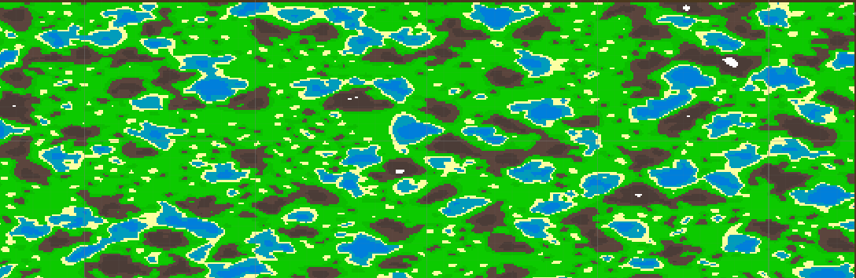

## Prototype using the Unity Perlin Noise Function

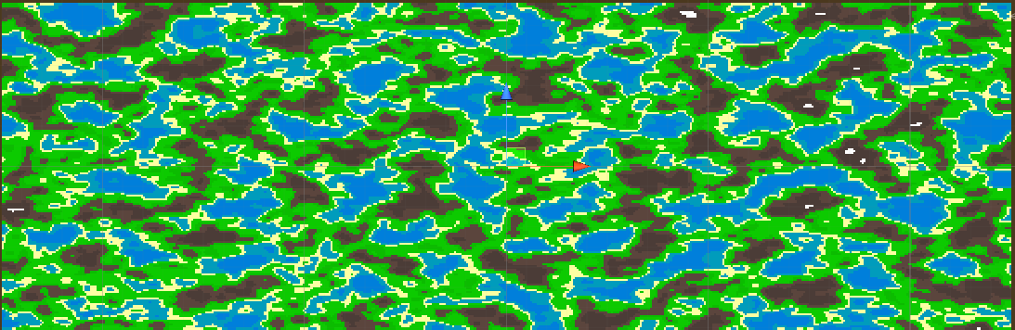

## Perlin Noise from my function



## Perlin Noise from unity



## Ken Perlin’s original gradient function

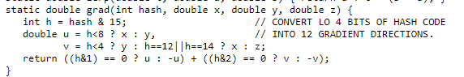

## Riven Calculate Perlin Noise twice as fast

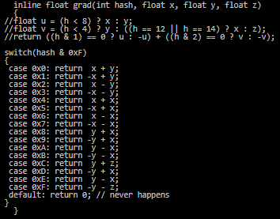

# Reference

ANDERSON, D.J., 2010. Kanban. Sequim, Wash: Blue Hole Press

CIRILLO, F., 2006. The Pomodoro Technique. [viewed 02/05/ 2018]. Available from: <http://baomee.info/pdf/technique/1.pdf>

CIRILLO, F., 2017. Do more and have fun with time management. [viewed 02/05/ 2018]. Available from: <https://francescocirillo.com/pages/pomodoro-technique/book/>

CUMMINGS, T., 2018. The Pomodoro Technique: Is It Right For You? [viewed 02/05/ 2018]. Available from: <https://www.lifehack.org/articles/productivity/the-pomodoro-technique-is-it-right-for-you.html>

MARCUS HAMMARBERG and JOAKIM SUNDÉN, 2014. Kanban in Action. Manning Publications

PETERSON, D., 2015. What is Kanban? [viewed 02/05/ 2018]. Available from: <http://kanbanblog.com/explained/>