SOUTHAMPTON SOLENT UNIVERSITY

BSc (Hons) Computer Games (Software Development)

Academic Year 2017 – 2019

Terrain Generation Report

Flavio Fiori

# Abstract

Contents

1. Abstract 2

2. Progress Report 5

2.1 Overview 5

2.1.1 Project 5

2.1.2 Why I want to undertake this project and how it is going to challenge me 5

2.1.3 Aims 5

2.1.4 Objectives 6

2.1.5 Stretch Goals 6

2.2 Project Specification 7

2.2.1 Software 7

2.3 Research 8

2.3.1 Perlin Noise 8

2.3.2 Diamond-Square Algorithm 8

2.3.3 Simplex Noise 8

2.4 Prototyping 9

2.5 Project Management 10

2.5.1 Methodologies 10

2.5.2 Tools for Time Management 12

2.6 Design 13

2.6.1 Perlin Noise Class 13

2.6.2 Mesh Generation Class 13

2.6.3 Map Generation Class 14

2.7 Project Plan 14

2.7.1 Time estimation 15

2.7.2 Feasibility and Risk 16

2.7.3 Risk Analysis 16

Appendix 17

A) Prototype using the 2D Perlin noise function that I created 17

B) Prototype using the Unity Perlin Noise Function 17

C) Perlin Noise from my function 18

D) Perlin Noise from unity 19

E) Ken Perlin’s original gradient function 19

F) Riven Calculate Perlin Noise twice as fast 20

G) Noise Displaced super quadric with old interpolants 20

H) Noise Displaced super quadric with new interpolants 21

I) Risk and Analysis 22

Reference 22

# Progress Report

## Overview

### Project

The goal is to create a procedural generation of terrain, where the user can define the size of it. Randomly generate a smooth transition from mountains to valleys, simulating a terrain and applying textures in relation of the type of terrain. The end goal is to be able to create a plug-in for Unity that allows random terrain generation inside the editor, without the need for the user to design and generate terrain.

### Why I want to undertake this project and how it is going to challenge me

Terrain generation is something that I find fascinating. Due to this reason I find that undertaking this project not only is going to drastically improve my knowledge in Unity and C# but also is going to increase my job opportunities in the game industry. Programming a random terrain generation using Hight maps, is going to be one of the biggest challenges for me. Since I do not have an idea where to start. Long hours of study and programming are going to be required for me to complete this project.

### 2.1.3 Aims

The aim of this project is to create a procedural terrain generation.

This project will contain different researches into what are the most cost-efficient terrain synthesis techniques to use for procedural terrain generation.

When the terrain generation is successfully complete, a method for synthesis of eroded terrain is going to be implemented (Olsen 2004).

### 2.1.4 Objectives

* Research the best algorithms to create procedural terrain.
* Implement one of the three algorithms to create procedural generated terrain:
* Perlin Noise
* Diamond-Square
* Simplex Noise
* Create a 3D wireframe in unity using the algorithm selected
* Implement an algorithm for eroded terrain
  + Thermal erosion
  + Hydraulic erosion
* Implement the Diamond-Square algorithm to create the noise and generate the height maps using this algorithm.
* Implement the Simplex Noise algorithm to create the noise and generate the height maps using the algorithm.
* In unity editor the user can chose what algorithm use when generating the terrain.

### 2.1.5 Stretch Goals

* Create the procedural terrain generation plug-in for unity
* Implement the terrain synthesis techniques in C++ and OpenGL
* Create the Graphic class
* Create the Mesh Class
* Generate a 3D terrain using the terrain synthesis technique

## 2.2 Project Specification

### 2.2.1 Software

The required software needed is Visual Studio, Unity, Microsoft Excel, Microsoft Word, GitHub, Gantt Project, Visio, Photoshop, Kanbanflow, HacknPlan, and Google Drive.

* Visual studio is my favourite IDE for creating the scripts in C#.
* Unity is the 3D engine that will be responsible to handle and render the procedural terrain.
* Microsoft Excel is the program that will be responsible to create the work schedule for each week
* Microsoft Word allows me to create the documentation for the project.
* Github and Google Drive is where the backups of the project are stored.
* Gantt Project is the responsible program to create the Gantt chart for this project.
* Visio is where I am going to create the UML Class Diagrams for the project.
* Photoshop is used for the making of the terrain textures.

## Research

### 2.3.1 Perlin Noise (350 Words)

What it is?

Who Invented it?

When it was invented?

During the research was discovered that the original Perlin Noise created in 1980 had two deficiencies in the algorithm. One of them was the gradient computation, to fix this problem Ken Perlin discovered that was not necessary the G equation to be random at all. In the journal Improving Noise the G function was replaced by 12 vectors defined by the directions from the centre of a cube to its edges instead of the original G equation that take each grid point and assigns a pseudorandom vector of length 1 in R^2 (Perlin 2002). The other deficiency was found in the function to ease the curve, see (Appendix G) (Appendix H)

“The above algorithm is very efficient but contains some deficiencies. One is in the cubic interpolant function's second derivative 6-12t, which is not zero at either t=0 or t=1. This nonzero value creates second order discontinuities across the coordinate-aligned faces of adjoining cubic cells.”

-Ken Perlin

### 2.3.2 Diamond-Square Algorithm (350 Words)

### 2.3.3 Simplex Noise (350 Words)

## 2.4 Prototyping

When developing a prototype of the procedural terrain, the premade Unity Perlin Noise function was used to generate a noise map and after converting it to a colour map (Appendix B), this allowed to get an idea of the result of the prototype.

With the prototype in hand, now was time to implement the Perlin Noise function. This function was based on the java reference implementation of improved noise function with slightly modifications.

When creating the noise function, few problems raised, one of them is the original Ken Perlin’s gradient function using complicated, and confusing bit-flipping code to calculate the dot product of a randomly selected vector and the 8 location vectors (Appendix E) (Perlin 2002).

An easy alternate way of writing the code and even fast to compile in many languages, is to write a switch statement with all the 16 possible cases from the 8 location vectors (Appendix F) (Riven 2010).

Is possible to see the first result of the 2D Perlin noise function that was implemented in the (Appendix A). While this function was far from perfect due to the fact that sometimes the output was negative, the result was satisfactory. To improve the function it was necessary to add the third axis (Z), to create a the correct output value (Appendix C) similar to the original Unity function (Appendix D).

## 2.5 Project Management

### 2.5.1 Methodologies

#### 2.5.1.1 Waterfall

In the waterfall methodology the scope of the project is defined in the beginning and cannot be changed once development starts.

The advantages of using waterfall methodology is the fact that it is going to help organize the project with defined tasks. In the future, if all the steps are followed, a complete product is achieved. The waterfall model is simple and easy to understand, each phase of the model has specific deliverable dates and review processes, helping to create a linear structure for the project (ISTQB 2013).

##### 2.5.1.1.1 Pros

* Simple to Implement
* Easier to manage due to the fact that the stages are more rigid
* Is great for small projects

2.5.1.1.2 Cons

* Difficult to make changes once the project begins
* Software is created near the end of the development cycle
* The risks are high and unpredictable
* Does not work well for long projects

#### 2.5.1.2 Agile

Agile use sprints, each sprint is a time period that is allocated for each phase of the project. A sprint is complete when the time defined for it expires. If the development of the project is not satisfactory in that sprint, or the tasks were not met, then that sprint is considered a fail, sending all the failed tasks to the next sprint and so on.

##### 2.5.1.2.1 Pros

* Software is created in the beginning of the development cycle
* Decreases the risk associated with software development
* Requirements can change during the development of the project, implementing new features, this helps companies create the right product for the market

##### 2.5.1.2.2 Cons

* It is more focused on the developer instead of the client
* Easy to get lost if no clear focus is applied in the final outcome
* Less focus on the product design
* Ineffective in large organizations

#### 2.5.1.3 Time-Box

Time-box is a short period of time that person works towards a specific goal. If this goal is not reached when the time period ends, then the person stops working on the project and start evaluating what went well, what went wrong, has the goal been met, or to some extent met (Rothman 2017).

##### 2.5.1.3.1 Pros

Easy to implement

Easy to follow

Always updated with the project progress

Focus on the important things under time constraints

##### 2.5.1.3.2 Cons

Time consuming

Sometimes work cannot be completed on time, causing unfinished products.

Time estimation is not accurate

### 2.5.2 Tools for Time Management

#### 2.5.2.1 Trello

Trello is a project management application that uses the Kanban system. The projects are represented by boards, each of the boards contains a list of tasks. The tasks are represented by cards, that are created inside the boards.

“Trello is an online tool for managing projects and personal tasks. That may sound rather prosaic. But this increasingly popular app often inspires the sort of passion usually reserved for consumer apps like Pinterest or Instagram. It’s the kind of business software that slips into businesses through the backdoor, just because individual employees like how it works.”

-Finley 2014

#### 2.5.2.2 KanBanFlow

KanBan Flow is a cloud-based project management solution similar to trello, it uses the Kanban system but there is one thing that it excels compared to trello. KanbanFlow features the pomodoro technique for time tracking of tasks. This feature makes KanbanFlow my number one choice in time management tools (Software Advice 2017).

#### 2.5.2.3 HacknPlan

Basically, HacknPlan is an alternative of trello for game developers. The difference is that HacknPlan brings game design and task management together to provide a better organization while creating a game project. HacknPlan features stock headings with categories like programming, art, design, writing and more. Not only that but also each heading features different subcategories; In programming there is AI, Physics and more (Estevez 2019; GameDesigning 2018).

#### 2.5.2.4 Microsoft OneNote

Microsoft OneNote is an app that simulates a notebook, were the user can gather handwritten or typed notes, drawings or even audio commentaries.

## 2.6 Design

### 2.6.1 Perlin Noise Class

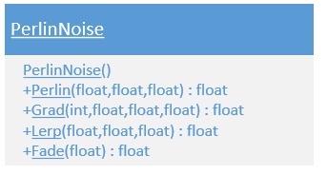

### 2.6.2 Mesh Generation Class

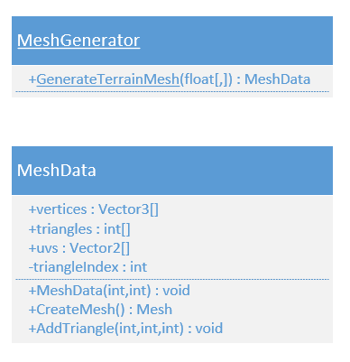

### 2.6.3 Map Generation Class

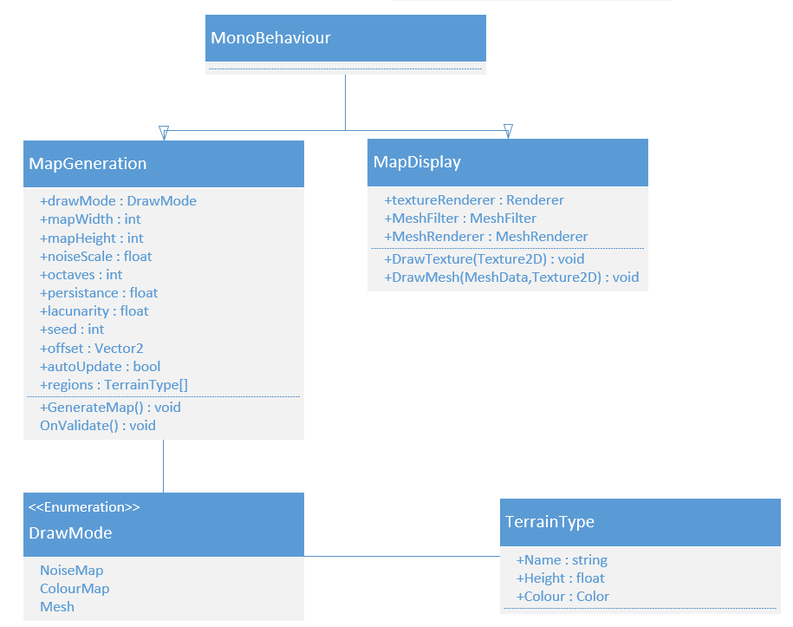

## 2.7 Project Plan

Planning a project beforehand is a critical process to ensure that the project is going to be completed successfully. To ensure that everything goes as planned, a methodology named “Time-Box” is going to be applied to the project.

At the start of each week, a Gant Chart and a work break down structure is going to be created, this will be called a sprint. The risks will be managed at the end of each sprint.

### 2.7.1 Time estimation

#### 2.7.1.3 Sprint 3 – Finishing the Perlin Noise Function and Research in Terrain Synthesis techniques

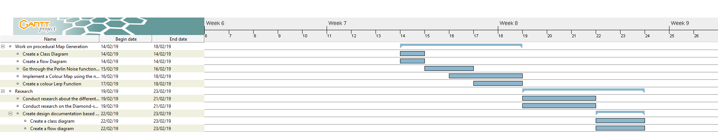

Figure 1 – Weekly Gant Chart using the Time-Box methodology

Week 13/02/2019 – 23/02/2019

WBS

1. Work on the Procedural Map Generation (50%) (15 hours)
   1. Create a Class Diagram (5% Design)1h30m
   2. Create a flow Diagram (5% Design)1h30m
   3. Go through the Perlin Noise function done last week, and check for improvement (10% Programming)3h
   4. Implement a Colour Map using the noise map (20% Research/Programming)6h
   5. Create a colour Lerp Function (10% Research/Programming)3h
2. Research (50%) (15 hours)
   1. Conduct research about the different techniques to improve Procedural Terrain Generation (20% Research)
   2. Conduct research on the Diamond-square algorithm (20% Research)
   3. Create design documentation based on the research (10% Design)
      1. Create a class diagram (5% Design)
      2. Create a flow diagram (5% Design)

### 2.7.2 Feasibility and Risk

To prevent any risk from occurring, I am going to use time management techniques like pomodoro and Kanban (Cirillo 2006; Cummings 2018; Cirillo 2017; Marcus Hammarberg and Joakim Sundén 2014; Anderson 2010; Peterson 2015).

I believe that creating a terrain generator with Hight maps is a feasible project, for avoiding some of the risks, I will make sure that I work at least 30 hours per week on the project. To see the risks that may occur during the development of this project see the Risk Analysis (Appendix I).

### 2.7.3 Risk Analysis

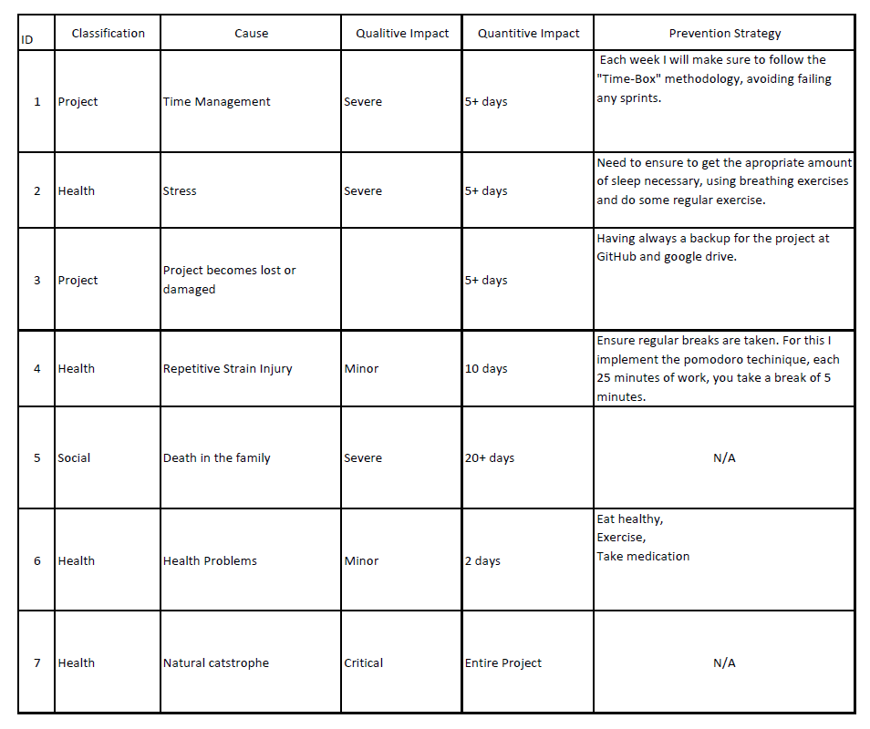

# Appendix

## Prototype using the 2D Perlin noise function that I created

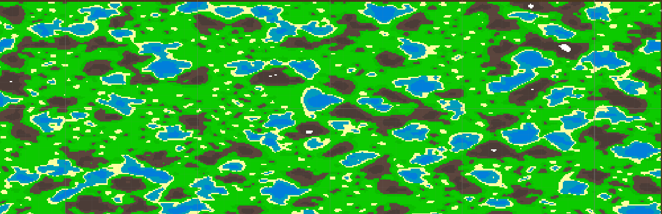

## Prototype using the Unity Perlin Noise Function

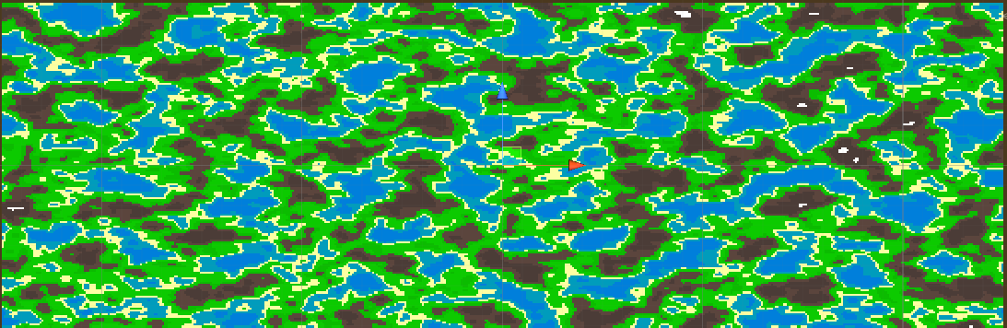

## Perlin Noise from my function



## Perlin Noise from unity



## Ken Perlin’s original gradient function

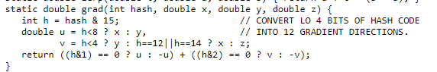

## Riven Calculate Perlin Noise twice as fast

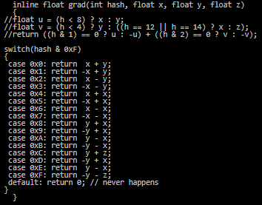

## Noise Displaced super quadric with old interpolants

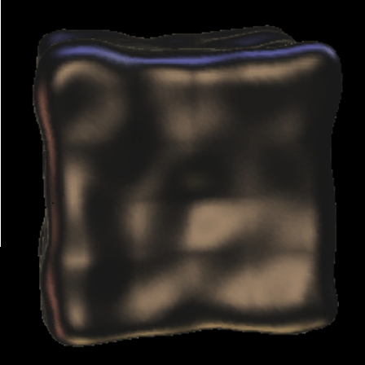

## Noise Displaced super quadric with new interpolants

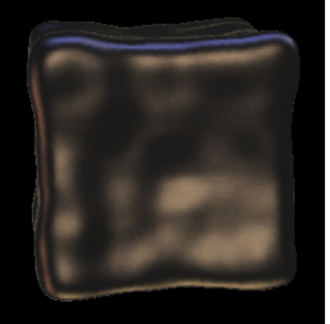

## Risk and Analysis



# Reference

ANDERSON, D.J., 2010. Kanban. Sequim, Wash: Blue Hole Press

CIRILLO, F., 2006. The Pomodoro Technique. [viewed 02/05/ 2018]. Available from: <http://baomee.info/pdf/technique/1.pdf>

CIRILLO, F., 2017. Do more and have fun with time management. [viewed 02/05/ 2018]. Available from: <https://francescocirillo.com/pages/pomodoro-technique/book/>

CUMMINGS, T., 2018. The Pomodoro Technique: Is It Right For You? [viewed 02/05/ 2018]. Available from: <https://www.lifehack.org/articles/productivity/the-pomodoro-technique-is-it-right-for-you.html>

FINLEY, K., 2014. WHY A SIMPLE TO-DO LIST TOOL IS WINNING OVER LEGIONS OF FANS [viewed 23/02/ 2019]. Available from: <https://www.wired.com/2014/08/why-a-simple-to-do-list-tool-is-winning-over-legions-of-fans/>

MARCUS HAMMARBERG and JOAKIM SUNDÉN, 2014. Kanban in Action. Manning Publications

OLSEN, J., 2004. Realtime Synthesis of Eroded Fractal Terrain for Use in Computer Games. Department of Mathematics And Computer Science

PETERSON, D., 2015. What is Kanban? [viewed 02/05/ 2018]. Available from: <http://kanbanblog.com/explained/>

PERLIN, K., 2002a. Improved Noise reference implementation [viewed 13/02/ 2019]. Available from: <https://mrl.nyu.edu/~perlin/noise/>

PERLIN, K., 2002b. Improving noise. ACM Transactions on Graphics (TOG), 21(3), 681-682

RIVEN, 2010. Calculate PerlinNoise faster with an optimization to grad(). In: August, Available from: <http://riven8192.blogspot.com/2010/08/calculate-perlinnoise-twice-as-fast.html>

ROTHMAN, J., 2017. Why We All Use Timeboxes Available from: <https://www.agilealliance.org/why-we-all-use-timeboxes/>

SOFTWARE ADVICE, 2017. KanbanFlow Software [viewed 23/02/ 2019]. Available from: <https://www.softwareadvice.com/uk/project-management/kanbanflow-profile/>

ZUCKER, M., 2001. The Perlin noise math FAQ [viewed 10/02/ 2019]. Available from: <https://mzucker.github.io/html/perlin-noise-math-faq.html>