# Sprint 4 – Implementing the Mesh Generator class to display the heightmap 27/02/2019 – 08/03/2019

# Abstract

The goal of this sprint is to create a class to generate a basic mesh during run time. The mesh is going to get the height map values and the colour from the colour map.

# Research

I already had previously knowledge in how to create meshes in DirectX, and this uses the same principle.

# Sprint Review

During the implementation of the class I struggled with different problems. The first problem was found on the initialization of the vertices, for example I created a vector3 named vertices with the size of , let’s imagine that MapWidth and MapHeight have a value of 10, this means that the vector has a size of 100 in total. The only problem is that I wanted to have to have 10 quads per row, but for this I need to have 11 vertices per row. The problem was that the last vertices for the rightest corner quad were present in the other side of the map creating these strange connections (Figure 2).

The solution for this was to create the vertices with the size of (Figure 1)

The terrain generation was looking to soft and far from realistic (Figure 3), to resolve this problem I found that limiting the persistence level between 0 and 1 and increasing the lacunarity to 2.6 fixed the problem (Figure 4).

An animation curve from unity was implemented in the code to limit the height map range (Figure 5). In other words, an animation curve in unity has multiple keys in were the user can control the points in what that curve passes through (Unity Technologies 2018).

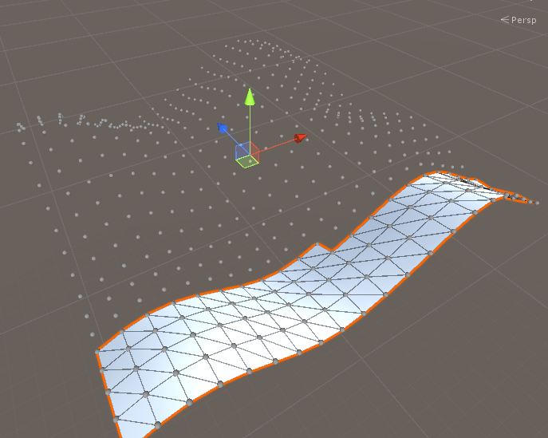

Figure 1 - Mesh Terrain Generation

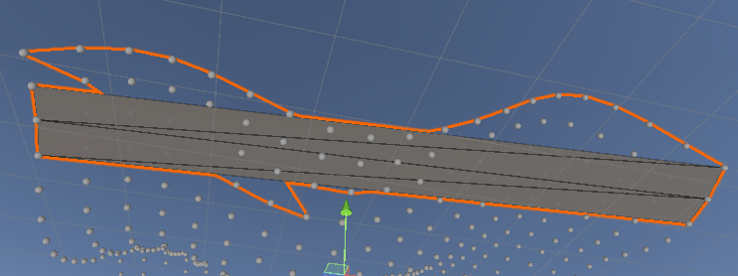

Figure 2 - Generation Mesh Problem

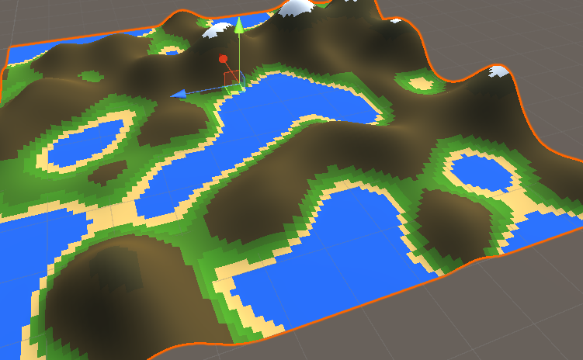

Figure 3 - Terrain Generation with low level of lacunarity

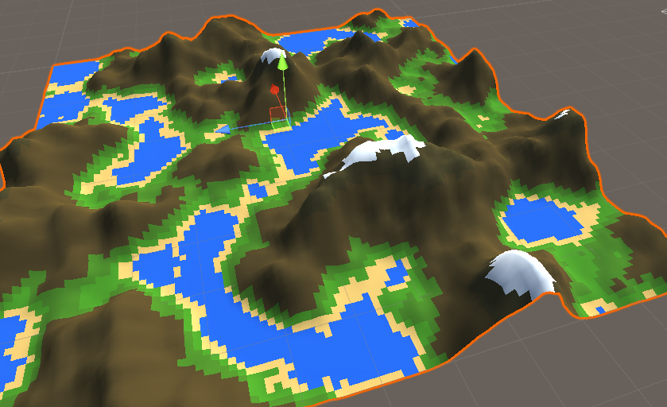

Figure 4 - Terrain Generation with high level of lacunarity



Figure 5 - Evaluate function in Animation Curve

# WBS

1. Research (35%) (8 hours)
2. Create a Mesh Class (50%) (12 hours)
3. Display the terrain using the heightmap inside the mesh class (15%) (3 hours)

# Bibliography

ABHINAV A.K.A DEMKEYS, 2017. *Mathf.PerlinNoise | Smooth Random Values | Unity Quick Tutorial*[viewed 15/03/ 2019]. Available from: <https://www.youtube.com/watch?v=gdSFs0PeBNQ>

BRACKEYS, 2018. *MESH GENERATION in Unity - Basics*[viewed 15/03/ 2019]. Available from: <https://www.youtube.com/watch?v=eJEpeUH1EMg>

BRACKEYS, 2018. *PROCEDURAL TERRAIN in Unity! - Mesh Generation*[viewed 15/03/ 2019]. Available from: <https://youtu.be/64NblGkAabk>

FLICK, J., 2018. *Procedural Grid*[viewed 15/03/ 2019]. Available from: <https://catlikecoding.com/unity/tutorials/procedural-grid/>

UNITY TECHNOLOGIES, 2018. *Using Animation Curves*[viewed 12/03/ 2019]. Available from: <https://docs.unity3d.com/Manual/animeditor-AnimationCurves.html>

UNITY TECHNOLOGIES, 2019. *Procedural Mesh Geometry*[viewed 15/03/ 2019]. Available from: <https://docs.unity3d.com/Manual/Example-CreatingaBillboardPlane.html>

# References

UNITY TECHNOLOGIES, 2018. Using Animation Curves [viewed 12/03/ 2019]. Available from: <https://docs.unity3d.com/Manual/animeditor-AnimationCurves.html>