Codebook for orov_clean
  - Autogenerated data summary from dataMaid
2026-10-01 18:48:24.650359

Data report overview
The dataset examined has the following dimensions:
Feature | Result
Number of observations | 2716
Number of variables | 247

Codebook summary table
Label | Variable | Class | # unique values | Missing | Description
study participant ID, the first 2 to 4 letters indicate site | p_id | factor | 2716 | 0.00 %
Has the participant consented to be included in the study | consented | factor | 1 | 0.00 %
Country of residence | country_residence | factor | 3 | 0.00 %
Country of origin | country_origin | factor | 3 | 3.90 %
Province of residence | province_residence | factor | 10 | 0.00 %
City of residence | city_residence | factor | 81 | 0.07 %
Age (years) | age | numeric | 95 | 0.11 %
gender identity | gender_identity | factor | 7 | 0.11 %
self-reported ethnicity/race | ethnicity | factor | 12 | 7.29 %
freetext for ethnicity/race not in census | ethnicity_other | factor | 3 | 99.12 %
autochthonous or travel-related type | case_type | factor | 3 | 8.51 %
Specify country of travel (only for international travel-associated cases) | travel_location | factor | 2 | 97.75 %
Specify province/region of travel (only for internal travel-associated cases) | travel_province | factor | 6 | 98.82 %
Specify date of travel | travel_date | Date | 20 | 98.97 %
highest education level | education | factor | 5 | 36.34 %
Living where (Urban/Periurban/Rural) | housing_location | factor | 4 | 11.89 %
Lives in a favela or slum (Yes/no/Not known) | favela | factor | 2 | 79.75 %
Sleeping under mosquito net (Yes/no/Not known) | net | factor | 3 | 80.71 %
Number of household members (including the case) | household_number | numeric | 7 | 82.25 %
Confirmed or suspected contact case within the same household | household_contact | factor | 4 | 97.57 %
Pregnant at time of OROV infection (yes/no/not known) | pregnancy | factor | 3 | 0.00 %
Weeks of pregnancy at time of OROV infection | pregnancy_weeks | numeric | 29 | 97.09 %
Hypertension (yes/no/not known) | hypertension | factor | 3 | 40.21 %
Diabetes Mellitus (yes/no/not known) | diabetes | factor | 3 | 40.13 %
Obesity (yes/no/not known) | obesity | factor | 3 | 97.13 %
Cardiovascular disease (yes/no/not known) | cvd | factor | 3 | 95.18 %
Preexisting renal disease (yes/no/not known) | renal | factor | 3 | 40.24 %
Immunosuppresion (Yes/No/Not known) | immuno | factor | 3 | 40.13 %
freetext to specify immunosupression | immuno_specify | factor | 3 | 99.59 %
Report any other relevant comorbidity | other_comorbidity | factor | 7 | 52.43 %
Date of first symptom (DDMMYYYY) | sx_date | Date | 343 | 1.44 %
Fever (yes/no) | fever | factor | 3 | 0.88 %
Chills (yes/no) | chills | factor | 3 | 55.93 %
Headache (yes/no) | headache | factor | 3 | 0.92 %
Retro-orbital pain (yes/no) | ro_pain | factor | 3 | 1.14 %
Nausea (yes/no) | nausea | factor | 3 | 1.14 %
Vomiting symptom (yes/no) | vomiting | factor | 3 | 1.18 %
Diarrhea (yes/no) | diarrhea | factor | 3 | 55.93 %
Abdominal pain (yes/no) | abdominal_pain | factor | 3 | 55.93 %
General malaise (yes/no) | malaise | factor | 3 | 94.00 %
Asthenia / fatigue (yes/no) | fatigue | factor | 3 | 75.59 %
Arthralgia (yes/no) | arthralgia | factor | 3 | 1.07 %
Myalgia (yes/no) | myalgia | factor | 3 | 8.51 %
Back pain (yes/no) | back_pain | factor | 3 | 20.80 %
Skin rash (yes/no) | skin_rash | factor | 3 | 18.63 %
Odynophagia (yes/no) | odynophagia | factor | 3 | 73.60 %
Photophobia (yes/no) | photophobia | factor | 3 | 75.52 %
Conjunctival injection (yes/no) | conjunct_injection | factor | 3 | 20.66 %
Chest pain (yes/no) | chest_pain | factor | 3 | 75.81 %
Stiff neck (yes/no) | stiff_neck | factor | 2 | 75.85 %
Altered mental status (yes/no) | mental | factor | 3 | 73.71 %
Seizures (yes/no) | seizures | factor | 2 | 75.81 %
Limb weakness (yes/no) | limb_weakness | factor | 3 | 75.81 %
Dizziness (yes/no) | dizziness | factor | 3 | 58.14 %
freetext for any other symptoms | other_sx | character | 18 | 96.91 %
Overall end of symptoms (DDMMYYYY) | sx_end | Date | 104 | 86.38 %
Presence of recurrent symptoms (yes/no) | sx_recurrent | factor | 3 | 98.12 %
End of acute symptoms (only if patient presented recurrent symptoms) in DDMMYYYY | sx_acute_end | Date | 3 | 99.93 %
Start of recurrent symptoms (only if patient presented recurrent symptoms) DDMMYYYY | sx_recurrent_start | POSIXct | 2 | 99.96 %
Was consultation during acute illness, or recurrent symptoms? | sx_recurrent_consult | factor | 3 | 98.56 %
Long-lasting sequelae (yes/no) | sequelae | factor | 3 | 82.14 %
Specify long-lasting sequelae | sequelae_freetext | factor | 8 | 99.74 %
Duration of long-lasting sequelae (weeks) | sequelae_duration | factor | 6 | 99.74 %
Date of consultation (DDMMYYYY) | consult_date | Date | 66 | 81.96 %
Emergency department of consultation | department | factor | 5 | 58.21 %
Dengue (yes/no) | dengue | factor | 2 | 0.00 %
Chikungunya (yes/no) | chikungunya | factor | 2 | 0.00 %
Zika (yes/no) | zika | factor | 1 | 0.00 %
Mayaro (yes/no) | mayaro | factor | 1 | 0.00 %
coinfection Other (yes/no) | co_inf_other | factor | 2 | 0.00 %
coinfection If other yes, specify | co_inf_other_specify | factor | 4 | 99.89 %
How was OROV diagnosed? | orov_dx | factor | 3 | 0.00 %
SERUM sample taken (Y/N) | orov_serum | character | 2 | 0.00 %
serum test POSITIVE (Y/N) | orov_serum_pos | character | 3 | 1.29 %
serum test Ct value | orov_serum_ct | numeric | 1029 | 57.36 %
serum test Date | orov_serum_date | Date | 180 | 32.88 %
whole BLOOD sample taken (Y/N) | orov_blood | factor | 2 | 82.29 %
blood test POSITIVE (Y/N) | orov_blood_pos | character | 1 | 100.00 %
blood test Ct value | orov_blood_ct | factor | 1 | 100.00 %
blood test Date | orov_blood_date | Date | 1 | 100.00 %
URINE sample taken (Y/N) | orov_urine | factor | 3 | 77.87 %
urine test POSITIVE (Y/N) | orov_urine_pos | character | 3 | 96.80 %
urine test Ct value | orov_urine_ct | numeric | 20 | 99.30 %
urine test Date | orov_urine_date | Date | 37 | 96.80 %
semen sample taken (Y/N) | orov_semen | factor | 3 | 79.90 %
semen test POSITIVE (Y/N) | orov_semen_pos | character | 2 | 99.96 %
semen test Ct value | orov_semen_ct | numeric | 2 | 99.96 %
semen test Date | orov_semen_date | Date | 2 | 99.96 %
CSF sample taken (Y/N) | orov_csf | factor | 2 | 79.90 %
CSF test POSITIVE (Y/N) | orov_csf_pos | character | 1 | 100.00 %
CSF test Ct value | orov_csf_ct | factor | 1 | 100.00 %
CSF test Date | orov_csf_date | Date | 1 | 100.00 %
Sequencing done (Y/N) | sequencing | factor | 3 | 78.24 %
Sequencing data | sequencing_data | factor | 13 | 78.28 %
IgM (positive, negative, not done) | sero_igm | factor | 3 | 95.29 %
IgM (dilution) | sero_igm_dilution | factor | 1 | 100.00 %
IgG (positive, negative, not done) | sero_igg | factor | 4 | 96.10 %
IgG (dilution) | sero_igg_dilution | factor | 1 | 100.00 %
Date of serology | sero_date | Date | 39 | 97.46 %
Neutralizing antibodies | nab | character | 2 | 98.49 %
Date of neutralizing Ab | nab_date | Date | 14 | 99.01 %
serum test SERUM sample taken (Y/N) during follow up | orov_serum_fu | factor | 3 | 80.78 %
serum test POSITIVE (Y/N) during follow up | orov_serum_pos_fu | character | 3 | 99.19 %
serum test Ct value during follow up | orov_serum_ct_fu | numeric | 2 | 99.96 %
serum test Date during follow up | orov_serum_date_fu | Date | 12 | 99.37 %
blood test WHOLE BLOOD sample taken (Y/N) during follow up | orov_blood_fu | factor | 2 | 99.96 %
blood test POSITIVE (Y/N) during follow up | orov_blood_pos_fu | character | 1 | 100.00 %
blood test Ct value during follow up | orov_blood_ct_fu | factor | 1 | 100.00 %
blood test Date during follow up | orov_blood_date_fu | Date | 1 | 100.00 %
urine test URINE sample taken (Y/N) during follow up | orov_urine_fu | factor | 3 | 80.67 %
urine test POSITIVE | orov_urine_pos_fu | character | 3 | 98.67 %
(Y/N) during follow up
urine test Ct value during follow up | orov_urine_ct_fu | numeric | 19 | 99.34 %
urine test Date during follow up | orov_urine_date_fu | Date | 24 | 98.67 %
SEMEN sample taken (Y/N) during follow up | orov_semen_fu | factor | 3 | 80.71 %
semen test POSITIVE | orov_semen_pos_fu | character | 2 | 99.93 %
(Y/N) during follow up
semen test Ct value during follow up | orov_semen_ct_fu | factor | 1 | 100.00 %
semen test Date during follow up | orov_semen_date_fu | Date | 3 | 99.93 %
CSF test CSF sample taken (Y/N) during follow up | orov_csf_fu | factor | 2 | 80.71 %
CSF test POSITIVE | orov_csf_pos_fu | character | 1 | 100.00 %
(Y/N) during follow up
CSF test Ct value during follow up | orov_csf_ct_fu | factor | 1 | 100.00 %
CSF test Date during follow up | orov_csf_date_fu | Date | 1 | 100.00 %
IgM (positive, negative, not done) during follow up | sero_igm_fu | factor | 4 | 80.63 %
IgM (dilution) during follow up | sero_igm_dilution_fu | factor | 1 | 100.00 %
IgG (positive, negative, not done) during follow up | sero_igg_fu | factor | 4 | 96.83 %
IgG (dilution) during follow up | sero_igg_dilution_fu | factor | 1 | 100.00 %
Date of serology during follow up | sero_date_fu | Date | 10 | 99.52 %
Neutralizing antibodies | nab_fu | factor | 7 | 98.49 %
Date of neutralizing Ab during follow up | nab_date_fu | Date | 22 | 98.49 %
Date of first complication | compl_date | Date | 2 | 99.96 %
(Please write the dates of illness of complications)
Any of the complications was life-threatening with intervention indicated to prevent permanent impairment or death? | compl_life_threat | factor | 3 | 81.74 %
Type of CNS involvement outcome | cns_involvment | factor | 5 | 81.41 %
Describe CNS abnormalities | cns_abnormalities | factor | 3 | 99.89 %
Haemorrhagic complications | haemorrhagic | factor | 6 | 80.27 %
Plasma leakage | plasma_leakage | factor | 4 | 81.70 %
Organ impairment | organ_impairement | factor | 3 | 81.55 %
Adverse pregnancy outcomes | pregnancy_outcomes | factor | 14 | 59.94 %
Other complications | compl_others | factor | 6 | 95.54 %
temperature recorded during consultation in Celsius | temperature_celsius | numeric | 42 | 90.65 %
Tourniquete test (Positive, negative, Not done) | tourniquete | factor | 4 | 30.41 %
freetext for any relevant examination abnormalities | exam_abnormalities | factor | 1 | 100.00 %
final outcome of case | final_outcome | character | 4 | 0.00 %
Hospitalization date | hospitalization_date | Date | 19 | 99.19 %
ICU admission date | icu_date | Date | 3 | 99.93 %
Date of death | death_date | Date | 2 | 99.96 %
Cause of death | death_cause | factor | 1 | 100.00 %
Dialysis (yes/no) | dialysis | factor | 3 | 83.69 %
Ventilated (Indication: respiratory failure, coma, sedation, other) | ventilated | factor | 3 | 83.76 %
Ventilation (No, NIV, Invasive) | ventilation | factor | 3 | 83.73 %
Inotropic support(yes/no) | iotropic | factor | 3 | 83.69 %
IV fluid (yes/no) | iv | factor | 5 | 83.65 %
Platelet transfusion (Y/N) | platelet_transfusion | factor | 2 | 83.73 %
Other treatment specify | tx_other | factor | 2 | 99.93 %
Number of days admitted | admission_days | numeric | 8 | 99.71 %
freetext for any other comments on the case | other_freetext | factor | 56 | 97.42 %
participant/patient ID at local site, if any | p_id_site | numeric | 107 | 96.10 %
EDTA sample taken (Y/N) | orov_edta | factor | 3 | 97.75 %
EDTA test POSITIVE (Y/N) | orov_edta_pos | character | 3 | 98.78 %
EDTA test Ct value | orov_edta_ct | factor | 23 | 99.19 %
EDTA test Date | orov_edta_date | Date | 24 | 98.78 %
EDTA sample taken (Y/N) during follow up | orov_edta_fu | factor | 3 | 97.75 %
EDTA test POSITIVE (Y/N) during follow up | orov_edta_pos_fu | character | 3 | 99.63 %
EDTA test Ct value during follow up | orov_edta_ct_fu | factor | 5 | 99.85 %
EDTA test Date during follow up | orov_edta_date_fu | Date | 10 | 99.63 %
pregnancy trimester at time of OROV infection | pregnancy_trimester | character | 5 | 7.40 %
apgar score at 1 min | apgar1 | numeric | 5 | 99.67 %
apgar score at 5 min | apgar5 | numeric | 4 | 99.67 %
weight at birth | weight_g | numeric | 10 | 99.67 %
 | num_prev_preg | numeric | 5 | 99.67 %
 | num_vag_birth | numeric | 4 | 99.67 %
 | num_c_sec_birth | numeric | 4 | 99.67 %
Freetext for fetal outcomes | fetal_outcomes | factor | 24 | 99.12 %
Organ impairment | organ_impairment | factor | 3 | 99.93 %
study site | site | factor | 8 | 0.00 %
number of haemorrhagic complications | n_haemorrhagic | factor | 2 | 0.00 %
Any other comorbidity (yes/no) | other_comorbidity_bin | factor | 2 | 0.00 %
sex | sex | factor | 3 | 0.11 %
self-reported ethnicity/race, standardized according to each country’s census | ethnicity2 | factor | 9 | 7.29 %
self-reported ethnicity/race, standardized according to each country’s census, with afrodescendiente/Preta and Blanco/Branca grouped | ethnicity3 | factor | 7 | 7.29 %
number of co-infections (dengue, zika, chikungunya, mayaro, or any other) | n_co_inf | factor | 2 | 0.00 %
Adult (over 18 years) or pediatric participant (<18 years) | adult_vs_ped | factor | 3 | 0.11 %
Age categories: 0 to <5yrs, 5 to <18 yrs, 18 to <40 yrs, 40 to <65 years, 65 yrs or above | age_cat | factor | 6 | 0.11 %
year of inclusion in the study | year | numeric | 2 | 0.00 %
number of comorbidities (hypertension, diabetes, immunosuppresion, renal disease, obesity, or any other | n_comorb | character | 2 | 0.00 %
Endemic area: Manaus, Yurimaguas (yes/no) | endemic_area | character | 2 | 0.00 %
Any dengue warning signs (vomiting and/or abdominal pain) | warning_signs | factor | 3 | 1.18 %
two dengue warning signs (vomiting and abdominal pain) | two_ws | factor | 3 | 1.18 %
number of dengue warning signs (abdominal pain and vomiting) | n_ws | numeric | 4 | 1.18 %
any risk factors (comorbidity or pregant during OROV infection) | risk_factors | factor | 3 | 0.00 %
respiratory complication | respiratory | character | 4 | 99.85 %
renal complication | renal_compl | character | 3 | 99.89 %
hepatic complications | hepatic | character | 3 | 99.89 %
Type of cardiac outcome | cardiac | character | 3 | 99.93 %
Type of complication: No reported complications, pregnancy complications, non-pregnancy complications | complication | factor | 3 | 0.00 %
Type of complication: No reported complications, pregnancy complications, haemorrhagic complication, arthritis, severe disease | complication2 | factor | 5 | 0.00 %
Any complications (yes/no) | compl_bin | character | 2 | 0.00 %
any other symptoms (yes/no) | other_sx_bin | character | 2 | 0.00 %
number of symptoms | n_sx | numeric | 14 | 0.00 %
OROV diagnosis by RTPCR (yes/no) | orov_dx_pcr | factor | 2 | 0.00 %
OROV diagnosis by NAB (yes/no) | orov_dx_nab | factor | 2 | 0.00 %
OROV diagnosis by ELISA (yes/no) | orov_dx_elisa | factor | 2 | 0.00 %
Confirmed or suspected OROV case according to WHO definition | orov_confirmation | character | 2 | 0.00 %
time between start of symptoms until OROV diagnosis in days | time_sx_to_dx | difftime | 34 | 31.92 %
time between start of symptoms until OROV diagnosis by RTPCR in days | time_sx_to_pcr | difftime | 24 | 33.98 %
time between start of symptoms until OROV diagnosis by NAB in days | time_sx_to_nab | difftime | 9 | 99.01 %
time between start of symptoms until OROV diagnosis by ELISA in days | time_sx_to_elisa | difftime | 25 | 98.09 %
time between start of symptoms until OROV diagnosis by IGM in days | time_sx_to_igm | difftime | 25 | 98.09 %
time between start of symptoms until OROV diagnosis by IGG in days | time_sx_to_igg | difftime | 5 | 99.48 %
time between start of symptoms until OROV diagnosis by RTPCR from urine in days | time_sx_to_pcr_urine | difftime | 24 | 98.42 %
time between start of symptoms until OROV diagnosis by RTPCR from serum in days | time_sx_to_pcr_edta | difftime | 14 | 99.12 %
time between start of symptoms until OROV diagnosis by RTPCR from semen in days | time_sx_to_pcr_semen | difftime | 2 | 99.96 %
time between start of symptoms until OROV diagnosis by RTPCR during follow-up in days | time_sx_to_pcr_fu | difftime | 3 | 99.93 %
time between start of symptoms until OROV diagnosis by RTPCR from urine during follow-up in days | time_sx_to_pcr_urine_fu | difftime | 18 | 99.08 %
time between start of symptoms until OROV diagnosis by RTPCR from serum during follow-up in days | time_sx_to_pcr_edta_fu | difftime | 6 | 99.82 %
time between start of symptoms until OROV diagnosis by RTPCR from semen durign follow-up in days | time_sx_to_pcr_semen_fu | difftime | 1 | 100.00 %
overall length of symptoms in days | sx_length | difftime | 43 | 86.38 %
date of start of recorded complications (DDMMYYYY) | compl_onset | difftime | 2 | 99.96 %
Ct value from stillbirth | still_birth_ct | numeric | 5 | 99.85 %
Peak haemoglobin (g/L) | haemoglobin_lab | numeric | 93 | 95.99 %
Above, within, or below range according to reference standards | haemoglobin_lab_cat | character | 4 | 95.91 %
Peak Haematocrit (%) | haematocrit_lab | numeric | 95 | 96.39 %
Above, within, or below range according to reference standards | haematocrit_lab_cat | factor | 4 | 96.39 %
Peak White blood cells (cellsx10^9/L) | wbc_lab | numeric | 103 | 96.10 %
Above, within, or below range according to reference standards | wbc_lab_cat | character | 4 | 48.67 %
Peak neutrophils (cells x10^9/L) | neutrophils_lab | numeric | 66 | 97.61 %
Above, within, or below range according to reference standards | neutrophils_lab_cat | factor | 4 | 97.61 %
Peak Lymphocytes (x10^9/L) | lymphocytes_lab | numeric | 65 | 97.64 %
Above, within, or below range according to reference standards | lymphocytes_lab_cat | factor | 4 | 97.64 %
Peak platelets (cellsx10^9/L) | platelets_lab | numeric | 102 | 95.84 %
Above, within, or below range according to reference standards | platelets_lab_cat | character | 4 | 95.80 %
Peak CRP (cells mg/L) | crp_lab | numeric | 26 | 99.01 %
Above, within, or below range according to reference standards | crp_lab_cat | factor | 3 | 99.01 %
Peak ESR (mm/h) | esr_lab | numeric | 14 | 99.01 %
Above, within, or below range according to reference standards | esr_lab_cat | factor | 3 | 99.01 %
Peak creatinine (umol/L) | creatinine_lab | numeric | 32 | 97.94 %
Above, within, or below range according to reference standards | creatinine_lab_cat | factor | 4 | 97.94 %
Peak bilirubin (umol/L) | bilirubin_lab | numeric | 22 | 99.01 %
Above, within, or below range according to reference standards | bilirubin_lab_cat | factor | 3 | 99.01 %
Peak ALT (IU/L) | alt_lab | numeric | 66 | 96.72 %
Above, within, or below range according to reference standards | alt_lab_cat | factor | 3 | 96.72 %
Peak AST (IU/L) | ast_lab | numeric | 57 | 96.83 %
Above, within, or below range according to reference standards | ast_lab_cat | factor | 3 | 96.83 %
 | normal_lab_values | character | 1 | 100.00 %
ALT above range (yes/no) | alt_lab_elevated | character | 3 | 96.72 %
Haematocrit above range (yes/no) | haematocrit_lab_elevated | character | 3 | 96.39 %
platelets below normal range | platelets_lab_low | character | 3 | 95.80 %
Creatinine above range (yes/no) | creatinine_lab_elevated | character | 3 | 97.94 %
lymphocytes above range (yes/no) | lymphocytes_lab_low | character | 3 | 97.64 %

Variable list

p_id
study participant ID, the first 2 to 4 letters indicate site
- The variable is a key (distinct values for each observation).

consented
Has the participant consented to be included in the study
- The variable only takes one (non-missing) value: "Yes". The variable contains 0 % missing observations.

country_residence
Country of residence
Feature | Result
Variable type | factor
Number of missing obs. | 0 (0 %)
Number of unique values | 3
Mode | “Brazil”
Reference category | Brazil
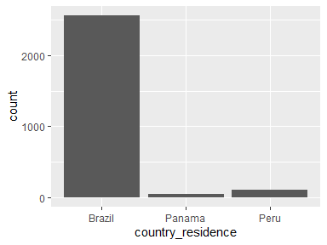
- Observed factor levels: "Brazil", "Panama", "Peru".

country_origin
Country of origin
Feature | Result
Variable type | factor
Number of missing obs. | 106 (3.9 %)
Number of unique values | 2
Mode | “Brazil”
Reference category | Brazil
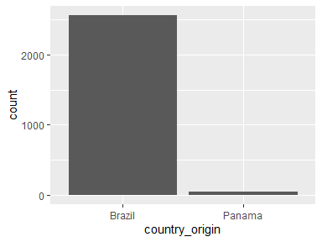
- Observed factor levels: "Brazil", "Panama".

province_residence
Province of residence
Feature | Result
Variable type | factor
Number of missing obs. | 0 (0 %)
Number of unique values | 10
Mode | “Espirito Santo”
Reference category | Alto Amazonas
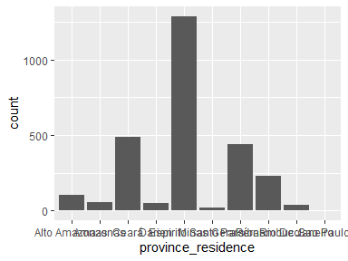
- Observed factor levels: "Alto Amazonas", "Amazonas", "Ceará", "Darien", "Espirito Santo", "Minas Gerais", "Paraíba", "Pernambuco", "Rio De Janeiro", "Sao Paulo".

city_residence
City of residence
Feature | Result
Variable type | factor
Number of missing obs. | 2 (0.07 %)
Number of unique values | 80
Mode | “Alfredo Chaves”
Reference category | 30 DE AGOSTO
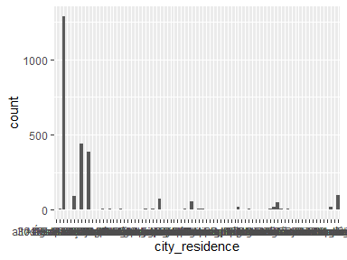
- Observed factor levels: "30 DE AGOSTO", "Água Preta", "Alfredo Chaves", "Aliança", "altos de piedra candela", "Aratuba", "aruza", "Bananeiras", "Barra de Guabiraba", "Baturité", "bello horizonte", "bijagual", "Bonito", "Cabo de Santo Agostinho", "Cabo Frio", "Camaragibe", "Capistrano", "Catende", "Duque De Caxias", "Fortaleza", "Gameleira", "Garanhuns", "Goiana", "Guaramiranga", "Ilha de Itamaracá", "Ipojuca", "Itaquitinga", "Jaboatão dos Guararapes", "Japeri", "Jaqueira", "Juiz De Fora", "Lago Cuipari", "Lagoa dos Gatos", "Lagunas", "Limoeiro", "Macaparana", "Machados", "Mage", "Manaus", "Maracanau", "Maraial", "Moreno", "Mulungu", "Niteroi", "Nova Iguacu", "nueva esperanza", "Nuevo Mundo", "nuevo vigia", "Paudalho", "Paulista", "peñita", "Piau", "piedra candela", "Pombos", "portuchada", "Progreso", "punulosito", "punuloso", "Queimados", "Quixada", "Recife", "Rio De Janeiro", "Rio Formoso", "rio iglesias", "san cristobal", "san francisco", "san jose", "San Juan De Zapote", "san vicente", "sanson", "sansoncito", "Santa Cruz do Capibaribe", "São Benedito do Sul", "Sao Paulo", "São Vicente Ferrer", "Sirinhaém", "Tiangua", "Timbaúba", "villa darien", "Yurimaguas".

age
Age (years)
Feature | Result
Variable type | numeric
Number of missing obs. | 3 (0.11 %)
Number of unique values | 94
Median | 38
1st and 3rd quartiles | 25; 51
Min. and max. | 0; 96
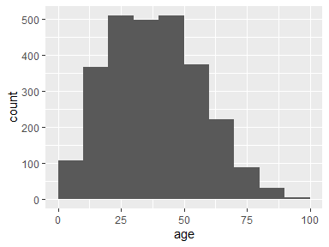

gender_identity
gender identity
Feature | Result
Variable type | factor
Number of missing obs. | 3 (0.11 %)
Number of unique values | 6
Mode | “M”
Reference category | F
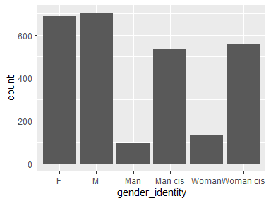
- Observed factor levels: "F", "M", "Man", "Man cis", "Woman", "Woman cis".

ethnicity
self-reported ethnicity/race
Feature | Result
Variable type | factor
Number of missing obs. | 198 (7.29 %)
Number of unique values | 11
Mode | “Branca”
Reference category | Asian
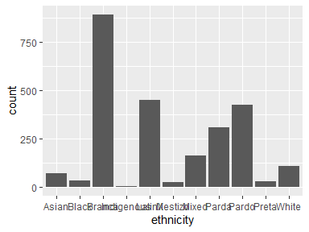
- Observed factor levels: "Asian", "Black", "Branca", "Indigenous", "LatinX", "Mestizo", "Mixed", "Parda", "Pardo", "Preta", "White".

ethnicity_other
freetext for ethnicity/race not in census
Feature | Result
Variable type | factor
Number of missing obs. | 2692 (99.12 %)
Number of unique values | 2
Mode | “Pardo”
Reference category | indigenous
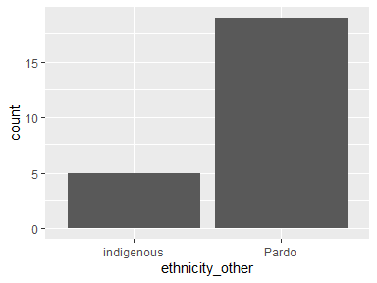
- Observed factor levels: "indigenous", "Pardo".

case_type
autochthonous or travel-related type
Feature | Result
Variable type | factor
Number of missing obs. | 231 (8.51 %)
Number of unique values | 2
Mode | “Autochthonous”
Reference category | Autochthonous
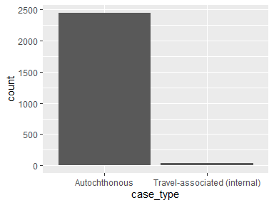
- Observed factor levels: "Autochthonous", "Travel-associated (internal)".

travel_location
Specify country of travel (only for international travel-associated cases)
- The variable only takes one (non-missing) value: "Brazil". The variable contains 97.75 % missing observations.

travel_province
Specify province/region of travel (only for internal travel-associated cases)
Feature | Result
Variable type | factor
Number of missing obs. | 2684 (98.82 %)
Number of unique values | 5
Mode | “Rio De Janeiro”
Reference category | Capistrano
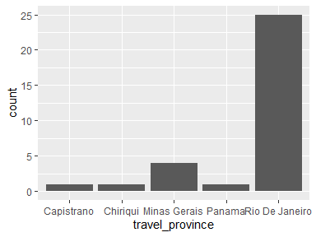
- Observed factor levels: "Capistrano", "Chiriqui", "Minas Gerais", "Panama", "Rio De Janeiro".

travel_date
Specify date of travel
Feature | Result
Variable type | Date
Number of missing obs. | 2688 (98.97 %)
Number of unique values | 19
Mode | “2025-02-10”
Min. and max. | 2024-01-12; 2025-04-21
1st and 3rd quartiles | 2025-01-26; 2025-03-07
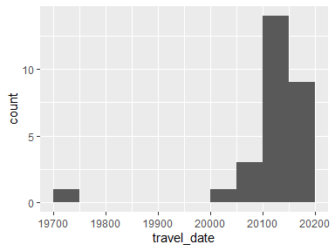

education
highest education level
Feature | Result
Variable type | factor
Number of missing obs. | 987 (36.34 %)
Number of unique values | 4
Mode | “Secondary education”
Reference category | No schooling
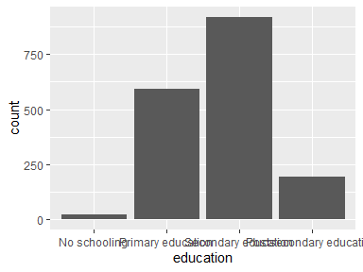
- Observed factor levels: "No schooling", "Postsecondary education", "Primary education", "Secondary education".

housing_location
Living where (Urban/Periurban/Rural)
Feature | Result
Variable type | factor
Number of missing obs. | 323 (11.89 %)
Number of unique values | 3
Mode | “Urban”
Reference category | Urban
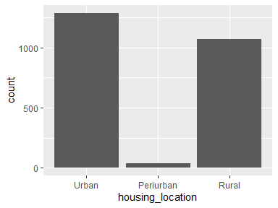
- Observed factor levels: "Periurban", "Rural", "Urban".

favela
Lives in a favela or slum (Yes/no/Not known)
- The variable only takes one (non-missing) value: "No". The variable contains 79.75 % missing observations.

net
Sleeping under mosquito net (Yes/no/Not known)
Feature | Result
Variable type | factor
Number of missing obs. | 2192 (80.71 %)
Number of unique values | 2
Mode | “Yes”
Reference category | No
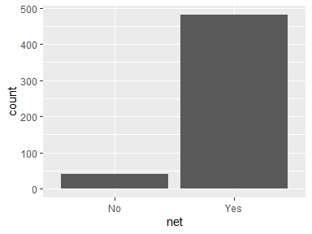
- Observed factor levels: "No", "Yes".

household_number
Number of household members (including the case)
Feature | Result
Variable type | numeric
Number of missing obs. | 2234 (82.25 %)
Number of unique values | 6
Median | 5
1st and 3rd quartiles | 4; 6
Min. and max. | 2; 7
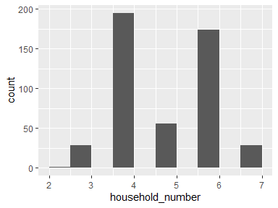

household_contact
Confirmed or suspected contact case within the same household
Feature | Result
Variable type | factor
Number of missing obs. | 2650 (97.57 %)
Number of unique values | 3
Mode | “Confirmed OROV case contact”
Reference category | Confirmed OROV case contact
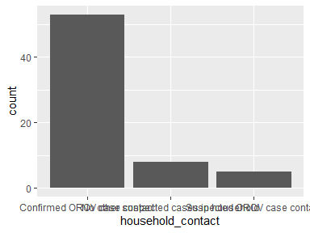
- Observed factor levels: "Confirmed OROV case contact", "No other suspected cases in household", "Suspected OROV case contact".

pregnancy
Pregnant at time of OROV infection (yes/no/not known)
Feature | Result
Variable type | factor
Number of missing obs. | 0 (0 %)
Number of unique values | 3
Mode | “Not applicable”
Reference category | No
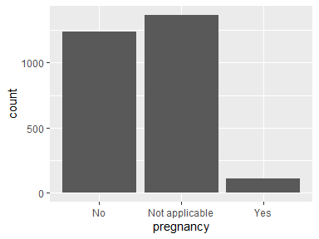
- Observed factor levels: "No", "Not applicable", "Yes".

pregnancy_weeks
Weeks of pregnancy at time of OROV infection
Feature | Result
Variable type | numeric
Number of missing obs. | 2637 (97.09 %)
Number of unique values | 28
Median | 29
1st and 3rd quartiles | 16; 33.5
Min. and max. | 5; 39
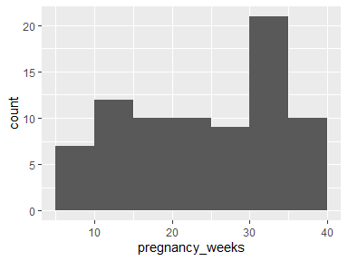

hypertension
Hypertension (yes/no/not known)
Feature | Result
Variable type | factor
Number of missing obs. | 1092 (40.21 %)
Number of unique values | 2
Mode | “No”
Reference category | No
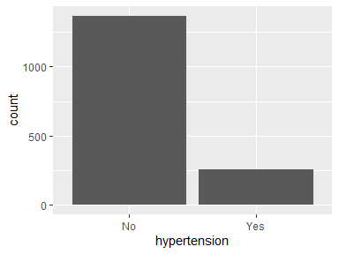
- Observed factor levels: "No", "Yes".

diabetes
Diabetes Mellitus (yes/no/not known)
Feature | Result
Variable type | factor
Number of missing obs. | 1090 (40.13 %)
Number of unique values | 2
Mode | “No”
Reference category | No
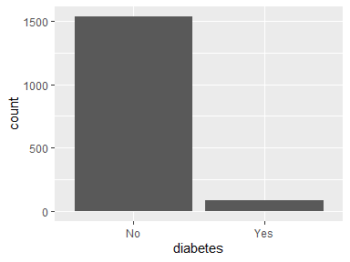
- Observed factor levels: "No", "Yes".

obesity
Obesity (yes/no/not known)
Feature | Result
Variable type | factor
Number of missing obs. | 2638 (97.13 %)
Number of unique values | 2
Mode | “No”
Reference category | Yes
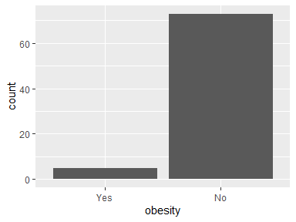
- Observed factor levels: "No", "Yes".

cvd
Cardiovascular disease (yes/no/not known)
Feature | Result
Variable type | factor
Number of missing obs. | 2585 (95.18 %)
Number of unique values | 2
Mode | “No”
Reference category | Yes
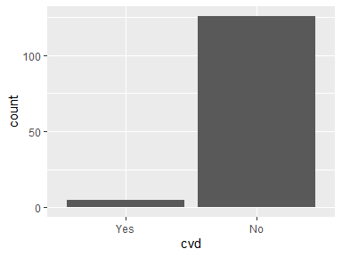
- Observed factor levels: "No", "Yes".

renal
Preexisting renal disease (yes/no/not known)
Feature | Result
Variable type | factor
Number of missing obs. | 1093 (40.24 %)
Number of unique values | 2
Mode | “No”
Reference category | No
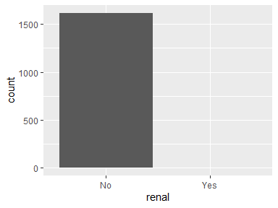
- Observed factor levels: "No", "Yes".

immuno
Immunosuppresion (Yes/No/Not known)
Feature | Result
Variable type | factor
Number of missing obs. | 1090 (40.13 %)
Number of unique values | 2
Mode | “No”
Reference category | No
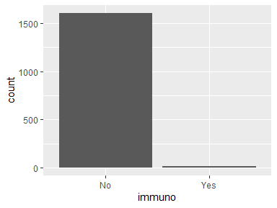
- Observed factor levels: "No", "Yes".

immuno_specify
freetext to specify immunosupression
Feature | Result
Variable type | factor
Number of missing obs. | 2705 (99.59 %)
Number of unique values | 2
Mode | “HIV”
Reference category | HIV
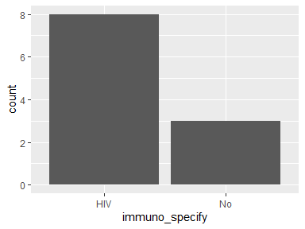
- Observed factor levels: "HIV", "No".

other_comorbidity
Report any other relevant comorbidity
Feature | Result
Variable type | factor
Number of missing obs. | 1424 (52.43 %)
Number of unique values | 6
Mode | “No”
Reference category | Asthma
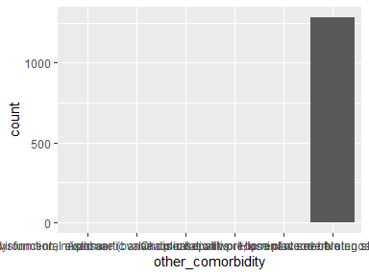
- Observed factor levels: "Asthma", "chronic alcoholism, environmental exposure (banana plantation work, use of wood-burning stove)", "Chronic hepatitis", "Dilated cardiomyopathy with biventricular dysfunction, mixed aortic valve disease with predominant severe stenosis (listed for cardiac transplant), Chronic alcoholism, Smoker", "Hip replacement", "No".

sx_date
Date of first symptom (DDMMYYYY)
Feature | Result
Variable type | Date
Number of missing obs. | 39 (1.44 %)
Number of unique values | 342
Mode | “2024-11-24”
Min. and max. | 2024-01-25; 2025-11-04
1st and 3rd quartiles | 2024-11-11; 2025-02-16
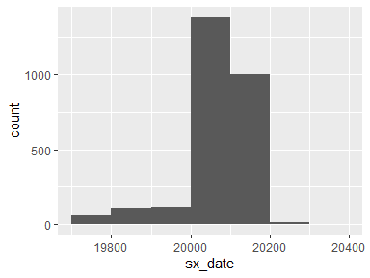

fever
Fever (yes/no)
Feature | Result
Variable type | factor
Number of missing obs. | 24 (0.88 %)
Number of unique values | 2
Mode | “Yes”
Reference category | No
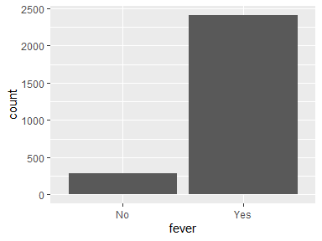
- Observed factor levels: "No", "Yes".

chills
Chills (yes/no)
Feature | Result
Variable type | factor
Number of missing obs. | 1519 (55.93 %)
Number of unique values | 2
Mode | “No”
Reference category | No
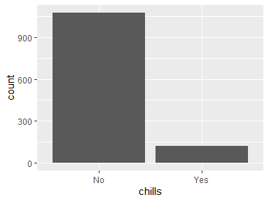
- Observed factor levels: "No", "Yes".

headache
Headache (yes/no)
Feature | Result
Variable type | factor
Number of missing obs. | 25 (0.92 %)
Number of unique values | 2
Mode | “Yes”
Reference category | No
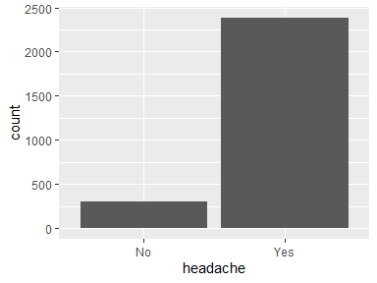
- Observed factor levels: "No", "Yes".

ro_pain
Retro-orbital pain (yes/no)
Feature | Result
Variable type | factor
Number of missing obs. | 31 (1.14 %)
Number of unique values | 2
Mode | “No”
Reference category | No
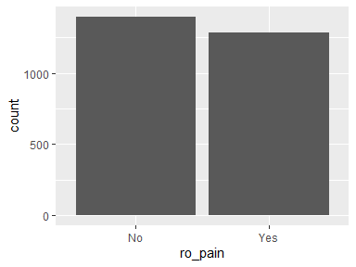
- Observed factor levels: "No", "Yes".

nausea
Nausea (yes/no)
Feature | Result
Variable type | factor
Number of missing obs. | 31 (1.14 %)
Number of unique values | 2
Mode | “No”
Reference category | No
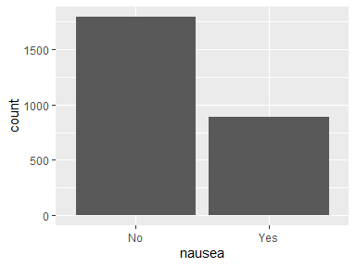
- Observed factor levels: "No", "Yes".

vomiting
Vomiting symptom (yes/no)
Feature | Result
Variable type | factor
Number of missing obs. | 32 (1.18 %)
Number of unique values | 2
Mode | “No”
Reference category | No
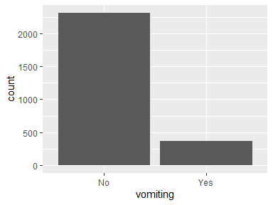
- Observed factor levels: "No", "Yes".

diarrhea
Diarrhea (yes/no)
Feature | Result
Variable type | factor
Number of missing obs. | 1519 (55.93 %)
Number of unique values | 2
Mode | “No”
Reference category | No
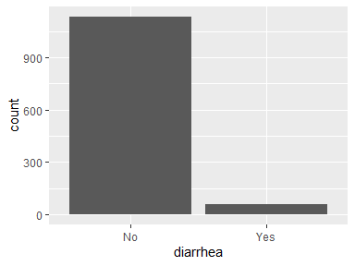
- Observed factor levels: "No", "Yes".

abdominal_pain
Abdominal pain (yes/no)
Feature | Result
Variable type | factor
Number of missing obs. | 1519 (55.93 %)
Number of unique values | 2
Mode | “No”
Reference category | No
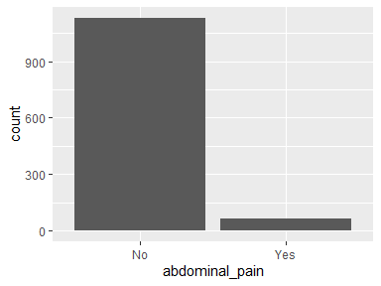
- Observed factor levels: "No", "Yes".

malaise
General malaise (yes/no)
Feature | Result
Variable type | factor
Number of missing obs. | 2553 (94 %)
Number of unique values | 2
Mode | “No”
Reference category | No
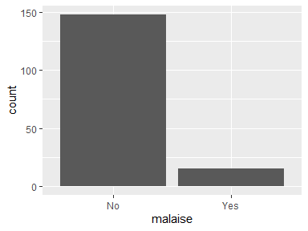
- Observed factor levels: "No", "Yes".

fatigue
Asthenia / fatigue (yes/no)
Feature | Result
Variable type | factor
Number of missing obs. | 2053 (75.59 %)
Number of unique values | 2
Mode | “Yes”
Reference category | No
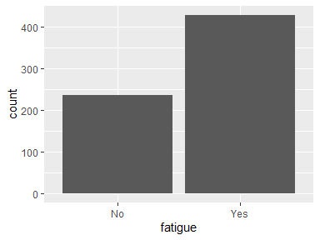
- Observed factor levels: "No", "Yes".

arthralgia
Arthralgia (yes/no)
Feature | Result
Variable type | factor
Number of missing obs. | 29 (1.07 %)
Number of unique values | 2
Mode | “No”
Reference category | No
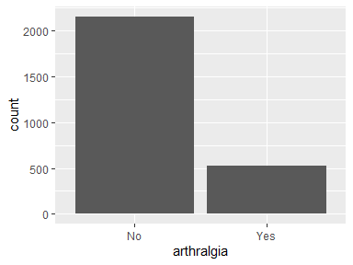
- Observed factor levels: "No", "Yes".

myalgia
Myalgia (yes/no)
Feature | Result
Variable type | factor
Number of missing obs. | 231 (8.51 %)
Number of unique values | 2
Mode | “Yes”
Reference category | No
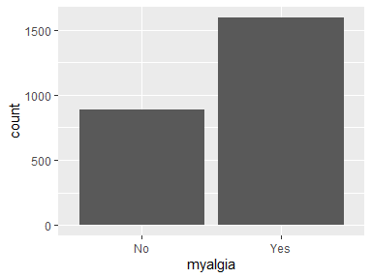
- Observed factor levels: "No", "Yes".

back_pain
Back pain (yes/no)
Feature | Result
Variable type | factor
Number of missing obs. | 565 (20.8 %)
Number of unique values | 2
Mode | “No”
Reference category | No
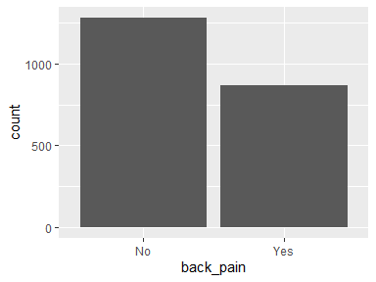
- Observed factor levels: "No", "Yes".

skin_rash
Skin rash (yes/no)
Feature | Result
Variable type | factor
Number of missing obs. | 506 (18.63 %)
Number of unique values | 2
Mode | “No”
Reference category | No
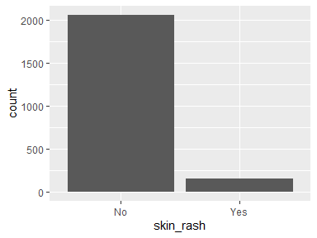
- Observed factor levels: "No", "Yes".

odynophagia
Odynophagia (yes/no)
Feature | Result
Variable type | factor
Number of missing obs. | 1999 (73.6 %)
Number of unique values | 2
Mode | “No”
Reference category | No
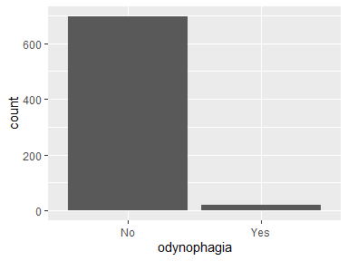
- Observed factor levels: "No", "Yes".

photophobia
Photophobia (yes/no)
Feature | Result
Variable type | factor
Number of missing obs. | 2051 (75.52 %)
Number of unique values | 2
Mode | “No”
Reference category | No
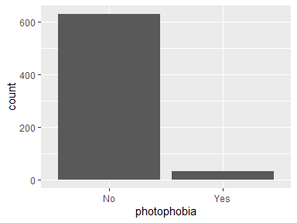
- Observed factor levels: "No", "Yes".

conjunct_injection
Conjunctival injection (yes/no)
Feature | Result
Variable type | factor
Number of missing obs. | 561 (20.66 %)
Number of unique values | 2
Mode | “No”
Reference category | No
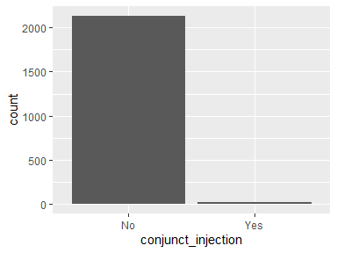
- Observed factor levels: "No", "Yes".

chest_pain
Chest pain (yes/no)
Feature | Result
Variable type | factor
Number of missing obs. | 2059 (75.81 %)
Number of unique values | 2
Mode | “No”
Reference category | No
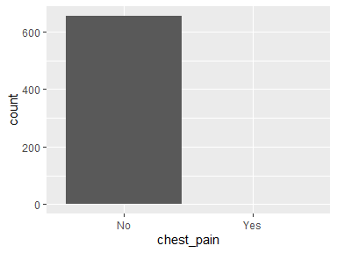
- Observed factor levels: "No", "Yes".

stiff_neck
Stiff neck (yes/no)
- The variable only takes one (non-missing) value: "No". The variable contains 75.85 % missing observations.

mental
Altered mental status (yes/no)
Feature | Result
Variable type | factor
Number of missing obs. | 2002 (73.71 %)
Number of unique values | 2
Mode | “No”
Reference category | No
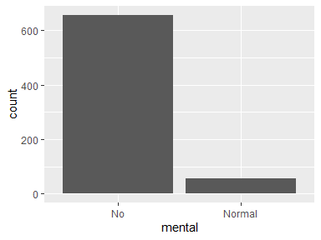
- Observed factor levels: "No", "Normal".

seizures
Seizures (yes/no)
- The variable only takes one (non-missing) value: "No". The variable contains 75.81 % missing observations.

limb_weakness
Limb weakness (yes/no)
Feature | Result
Variable type | factor
Number of missing obs. | 2059 (75.81 %)
Number of unique values | 2
Mode | “No”
Reference category | No
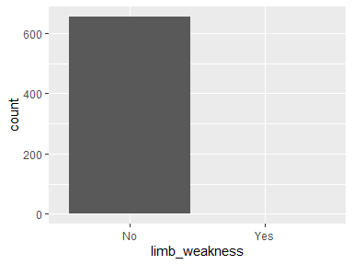
- Observed factor levels: "No", "Yes".

dizziness
Dizziness (yes/no)
Feature | Result
Variable type | factor
Number of missing obs. | 1579 (58.14 %)
Number of unique values | 2
Mode | “No”
Reference category | No
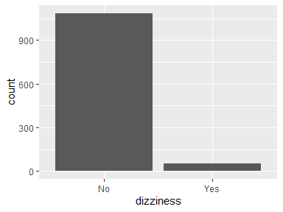
- Observed factor levels: "No", "Yes".

other_sx
freetext for any other symptoms
Feature | Result
Variable type | character
Number of missing obs. | 2632 (96.91 %)
Number of unique values | 17
Mode | “Prostration”
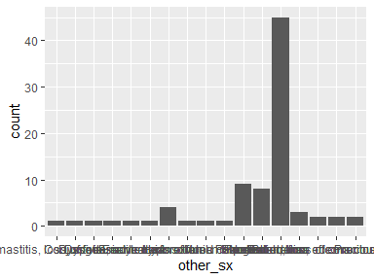
- Observed factor levels: "Bilateral mastitis, loss of fetal movement", "Conjuntivite", "Dysgeusia", "Dyspnea, adynamia", "Enantema", "Erectile dysfunction", "Hyporexia", "Insomnia", "Loss of fetal movement", "Mood changes", "None", "Palpebral edema", "Prostration", "Prostration, edema", "Prostration, loss of consciousness", "Prostration, loss of consciousness, edema", "Pruritus".

sx_end
Overall end of symptoms (DDMMYYYY)
Feature | Result
Variable type | Date
Number of missing obs. | 2346 (86.38 %)
Number of unique values | 103
Mode | “2025-03-28”
Min. and max. | 2024-02-01; 2025-06-26
1st and 3rd quartiles | 2025-03-06; 2025-04-07
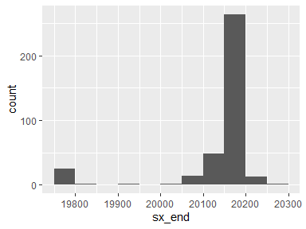

sx_recurrent
Presence of recurrent symptoms (yes/no)
Feature | Result
Variable type | factor
Number of missing obs. | 2665 (98.12 %)
Number of unique values | 2
Mode | “No”
Reference category | No
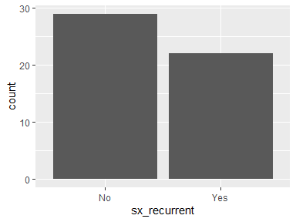
- Observed factor levels: "No", "Yes".

sx_acute_end
End of acute symptoms (only if patient presented recurrent symptoms) in DDMMYYYY
Feature | Result
Variable type | Date
Number of missing obs. | 2714 (99.93 %)
Number of unique values | 2
Mode | “2024-03-05”
Min. and max. | 2024-03-05; 2024-08-06
1st and 3rd quartiles | 2024-03-05; 2024-08-06
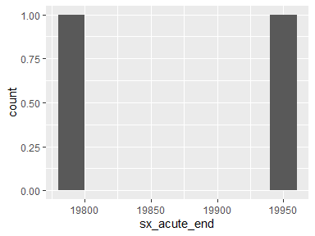

sx_recurrent_start
Start of recurrent symptoms (only if patient presented recurrent symptoms) DDMMYYYY
- The variable only takes one (non-missing) value: "2024-08-08". The variable contains 99.96 % missing observations.
- The variable has class POSIXct which is not supported by dataMaid.

sx_recurrent_consult
Was consultation during acute illness, or recurrent symptoms?
Feature | Result
Variable type | factor
Number of missing obs. | 2677 (98.56 %)
Number of unique values | 2
Mode | “Acute illness”
Reference category | Acute illness
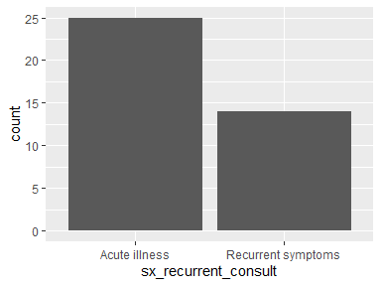
- Observed factor levels: "Acute illness", "Recurrent symptoms".

sequelae
Long-lasting sequelae (yes/no)
Feature | Result
Variable type | factor
Number of missing obs. | 2231 (82.14 %)
Number of unique values | 2
Mode | “No”
Reference category | No
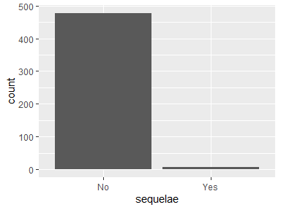
- Observed factor levels: "No", "Yes".

sequelae_freetext
Specify long-lasting sequelae
Feature | Result
Variable type | factor
Number of missing obs. | 2709 (99.74 %)
Number of unique values | 7
Mode | “fatigue”
Reference category | fatigue
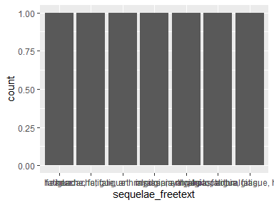
- Observed factor levels: "fatigue", "headache, fatigue", "headache, fatigue, arthralgias, myalgias", "insomnia", "myalgia, arthralgia, fatigue", "myalgias, arthralgias,", "photophobia, fatigue, headache".

sequelae_duration
Duration of long-lasting sequelae (weeks)
Feature | Result
Variable type | factor
Number of missing obs. | 2709 (99.74 %)
Number of unique values | 5
Mode | “3 weeks”
Reference category | >8 weeks
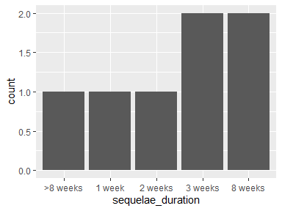
- Observed factor levels: ">8 weeks", "1 week", "2 weeks", "3 weeks", "8 weeks".

consult_date
Date of consultation (DDMMYYYY)
Feature | Result
Variable type | Date
Number of missing obs. | 2226 (81.96 %)
Number of unique values | 65
Mode | “2025-02-15”
Min. and max. | 2024-05-22; 2025-07-02
1st and 3rd quartiles | 2025-02-09; 2025-02-22
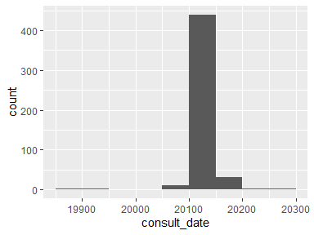

department
Emergency department of consultation
Feature | Result
Variable type | factor
Number of missing obs. | 1581 (58.21 %)
Number of unique values | 4
Mode | “Primary care/GP”
Reference category | Emergency department
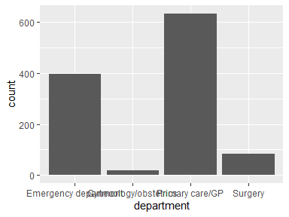
- Observed factor levels: "Emergency department", "Gynecology/obstetrics", "Primary care/GP", "Surgery".

dengue
Dengue (yes/no)
Feature | Result
Variable type | factor
Number of missing obs. | 0 (0 %)
Number of unique values | 2
Mode | “No”
Reference category | No
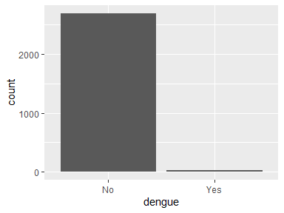
- Observed factor levels: "No", "Yes".

chikungunya
Chikungunya (yes/no)
Feature | Result
Variable type | factor
Number of missing obs. | 0 (0 %)
Number of unique values | 2
Mode | “No”
Reference category | Yes
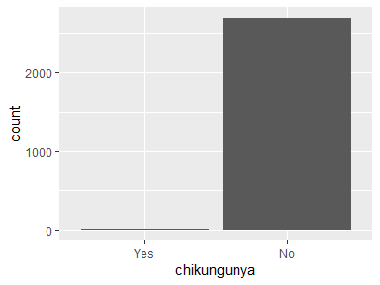
- Observed factor levels: "No", "Yes".

zika
Zika (yes/no)
- The variable only takes one (non-missing) value: "No". The variable contains 0 % missing observations.

mayaro
Mayaro (yes/no)
- The variable only takes one (non-missing) value: "No". The variable contains 0 % missing observations.

co_inf_other
coinfection Other (yes/no)
Feature | Result
Variable type | factor
Number of missing obs. | 0 (0 %)
Number of unique values | 2
Mode | “No”
Reference category | No
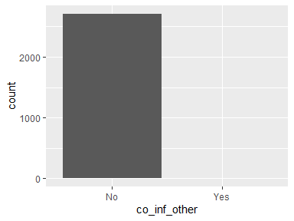
- Observed factor levels: "No", "Yes".

co_inf_other_specify
coinfection If other yes, specify
Feature | Result
Variable type | factor
Number of missing obs. | 2713 (99.89 %)
Number of unique values | 3
Mode | “malaria”
Reference category | malaria
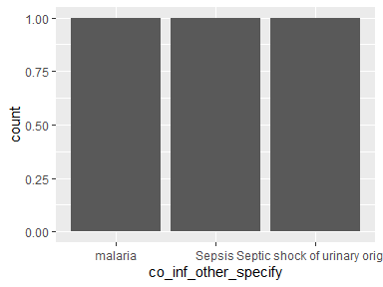
- Observed factor levels: "malaria", "Sepsis", "Septic shock of urinary origin".

orov_dx
How was OROV diagnosed?
Feature | Result
Variable type | factor
Number of missing obs. | 0 (0 %)
Number of unique values | 3
Mode | “PCR”
Reference category | PCR
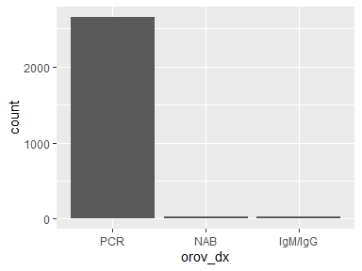
- Observed factor levels: "IgM/IgG", "NAB", "PCR".

orov_serum
SERUM sample taken (Y/N)
Feature | Result
Variable type | character
Number of missing obs. | 0 (0 %)
Number of unique values | 2
Mode | “Yes”
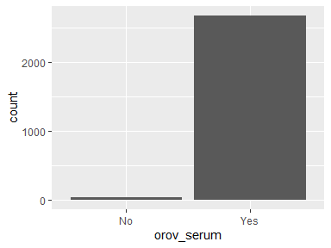
- Observed factor levels: "No", "Yes".

orov_serum_pos
serum test POSITIVE (Y/N)
Feature | Result
Variable type | character
Number of missing obs. | 35 (1.29 %)
Number of unique values | 2
Mode | “Positive”
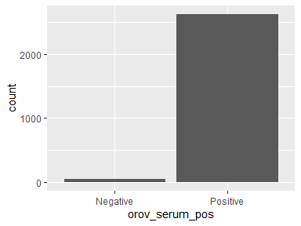
- Observed factor levels: "Negative", "Positive".

orov_serum_ct
serum test Ct value
Feature | Result
Variable type | numeric
Number of missing obs. | 1558 (57.36 %)
Number of unique values | 1028
Median | 23
1st and 3rd quartiles | 20.26; 29.1
Min. and max. | 13.5; 40.51
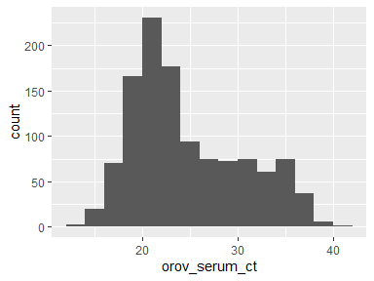

orov_serum_date
serum test Date
Feature | Result
Variable type | Date
Number of missing obs. | 893 (32.88 %)
Number of unique values | 179
Mode | “2024-11-25”
Min. and max. | 2024-01-31; 2025-11-04
1st and 3rd quartiles | 2024-11-18; 2025-02-08
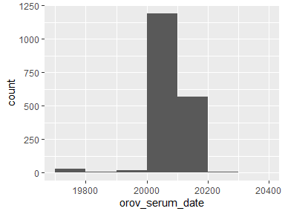

orov_blood
whole BLOOD sample taken (Y/N)
- The variable only takes one (non-missing) value: "No". The variable contains 82.29 % missing observations.

orov_blood_pos
blood test POSITIVE (Y/N)
- The variable only takes one value: "NA".

orov_blood_ct
blood test Ct value
- The variable only takes one value: "NA".

orov_blood_date
blood test Date
- The variable only takes one value: "NA".

orov_urine
URINE sample taken (Y/N)
Feature | Result
Variable type | factor
Number of missing obs. | 2115 (77.87 %)
Number of unique values | 2
Mode | “No”
Reference category | No
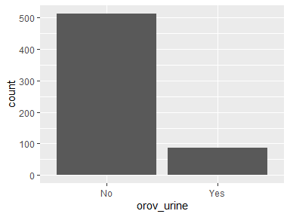
- Observed factor levels: "No", "Yes".

orov_urine_pos
urine test POSITIVE (Y/N)
Feature | Result
Variable type | character
Number of missing obs. | 2629 (96.8 %)
Number of unique values | 2
Mode | “Negative”
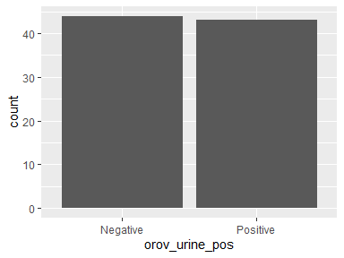
- Observed factor levels: "Negative", "Positive".

orov_urine_ct
urine test Ct value
Feature | Result
Variable type | numeric
Number of missing obs. | 2697 (99.3 %)
Number of unique values | 19
Median | 32.9
1st and 3rd quartiles | 29.27; 34.62
Min. and max. | 21.31; 37.21
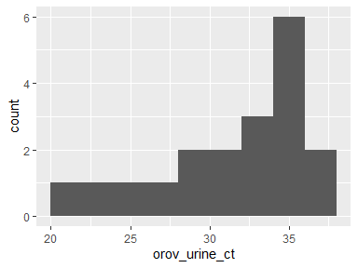

orov_urine_date
urine test Date
Feature | Result
Variable type | Date
Number of missing obs. | 2629 (96.8 %)
Number of unique values | 36
Mode | “2024-02-09”
Min. and max. | 2024-02-09; 2025-06-16
1st and 3rd quartiles | 2024-02-16; 2025-02-17
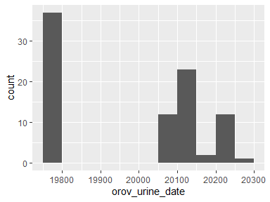

orov_semen
semen sample taken (Y/N)
Feature | Result
Variable type | factor
Number of missing obs. | 2170 (79.9 %)
Number of unique values | 2
Mode | “No”
Reference category | No
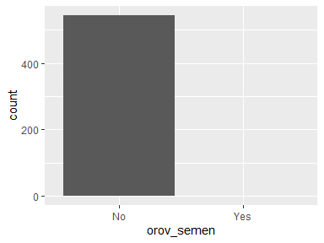
- Observed factor levels: "No", "Yes".

orov_semen_pos
semen test POSITIVE (Y/N)
- The variable only takes one (non-missing) value: "Positive". The variable contains 99.96 % missing observations.

orov_semen_ct
semen test Ct value
- The variable only takes one (non-missing) value: "33.09". The variable contains 99.96 % missing observations.

orov_semen_date
semen test Date
- The variable only takes one (non-missing) value: "2025-06-16". The variable contains 99.96 % missing observations.

orov_csf
CSF sample taken (Y/N)
- The variable only takes one (non-missing) value: "No". The variable contains 79.9 % missing observations.

orov_csf_pos
CSF test POSITIVE (Y/N)
- The variable only takes one value: "NA".

orov_csf_ct
CSF test Ct value
- The variable only takes one value: "NA".

orov_csf_date
CSF test Date
- The variable only takes one value: "NA".

sequencing
Sequencing done (Y/N)
Feature | Result
Variable type | factor
Number of missing obs. | 2125 (78.24 %)
Number of unique values | 2
Mode | “No”
Reference category | No
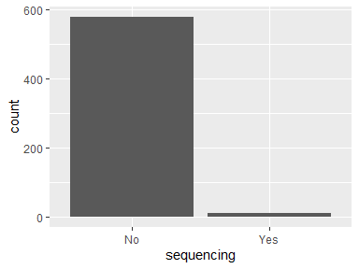
- Observed factor levels: "No", "Yes".

sequencing_data
Sequencing data
Feature | Result
Variable type | factor
Number of missing obs. | 2126 (78.28 %)
Number of unique values | 12
Mode | “Not done”
Reference category | >hOROV/Brazil/AM-FAMERP-005/2024|EPI_ISL_19793862|2024-01-31
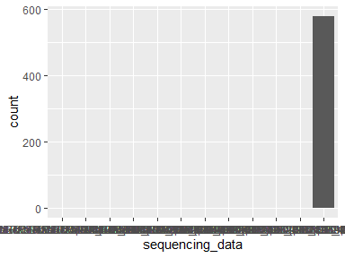
- Observed factor levels: ">hOROV/Brazil/AM-FAMERP-005/2024|EPI_ISL_19793862|2024-01-31", ">hOROV/Brazil/AM-FAMERP-017/2024|EPI_ISL_19793863|2024-02-01", ">hOROV/Brazil/AM-FAMERP-024/2024|EPI_ISL_19793864|2024-02-05", ">hOROV/Brazil/AM-FAMERP-043/2024|EPI_ISL_19793865|2024-02-08", ">hOROV/Brazil/AM-FAMERP-509/2024|EPI_ISL_19793866|2024-02-01", ">hOROV/Brazil/AM-FAMERP-514/2024|EPI_ISL_19793867|2024-02-02", ">hOROV/Brazil/AM-FAMERP-515/2024|EPI_ISL_19793868|2024-02-02", ">hOROV/Brazil/AM-FAMERP-518/2024|EPI_ISL_19793869|2024-02-02", ">hOROV/Brazil/AM-FAMERP-559/2024|EPI_ISL_19793870|2024-02-07", ">hOROV/Brazil/AM-FAMERP-560/2024|EPI_ISL_19793871|2024-02-07", ">hOROV/Brazil/AM-FAMERP-576/2024|EPI_ISL_19793872|2024-02-16", "Not done".

sero_igm
IgM (positive, negative, not done)
Feature | Result
Variable type | factor
Number of missing obs. | 2588 (95.29 %)
Number of unique values | 2
Mode | “Positive”
Reference category | Not done
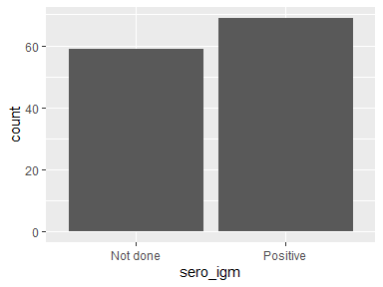
- Observed factor levels: "Not done", "Positive".

sero_igm_dilution
IgM (dilution)
- The variable only takes one value: "NA".

sero_igg
IgG (positive, negative, not done)
Feature | Result
Variable type | factor
Number of missing obs. | 2610 (96.1 %)
Number of unique values | 3
Mode | “Not done”
Reference category | Negative
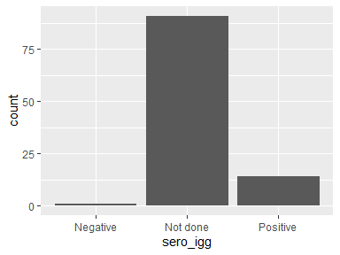
- Observed factor levels: "Negative", "Not done", "Positive".

sero_igg_dilution
IgG (dilution)
- The variable only takes one value: "NA".

sero_date
Date of serology
Feature | Result
Variable type | Date
Number of missing obs. | 2647 (97.46 %)
Number of unique values | 38
Mode | “2025-01-09”
Min. and max. | 2024-05-30; 2025-07-02
1st and 3rd quartiles | 2025-01-09; 2025-02-07
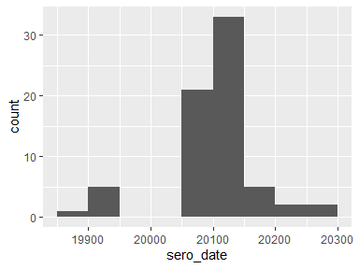

nab
Neutralizing antibodies
- The variable only takes one (non-missing) value: "Positive". The variable contains 98.49 % missing observations.

nab_date
Date of neutralizing Ab
Feature | Result
Variable type | Date
Number of missing obs. | 2689 (99.01 %)
Number of unique values | 13
Mode | “2024-02-19”
Min. and max. | 2024-01-31; 2024-02-28
1st and 3rd quartiles | 2024-02-06; 2024-02-21
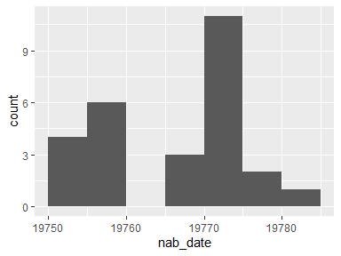

orov_serum_fu
serum test SERUM sample taken (Y/N) during follow up
Feature | Result
Variable type | factor
Number of missing obs. | 2194 (80.78 %)
Number of unique values | 2
Mode | “No”
Reference category | No
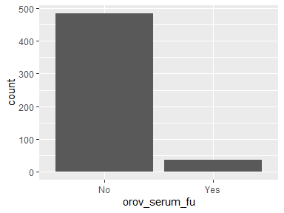
- Observed factor levels: "No", "Yes".

orov_serum_pos_fu
serum test POSITIVE (Y/N) during follow up
Feature | Result
Variable type | character
Number of missing obs. | 2694 (99.19 %)
Number of unique values | 2
Mode | “Negative”
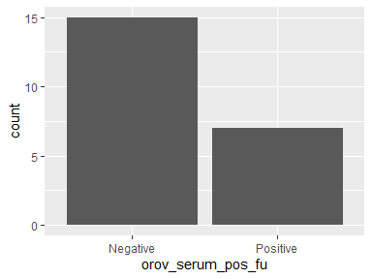
- Observed factor levels: "Negative", "Positive".

orov_serum_ct_fu
serum test Ct value during follow up
- The variable only takes one (non-missing) value: "35.79". The variable contains 99.96 % missing observations.

orov_serum_date_fu
serum test Date during follow up
Feature | Result
Variable type | Date
Number of missing obs. | 2699 (99.37 %)
Number of unique values | 11
Mode | “2025-01-15”
Min. and max. | 2025-01-09; 2025-04-03
1st and 3rd quartiles | 2025-01-14; 2025-02-20
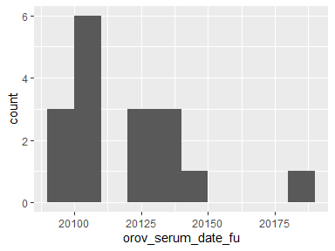

orov_blood_fu
blood test WHOLE BLOOD sample taken (Y/N) during follow up
- The variable only takes one (non-missing) value: "No". The variable contains 99.96 % missing observations.

orov_blood_pos_fu
blood test POSITIVE (Y/N) during follow up
- The variable only takes one value: "NA".

orov_blood_ct_fu
blood test Ct value during follow up
- The variable only takes one value: "NA".

orov_blood_date_fu
blood test Date during follow up
- The variable only takes one value: "NA".

orov_urine_fu
urine test URINE sample taken (Y/N) during follow up
Feature | Result
Variable type | factor
Number of missing obs. | 2191 (80.67 %)
Number of unique values | 2
Mode | “No”
Reference category | No
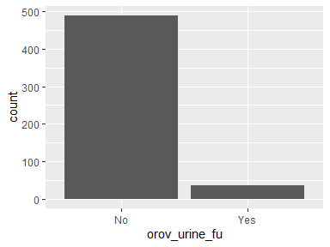
- Observed factor levels: "No", "Yes".

orov_urine_pos_fu
*urine test POSITIVE
(Y/N) during follow up*
Feature | Result
Variable type | character
Number of missing obs. | 2680 (98.67 %)
Number of unique values | 2
Mode | “Positive”
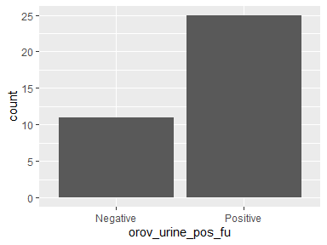
- Observed factor levels: "Negative", "Positive".

orov_urine_ct_fu
urine test Ct value during follow up
Feature | Result
Variable type | numeric
Number of missing obs. | 2698 (99.34 %)
Number of unique values | 18
Median | 32.15
1st and 3rd quartiles | 29.45; 34.59
Min. and max. | 20.37; 38
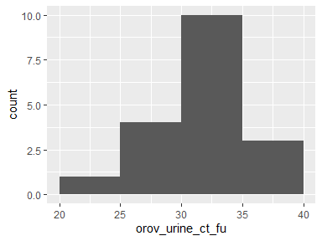

orov_urine_date_fu
urine test Date during follow up
Feature | Result
Variable type | Date
Number of missing obs. | 2680 (98.67 %)
Number of unique values | 23
Mode | “2025-02-20”
Min. and max. | 2025-01-09; 2025-06-27
1st and 3rd quartiles | 2025-01-16; 2025-05-05
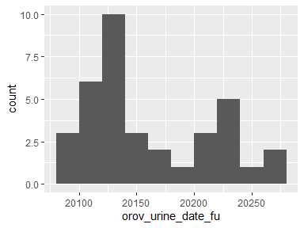

orov_semen_fu
SEMEN sample taken (Y/N) during follow up
Feature | Result
Variable type | factor
Number of missing obs. | 2192 (80.71 %)
Number of unique values | 2
Mode | “No”
Reference category | No
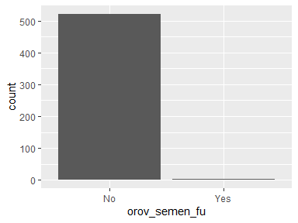
- Observed factor levels: "No", "Yes".

orov_semen_pos_fu
*semen test POSITIVE
(Y/N) during follow up*
- The variable only takes one (non-missing) value: "Negative". The variable contains 99.93 % missing observations.

orov_semen_ct_fu
semen test Ct value during follow up
- The variable only takes one value: "NA".

orov_semen_date_fu
semen test Date during follow up
Feature | Result
Variable type | Date
Number of missing obs. | 2714 (99.93 %)
Number of unique values | 2
Mode | “2025-06-26”
Min. and max. | 2025-06-26; 2025-06-27
1st and 3rd quartiles | 2025-06-26; 2025-06-27
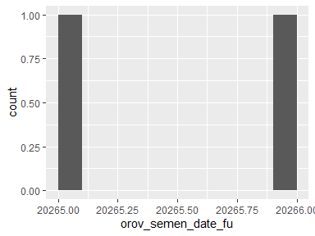

orov_csf_fu
CSF test CSF sample taken (Y/N) during follow up
- The variable only takes one (non-missing) value: "No". The variable contains 80.71 % missing observations.

orov_csf_pos_fu
*CSF test POSITIVE
(Y/N) during follow up*
- The variable only takes one value: "NA".

orov_csf_ct_fu
CSF test Ct value during follow up
- The variable only takes one value: "NA".

orov_csf_date_fu
CSF test Date during follow up
- The variable only takes one value: "NA".

sero_igm_fu
IgM (positive, negative, not done) during follow up
Feature | Result
Variable type | factor
Number of missing obs. | 2190 (80.63 %)
Number of unique values | 3
Mode | “No”
Reference category | No
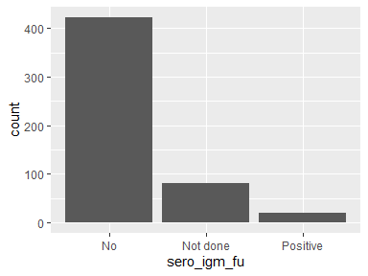
- Observed factor levels: "No", "Not done", "Positive".

sero_igm_dilution_fu
IgM (dilution) during follow up
- The variable only takes one value: "NA".

sero_igg_fu
IgG (positive, negative, not done) during follow up
Feature | Result
Variable type | factor
Number of missing obs. | 2630 (96.83 %)
Number of unique values | 3
Mode | “Not done”
Reference category | Negative
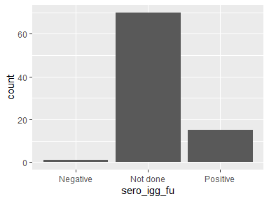
- Observed factor levels: "Negative", "Not done", "Positive".

sero_igg_dilution_fu
IgG (dilution) during follow up
- The variable only takes one value: "NA".

sero_date_fu
Date of serology during follow up
Feature | Result
Variable type | Date
Number of missing obs. | 2703 (99.52 %)
Number of unique values | 9
Mode | “2025-01-15”
Min. and max. | 2024-06-25; 2025-02-25
1st and 3rd quartiles | 2025-01-10; 2025-01-16
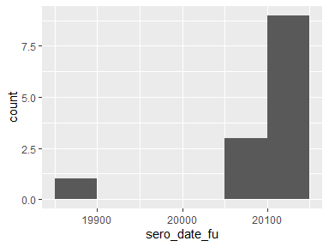

nab_fu
Neutralizing antibodies
Feature | Result
Variable type | factor
Number of missing obs. | 2675 (98.49 %)
Number of unique values | 6
Mode | “1: >640”
Reference category | 1: >640
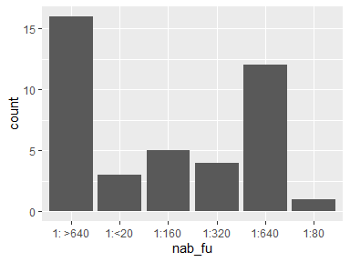
- Observed factor levels: "1: >640", "1:<20", "1:160", "1:320", "1:640", "1:80".

nab_date_fu
Date of neutralizing Ab during follow up
Feature | Result
Variable type | Date
Number of missing obs. | 2675 (98.49 %)
Number of unique values | 21
Mode | “2024-03-20”
Min. and max. | 2024-02-27; 2024-04-09
1st and 3rd quartiles | 2024-03-11; 2024-03-20
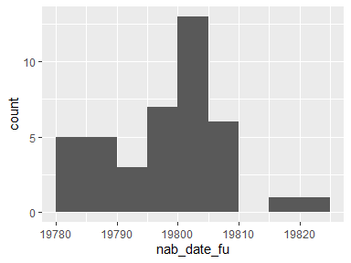

compl_date
*Date of first complication
(Please write the dates of illness of complications)*
- The variable only takes one (non-missing) value: "2024-07-25". The variable contains 99.96 % missing observations.

compl_life_threat
Any of the complications was life-threatening with intervention indicated to prevent permanent impairment or death?
Feature | Result
Variable type | factor
Number of missing obs. | 2220 (81.74 %)
Number of unique values | 2
Mode | “No”
Reference category | No
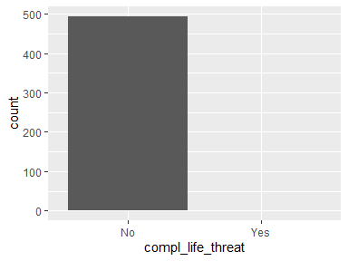
- Observed factor levels: "No", "Yes".

cns_involvment
Type of CNS involvement outcome
Feature | Result
Variable type | factor
Number of missing obs. | 2211 (81.41 %)
Number of unique values | 4
Mode | “No”
Reference category | Agitation, disorientation, confusion
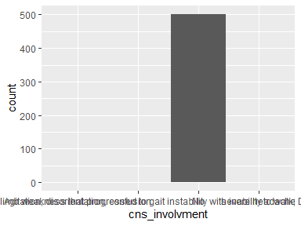
- Observed factor levels: "Agitation, disorientation, confusion", "Bilateral lower limb weakness that progressed to gait instability with inability to walk; Dizziness", "No", "severe headache".

cns_abnormalities
Describe CNS abnormalities
Feature | Result
Variable type | factor
Number of missing obs. | 2713 (99.89 %)
Number of unique values | 2
Mode | “No”
Reference category | 14/12/2024: RBD 0, WBC 0, glucose 103 mg/dl, PTN 46 mg/dl, clear xanthochromic serum. RPR N
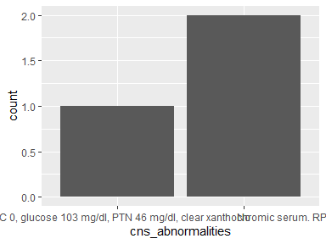
- Observed factor levels: "14/12/2024: RBD 0, WBC 0, glucose 103 mg/dl, PTN 46 mg/dl, clear xanthochromic serum. RPR N", "No".

haemorrhagic
Haemorrhagic complications
Feature | Result
Variable type | factor
Number of missing obs. | 2180 (80.27 %)
Number of unique values | 5
Mode | “No”
Reference category | Epistaxis
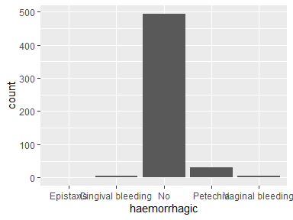
- Observed factor levels: "Epistaxis", "Gingival bleeding", "No", "Petechia", "Vaginal bleeding".

plasma_leakage
Plasma leakage
Feature | Result
Variable type | factor
Number of missing obs. | 2219 (81.7 %)
Number of unique values | 3
Mode | “No”
Reference category | No
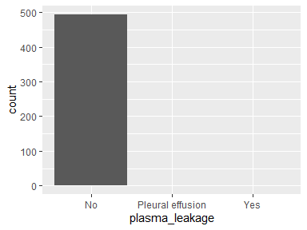
- Observed factor levels: "No", "Pleural effusion", "Yes".

organ_impairement
Organ impairment
Feature | Result
Variable type | factor
Number of missing obs. | 2215 (81.55 %)
Number of unique values | 2
Mode | “No”
Reference category | Cardiac complications
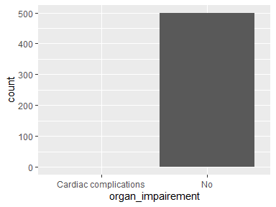
- Observed factor levels: "Cardiac complications", "No".

pregnancy_outcomes
Adverse pregnancy outcomes
Feature | Result
Variable type | factor
Number of missing obs. | 1628 (59.94 %)
Number of unique values | 13
Mode | “No reported complications”
Reference category | Abortion (8w)
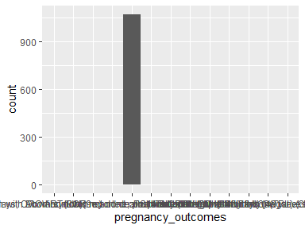
- Observed factor levels: "Abortion (8w)", "Abortion (9w)", "Newborn with Down syndrome and death 14 days after birth", "Newborn with fever 3 days after birth for 3 days; OROV RT-PCR not done; positive OROV IgM at 40 days (negative DENV, ZIKV, CHIKV IgM)", "No reported complications", "Preterm", "Stillbirth (29w)", "Stillbirth (30w)", "Stillbirth (32w)", "Stillbirth (38w)", "Stillbirth (39w)", "Stillbirth (40 weeks)", "Threatened preterm labor (TPL) (33w) during OROV infection".

compl_others
Other complications
Feature | Result
Variable type | factor
Number of missing obs. | 2595 (95.54 %)
Number of unique values | 5
Mode | “Arthritis”
Reference category | Arthritis
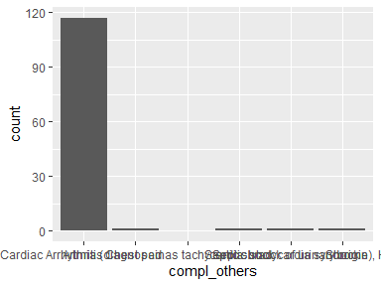
- Observed factor levels: "Arthritis", "Chest pain", "Hypotension, Cardiac Arrhytmia (diagnosed as tachycardia-bradycardia syndrome), Heart Failure", "Septic shock", "Septic shock of urinary origin", "Shock".

temperature_celsius
temperature recorded during consultation in Celsius
Feature | Result
Variable type | numeric
Number of missing obs. | 2462 (90.65 %)
Number of unique values | 41
Median | 37.85
1st and 3rd quartiles | 36.9; 38.5
Min. and max. | 35; 41
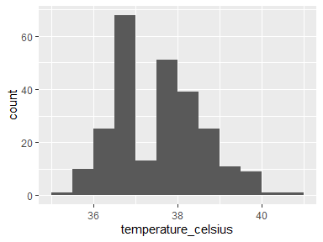

tourniquete
Tourniquete test (Positive, negative, Not done)
Feature | Result
Variable type | factor
Number of missing obs. | 826 (30.41 %)
Number of unique values | 3
Mode | “Negative”
Reference category | Positive
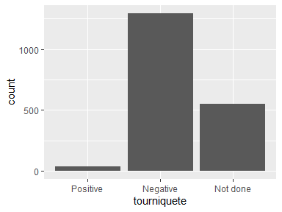
- Observed factor levels: "Negative", "Not done", "Positive".

exam_abnormalities
freetext for any relevant examination abnormalities
- The variable only takes one value: "NA".

final_outcome
final outcome of case
Feature | Result
Variable type | character
Number of missing obs. | 0 (0 %)
Number of unique values | 4
Mode | “Outpatient”
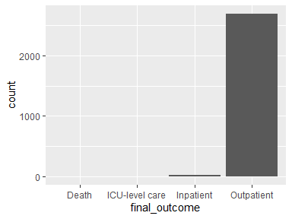
- Observed factor levels: "Death", "ICU-level care", "Inpatient", "Outpatient".

hospitalization_date
Hospitalization date
Feature | Result
Variable type | Date
Number of missing obs. | 2694 (99.19 %)
Number of unique values | 18
Mode | “2024-11-13”
Min. and max. | 2024-04-16; 2025-09-30
1st and 3rd quartiles | 2024-11-13; 2024-12-02
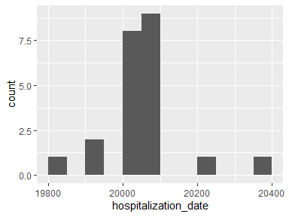

icu_date
ICU admission date
Feature | Result
Variable type | Date
Number of missing obs. | 2714 (99.93 %)
Number of unique values | 2
Mode | “2024-08-09”
Min. and max. | 2024-08-09; 2024-12-03
1st and 3rd quartiles | 2024-08-09; 2024-12-03
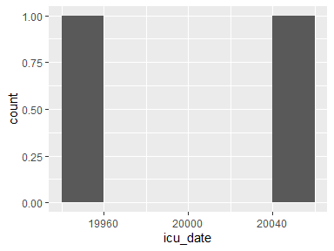

death_date
Date of death
- The variable only takes one (non-missing) value: "2024-12-23". The variable contains 99.96 % missing observations.

death_cause
Cause of death
- The variable only takes one value: "NA".

dialysis
Dialysis (yes/no)
Feature | Result
Variable type | factor
Number of missing obs. | 2273 (83.69 %)
Number of unique values | 2
Mode | “No”
Reference category | No
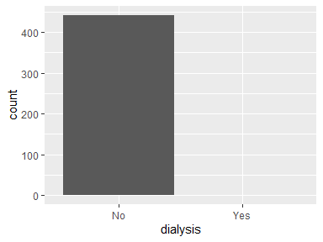
- Observed factor levels: "No", "Yes".

ventilated
Ventilated (Indication: respiratory failure, coma, sedation, other)
Feature | Result
Variable type | factor
Number of missing obs. | 2275 (83.76 %)
Number of unique values | 2
Mode | “No”
Reference category | No
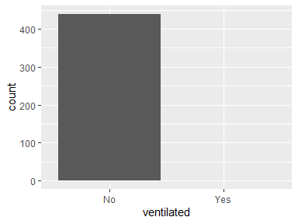
- Observed factor levels: "No", "Yes".

ventilation
Ventilation (No, NIV, Invasive)
Feature | Result
Variable type | factor
Number of missing obs. | 2274 (83.73 %)
Number of unique values | 2
Mode | “No”
Reference category | NIV, IMV
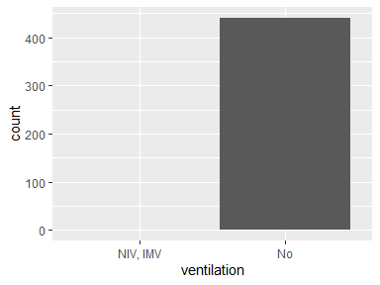
- Observed factor levels: "NIV, IMV", "No".

iotropic
Inotropic support(yes/no)
Feature | Result
Variable type | factor
Number of missing obs. | 2273 (83.69 %)
Number of unique values | 2
Mode | “No”
Reference category | Dobutamine
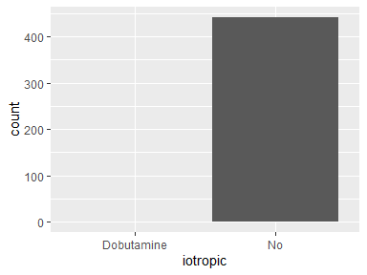
- Observed factor levels: "Dobutamine", "No".

iv
IV fluid (yes/no)
Feature | Result
Variable type | factor
Number of missing obs. | 2272 (83.65 %)
Number of unique values | 4
Mode | “No”
Reference category | IV fluids
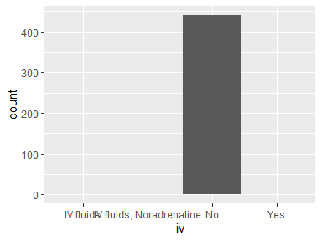
- Observed factor levels: "IV fluids", "IV fluids, Noradrenaline", "No", "Yes".

platelet_transfusion
Platelet transfusion (Y/N)
- The variable only takes one (non-missing) value: "No". The variable contains 83.73 % missing observations.

tx_other
Other treatment specify
- The variable only takes one (non-missing) value: "Antibiotics". The variable contains 99.93 % missing observations.

admission_days
Number of days admitted
Feature | Result
Variable type | numeric
Number of missing obs. | 2708 (99.71 %)
Number of unique values | 7
Median | 5.5
1st and 3rd quartiles | 4.5; 7.5
Min. and max. | 2; 66
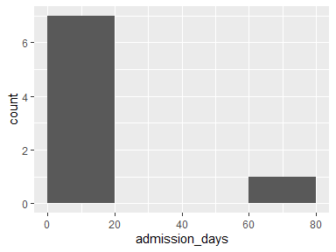

other_freetext
freetext for any other comments on the case
Feature | Result
Variable type | factor
Number of missing obs. | 2646 (97.42 %)
Number of unique values | 55
Mode | “DESCARTADO”
Reference category | A 45-YEAR-OLD PATIENT WITH SEVERE HEART FAILURE WITH REDUCED EJECTION FRACTION (HFREF) SEEKED MEDICAL ATTENTION FOR ACUTE FEBRILE SYNDROME THAT BEGAN ON 02/12/24, CHARACTERIZED BY VERTIGO, PROSTRAZIONE, MYALGIA, NAUSEA, INTENSE ABDOMINAL PAIN, LACK OF APPETITE, UNMEASURED FEVER, DIARRHEA, AND HYPOTENSION. HE REPORTED HOME CONTACTS WITH A CONFIRMED DIAGNOSIS OF OROPOUCHE FEVER. AT THE ORIGINAL UNIT, HE DEVELOPED HYPOTENSION REFRACTORY TO INTRAVENOUS HYDRATION (1000 ML OF 0.9% SF) AND NORADRENALINE INFUSION WAS STARTED INTO A PERIPHERAL VENOUS ACCESS. ADMITTED TO THE RED ROOM, WHERE DOBUTAMINE WAS INITIATED AFTER CENTRAL VENOUS ACCESS PUNCTURE IN THE RIGHT JUGULAR VEIN. PATIENT DECOMPENSATED BY SEVERE HF (TRANSPLANT WAITING LIST), EVOLVED WITH DEHYDRATION, VERY NEGATIVE WATER BALANCE, BUT REMAINED HEMODYNAMICALLY STABLE AFTER INTRODUCTION OF VASOACTIVE DRUGS.
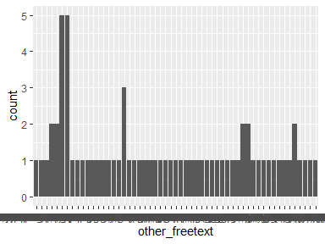
- Observed factor levels: "A 45-YEAR-OLD PATIENT WITH SEVERE HEART FAILURE WITH REDUCED EJECTION FRACTION (HFREF) SEEKED MEDICAL ATTENTION FOR ACUTE FEBRILE SYNDROME THAT BEGAN ON 02/12/24, CHARACTERIZED BY VERTIGO, PROSTRAZIONE, MYALGIA, NAUSEA, INTENSE ABDOMINAL PAIN, LACK OF APPETITE, UNMEASURED FEVER, DIARRHEA, AND HYPOTENSION. HE REPORTED HOME CONTACTS WITH A CONFIRMED DIAGNOSIS OF OROPOUCHE FEVER. AT THE ORIGINAL UNIT, HE DEVELOPED HYPOTENSION REFRACTORY TO INTRAVENOUS HYDRATION (1000 ML OF 0.9% SF) AND NORADRENALINE INFUSION WAS STARTED INTO A PERIPHERAL VENOUS ACCESS. ADMITTED TO THE RED ROOM, WHERE DOBUTAMINE WAS INITIATED AFTER CENTRAL VENOUS ACCESS PUNCTURE IN THE RIGHT JUGULAR VEIN. PATIENT DECOMPENSATED BY SEVERE HF (TRANSPLANT WAITING LIST), EVOLVED WITH DEHYDRATION, VERY NEGATIVE WATER BALANCE, BUT REMAINED HEMODYNAMICALLY STABLE AFTER INTRODUCTION OF VASOACTIVE DRUGS.", "ABORTION, PCR placenta not done, PCR serum newborn not done", "Blood pressure within normal limits. OROV RNA detected in several fetal samples: brain (Ct 24), liver (32), spleen (30), heart (29), kidney (29)", "Ceasarian section", "CONFIRMADO POR LABORATORIO REFERENCIAL (NS1) CORRIDA", "DESCARTADO", "DESCARTADO POR NO CONTAR CON CRITERIOS EPIDEMIOLOGICOS", "dx. infeccion vias urinarias", "Emergency C-section at 37w due to preeclampsia", "Fetal death confirmed on 16/07/2024. Labor induced using oxytocin with date of delivery 18/07/2024. Fetal autopsy with no congenital malformations, with severe maceration including skin desquamation, autolysis affected all internal organs, notable encephalomalacia and epidural hemorrhage in the frontal and occipital regions. OROV RNA detected in several fetal samples: brain (Ct 23), spleen (24), heart (27), kidney (28), umbilical cord blood (27), placenta (24)", "Fetal tissues: Not analyzed", "HOSPITALIZADO EN carpa de contigencia cama 04", "HOSPITALIZADO EN GINECO OBSTETRICIA CAMA 06", "HOSPITALIZADO EN GINECO OBSTETRICIA CAMA 307-A", "HOSPITALIZADO EN GINECO OBSTETRICIA CAMA 312-B SD. FEBRIL", "HOSPITALIZADO EN GINECO OBSTETRICIA CAMA 06", "HOSPITALIZADO EN GINECO OBSTETRICIA DX. SD FEBRIL, ITU", "hospitalizado en GINECOLOGIA", "hospitalizado en GINECOLOGIA cama 3", "HOSPITALIZADO EN GINECOLOGIA CAMA 312-A, confirmado por ns1 lab ref", "HOSPITALIZADO EN MEDICINA CAMA 405-A", "HOSPITALIZADO EN MEDICINA CAMA 408-A", "HOSPITALIZADO EN NEUMOLOGIA CAMA 1 - TBC EN TRATAMIENTO", "Lack of fetal movement notes on 03/06/2024, absence of heartbeat 05/06/2024 (30 weeks and 5 days gestation), labor induced 06/06/2024. OROV RNA detected in several fetal samples: brain (Ct 17.5), liver (12.5), spleen (12.9), heart (17.7), lung (18.8), kidney (20.5), umbilical cord (25), placenta (32.5). Also complete histopathological characterisation in article.", "Live birth (38w), male, weight 3558g, length 50cm.", "NA", "Newborn with fever 3 days after birth for 3 days; OROV RT-PCR not done; positive OROV IgM at 40 days (negative DENV, ZIKV, CHIKV IgM)", "No changes during infection at 9w, Emergency cesarean section at week 39 due to preeclampsia and fetal macrosomia,", "PATIENT HAS HAD FEVER, MYALGIA, ADYNAMIA, AND BACK PAIN FOR 7 DAYS. HAS BEEN SEEKING INVESTIGATION OF FEVER LINKED TO POSSIBLE ARBOVIRUS INFECTION FOR 4 DAYS. PROGRESSES WITH ASTHENIA, SWEATING, AND PROGRESSIVE DYSPNEA AT MINIMAL EFFORT, SATURATING 87% IN AMBIENT AIR. WORKS ON A BANANA PLANTATION. MODERATE PLEURAL EFFUSION ON THE RIGHT AND LARGE LOCULATED PLEURAL EFFUSION ON THE LEFT. PATIENT ADMITTED TO THE HDDS FROM 03/12/2024 TO 07/02/2025.", "PCR placenta negative, PCR serum newborn negative, live birth", "PCR placenta negative, PCR serum newborn not done, live birth (w39) - F", "PCR placenta not done, PCR serum newborn negative, live birth (w37) - F, Ceasarian section", "PCR placenta not done, PCR serum newborn negative, live birth (w38) - M, Ceasarian section", "PCR placenta not done, PCR serum newborn negative, live birth (w39) - F, Ceasarian - section", "PCR placenta not done, PCR serum newborn negative, live birth (w39) - M, Ceasarian section", "PCR placenta not done, PCR serum newborn not done, live birth (w37) - M, Ceasarian section", "PCR placenta not done, PCR serum newborn not done, live birth (w41) - F", "Positive Placenta tissues, PCR serum newborn negative, live birth (w40) - F, cessarean", "Premature, PCR placenta not done, PCR serum newborn negative, live birth (w36) - F, Ceasarian section", "Preterm premature rupture of membranes (PPROM)", "puerperal-newborn without alterations", "puerperal - newborn born without comolications", "puerperal - newborns without alterations", "resultado ins - pcr oropuche", "RMN (16/12/2024): Mild involutive changes of the cerebral parenchyma. Correlate with clinical and laboratory findings. Guillain-Barré", "sd, febril", "sd. febril, itu - DESCARTADO", "Sex: Male, Weight: 2190g, No malformations; OROV RNA detected in several fetal samples: CSF (Ct 21), brain (34), lungs (33),liver (34), umbilical cord (33), and placenta (32); Ultrasonography: fetal macrosomia, normal fetal heart rate and spontaneous movements", "Signs of fetal distress, dystocic labor requiring c-section", "Signs of foetal distress by abnormal velocimetry (<3rd percentile) from 38 weeks of gestation – considered subsequent to a peak in maternal hypertension; Stillbirth (40 week); Sex Male, Weight 2340g, Length 51cm, HC 31cm", "the age in month is 1 month(s)", "Ultrasound at 39w: intrauterine fetal demise and large retroplacental clots consistent with placental abruption", "Ultrasound during pregnancy with No changes; Pregnancy outcome Live birth (36 weeks); Newborn with Down syndrome and death 14 days after birth", "Ultrasound during pregnancy with No changes; Pregnancy outcome Live birth (37 weeks); Newborn with Down syndrome still alive under investigation; Newborn Sex Male, Weight 3450g, Length 48cm, HC 35cm; TF ultrasound with no abnormalities", "YEAR-OLD FEMALE PATIENT ARRIVED AT THE ALFREDO CHAVES EMERGENCY ROOM ON 13/11/2024 WITH HEADACHE, MYALGIA, FEVER, RETRO-OCULAR PAIN, NAUSEA, VOMITING, LOSS OF APPETITE, WEAKNESS, AND DETERIORATION IN OVERALL HEALTH BEGINNING ONE WEEK AGO ASSOCIATED WITH ARTERIAL HYPOTENSION (PATIENT ARRIVED AT THE EMERGENCY ROOM YESTERDAY WITH A BLOOD PRESSURE OF 89/45 MMHG). VOLUME WAS ADMINISTERED YESTERDAY IN CONJUNCTION WITH SYMPTOMATIC TREATMENT. THIS MORNING (11/14/2024) PATIENT RETURNS WITH ARTERIAL HYPOTENSION (90/50 MMHG). ANOTHER 500 ML SF ADMINISTERED AND BP RETURNS TO 100/60 MMHG WITHOUT THE NEED FOR VASOACTIVE DRUGS AT THIS TIME. THE PATIENT HAS NO BLEEDING OR OTHER COMPLAINTS. LAB TESTS SHOW PLATELET PENDENCY AND MODERATE ANEMIA. DIAGNOSIS OF CARDIAC ARRHYTHMIA AND HEART FAILURE AT THE EVANG CACHOEIRO DE ITAPEMIRIM HOSPITAL. BRADI SYNDROME.".

p_id_site
participant/patient ID at local site, if any
Feature | Result
Variable type | numeric
Number of missing obs. | 2610 (96.1 %)
Number of unique values | 106
Median | 2744742
1st and 3rd quartiles | 2723398; 2772254.75
Min. and max. | 2198137; 2905284
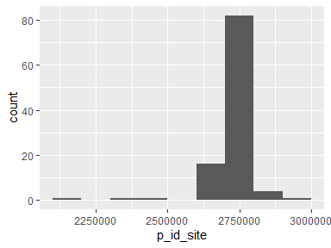

orov_edta
EDTA sample taken (Y/N)
Feature | Result
Variable type | factor
Number of missing obs. | 2655 (97.75 %)
Number of unique values | 2
Mode | “Yes”
Reference category | No
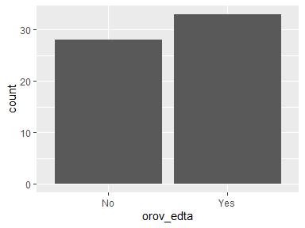
- Observed factor levels: "No", "Yes".

orov_edta_pos
EDTA test POSITIVE (Y/N)
Feature | Result
Variable type | character
Number of missing obs. | 2683 (98.78 %)
Number of unique values | 2
Mode | “Positive”
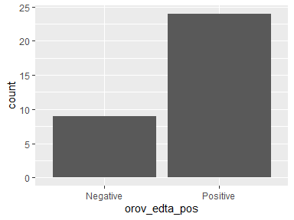
- Observed factor levels: "Negative", "Positive".

orov_edta_ct
EDTA test Ct value
Feature | Result
Variable type | factor
Number of missing obs. | 2694 (99.19 %)
Number of unique values | 22
Mode | “19.31”
Reference category | 19.31
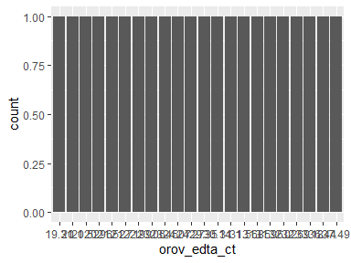
- Observed factor levels: "19.31", "20.1", "20.52", "20.96", "21.52", "21.71", "22.99", "23.06", "23.45", "24.07", "24.27", "29.35", "30.14", "31.1", "31.56", "31.85", "31.96", "32.02", "32.69", "33.18", "36.44", "37.49".

orov_edta_date
EDTA test Date
Feature | Result
Variable type | Date
Number of missing obs. | 2683 (98.78 %)
Number of unique values | 23
Mode | “2025-02-14”
Min. and max. | 2025-01-22; 2025-06-16
1st and 3rd quartiles | 2025-02-14; 2025-04-30
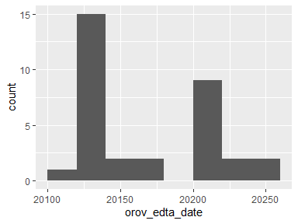

orov_edta_fu
EDTA sample taken (Y/N) during follow up
Feature | Result
Variable type | factor
Number of missing obs. | 2655 (97.75 %)
Number of unique values | 2
Mode | “No”
Reference category | No
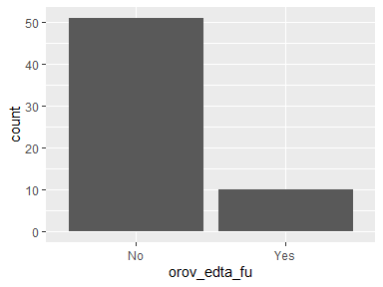
- Observed factor levels: "No", "Yes".

orov_edta_pos_fu
EDTA test POSITIVE (Y/N) during follow up
Feature | Result
Variable type | character
Number of missing obs. | 2706 (99.63 %)
Number of unique values | 2
Mode | “Negative”
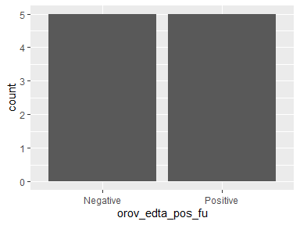
- Observed factor levels: "Negative", "Positive".

orov_edta_ct_fu
EDTA test Ct value during follow up
Feature | Result
Variable type | factor
Number of missing obs. | 2712 (99.85 %)
Number of unique values | 4
Mode | “31.29”
Reference category | 31.29
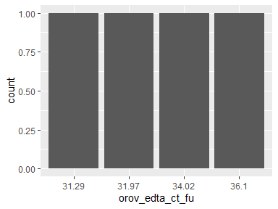
- Observed factor levels: "31.29", "31.97", "34.02", "36.1".

orov_edta_date_fu
EDTA test Date during follow up
Feature | Result
Variable type | Date
Number of missing obs. | 2706 (99.63 %)
Number of unique values | 9
Mode | “2025-05-13”
Min. and max. | 2025-02-20; 2025-06-26
1st and 3rd quartiles | 2025-02-25; 2025-05-19
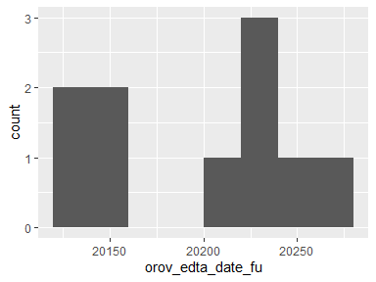

pregnancy_trimester
pregnancy trimester at time of OROV infection
Feature | Result
Variable type | character
Number of missing obs. | 201 (7.4 %)
Number of unique values | 4
Mode | “Not applicable”
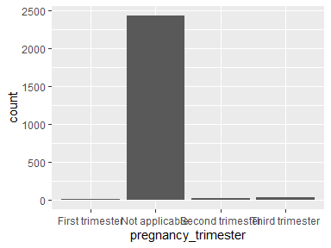
- Observed factor levels: "First trimester", "Not applicable", "Second trimester", "Third trimester".

apgar1
apgar score at 1 min
Feature | Result
Variable type | numeric
Number of missing obs. | 2707 (99.67 %)
Number of unique values | 4
Median | 8
1st and 3rd quartiles | 8; 8
Min. and max. | 7; 10
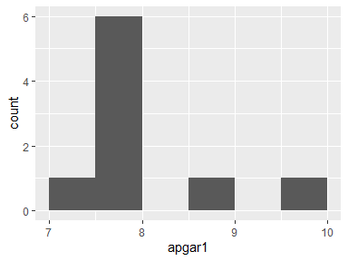

apgar5
apgar score at 5 min
Feature | Result
Variable type | numeric
Number of missing obs. | 2707 (99.67 %)
Number of unique values | 3
Median | 9
1st and 3rd quartiles | 9; 10
Min. and max. | 8; 10
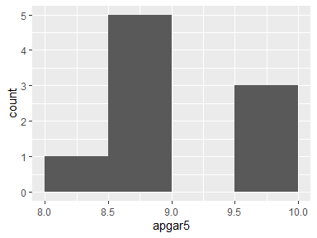

weight_g
weight at birth
Feature | Result
Variable type | numeric
Number of missing obs. | 2707 (99.67 %)
Number of unique values | 9
Median | 3450
1st and 3rd quartiles | 3260; 3788
Min. and max. | 1950; 3910
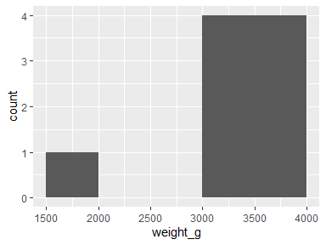

num_prev_preg
NA
Feature | Result
Variable type | numeric
Number of missing obs. | 2707 (99.67 %)
Number of unique values | 4
Median | 1
1st and 3rd quartiles | 0; 1
Min. and max. | 0; 4
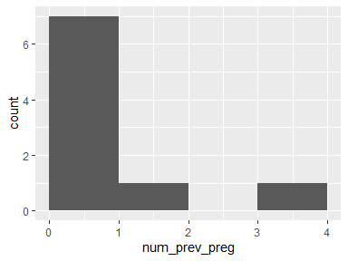

num_vag_birth
NA
Feature | Result
Variable type | numeric
Number of missing obs. | 2707 (99.67 %)
Number of unique values | 3
Median | 0
1st and 3rd quartiles | 0; 0
Min. and max. | 0; 2
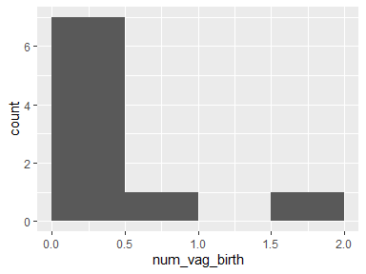

num_c_sec_birth
NA
Feature | Result
Variable type | numeric
Number of missing obs. | 2707 (99.67 %)
Number of unique values | 3
Median | 0
1st and 3rd quartiles | 0; 1
Min. and max. | 0; 2
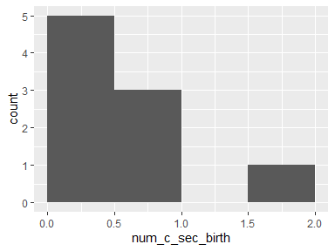

fetal_outcomes
Freetext for fetal outcomes
Feature | Result
Variable type | factor
Number of missing obs. | 2692 (99.12 %)
Number of unique values | 23
Mode | “Ceasarian section”
Reference category | ABORTION, PCR placenta not done, PCR serum newborn not done
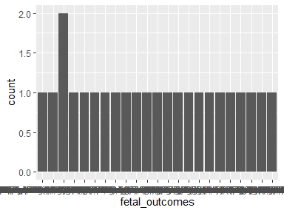
- Observed factor levels: "ABORTION, PCR placenta not done, PCR serum newborn not done", "Blood pressure within normal limits. OROV RNA detected in several fetal samples: brain (Ct 24), liver (32), spleen (30), heart (29), kidney (29)", "Ceasarian section", "Fetal death confirmed on 16/07/2024. Labor induced using oxytocin with date of delivery 18/07/2024. Fetal autopsy with no congenital malformations, with severe maceration including skin desquamation, autolysis affected all internal organs, notable encephalomalacia and epidural hemorrhage in the frontal and occipital regions. OROV RNA detected in several fetal samples: brain (Ct 23), spleen (24), heart (27), kidney (28), umbilical cord blood (27), placenta (24)", "Fetal tissues: Not analyzed", "Lack of fetal movement notes on 03/06/2024, absence of heartbeat 05/06/2024 (30 weeks and 5 days gestation), labor induced 06/06/2024. OROV RNA detected in several fetal samples: brain (Ct 17.5), liver (12.5), spleen (12.9), heart (17.7), lung (18.8), kidney (20.5), umbilical cord (25), placenta (32.5). Also complete histopathological characterisation in article.", "Live birth (38w), male, weight 3558g, length 50cm.", "Newborn with fever 3 days after birth for 3 days; OROV RT-PCR not done; positive OROV IgM at 40 days (negative DENV, ZIKV, CHIKV IgM)", "PCR placenta negative, PCR serum newborn negative, live birth", "PCR placenta negative, PCR serum newborn not done, live birth (w39) - F", "PCR placenta not done, PCR serum newborn negative, live birth (w37) - F, Ceasarian section", "PCR placenta not done, PCR serum newborn negative, live birth (w38) - M, Ceasarian section", "PCR placenta not done, PCR serum newborn negative, live birth (w39) - F, Ceasarian - section", "PCR placenta not done, PCR serum newborn negative, live birth (w39) - M, Ceasarian section", "PCR placenta not done, PCR serum newborn not done, live birth (w37) - M, Ceasarian section", "PCR placenta not done, PCR serum newborn not done, live birth (w41) - F", "Positive Placenta tissues, PCR serum newborn negative, live birth (w40) - F, cessarean", "Premature, PCR placenta not done, PCR serum newborn negative, live birth (w36) - F, Ceasarian section", "Sex: Male, Weight: 2190g, No malformations; OROV RNA detected in several fetal samples: CSF (Ct 21), brain (34), lungs (33),liver (34), umbilical cord (33), and placenta (32); Ultrasonography: fetal macrosomia, normal fetal heart rate and spontaneous movements", "Signs of foetal distress by abnormal velocimetry (<3rd percentile) from 38 weeks of gestation – considered subsequent to a peak in maternal hypertension; Stillbirth (40 week); Sex Male, Weight 2340g, Length 51cm, HC 31cm", "Ultrasound during pregnancy with No changes; Pregnancy outcome Live birth (36 weeks); Newborn with Down syndrome and death 14 days after birth", "Ultrasound during pregnancy with No changes; Pregnancy outcome Live birth (37 weeks); Newborn with Down syndrome still alive under investigation; Newborn Sex Male, Weight 3450g, Length 48cm, HC 35cm; TF ultrasound with no abnormalities", "Unknown".

organ_impairment
Organ impairment
Feature | Result
Variable type | factor
Number of missing obs. | 2714 (99.93 %)
Number of unique values | 2
Mode | “Cardiac complications”
Reference category | Cardiac complications
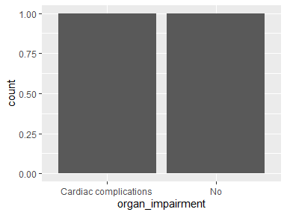
- Observed factor levels: "Cardiac complications", "No".

site
study site
Feature | Result
Variable type | factor
Number of missing obs. | 0 (0 %)
Number of unique values | 8
Mode | “espirito santo”
Reference category | bananeiras
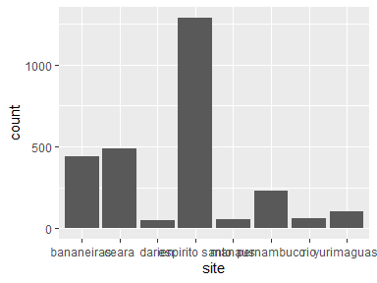
- Observed factor levels: "bananeiras", "ceara", "darien", "espirito santo", "manaus", "pernambuco", "rio", "yurimaguas".

n_haemorrhagic
number of haemorrhagic complications
Feature | Result
Variable type | factor
Number of missing obs. | 0 (0 %)
Number of unique values | 2
Mode | “No”
Reference category | No
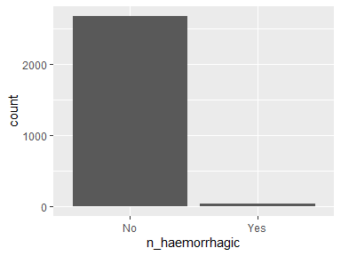
- Observed factor levels: "No", "Yes".

other_comorbidity_bin
Any other comorbidity (yes/no)
Feature | Result
Variable type | factor
Number of missing obs. | 0 (0 %)
Number of unique values | 2
Mode | “No”
Reference category | No
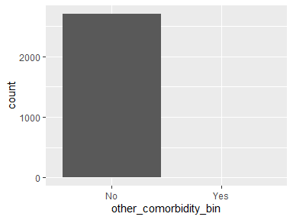
- Observed factor levels: "No", "Yes".

sex
sex
Feature | Result
Variable type | factor
Number of missing obs. | 3 (0.11 %)
Number of unique values | 2
Mode | “F”
Reference category | F
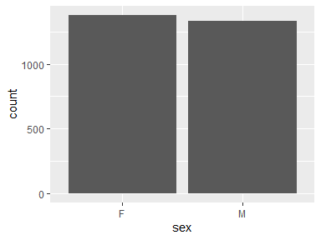
- Observed factor levels: "F", "M".

ethnicity2
self-reported ethnicity/race, standardized according to each country’s census
Feature | Result
Variable type | factor
Number of missing obs. | 198 (7.29 %)
Number of unique values | 8
Mode | “Parda”
Reference category | Afrodescendiente
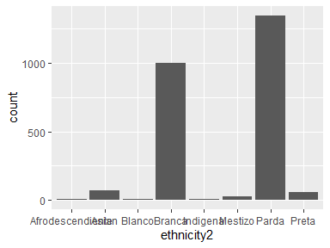
- Observed factor levels: "Afrodescendiente", "Asian", "Blanco", "Branca", "Indigena", "Mestizo", "Parda", "Preta".

ethnicity3
self-reported ethnicity/race, standardized according to each country’s census, with afrodescendiente/Preta and Blanco/Branca grouped
Feature | Result
Variable type | factor
Number of missing obs. | 198 (7.29 %)
Number of unique values | 6
Mode | “Parda”
Reference category | Afrodescendiente/Preta
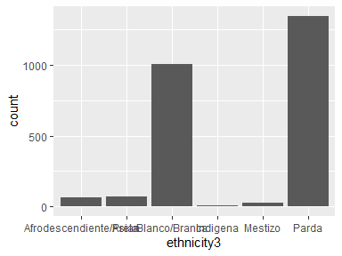
- Observed factor levels: "Afrodescendiente/Preta", "Asian", "Blanco/Branca", "Indigena", "Mestizo", "Parda".

n_co_inf
number of co-infections (dengue, zika, chikungunya, mayaro, or any other)
Feature | Result
Variable type | factor
Number of missing obs. | 0 (0 %)
Number of unique values | 2
Mode | “No”
Reference category | No
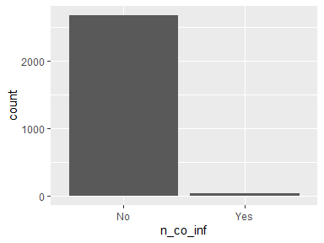
- Observed factor levels: "No", "Yes".

adult_vs_ped
Adult (over 18 years) or pediatric participant (<18 years)
Feature | Result
Variable type | factor
Number of missing obs. | 3 (0.11 %)
Number of unique values | 2
Mode | “adult”
Reference category | adult
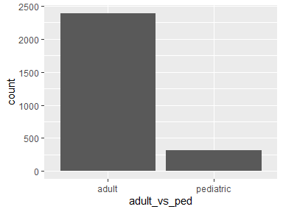
- Observed factor levels: "adult", "pediatric".

age_cat
Age categories: 0 to <5yrs, 5 to <18 yrs, 18 to <40 yrs, 40 to <65 years, 65 yrs or above
Feature | Result
Variable type | factor
Number of missing obs. | 3 (0.11 %)
Number of unique values | 5
Mode | “18 to <40”
Reference category | 0 to <5
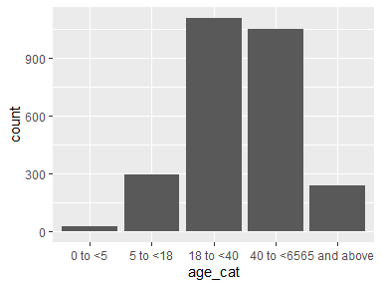
- Observed factor levels: "0 to <5", "18 to <40", "40 to <65", "5 to <18", "65 and above".

year
year of inclusion in the study
Feature | Result
Variable type | numeric
Number of missing obs. | 0 (0 %)
Number of unique values | 2
Median | 2024
1st and 3rd quartiles | 2024; 2025
Min. and max. | 2024; 2025
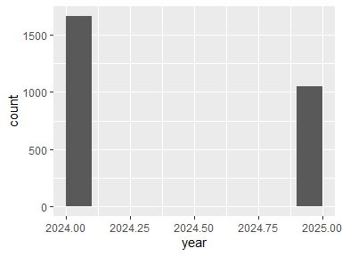

n_comorb
number of comorbidities (hypertension, diabetes, immunosuppresion, renal disease, obesity, or any other
Feature | Result
Variable type | character
Number of missing obs. | 0 (0 %)
Number of unique values | 2
Mode | “No”
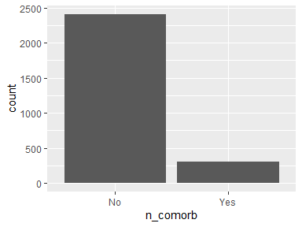
- Observed factor levels: "No", "Yes".

endemic_area
Endemic area: Manaus, Yurimaguas (yes/no)
Feature | Result
Variable type | character
Number of missing obs. | 0 (0 %)
Number of unique values | 2
Mode | “Newly affected”
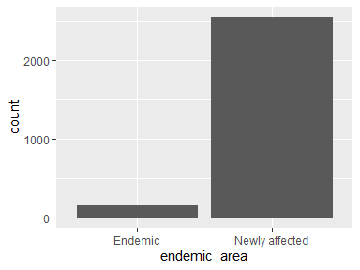
- Observed factor levels: "Endemic", "Newly affected".

warning_signs
Any dengue warning signs (vomiting and/or abdominal pain)
Feature | Result
Variable type | factor
Number of missing obs. | 32 (1.18 %)
Number of unique values | 2
Mode | “No”
Reference category | Yes
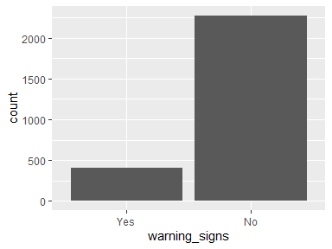
- Observed factor levels: "No", "Yes".

two_ws
two dengue warning signs (vomiting and abdominal pain)
Feature | Result
Variable type | factor
Number of missing obs. | 32 (1.18 %)
Number of unique values | 2
Mode | “No”
Reference category | Yes
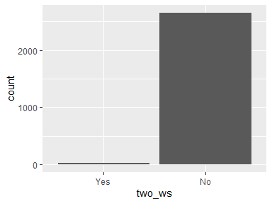
- Observed factor levels: "No", "Yes".

n_ws
number of dengue warning signs (abdominal pain and vomiting)
Feature | Result
Variable type | numeric
Number of missing obs. | 32 (1.18 %)
Number of unique values | 3
Median | 0
1st and 3rd quartiles | 0; 0
Min. and max. | 0; 2
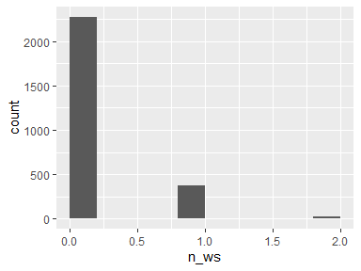

risk_factors
any risk factors (comorbidity or pregant during OROV infection)
Feature | Result
Variable type | factor
Number of missing obs. | 0 (0 %)
Number of unique values | 3
Mode | “None”
Reference category | None
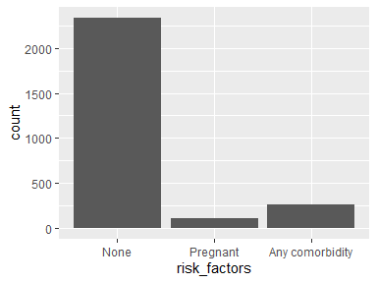
- Observed factor levels: "Any comorbidity", "None", "Pregnant".

respiratory
respiratory complication
Feature | Result
Variable type | character
Number of missing obs. | 2712 (99.85 %)
Number of unique values | 3
Mode | “No”
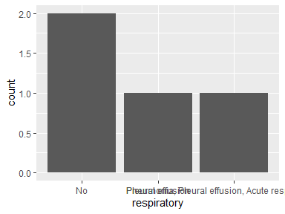
- Observed factor levels: "No", "Pleural effusion", "Pneumonia, Pleural effusion, Acute respiratory failure".

renal_compl
renal complication
Feature | Result
Variable type | character
Number of missing obs. | 2713 (99.89 %)
Number of unique values | 2
Mode | “Acute kidney failure”
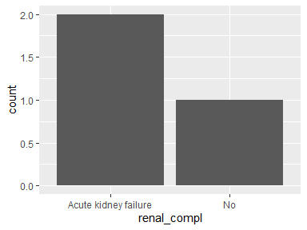
- Observed factor levels: "Acute kidney failure", "No".

hepatic
hepatic complications
Feature | Result
Variable type | character
Number of missing obs. | 2713 (99.89 %)
Number of unique values | 2
Mode | “No”
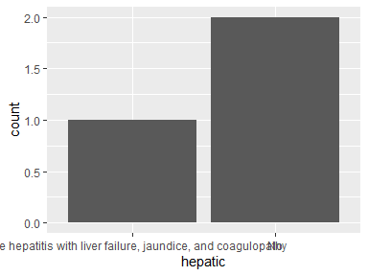
- Observed factor levels: "Acute hepatitis with liver failure, jaundice, and coagulopathy", "No".

cardiac
Type of cardiac outcome
Feature | Result
Variable type | character
Number of missing obs. | 2714 (99.93 %)
Number of unique values | 2
Mode | “Decompensation of heart failure secondary to OROV disease”
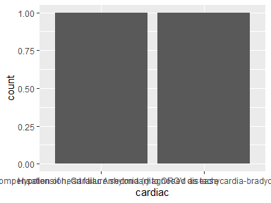
- Observed factor levels: "Decompensation of heart failure secondary to OROV disease", "Hypotension, Cardiac Arrhytmia (diagnosed as tachycardia-bradycardia syndrome), Heart Failure".

complication
Type of complication: No reported complications, pregnancy complications, non-pregnancy complications
Feature | Result
Variable type | factor
Number of missing obs. | 0 (0 %)
Number of unique values | 3
Mode | “No reported complications”
Reference category | No reported complications
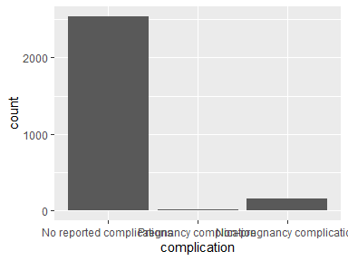
- Observed factor levels: "No reported complications", "Non-pregnancy complication", "Pregnancy complication".

complication2
Type of complication: No reported complications, pregnancy complications, haemorrhagic complication, arthritis, severe disease
Feature | Result
Variable type | factor
Number of missing obs. | 0 (0 %)
Number of unique values | 5
Mode | “No reported complications”
Reference category | No reported complications
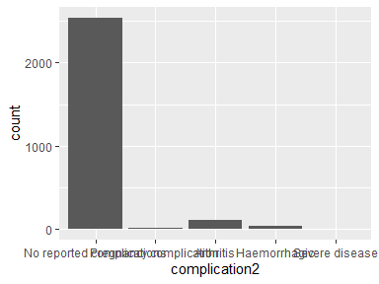
- Observed factor levels: "Arthritis", "Haemorrhagic", "No reported complications", "Pregnancy complication", "Severe disease".

compl_bin
Any complications (yes/no)
Feature | Result
Variable type | character
Number of missing obs. | 0 (0 %)
Number of unique values | 2
Mode | “No reported complications”
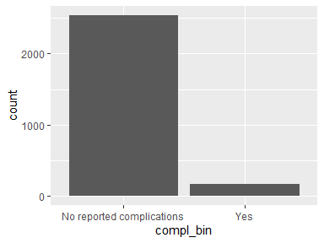
- Observed factor levels: "No reported complications", "Yes".

other_sx_bin
any other symptoms (yes/no)
Feature | Result
Variable type | character
Number of missing obs. | 0 (0 %)
Number of unique values | 2
Mode | “No”
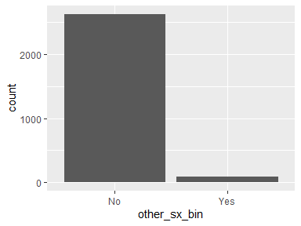
- Observed factor levels: "No", "Yes".

n_sx
number of symptoms
Feature | Result
Variable type | numeric
Number of missing obs. | 0 (0 %)
Number of unique values | 14
Median | 4
1st and 3rd quartiles | 3; 5
Min. and max. | 0; 13
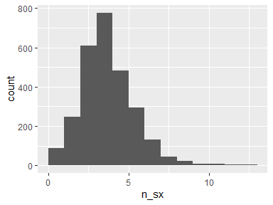

orov_dx_pcr
OROV diagnosis by RTPCR (yes/no)
Feature | Result
Variable type | factor
Number of missing obs. | 0 (0 %)
Number of unique values | 2
Mode | “Yes”
Reference category | No
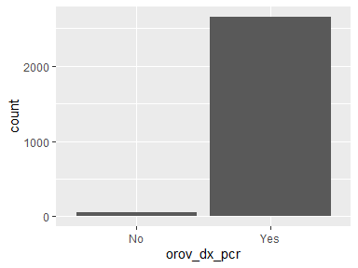
- Observed factor levels: "No", "Yes".

orov_dx_nab
OROV diagnosis by NAB (yes/no)
Feature | Result
Variable type | factor
Number of missing obs. | 0 (0 %)
Number of unique values | 2
Mode | “No”
Reference category | No
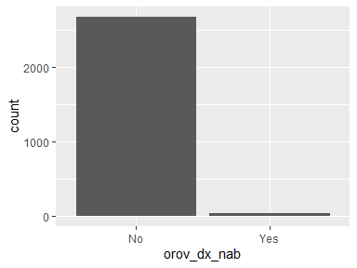
- Observed factor levels: "No", "Yes".

orov_dx_elisa
OROV diagnosis by ELISA (yes/no)
Feature | Result
Variable type | factor
Number of missing obs. | 0 (0 %)
Number of unique values | 2
Mode | “No”
Reference category | No
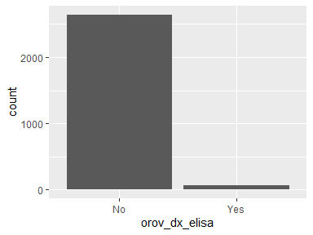
- Observed factor levels: "No", "Yes".

orov_confirmation
Confirmed or suspected OROV case according to WHO definition
Feature | Result
Variable type | character
Number of missing obs. | 0 (0 %)
Number of unique values | 2
Mode | “Confirmed case”
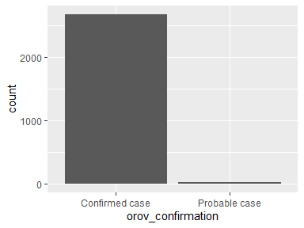
- Observed factor levels: "Confirmed case", "Probable case".

time_sx_to_dx
time between start of symptoms until OROV diagnosis in days
- The variable has class difftime which is not supported by dataMaid.

time_sx_to_pcr
time between start of symptoms until OROV diagnosis by RTPCR in days
- The variable has class difftime which is not supported by dataMaid.

time_sx_to_nab
time between start of symptoms until OROV diagnosis by NAB in days
- The variable has class difftime which is not supported by dataMaid.

time_sx_to_elisa
time between start of symptoms until OROV diagnosis by ELISA in days
- The variable has class difftime which is not supported by dataMaid.

time_sx_to_igm
time between start of symptoms until OROV diagnosis by IGM in days
- The variable has class difftime which is not supported by dataMaid.

time_sx_to_igg
time between start of symptoms until OROV diagnosis by IGG in days
- The variable has class difftime which is not supported by dataMaid.

time_sx_to_pcr_urine
time between start of symptoms until OROV diagnosis by RTPCR from urine in days
- The variable has class difftime which is not supported by dataMaid.

time_sx_to_pcr_edta
time between start of symptoms until OROV diagnosis by RTPCR from serum in days
- The variable has class difftime which is not supported by dataMaid.

time_sx_to_pcr_semen
time between start of symptoms until OROV diagnosis by RTPCR from semen in days
- The variable only takes one (non-missing) value: "18". The variable contains 99.96 % missing observations.
- The variable has class difftime which is not supported by dataMaid.

time_sx_to_pcr_fu
time between start of symptoms until OROV diagnosis by RTPCR during follow-up in days
- The variable has class difftime which is not supported by dataMaid.

time_sx_to_pcr_urine_fu
time between start of symptoms until OROV diagnosis by RTPCR from urine during follow-up in days
- The variable has class difftime which is not supported by dataMaid.

time_sx_to_pcr_edta_fu
time between start of symptoms until OROV diagnosis by RTPCR from serum during follow-up in days
- The variable has class difftime which is not supported by dataMaid.

time_sx_to_pcr_semen_fu
time between start of symptoms until OROV diagnosis by RTPCR from semen durign follow-up in days
- The variable only takes one value: "NA".
- The variable has class difftime which is not supported by dataMaid.

sx_length
overall length of symptoms in days
- The variable has class difftime which is not supported by dataMaid.

compl_onset
date of start of recorded complications (DDMMYYYY)
- The variable only takes one (non-missing) value: "1". The variable contains 99.96 % missing observations.
- The variable has class difftime which is not supported by dataMaid.

still_birth_ct
Ct value from stillbirth
Feature | Result
Variable type | numeric
Number of missing obs. | 2712 (99.85 %)
Number of unique values | 4
Median | 22
1st and 3rd quartiles | 18.88; 23.25
Min. and max. | 12.5; 24
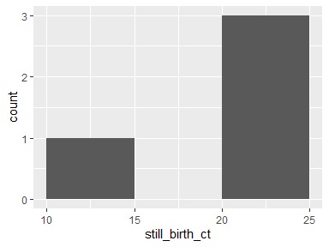

haemoglobin_lab
Peak haemoglobin (g/L)
Feature | Result
Variable type | numeric
Number of missing obs. | 2607 (95.99 %)
Number of unique values | 92
Median | 134.7
1st and 3rd quartiles | 119; 147.9
Min. and max. | 83; 182.1
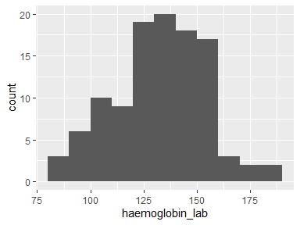

haemoglobin_lab_cat
Above, within, or below range according to reference standards
Feature | Result
Variable type | character
Number of missing obs. | 2605 (95.91 %)
Number of unique values | 3
Mode | “within”
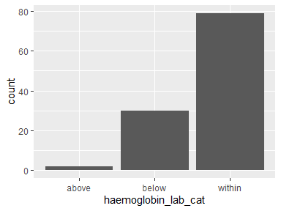
- Observed factor levels: "above", "below", "within".

haematocrit_lab
Peak Haematocrit (%)
Feature | Result
Variable type | numeric
Number of missing obs. | 2618 (96.39 %)
Number of unique values | 94
Median | 40.94
1st and 3rd quartiles | 38.31; 44.58
Min. and max. | 28.5; 53.76
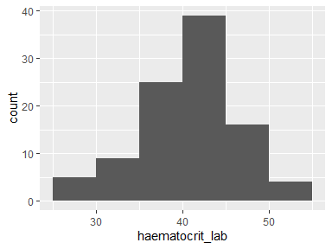

haematocrit_lab_cat
Above, within, or below range according to reference standards
Feature | Result
Variable type | factor
Number of missing obs. | 2618 (96.39 %)
Number of unique values | 3
Mode | “within”
Reference category | above
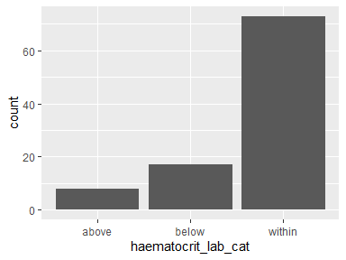
- Observed factor levels: "above", "below", "within".

wbc_lab
Peak White blood cells (cellsx10^9/L)
Feature | Result
Variable type | numeric
Number of missing obs. | 2610 (96.1 %)
Number of unique values | 102
Median | 6.97
1st and 3rd quartiles | 4.66; 8.86
Min. and max. | 1.6; 20.6
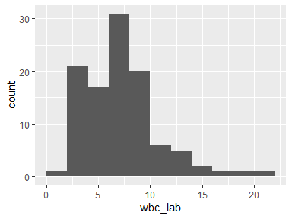

wbc_lab_cat
Above, within, or below range according to reference standards
Feature | Result
Variable type | character
Number of missing obs. | 1322 (48.67 %)
Number of unique values | 3
Mode | “within”
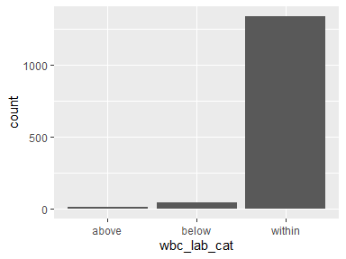
- Observed factor levels: "above", "below", "within".

neutrophils_lab
Peak neutrophils (cells x10^9/L)
Feature | Result
Variable type | numeric
Number of missing obs. | 2651 (97.61 %)
Number of unique values | 65
Median | 3.8
1st and 3rd quartiles | 2.3; 5.53
Min. and max. | 0.62; 16.2
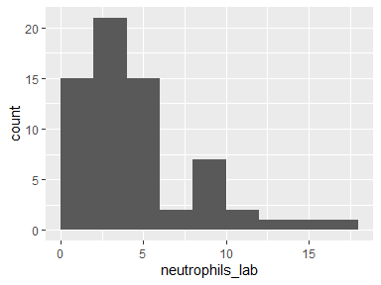

neutrophils_lab_cat
Above, within, or below range according to reference standards
Feature | Result
Variable type | factor
Number of missing obs. | 2651 (97.61 %)
Number of unique values | 3
Mode | “within”
Reference category | above
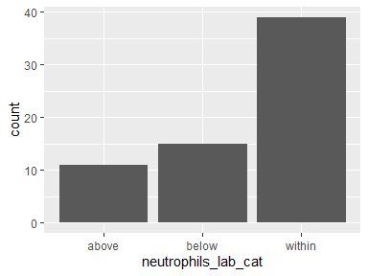
- Observed factor levels: "above", "below", "within".

lymphocytes_lab
Peak Lymphocytes (x10^9/L)
Feature | Result
Variable type | numeric
Number of missing obs. | 2652 (97.64 %)
Number of unique values | 64
Median | 1.28
1st and 3rd quartiles | 0.72; 2.08
Min. and max. | 0.26; 5.91
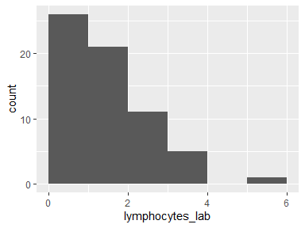

lymphocytes_lab_cat
Above, within, or below range according to reference standards
Feature | Result
Variable type | factor
Number of missing obs. | 2652 (97.64 %)
Number of unique values | 3
Mode | “within”
Reference category | above
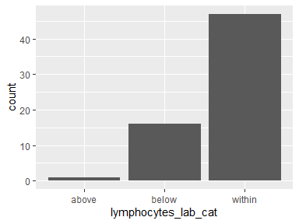
- Observed factor levels: "above", "below", "within".

platelets_lab
Peak platelets (cellsx10^9/L)
Feature | Result
Variable type | numeric
Number of missing obs. | 2603 (95.84 %)
Number of unique values | 101
Median | 224
1st and 3rd quartiles | 160; 273
Min. and max. | 52; 456
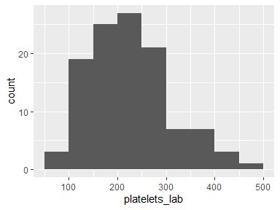

platelets_lab_cat
Above, within, or below range according to reference standards
Feature | Result
Variable type | character
Number of missing obs. | 2602 (95.8 %)
Number of unique values | 3
Mode | “within”
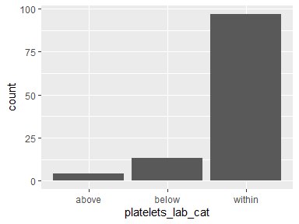
- Observed factor levels: "above", "below", "within".

crp_lab
Peak CRP (cells mg/L)
Feature | Result
Variable type | numeric
Number of missing obs. | 2689 (99.01 %)
Number of unique values | 25
Median | 1.18
1st and 3rd quartiles | 0.43; 2.69
Min. and max. | 0.11; 20.54
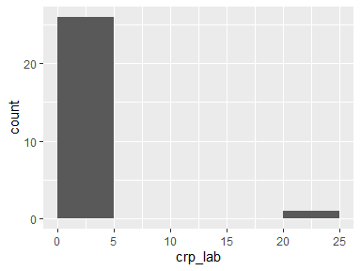

crp_lab_cat
Above, within, or below range according to reference standards
Feature | Result
Variable type | factor
Number of missing obs. | 2689 (99.01 %)
Number of unique values | 2
Mode | “within”
Reference category | above
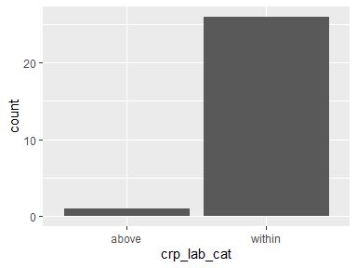
- Observed factor levels: "above", "within".

esr_lab
Peak ESR (mm/h)
Feature | Result
Variable type | numeric
Number of missing obs. | 2689 (99.01 %)
Number of unique values | 13
Median | 20
1st and 3rd quartiles | 10; 26
Min. and max. | 2; 70
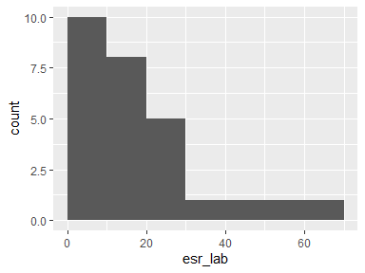

esr_lab_cat
Above, within, or below range according to reference standards
Feature | Result
Variable type | factor
Number of missing obs. | 2689 (99.01 %)
Number of unique values | 2
Mode | “within”
Reference category | above
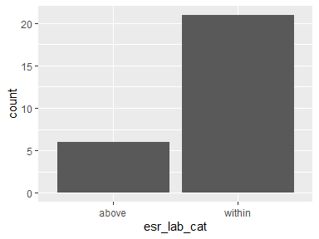
- Observed factor levels: "above", "within".

creatinine_lab
Peak creatinine (umol/L)
Feature | Result
Variable type | numeric
Number of missing obs. | 2660 (97.94 %)
Number of unique values | 31
Median | 77.79
1st and 3rd quartiles | 61.88; 91.27
Min. and max. | 17.68; 118.46
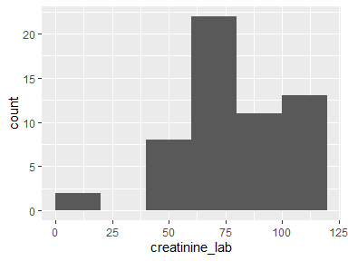

creatinine_lab_cat
Above, within, or below range according to reference standards
Feature | Result
Variable type | factor
Number of missing obs. | 2660 (97.94 %)
Number of unique values | 3
Mode | “within”
Reference category | above
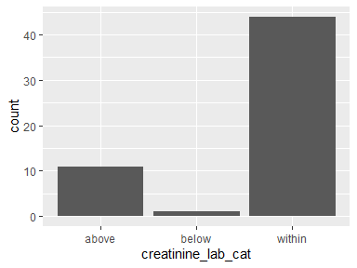
- Observed factor levels: "above", "below", "within".

bilirubin_lab
Peak bilirubin (umol/L)
Feature | Result
Variable type | numeric
Number of missing obs. | 2689 (99.01 %)
Number of unique values | 21
Median | 0.38
1st and 3rd quartiles | 0.29; 0.43
Min. and max. | 0.2; 1.33
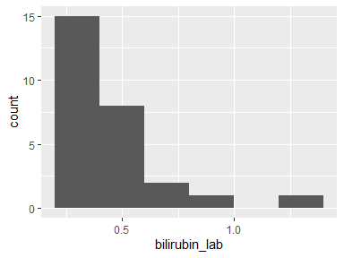

bilirubin_lab_cat
Above, within, or below range according to reference standards
Feature | Result
Variable type | factor
Number of missing obs. | 2689 (99.01 %)
Number of unique values | 2
Mode | “within”
Reference category | above
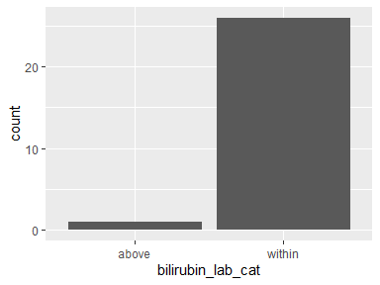
- Observed factor levels: "above", "within".

alt_lab
Peak ALT (IU/L)
Feature | Result
Variable type | numeric
Number of missing obs. | 2627 (96.72 %)
Number of unique values | 65
Median | 47
1st and 3rd quartiles | 27; 79
Min. and max. | 10; 324
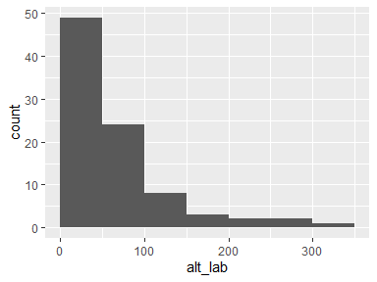

alt_lab_cat
Above, within, or below range according to reference standards
Feature | Result
Variable type | factor
Number of missing obs. | 2627 (96.72 %)
Number of unique values | 2
Mode | “above”
Reference category | above
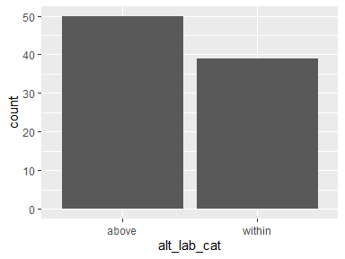
- Observed factor levels: "above", "within".

ast_lab
Peak AST (IU/L)
Feature | Result
Variable type | numeric
Number of missing obs. | 2630 (96.83 %)
Number of unique values | 56
Median | 44.5
1st and 3rd quartiles | 24; 75
Min. and max. | 11; 775
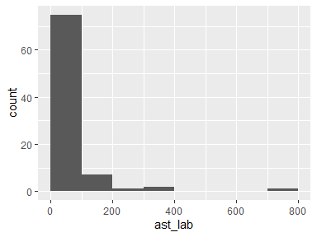

ast_lab_cat
Above, within, or below range according to reference standards
Feature | Result
Variable type | factor
Number of missing obs. | 2630 (96.83 %)
Number of unique values | 2
Mode | “above”
Reference category | above
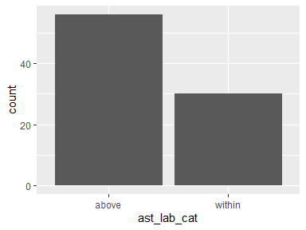
- Observed factor levels: "above", "within".

normal_lab_values
NA
- The variable only takes one value: "NA".

alt_lab_elevated
ALT above range (yes/no)
Feature | Result
Variable type | character
Number of missing obs. | 2627 (96.72 %)
Number of unique values | 2
Mode | “Yes”
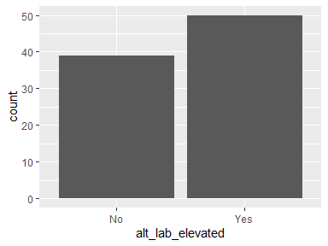
- Observed factor levels: "No", "Yes".

haematocrit_lab_elevated
Haematocrit above range (yes/no)
Feature | Result
Variable type | character
Number of missing obs. | 2618 (96.39 %)
Number of unique values | 2
Mode | “No”
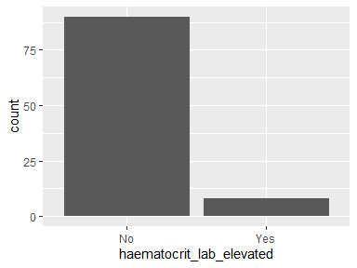
- Observed factor levels: "No", "Yes".

platelets_lab_low
platelets below normal range
Feature | Result
Variable type | character
Number of missing obs. | 2602 (95.8 %)
Number of unique values | 2
Mode | “No”
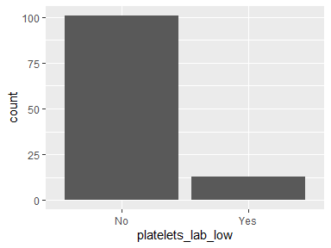
- Observed factor levels: "No", "Yes".

creatinine_lab_elevated
Creatinine above range (yes/no)
Feature | Result
Variable type | character
Number of missing obs. | 2660 (97.94 %)
Number of unique values | 2
Mode | “No”
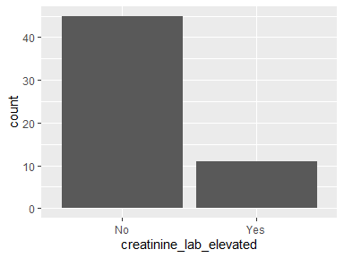
- Observed factor levels: "No", "Yes".

lymphocytes_lab_low
lymphocytes above range (yes/no)
Feature | Result
Variable type | character
Number of missing obs. | 2652 (97.64 %)
Number of unique values | 2
Mode | “No”
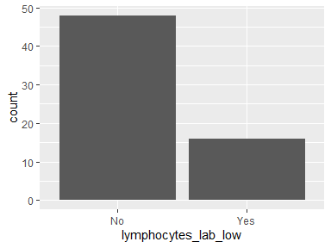
- Observed factor levels: "No", "Yes".

Report generation information:
- Created by: fiovialard (username: fvialard).
- Report creation time: ju. oct. 01 2026 18:48:26
- Report was run from directory: C:/Users/fvialard/Documents/orov_out
- dataMaid v1.4.2 [Pkg: 2025-04-13 from standard (@1.4.2)]
- R version 4.4.3 (2025-02-28 ucrt).
- Platform: x86_64-w64-mingw32/x64(Europe/Madrid).
- Function call: dataMaid::makeDataReport(data = orov_clean, mode = c("summarize", "visualize", "check"), smartNum = FALSE, file = "C:/Users/fvialard/Documents/orov_out/1_data/01_dict/orov_out_codebook.Rmd", replace = TRUE, checks = list(character = "showAllFactorLevels", factor = "showAllFactorLevels", labelled = "showAllFactorLevels", haven_labelled = "showAllFactorLevels", numeric = NULL, integer = NULL, logical = NULL, Date = NULL), listChecks = FALSE, maxProbVals = Inf, codebook = TRUE, reportTitle = "Codebook for orov_clean", tile = "OROV-OUT master database")

