吉林大学

WebSphere实验报告

班级：8
姓名：张天浩
学号：55190828

姓名 | 张天浩 | 学号 | 55190828
实验项目 | 1. Simple Registration Servlet
实验性质 | □演示性实验 □验证性实验  ☑操作性实验 □综合性实验
实验地点 |  | 机器编号
指导教师 | 吴静 | 实验时间 | 2022年9月5日
一、实验综述
1. 实验目的及要求
In this exercise you build and test a simple servlet using Rational Application Developer. This servlet creates a simple document and returns it to the client’s Web browser. The document confirms that a new library patron has been created and displays the patron id. This servlet is used by librarians registering a new patron. At the end of the lab, you should be able to:
• Create an enterprise application project and a Web project using Application Developer
• Create a servlet using Application Developer
• Test the servlet within Application Developer, using the WebSphere Application Server test environment
• Use a Web browser to invoke the servlet
2. 实验设备、软件
PC, windows XP Professional, RAD v7.0
二、实验过程（实验步骤、记录、数据、分析）
Section 1 - Create Enterprise Application and Web Projects
1. Start Rational Application Developer, if it is not already running.
And change the workspace to C:\LabFiles70\ServletJSP\workspace.
Show your work below by printing screen.

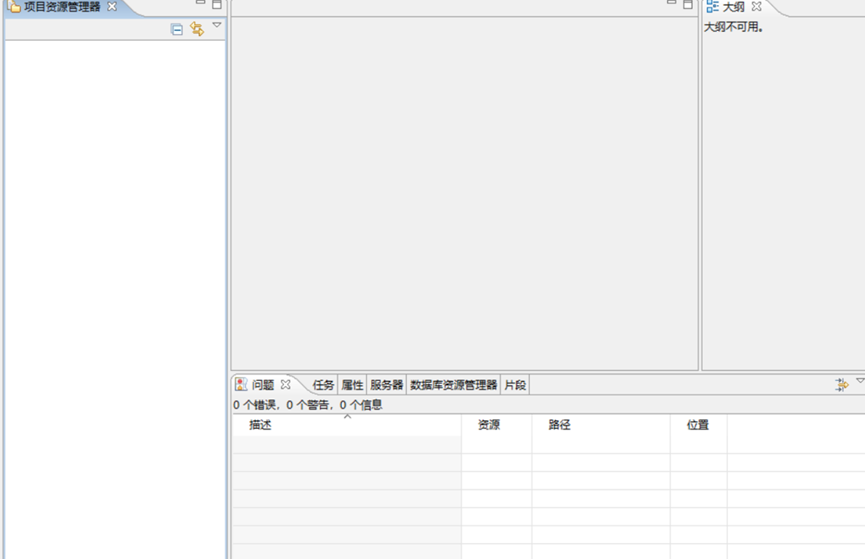
2. From the J2EE Perspective, create a new Enterprise Application called LibraryEnterpriseApplication. Create a J2EE 1.4 enterprise application that is deployed to WebSphere Application Server v6.1. The enterprise application includes a Web module called LibraryWebProject.
Show your work below by printing screen.
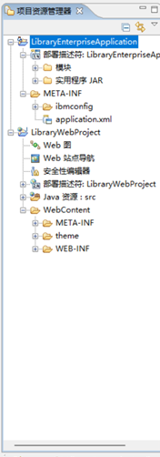
3. Examine the Project Explorer view.
Show your work below by printing screen.

Section 2 - Creating the RegisterPatron Servlet
1. If you selected “Yes” in the perspective switch dialog in the previous step, the Web perspective should already be opened. Otherwise, switch to the Web perspective before you continue.
2. Create a new Java package in the LibraryWebProject called com.ibm.library.servlets.
Show your work below by printing screen.
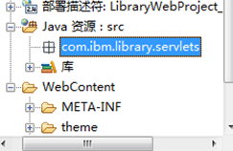

3. In the Wizards field, type pack. This is a quick way of drilling down to a specific wizard. As you type, matches appear below. Select Java -> Package. Note that you can click the clear button beside the Wizards text field to make the wizards reappear. You can also select the Show All Wizards to make all of the wizards to appear. Click Next.
Show your work below by printing screen.
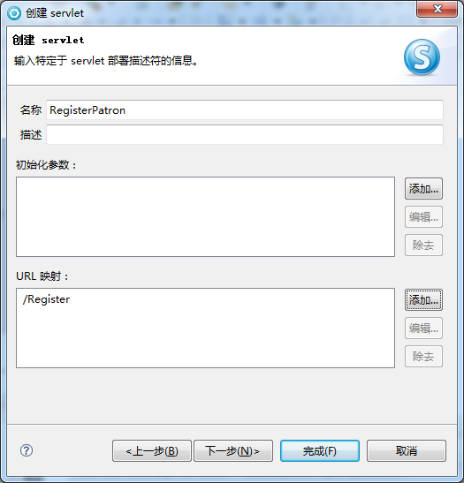

4. Create a new servlet, RegisterPatron, in the package com.ibm.library.servlets. Your new servlet extends the class javax.servlet.http.HttpServlet and implements the interface javax.servlet.Servlet. Override the doGet() and doPost() methods, and map your servlet to the URL pattern /Register.
Show your work below by printing screen.
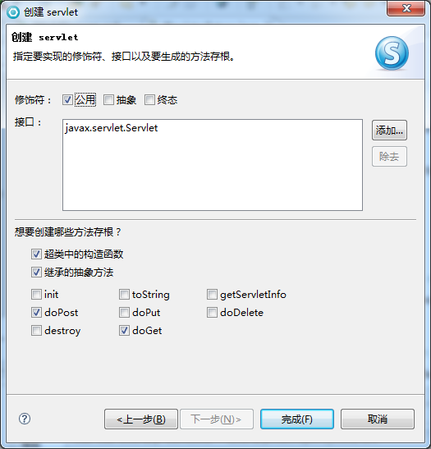

5. You can use Quick Fix to fix the warning that appeared when RegisterPatron servlet was created. This warning appears because the servlet extends javax.servlet.http.HttpServlet implements java.io.Serializable. Java documentation strongly suggests adding a Serial Version UID to a class whenever it implements Serializable.
Show your work below by printing screen.
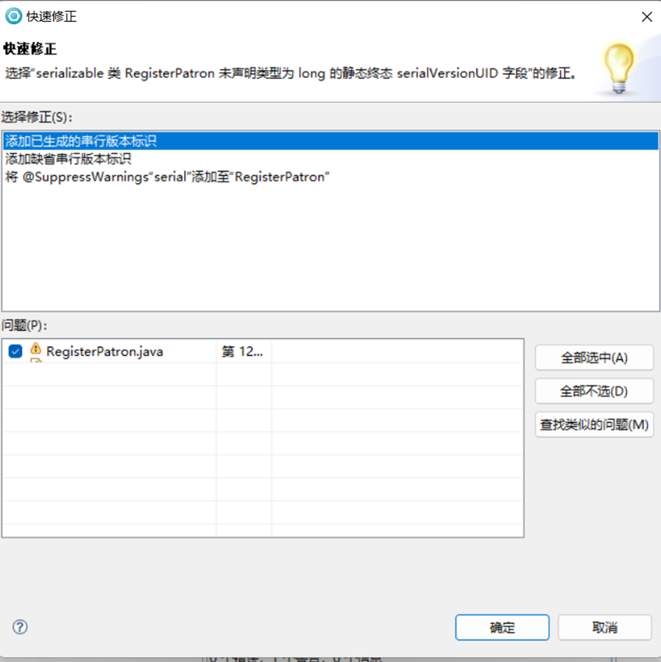
6. Review the deployment descriptor for LibraryWebProject.
Show your work below by printing screen.
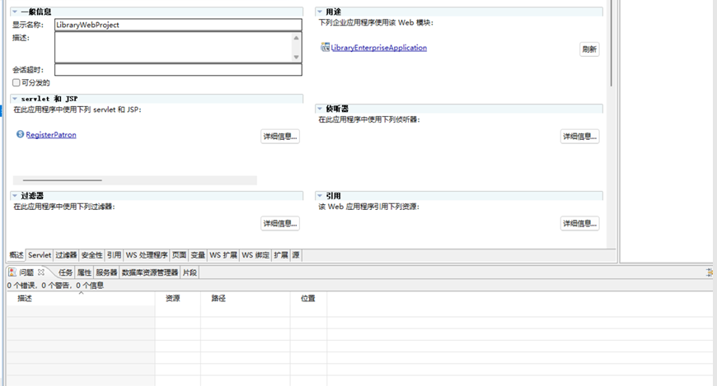

Section 3 - Adding the Logic to the RegisterPatron Servlet
1. In the Project Explorer view, navigate to LibraryWebProject -> Java Resources: src -> com.ibm.library.servlets and double-click RegisterPatron.java to open the file in the Java editor.
2. Select the Outline view tab in the lower-left frame of the workbench, or open the view by selecting Window -> Show View -> Outline.
3. Complete the implementation of the RegisterPatron Servlet. The doGet() and doPost() methods both call the processRequest() method. Thus POST and GET requests go to the same method.
Show your work below by printing screen.
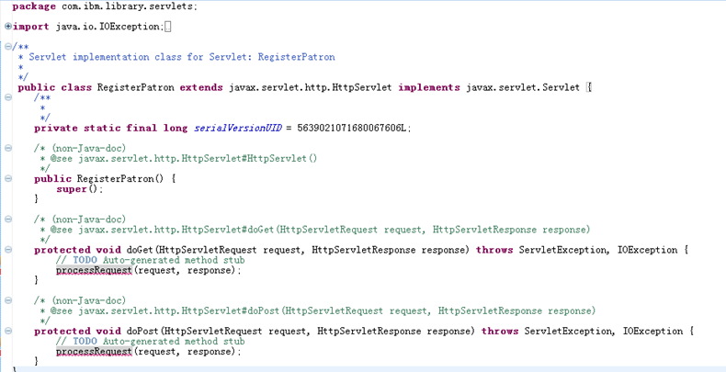

4. Use the Quick Fix option to resolve the errors related to the missing
processRequest() method.
Show your work below by printing screen.
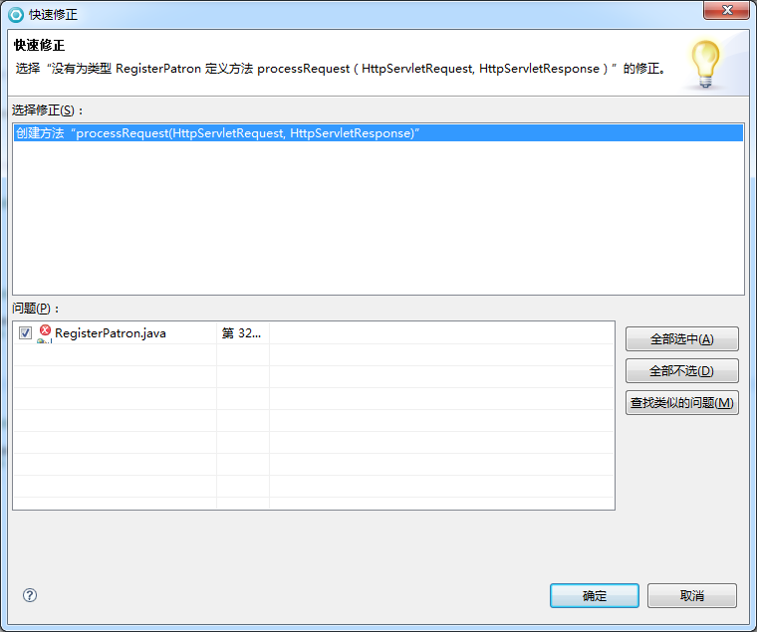

5. Implement the processRequest() method. The method uses a PrintWriter object from the HttpServletResponse parameter to display a patron ID of type int generated by LibraryIdGenerator.generateId(). The LibraryIdGenerator class does not exist yet. You create this class later. After a patron ID has been generated, the servlet outputs HTML to display a message to the librarian that the patron has been added with the new ID. Once you have finished this step, you should only have one error in your servlet. It indicates that LibraryIdGenerator cannot be resolved.
Show your work below by printing screen.

Section 4 - Creating the LibraryIdGenerator Class and generateId() Method
1. Create a new class, LibraryIdGenerator, in package com.ibm.library.servlets.
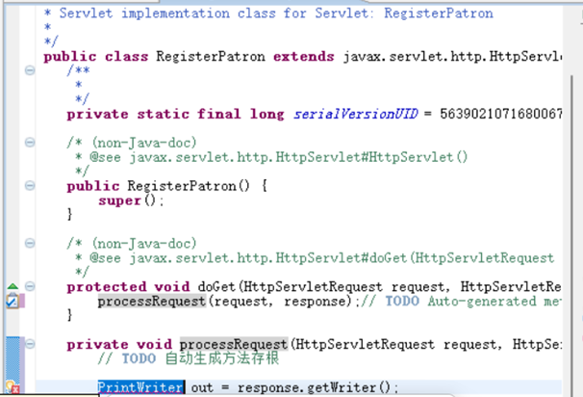

2. Create the public static method generateId() in the LibraryIdGenerator class. The generateId() method returns a value of type int. For now, it should return a value of zero.
Show your work below by printing screen.
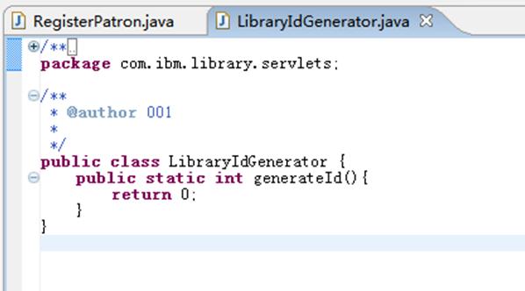

Section 5 - Testing the Servlet
1. Run the RegisterPatron servlet by running RegisterPatron.java on the server. Make the server the default server for the RegisterPatron servlet. This stops Application Developer from prompting you for the server to run on.
Show your work below by printing screen.
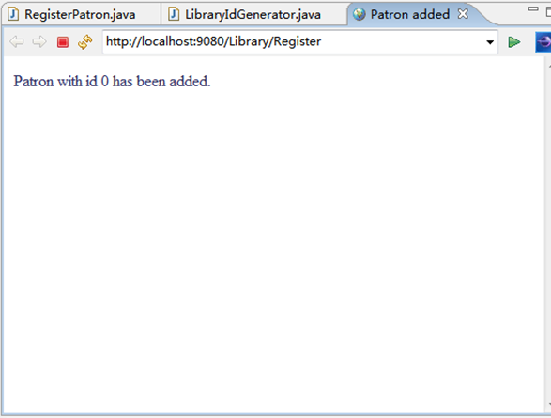

Section 6 - Update the LibraryIdGenerator.generateId() Method
1. Update the generateId() method in the LibraryIdGenerator class to generate a positive integer value greater than 0. In subsequent exercises, you modify this so that you get a value from a database. For now, you simply generate a random value.
Show your work below by printing screen.
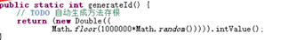

Section 7 - Test the RegisterPatron Servlet with the Updated generateId Method
1. Test the servlet with the new generateId() method implementation.
Show your work below by printing screen.

2. Optional: Try to access the servlet from a separate Web browser such as Internet Explorer or Mozilla Firefox. The URL for the servlet is: http://localhost:9080/Library/Register
3. Close any editor windows and Web browsers.

