## [end-user] Infrastructure/Organization/Front office desk

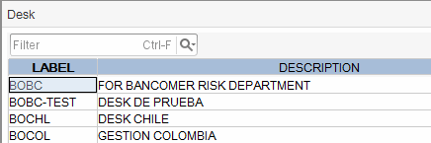

Table: TRN_DSKD_DBF

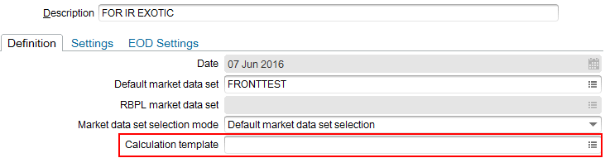

: TRN_DSKD_DBF.M_CALCCYCLE 🡪 MRKP_FRM_DBF.M_CFGLABEL

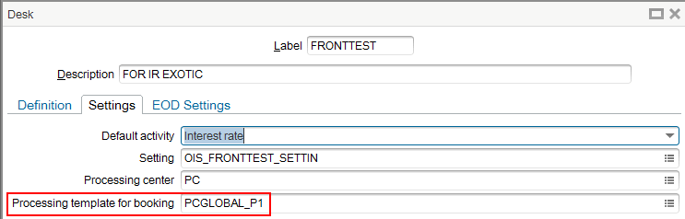

: TRN_DSKD_DBF.M_STP_TPL 🡪 WF_TPL_DBF.M_REFERENCE

## [end-user] Pricing/e-Tradepad

### Product classification

|  |  |
| --- | --- |
|  | The classification tree is exported with object ‘Pattern classification’ |

### Folders

|  |  |
| --- | --- |
| cid:image001.png@01D1FA03.82786830 | This classification is stored in NPD_HDR_DBF and NPD_BDY_DBF.  Those objects should be exported with:   * MX.End-user.Pricing.e-Tradepad.Notepad (CM.476) * MX.End-user.Pricing.e-Tradepad.Public strategy (CM.97) |

The e-Tradepad configuration is stored per user in table EBX_BOX_DBF. This configuration is private.

One one to speed-up its configuration is to open a session with /EBOX_SAFE, open e-Tradepad and hide the panel we don’t want to load.

## [Config] Infrastructure/FO Desk/Calculation templates

Calculation and pricing sequence are defined in this screen under Calculation/Trade/Tasks/Config (see left)

Those objects are exported withCM.368 (workflows) with filter processingTemplate=’_CALCCYCLE_’ on the items

|  |  |
| --- | --- |
|  |  |

|  |  |
| --- | --- |
| The booking sequence is exported with CM.368 (workflows) with filter  processingTemplate=’PCGLOBAL_P1’ and workflowCode=’Pretrade’ on the items |  |