1. **Hasil observasi dan dokumentasi pada polres kabupaten gorontalo**

Berdasarkan hasil yang didapatkan langsung di lokasi penelitian dapat disimpulkan sebagai berikut:

* Tidak adanya sistem yang digunakan dalam pemetaan daerah rawan kecelakaan
* data yang ada hanya berupa hasil dokumentasi data laka lantas yang berisi TOTAL LAKA, Korban Meninggal Dunia, Luka Berat dan Luka Ringan dari tiap desa dan kecamatan di kabupaten Gorontalo

dari hasil dokumentasi di dapatkan data sebagai berikut:

|  |  |  |  |  |
| --- | --- | --- | --- | --- |
| **alamat** | **TOTAL LAKA** | **MD** | **LB** | **LR** |
| DESA BALAHU | 1 | 0 | 0 | 2 |
| DESA BILUHU TIMUR | 1 | 0 | 0 | 1 |
| DESA BUA | 1 | 0 | 0 | 2 |
| DESA BUKIT AREN | 2 | 0 | 0 | 2 |
| DESA DATAHU | 3 | 1 | 0 | 6 |
| DESA HUIDU | 2 | 2 | 0 | 4 |
| DESA ILOTIDEA | 1 | 0 | 1 | 0 |
| DESA LAWONO | 1 | 1 | 0 | 0 |
| DESA MOLOHU | 1 | 0 | 1 | 1 |
| DESA OLIMOO'O | 1 | 1 | 0 | 0 |
| DESA PANTUNGO | 8 | 5 | 0 | 4 |
| DESA TIMUATO | 2 | 1 | 0 | 3 |
| DESA. AMBARA | 1 | 1 | 0 | 0 |
| DESA. BALAHU | 3 | 3 | 0 | 3 |
| DESA. BILATO | 1 | 0 | 1 | 2 |
| DESA. BILUHU | 2 | 2 | 0 | 4 |
| DESA. BONGOMEME | 1 | 0 | 0 | 1 |
| DESA. BOTUBOLUWE | 1 | 0 | 1 | 0 |
| DESA. BUHU | 4 | 1 | 0 | 6 |
| DESA. BULILA | 2 | 1 | 1 | 2 |
| DESA. BULULI | 1 | 0 | 1 | 1 |
| DESA. DILONIYOHU | 2 | 0 | 2 | 2 |
| DESA. DULOHUPA | 1 | 0 | 0 | 1 |
| DESA. DUMATI | 4 | 1 | 3 | 6 |
| DESA. DUNGALIYO | 2 | 1 | 0 | 3 |
| DESA. DUTULANAA | 4 | 0 | 1 | 3 |
| DESA. DUWANGA | 1 | 1 | 0 | 1 |
| DESA. GANDARIA | 1 | 0 | 0 | 2 |
| DESA. GANDASARI | 1 | 0 | 1 | 1 |
| DESA. HAYA-HAYA | 3 | 3 | 0 | 2 |
| DESA. HUIDU | 1 | 0 | 0 | 2 |
| DESA. ILOMANGGA | 2 | 2 | 0 | 4 |
| DESA. KALIYOSO | 2 | 1 | 1 | 1 |
| DESA. KARYA BARU | 1 | 0 | 1 | 0 |
| DESA. LAKEYA | 1 | 0 | 0 | 1 |
| DESA. LAWONO | 0 | 0 | 0 | 0 |
| DESA. LIMEHE TIMUR | 2 | 1 | 1 | 4 |
| DESA. MARGOMULYO | 1 | 1 | 0 | 2 |
| DESA. MOHIYOLO | 1 | 0 | 0 | 2 |
| DESA. MONGGOLITO | 1 | 1 | 0 | 1 |
| DESA. MONGOLATO | 5 | 3 | 0 | 9 |
| DESA. PADENGO | 9 | 0 | 4 | 13 |
| DESA. PANGADAA | 1 | 0 | 0 | 2 |
| DESA. PANGADAA | 1 | 0 | 0 | 2 |
| DESA. PARIS | 3 | 1 | 2 | 6 |
| DESA. PARUNGI | 3 | 0 | 2 | 4 |
| DESA. PATUNGO | 3 | 0 | 0 | 5 |
| DESA. PAYANGO | 1 | 1 | 0 | 0 |
| DESA. PILOBUHUTA | 1 | 0 | 0 | 2 |
| DESA. PILOHAYANGA | 5 | 5 | 0 | 1 |
| DESA. PONE | 5 | 4 | 0 | 3 |
| DESA. PONGONGAILA | 5 | 5 | 0 | 8 |
| DESA. REKSONEGORO | 1 | 0 | 1 | 2 |
| DESA. SATRIA | 1 | 0 | 0 | 1 |
| DESA. SIDOMUKTI | 1 | 0 | 1 | 2 |
| DESA. SUKA DAMAI | 2 | 0 | 1 | 4 |
| DESA. SUKA MAKMUR | 1 | 0 | 0 | 1 |
| DESA. TABONGGO TIMUR | 1 | 0 | 0 | 2 |
| DESA. TABONGO BARAT | 1 | 0 | 0 | 1 |
| DESA. TABONGO TIMUR | 1 | 0 | 0 | 1 |
| DESA. TALUMELITO | 1 | 0 | 0 | 1 |
| DESA. TILOTE | 1 | 0 | 0 | 1 |
| DESA. TINELO | 2 | 0 | 2 | 3 |
| DESA. TIOHU | 1 | 0 | 0 | 2 |
| DESA. YOSONEGORO | 7 | 0 | 7 | 12 |
| KEL TENILO | 1 | 0 | 0 | 1 |
| KEL. BAKTI | 3 | 0 | 3 | 2 |
| KEL. BIYONGA | 2 | 0 | 1 | 4 |
| KEL. BOLIHUANGGA | 2 | 0 | 0 | 4 |
| KEL. BOTUMOPUTI | 2 | 0 | 2 | 0 |
| KEL. HEPUHULAWA | 5 | 0 | 3 | 7 |
| KEL. HULAWA | 8 | 0 | 0 | 11 |
| KEL. HUNGGALUWA | 10 | 0 | 0 | 17 |
| KEL. HUTABOHU | 1 | 0 | 0 | 1 |
| KEL. HUTUDAA | 1 | 0 | 0 | 1 |
| KEL. HUTUO | 8 | 0 | 0 | 16 |
| KEL. ILOPONU | 6 | 0 | 0 | 11 |
| KEL. ILOTIDEA | 1 | 0 | 0 | 1 |
| KEL. ILUTA | 4 | 0 | 0 | 7 |
| KEL. ISIMU RAYA | 2 | 0 | 0 | 3 |
| KEL. ISIMU SELATAN | 3 | 0 | 0 | 6 |
| KEL. KAYUBULAN | 12 | 0 | 0 | 16 |
| KEL. KAYUMERAH | 1 | 0 | 0 | 2 |
| KEL. LABANU | 4 | 0 | 0 | 5 |
| KEL. LAMAHU | 3 | 0 | 0 | 4 |
| KEL. LUHU | 10 | 0 | 0 | 18 |
| KEL. LUPOYO | 1 | 0 | 0 | 1 |
| KEL. MOAHUDU | 1 | 0 | 0 | 1 |
| KEL. MOLAMAHU | 3 | 0 | 0 | 4 |
| KEL. MULYONEGORO | 3 | 0 | 0 | 4 |
| KEL. OMBULO | 8 | 0 | 0 | 11 |
| KEL. OTOPADE | 1 | 0 | 0 | 2 |
| KEL. PANGADAA | 1 | 0 | 0 | 1 |
| KEL. PAYUNGA | 1 | 0 | 0 | 2 |
| KEL. PENTADIO BARAT | 4 | 0 | 0 | 6 |
| KEL. PENTADIO TIMUR | 8 | 0 | 0 | 9 |
| KEL. PILOLALENGA | 1 | 0 | 0 | 1 |
| KEL. PULUBALA | 5 | 0 | 0 | 6 |
| KEL. SIDOHARJO | 1 | 0 | 0 | 2 |
| KEL. TENGGELA | 2 | 0 | 0 | 3 |
| KEL. TENILO | 1 | 0 | 0 | 2 |
| KEL. TILIHUWA | 1 | 0 | 0 | 2 |
| KEL. TIMUATO | 4 | 0 | 0 | 6 |
| KEL. TINELO | 1 | 0 | 0 | 1 |
| KEL. TOLOTIO | 2 | 0 | 0 | 4 |
| KEL. TRIDARMA | 4 | 0 | 0 | 5 |
| KEL. TULADENGGI | 7 | 0 | 0 | 11 |
| KEL. TUNGGULO | 7 | 0 | 0 | 13 |
| KEL. ULAPATO | 9 | 0 | 0 | 9 |
| KEL. ULAPATO A | 1 | 0 | 0 | 2 |
| KEL. ULAPATO B | 1 | 0 | 0 | 2 |

dari data yang di kumpulkan periode 2023 dan 2024, didaptkan berupa total jumlah kasus kecelakaan dari tahun 2023 sampai dengan 2024 (september) yaitu 301 total kecelakaan, dengan korban kecelakaan Meninggal dunia 50 Korban, Luka Berat 45 Korban, Luka Ringan 417 Korban

1. **Percobaan Dengan program Python**

Dengan data yang telah didapatkan dilakukan uji coba untuk mengetahui apakah algoritma fuzzy c-means dapat di gunakan untuk cluster pengelompokkan data dengan menggunakan program python

1. **Program yang digunakan**

from sklearn.metrics import silhouette_samples

import pandas as pd

import numpy as np

from sklearn.preprocessing import StandardScaler

from skfuzzy import cmeans

from sklearn.metrics import silhouette_score

import matplotlib.pyplot as plt

plt.rcParams['font.sans-serif'] = ['Arial Unicode MS']

# Membaca file Excel

df = pd.read_excel('lakalantas2023-2024_distributed.xlsx')

# Menyiapkan fitur untuk klasterisasi

feature_columns = ['TOTAL LAKA', 'MD', 'LB', 'LR']

features = df[feature_columns].values

# Normalisasi fitur

scaler = StandardScaler()

normalized_features = scaler.fit_transform(features)

# Klasterisasi Fuzzy C-Means

n_clusters = 3

cntr, u, u0, d, jm, p, fpc = cmeans(

    normalized_features.T, n_clusters, 2, *error*=0.001, *maxiter*=1000)

cluster_labels = np.argmax(u, *axis*=0)

df['Klaster'] = cluster_labels

for i in range(n_clusters):

    df[*f*'DKK_{i}'] = u[i]

cluster_centers = scaler.inverse_transform(cntr)

risk_order = np.argsort(cluster_centers.sum(*axis*=1))

risk_levels = {risk_order[0]: 'Aman', risk_order[1]               : 'Cukup Rawan', risk_order[2]: 'Rawan'}

df['Tingkat_Risiko'] = df['Klaster'].map(risk_levels)

df_sorted = df.sort_values(['Klaster', 'TOTAL LAKA'], *ascending*=[True, False])

# Menghitung Silhouette Score

silhouette_avg = silhouette_score(normalized_features, cluster_labels)

print(*f*'Silhouette Score: {silhouette_avg*:.4f*}')

# Visualisasi Kluster

plt.figure(*figsize*=(15, 10))

scatter = plt.scatter(df['TOTAL LAKA'], df['MD'],

*c*=df['Klaster'], *cmap*='viridis', *s*=50)

plt.xlabel('Total Kecelakaan')

plt.ylabel('Korban Meninggal')

plt.title('Klasterisasi Fuzzy C-Means Data Kecelakaan')

# Plot pusat klaster

for i, center in enumerate(cluster_centers):

    plt.scatter(center[0], center[1], *c*='red', *marker*='x',

*s*=200, *linewidths*=3, *label*=*f*'Pusat Klaster {i}')

cbar = plt.colorbar(scatter)

cbar.set_label('Klaster')

plt.legend()

plt.tight_layout()

plt.show()

# Plot derajat keanggotaan

plt.figure(*figsize*=(15, 6))

for i in range(n_clusters):

    plt.plot(range(len(df)),

             df[*f*'DKK_{i}'], *label*=*f*'Klaster {i}')

plt.xlabel('Titik Data')

plt.ylabel('Derajat Keanggotaan')

plt.title('Derajat Keanggotaan Fuzzy C-Means')

plt.legend()

plt.tight_layout()

plt.show()

# Visualisasi Silhouette per titik data

sample_silhouette_values = silhouette_samples(

    normalized_features, cluster_labels)

plt.figure(*figsize*=(10, 6))

y_lower = 10

for i in range(n_clusters):

    ith_cluster_silhouette_values = sample_silhouette_values[cluster_labels == i]

    ith_cluster_silhouette_values.sort()

    size_cluster_i = ith_cluster_silhouette_values.shape[0]

    y_upper = y_lower + size_cluster_i

    plt.fill_betweenx(np.arange(y_lower, y_upper),

                      0, ith_cluster_silhouette_values)

    plt.text(-0.05, (y_lower + y_upper) / 2, str(i))

    y_lower = y_upper + 10

plt.title('Visualisasi Silhouette per Kluster')

plt.xlabel('Nilai Silhouette')

plt.ylabel('Kluster')

plt.axvline(*x*=silhouette_avg, *color*='red', *linestyle*='--')

plt.show()

output_columns = ['alamat', 'TOTAL LAKA', 'MD', 'LB', 'LR', 'Klaster',

                  'Tingkat_Risiko'] + [*f*'DKK_{i}' for i in range(n_clusters)]

df_output = df_sorted[output_columns]

# Menyimpan hasil ke file Excel baru

with pd.ExcelWriter('hasil_klaster_kecelakaan.xlsx') as writer:

    df_output.to_excel(writer, *sheet_name*='Hasil Klasterisasi', *index*=False)

    pd.DataFrame(cluster_centers, *columns*=feature_columns).to_excel(

        writer, *sheet_name*='Pusat Klaster', *index*=False)

print("Hasil telah disimpan ke 'hasil_klaster_kecelakaan.xlsx'")

**Hasil percobaan menggunakan algoritma fuzzy c-means dengan data yang ada**

|  |  |  |  |  |  |  |  |  |  |
| --- | --- | --- | --- | --- | --- | --- | --- | --- | --- |
| **ALAMAT** | **TOTAL LAKA** | **MD** | **LB** | **LR** | **Klaster** | **Tingkat** | **DKK_0** | **DKK_1** | **DKK_2** |
| LABANU | 4 | 0 | 0 | 5 | 0 | Aman | 0,449992 | 0,149125 | 0,400883 |
| TRIDARMA | 4 | 0 | 0 | 5 | 0 | Aman | 0,449992 | 0,149125 | 0,400883 |
| PATUNGO | 3 | 0 | 0 | 5 | 0 | Aman | 0,565563 | 0,093625 | 0,340812 |
| ISIMU SELATAN | 3 | 0 | 0 | 6 | 0 | Aman | 0,490289 | 0,13008 | 0,379631 |
| LAMAHU | 3 | 0 | 0 | 4 | 0 | Aman | 0,650688 | 0,066197 | 0,283115 |
| MOLAMAHU | 3 | 0 | 0 | 4 | 0 | Aman | 0,650688 | 0,066197 | 0,283115 |
| MULYONEGORO | 3 | 0 | 0 | 4 | 0 | Aman | 0,650688 | 0,066197 | 0,283115 |
| BUKIT AREN | 2 | 0 | 0 | 2 | 0 | Aman | 0,940728 | 0,009486 | 0,049786 |
| DILONIYOHU | 2 | 0 | 2 | 2 | 0 | Aman | 0,453339 | 0,105263 | 0,441397 |
| SUKA DAMAI | 2 | 0 | 1 | 4 | 0 | Aman | 0,564509 | 0,060776 | 0,374715 |
| BIYONGA | 2 | 0 | 1 | 4 | 0 | Aman | 0,564509 | 0,060776 | 0,374715 |
| BOLIHUANGGA | 2 | 0 | 0 | 4 | 0 | Aman | 0,794946 | 0,035396 | 0,169658 |
| BOTUMOPUTI | 2 | 0 | 2 | 0 | 0 | Aman | 0,48692 | 0,100832 | 0,412248 |
| ISIMU RAYA | 2 | 0 | 0 | 3 | 0 | Aman | 0,892217 | 0,017497 | 0,090286 |
| TENGGELA | 2 | 0 | 0 | 3 | 0 | Aman | 0,892217 | 0,017497 | 0,090286 |
| TOLOTIO | 2 | 0 | 0 | 4 | 0 | Aman | 0,794946 | 0,035396 | 0,169658 |
| BALAHU | 1 | 0 | 0 | 2 | 0 | Aman | 0,97457 | 0,004182 | 0,021248 |
| BILUHU TIMUR | 1 | 0 | 0 | 1 | 0 | Aman | 0,962762 | 0,006227 | 0,031011 |
| BUA | 1 | 0 | 0 | 2 | 0 | Aman | 0,97457 | 0,004182 | 0,021248 |
| ILOTIDEA | 1 | 0 | 1 | 0 | 0 | Aman | 0,742075 | 0,039894 | 0,218031 |
| LAWONO | 1 | 1 | 0 | 0 | 0 | Aman | 0,671679 | 0,036934 | 0,291387 |
| MOLOHU | 1 | 0 | 1 | 1 | 0 | Aman | 0,752395 | 0,036205 | 0,2114 |
| OLIMOO'O | 1 | 1 | 0 | 0 | 0 | Aman | 0,671679 | 0,036934 | 0,291387 |
| AMBARA | 1 | 1 | 0 | 0 | 0 | Aman | 0,671679 | 0,036934 | 0,291387 |
| BILATO | 1 | 0 | 1 | 2 | 0 | Aman | 0,739211 | 0,036873 | 0,223916 |
| BONGOMEME | 1 | 0 | 0 | 1 | 0 | Aman | 0,962762 | 0,006227 | 0,031011 |
| BOTUBOLUWE | 1 | 0 | 1 | 0 | 0 | Aman | 0,742075 | 0,039894 | 0,218031 |
| BULULI | 1 | 0 | 1 | 1 | 0 | Aman | 0,752395 | 0,036205 | 0,2114 |
| DULOHUPA | 1 | 0 | 0 | 1 | 0 | Aman | 0,962762 | 0,006227 | 0,031011 |
| DUWANGA | 1 | 1 | 0 | 1 | 0 | Aman | 0,666743 | 0,032997 | 0,30026 |
| GANDARIA | 1 | 0 | 0 | 2 | 0 | Aman | 0,97457 | 0,004182 | 0,021248 |
| GANDASARI | 1 | 0 | 1 | 1 | 0 | Aman | 0,752395 | 0,036205 | 0,2114 |
| HUIDU | 1 | 0 | 0 | 2 | 0 | Aman | 0,97457 | 0,004182 | 0,021248 |
| KARYA BARU | 1 | 0 | 1 | 0 | 0 | Aman | 0,742075 | 0,039894 | 0,218031 |
| LAKEYA | 1 | 0 | 0 | 1 | 0 | Aman | 0,962762 | 0,006227 | 0,031011 |
| MARGOMULYO | 1 | 1 | 0 | 2 | 0 | Aman | 0,63402 | 0,032568 | 0,333412 |
| MOHIYOLO | 1 | 0 | 0 | 2 | 0 | Aman | 0,97457 | 0,004182 | 0,021248 |
| MONGGOLITO | 1 | 1 | 0 | 1 | 0 | Aman | 0,666743 | 0,032997 | 0,30026 |
| PANGADAA | 1 | 0 | 0 | 2 | 0 | Aman | 0,97457 | 0,004182 | 0,021248 |
| PANGADAA | 1 | 0 | 0 | 2 | 0 | Aman | 0,97457 | 0,004182 | 0,021248 |
| PAYANGO | 1 | 1 | 0 | 0 | 0 | Aman | 0,671679 | 0,036934 | 0,291387 |
| PILOBUHUTA | 1 | 0 | 0 | 2 | 0 | Aman | 0,97457 | 0,004182 | 0,021248 |
| REKSONEGORO | 1 | 0 | 1 | 2 | 0 | Aman | 0,739211 | 0,036873 | 0,223916 |
| SATRIA | 1 | 0 | 0 | 1 | 0 | Aman | 0,962762 | 0,006227 | 0,031011 |
| SIDOMUKTI | 1 | 0 | 1 | 2 | 0 | Aman | 0,739211 | 0,036873 | 0,223916 |
| SUKA MAKMUR | 1 | 0 | 0 | 1 | 0 | Aman | 0,962762 | 0,006227 | 0,031011 |
| TABONGGO TIMUR | 1 | 0 | 0 | 2 | 0 | Aman | 0,97457 | 0,004182 | 0,021248 |
| TABONGO BARAT | 1 | 0 | 0 | 1 | 0 | Aman | 0,962762 | 0,006227 | 0,031011 |
| TABONGO TIMUR | 1 | 0 | 0 | 1 | 0 | Aman | 0,962762 | 0,006227 | 0,031011 |
| TALUMELITO | 1 | 0 | 0 | 1 | 0 | Aman | 0,962762 | 0,006227 | 0,031011 |
| TILOTE | 1 | 0 | 0 | 1 | 0 | Aman | 0,962762 | 0,006227 | 0,031011 |
| TIOHU | 1 | 0 | 0 | 2 | 0 | Aman | 0,97457 | 0,004182 | 0,021248 |
| KEL TENILO | 1 | 0 | 0 | 1 | 0 | Aman | 0,962762 | 0,006227 | 0,031011 |
| HUTABOHU | 1 | 0 | 0 | 1 | 0 | Aman | 0,962762 | 0,006227 | 0,031011 |
| HUTUDAA | 1 | 0 | 0 | 1 | 0 | Aman | 0,962762 | 0,006227 | 0,031011 |
| ILOTIDEA | 1 | 0 | 0 | 1 | 0 | Aman | 0,962762 | 0,006227 | 0,031011 |
| KAYUMERAH | 1 | 0 | 0 | 2 | 0 | Aman | 0,97457 | 0,004182 | 0,021248 |
| LUPOYO | 1 | 0 | 0 | 1 | 0 | Aman | 0,962762 | 0,006227 | 0,031011 |
| MOAHUDU | 1 | 0 | 0 | 1 | 0 | Aman | 0,962762 | 0,006227 | 0,031011 |
| OTOPADE | 1 | 0 | 0 | 2 | 0 | Aman | 0,97457 | 0,004182 | 0,021248 |
| PANGADAA | 1 | 0 | 0 | 1 | 0 | Aman | 0,962762 | 0,006227 | 0,031011 |
| PAYUNGA | 1 | 0 | 0 | 2 | 0 | Aman | 0,97457 | 0,004182 | 0,021248 |
| PILOLALENGA | 1 | 0 | 0 | 1 | 0 | Aman | 0,962762 | 0,006227 | 0,031011 |
| SIDOHARJO | 1 | 0 | 0 | 2 | 0 | Aman | 0,97457 | 0,004182 | 0,021248 |
| TENILO | 1 | 0 | 0 | 2 | 0 | Aman | 0,97457 | 0,004182 | 0,021248 |
| TILIHUWA | 1 | 0 | 0 | 2 | 0 | Aman | 0,97457 | 0,004182 | 0,021248 |
| TINELO | 1 | 0 | 0 | 1 | 0 | Aman | 0,962762 | 0,006227 | 0,031011 |
| ULAPATO A | 1 | 0 | 0 | 2 | 0 | Aman | 0,97457 | 0,004182 | 0,021248 |
| ULAPATO B | 1 | 0 | 0 | 2 | 0 | Aman | 0,97457 | 0,004182 | 0,021248 |
| LAWONO | 0 | 0 | 0 | 0 | 0 | Aman | 0,870621 | 0,023836 | 0,105543 |
| KAYUBULAN | 12 | 0 | 0 | 16 | 1 | Rawan | 0,096102 | 0,778927 | 0,124971 |
| HUNGGALUWA | 10 | 0 | 0 | 17 | 1 | Rawan | 0,075874 | 0,824511 | 0,099614 |
| LUHU | 10 | 0 | 0 | 18 | 1 | Rawan | 0,088151 | 0,797141 | 0,114708 |
| PADENGO | 9 | 0 | 4 | 13 | 1 | Rawan | 0,216807 | 0,484475 | 0,298717 |
| ULAPATO | 9 | 0 | 0 | 9 | 1 | Rawan | 0,056199 | 0,865577 | 0,078224 |
| HULAWA | 8 | 0 | 0 | 11 | 1 | Rawan | 0,011651 | 0,971982 | 0,016367 |
| HUTUO | 8 | 0 | 0 | 16 | 1 | Rawan | 0,051831 | 0,878956 | 0,069212 |
| OMBULO | 8 | 0 | 0 | 11 | 1 | Rawan | 0,011651 | 0,971982 | 0,016367 |
| PENTADIO TIMUR | 8 | 0 | 0 | 9 | 1 | Rawan | 0,053204 | 0,871677 | 0,075119 |
| YOSONEGORO | 7 | 0 | 7 | 12 | 1 | Rawan | 0,285875 | 0,365747 | 0,348378 |
| TULADENGGI | 7 | 0 | 0 | 11 | 1 | Rawan | 0,024695 | 0,940476 | 0,034829 |
| TUNGGULO | 7 | 0 | 0 | 13 | 1 | Rawan | 0,021919 | 0,947792 | 0,030289 |
| ILOPONU | 6 | 0 | 0 | 11 | 1 | Rawan | 0,067543 | 0,838029 | 0,094428 |
| PANTUNGO | 8 | 5 | 0 | 4 | 2 | Cukup Rawan | 0,25999 | 0,301065 | 0,438946 |
| MONGOLATO | 5 | 3 | 0 | 9 | 2 | Cukup Rawan | 0,207931 | 0,298214 | 0,493855 |
| PILOHAYANGA | 5 | 5 | 0 | 1 | 2 | Cukup Rawan | 0,290887 | 0,229723 | 0,47939 |
| PONE | 5 | 4 | 0 | 3 | 2 | Cukup Rawan | 0,263921 | 0,21289 | 0,523189 |
| PONGONGAILA | 5 | 5 | 0 | 8 | 2 | Cukup Rawan | 0,257162 | 0,28896 | 0,453879 |
| HEPUHULAWA | 5 | 0 | 3 | 7 | 2 | Cukup Rawan | 0,27498 | 0,314067 | 0,410953 |
| PULUBALA | 5 | 0 | 0 | 6 | 2 | Cukup Rawan | 0,320037 | 0,290584 | 0,389379 |
| BUHU | 4 | 1 | 0 | 6 | 2 | Cukup Rawan | 0,209253 | 0,118428 | 0,672318 |
| DUMATI | 4 | 1 | 3 | 6 | 2 | Cukup Rawan | 0,267644 | 0,230551 | 0,501804 |
| DUTULANAA | 4 | 0 | 1 | 3 | 2 | Cukup Rawan | 0,420985 | 0,100968 | 0,478047 |
| ILUTA | 4 | 0 | 0 | 7 | 2 | Cukup Rawan | 0,350154 | 0,252972 | 0,396874 |
| PENTADIO BARAT | 4 | 0 | 0 | 6 | 2 | Cukup Rawan | 0,397549 | 0,194495 | 0,407956 |
| TIMUATO | 4 | 0 | 0 | 6 | 2 | Cukup Rawan | 0,397549 | 0,194495 | 0,407956 |
| DATAHU | 3 | 1 | 0 | 6 | 2 | Cukup Rawan | 0,231289 | 0,079808 | 0,688903 |
| BALAHU | 3 | 3 | 0 | 3 | 2 | Cukup Rawan | 0,254234 | 0,126536 | 0,61923 |
| HAYA-HAYA | 3 | 3 | 0 | 2 | 2 | Cukup Rawan | 0,268075 | 0,122671 | 0,609254 |
| PARIS | 3 | 1 | 2 | 6 | 2 | Cukup Rawan | 0,231105 | 0,134794 | 0,634101 |
| PARUNGI | 3 | 0 | 2 | 4 | 2 | Cukup Rawan | 0,36999 | 0,140682 | 0,489328 |
| BAKTI | 3 | 0 | 3 | 2 | 2 | Cukup Rawan | 0,3718 | 0,17917 | 0,44903 |
| HUIDU | 2 | 2 | 0 | 4 | 2 | Cukup Rawan | 0,225234 | 0,064291 | 0,710475 |
| TIMUATO | 2 | 1 | 0 | 3 | 2 | Cukup Rawan | 0,439293 | 0,034892 | 0,525814 |
| BILUHU | 2 | 2 | 0 | 4 | 2 | Cukup Rawan | 0,225234 | 0,064291 | 0,710475 |
| BULILA | 2 | 1 | 1 | 2 | 2 | Cukup Rawan | 0,273152 | 0,030868 | 0,695979 |
| DUNGALIYO | 2 | 1 | 0 | 3 | 2 | Cukup Rawan | 0,439293 | 0,034892 | 0,525814 |
| ILOMANGGA | 2 | 2 | 0 | 4 | 2 | Cukup Rawan | 0,225234 | 0,064291 | 0,710475 |
| KALIYOSO | 2 | 1 | 1 | 1 | 2 | Cukup Rawan | 0,360008 | 0,037858 | 0,602134 |
| LIMEHE TIMUR | 2 | 1 | 1 | 4 | 2 | Cukup Rawan | 0,146294 | 0,024306 | 0,829401 |
| TINELO | 2 | 0 | 2 | 3 | 2 | Cukup Rawan | 0,431715 | 0,11193 | 0,456355 |

*DKK_ = Derajat keanggotaan klaster*

1. **Pusat Cluster**

|  |  |  |  |  |
| --- | --- | --- | --- | --- |
| **CLUSTER** | **PUSAT CLUSTER (V)** | | | |
| **TOTAL LAKA** | **MD** | **LB** | **LR** |
| V1 | 2,997361922 | 1,24531 | 0,682331 | 4,018041 |
| V2 | 7,904504794 | 0,180976 | 0,260767 | 11,89317 |
| V3 | 1,309318614 | 0,11489 | 0,173565 | 1,802823 |

**Derajat Keanggotaan (visualisasi)**

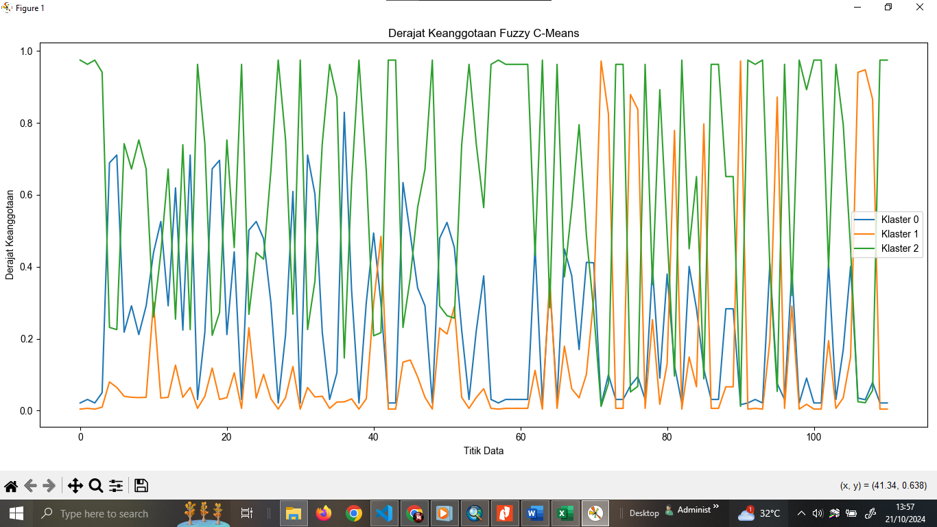

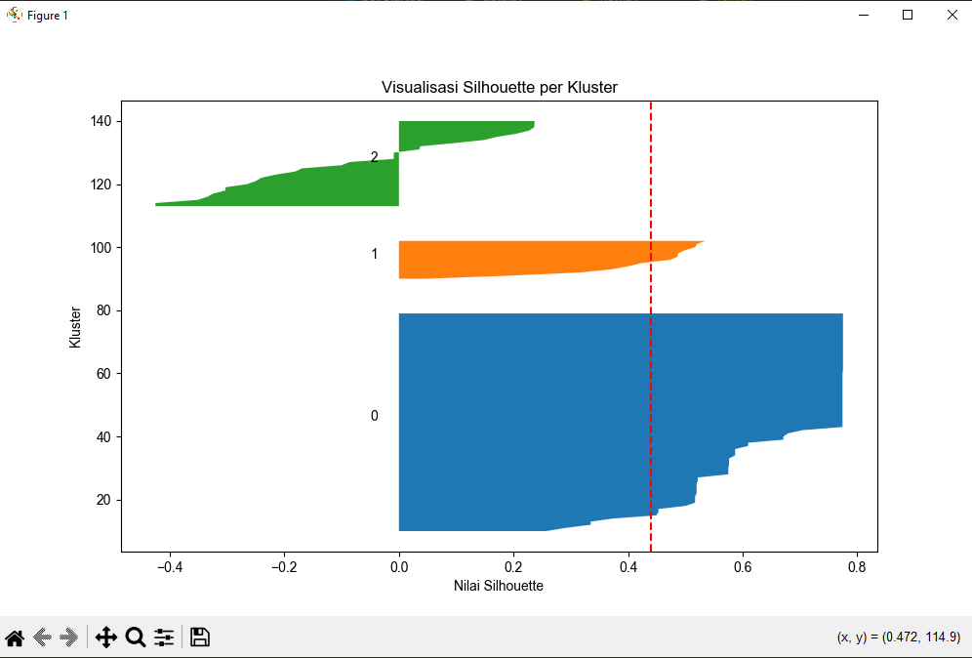

nilai silhoutte score yaitu: **0.440**