**VISVESVARAYA TECHNOLOGICAL UNIVERSITY**

**Jnana Sangama, Belgaum-590018**



**A Cryptography, Network Security and Cyber Law Mini Project Report**

**on**

**“Image Steganography”**

**Submitted in Partial fulfillment of the Requirements for VI Semester of the Degree of**

**Bachelor of Engineering**

**In**

**Computer Science & Engineering**

**By**

**FIROJ SIDDIKI**

**(1CR16CS049)**

**AMAN GUPTA**

**(1CR16CS185)**

**Under the Guidance of**

**Mrs. Shanthi M B**

**Associate Professor, Dept. of CSE**



# DEPARTMENT OF Computer SCIENCE AND ENGINEERING

**CMR INSTITUTE OF TECHNOLOGY**

#132, AECS LAYOUT, IT PARK ROAD, KUNDALAHALLI,

BANGALORE-560037

**CMR INSTITUTE OF TECHNOLOGY**

1. #132, AECS LAYOUT, IT PARK ROAD, KUNDALAHALLI,
2. BANGALORE-560037

# DEPARTMENT OF Computer SCIENCE AND ENGINEERING

1. 

**CERTIFICATE**

This is to certify that the Cryptography, Network Security and Cyber Law project work entitled **“IMAGE STEGANOGRAPHY”** has been carried out by **FIROJ SIDDIKI (1CR16CS049)** and **AMAN GUPTA (1CR16CS185)** bonafide students of CMR Institute of Technology in partial fulfillment for the award of **Bachelor of Engineering** in **Computer Science and Engineering** of the Visvesvaraya Technological University, Belgaum during the year **2017-2018**. It is certified that all corrections/suggestions indicated for Internal Assessment have been incorporated in the report deposited in the departmental library. This CNS project report has been approved as it satisfies the academic requirements in respect of project work prescribed for the said degree.

**----------------------- ----------------------**

**Signature of Guide Signature of HOD**

**Mr. Guide Name Dr. Jhansi Rani P**

**Designation Professor & Head**

**Dept. of CSE, CMRIT** **Dept. of CSE, CMRIT**

External Viva

Name of the examiners                                                                          Signature with date

1.

2.

**Problem Statement:**

*Write an intractive Client-Server Program to demonstrate Steganograhy where the Sender encodes message in image and the Receiver extracts the same message from the received Image.*

**Introduction to Steganography:**

Steganography is a form of security technique through obscurity, the science and art of hiding the existence of a message between sender and intended recipient. Steganography has been used to hide secret messages in various types of files, including digital images, audio and video. The three most important parameters for audio steganography are imperceptibility, payload, and robustness. Different applications have different requirements of the steganography technique used.

This project intends to give an overview of image steganography, its uses and techniques.

**Overview:**

We have Written two Python Programs. Program 1 (Client.py) is the Sender who wants to send some text message to the Receiver . Receiver is the Program 2 (Server.py) who is receiving the message.

Here Sender is not simply sending the text message to the receiver rather he first hiding his message into the image and the sending the image to receiver. After Receiving the Message, the Receiver has to extract the hidden text message from the image to View the message.

In this Way, Both Sender and Receiver are being able to securely exchange the text message. In this case even if some hacker is trying to perform MAN-IN-THE-MIDDLE attack and intercept the data , he will the image as data but he will not be aware about the message hidden into the image.

**Scope :**

Such Programs can be used in any almost any field which involves secure and confidential communicationover the internet.

Link for Code: <https://github.com/fir0j/Steganography>

Client side Program:

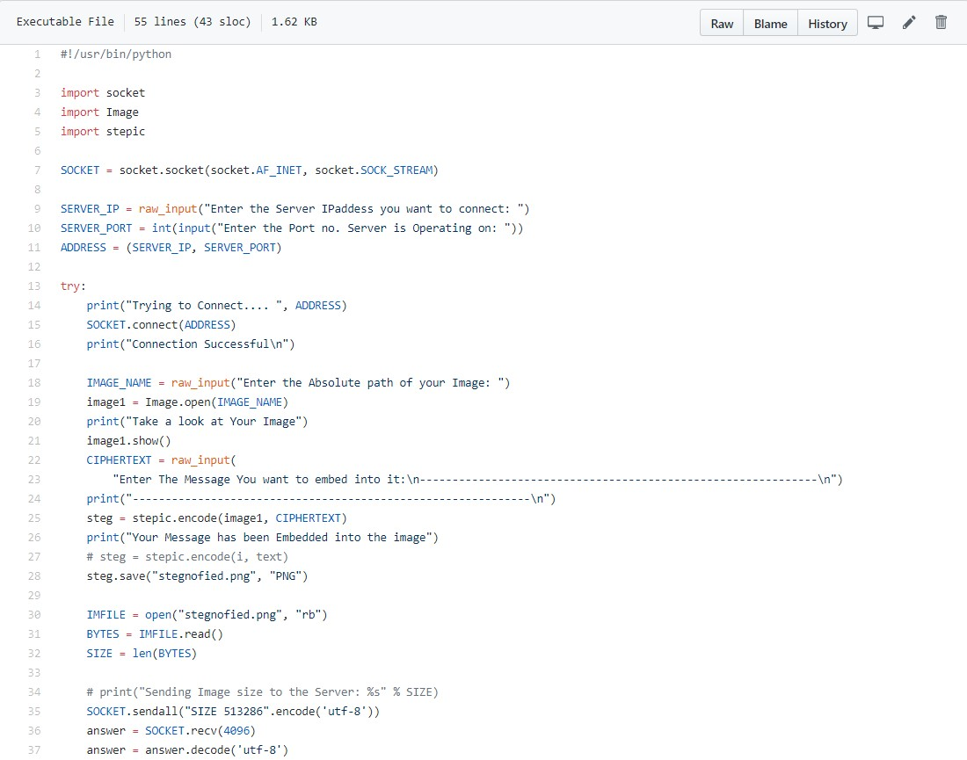

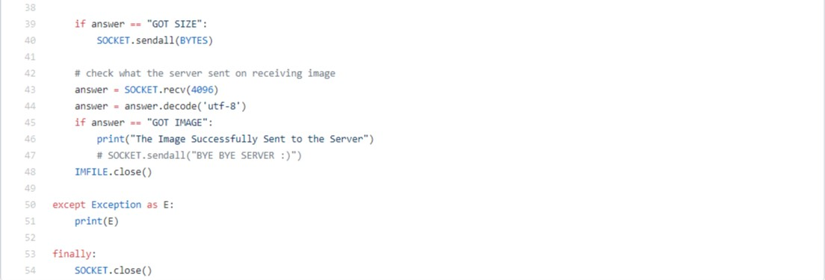

Server Side Program:

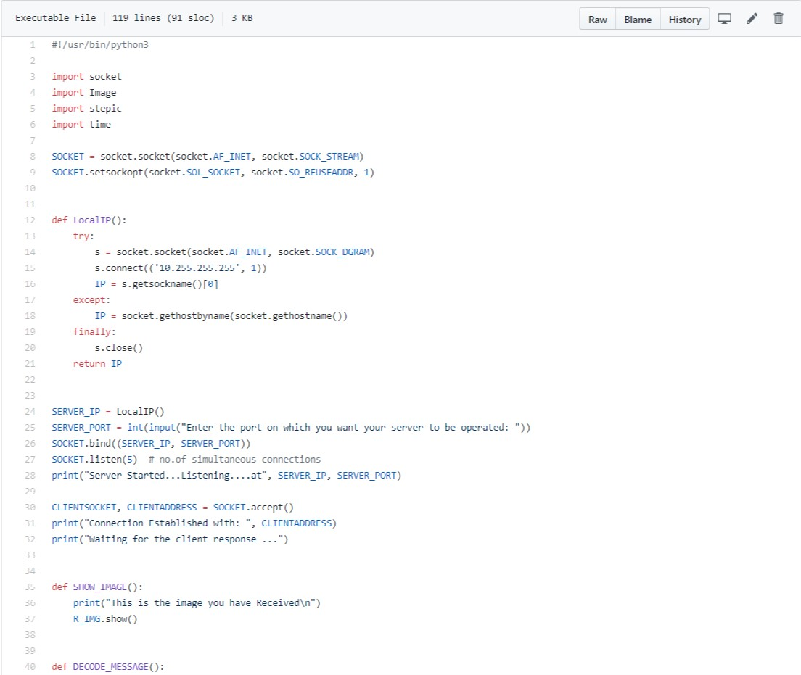

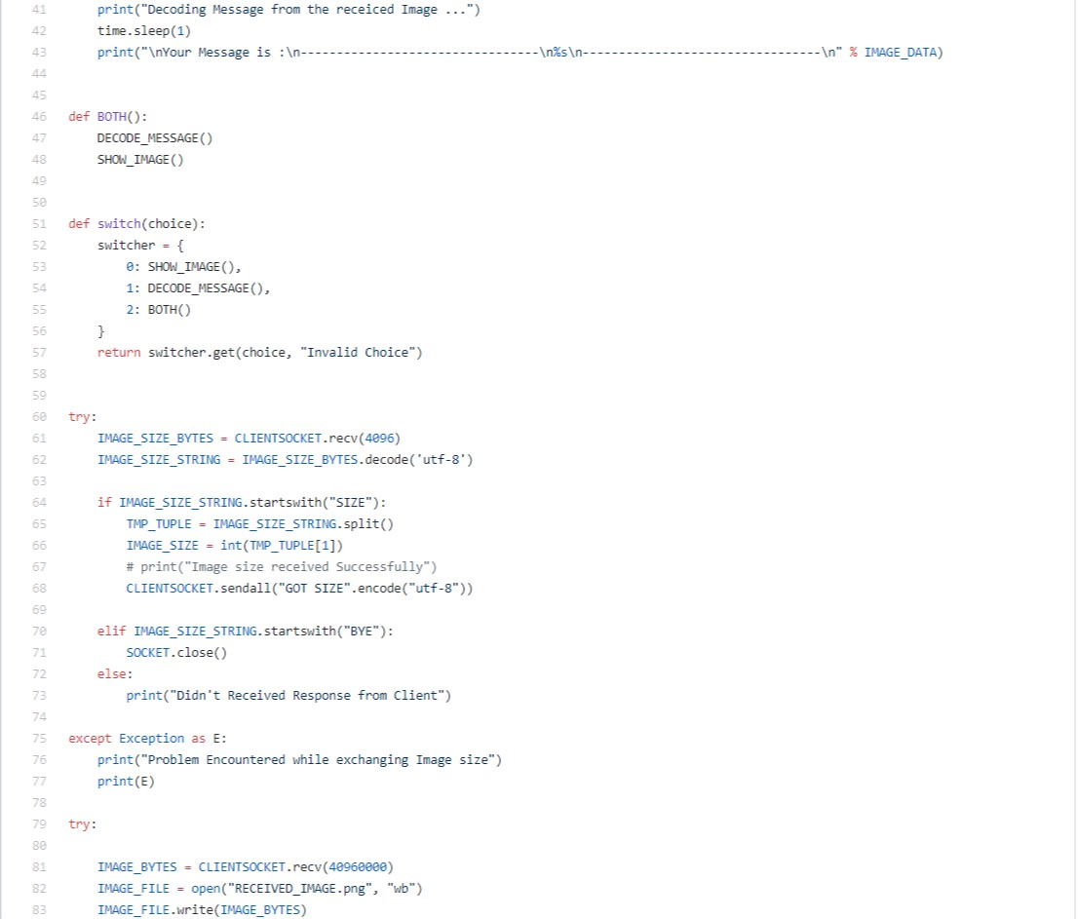

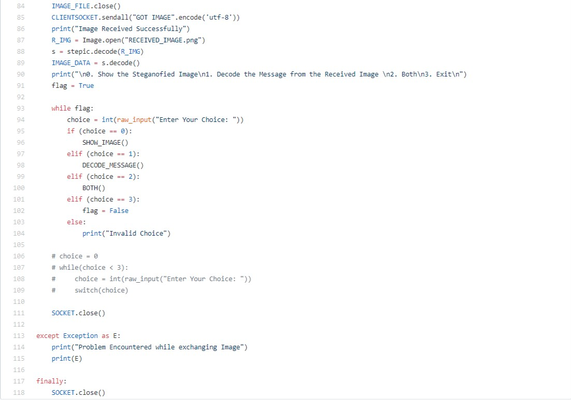

Output Screenshot:

