Write-UP
The retention analysis of version 11.0 shows a drop in D1, D3, and D7 retention compared to version 10.2 (Figure 1). The retention trend between the US and worldwide populations does not show any significant difference. However, I cannot yet conclude that the retention decrease is directly linked to the new build.
For Lea, I would recommend first reviewing the acquisition performance, particularly the ad campaigns and network mix, because the number of installs coming from different networks clearly decreased between versions 10.2 and 11.0(see notebook). Evaluating statistical significance, calculating confidence intervals, and potentially performing a seasonality analysis would be necessary before concluding that the issue is caused by the build itself. Additionally, overall playtime per level increased in version 11.0 (Figure 2), which suggests that the engagement impact is not entirely negative and requires further investigation.
For Marc, the overall difficulty appears to have slightly increased across levels in version 11.0 compared to 10.2. Two distinguishable difficulty peaks appear at levels 7 and 27 (Figure 3). I would recommend reviewing these two levels and investigating whether changes introduced in the new build created unexpected difficulty spikes.
For the data modeling approach, I created views on top of the provided tables to facilitate filtering by version, handle immature cohorts, and avoid unnecessary duplication of data in physical tables. For the progression analysis, I created an intermediate table because additional aggregations were required before calculating the final KPIs.
I used LLM tools to better understand the analysis requirements and assist with generating SQL code. However, for data modeling, the initial LLM suggestions were not always appropriate because they directly used the already aggregated tables to calculate KPIs without considering the correct weighting methodology and cohort structure.
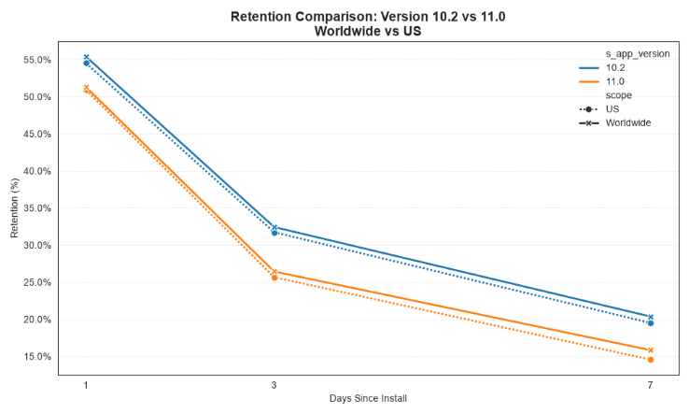
Figure 1
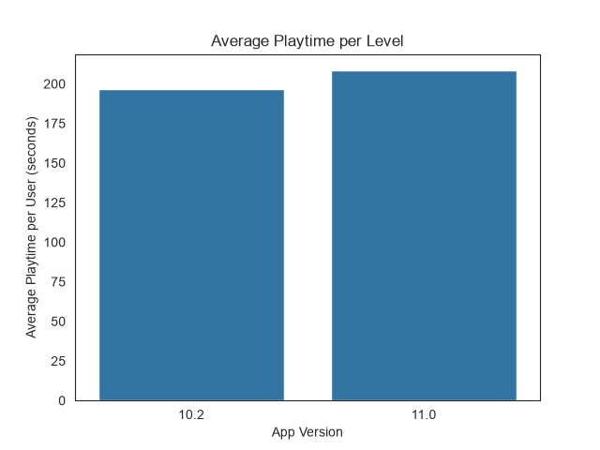
Figure 2
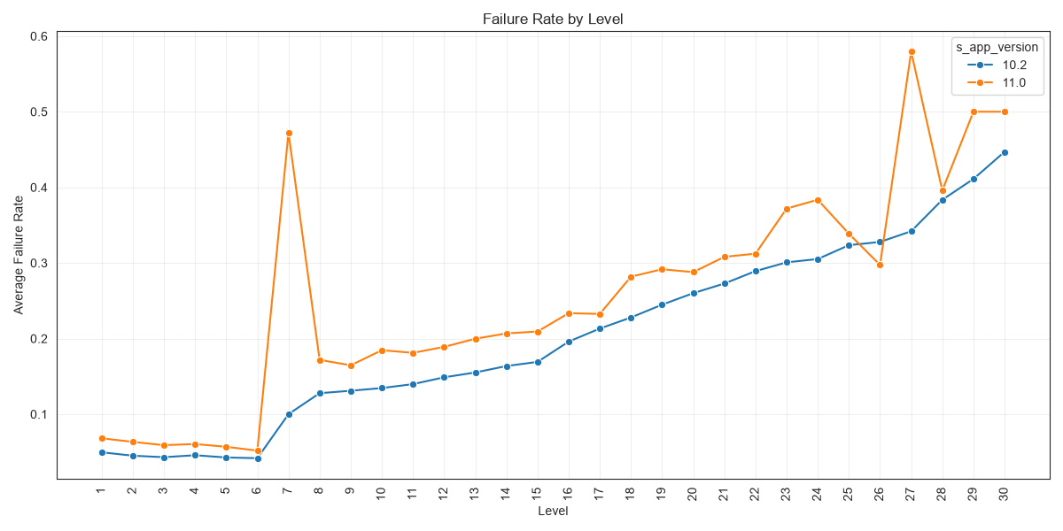
Figure 3

