**Firas Ayoub-308185313**

**Sherein Dabbah-** **311382840**

**Testing algorithm** :

for seg in segments :

seg = foreground

segments-seg=background

->create the mask -It is a mask image where we specify which areas are background, foreground

->use grabcut on that mask and create an image of single color for the seg

Save single color img

**segmaskImage** = Add all 4 images together to get an image of all the colored segments together

**segmentedImage** = cv2.addWeighted(orig_img, 0.6, **segmaskImage** , 0.4, 0)

**problems**: the method was very heavy for the computer to run and surprisingly slow ,

and whenever the was tiny spots of color relatively different than most of the colors in the image we would get white spots in the **segmaskImage** and in the **segmentedImage** the same spots would be left as the original image or if color was very close to both segments we would get a mixture of both colors in the mask .

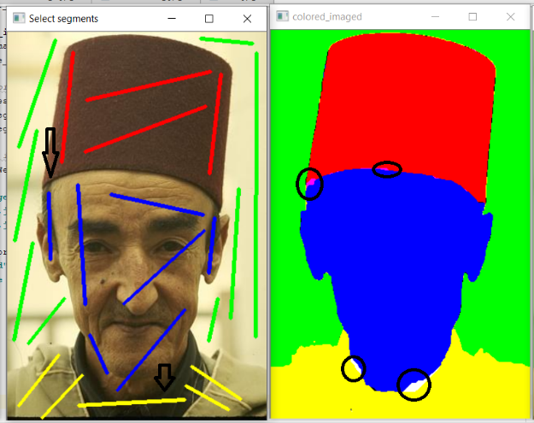

**ALGORITHM USED:**

SEG1=(seg1 concatenate seg2)

SEG2=(seg3 concatenate seg4)

1-Perform grab cut while setting SEG1 as foreground and SEG2 as background -> FGmask where seg1 and seg2 are in it and FGmask for seg3,4

2-perform another grab cut on MASK where seg1 is the FG and seg2 is the BG ,mask1 -> subtract mask1 from MASK to get mask for seg2, mask2=MASK-mask1

* Repeat -2- for the BGMASK

This algorithm solved the problems in the first algorithm…

