Appendix B - User Guide

The aim of this project, Final Kanji Quest, is to teach the Japanese writing system by transforming traditional learning steps into a game. Two versions of the software were made available to users, an Android version and a Desktop[1] version that share most of the functionality. Unless stated otherwise, the following guide applies to all the versions.

B.1 Starting Game

When the game is first run, the main menu screen that contains two buttons, “New Game” and “Load Game “, appears.

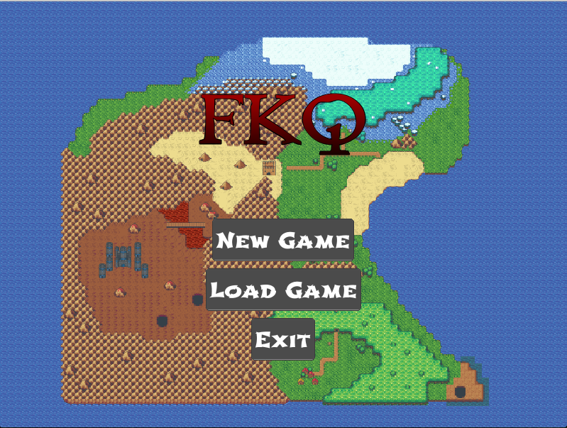

Figure 1 – Main Menu Screen

By pressing the “Load Game” button, the user will be sent to a screen that contains a list of previous game runs (saves).

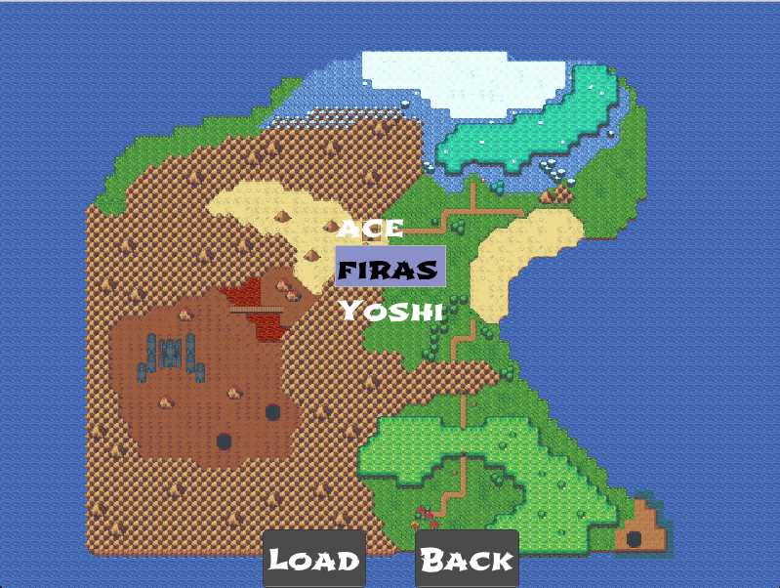

Figure 2 – Load Game Screen

Selecting one of the items will start the game where the last run/session was stopped. If no previous runs were made, the list will be empty. Pressing the “Back” button will return the user to the main menu screen.

Clicking the “New Game” button in the main menu screen (Figure 1) will send the user to a screen where he/she can create a new save file.

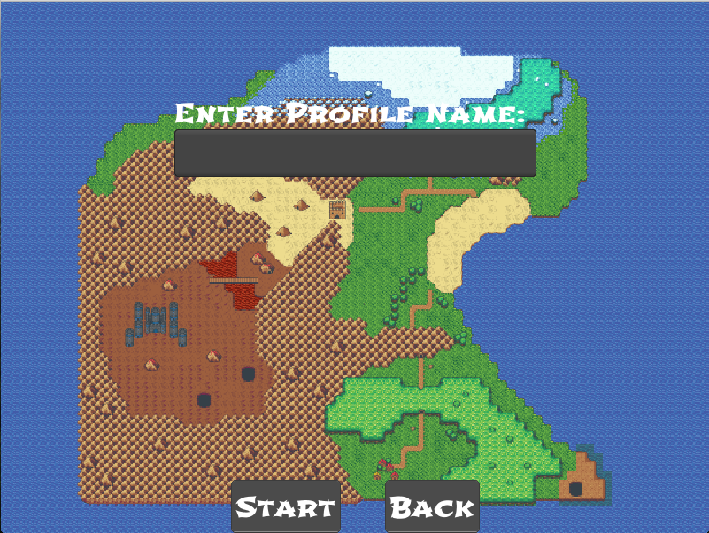­

Figure 3 – New Game Screen  
  
By clicking on the text field, the user will be able to type in a name for his/her save file. Clicking the “Back” button at any point will return the user to the Main Menu Screen. Clicking the “Start” button after entering a name will start a session (Figure 5). If the typed name is already in use, the user will be prompted to either press “Cancel” and choose another name or press the “Overwrite” button and overwrite the save file with the same name.

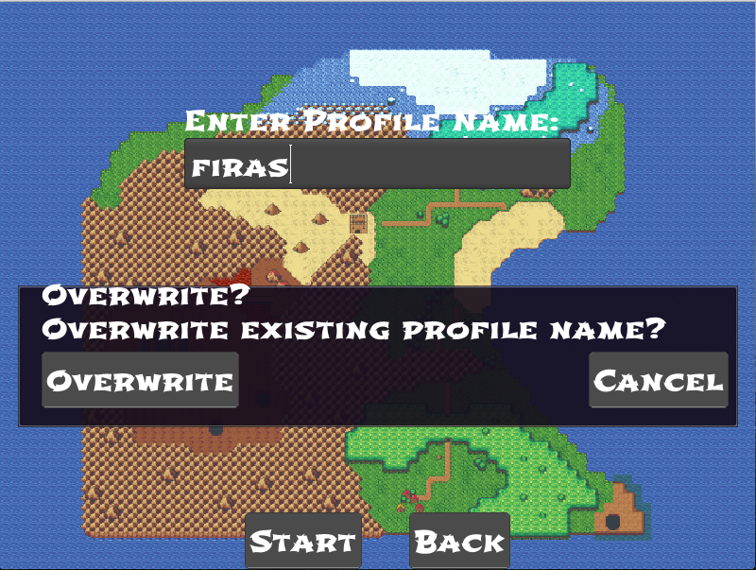

Figure 4 – Overwrite Dialog

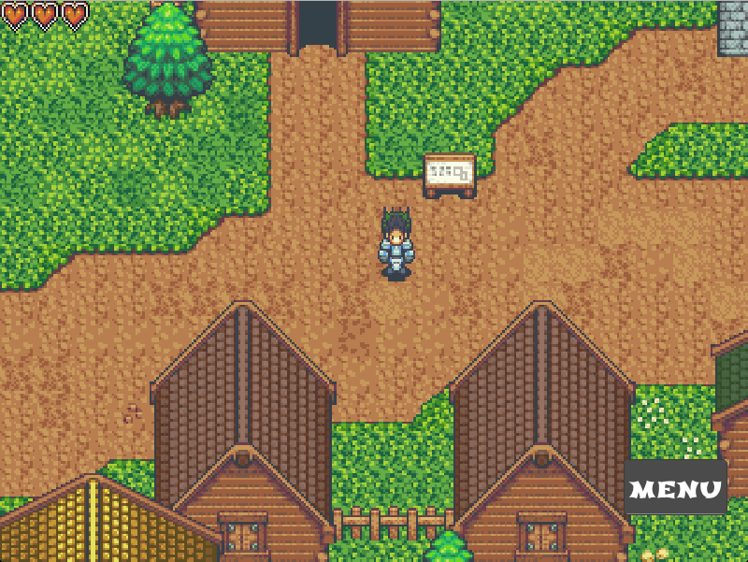

Figure 5 – Main Game Screen

B.2 Player Controllers

The button scheme for the desktop version is as follow:

Up Arrow or W Key – Move Up

Left Arrow or A Key – Move Left

Right Arrow or W Key – Move Right

Down Arrow or W Key – Move Down

“Q” Key – Quit

“P” Key – Pause

“Y” Key – Move Up-Left

“I” Key – Move Up-right

“N” Key – Move Down-Left

“,” Key – Move Down-Right

For the Android version, the character will move based on where the user clicks on the Screen.

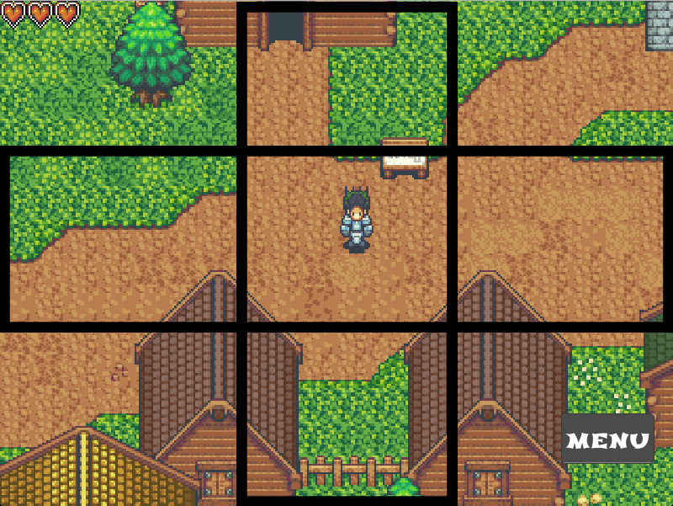

Figure 6 – The nine directional boxes

Pressing the top-left box will move the character diagonally up-left and pressing the bottom-right box will move the character diagonally down-right and so on for all the other boxes.

The middle box is reserved for selecting things when the player character is facing them such as non-player character (NPC) or a treasure box – not yet implemented.

B.3 Menu Buttons

Pressing the “Menu” button at any time will pop-up a list that contain buttons for Progress, Inventory, Hiragana, Katakana, Kanji and Mnemonics windows.

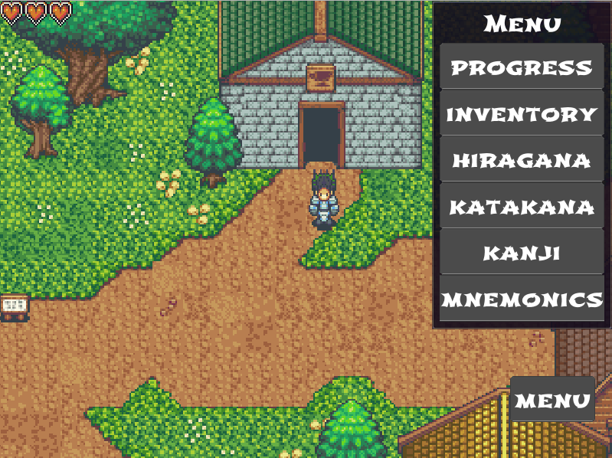

Figure 7 – Menu Button List

By pressing the “Progress” button, a window will pop up displaying the users SRS hiragana progress (Figure 8).

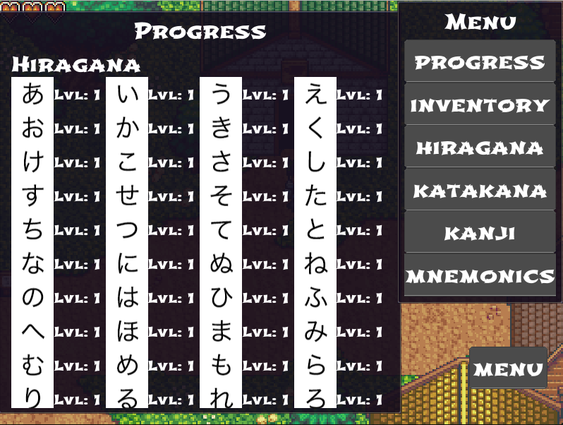

Figure 8 – Hiragana Progress

Scrolling down while the progress window is open will reveal the users Katakana and Kanji progress.

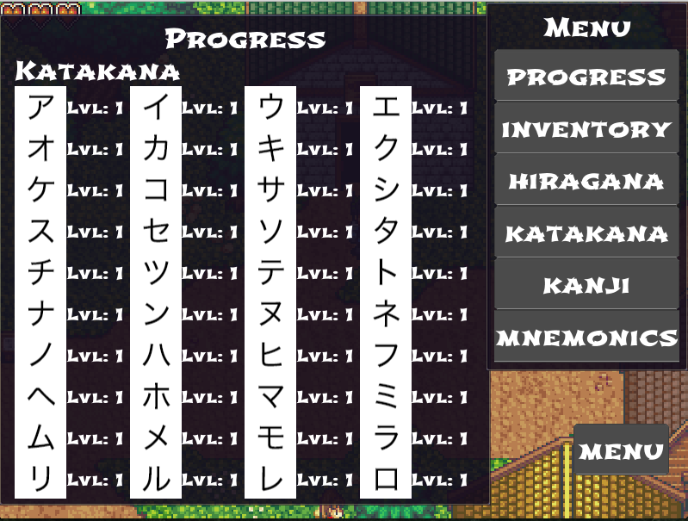  
Figure 9 – Katakana Progress  
  
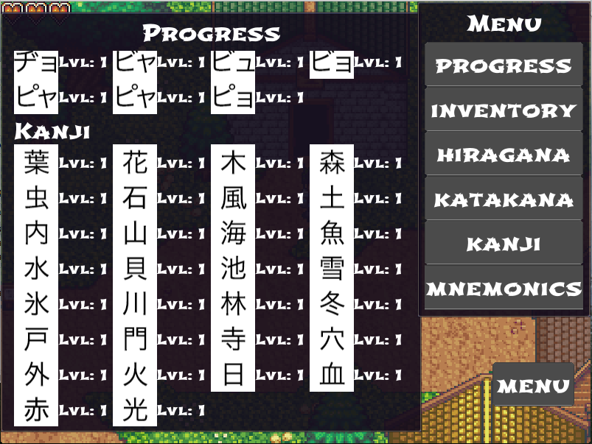

Figure 10 – Kanji Progress

By pressing the “Inventory” button, a window will pop up displaying the user’s inventory (Figure 11).

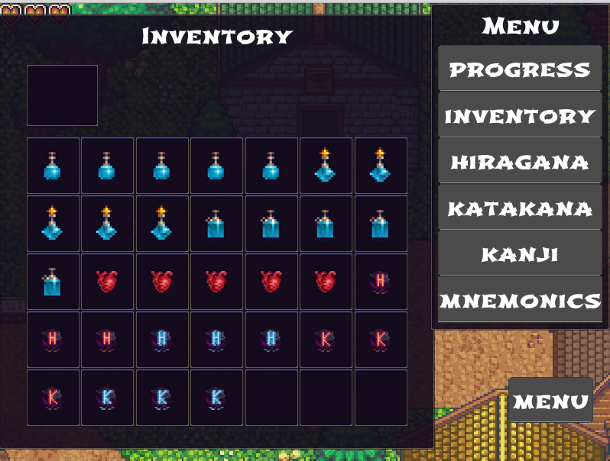

Figure 11 – Inventory window

By pressing any of the items slots, the selected item will appear in the top slot with its description alongside it (figure 12).

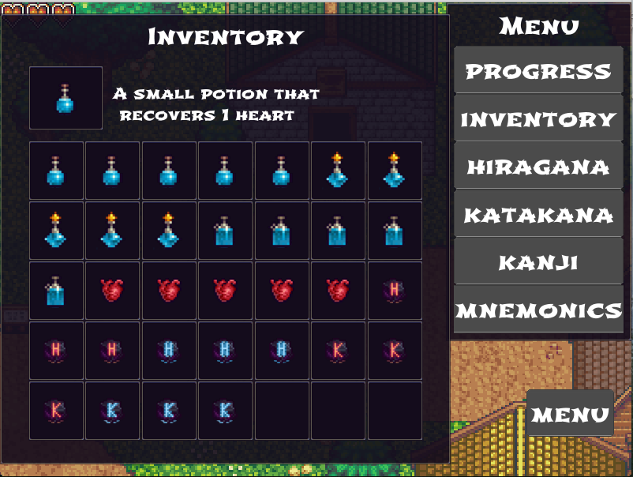  
Figure 12 – Potion Top

Clicking a filled top slot will allow the player character to consume the selected item. In figure 12’s instance, drinking the health potion will increase the number of hearts currently available for the user from 3 to 4.

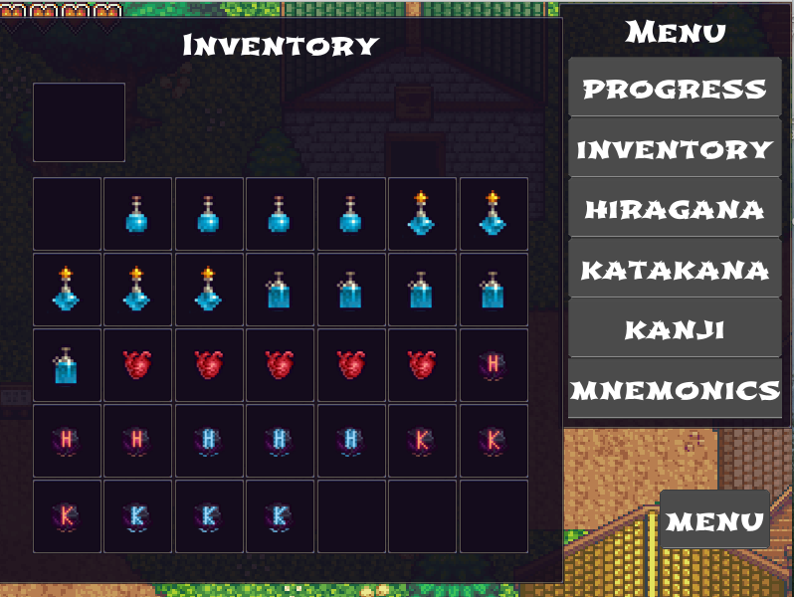

Figure 13 – Potion Consumed

The remaining item effects are as follows: -

Medium potion – recovers 3 hearts

Large potion – recover 5 hearts

Heart – increase the max number of available hearts a person can have by one.

Positive Hiragana Mysterious stone – Stops encounters with hiragana characters

Negative Hiragana Mysterious Stone – Resets encounters with hiragana characters

Positive Katakana Mysterious stone – Stops encounters with katakana characters

Negative Katakana Mysterious Stone – Resets encounters with katakana characters

Clicking either the “HIRAGANA” or “KATAKANA” buttons from the menu button list will pop up a window showing kana character with their romaji equivalents, see Figure 14 and 15.

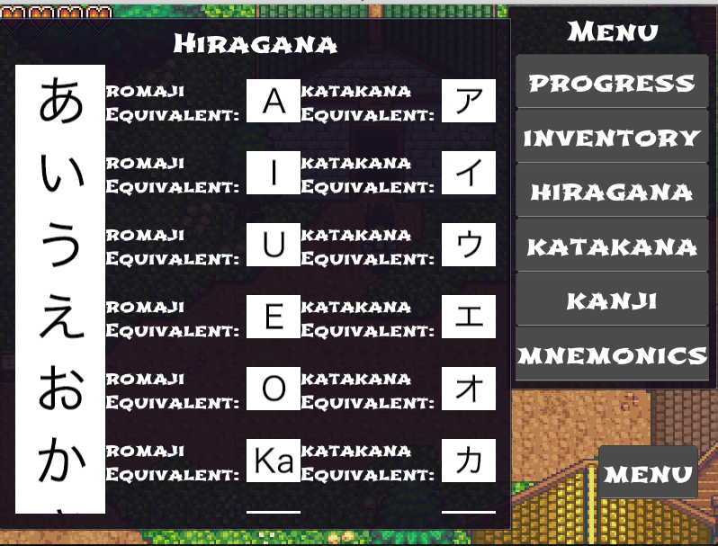

Figure 14 – Hiragana List

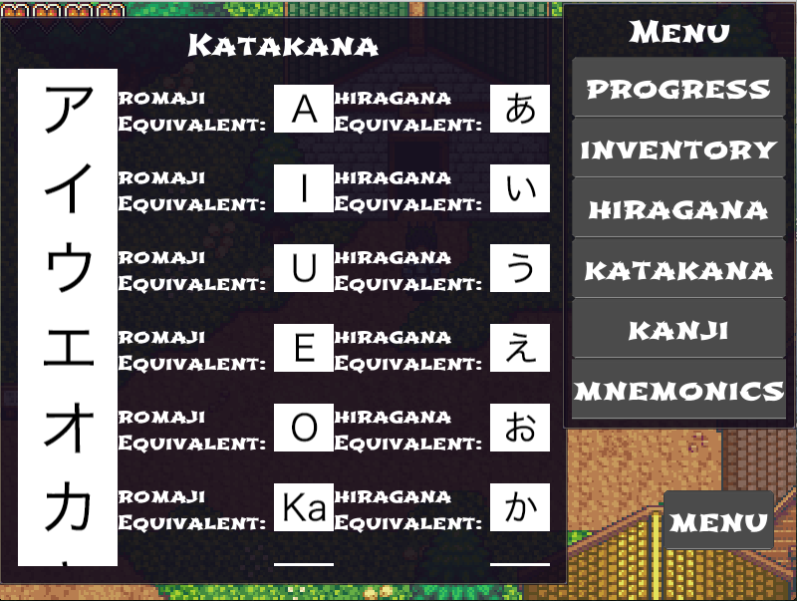  
Figure 15 – Katakana List

Clicking the “KANJI” button in the menu button list will pop up a window showing all the Kanji available in FKQ with their meaning and hiragana equivalent, see Figure 15.

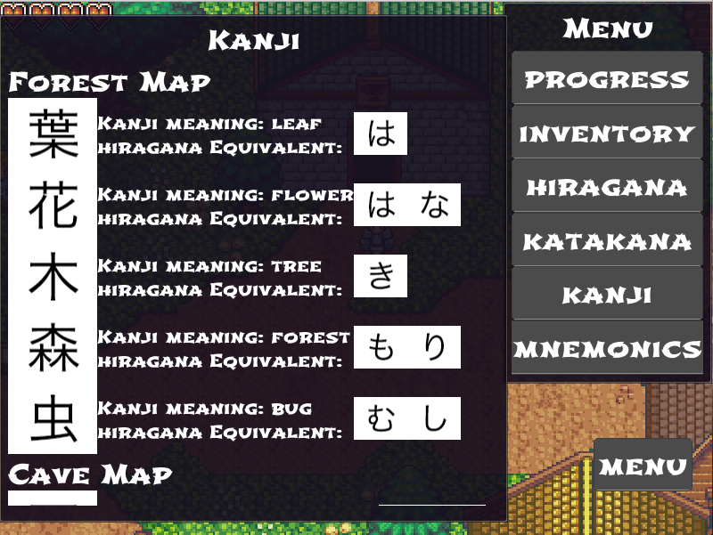

Figure 16 – Kanji List

Clicking the “MNEMONICS” button in the menu button list will pop up a window showing the same kanji letters with mnemonic stories that connect each kanji’s meaning with its reading, see Figure 17.

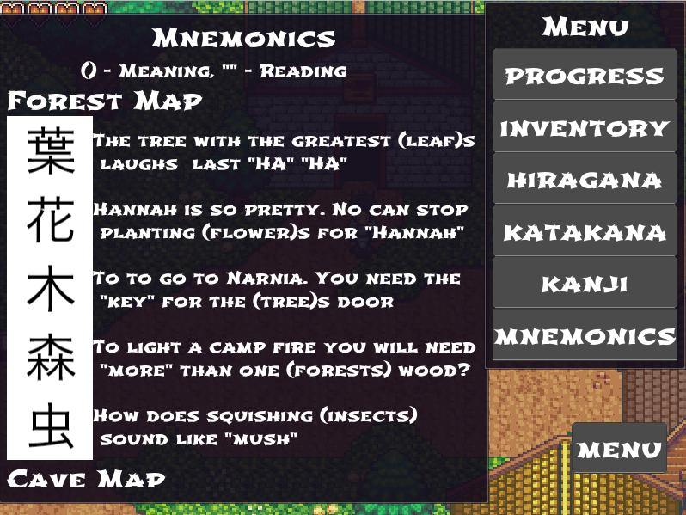

Figure 17 – Mnemonics List

*Pressing any menu item twice will close its window. Pressing any of the item windows (Hiragana, Katakana, Kanji or Mnemonics) will allow the user to scroll down. Pressing the “MENU” button at any time will close the menu button list alongside any opened window.*

While traversing the world of FKQ, the player character will encounter enemies that have to be defeated (answered) in order to progress. Figure 18 is an example.

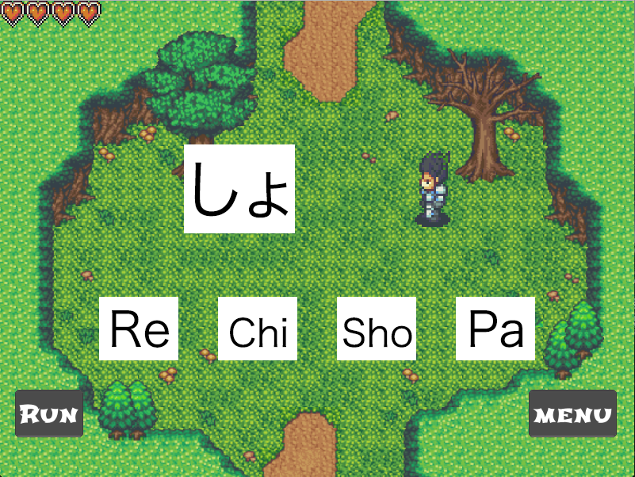

Figure 18 – Hiragana Battle

In order to defeat the enemy character, the user has to choose the correct equivalent for the character, e.g. in the above case the correct equivalent character is the romaji character “Sho”. Answering the letter correctly will increase the user level for that specific character and stop it from appearing when it is answered correctly 3 consecutive times - 5 consecutive answers are necessary for Kanji as they are more difficult to learn. If the player clicks the incorrect equivalent, the player will lose a heart.

Game over occurs when a player loses all his hearts (see Figure 19). To avoid that, the user can instead escape encounters or use the “MENU” button to learn about the encountered character. To discourage users from continuously clicking “RUN”, there is a 15% chance the escape will fail and for each failed escape, the player character loses a heart.

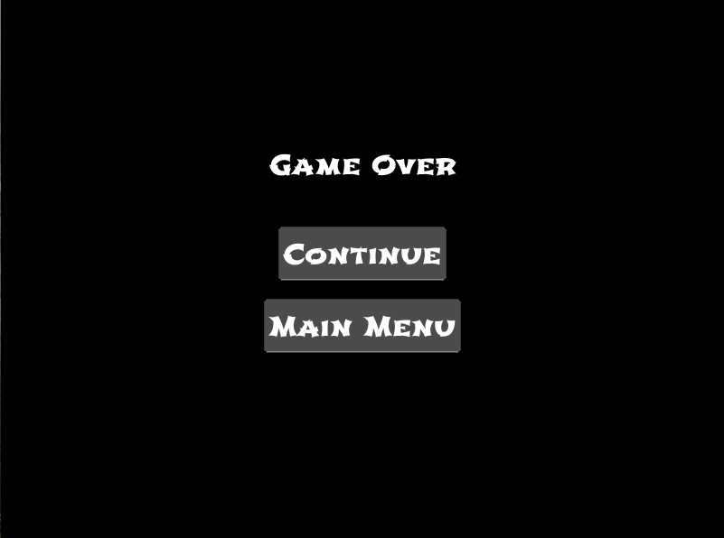

Figure 19 – Game over Screen

By clicking the “Continue” button in the game over screen, the user will be sent to the loading screen where he or she can restart with the latest save file. Clicking the “MAIN MENU” Button will send the user to the main menu screen.

1. The desktop versions work on Mac, Windows & Linux