Functional Document — CloudSquare (CSQ) Application Intake

CS Exam
Firas Khoury
Date: 1/31/2026

Portal & Webhook Functional Specification
1. Purpose and Scope
This solution provides a unified Application Intake capability that accepts applications from:
- Public-facing Portal form (Experience Cloud / LWC)
- External Webhook API (Apex REST endpoint)
Both channels follow the same standardized business behavior:
- Validate submissions
- Attempt to match an existing Account
- Create an Opportunity or Lead
- Stamp origin channel
- Return user-safe responses without Salesforce record IDs
2. Primary Users and Actors
- Portal Applicant: Submits applications via website form
- External System: Submits applications via webhook API
- Client Admin / Ops User: Reviews and follows up on records
3. High-Level Business Rules
3.1 Account Matching Logic
When a submission is received:
- Match by Tax ID when provided
- Fallback to Company/Legal Name
- If match found: Create Opportunity
- If no match: Create Lead
3.2 Channel Source Stamping
- Portal: SourceType__c = "Community"
- Webhook: SourceType__c = "Webhook"
3.3 Record IDs Not Returned
Responses include only:
- Success status (ok)
- User-friendly message
- Created record type
4. Portal — Functional Behavior
4.1 User Interface
The portal provides an application form where users enter:
- Organization details
- Applicant contact details
- Optional financial data
4.2 Portal Use Cases
Use Case P1 — Account Match → Opportunity
- User submits form
- System validates fields
- Account matched
- Opportunity created
- Success message displayed
Use Case P2 — No Match → Lead
- User submits form
- No account match
- Lead created
- Success message displayed
Use Case P3 — Error Correction
- Validation fails
- Inline errors shown
- User corrects and resubmits
4.3 Portal Error Handling
- Missing fields: Inline validation message
- Server rejection: Friendly error message
- Unexpected error: Retry message
5. Webhook API — Functional Behavior
5.1 Endpoint Summary
- Method: POST
- Content-Type: application/json
- Path: /services/apexrest/cloudsquare/external/applications
5.2 Webhook Use Cases
Use Case W1 — Match → Opportunity
- Valid JSON submitted
- Account matched
- Opportunity created
- HTTP 200 returned
Use Case W2 — No Match → Lead
- Valid JSON submitted
- No account match
- Lead created
- HTTP 200 returned
5.3 Webhook Request Payload
{
"organization": {
"legalName": "Acme Inc",
"taxId": "12-3456789"
},
"applicant": {
"givenName": "Jane",
"familyName": "Doe",
"emailAddress": "jane.doe@example.com",
"phoneNumber": "+1 415 555 0100"
},
"financials": {
"annualRevenue": 2500000
}
}
Notes: Tax ID is preferred for matching. Financials are optional.
5.4 Webhook Responses
{
"ok": true,
"userMessage": "Application submitted successfully.",
"created": {
"sObjectType": "Opportunity"
}
}
5.5 Webhook Error Handling
- 415: Invalid content type
- 400: Missing body
- 400: Invalid JSON
- 400: Business validation failure
- 500: Server error

5.5 Webhook Missing fields Handling
- If a required field is missing: the required field(s) will be returned in the response.
6. Data Outcomes
- Opportunity created when Account matched
- Lead created when no match found
- SourceType__c populated
- Tax ID stored when provided
7. Operational Notes and Limitations
- No webhook authentication
- No rate limiting
- No async processing
- Limited monitoring
- No custom labels(can be added as an evolution).
- Image Placeholders
- Succesful opportunity creation
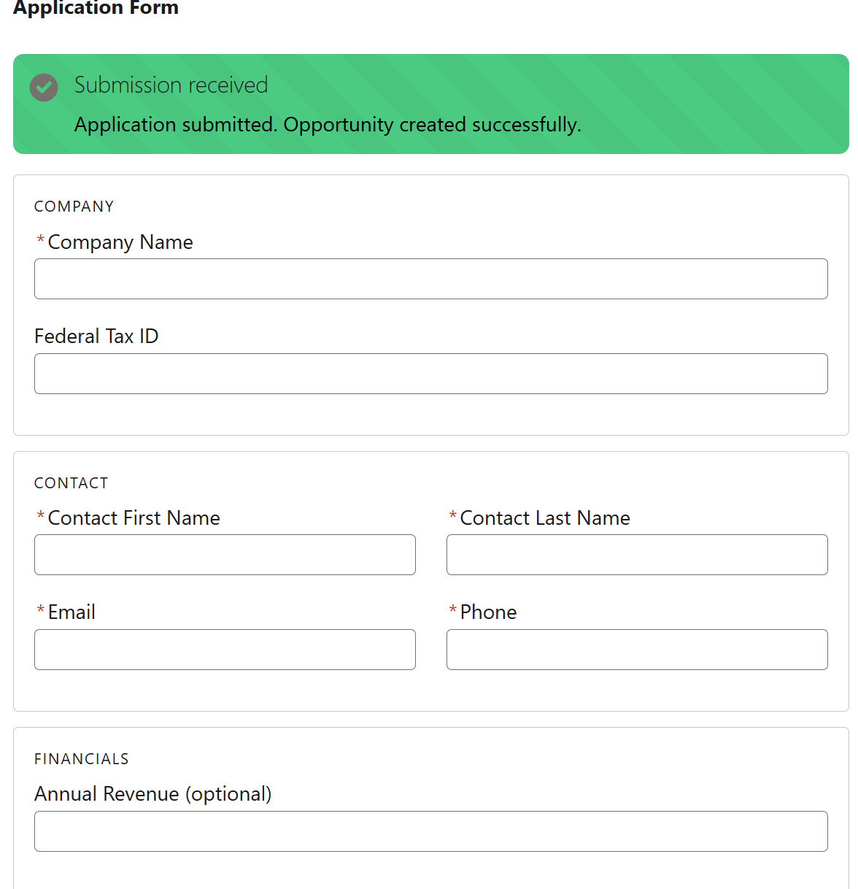
- Succesful opportunity creation


- Succesful webhook opportunity creation:
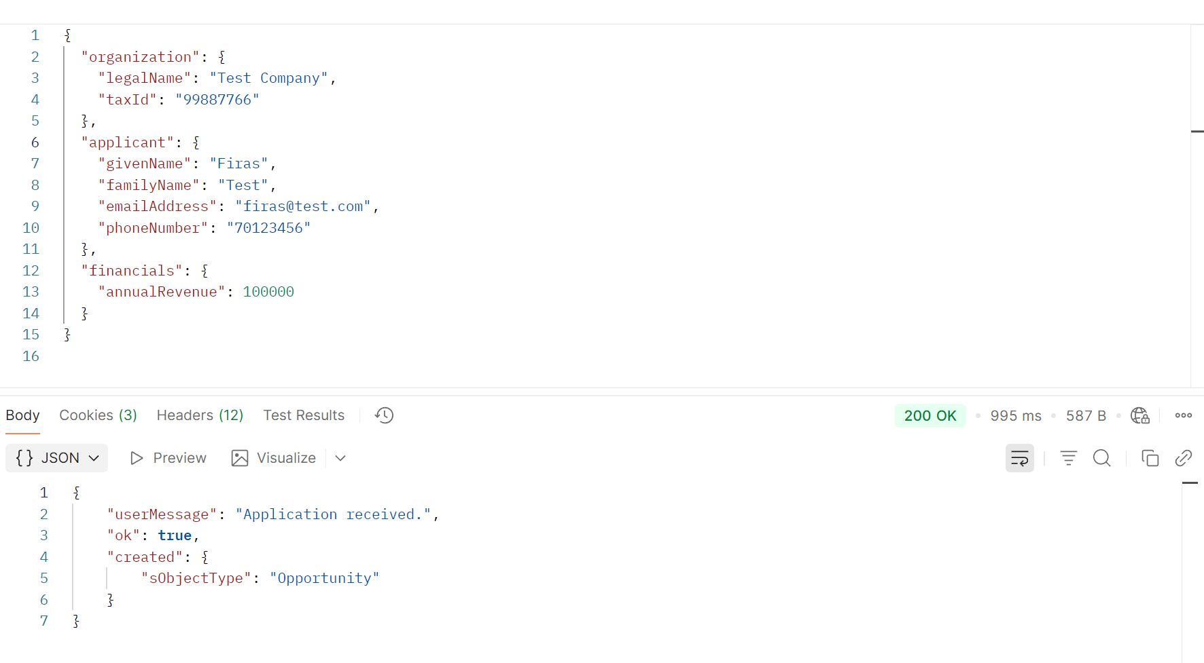
- Missing required fields webhook creation: