Yeast Projects, Experimental Design

## Goal

The goal of the yeast projects is to test the predictions you made (see Reading Guide) regarding the effects of HOG pathway mutants on sensitivity to osmostress and cross-talk between the HOG MAPK and Filamentous Growth (FG) MAPK pathways.

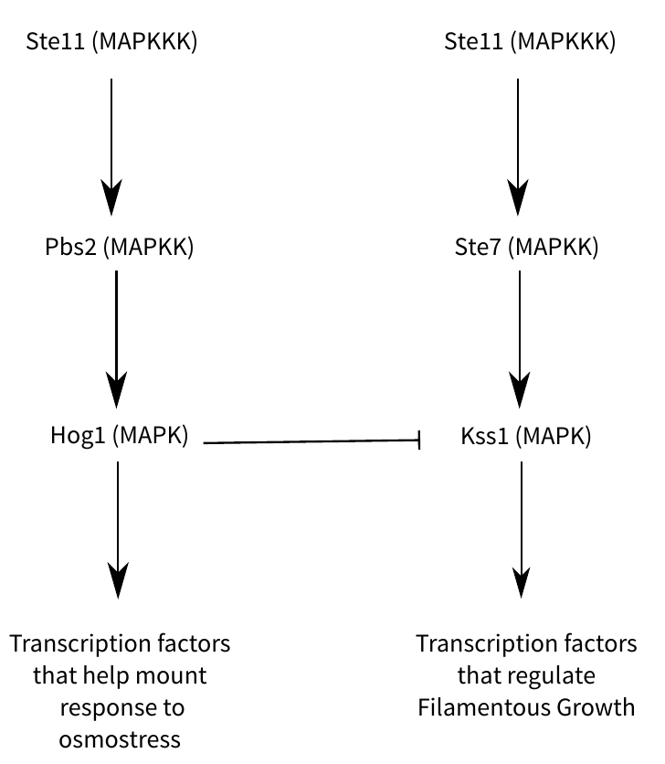

## Overview

You will do two sets of experiments: 1) Growth in liquid media to measure sensitivity to osmostress; 2) Growth on agar plates to observe cellular and colony phenotypes.

## Growth in Liquid Media

You have access to the following strains and reagents for this experiment:

* 3 strain genotypes: wild-type (WT), *hog1* mutants, and *ste11* mutants
* Osmostressors – NaCL and Sorbitol. Lethal concentrations for these two stressors are: NaCL = 2.5M, Sorbitol = 1.5M

As you think about your experimental design:

* You have access to up to 48 wellls of a 96-well plate in which to run your samples
* Consider how many and which concentrations of each osmostressor you want to test
* Consider how many replicates of each combination of stressor x concentration x genotype you need

## Growth on Agar Plates

Cell and colony morphologies are most easily observed by growing yeast strains on agar plates for several days and then making observations of the resulting phenotypes with the naked eye or under a microscope.

You will have access to the 3 strain genotypes listed above, plus agar plates containing: a) standard growth medium (abundant nitrogen and carbon sources); and b) filamentous growth inducing medium (contains only limited nitrogen sources that the cells can use).