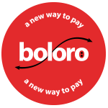

Boloro POS
Integration Guide

Last updated: August 17, 2015
Document Version: - 1.1Revision History:-
Created By: Nabeel Arshad & Muhammad Arfeen
Created On: 14 April 2015
Reviewed By: Muhammad Adnan Khan
Date | Revised By | Revision Section | Incorporated Changes
17 August 2015 | Wahab Hussain | Version 1.1 | - https to be used for all APIs

Table of Contents
1. Preface 5
1.1. About 5
1.2. Intended Audience 5
1.3. Integration scope 5
2. BOLORO – A New Way to Pay! 6
2.1. Key features of Boloro: 6
2.2. How BOLORO Works 7
3. POS checkout 8
3.1. Process diagram 9
3.2. Integration Prerequisites 10
4. Checkout Process 11
4.1. Boloro Payment Option 11
4.2. Customer Identification 11
4.3. Manual Entry 12
4.4. Boloro Transaction 13
4.5. Successful Transaction 14
4.6. Receipt 15
5. API End Points 16
5.1. Send Transaction 16
5.2. Transaction Status Polling 17
5.3. All Telco (Carrier) of Market 18
5.4. Get Telco and Amount Details by NFC Tag id 19
5.5. Get Telco and Amount Details 20
5.6. Get Transaction Status 21
5.7. Get Transaction Status by Merchant Order ID 22
5.8. Cancel Transaction 23
5.9. Keep Alive API 24
6. Transactions of multiple funding Source 25
6.1. Get Mapped Accounts 28
7. Automatic Request for Reversal 30
8. Error Codes: 34

Preface

About
This document contains a detailed explanation about how to integrate a merchant’s existing POS hardware and software system with Boloro.

Intended Audience
This document is for merchants and POS software developers and POS Hardware developers, who want to integrate with Boloro.

Integration scope
All the commerce functionality will be implemented by the merchant. Boloro will be used only for payment processing.

BOLORO – A New Way to Pay!
Boloro is the first ever Global Mobile Payments system which allows mobile phone users to pay for physical goods and services using their mobile phone airtime or mobile wallet.
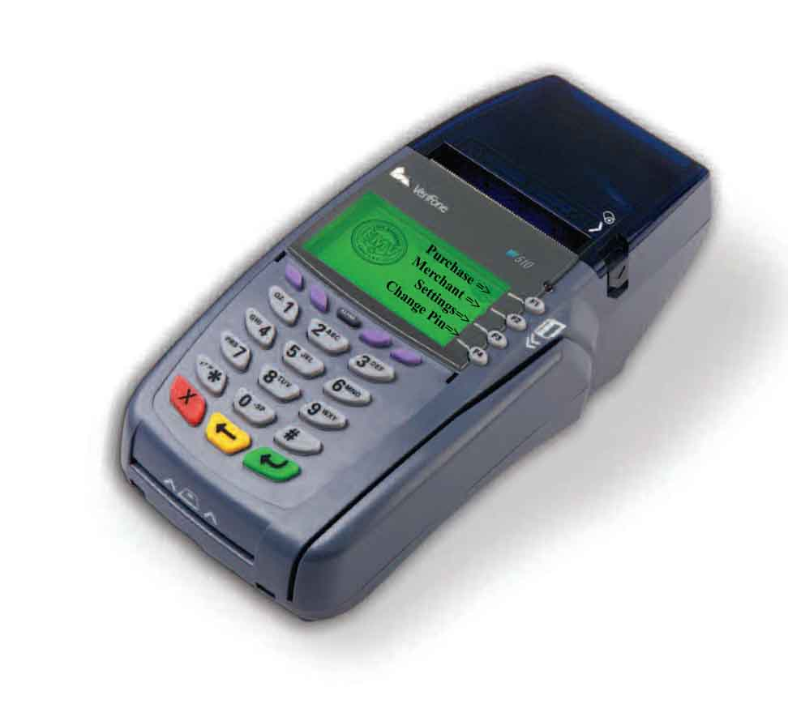
MNO
MERCHANTS /
POS

Key features of Boloro:
- Simple, secure and low risk
- Offers easy integration and a broad application suite
- Capable of customizing online and face-to-face payment acceptance solutions for Merchants
- Directly charges customer’s telephone account balance
- Guaranteed prompt payment to Merchants
- Integrates easily with Mobile Network Operators
- Connects to a variety of Merchants organizations including retail stores, governments, online, etc.

How BOLORO Works
A complete transaction takes place using the SMS facility on every cell phone. A customer will receive a message on their mobile requesting authorization of a purchase request. To approve the authorization the customer will reply with their unique 4 digit PIN number. The amount is validated against their available funds in their mobile account balance to process transactions instantly.
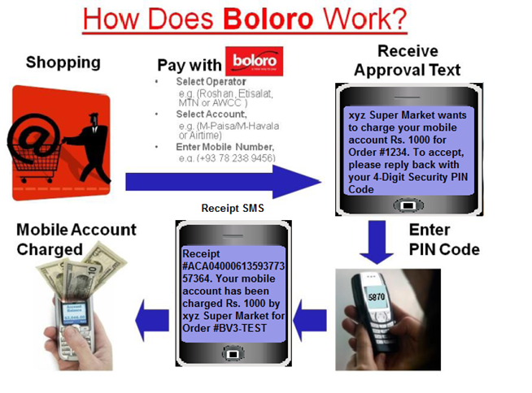

POS checkout
Boloro POS checkout makes it easy for customers to pay with their mobile account. The following high level steps define the transaction flow:
- Scan Purchase goods
- Calculate the amount to charge
- Payment Option: Select “Pay with Boloro” payment option.
- Amount is entered or carried from the internal POS system.
- Customer Identification:
  - Tap the NFC Tag: Customer can be identified by tapping his Boloro sticker on the NFC reader integrated into the POS.
    - Tap the NFC Tag.
  - Key Entry: Customer information is entered manually only when the customer does not have a Boloro sticker or if the NFC reader is malfunctioning.
    - Select Carrier e.g. DU
    - Select Account e.g. Prepaid
    - Enter phone number e.g. 971553216563
- Pin Verification:
  - An SMS is sent to customer on his provided mobile number to confirm his transaction
  - The customer then replies with his PIN number.
- After the Boloro network authorizes the transaction the POS will display a confirmation and the transaction is completed. The cashier is redirected to print transaction receipt.
- Click on the Print button to print the transaction receipt.

 

Process diagram

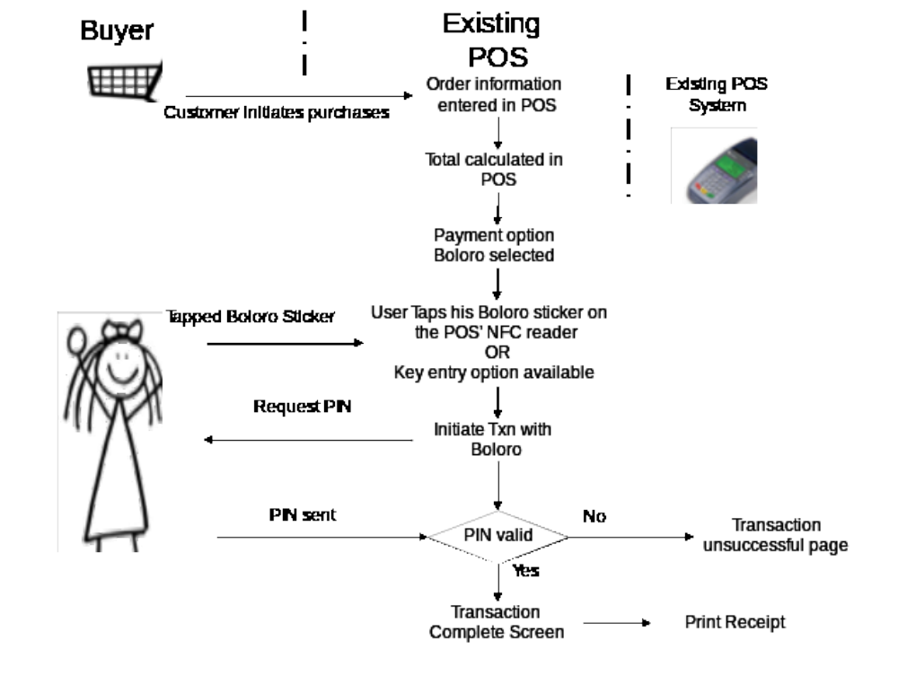

Integration Prerequisites
Merchant must be registered on Boloro prior to integration. After merchant signs up for a Boloro account, following three unique values will be provided to merchant to operate:
- API Login ID
- API transaction key
- Server URL
These keys are required by every API call for merchant authentication.

Checkout Process

Boloro Payment Option
A button is required to be added to the available payments on POS as follows,


Customer Identification
Customer is required to tap his Boloro sticker on the POS’ NFC reader. gettelcoinfobytag function is called to calculate transaction totals and verify customer. If customer is verified, Processcheckout function will be called to initiate the transaction with Boloro.
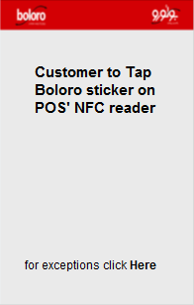
For any exceptions like customer does not have a Boloro sticker or the NFC reader is not working, the following screen is displayed.

Manual Entry
This page is only displayed for exceptions where the customer cannot be identified with his Boloro sticker. getmarkettelcos API is called to populate the value of Carrier and Account drop down boxes.
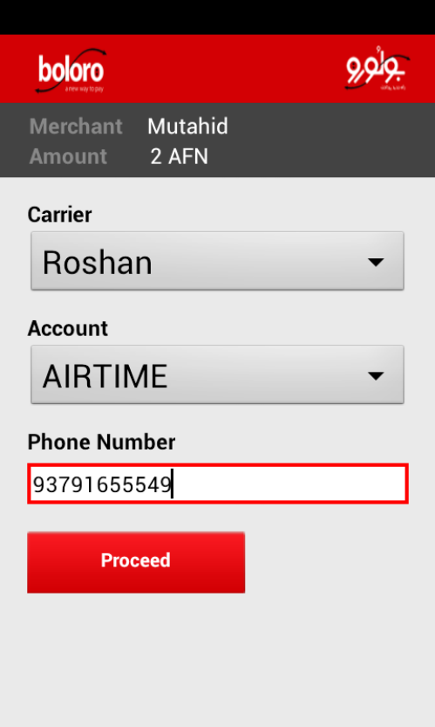

Boloro Transaction
Boloro transaction should be initiated as soon as the customer taps his Boloro sticker on NFC reader or the “Proceed” option is selected on “Manual Entry” screen.
Customer will get an SMS to provide his PIN for transaction authorization. On receiving correct PIN from customer, Boloro charges the Payment from customer’s mobile account and completes the Payment check out Process.
Processcheckout function will be called to initiate transaction with Boloro.
While the POS is waiting for customer to verify his transaction it polls Boloro by calling the pollcheckouttransaction function and displays the status information of the transaction to client.

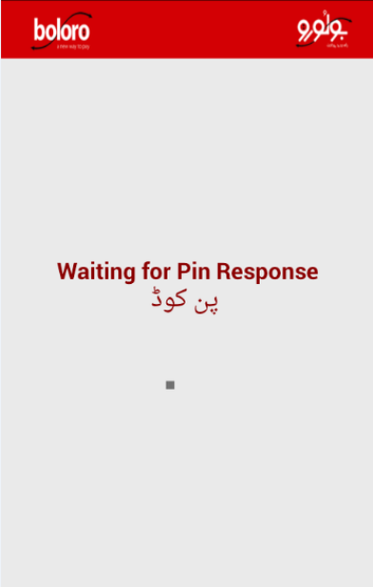

Successful Transaction
Information similar to following screen is presented to the customer when successful transaction status is returned from pollcheckouttransaction function.
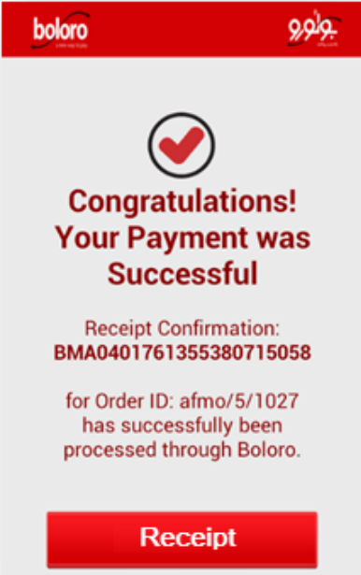

Receipt
Receipt button is required to print the receipt via POS printer or it can be printed by your system as soon as the Boloro transaction is successful.

API End Points
Boloro URL, Market Id and Currency Code: Value of these parameters will be shared with merchant when merchant account is created on Boloro.

Send Transaction
This API is called when you need to send the transaction from POS. HTTP Post request is required to access this API.
Send Transaction
Request Type: POST
Parameters | Description |  | Required
api_login_id | Merchant API Login |  | Yes
transaction_key | Merchant Transaction Key |  | Yes
order_id | Order Id from Merchant system |  | Yes
telco_id | Issuer’s Id (refer getmarkettelcos API) |  | Yes
total | Transaction Total Amount |  | Yes
currency_code | Transaction Currency (AFN, KWD, US$) |  | Yes
trans_mode | Issuer’s Payment Mode (refer payment_mode_id of getmarkettelcos API) |  | Yes
mobileno | Customer Mobile Number |  | Yes
customer_name | Customer Name |  | No
order_date | Order Date |  | No
order_total | Order Net Total Amount |  | No
order_tax | Tax Amount |  | No
shippinghandling | Shipping Amount |  | No
shipping_discount | Discount Amount |  | No
insurance | Insurance Amount |  | No
tag_id | This field is required only for Tag transactions and not for Manual Transactions |  | Yes
terminal_id | Merchant Terminal Id |  | Yes
sp_id | Service Provider Id |  | No
Format | JSON
URL | https://[Boloro URL]/processcheckout
Response
JSON | {  "success":true/ false,  "long_message": "",  "short_message": "",  "transaction_id": "",  "error_message": "",  "error_code": "[ERROR LIST]"  }

Transaction Status Polling
This API is used to poll the status of any transaction with respect to the transaction id and the market id. If this API is called for online transactions the merchant API and the transaction key is not required because it is fetched from the session if not provided. For calling the API from POS or any other source, the merchant authentication is required
Transaction Status Polling
Request Type: POST
Parameters | Description |  | Required
api_login_id | Merchant API Login |  | Yes
transaction_key | Merchant Transaction Key |  | Yes
Transaction_id | “TXNID” returned from Send Transaction API |  | Yes
Market_id | Merchant Market (AFG, KWT, …) |  | Yes
Format | JSON
URL | https://[Boloro URL]/PollCheckoutTransaction
Response
JSON | {  "success": true/false,  "long_message": "",  "short_message": "",  "next_action": "FAILED/POLL/SUCCESS",  "cancel_allowed": true/false,  "statuscode": "[SEE LIST]",  "error_message": "",  "error_code": "[SEE ERROR LIST]"  }

All Telco (Carrier) of Market
This API returns the details of the MNOs which are integrated with the market, including all the payment modes which the particular MNO offers. The results can be found after the authentication of the merchant
All Telcos(Carrier) of Market
Request Type: GET
Parameters | Description |  | Required
api_login_id | Merchant API Login |  | Yes
transaction_key | Merchant Transaction Key |  | Yes
market_id | Merchant Market (AFG, KWT, …) |  | Yes
Format | JSON
URL | https://[Boloro URL]/GetMarketTelcos
Response
JSON | {  "success": true/false,  "error_message": "",  "error_code": "[SEE ERROR LIST]",  "telco": [  {  "telco_id": "",  "telco_name": "",  "telco_payment_modes": []  }  ]  }

Get Telco and Amount Details by NFC Tag id
This API will tell the bifurcations of the given amount by the Tag id

Get Telco and Amount Details By NFC Tag id
Request Type: GET
Parameters | Description |  | Required
api_login_id | Merchant API Login |  | Yes
transaction_key | Merchant Transaction Key |  | Yes
market_id | Merchant Market (AFG, KWT, …) |  | Yes
total | Transaction Total Amount |  | Yes
tag_id | Mifare Classic NFC Tag’s UID |  | Yes
Currency_code | Transaction Currency (AFN, KWD, US$) |  | Yes
Format | JSON
URL | https://[Boloro URL]/gettelcoinfobytag
Response
JSON | {  "success": true/false,  "surcharge_terms": "",  "surcharge_desc": "",  "converted_amount": "",  "surcharge": "",  "totalamount":,  "addnote": "",  "currency": "",  "marketid": "",  "default_paymentmode":,  "msisdn": "",  "surchargeamountcomplete": "",  "convamountcomplete": "",  "targetamount": "",  "hedgetargetamount": "",  "i_currency": "",  "surcharge_id": "",  "rate":,  "hedgerate":,  "hedgepercent":,  "totalamountcomplete": "",  "telco_name": "",  "telcoid": "",  "balance":,  "payment_mode": ""  }

Get Telco and Amount Details
This API tells the breakup of the given amount according the given Telco id.
Get Telco and Amount Details
Request Type: GET
Parameters | Description |  | Required
api_login_id | Merchant API Login |  | Yes
transaction_key | Merchant Transaction Key |  | Yes
market_id | Merchant Market (AFG, KWT, …) |  | Yes
total | Transaction Total Amount |  | Yes
Currency_code | Transaction Currency (AFN, KWD, US$) |  | Yes
Telco_id | Issuer ID |  | Yes
Format | JSON
URL | https://[Boloro URL]/gettelcoinfo
Response
JSON | {  "success": true/false,  "surcharge_terms": "”,  "surcharge_desc": "",  "converted_amount": "",  "surcharge": "",  "totalamount":,  "addnote": "",  "currency": "",  "marketid": "",  "default_paymentmode": "",  "msisdn": "",  "surchargeamountcomplete": "",  "convamountcomplete": "",  "targetamount": "",  "hedgetargetamount": "",  "i_currency": "",  "surcharge_id": "",  "rate":,  "hedgerate":,  "hedgepercent":,  "totalamountcomplete": "",  "telco_name": "",  "telcoid": "",  "balance": "",  "payment_mode": ""  }

Get Transaction Status
Request Type: GET
Parameters | Description |  | Required
api_login_id | Merchant API Login |  | Yes
transaction_key | Merchant Transaction Key |  | Yes
Transaction_id | “TXNID” returned from Send Transaction API |  | Yes
marketid | Merchant Market (AFG, KWT, …) |  | Yes
Format | JSON
URL | https://[Boloro URL]/gettransactionstatus
Response
JSON | {  "long_message": "",  "short_message": "",  "next_action": "",  "cancel_allowed": false/true,  "statuscode": “”,  "success": true/false,  "error_message": "",  "error_code": ""  }

Get Transaction Status
This API will inform the current status of the transaction with respect to the transaction Id

Get Transaction Status by Merchant Order ID
This API will return the transaction status with respect to the given order id and the transaction id
Get Transaction Status By Merchant Order ID (Latest Transaction)
Request Type: GET
Parameters | Description |  | Required
api_login_id | Merchant API Login |  | Yes
transaction_key | Merchant Transaction Key |  | Yes
order_id | Merchant Transaction Key |  | Yes
Transaction_id | “TXNID” returned from Send Transaction API |  | No
Market_id | Merchant Market (AFG, KWT, …) |  | Yes
Format | JSON
URL | https://[Boloro URL]/gettransactionstatusbyorderid
Response
JSON | {  "long_message": "",  "short_message": "",  "next_action": "",  "cancel_allowed": false/true,  "statuscode":,  "success": true/false,  "error_message": "",  "error_code": ""  }

Cancel Transaction
This API will be used to cancel the transaction if allowed
Cancel Transaction
Request Type: GET
Parameters | Description |  | Required
api_login_id | Merchant API Login |  | Yes
transaction_key | Merchant Transaction Key |  | Yes
transaction_id | “TXNID” returned from Send Transaction API |  | Yes
market_id | Merchant Market (AFG, KWT, …) |  | Yes
Format | JSON
URL | https://[Boloro URL]/canceltransaction
Response
JSON | {  "success": true/false,  "long_message": "",  "short_message": "",  "error_message": "",  "error_code": "[SEE ERROR LIST]"  }

Keep Alive API
This API will inform the terminal if the service is working correctly or there are any system errors
Keep Alive API
Request Type: GET
Parameters | Description |  | Required
api_login_id | Merchant API Login |  | Yes
transaction_key | Merchant Transaction Key |  | Yes
message | Optional message |  | NO
terminal_id | ID of the terminal being logged |  | Yes
Format | JSON
URL | https://[Boloro URL]/pingprocessor
Response
JSON | {  "success": true,  "error_message": "",  "error_code": ""  }

Transactions of multiple funding Source
The multiple funding sources are a new module added to Boloro which allows user to deduct the amount from any other source from its own mobile number. It could be a bank account, any other mobile number or any other Funding source which is integrated with Boloro. The primary number needs to be subscribed with Boloro and in active state. The secondary Msisdn are not supposed to be subscribed by Boloro. But in case they are the Boloro subscribers then it has to be made sure that none of them in LOCK state. If any msisdn is in LOCK state the mapping will not be performed successfully. This is also to be noted that Boloro do not check that the given secondary MSISDN is Boloro subscriber or not but it make sure that the secondary msisdn is approved by the provided issuer. Only those issuers can be considered as the secondary funding source if they are integrated with Boloro.
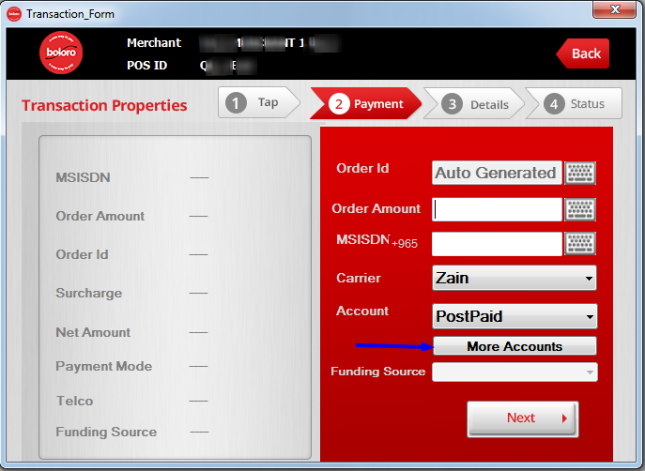

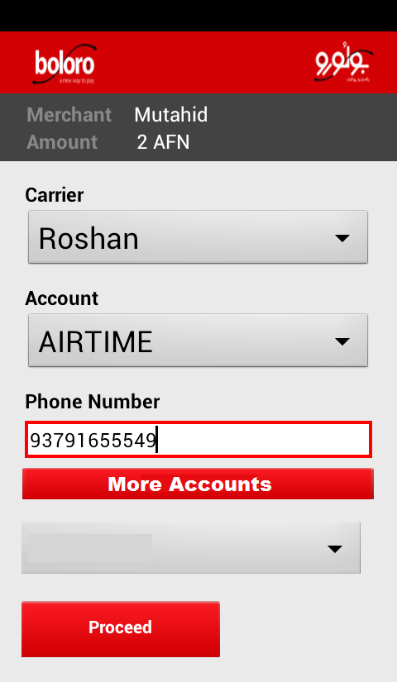

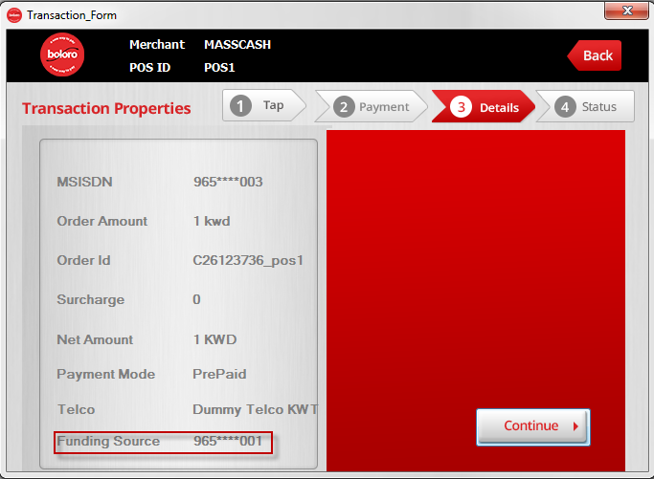

Get Mapped Accounts
If the customer requires to debit from the secondary source POS need to request for the mapped secondary sources from Boloro.
Get Mapped Accounts
Request Type: GET
Parameters | Description |  | Required
api_login_id | Merchant API Login |  | Yes
transaction_key | Merchant Transaction Key |  | Yes
market_id | Merchant Market (AFG, KWT, …) |  | Yes
primary_msisdn | The MSISDN provided by the customer |  | Yes
telco_id | Id of the selected telco |  | Yes
transtype | Transaction type of the selected msisdn(prepaid/postpaid) |  | No
Format | JSON
URL | https://[Boloro URL]/ getmappedaccounts
Response
JSON | {  "success": true/false,  "error_message": "",  "error_code": "",  "data": [  {  "primary_msisdn": "",  "primary_issuer": "",  "primary_transmode_id": "",  "secondary_msisdn": "",  "secondary_issuer": "",  "secondary_transmode_id": "",  "market_id": "",  "status": "",  "created_on": "",  "updated_on": "",  "label": ""  }  ],  "html": ""  }

Please note after getting the list of the mapped transaction there is some procedure need to be followed before initiating the transaction.
- Change the value of mobileno to the selected primary_msisdn
- Change the value of telco_id to selected secondary_issuer
- Change the value of trans_mode to selected secondary_transmode_id
- Add a new variable primary_msisdn and set the value of the provided MSISDN of the customer.
After this you can now send the transaction.

Automatic Request for Reversal
Boloro allows its merchant to initiate the request for the reverse transaction in case of any dispute in the transaction.

Refund Transaction
Request Type: GET
Parameters | Description |  | Required
api_login_id | Merchant API Login |  | Yes
transaction_key | Merchant Transaction Key |  | Yes
transaction_id | The Transaction id for which the refund request need to be initiated |  | Yes
Format | JSON
URL | https://[Boloro URL]/refundtransaction
Response
JSON | {  "success": true,  "long_message": "",  "short_message": "",  "error_message": "",  "error_code": ""  }

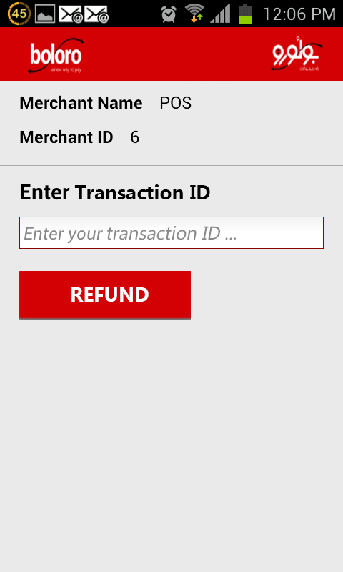

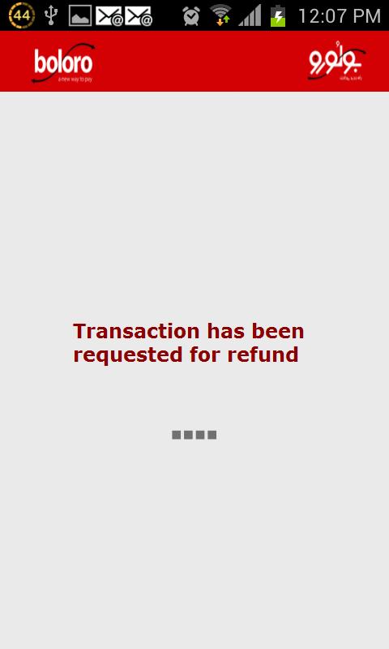Status Codes:

Status Code | State | Public Message | Description
101 | In-Progress | Checking Subscription Status | Checking Boloro Subscription Status
102 | In-Progress | Sending Pin Request | Sending Pin Request Message
103 | In-Progress | Verifying Pin | Waiting for Pin Response
104 | In-Progress | Debit Instruction Sent | Pin Verified! Charging Your Mobile Account
105 | In-Progress | VAS Instruction Sent | Payment Processed! Awarding Free On-Network Minutes
106 | In-Progress | Verifying Pin - Retry | Pin verification failed for the first time ...retry
107 | In-Progress | M-Wallet Instruction Sent | M-Wallet instruction has been sent
120 | In-Progress | Wallet Instruction Sent | Wallet instruction has been sent
1000 | Closed | Completed | Transaction completed successfully
1001 | Closed | Not a Telco Customer | The given number is not for given Telco
1002 | Closed | Not a Boloro Subscriber | The given number is not subscribed with Boloro
1003 | Closed | Pin Verification Failed | Incorrect PIN code was provided twice
1004 | Closed | Insufficient Credit | Customer do not have the sufficient Credit for the transaction
1005 | Closed | Debit Instruction Failed | Unable to deduct the amount from Telco
1006 | Closed | Request Timed Out | Transaction was not completed within the given time threshold
1007 | Closed | Completed with Errors | Transaction completed successfully but with some errors
1008 | Closed | Closed (Transaction Cancelled) | Transaction Cancelled by customer
1009 | Closed | Minimum Limit Failed | Transaction was less than the minimum limit
1010 | Closed | Closed (Rule Validation Failed) | Boloro Rules validation failed for this transaction.
1050 | Closed | System Error | There was some system error
1070 | Closed | Invalid Tag | NFC tag was not valid for the Boloro System
9999 | Closed | Unknown Transaction Status | If there are no valid transaction status

Error Codes:

Error Codes | Description
2001 | Error initiating transaction
2002 | Missing transaction id
2003 | Invalid transaction id
2004 | Missing order id
3000 | Merchant not authorized
3001 | Invalid Telco
3002 | Telco not found or Telco id not active
3003 | Invalid Service Provider
3004 | Missing merchant id
4000 | Merchant is not allowed to perform pin less transactions
4001 | Amount exceeded then allowed
4002 | Invalid amount
4003 | Invalid currency
4004 | Missing market id
4005 | No tag id provided
4006 | No Telco is associated with this tag id
4007 | The transaction amount is less the min. amount allowed
4008 | Conflicted market id of merchant and Telco
9000 | Unknown error
9001 | Session timed out
9002 | Error recording log. Please try again.

