<https://github.com/firaswehbe/U54NigeriaCode> - Here is the link to download the latest csv files for arms, events, data dictionary and instrument mapping on GitHub. **Download ZIP** folder with all the files and save it on your desktop.

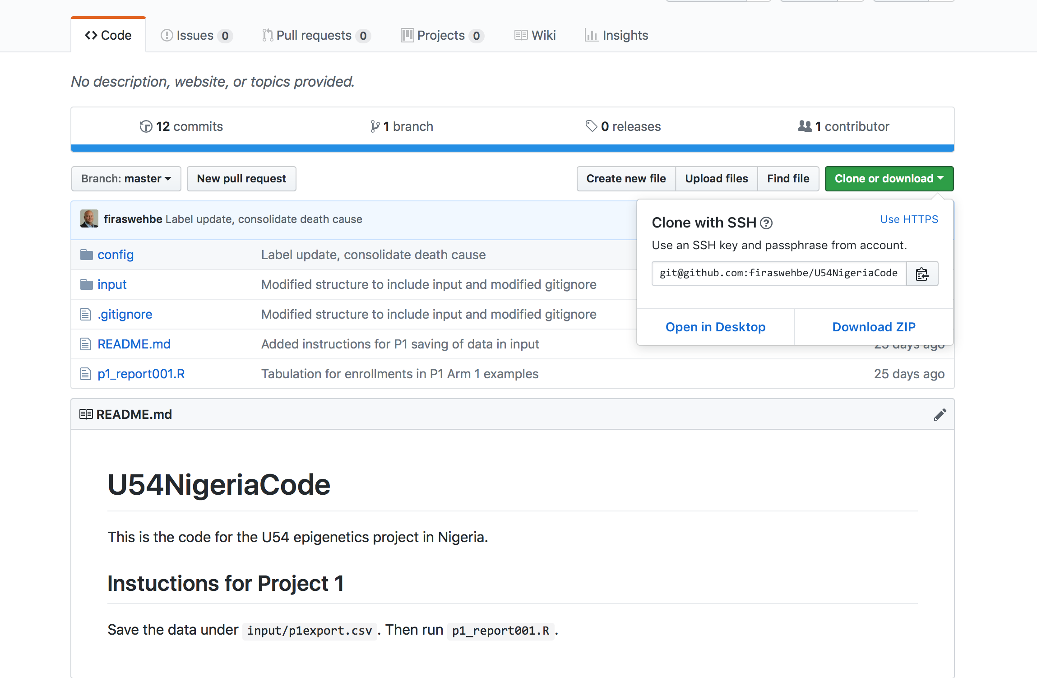

Follow the steps 1- 5 to set up a REDCap database.

If you are updating the data dictionary for an existing project, Please create a backup copy of

1. Existing REDCap database by exporting the data dictionary.
2. REDCap data by exporting raw data as a csv. **Do not open the exported raw data file** as it changes the date format in csv.
3. Skip steps 1, 2 and proceed to STEP 3.

**STEP 1** : This is how the Project Setup should look like.

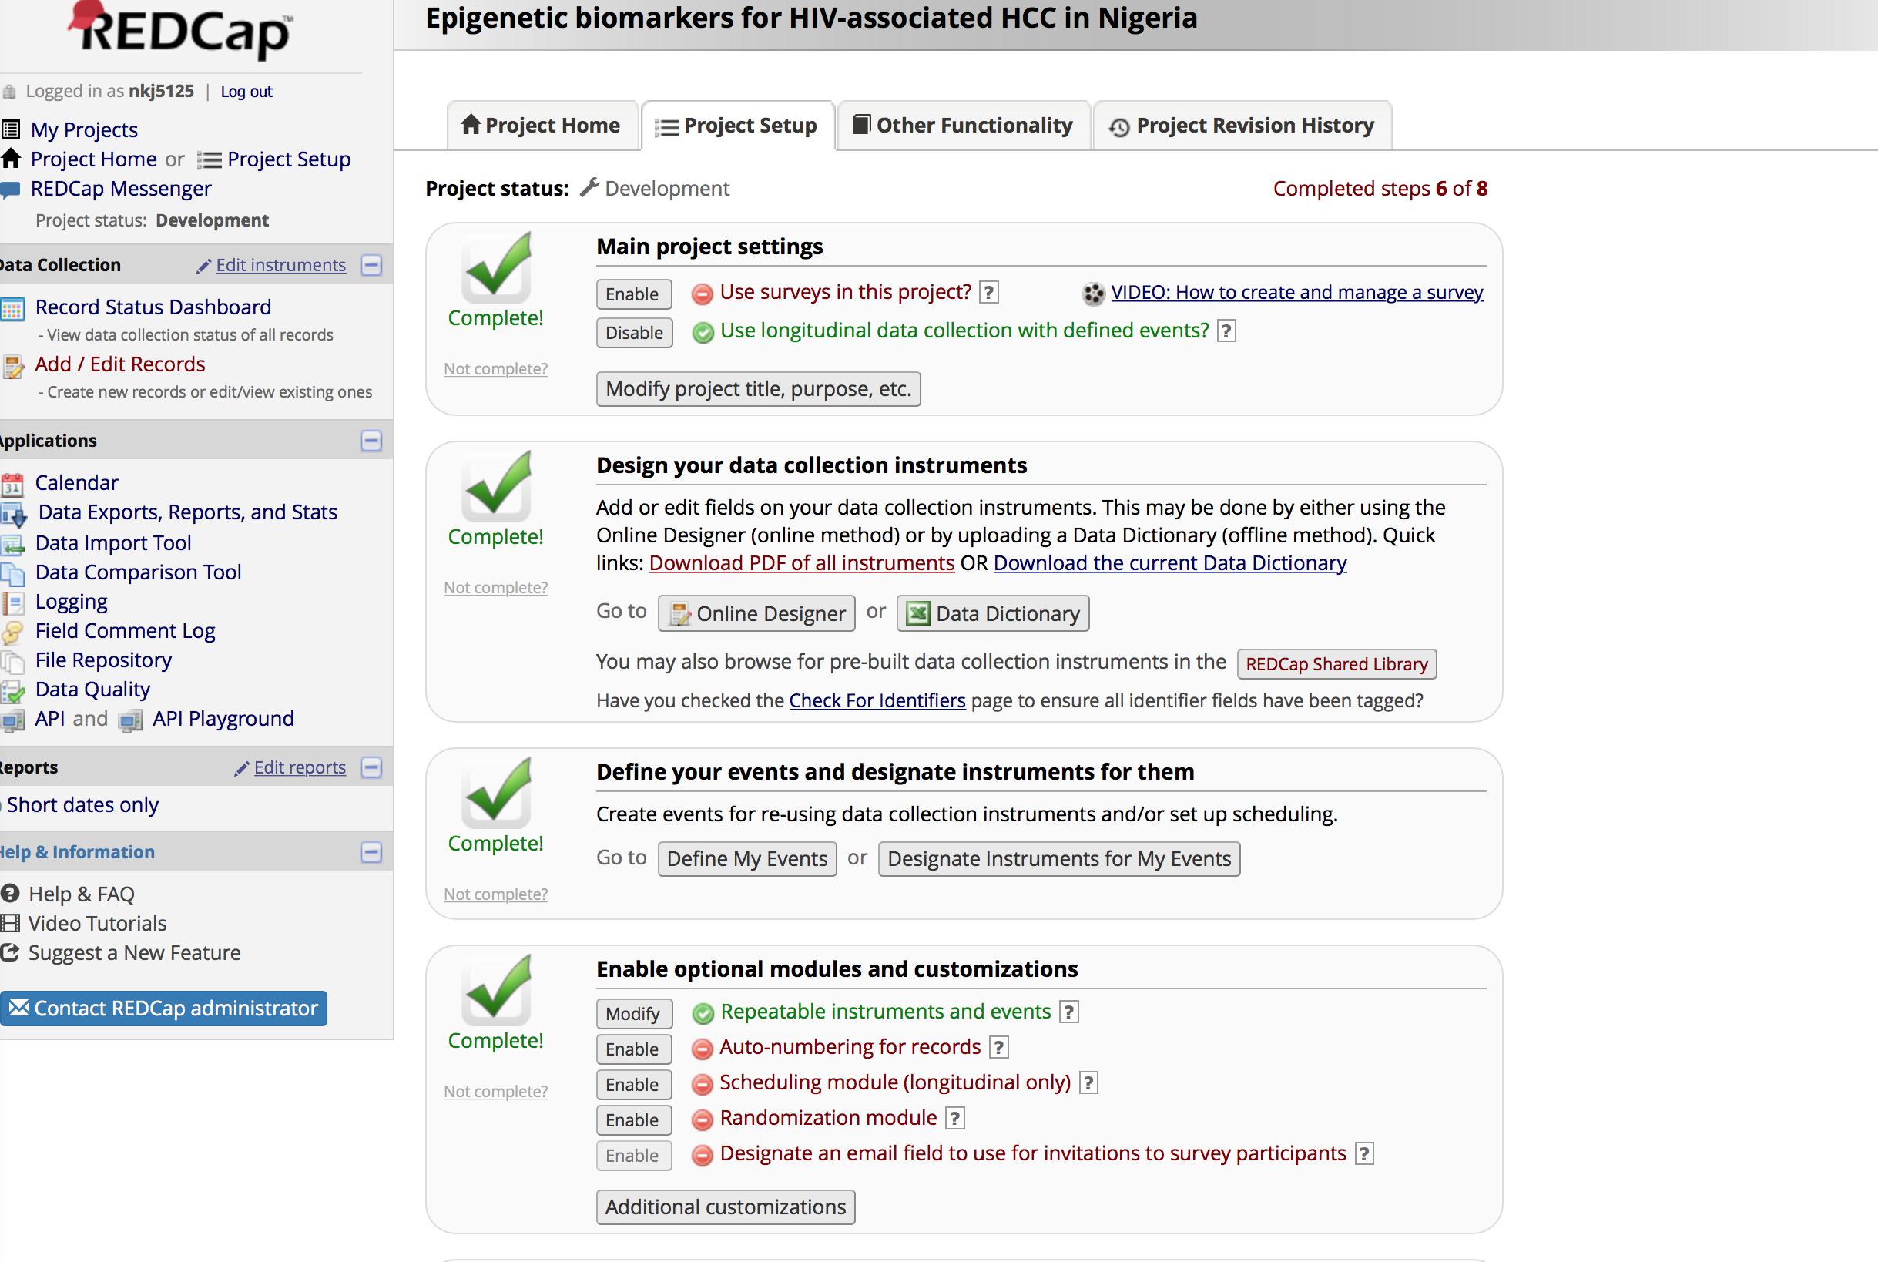

* Under Main Project settings - Enable the “Use longitudinal data collection with defined events?”
* Go to the third section “Define your events and designate instruments for them” and click “Define My Events”
* **STEP 2** : Click on “Upload or download arms/events” – and Upload P2_arms.csv file, then P2_events.csv file in the same order. Once you upload the csv files for arms and events, it should like the screenshot below.

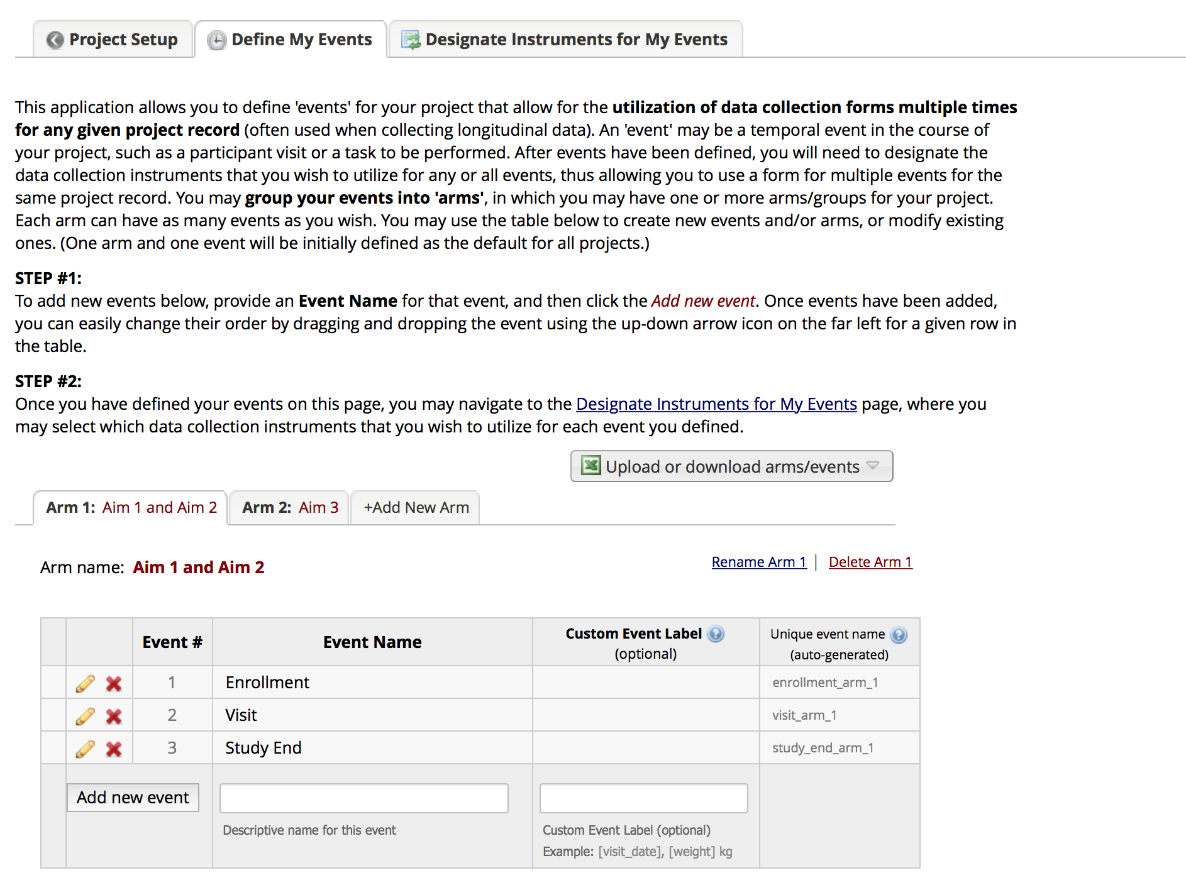

**STEP 3** : Go back to “Project Setup” tab on the top. Navigate to the section “Design your data collection instruments” and click Data Dictionary.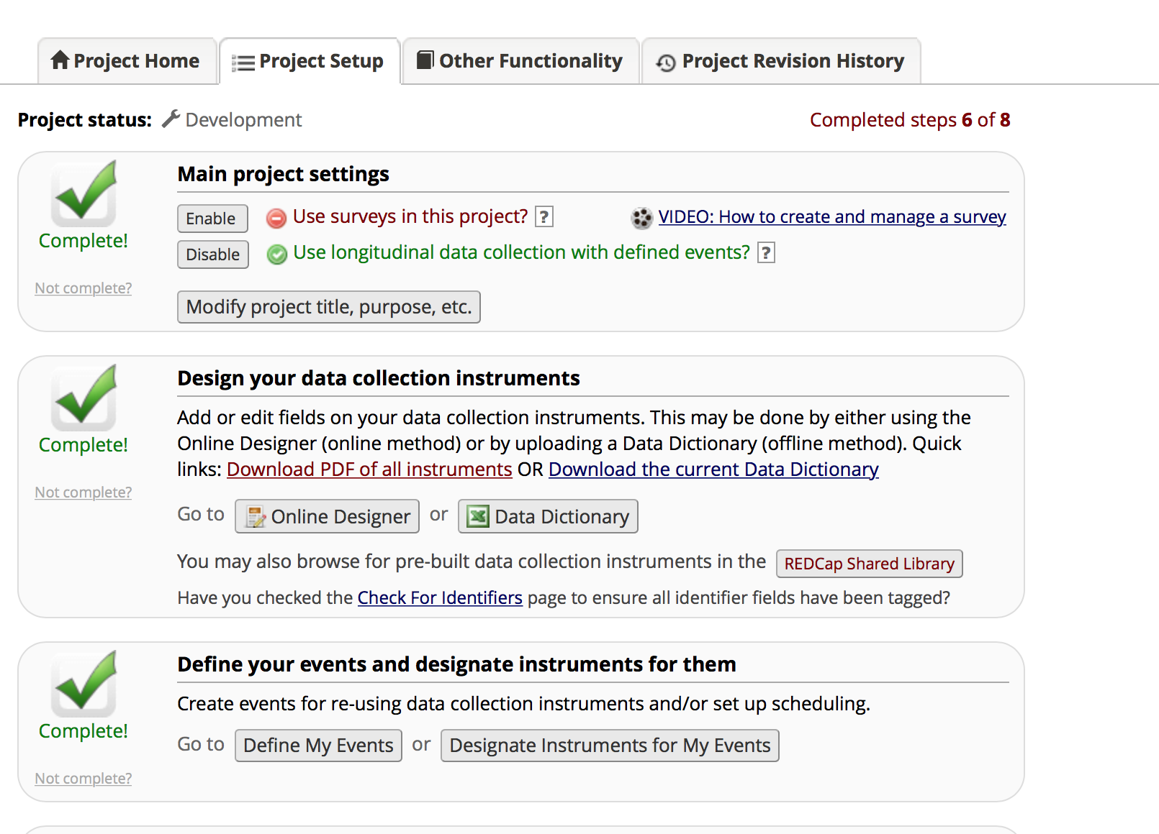

* Once you click Data dictionary, you will be directed to a page as shown in the screenshot below. Choose the data dictionary csv file(P2_DataDictionary.csv downloaded from github) and upload it.

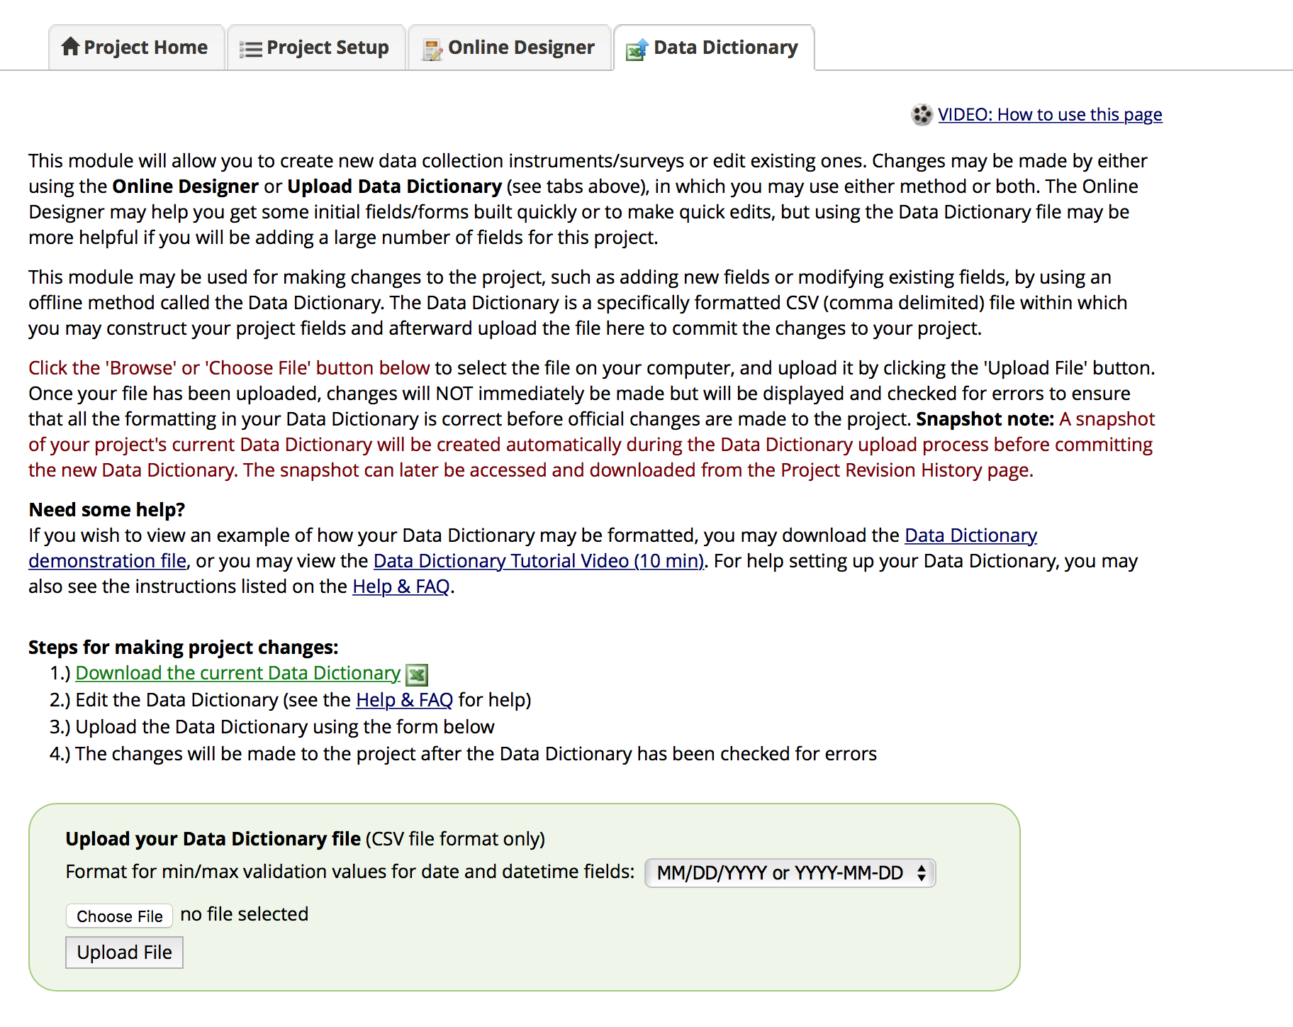

**STEP 4** : After uploading the data dictionary, Go back to “Project Setup” tab on the top. Navigate to “Define your events and designate instruments for them” section. Click on “Designate instruments for my events” and upload instrument- event mappings csv file(upload P2_Events2Forms.csv downloaded from github).

Aim 1 and 2 should look like this.

Aim 3 should look like this.

**STEP 5** : Go back to project setup tab on the top and click on “Repeatable instruments and events” under “Enable optional modules and customizations” section.

* The events should be repeated in both Arms as shown below.







* Click Additional Customizations in the ‘Project setup’ Tab under Enable optional modules and Customizations.

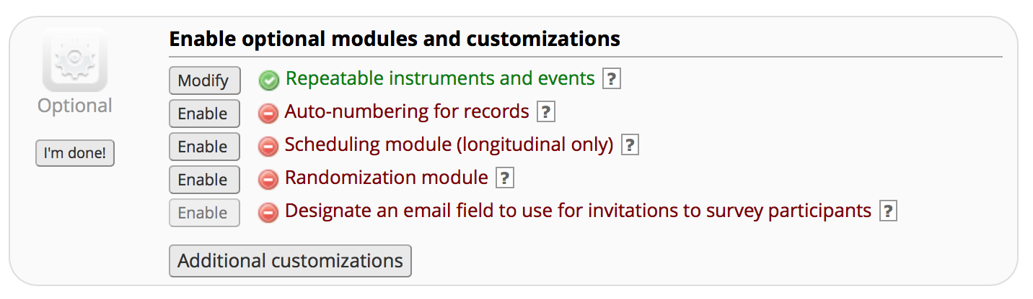

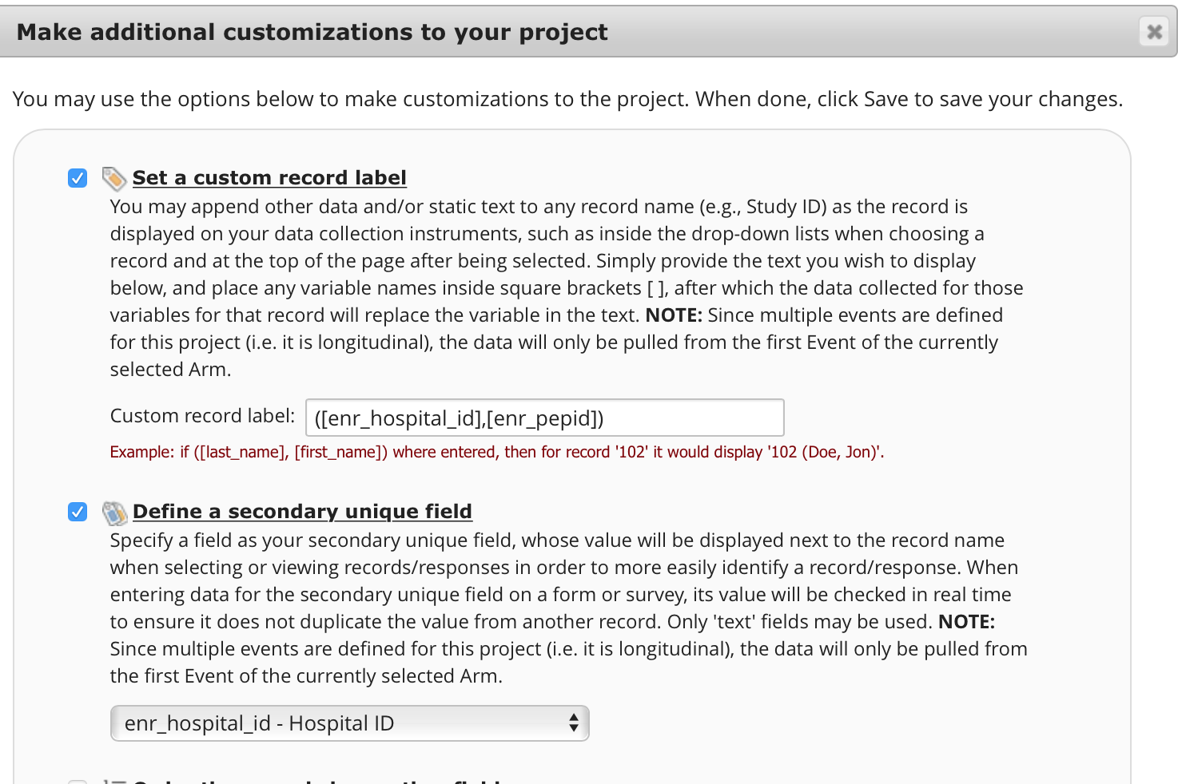

***Once all of this is done, your project will be ready.***

***Please do some spot checks and verify that the data is intact.***