IE306 Term Project
Learning Curves Appendix

- DQN’S and BC’s Curves

DQN Learning Curve
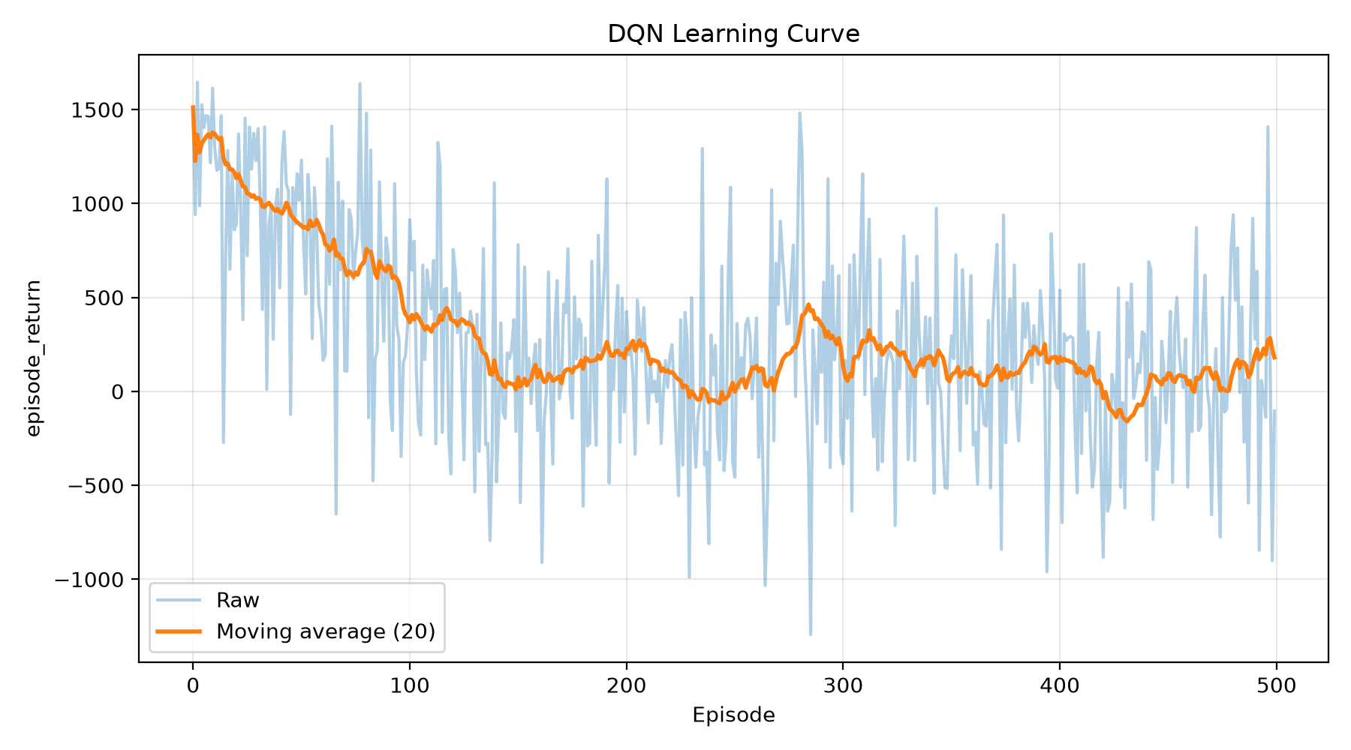

Double DQN Learning Curve
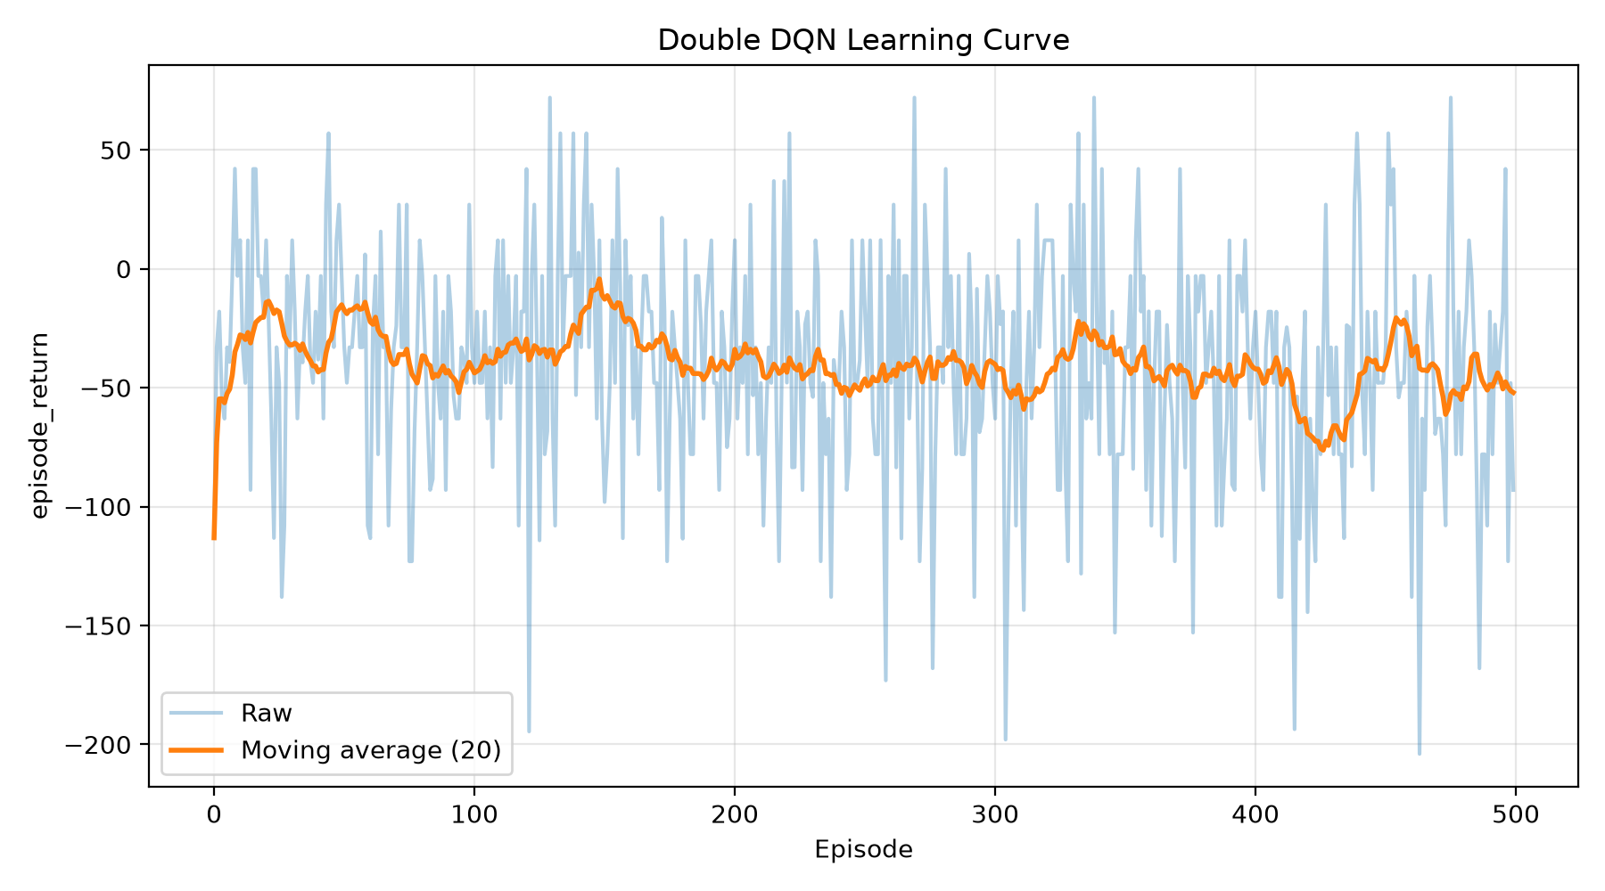

Dueling DQN Learning Curve
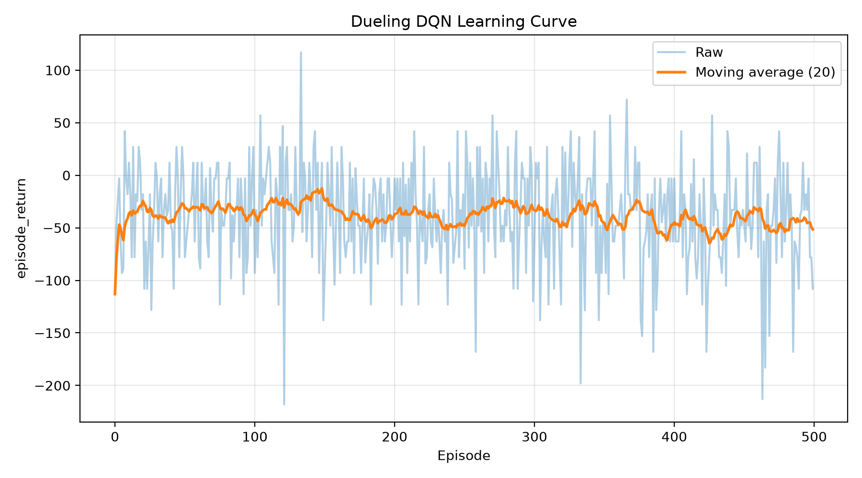

BC Seed 0 Loss Curve
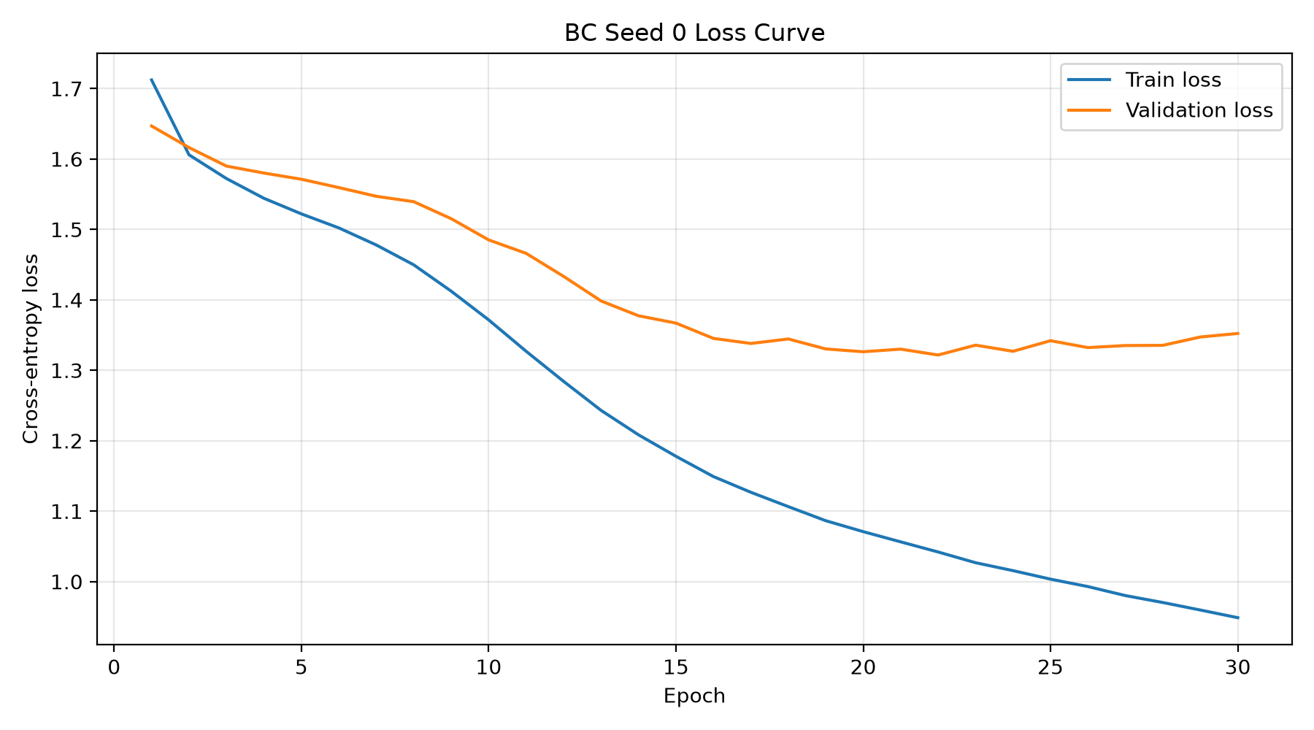

BC Seed 0 Accuracy Curve
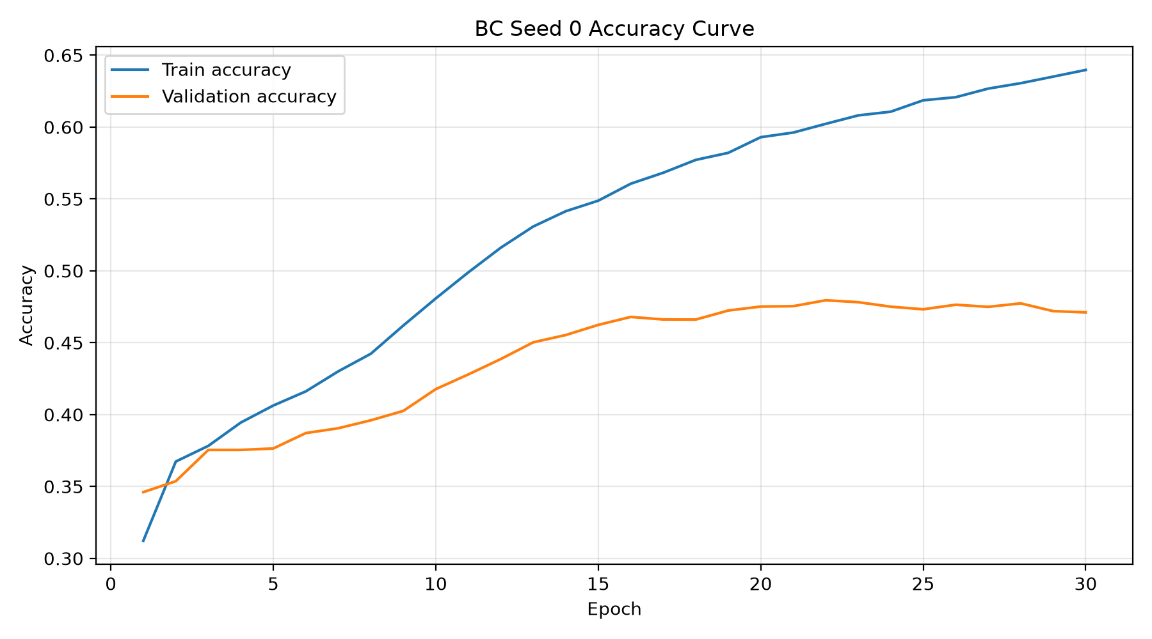

BC Seed 1 Loss Curve
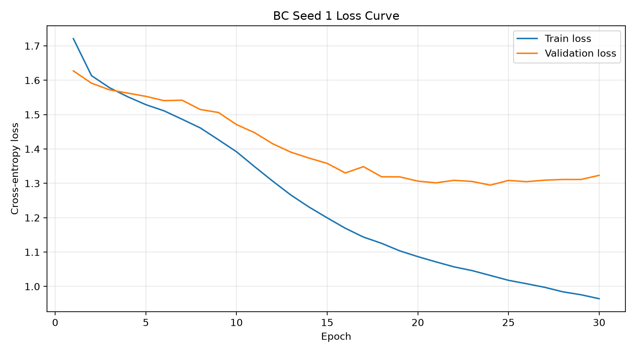

BC Seed 1 Accuracy Curve
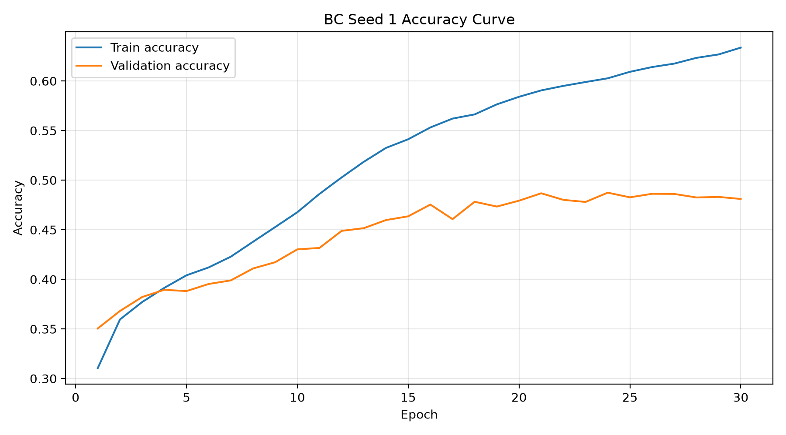

BC Seed 2 Loss Curve
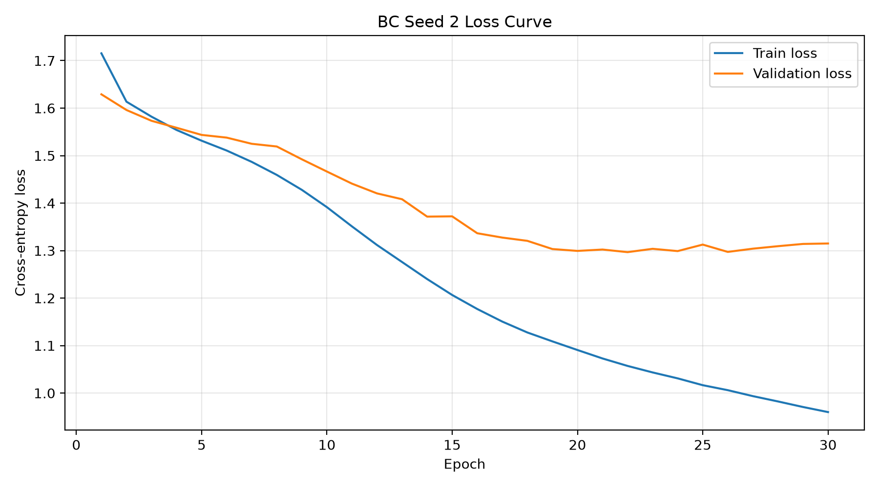

BC Seed 2 Accuracy Curve
