SIMPLE MICROPROCESSOR
DESIGN AND SPECIFICATIONS

Öğr. Gör. Fırat KÜÇÜK

legally free to copy, modify and redistrubute.

OpCode Table

Hexadecimal | Binary | OpCode
00 | 00000000 | JMP 8bit_address
01 | 00000001 | JMPA
02 | 00000010 | JMPB
03 | 00000011 | MOVA 8bit_data
04 | 00000100 | MOVB 8bit_data
05 | 00000101 | ADDAB
06 | 00000110 | NOP

Simple Assemly Program

Offset | Binary | Hex | Mnemonic
00 | 00000000 00000010 | 00 02 | JMP 02
02 | 00000011 00000101 | 03 05 | MOVA
04 | 00000001 | 01 | JMPA
05 | 00000100 00001000 | 04 08 | MOVB 08
07 | 00000010 | 02 | JMPB
08 | 00000101 | 05 | ADDAB
09 | 00000001 | 01 | JMPA
0A | 00000110 | 06 | NOP
0B | 00000110 | 06 | NOP
0C | 00000110 | 06 | NOP
0D | 00000000 00000000 | 00 00 | JMP 00

Signal Output

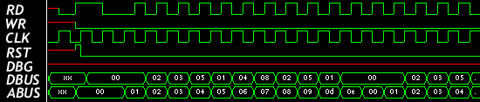

Microprocessor specification

Data Bus Length | 8 bits
Address Bus Length | 8 bits
Address Model | flat
Total Addressable Memory | 256 Byte
General Purpose Registers | A, B, IP
Max.Opcode Length | 2 Bytes
Supported Instructions | JMP, MOVA, MOVB, ADDAB, JMPA, JMPB, NOP

