Nama : Firda Rosela Sundari

NIM : 2200198

Kelas : 5B

Mata Kuliah : Sistem Tertanam

**Bukti Tugas P3**

1. **Bukti Instal VSCode**

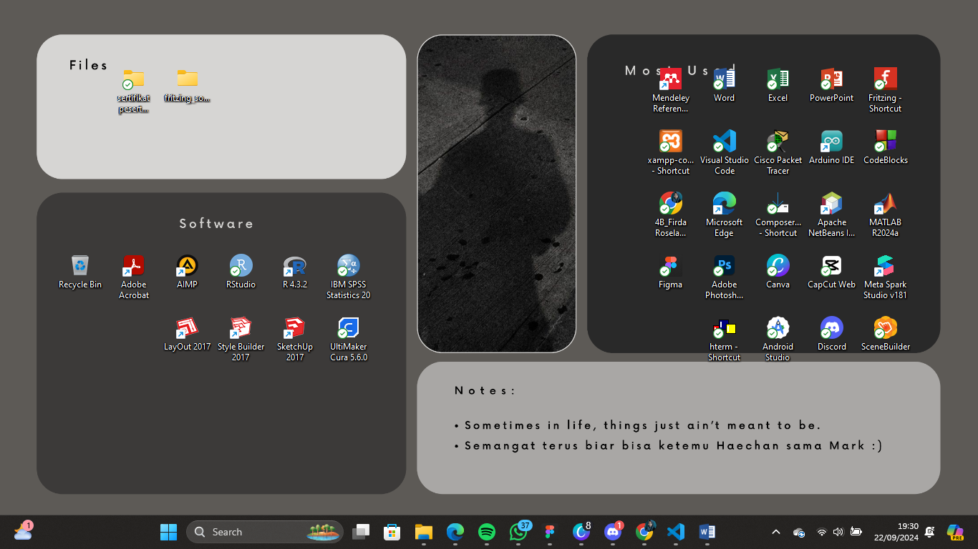

1. **Bukti Instal Platform IO**

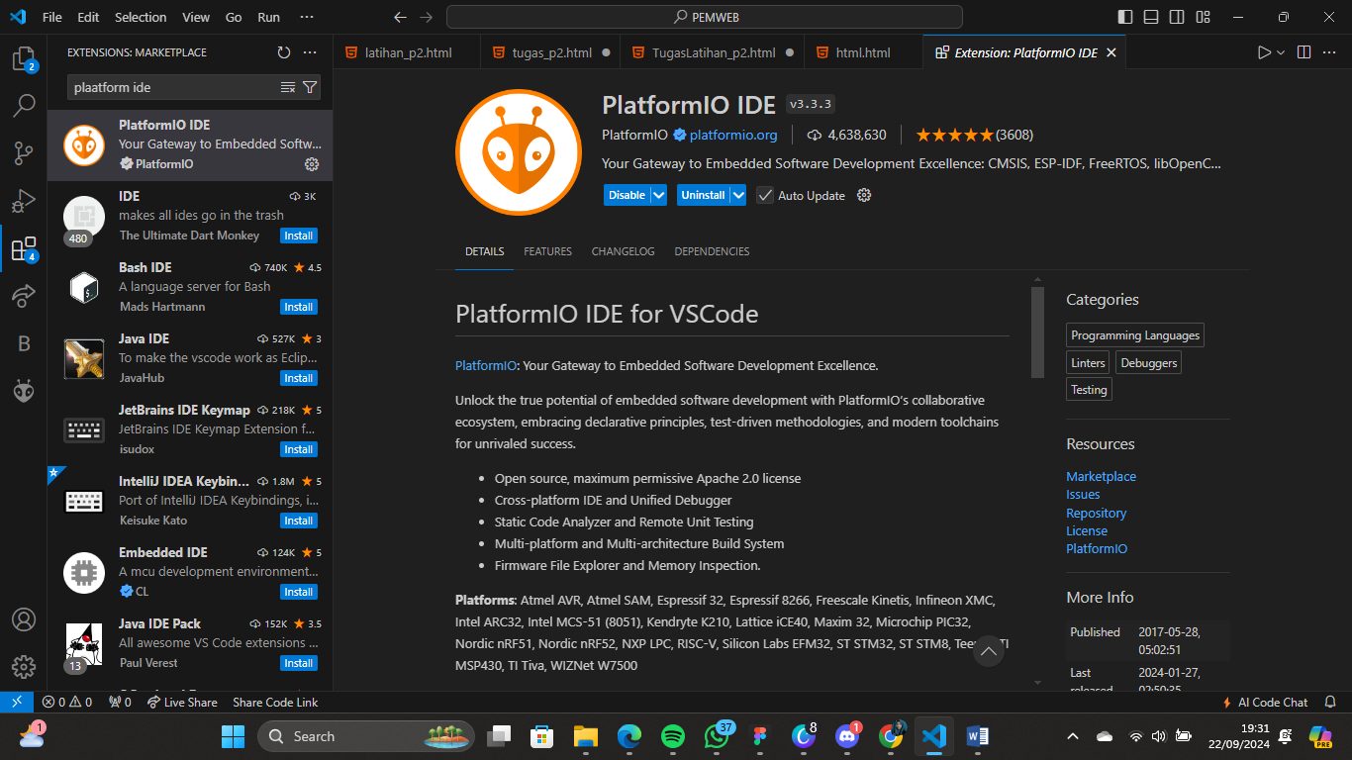

1. **Bukti Instal Serial Monitor Hterm**



1. **Source Code Akes GitHub**

