TUGAS BASIS DATA

Kelompok 2

Anggota :

1. Irfan Muhammad Iqbal (1201170279)
2. Firdayanti Nur Sastiananda (1201170147)
3. Muhammad Syafiq Ahnaf (1201170420)
4. Munalys Hidayatul Nafisa (1201174173)
5. Amalia Nur Azizah (1201174207)
6. Pradipta Ricky Baskara (1201174222)
7. Putu Andrian Surya Indirva (1201174187)

**ER Diagram :**

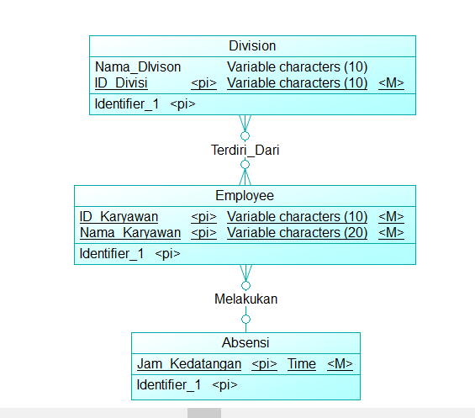

**DDL :**

CREATE TABLE division (

id_divisi varchar (10) NOT NULL,

nama_division varchar (10) default NULL,

PRIMARY KEY (id_divisi)

)

CREATE TABLE employee (

id_karyawan varchar (10) NOT NULL,

nama_karyawan varchar (20) default NULL,

PRIMARY KEY (id_karyawan)

)

CREATE TABLE absensi (

jam_kedatangan time NOT NULL,

PRIMARY KEY (jam_kedatangan)

)

**DML :**

INSERT INTO division (id_divisi, nama_division)

VALUES ('D001', 'Human Resources'),

('D002', 'Operating General'),

('D003', 'Admin'),

('D004', 'Finance'),

('D005', 'Marketing & Sales');

INSERT INTO employee (id_karyawan, nama_karyawan)

VALUES ('HR001', 'Adam'),

('HR002', 'Beta'),

('OG001', 'Charlie'),

('OG002', 'Darwin'),

('AD001', 'Edna'),

('AD002', 'Fraser'),

('FI001', 'Harry'),

('FI002', 'Igor'),

('MS001', 'Jake'),

('MS002', 'Lavine');

INSERT INTO absensi (jam_kedatangan)

VALUES (07:30),

(08:00),

(07:00),

(07:45),

(08:10),

(08:15),

(07:00),

(07:10),

(08:30),

(07:30);