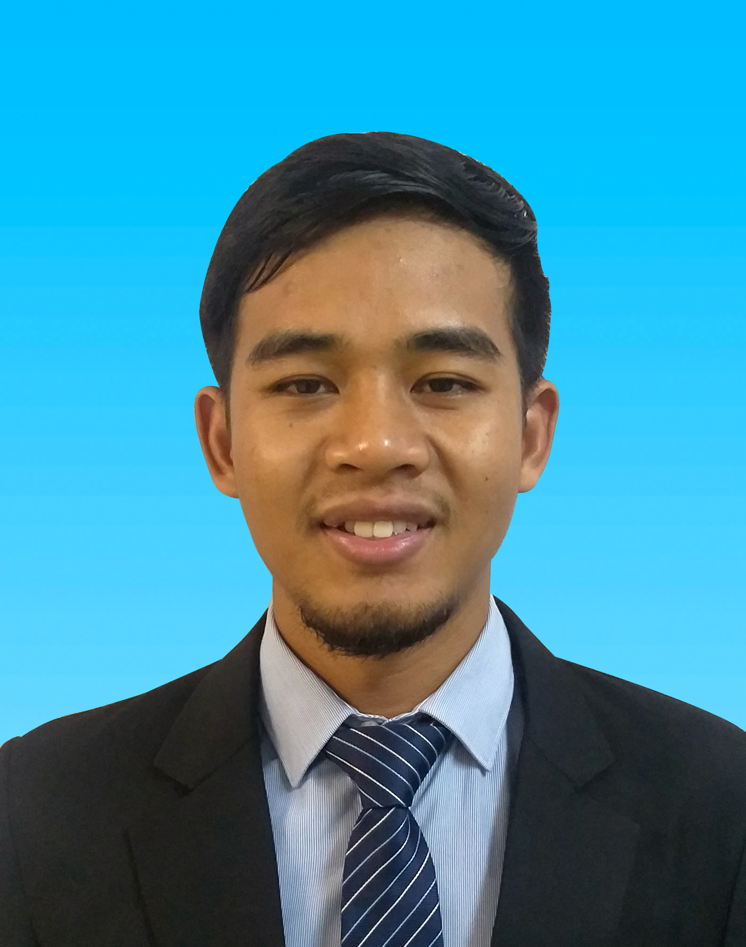
MUHAMMAD FIRDAUS BIN AZIZ

011-51381227

muhammad93firdaus@gmail.com

No 39, Kg Parit Buluh, Air Kuning Selatan, Gemencheh Negeri Sembilan, Malaysia
System Analyst

PROFILE

I am Muhammad Firdaus and currently seeking for job to acquire more knowledge. Perceptive Systems Analyst adept at designing innovative IT solutions and enhancing existing systems with new features. Committed to improving business productivity and efficiency. I would like to be a part of a company where I could use and enhance my skills and gain work experience for the future development of myself.

…………………………………………………………………………………………………………………………………..

EDUCATION
Universiti Teknologi MARA – (2016 – 2018)

Bachelor Degree in Information Technology
CGPA: 3.17
Universiti Teknologi MARA – (2011 - 2014)

Diploma in Computer Science
CGPA: 2.98
Sekolah Kebangsaan Bukit Jalor – (2006 - 2010)
Sijil Pelajaran Malaysia
4A, 2C, 1D, 2E
Penilaian Menegah Rendah
2A, 4B, 2D

.....................................................................................................................................................

COMPUTER SKILLS

- React Javascript

- Node.JS

- HTML, CSS
- Mongo.DB
- Microsoft SQL Server
- Unity 3D
- C# Programming
- MySQL
- PHP

…………………………………………………………………………………………………………………………………

EXPERIENCE
Pengaturcaraan Teknologi Maklumat/ Programmer | Bukit Jalil

Majlis Sukan Negara | September 2020 - Present
Scope:

- Writing well designed, testable, efficient code by using software development practice
- Maintained current system by updating the code
- Upload the new code on the server
- Perform debugging on web page
- Made modification to the database structure for the system using
- Involved extensively in Unit Testing and User Acceptance Testing
Skills:
- PHP
- Javascript
- Laravel Framework
- MySQL

System Analyst Programmer | Kajang

Synergy System Integration Service | February 2019 – August 2020
Scope:

- Develop system that met user requirements by performing system analysis and database design.
- Develop new user-facing features.
- Performing code and report development to meet the user requirements.
- Perform debugging on web page using React Development Tools.
- Involve extensively in Unit Testing and User Acceptance Testing.
- Made modification to the database structure for the system using MSSQL Database
- Develop Mobile Application by using React Cordova
Skills:
- React Javascript Framework
- Node.JS
- Microsoft SQL Server
- Material UI
- Mongo DB

Mobile Apps Developer (Augmented Reality & Virtual Reality) - Intership | Bukit Jalil

MIMOS Berhad | August 2018 – January 2019
Scope:

- Develop a virtual reality and augmented reality for industry.
- Develop Mock Up Apps Underground Utilities Augmented Reality for JUPEM
- Develop Virtual Reality Application Football Kicking VR 360 for gimmick Ceremony – UITM Fakulti Pendidikan
Skills:
- Unity 3D
- C# Programming
- Vuforia Engine

Assistant Supervisor | Negeri Sembilan

Nam Bee Company Sdn. Bhd | January 2015 – May 2016
Scope:

- Supervise employee to help ensure efficiency and productivity, perform administrative task under guidance of the supervisor like guidelines.

Cashier | Gemencheh NSDK

Shell Pump Station Gemencheh | November 2010 – January 2011
Scope:

- Operating the cash register and handling cash transactions with customer.

...............................................................................................................................................…

EXTRA CURRICULAR

- Cycling Competition Karnival Sukan Mahasiswa (KARiSMA) at UiTM Sri Iskandar, Perak Campus – 2018
- President of UiTM Cycling Club (UiTM Shah Alam Campus) – (2017-2018)
- Cycling Competition Karnival Sukan Mahasiswa (KARiSMA) at UiTM Arau, Perlis Campus – 2017
- Cycling Competition Karnival Sukan Mahasiswa (KARiSMA) at UiTM Puncak Alam Campus – 2013
- Komander Kesatria UiTM Melaka (2012-2014)
- President of UiTM Melaka Cycling Club (2012-2013)

...............................................................................................................................................…

LANGUAGE

- Bahasa

- English

…………………………………………………………………………………………………………………………………..

REFERENCE

Dr. Emma Nuraihan Mior Ibrahim (UiTM Shah Alam) – 03 55211155
emma@tmsk.uitm.edu.my

Faisal Bin Embong (Majlis Sukan Negara) – 019 9663343
faisal.nsc.gov.my

