Strengthening Sanitation During Pandemic:
Implementation in Patutrejo Village, Grabag, Purworejo

Febriansyah Ignas Pradana
Air Transportation Management
Sekolah Tinggi Teknologi Kedirgantaraan
Yogyakarta, Indonesia
febriansyah.ignas@sttkd.ac.id

Zenita Kurniasari
Transportation Management
Sekolah Tinggi Teknologi Kedirgantaraan
Yogyakarta, Indonesia
zenita.kurniasari@sttkd.ac.id

Desiana Rachmawati
Air Transportation Management
Sekolah Tinggi Teknologi Kedirgantaraan
Yogyakarta, Indonesia
desiana.rachmawati@sttkd.ac.id

Indreswari Suroso
Aeronautical Engineering
Sekolah Tinggi Teknologi Kedirgantaraan
Yogyakarta, Indonesia
Indreswari.suroso@sttkd.ac.id

Abstract— In early March 2020, the Covid-19 pandemic began to enter Indonesia. Almost all areas in Indonesia were exposed, one of them was Purworejo Regency, Central Java. The citizen of Purworejo Regency, especially Patutrejo Village, had limited internet access which became an obstacle in delivering information related to habitual adaptation in preventing the transmission of Covid-19. This activity aims to increase people understanding about the procedures of implementation of New Habit Adaptation and their compliance with health protocols during the Covid 19 pandemic; and to strengthen the sanitation procedures during Covid-19 pandemic. It is qualitative study based on observation, socialization activities, discussions, questions and answers. The subject is all citizen of Patutrejo Village, Purworejo Regency. The results show implementation of socialization against the dangers of Covid-19 and the application of health protocols. A hand washing place which were equipped by hand soap installed in four areas in Patutrejo village. The results of this activity are expected to increase awareness of Patutrejo's people about the dangers of Covid-19 transmission and the importance of implementation of health protocols in 3 M (maintaining distance, wearing masks and washing hands with soap).
Keywords— Covid-19 pandemic; health protocol; sanitation strengthening

Introduction
The Covid-19 virus started to spread to Indonesia in early March 2020. It was known when two Depok, West Java, residents were identified as the first Covid-19 positive cases on March 2, 2020 [1]. These first cases were declared by President Joko Widodo on March 2, 2020 [2]. The condition results in multidimensional impacts on people's lives, both in terms of economy, social interaction until finally leading to a new order of life. The new normal condition has been widely echoed, including by Indonesia. It represents a new hope to adjust life in the midst of a pandemic with more appropriate measures [3]. Numerous measures have been implemented in combatting the spread of Covid-19 in Indonesia, one of which is through the 3M Movement [4]. Some people are starting to be vigilant and careful and adopt a healthy lifestyle, but there are some who don't care and seem dismissive. It is this indifferent attitude that then accelerates the spread of the coronavirus [5]. Some people are apathetic towards the virus prevention due to their ignorance of the dangers and impacts of the increasingly severe spread of the coronavirus. In order to reduce the number of Covid-19 cases, the urgency of independence and innovation from the community is currently of great importance [6].
Up to October 17, 2020, there were 357,762 positive cases, 281, 592 were declared cured, 12,431 were declared dead and 63,739 were still being treated. From all the positive cases, Central Java became the top four provinces with 28,723 positive cases or 8.0% of the total cases [7]. One of the affected regencies in Central Java is Purworejo Regency, with positive cases of 750 cases as of October 17, 2020, with details of 126 positive cases without symptoms, 5 positive people were still being treated, 26 have died and 593 have recovered [8].
Of 16 subdistricts in Purworejo Regency, Grabag Sub-District is a sub-district without a confirmed positive case [9]. Grabag Sub-District is a green zone, but it does not close access for visitors from other areas. If health protocols are not properly implemented, there is a possibility of transmission of Covid-19 in villages with green zone status. Villagers think that the corona virus has disappeared so they no longer carry out health protocols and they also often travel with no regard to social distancing [10]. Community empowerment is needed to significantly accelerate the handling of the Covid-19 pandemic [11].
From a social perspective, community life in Patutrejo Village shows what it is called as a close-knit community. The strong bond among inhabitants indicates that the community can collectively prevent the spread of Covid-19. However, limited internet access in Patutrejo Village presents an obstacle in delivering information related to the adaptation of new habits and the importance of implementing health protocols. There is a need for a system that can deliver accurate and directed information on the danger of Covid-19 and how to prevent it to the people of Patutrejo Village to halt additional cases in the area.
Based on the background above, the researcher sets the main objective of this study to increase people understanding about the procedures of implementation of New Habit Adaptation and their compliance with health protocols during the Covid 19 pandemic; and to strengthen the sanitation procedures during Covid-19 pandemic.

RESEARCH METHODS
A dissemination program to be enacted for the community was sanitation strengthening during the Covid-19 pandemic. The study location was in Patutrejo Village, Grabag Sub-District, Central Java. It was a qualitative study based on observation, dissemination activities, discussions, questions and answers. Observation was performed first to determine the problem faced by partners and solution to help them in overcoming the problem. Dissemination was carried out with material regarding the dangers of the coronavirus and procedures for implementing new habits by always complying with health protocols. It was carried by the means of lectures accompanied by discussions and a question-and-answer forum for people who need further information on the dissemination materials. At the end of the activity, the handover of thermo-guns, hand sanitizers and installation of sanitation in the form of hand washing facilities as one of the supporting facilities for the implementation of health protocols were carried out.

RESULTS AND DISCUSSIONS

Result
The program was carried out on Wednesday, November 25, 2020 at Patutrejo Village Hall, Grabag Sub-District, Purworejo Regency, Centra Java. The first agenda was the dissemination on the dangers of coronavirus and procedures for implementing new habits, attended by 26 participants. Then, it was followed by the handover of hand-washing facilities placed in Hamlet I, Hamlet II, Hamlet III and Hamlet IV of Patutrejo Village.

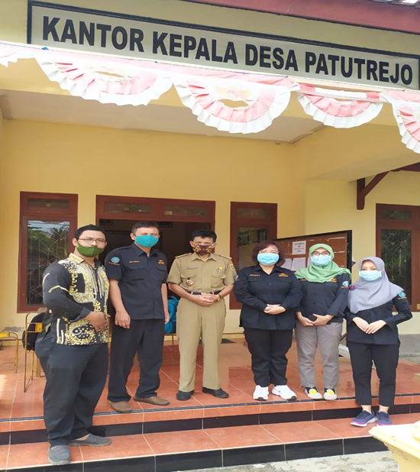
Fig. 1. Observation Activity

Fig. 2. Dissemination Activity
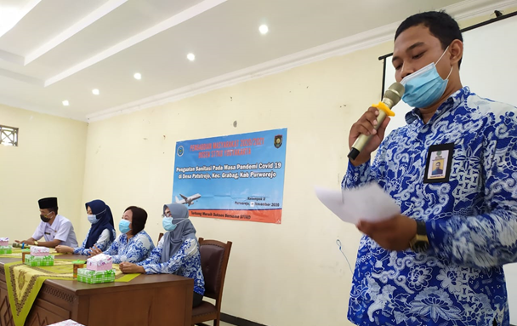
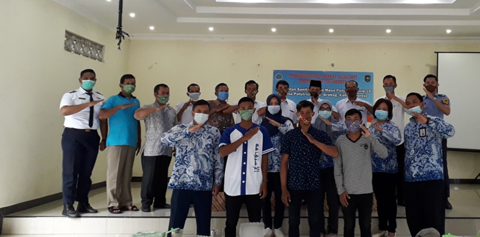
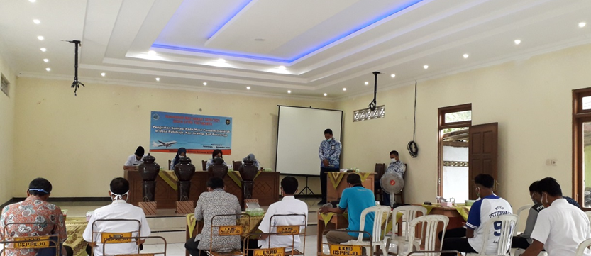
Fig. 3. The handover of hand-washing facilities and health protocol equipment
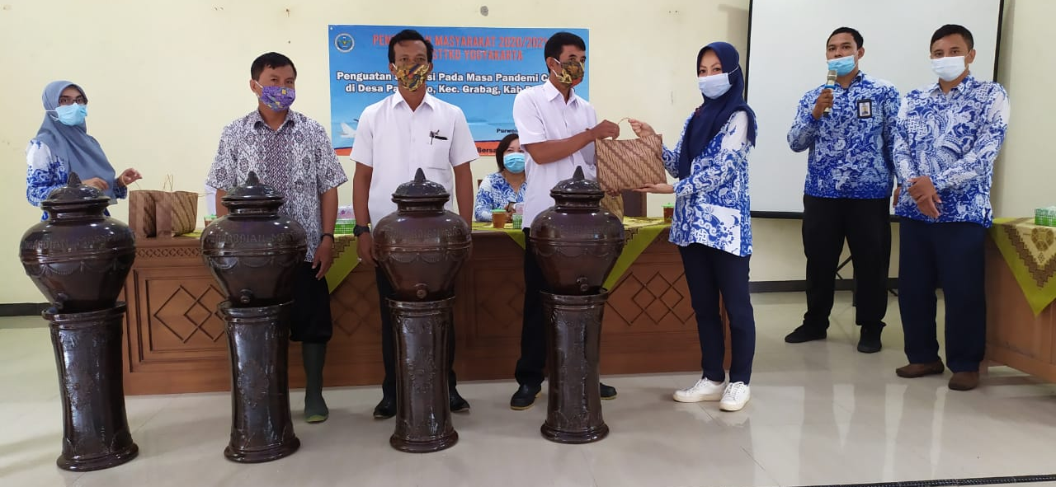

Discussions
SARS-CoV-2, the cause of Covid-19, is transmitted through a contact with respiratory droplets of from infected individuals generated by talking, coughing, or sneezing. Droplets may stay airborne for up to a certain time and up to a certain distance [12]. Spokesperson for the Covid-19 Handling Task Force urged people who have complied with health protocols to remind those around them [13]. To heed the call, the community service team invited the people of Patutrejo Village to comply with health protocols. The Covid 19 outbreak is a global problem [14]. Social distancing is very necessary to prevent this virus [15].
The community service activity was carried out in the form of dissemination in order to foster awareness and vigilance against the dangers of Covid-19 which is still widespread both in the world and in Indonesia. The results of the first activity show that there were some participants who did not understand the meaning of adapting new habits and implementing the correct health protocol, thus, the dissemination is expected to improve the understanding of Patutrejo Village residents regarding the prevention of the transmission of Covid-19.
The dissemination was then continued with the handover of aids to strengthen sanitation and the enforcement of health protocols. The second activity results in the delivery of sanitation tools and equipment to facilitate the implementation of health protocols. The sanitary equipment includes hand washing instrument in the form of a jar or equivalent, as well as several other complementary health protocols such as hand washing soap, hand sanitizer and masks. The installation of this hand washing facility received a very good response from local residents. Hand washing facilities equipped with soap encourage residents to always wash their hands before their daily routines so that public health is maintained.

CONCLUSION
Public awareness in implementing health protocols during a pandemic is very important and must be improved. Some important aspects are still not well understood by some residents of Patutrejo Village in facing the adaptation of new habits. The results of this activity are expected to improve awareness of Patutrejo people about the dangers of Covid-19 transmission and the importance of implementation of health protocols in 3M (maintaining distance, wearing masks and washing hands with soap).

Acknowledgment
The implementation of this community service is funded by the Center for Research and Community Service (P3M) of Sekolah Tinggi Teknologi Kedirgantaraan Yogyakarta in fiscal year 2020. We would like to express our utmost gratitude to the P3M of STTD Yogyakarta, village officials and residents of Patutrejo Village as well as all parties who have assisted in the implementation of this community service program.

References

- E. Wahyono, “Kapan sebenarnya corona pertama kali masuk RI?, https://news.detik.com/berita/d-4991485/kapan-sebenarnya-corona-pertama-kali-masuk-ri, April 2020, Diakses 17 Oktober 2020 pukul 19.03 WIB
- CNN Indonesia, “Jokowi umumkan dua WNI positif corona di Indonesia”, https://www.cnnindonesia.com/nasional/20200302111534-20-479660/jokowi-umumkan-dua-wni-positif-corona-di-indonesia, Maret 2020, Diakses 17 Oktober 2020 pukul 18.36 WIB.
- Binus Graduate Program, “Mengawali New Normal, 3 Aspek Penting Yang Akan Berubah Di New Society”, https://dcs.binus.ac.id/2020/07/21/mengawali-new-normal-3-aspek-penting-yang-akan-berubah-di-new-society/, Juli 2020, Diakses 17 Oktiber 2020.
- BPKAD Provinsi Jawa Tengah, Gerakan 3m Dalam Pencegahan Covid-19,https://bpkad.jatengprov.go.id/berita2/gerakan-3m-dalam-pencegahan-covid-19, Oktober 2020, Diakses 23 Oktober 2020.
- N. Salsabila, “Perubahan yang terjadi dalam masyarakat sebagai dampak dari Covid-19,” https://fisip.ub.ac.id/perubahan-yang-terjadi-dalam-masyarakat-sebagai-dampak-dari-covid-19, Mei 2020, Diakses diakses 17 Oktober 2020 pukul 20.12 WIB.
- Rahmi, V. A., Ismanto, H., &Fathoni, M. Z., Inovatif Saat Pandemi Covid “ Pelatihan Kewirausahaan Khas Perempuan Berbahan Sampah “ Kolaborasi BUMDes .” DINAMISIA: Jurnal Pengabdian Kepada Masyarakat, 4(3), 2020, pp 418–425.
- Satuan Tugas Penanganan COVID-19, “Data Sebaran Covid-19 Indonesia”, https://covid19.go.id/, Oktober 2020, Diakses 18 Oktober 2020 pukul 10.04 WIB.
- Pemerintah Kabupaten Purworejo, “Statistik terbaru kasus Covid-19 Purworejo,” https://covid19.purworejokab.go.id/, Oktober 2020, Diaskses 18 Oktober 2020 pukul 08.34 WIB.
- Pemerintah Kabupaten Purworejo, “Peta daerah rawan Covid-19 Purworejo,” https://covid19.purworejokab.go.id/, Oktober 2020, Diaskses 18 Oktober 2020 pukul 08.38 WIB.
- Susilowati, Dwi, dkk., “Pengabdian Masyarakat Melalui Sosialisasi Protokol Kesehatanmenghadapi Pandemi Covid-19”. Jurnal Pembelajaran Pemberdayaan Masyarakat JP2M Vo.1 No.4, eISSN 2721-5148, 2020, Hal. 300-304.
- Sunuantari, M., Sub TEMA : Covid-19 , Komunikasi dan Community Empowerment Tata Kelola Black Zone Covid-19 Berbasis Komunitas Vol. 17, 2020.
- Layanan Darurat Covid-19 Jakarta, “Waspada Penularan Covid-19”. https://corona.jakarta.go.id/id/faq, Diakses 20 Oktober 2020.
- Hakim, Lukman, “Disiplin 3M, Kunci Utama Tekan Penularan Covid-19”. https://www.kominfo.go.id/content/detail/29899/disiplin-3m-kunci-utama-tekan-penularan-covid-19/0/sorotan_media, Oktober 2020, Diakses 22 Oktober 2020.
- Syafrida, S., & Hartati, R. (2020). Bersama melawan virus covid 19 di Indonesia. SALAM: Jurnal Sosial Dan Budaya Syar-I, 7(6), 495-508.
- Pradana, A. A., & Casman, C. (2020). Pengaruh Kebijakan Social Distancing pada Wabah COVID-19 terhadap Kelompok Rentan di Indonesia. Jurnal Kebijakan Kesehatan Indonesia: JKKI, 9(2), 61-67.

