Company Performance Review during the Covid-19 Pandemic,
A Bibliometric Study

Arifah, Siti¹
Faculty of Economics
Universitas Tidar
Magelang, Indonesia
sitiarifah@untidar.ac.id

Probohudono, Agung Nur³
Faculty of Economics and Business
Universitas Sebelas Maret
Surakarta, Indonesia
agungnp@staff.uns.ac.id

Prasetyanto, Didik²
Faculty of Economics and Business
Universitas Sebelas Maret
Surakarta, Indonesia
didikprasetyanto@gmail.com

Widarjo, Wahyu⁴
Faculty of Economics and Business
Universitas Sebelas Maret
Surakarta, Indonesia
widarjo@staff.uns.ac.id

Abstract—This study aims to provide empirical evidence regarding the growth and trend of publications related to the performance of companies/business entities during the Covid-19 pandemic and to review what variables are often associated with performance. The data in this study are the results of research published during the Covid-19 period, limited until the time this research was carried out using a systematic literature review method using bibliometric analysis with the VOS viewer app. The number of studies used as data in this study amounted to 374 articles obtained from the Science Direct page. The results of this study indicate that research on performance during the Covid-19 pandemic has been widely carried out in various countries and published. There are several variables related to the topic of performance, companies, and Covid, including innovation, sustainability, crisis, SMES, and resilience. Some of the names of the authors that appeared, namely, Sascha Kraus, Andreas Kallmuenzer, and Johanna Gast who could be considered references/references. The limitation of this study is that it cannot provide an overview of the direction of the trend in the use of research variables in 2021. This research is expected to provide implications in the development of future research, especially related to performance and the pandemic situation.

Keywords— Performance; Company; Covid; Bibliometrics

Introduction
The Covid-19 pandemic is a health and humanitarian disaster that affects all lines of human life in every region of the world [1]. Starting from health problems, the impact of the Covid-19 pandemic has spread to social problems, economic problems, and even to the financial sector. Covid-19 emerged in December 2019 from Wuhan, China and became a global pandemic causing sudden and massive business disruptions globally. On March 11, 2020, the World Health Organization (WHO) officially announced that Covid-19 was a global pandemic. The Covid-19 pandemic has been categorized as a black swan event that triggers a ripple effect on all aspects of human life [2].
The Covid-19 pandemic has affected all segments of the population, especially vulnerable groups such as the elderly, the weak, the disabled, the marginalized, and the poor [3]. In response to the pandemic outbreak, the leaders of many countries decided to save the lives of their citizens before saving the economy, declaring sudden or gradual restrictions and lockdowns in their countries. Policies such as social distancing and work from home were implemented suddenly and severely impacted several businesses across industries [3,4].
According to the World Trade Organization (WTO, 2020), world trade has experienced a slump in 2019, and then the Covid-19 pandemic triggered a global financial crisis. Preliminary estimates have estimated that each country's economy will lose around 2.4 to 3.0 per cent of their Gross Domestic Product (GDP) during 2020 due to the Covid-19 pandemic (WTO, 2020). It is becoming a challenge for most businesses around the world to keep their financial wheels turning, given dwindling revenues and high levels of uncertainty. Therefore, it is very important for businesses to carry out a proper assessment and analysis of the feasibility of their business model [3].
Compared to the 2008 global financial crisis, the Covid-19 pandemic was associated with several new challenges, due to the widespread restrictions on protecting the functioning of the health system [5]. The widespread of Covid-19 worldwide has increased uncertainty regarding consumption and investment among various stakeholders, such as consumers, trading partners, suppliers and investors [3]. The increase in travel restrictions both nationally and internationally greatly affects the economy in general. The Covid-19 crisis produced a domino effect across global and regional supply chains, disrupting demand and supply [6]. In addition, social distancing policies have almost destroyed service industries, such as travel and tourism and hospitality, which can trigger a recession [3]. Recent research has shown that overall financial performance in China has declined across industries since the Covid-18 pandemic [7]. This is reflected in declining revenues, profitability and overall investment in companies across industries. Nonetheless, the sharpest declines were shown in the travel and tourism industries, and transportation [8].
In addition, to flatten or lower the Covid-19 infection rate curve, several countries around the world have imposed social restrictions and lockdowns. This has had a huge direct impact on economic activity in almost every sector. For example, activities involving direct contact between consumers and service providers have been affected by social restrictions [9]. Many companies face bankruptcy or reduce their production capacity, leading to higher unemployment and underemployment [1]. A prolonged lockdown period also increases the risk of a massive increase in corporate and government debt, leading to underlying financial imbalances that could prolong the recovery period from the Covid-19 crisis [3].
The research of [10] examines the impact of Covid-19 on corporate innovation using data on companies registered in China from January 2020 to October 2020. The results show that Covid-19 hinders corporate innovation in China at the national level. Covid-19 has a greater negative effect on the innovation quality of state-owned enterprises at the company level. Innovation in large companies is more vulnerable to Covid-19 than in small and medium-sized companies. The research of [11] shows that high investment in R&D will improve the performance of companies during the Covid-19 pandemic. In addition, during the Covid-19 pandemic, the performance of several companies deteriorated in China. This shows that the Covid-19 pandemic has affected company innovation, especially large companies and also state-owned companies. Based on [12], the research regarding the response of companies in China to the Covid-19 pandemic shows that manufacturing companies are negatively affected by the Covid-19 pandemic. While companies in industries such as construction, information transfer, computer and software services, and maintenance health and social work have had a positive response to the Covid-19 shock. The decline in business activity of private companies due to the pandemic was greater than that of public companies and foreign companies. The effect on private companies was the strongest indicating that private companies were more affected by the impact of the lockdown and restrictions on workers' mobility.
While the Covid-19 pandemic has had a significant negative impact on the Irish economy as a whole [13], the severity of the impact on individual companies largely depends on the sector in which they operate. Covid-19 has also driven businesses over the world to operate rapidly in newer and more resilient ways. As companies change their priorities in response to old challenges such as decision making, workforce productivity, business continuity, and security risks, the new challenges introduced by the pandemic are testing the resilience of businesses as they try to lay the foundations for the company's future [14].
The impact of the Covid-19 pandemic on the Indonesian economy is at least not much different from that of other countries. The first confirmed case of Covid-19 in Indonesia was in March 2020. Furthermore, the government made various efforts to reduce the impact of Covid-19 in various sectors, not only in the health sector but also in the economic sector, the tourism industry sector, retail, manufacturing, and even the MSME sector. Business activities have a great impact on the Economic sector by the restriction of community activities. In August 2020, BPS Indonesia reported that Indonesia's economic growth in the second quarter was -5.32%. Whereas previously in the first quarter it grew only 2.97%. To assist researchers and business practitioners understand the impact of the Covid-19 pandemic on company performance, this study analyzes Covid-19 and business and management articles to answer the following questions: How are the growth and publication trends related to company performance during the Covid-19 pandemic? What variables are associated with company performance in published research during the Covid-19 period? This review captures the current state of research on Covid-19 through a systematic review of the literature and develops propositions to guide future research.

METHOD
This research uses bibliometric analysis (bibliometrics) or sometimes referred to as scientometrics, which is part of the research evaluation methodology, and from the various kinds of literature that have been produced, it is possible to carry out bibliometric analysis using separate methods [15]. The bibliometric method is a method of measuring the literature using a statistical approach that includes the application of quantitative analysis.
The data processed in this study were obtained with the following limitations:
- Articles were collected using the keywords: performance, profit, firm, and Covid.
- The search was made from the Science Direct page because this page is assumed to include all publications at the international level.
Research data is processed using the VOS viewer application which includes: Co-occurrence analysis to reveal research topics statistically, namely counting paired data in the collection unit, Co-authorship analysis to find relationships between various studies based on research documents produced by researchers, and Bibliographic analysis to reveal what researchers are doing, related to the field of research.

RESULT AND DISCUSSION
This study managed to collect data as many as 374 articles obtained using the keywords: performance, profit, firm, and covid. Categories were carried out from journal publications on the Science Direct page, and with a period between 2020–2021, but for 2021 it is limited to references obtained until September 20, 2021, so that it does not or does not include all publications published throughout 2021. Some reasons why only take it from Science Direct is because the references presented include publications from various publishers in the world.
The trend of research and publications related to the performance of companies/business entities during the Covid-19 pandemic shows high numbers. It is evident that in searching for research data, the results of a search on the Science Direct page show the number of 695 (six hundred and ninety-five) articles. Next, the writer makes the following selections:
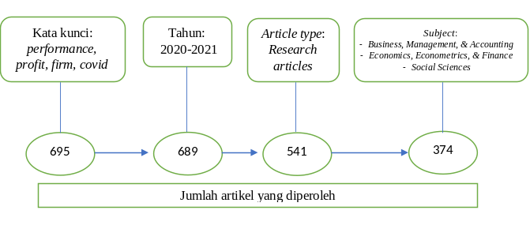
Figure 1. Data Selection Process

Figure 1 is the process of selecting data from Science Direct where there are 695 articles at the beginning of the search. The years 2020-2021 are used as the second screening stage because publications related to performance during the covid pandemic are assumed to be published in that year. The type of articles selected is only from research articles to determine that the articles used as data in this study are publications of research results only. Furthermore, the data used in this research is from publications in journals with the subject of Business, Management, & Accounting; Economics, Econometrics, & Finance; and Social Sciences because research on this subject is research in the field that is by the aims and objectives of this research, which is a total of 374 articles. The following table presents the twenty publishers with the highest number of publications.

Table 1. Twenty (20) Journals with the Highest Publications
No | Journal Name | Number of Publications | Quartile Scopus
1 | Journal of Business Research | 30 | Q1
2 | Technological Forecasting and Social Change | 29 | Q1
3 | International Journal of Hospitality Management | 14 | Q1
4 | Industrial Marketing Management | 11 | Q1
5 | Energy Economics | 8 | Q1
6 | International Business Review | 7 | Q1
7 | Cities | 7 | Q1
8 | Journal of Air Transport Management | 7 | Q1
9 | International Journal of Production Economics | 6 | Q1
10 | Tourism Management | 6 | Q1
11 | Telecommunications Policy | 6 | Q1
12 | Technology in Society | 6 | Q1
13 | Resources, Conservation and Recycling | 6 | Q1
14 | Journal of Environmental Management | 6 | Q1
15 | Research in International Business and Finance | 6 | Q1
16 | International Journal of Information Management | 5 | Q1
17 | Transportation Research Part E: Logistics and Transportation Review | 5 | Q1
18 | Geoforum | 5 | Q1
19 | International Review of Economics & Finance | 5 | Q2
20 | Economic Analysis and Policy | 5 | Q1
Source: Data processed by the author (2021)

Table 1 provides information on journals that publish research results or articles related to performance, profit, company, and Covid. This illustrates that with the Covid pandemic, scientific movements are also in line with the movement of problems facing the world. With the description in table 1, it means that articles related to performance, companies, and covid are topics that still deserve to be studied and developed as proven so far. They still occupy the best quartile Scopus journals. This should further spur the authors to expand this topic more. Furthermore, the following figure presents information about what variables often appear and are associated with company performance in published research related to the topic in this study.
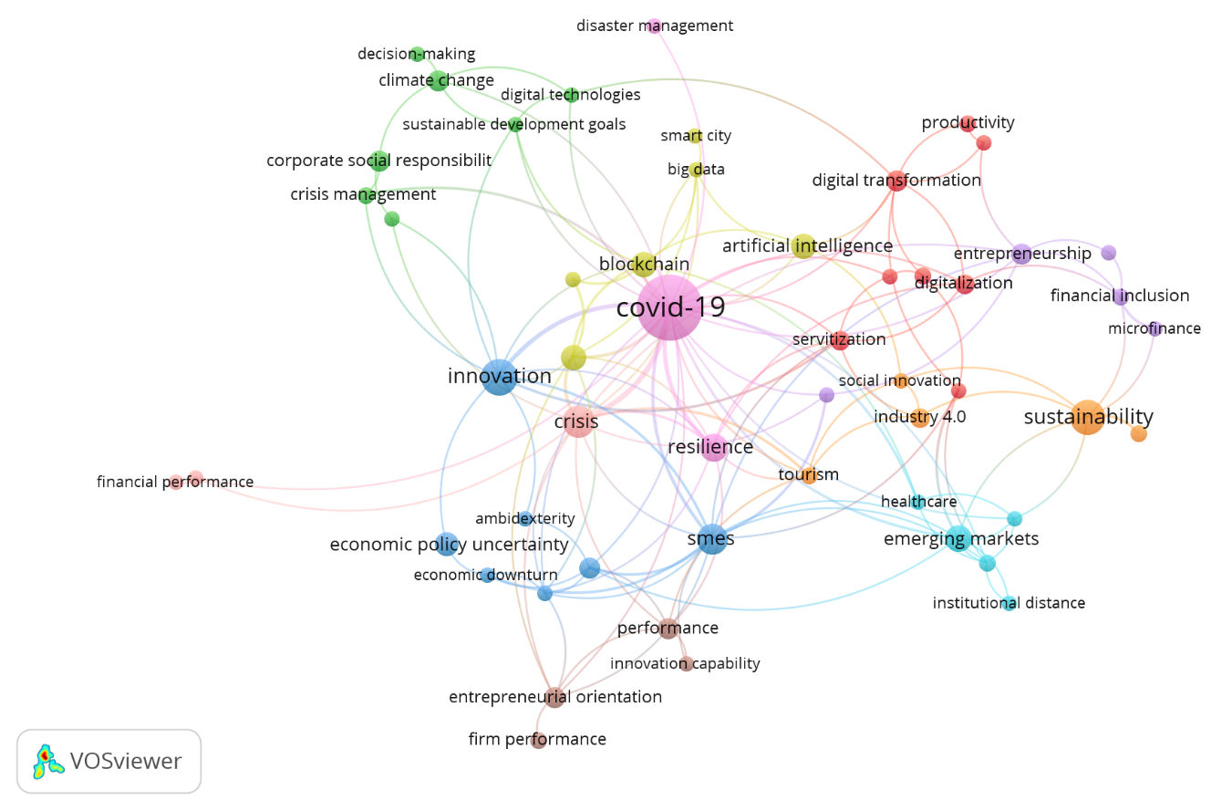
Figure 2. Frequently Appearing Variables

Figure 2 provides information on variables that often appear along with topics about performance, companies, and Covid, including innovation, sustainability, crisis, SMEs, blockchain, artificial intelligence, resilience, and digital transformation. It shows that these variables are widely observed by the authors. So, we can say that these variables are closely related or affected by the current Covid pandemic situation.
The line connecting the variables shows there is a relationship between these variables in published research. For example, in several studies, the innovation variable is associated with economic policy uncertainty, corporate social responsibility, and sustainable development goals. In another study, the digital transformation variable was associated with productivity and sustainable development goals. The relationship between these variables is described in Table 2 regarding the cluster of linkages between variables.

Table 2. Variables Used according to Cluster
Variable | Cluster | Total link strength | Occur- rence | Average year
Digital transformation | 1 | 8 | 6 | 2020.67
Servitization | 1 | 8 | 5 | 2020.6
Internationalization | 1 | 6 | 3 | 2021
Digitization | 1 | 5 | 5 | 2020.6
Competitiveness | 1 | 3 | 3 | 2020.67
Family business | 1 | 3 | 3 | 2021
Resource-based view | 1 | 3 | 4 | 2021
Productivity | 1 | 2 | 4 | 2021
Climate change | 2 | 5 | 6 | 2020.83
Sustainable development goals | 2 | 5 | 3 | 2021
Crisis management | 2 | 4 | 4 | 2020.75
Digital technologies | 2 | 4 | 3 | 2021
Corporate social responsibility | 2 | 3 | 6 | 2020.67
Customer | 2 | 3 | 3 | 2020.67
Decision-making | 2 | 1 | 3 | 2021
Sms | 3 | 20 | 12 | 2020.75
Innovation | 3 | 17 | 17 | 2020.76
Dynamic capabilities | 3 | 8 | 6 | 2021
Survival | 3 | 8 | 3 | 2021
Economic downturn | 3 | 5 | 3 | 2020.67
Ambidexterity | 3 | 2 | 3 | 2021
Economic policy uncertainty | 3 | 2 | 7 | 2021
Supply chain | 4 | 15 | 8 | 2020.875
Blockchain | 4 | 11 | 8 | 2020.75
Big data | 4 | 6 | 3 | 2021
Artificial intelligence | 4 | 5 | 8 | 2020.875
Logistics | 4 | 4 | 3 | 2020.67
Smart city | 4 | 1 | 3 | 2021
Entrepreneurship | 5 | 7 | 6 | 2020.5
Financial inclusion | 5 | 6 | 4 | 2020.75
Strategy | 5 | 5 | 3 | 2020.67
Microfinance | 5 | 3 | 3 | 2021
Employment | 5 | 2 | 3 | 2020.67
Emerging markets | 6 | 10 | 9 | 2020.89
Institutions | 6 | 7 | 4 | 2021
Governance | 6 | 5 | 3 | 2021
Healthcare | 6 | 5 | 3 | 2021
Institutional distance | 6 | 2 | 3 | 2020.67
Sustainability | 7 | 8 | 16 | 2020.8
Tourism | 7 | 7 | 4 | 2020.5
Industry 4.0 | 7 | 4 | 5 | 2020.6
Social innovation | 7 | 4 | 3 | 2020.67
Supply chain management | 7 | 2 | 4 | 2020.75
Entrepreneurial orientation | 8 | 7 | 6 | 2020.5
Performance | 8 | 6 | 6 | 2020.83
Innovation capability | 8 | 2 | 3 | 2021
Firm performance | 8 | 1 | 4 | 2021
Covid-19 | 9 | 51 | 53 | 2020.8
Resilience | 9 | 14 | 10 | 2020.7
Disaster management | 9 | 1 | 3 | 2021
Crisis | 10 | 24 | 13 | 2020.54
Social distancing | 10 | 3 | 3 | 2020.67
Financial performance | 10 | 1 | 3 | 2021
Source: Data processed by the author (2021)

The cluster in Table 2 refers to a grouping of variables found from the results of processed data using the VOS viewer application in this study. From the publishing processed data, found that there were 10 clusters in the grouping of variables. This gives an illustration that certain variables tend to be associated with certain other variables that often appear together in research conducted and published, thus forming groups that link between these variables. However, this grouping is not closed, where certain variables in a cluster are possible to appear with other variables outside the cluster.
The number that appeared in the total link strength column shows the strength of a variable associated with other variables. The higher the number in the total link strength column, the more often this variable is associated with other variables. This number is almost in line with the number that appears in the occurrence column. The number that appears in the occurrence column indicates how many studies have used this variable. The year number in the Year (average) column indicates that publications with the associated variable appeared on average in that year. For example, the number 2020,5 means that research with this variable is widely published around June and July in 2020. While the number 2020,9 means that this variable will be published in November and December 2020. The following is a picture of the trend of the variables that emerged in the span of this research year.
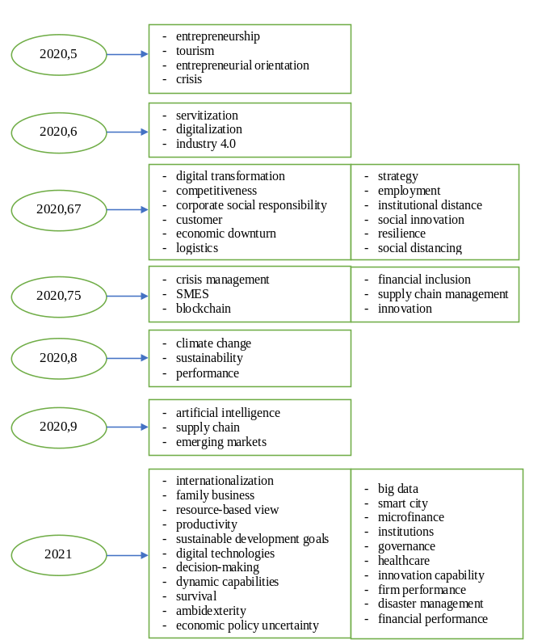
Figure 3. Trend of Variables Used

Figure 3 shows the trend of the variables used in research and publications in the 2020 - 2021time range. The trend of the emergence of this variable leads to the movement of problems observed by developing writers in the world. The trend of the emergence of this variable can provide an overview for the authors to develop further, both from existing variables and from other variables that still need to be explored, which should be by the development of problems in both the company and society in general.
Several authors/authors publish research results on topics related to this research individually or in partnership with other authors. The following is a picture of some of the authors' names and their relationship with other authors.

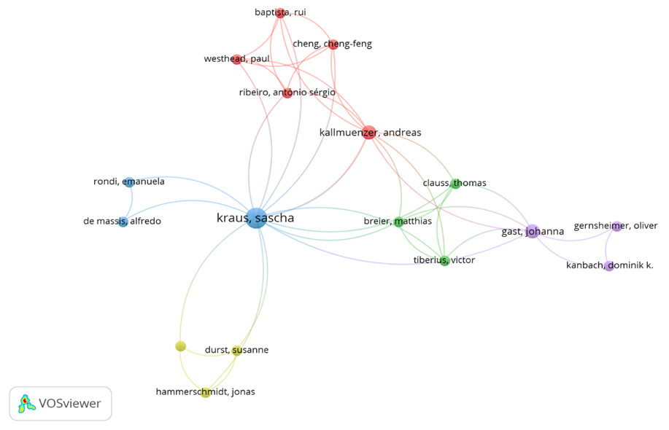
Figure 4. The author and his relationship with other authors

Figure 4 provides information on the names of the authors/authors who publish their research results related to this research topic. The line in Figure 4 shows the relationship/partner of one writer with another writer. For example, Shascha Kraus in conducting research and publications has partnered with Andreas Kallmuenzer, and in another research, Shascha Kraus has partnered with Breier Matthias. Then on another occasion, Breier Matthias partnered with Johanna Gast. The larger the circle in the author's name, the more publications he has done. This can indicate that the more often the author publishes, which in turn means that the author is getting deeper into the topics related to this research. The following table presents the names of the authors related to the topics in this study based on the results of VOS viewer data processing:

Table 3. Authors who Often Publish Research Related to Research Topics
Writer | Cluster | Total link strength | Document
Kraus, Sascha | 3 | 15 | 4
Kallmuenzer, Andreas | 1 | 10 | 2
Gast, Johanna | 5 | 7 | 2
Baptista, Rui | 1 | 5 | 1
Breier, Matthias | 2 | 5 | 1
Cheng, Cheng Feng | 1 | 5 | 1
Clauss, Thomas | 2 | 5 | 1
Ribeiro, Antonio Sérgio | 1 | 5 | 1
Tiberius, Victor | 2 | 5 | 1
Westhead, Paul | 1 | 5 | 1
Durst, Susanne | 4 | 3 | 1
Hammerschmidt, Jonas | 4 | 3 | 1
Puumalainen, Kaisu | 4 | 3 | 1
De Massis, Alfredo | 3 | 2 | 1
Gernsheimer, Oliver | 5 | 2 | 1
Kanbach, Dominic K. | 5 | 2 | 1
Rondi, Emanuela | 3 | 2 | 1
Source: Data processed by the author (2021)

Table 3 illustrates that the authors mentioned above publish their research results with the variables included in the cluster as written in the cluster column. The number on the strength of the link indicates showed how strongly or often the author publishes in partnership with other authors, on topics according to this research. The number in the number of documents column showed how many published documents were discovered by the VOS viewer application that mentions the author's name. The authors' names in Table 3 can be used as a reference in future research related to related topics. The more the author's name appears, the deeper and more familiar with issues related to the intended research topic.
In general, the results of data processing using the VOS viewer application show that several variables are often used in many publications related to this research topic. However, VOS viewer cannot display all the variables used in the processed publication data, especially for the variables that appear in very small quantities. This makes it difficult for the author to obtain an overview of using variables in related research in more detail and thoroughness. However, on the other hand, this can illustrate that the variables that have not been mentioned mean that they have not been explored much that they can be a renewable opportunity for further research.

CONCLUSION
This study found that research developments related to performance, companies, and the Covid pandemic situation developed very variedly, as evidenced by the abundance of publications related to these topics. There are several variables related to the topics of performance, profit, firm and Covid, including innovation, sustainability, crisis, SMEs, and resilience. However, there are still many unexplored variables that are related to the topic in this study and can be considered for further research as renewables for further research, such as digital technologies, innovation capability, logistics, and survival. Some of the authors' names that appeared, namely Shascha Kraus, Andreas Kallmuenzer, and Johanna Gast, indicated that these authors had several times published their research results related to this research topic so they could be considered as references. The limitation of this study is that it cannot provide an overview of the direction of the trend in the use of research variables in 2021. This research is expected to provide implications in the development of future research, especially related to performance and the pandemic situation.

References

[1] Bofinger P, Dullien S, Felbermayr G, Fuest C, Hüther M, Südekum J, et al. und wirtschaftspolitische Maßnahmen Die Corona-Krise hat ihren Ausgangspunkt in China und große gesundheitliche sowie. 2020;259–65.
[2] Verma S, Gustafsson A. Investigating the emerging COVID-19 research trends in the field of business and management: A bibliometric analysis approach. J Bus Res [Internet]. 2020;118:253–61. Available from: https://doi.org/10.1016/j.jbusres.2020.06.057
[3] Donthu N, Gustafsson A. Effects of Covid-19 on business and research. J Bus Res. 2020;117(June):284–9.
[4] Leite H, Hodgkinson IR, Gruber T. New development: ‘Healing at a distance’—telemedicine and COVID-19. Public Money Manag [Internet]. 2020;40(6):483–5. Available from: https://doi.org/10.1080/09540962.2020.1748855
[5] Michie J. The covid-19 crisis–and the future of the economy and economics. Int Rev Appl Econ [Internet]. 2020;34(3):301–3. Available from: https://doi.org/10.1080/02692171.2020.1756040
[6] Pantano E, Pizzi G, Scarpi D, Dennis C. Competing during a pandemic? Retailers’ ups and downs during the COVID-19 outbreak. J Bus Res [Internet]. 2020;116(May):209–13. Available from: https://doi.org/10.1016/j.jbusres.2020.05.036
[7] Rababah A, Al-Haddad L, Sial MS, Chunmei Z, Cherian J. Analyzing the effects of COVID-19 pandemic on the financial performance of Chinese listed companies. J Public Aff. 2020;20(4).
[8] Rababah A, Al-Haddad L, Sial MS, Chunmei Z, Cherian J. Analyzing the effects of COVID-19 pandemic on the financial performance of Chinese listed companies Analyzing the effects of COVID-19 pandemic on the financial performance of Chinese listed companies. J Public Aff. 2020;(September):1–6.
[9] Giritli Nygren K, Olofsson A. Managing the Covid-19 pandemic through individual responsibility: the consequences of a world risk society and enhanced ethopolitics. J Risk Res [Internet]. 2020;23(7–8):1031–5. Available from: https://doi.org/10.1080/13669877.2020.1756382
[10] Jin X, Zhang M, Sun G, Cui L. The impact of COVID-19 on firm innovation: Evidence from Chinese listed companies. Financ Res Lett [Internet]. 2021;(May):102133. Available from: https://doi.org/10.1016/j.frl.2021.102133
[11] She Q, Yu Y, Wu K. Is “Born Global” a Viable Market Entry Mode for the Internationalization of SMEs? Evidence from China before COVID-19. Emerg Mark Financ Trade [Internet]. 2020;56(15):3599–612. Available from: https://doi.org/10.1080/1540496X.2020.1854720
[12] Gu X, Ying S, Zhang W, Tao Y. How Do Firms Respond to COVID-19? First Evidence from Suzhou, China. Emerg Mark Financ Trade [Internet]. 2020;56(10):2181–97. Available from: https://doi.org/10.1080/1540496X.2020.1789455
[13] Palcic D, Reeves E. State-owned enterprise sector, 2020. Administration. 2021;69(1):85–95.
[14] Ivanov D, Dolgui A. Viability of intertwined supply networks : extending the supply chain resilience angles towards survivability . A position paper motivated by COVID-19 outbreak To cite this version : HAL Id : hal-02568319. Int J Prod Res. 2020;58(10):2904–15.
[15] Ellegaard O, Wallin JA. The bibliometric analysis of scholarly production: How great is the impact? Scientometrics. 2015;105(3):1809–31.

