Improving the Marketing Performance of Communities Affected by Covid-19 Through Digital Marketing
Based on Asset-Based Community Development,
Gumelar District, Banyumas Regency

Suryo Budi Santoso
Accounting, Economics and Business Faculty
Universitas Muhammadiyah Purwokerto
Purwokerto, Indonesia
E-mail: suryobs@gmail.com
Herni Justiana Astuti
Management, Economics and Business Faculty
Universitas Muhammadiyah Purwokerto
Purwokerto, Indonesia
E-mail: herni99@gmail.com

Muhammad Hamka
Information Technology, Faculty of Engineering and Science
Universitas Muhammadiyah Purwokerto
Purwokerto, Indonesia
E-mail: muhhamka@gmail.com

Abstract—The majority of community work in Gumelar District are Indonesian migrant workers in Saudi Arabia and Taiwan and work in big cities and outside the island. The impact of the Covid-19 outbreak has caused a significant increase in the number of layoffs. Their income began to fall. Former migrant workers formed IPAKARUMI (Women's Association of Indonesian Migrant Workers' Families). Its goal is to help its members become economically self-sufficient. Entrepreneurship is a suitable alternative livelihood for migrant communities. However, the impact of this epidemic caused them to lose their market as the people's purchasing power weakened. Besides the hilly area, it was difficult for the community to mobilize resources, both raw materials and finished goods that were sold. The scope of problems faced for partner business units are aspects of increasing production capacity, aspects of marketing technology and aspects of center development/group development. The solution offered is referring to the priorities set in accordance with the theme of Strengthening Marketing with Information Systems such as strengthening product attribute improvements and optimizing various promotional media to expand the marketing area and assisting in making promotions through the web and social media (Digital Marketing). The real form of this community service is making a software development model through the E-Commerce application for IPAKARUMI MSMEs.
Keywords: Covid-19; Digital Marketing; Community service; migrant workers; IPAKARUMI

Introduction

Situation Analysis
Gumelar District is located at the northwest end of the Banyumas Regency. The hilly area makes it difficult for the community to mobilize resources, both raw materials and finished goods that are sold. The main roads between villages are not all in good condition, it takes a lot of effort for mobility. The distance from Gumelar sub-district to the district government center, namely the city of Purwokerto, is 31 km. The total population is 55,694 people [1]. Generally, productive age migrates to big cities and outside the island. Even Gumelar District is famous for its suppliers of Indonesian Workers (TKI) from Banyumas Regency.
As a result of the Covid-19 outbreak, the wave of layoffs (PHK) has increased significantly. Many formal workers have started laying off their workers [2]. This is also felt by productive residents from the Gumelar sub-district. Meanwhile, the Indonesian Migrant Workers Protection Agency (BP2MI) recorded those 100,094 Indonesian migrant workers (PMI) from 83 countries returned to their homeland in the last three months [3], including migrant workers from Gumelar District, the majority of whom work in Saudi Arabia and Taiwan. This causes open unemployment more and more. Open unemployment occurs as a result of declining economic activity, from technological advances that reduce the use of labor, or as a result of a decline in the development of an industry [4]. On the other hand, the people of the Gumelar sub-district who have been living in the village and have home businesses have also been affected by this pandemic. They lost their market due to the weakening of people's purchasing power due to the decline in economic activity during large-scale social restrictions in a number of areas [5]. When there is demand, they are hampered by raw materials because the raw material providers also do not have the ability to provide the raw materials needed, even though the stock is running low [6].
The International Labor Organization (ILO) also emphasizes the importance of investment in migrant workers, one of which is small business. It is intended to overcome hazardous migration cycle (risky migration cycle), which after earning collected completely [7]. Wives left behind by their husbands work abroad and women who have not returned to their work destinations have formed an association called IPAKARUMI (Ikatan Wanita Keluarga Indonesian Migrant Workers) which is centered in Cihonje village and chaired by Ms. Yuliati. Yuliati's mother was a former migrant worker when she was young. Entrepreneurship is a suitable alternative livelihood for migrant communities in Gumelar District which is managed by IPAKARUMI. Therefore, the families of migrant workers took the initiative through PKARUMI to protect the wives of migrant workers who wanted to develop a home-based business. There are 30 members. IPAKARUMI aims to help its members become economically independent. Home business includes 3 main parts, namely Knitting, Various Chips and Garbage bank.

Partner Problems
From the analysis of the situation above, identification of the problems faced by partners is carried out:
- Aspects of increasing production capacity: knitting produced is still based on orders and less marketable and Marketing Technology Aspects: products are selling value and unique but sales are still conventional so it's very depending on the offer from shop to shop,
- Aspects of increasing production capacity for chips: less variety in terms of shape and taste while Marketing Technology Aspects: licensing stops, packaging is still simple, very dependent on offers from shop to shop,
- Aspects of center development/group development: Decreasing the sale value of garbage deposit by the community, financial records are still simple, accumulation garbage that is not picked up by the garbage collector

Problem Solution
- Production capacity increase: Solutions offered: Diversify souvenir products other than knitting with training and mentoring
- Marketing Technology Improvement Solution offered: Optimizing media variety promotion to expand the marketing and mentoring area make promotions through the web and social media (Digital Marketing)
- Center development/group development (waste bank) Solutions offered: Repair assistance bookkeeping, especially for the management of waste savings and Entering deposit transactions and waste canisters into the web

Implementation Method

Method
The method used in implementing e-commerce for IPAKARUMI is software development with a prototype model. The prototype model is used because the software development time can be done faster. In addition, users can experiment with early prototypes of e-commerce software and propose software changes as needed [8].

Stages of completing
The following describes the phases / stages of completing the implementation method as shown in Figure 1

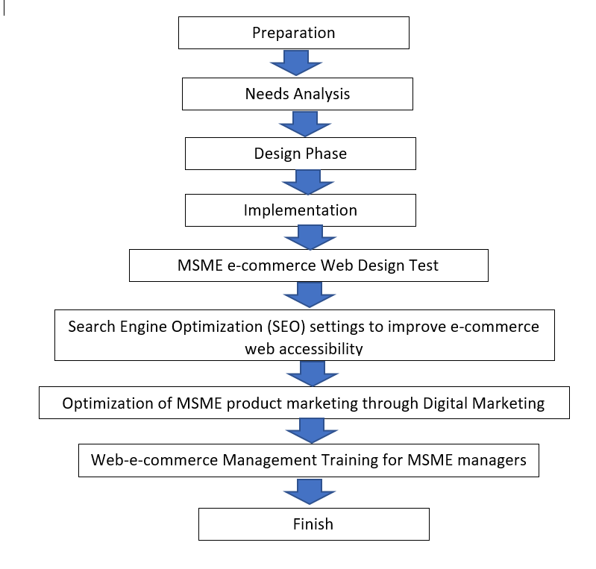
Figure 1. the phases / stages of completing the implementation method

Results of Service Implementation

Based on the completion phase of the preparation of digital marketing activities starting from the preparation stage then to the needs analysis stage. At this stage there are e-commerce software development activities starting with communication with IPAKARUMI to obtain information related to profiles, activities carried out, business units owned, and products owned by IPAKARUMI. In addition, at this stage observations were also carried out to collect data on IPAKARUMI's business processes in running their business units.

Furthermore is the design phase. This design phase consists of 4, namely (1) e-commerce web transaction process flow design, (2) e-commerce website display design, (3) holder template design involved in MSME business processes and (4) e-mail content design (Auto email replay).

In the implementation phase, what is done is registering business account under google, Create email for MSME managers, Migration for MSME managers. Furthermore, Creating Share Storage for MSME managers, MSME E-commerce web development, Uploading MSME E-commerce web to the hosting server, Migration of MSME E-commerce web domain DNS to G-Suite account, Installing e-commerce web chat line plug.
The MSME e-commerce web design test is the stage where we make sure whether we know whether the e-commerce web is in accordance with the needs of MSMEs? In addition, doing tests and checking with MSMEs about the e-commerce web design that was made.
The next stage is Search Engine Optimization (SEO) settings to improve e-commerce web accessibility. SEO is a step or effort to optimize a website so that it appears on the first page of a search engine (Google). So, the function of SEO is to increase website rankings so that people can find them easily through search engines.
The next phase is optimizing the marketing of MSME products through Digital Marketing (DM). At this stage perform product optimization through product differentiation. Product differentiation is an attempt by a company to differentiate its products from competitors' products by making the product special. At this stage, MSMEs are given assistance, especially adding product variations with additional assistance in making handicrafts from rope waste. Ultimately adding to the variety that is sold online.
The last stage is web-e-commerce management training for MSME managers. this stage is to conduct management training in managing the e-commerce web to IPAKARUMI managers. This is intended so that the e-commerce web can be managed and transformed from the community service team of the University of Muhammadiyah Purwokerto to IPAKARUMI MSMEs.

DIGITAL MARKETING, WEB E COMMERCE FOR IPAKARUMI

- Main Page
The IPAKARUMI e-Commerce main page contains a list of featured products, the latest products, IPAKARUMI location addresses, the IPAKARUMI e-Commerce main page is shown in Figure 2
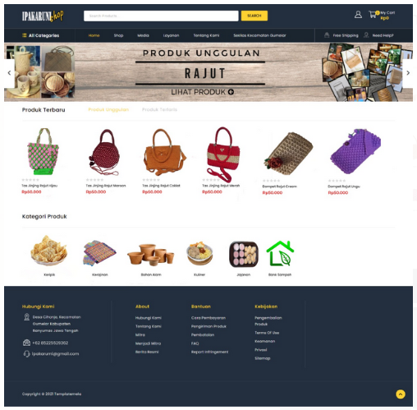

Figure 2. the main page of website

- Product Category Page
Page The product category page goes through the “Shop” menu then selects the “Product category” sub-menu. Products marketed through the IPAKARUMI e-commerce application are divided into 7 categories, namely: 1) chips, 2) crafts, 3) natural ingredients, 4) culinary arts, 5) snacks, and waste banks. The division of product categories is based on the potential of natural resources and products produced by IPAKARUMI. The product category page is shown in figure 3.
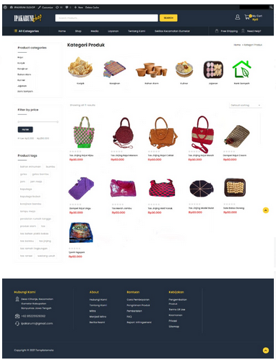
Figure 3. Product Category Page
- Product Details
Page Product details can be indicated by selecting a product. The product detail page will then be displayed. The information displayed includes: 1) product descriptions, 2) data tags so that a product appears on search engine pages when the keywords entered are in accordance with the contents of the tags, 3) stock quantities, 4) product images, and 5) related products that display products. with the same tags. This is intended to provide offers to potential buyers regarding other similar products. The product detail page is shown in figure 4
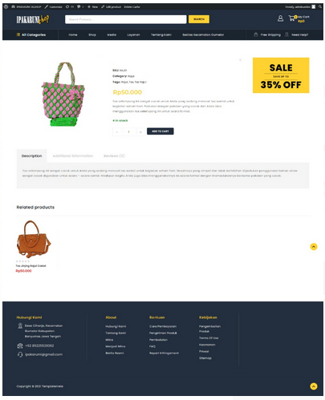
Figure 4. Product Details
In addition to displaying product information, potential buyers can directly add products to their shopping cart. To add products to the shopping cart, prospective buyers can select the amount to be purchased and press the "ADD TO CART" button.
- Prospective Buyer Registration
Page Before the prospective buyer makes a product purchase transaction, the prospective buyer is asked to register an account at the IPAKARUMI e-commerce. Registration is done by entering an active email address. After that, the IPAKARUMI e-commerce application will send a notification to the prospective buyer's email. After successful registration, prospective buyers are asked to fill in data including 1) First name, 2) Last name, and 3) address as shown in Figure 6

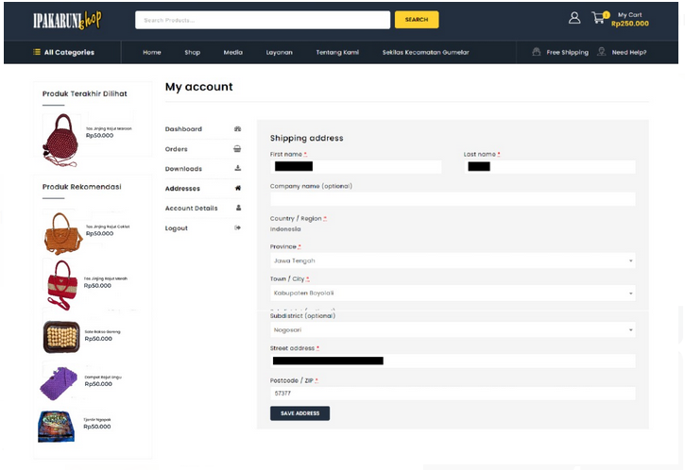
Figure 6. my account

- Shopping Cart Page
After the prospective buyer completes the data, the purchase transaction can be carried out. The product for which the transaction will be made will be added to the shopping cart as shown in Figure 7
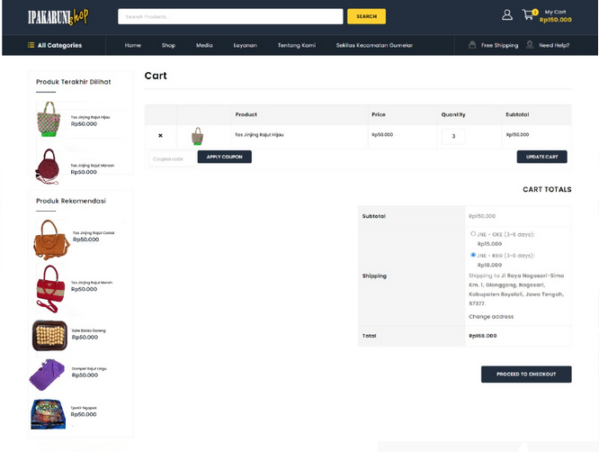
Figure 7. Shopping Cart Page
The IKAPARUMI e-commerce application will automatically calculate product delivery costs based on the selected courier rate and delivery location. The shipping costs displayed are the actual shipping rates from the selected courier service, this can be done because the IPAKARUMI e-commerce application uses the Application Programming Interface (API) from the Raja Ongkir plug-in which reads shipping rate data on the site of a shipping service.
- Transaction Process
Page The next process after the prospective buyer chooses the product to be transacted is the payment process. Payment methods available at IPAKARUMI e-commerce are using transfers to IPAKARUMI bank accounts and payment on the spot (cash on delivery). The payment method selection page is shown in figure 8

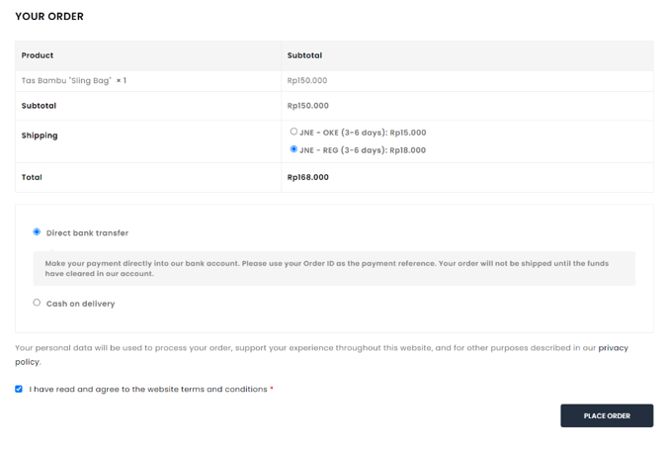
Figure 8: Transaction Process

IV Conclusion
Digital transformation from offline to online in the covid era is very necessary. This transformation is one of the business solutions in order to survive during the Corona pandemic. This market place can be used for other products from one village to another in the Gumelar sub-district.

References

- B. Banyumas, “Kabupaten Banyumas Dalam Angka 2020,” 2020. [Online].Available: https://banyumaskab.bps.go.id/publication/2020/04/27/fed8786afe3cb347eca4c132/kabupaten-banyumas-dalam-angka-2020.html
- C. Indonesia, “Pekerja Dirumahkan dan Kena PHK Akibat Corona Capai 3,05 Juta,” 2020. [Online]. Available: https://www.cnnindonesia.com/ekonomi/20200720114203-92-
526610/pekerja-dirumahkan-dan-kena-phk-akibat-corona-capai-305-juta
- Sania Mashabi, “Dampak Covid-19, 100.094 Pekerja Migran Pulang ke Indonesia Tiga Bulan Terakhir Artikel ini telah tayang di Kompas.com dengan judul ‘Dampak Covid-19, 100.094 Pekerja Migran Pulang ke Indonesia Tiga Bulan Terakhir’, Klik untuk baca: https://nasional.kompas.” [Online]. Available: https://nasional.kompas.com/read/2020/04/15/17132131/dampak-covid 19-100094-pekerja-migran-pulang-ke-indonesia-tiga-bulan
- S. Sukirno, Makro Ekonomi, Teori Pengantar. Jakarta: Penerbit PT. Raja Grafindo Persada, 2013.
- R. R. Ramli, “CSIS: Inflasi Rendah karena Daya Beli Masyarakat Menurun,” 2020. [Online]. Available: https://money.kompas.com/read/2020/07/03/164000826/csis--inflasi rendahkarena-daya-beli-masyarakat-menurun.
- C. G. Asmara, “Efek Corona, Kadin Akui Stok Bahan Baku Industri Menipis,” 2020. [Online]. Available: https://www.cnbcindonesia.com/news/20200311150930-4-144098/efek-coronakadin-akui-stok-bahan-baku-industri-menipis.
- M. K. Dewi, “Pendekatan Bottom-Up dalam Meningkatkan Proses Bisnis Kelompok Usaha Migran,” in Prosiding Seminar Nasional dan Call for Papers, 2019, pp. 425–441.
- Sommerville, Ian. 2011. Software Engineering. 9th ed. New York: Pearson

Acknowledgement:
Thank you very much to DIKTI Kemdikbud Republic of Indonesia for their support in funding this research.

