Analysis of password after encryption by using the combination of AES256 and MD5 algorithm methods
L Khakim^{1*}, M Mukhlisin², A Suharjono³
¹ Computer Engineering, Politeknik Harapan Bersama, Tegal, Indonesia
² Civil Engineering, Politeknik Negeri Semarang, Semarang, Indonesia
³ Electrical Engineering, Politeknik Negeri Semarang, Semarang, Indonesia
*Email : khakimthy@gmail.com
Abstract. Data security in the current era is very necessary to avoid crimes such as data theft, data manipulation and data destruction. Therefore it is very important if the data is secured. The data that is of concern to be secured is the password, in this study, password data security was carried out with an encryption method in combination with two algorithms. The first stage of security technique is by encrypting the password data used to log into the cloud system with MD5 encryption, then the results of the MD5 encryption will be encrypted with a second AES256 where the main password before being encrypted MD5 and AES256 is used as a key for the AES256 encryption process, this method is implemented by PHP programming language. The test was carried out 10 times, it can be analyzed that after the password is encrypted with the MD5 and AES256 combination method the number of characters increases to 64 characters for all test data, then the longest estimated time in password cracking is 34x10⁹⁹ years and the fastest time is 1x10⁸⁴ years, for the computation time required to encryption with the fastest combinational method is 0.00088 seconds and the longest is 0.0012 seconds.
- Introduction
Much of the research that discusses cloud technology for various purposes such as the use of cloud technology for smart city projects[1], or the use of cloud to AAMS (Automatic Attendance Monitoring System) which monitors the presence of research students in learning activities[2]. Another study also examines the use of cloud computing to the use of smart agriculture with IOT (Internet of Things) and cloud computing, where utilization is intended to monitor agricultural land for to know moisture content, pH, moisture, etc[3], or research that examines the use of IOT and cloud computing for green house where to utilize these technologies will make it easier to monitor the condition of the home environment such as rain and will automatically get rid of rainwater, where farmers are very difficult to manage rainwater excessive[4].
In terms of security in cloud computing facilities, there are some researchers who have done previous research, where the other research objects are secured or encryption is personal data and general data, where personal data is encrypted by using AES128 and general data encrypted by using MD5, but access into cloud computing system with the fingerprint image, the security level in the study was not secure enough, because the authentication (password) to the cloud computing system only uses encryption techniques MD5, wherein if the data encryption MD5 stored in the database technique of sql injection, and do the decryption, then the password will easily identified[5]. A similar study in a research paper built system serves to secure (authentication) access into cloud computing resource system, in this study, the object is encrypted using AES encryption is the user password used to login to access the cloud computing system[6]. The key used to encrypt the password is the key length of 128 bits. Further research on a system that functions to secure data encryption method, the encryption used is AES and RSA (Rivest-Shamir-Adleman), with a 128 bit key. The system works when the data stored in the cloud storage system, with the work step data from IoT (Internet of Things) will be encrypted by using a key are specified before the data is stored in the storage cloud storage, with the above encryption, the IoT data will be more safely uploaded with cloud facilities on a public path[7]. From the observation of existing passwords, no one has tried to use a combination of AES256 and MD5 to secure passwords.
In this research, the method that will be discussed is data encryption with multiple systems, that is by encrypting data by two methods of encryption is done gradually. In this study, the method to be used to perform the encryption is a type of encryption or hash Message-Digest 5 (MD5) and Advanced Encryption Standard (AES) using a key length of 256 bits[8]. By using the above encryption method, and is done by double encryptions, it is expected that data security will be more safe and secure[9].
- Theoretical Background

Advanced Encryption Standard (AES)
AES is a contest winner replacement DES cryptographic algorithm held by NIST (National Institutes of Standards and Technology) the United States government on November 26, 2001[10]. Rijndael algorithm is then known as the Advanced Encryption Standard[6].AES cryptographic types are divided into three types[11]:
- AES 128
- AES 192
- AES 256
AES is a block cipher algorithm using permutation and substitution system (P-Box and S-box) not in the Feistel network as a block cipher in general. Grouping is based on the type of AES key length used. The three digit number that is placed behind the AES is the code to determine the length of the key used by each type of AES, besides differentiating key length to use, these numbers also as distinct from the number of rounds used by each type of AES, for the type of AES128 round used as many as 10 rounds, while AES192 as many as 12 rounds, and the latter is the type of AES256 with a round number used is 14 rounds[12]. Encryption of this type have a constant block size, with the size of 128, and a key length of each 128, 192 and 256 bits. Based on a fixed block size, this type of encryption can work on a 4x4 matrix in which each matrix consists of 1 byte or equal to 8 bits. AES256 work processes can be seen in Figure 1.
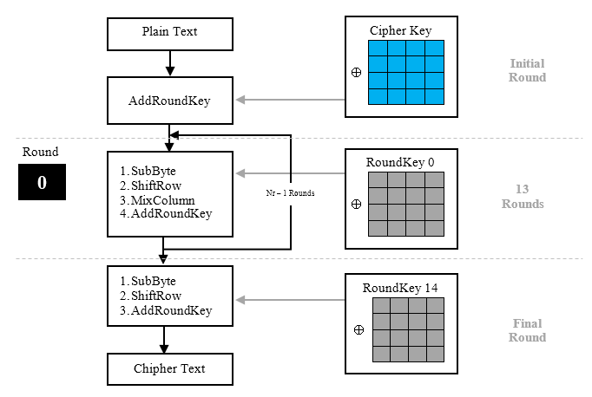
Figure 1. AES Encryption process 256[13]

Figure 1 is a process of encryption works by using AES with a key 256, whereby the text data to be encrypted with AES, early stages will perform an addroundkey where this stage will perform an XOR between text data with the cipher key, the next will be the process of rotation (round) as Nr-1 times, where the process is done at this stage is the process subbyte, shiftrow, mixcolumn and addroundkey, for the final stage is the process undertaken round subbyte, shiftrow and addroundkey and AES-256 encryption process by the method has been completed.
  - Message - Digest 5 (MD5)
MD5 is a one way hash function which is an improvement to replace the earlier hash function, namely MD4 were successfully attacked by cryptanalyst, the MD5 algorithm accepts as input a message with any size and produce a message digest of length 128 bits[13]. MD5 is one of the applications that are used to determine that the message sent no change while in the network[14]. MD5 algorithm outline is taking messages have variable length is converted into a fingerprint or message digest having a fixed length is 128 bits. This fingerprint cannot be reversed to get the message, in other words no one can see the message of fingerprint MD5.
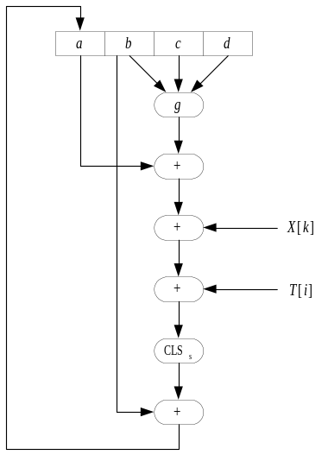  Figure 2. Basic Operation Message Digest[15] | 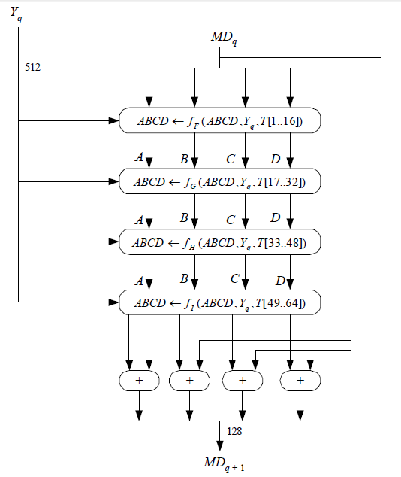  Figure 3. Processing block of 512 bits (Process HMD5)[15]
MD5 basic operations shown in Figure 2 can be written as an equation shown in equation (1).

a ← b + CLSS (a + g (b, c, d) + X [k] + T [i]) (1)
Information :  a, B, c, d = Four 32-bit variable buffer  (Containing buffer grades A, B, C, D)  g = One of the functions F, G, H, I  CLSS = Circular as s bit left shift | X[K] = Groups to-32-bitk of blocks of 512 bits  message all q. The value of k = 0 to 15  T[I] = Elements T all i (32 bit)  + = Operation summation modulo 2³²

HMD5 process shown in Figure 3, in which messages are divided into L pieces each block length of 512 bits (Y0 to YL-1). Each block is 512-bits processed together with the buffer MD into outputs 128 bit, and this is called the HMD5, Process HMD5 consists of 4 pieces of rounds, and each round perform basic operations MD5 16 times and each of the basic operations wears an element T[i]. So each round taking 16 element T[i] or (T[i]). In Figure 3, YQ stated 512 bit block q all of the messages that have been added bits booster and additional 64 bit length value of the original message. MDQ is the value of 128-bit message digest of the process HMD5 to-q. At the beginning of the process, MDQ MD buffer containing initialization values.
  - Model Combinational Encryption Method
In the method used to carry out the process of this study, the researchers conducted the design of systems for data encryption is enabled as entry or login into the cloud system. The method used is to combine the two methods of securing data between the encryption or MD5 hash with AES256 encryption method[9]. Where both the data security method will encrypt user password data that serves as entry or login into the cloud system. The encrypted password data will be stored into the database. Furthermore, by using these data will be analyzed on an increase in the characters making up the encrypted password, the computing time encryption process with combinatorial methods, analysis and estimation of the time required to do the password cracking process which has done the encryption process with combinatorial methods. For the programming language used to design this encryption system, using the programming language PHP (PHP preproceccor)[16].
In conducting this research, there is some equipment that will be used to support the success in getting the data, the tools and materials as well as the software used can be seen in Table 1.

Table 1. Tools and materials
No | Brand | Specifications | Capacity
1 | Notebook Toshiba  Satellite C640 | Proceccor | Intel Pentium 2.0Ghz (Dual CPU)
1 | Notebook Toshiba  Satellite C640 | Hard drive | 320 Gb
1 | Notebook Toshiba  Satellite C640 | RAM | 2 Gb
1 | Notebook Toshiba  Satellite C640 | Display (LCD) | 14”
1 | Notebook Toshiba  Satellite C640 | Operating System | Windows 7 Pro 64 bit
1 | Notebook Toshiba  Satellite C640 | Software Server | XAMPP 5.6.8

In this research data used as the test data shown in Table 2.
Table 2. Data Testing
No | Username | Password | Number of Characters
1 | pengguna1 | coba* 1 | 6
2 | pengguna 2 | coba ** 1 | 7
3 | pengguna 3 | coba ** # 1 | 8
4 | pengguna 4 | coba ** ## 1 | 9
5 | pengguna5 | coba *** ## 1 | 10
6 | pengguna6 | Coba * 1 | 6
7 | pengguna7 | Coba ** 1 | 7
8 | pengguna8 | Coba ** # 1 | 8
9 | pengguna9 | Coba ** ## 1 | 9
10 | pengguna10 | Coba *** ## 1 | 10

In Table 2 represents the test data whose number is 10 data to be used as data for testing, where test data consists of a combination of lowercase, uppercase, numbers and symbols, as well as the number of characters that range from a character which amounted to 6 to with 10 characters.

- Research Methods

Waterfall Development Model
The waterfall model is one of the many software development models contained in the sequential development life cycle (SDLC) model[17]. This model is a software development model which is often called a linear sequence model or generally called a life flow[18]. The SDLC waterfall model can be seen in Figure 4.
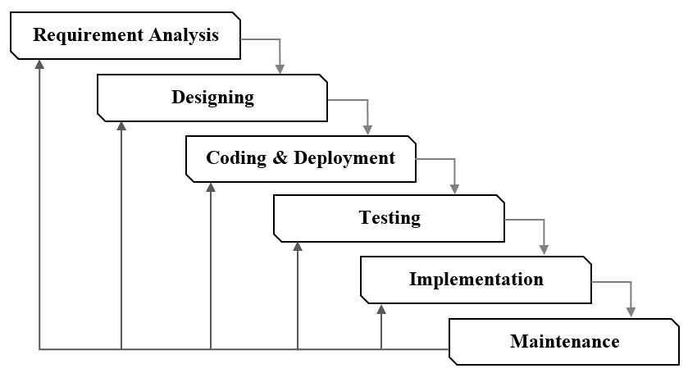
Figure 4. SDLC Waterflow model

- Requirement analysis aims to collect information on software requirements by means of discussions, observations, surveys and interviews.
- Designing aims to model the required software system according to the data obtained at the requirements analysis stage.
- Coding and deployment aims to transform the design results into a software that is built with the PHP programming language.
- Testing aims to try and analyze the software that has been done coding and deployment.
- Implementation aims to implement the software that has been built for use by users.
- Maintenance aims to analyze the performance of the software used by users and improve it if this step is necessary.

Workflow Login System
The workings of the security system for the process of password encryption methods combinational shown in Figure 5, that is a flowchart working system login with the method of combinational where for technical system works is the password data to be stored in the database, will be encoded in advance by the method MD5, next to the security process that goes along, the result of the encryption beforehand will do the encryption process the second stage by using AES256, where encryption with this method requires a key for encryption methods AES256[19], here keywords used are the initial input the password typed user prior to encryption. Furthermore, after the final data is encrypted with AES256 method, the data is stored into the database MySQL.
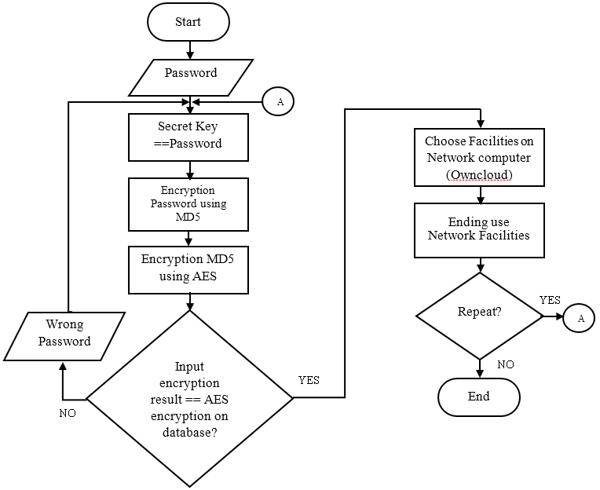
Figure 5. Workflow login system with combinational encryption method among the encryption methods combined with the MD5 and AES256 encryption method
- Results and Discussion
For the first analysis are analyzed on the computational time required to perform the encryption process using combinational encryption method between MD5 and AES256. Here are the results of testing of the computing time can be seen in Table 3.
In computing the time test results in Table 3, it can be seen for 10 data computation time testing and testing performed 5 times, then obtained the approximate time the fastest computing average on test data number 4 with the computation time is 0.00088 seconds, and time is the longest computation on test data numbers 2, 3, 7 and 9 with the computation time is 0.0012 seconds[20][21].

Table 3. The test results of computation time with combinational encryption methods MD5 and AES256
No | Password | Computing Time (s)
No | Password | Testing 1 | Testing 2 | Testing 3 | Testing 4 | Testing 5 | Average
1 | coba* 1 | 0,001 | 0,001 | 0,001 | 0,001 | 0,001 | 0,001
2 | coba ** 1 | 0,001 | 0,001 | 0,001 | 0,002 | 0,001 | 0,0012
3 | coba ** # 1 | 0,001 | 0,002 | 0,001 | 0,001 | 0,001 | 0,0012
4 | coba ** ## 1 | 0.0009 | 0.0009 | 0.0008 | 0.0009 | 0.0009 | 0,00088
5 | coba *** ## 1 | 0.0009 | 0.0009 | 0.0009 | 0.0009 | 0.0009 | 0,0009
6 | Coba * 1 | 0,002 | 0,001 | 0.0009 | 0,001 | 0,001 | 0,00118
7 | Coba ** 1 | 0,001 | 0,001 | 0,001 | 0,002 | 0,001 | 0,0012
8 | Coba ** # 1 | 0.0009 | 0.0009 | 0,002 | 0.0009 | 0.0009 | 0,00112
9 | Coba ** ## 1 | 0,001 | 0,002 | 0,001 | 0,001 | 0,001 | 0,0012
10 | Coba *** ## 1 | 0.0009 | 0.0009 | 0.0009 | 0.0009 | 0.0009 | 0,0009

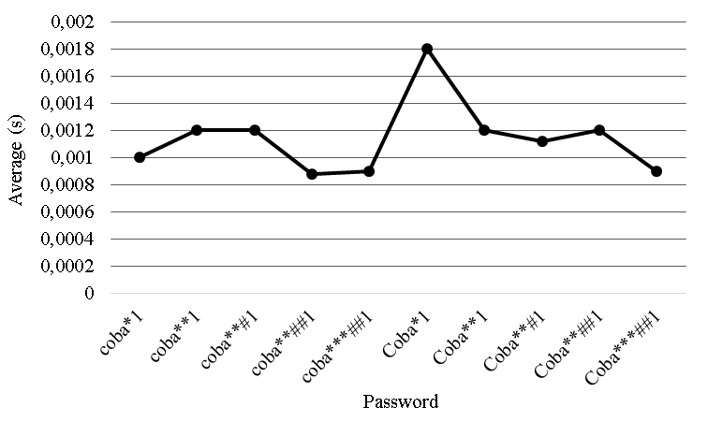
Average
Figure 6. Average computing time for the encryption process by the method of combinational MD5 and AES256

In Figure 6 tests passwords coba*1 shows the computation time of 0.001 seconds, while the testing of the password coba**1 showed a slowdown in the computing time on testing coba*1 became 0.0012 seconds, the last time in the third test in trying to password data coba**#1, while in the test data coba**##1 password try to accelerate the computation time becomes 0.00088 seconds, the last time until the test data password coba*** ##1, and the end of the test on the password data Coba***##1 to accelerate to 0.0009 seconds. Changes acceleration computing time can be caused by several factors, including too many server serves request from the client, or other causes[20][21].
After designing and testing systems combinational encryption method, then obtained the test results in Table 3, shows the increase will occur after the character encoding method MD5 and AES256. All input or password data with the number of characters ranging from 6, 7, 8, 9, and 10 characters, will increase for the same amount ultimately, ie to 32 characters. While data encryption with password after MD5 methods, will increase again after the result data encoded with MD5 method, amounting to 32 characters to 64 characters encrypted with AES256 method or after encryption with combinatorial methods. This proves that with the increasing number of characters of a keyword or password[22].
To analyze the complexity of a password before and after encoded and encrypted with MD5 and AES256. To get the data in Table 4, the researchers use an application or software available on passwordmeter.com page. On that page is no facility that serves to calculate and analyze a password data. Here are the results of the analysis can be shown in Figure 7.

Table 4. Improved password after encryption with MD5 and AES256
No |  | Password | Encryption |  |  | Number of Characters
 |  | Password | MD5 | The combination of MD5 and AES256 |  | Early | MD5 | The Combination of MD5 and AES256
1 | coba*1 |  | ed4f8383ae58af05da4da669fde25cad |  | t11hYjJiYOgLOJ2/1pU2t25nN+tz/2v34T2VoBu6t4h95NTF+Abb1PMvsTH9XV2q | 6 | 32 |  | 64
2 | coba**1 |  | 7b13b2e8c8923c380fea089cb7328b14 |  | 8sVQwi20EHxvp7Zpcgb10w3Es5EqFWCCMXWlMdldkhHrRzjQYWMODwNrJ5qfU2D1 | 7 | 32 |  | 64
3 | coba**#1 |  | 91a868102f0124ae6c1521cbc87718dd |  | 3ihzQrrDF/bg7BrKTRgx4KiuCoHxLHITr/Zt2s1nuXA6vdt5VQEHKEKDwxLC6uY1 | 8 | 32 |  | 64
4 | coba**##1 |  | d4c0a43b189b881cb35aefb0704887f9 |  | OYDGqRdgylmcukcc8fweKKAaKAKVakC6WszFpUVjbDg8I85YulwR8RlFJDJcUfxQ | 9 | 32 |  | 64
5 | coba***##1 |  | c3ea1d93b065fbfe665b6b8a51c6f685 |  | RyG+wy+9oTaP09/EUA008Ia0f4Adz8BFI+VruuZZbS+QLXuebJRIzAzSVyAbqrkN | 10 | 32 |  | 64
6 | Coba*1 |  | 2a4597cace46c97851b68031a5d87e46 |  | nIbnPGEfnIFhtCe/YT44EilddIbCgMZcGHdvgU+9U5nL7ZQTDxLRK3b64j3bWQT3 | 6 | 32 |  | 64
7 | Coba**1 |  | a7cc3e9229e0238a03f587aea59ce823 |  | nHflmFZQZdtKA1WbshgT3N82w/wC+Nr5NdEDgmy58K6OQFUYt7cqThEj3s3TLVth | 7 | 32 |  | 64
8 | Coba**#1 |  | a7cc3e9229e0238a03f587aea59ce823 |  | jEok42EVHeLV92jXsMOJVChPtmQO2wlXaA4SO6tKVbCoUUuyBzPrQ/B4/CiMZiH5 | 8 | 32 |  | 64
9 | Coba**##1 |  | 2b5b8be65ec0e48a69e5df2a7b3c75c0 |  | LBQ7BByqJacn5gvRDVylPrvGt7A432U4xj3W7dueCwdB2LChAmACZUQl0p4jykJi | 9 | 32 |  | 64
10 | Coba***##1 |  | 182b44764bf3655de064cd3a5038f637 |  | xS6vZRtN8IvUQJECXKo4hTl/84iWEA0/Bxc0PVStj1SdLEs+X3oteEWpeGTHngGv | 10 | 32 |  | 64

Figure 7 shows the increase and decrease in the number of characters before and after the process of encoding methods MD5 and AES256 encryption method. In Figure 6 (a) is the data of the original password (early), where the password data has not been carried out the process of encoding and encryption, from Figure 6 (a) is shown that the password is number 1 to 5 all aspects such as the number of characters, the character of capital, minor characters, number and complexity there are a few number of characters in it, with the exception of the number of capital letters is none in the password data from number 1 to 5, while data on number 6 to 10 of all aspects of the above are the number of characters in it. Furthermore, in Figure 6 (b) is the password data after the encoding process with MD5 method, where the increase of the most prominent was the increase in the number of characters, of all the password data increased to 32 characters[23], for the characters capital letters no increase to the password data number 1 through 5, but decreased to 0 (zero) in the password data no 6 to 10 and the decline also occurred in the character of the symbol, everything becomes 0 (zero), to other aspects of the majority have increased between 4 to 20 times that of the previous data. Furthermore, in Figure 6 (C) is the password data after AES256 encryption process method which previously had been done by the method MD5 encryption process, where all aspects have increased dramatically, to the amount of the overall character of the password data has increased to 64 characters[24].
The next step is analysis to calculate the time required to perform password cracking. The test is performed by using software to calculate the time required for cracking the password data. Software used is available on https://www.my1login.com page.

Table 5. Estimated time required to perform password cracking before and after the data is encrypted with MD5 and AES256 method
No | Password | Estimated Time (t)
No | Password | Before Encryption (minutes) | Once Encoded MD5 (years) | Combinational Methods MD5 and AES256 Encryption (years)
1 | coba*1 | 2,48 | 43x10²⁷ | 269x10⁹⁶
2 | coba**1 | 180 | 7x10³⁰ | 34x10⁹⁹
3 | coba**#1 | 11520 | 66x10²⁴ | 172x10⁹³
4 | coba**##1 | 1051200 | 2x10³⁰ | 2x10⁹⁸
5 | coba***##1 | 2628000 | 2x10³⁰ | 11x10⁸⁷
6 | Coba*1 | 4,69 | 1x10²⁶ | 146x10⁹⁰
7 | Coba**1 | 420 | 14x10²⁷ | 57x10⁹⁰
8 | Coba**#1 | 41760 | 56x10³⁶ | 1x10⁸⁴
9 | Coba**##1 | 4204800 | 224x10³³ | 3x10⁹⁶
10 | Coba***##1 | 1261400 | 329x10²⁴ | 24x10⁹³

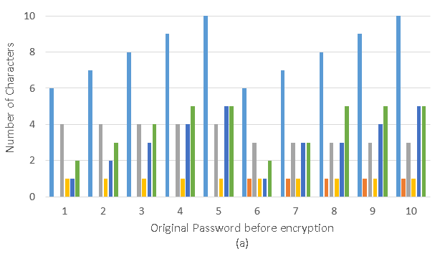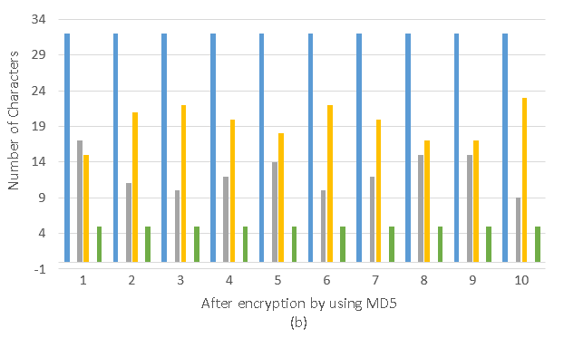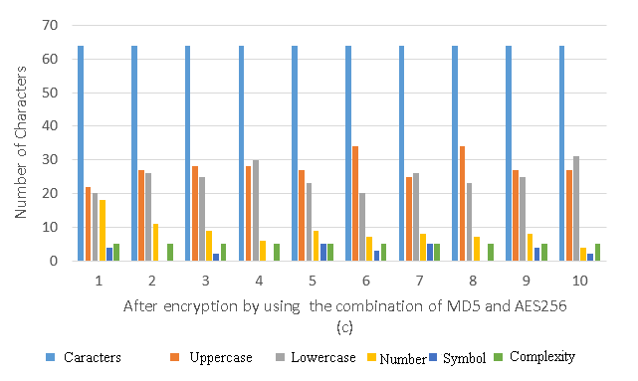

Figure 7. Increases and decreases in the number of characters, uppercase, lowercase, numbers, symbols and complexity of passwords before and after encoding by using MD5 and AES256 encryption method

In Table 5 are the results of testing the password data to analyze the duration of time it takes someone to do for cracking a password that has been encrypted with a combinational method. In Table 5 the numbers 1, seen initial password data is coba*1, it takes time to do a cracking for 2 minutes and 48 seconds, and after the password in encrypted with MD5 method, the estimated time required to perform the cracking increased to 43x10²⁷ years, this is a very long time for someone to make efforts for cracking passwords[25]. Not only up phase encoded with MD5 methods, the process security was carried out again by being encrypted password data encryption result with MD5 method using a method of securing the second is with AES256 encryption method 34x10⁹⁹ years, this is a very long time compared with the time estimate after the password encrypted with MD5 method[22].

- Conclusion
The results of the test, it can be concluded that all passwords, regardless of the number of characters, will be 32 characters after MD5 encryption and 64 characters after AES256 encryption. While the time required for the encryption process with the combination method of MD5 and AES256 produces the shortest time is 0.00088 seconds and the longest is 0.0012 seconds. In addition, the time required for cracking passwords after being encrypted with the combination method of MD5 and AES256 resulted in the longest time being 34x10⁹⁹ years and 1x10⁸⁴ years the fastest time.
- References
[1] L. Wieclaw, V. Pasichnyk, N. Kunanets, O. Duda, and O. Matsiuk, “Cloud Computing Technologies in ‘ Smart City ’ Projects,” in IEEE International Conference on Intelligent Data Acquisition and Advanced Computing Systems: Technology and Applications, 2017, pp. 339–342.
[2] T. Sharma and S. L. Aarthy, “An automatic attendance monitoring system using RFID and IOT using Cloud,” Proc. 2016 Online Int. Conf. Green Eng. Technol. IC-GET 2016, pp. 1–4, 2017, doi: 10.1109/GET.2016.7916851.
[3] M. S. Mekala and P. Viswanathan, “Smart Agriculture IoT with Cloud Computing,” in IEEE 2017 International conference on Microelectronic Devices, Circuits and Systems (ICMDCS), 2017, pp. 1–7, [Online]. Available: http://www.jstor.org/stable/20137917.
[4] S. Vatari, A. Bakshi, and T. Thakur, “Green house by using IOT and cloud computing,” 2016 IEEE Int. Conf. Recent Trends Electron. Inf. Commun. Technol. RTEICT 2016 - Proc., pp. 246–250, 2017, doi: 10.1109/RTEICT.2016.7807821.
[5] S. Ojha and V. Rajput, “AES and MD5 based secure authentication in cloud computing,” in Proceedings of the International Conference on IoT in Social, Mobile, Analytics and Cloud, I-SMAC 2017, 2017, pp. 856–860, doi: 10.1109/I-SMAC.2017.8058300.
[6] Imamah, A. Djunaidy, and M. Husni, “Penerapan AES Untuk Otentikasi Akses Cloud Computing,” Ilm. SimanteC, vol. 4, no. 1, pp. 3–5, 2014, doi: 10.1097/NNE.0b013e3182383371.
[7] J. D. Bokefode, A. S. Bhise, P. A. Satarkar, and D. G. Modani, “Developing A Secure Cloud Storage System for Storing IoT Data by Applying Role Based Encryption,” in Procedia Computer Science, 2016, vol. 89, pp. 43–50, doi: 10.1016/j.procs.2016.06.007.
[8] T. M. Zaw, M. Thant, and S. V. Bezzateev, “Database Security with AES Encryption, Elliptic Curve Encryption and Signature,” 2019 Wave Electron. its Appl. Inf. Telecommun. Syst. WECONF 2019, no. 978, pp. 1–6, 2019, doi: 10.1109/WECONF.2019.8840125.
[9] C. Irawan, A. Winarno, P. Studi, S. Informasi, F. I. Komputer, and U. D. Nuswantoro, “Kombinasi Algoritma Kriptogarafi Aes Dan Des Untuk Enkripsi,” Proceeding SENDIU, pp. 28–35, 2020.
[10] J. Daemen and V. Rijmen, “The Advanced Encryption Standard Process.” NIST, Gaithersburg, pp. 1–8, 2002, doi: 10.1007/978-3-662-04722-4_1.
[11] L. Khakim, M. Mukhlisin, and A. Suharjono, “Security system design for cloud computing by using the combination of AES256 and MD5 algorithm,” IOP Conf. Ser. Mater. Sci. Eng., vol. 732, no. 1, 2020, doi: 10.1088/1757-899X/732/1/012044.
[12] N. Su, Y. Zhang, and M. Li, “Research on data encryption standard based on AES algorithm in internet of things environment,” in Proceedings of 2019 IEEE 3rd Information Technology, Networking, Electronic and Automation Control Conference, ITNEC 2019, 2019, no. Itnec, pp. 2071–2075, doi: 10.1109/ITNEC.2019.8729488.
[13] R. Munir, Kriptografi. Bandung: Informatika Bandung, 2006.
[14] A. Chauhan and J. Gupta, “A novel technique of cloud security based on hybrid encryption by Blowfish and MD5,” 4th IEEE Int. Conf. Signal Process. Comput. Control. ISPCC 2017, vol. 2017-January, pp. 349–355, 2017, doi: 10.1109/ISPCC.2017.8269702.
[15] R. Munir, “Fungsi Hash Satu Arah dan Algoritma MD5,” Bandung, 2004.
[16] O. C. Briliyant and A. Baihaqi, “Implementation of RSA 2048-bit and AES 128-bit for Secure e-learning web-based application,” Proceeding 2017 11th Int. Conf. Telecommun. Syst. Serv. Appl. TSSA 2017, vol. 2018-January, pp. 1–5, 2018, doi: 10.1109/TSSA.2017.8272903.
[17] Y. Firmansyah and U. Udi, “Penerapan Metode SDLC Waterfall Dalam Pembuatan Sistem Informasi Akademik Berbasis Web Studi Kasus Pondok Pesantren Al-Habib Sholeh Kabupaten Kubu Raya, Kalimantan Barat,” J. Teknol. dan Manaj. Inform., vol. 4, no. 1, 2017, doi: 10.26905/jtmi.v4i1.1605.
[18] Sukamto and Shalahuddin, Analisa dan Desain Sistem Informasi. Yogyakarta: Andi Offset, 2013.
[19] L. Zhang, B. Li, and X. Zhao, “Reconfigurable Hardware Implementation of AES-RSA Hybrid Encryption and Decryption,” 2020 IEEE 5th Int. Conf. Signal Image Process. ICSIP 2020, pp. 970–974, 2020, doi: 10.1109/ICSIP49896.2020.9339251.
[20] S. D. Akik.Hidayat, “Perbandingan Waktu Dan Kecepatan Proses Enkripsi Dan Dekripsi Data Teks.Txt Menggunakan Algoritma Des Dan 3Des,” Siliwangi, J. No, Vol Sains, Seri Teks, Data Menggunakan, T X T Des, Algoritm. DES DAN 3DES, vol. 4, no. 2, pp. 93–99, 2018.
[21] I. H. Latif, “Time Evaluation of Different Cryptography Algorithms Using Labview,” IOP Conf. Ser. Mater. Sci. Eng., vol. 745, no. 1, 2020, doi: 10.1088/1757-899X/745/1/012039.
[22] M. Yildirim and I. Mackie, “Encouraging users to improve password security and memorability,” Int. J. Inf. Secur., vol. 18, pp. 741–759, 2019.
[23] H. Sibyan, “Implementasi Enkripsi Basis Data Dengan Algoritma Demgan Algoritma MD5 (Message Digest Algorithm 5) Dan Vigenere Cipher,” Ppkm I, vol. 5, pp. 114–121, 2017.
[24] G. Gumira, Ernawati, and A. Erlanshari, “Implementasi Metode Advanced Encryption Standard ( AES ) Dan Message Digest 5 ( MD5 ) Pada Enkripsi Dokumen ( Studi Kasus LPSE UNIB ),” J. Rekursif, vol. 4, no. 3, pp. 277–287, 2016.
[25] B. F. Halawa, A. Suwardi, R. Toro, and R. Syahputri, “Analisis Kelemahan Sistem Authentication Pengguna Pada Wireless IEEE 802 . 11i,” in Sinergitas Multidisiplin Ilmu Pengetahuan dan Teknologi, 2020, vol. 3, pp. 291–301.

