Analysis Of The Application Of Digital Applications In Compiling The Financial Statements Of Batik MSMEs In Talang Tegal County

Dewi Kartika¹, Arifani Ferida², Nurseha Ardi³
D3 Accounting^{1&3}, Public Sector Accounting²
Politeknik Harapan Bersama^{1,2&3}
dewikartika563@gmail.com¹, arifanyerida@poltektegal.ac.id², nursehaardi@gmail.com³.

Abstract— The purpose of this research was to analyze the Application of Digital Applications in Compiling Financial Reports for Batik MSMEs in Talang Tegal County. The used data collection Interviews, observations, literature studies, and documentation were used to obtain data. Qualitative data analysis with descriptive approaches was employed as the data analysis technique. The findings of the study demonstrate that adopting digital tools to record business transactions and produce financial reports makes it easier for MSMEs to do so. Users will easily input purchase and sales transactions, accounts payable and receivables, payment of operating expenses and others. In addition, business capital will also be more closely monitored. The digital application is also easy to use at any time because it can be accessed via a smartphone so that it can provide real-time information so that it can help operations move more effectively and efficiently and can find out financial position anytime and anywhere.
Keywords— Digital applications; Financial Reports; MSMEs

Introduction
Micro Small and Medium Enterprises (MSMEs) are one of the alternatives that can be chosen in increasing people's income. MSMEs, especially MSMEs have a very important role in the creation of job opportunities and sources of income in Indonesia and proved better able to withstand the impact of the economic crisis that had hit Indonesia in 1998. At that time the economic crisis reached its worst point with enormous negative impacts on almost all sectors (Amalia, 2018).
Micro, small, and medium-sized enterprises (MSMEs) have also been able to contribute to the expansion of the national economy. In 2016, MSMEs contributed 59.84 percent of GDP, which increased to 60% in 2017.
This contribution is in keeping with the continued rise of the number of MSMEs. From 61.7 million in 2016 to 62.9 million in 2017, the number of MSMEs increased by 2.06%, or 1.2 million.. This sector has a very large market share of 99.99% of all business people in the country. MSMES also have a role in absorbing a workforce of up to 116.6 million people or 97.02% in 2017 (Cooperatives and Small and Medium Enterprises Ministry, 2017).
Business development in the present period is fast-paced and dynamic, requiring business actors, particularly Micro, Small, and Medium Enterprises (MSMEs), to move quickly to keep up with technology advancements developments and have digital financial literacy in accordance with the times (Naufalin & Krisnaresanti, 2021). The goal is that these MSMEs actors can maintain markets and consumers and expand business networks. With the advancement of technology, it can help the development of MSMEs businesses and can even worsen the MSMEs situation.
Financial statements of good and high quality are those that can show information about a company's financial status so that it may be utilized as a guideline in making decisions, both by internal and external parties. Presenting financial statements becomes a problem for MSMEs actors, Especially for those who may still not have the ability to do bookkeeping either manually or system. This needs to be taken seriously, considering the fact that financial statements become a measure of the health and sustainability of the business carried out. (Legina dan Sofia, 2020)
The Indonesian government is currently working on Industry 4.0, which includes batik, to boost the industry's competitiveness and independence. (Muafi, 2020). The development of MSMEs in Batik Talang, Tegal Regency, requires financial reports and analyzing the application of digital application assistance so that they can be controlled and compete well with other MSMEs. Based on the phenomenon that occurred the MSMEs Batik Bengle Talang Village Tegal confusion that hit the MSMEs resulting in the report and writing scattered whether my mother, Keteledoran in financial bookkeeping in a business can be fatal which causes MSMEs to suffer losses and will falter their finances until out of business.
Currently, MSMEs do not recognize or appreciate the advantages of income statements, statements of financial position / balance sheet, capital change statements. This is because MSMEs actors themselves are still blind to financial statements The reason MSMEs do not use accounting, among others, accounting is considered something difficult and not important. Some MSMEs actors say that without accounting the company continues to run smoothly and always earn profits (Meilisa, Nopiandri, and Rosalinda, 2021).
Sophisticated internet services make it easier for MSMEs owners to have a Warung Book application that helps with financial bookkeeping of their business. Because all types of businesses both small and large need clear bookkeeping. So using digital application bookkeeping MSMEs because it will provide details of the influx of business money.
The development of MSMEs Batik Talang Tegal County demands that there be financial statements and analyze the help of digital applications in order to be controlled and compete well with other MSMEs. The researcher is interested in conducting research named "Analysis of the Use of Digital Applications in Compiling the Financial Statements of Batik MSMEs in Talang Tegal County" based on the following.

LITERATURE REVIEW

Micro, Small and Medium Enterprises
MSMEs (Micro, Small, and Medium-Sized Enterprises) According to the Indonesian Institute of Accountants, are entities that have met the definitions and criteria for micro, small, and medium enterprises as set forth in Indonesian laws and regulations for at least two years, as outlined in the Financial Accounting Standards for Micro, Small, and Medium Entities (SAK EMKM).

Basic Accounting Concepts

The American Institute of Certified Public Accountants (AICPA) published a report in 2007 that stated (Suhayati and Anggadini (2009:1) defines "accounting is the art of recording, classifying, and summarizing transactions and events of a financial nature in an efficient manner and in the form of units of money, and interpreting the result of the process".

Financial statements

Financial statements are recordings of a company's information during a given accounting period that describe its performance. Bankers, creditors, owners, and other interested parties can utilize financial statements to analyze and assess the company's financial performance and condition. (IAI, 2016)

Accounting Practices in Financial Statements
Accounting practices in a financial report are defined by the availability of financial statements that have been generated in a systematic manner and are backed up by sufficient evidence. It is dependent on the availability of accounting information systems in order to compile financial reports. In today's world, information technology is a critical component of a company's operations. Information systems have a significant impact on practically every element of corporate management, including the administration of SMEs (Naufalin and Krisnaresanti, 2021). However, the majority of Micro, Small, and Medium Enterprises (MSMEs) are still operated in a traditional manner, which means that the use of information technology is still limited.
There are two types of information systems, namely single user and multi user. A single user information system is an information system designed to meet the personal information needs of a single user. Meanwhile, multi-user information systems are designed to meet the information needs of work groups (departments, offices, divisions, sections) or the entire organization. To build an information system, both single user and multi user, it is necessary to effectively combine the following information system components (Romney and Steinbart, 2005): Human Resources, Procedures, Data, Software, Smartphone Financial Applications, and Information Technology Infrastructure.
In the accounting information system and presentation of financial statements a company consists of 3 main components, the three components of the system function/subsystem are input, process, so as to produce output in the form of financial reports as information needed in managerial decision making.
This function also shows that the system as a process cannot stand alone, there must be input, process, and output. There are several examples of financial accounting applications on Android-based smartphones that have developed in Indonesia, including: Akutansi UKM application and Buku Warung application.

RESEARCH METHODS
- Research Location and Time
This research was carried out in Bengle Village, Talang District Tegal County which will be carried out from October to January 2022.

Data Type
Qualitative and quantitative data are the two categories of data employed. Interview data from SMEs in Bengle Village regarding their company and financial reporting provided the qualitative data for this study. Payment notes, income and expenditure records were employed as quantitative data in this study.

- Data source
This inquiry included both primary and secondary data sources. Direct interviews with the people concerned produce primary data in the form of information, conditions and allocation of the use of financial reports and applications used from MSMEs Batik Talang Tegal County. MSMEs Batik Bengle Talang Tegal County provide secondary data in the form of simple financial reports or manual bookkeeping.

- Data Collection Technique
Interviews, observations, literature studies, and documentation were used to obtain data.

- Data Analysis Technique
Qualitative data analysis with descriptive approaches was employed as the data analysis technique.

RESULTS
Based on the results of field observations, researchers got an initial description of the general transactions that occur in batik MSMEs in Talang. These transactions are inputted manually or do not even do the bookkeeping at all. Manual recording only follows the stages in the accounting cycle. We will go through many stages in accounting activities, spanning from financial transactions to bookkeeping and financial statement production. The accounting cycle refers to a set of activities that are repeated over and over again. The accounting cycle can be characterized in general as follows:
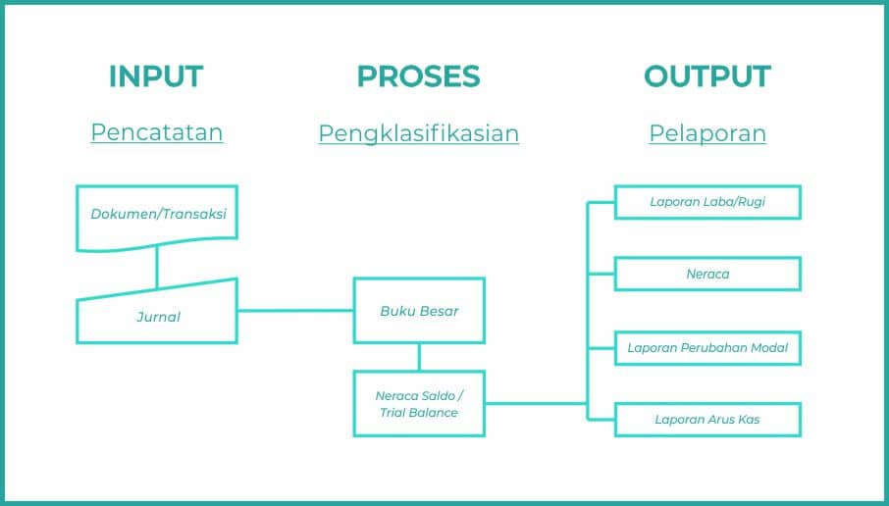

Fig 1. Accounting Cycle

According on the findings of researchers' observations and interviews, there are still many batik SMEs in Talang that have not done digital bookkeeping. However, there are some batik MSMEs in Talang that already use digital applications in their business books. The MSMEs is UD Putra Amalia Batik which uses Akuntansi UKM application.

- Analysis of Akuntansi UKM application in Compiling Financial Statements UD Putra Amalia Batik
In financial recording using digital applications, the first thing to do is to install the application program. Then then do the registration process by entering the company name, address, telephone and email as a step to create a company database. Furthermore, the user can enter the initial capital. If the database has been created, the company can process financial transactions starting from input sales, input purchases to input expenses that occur during a certain period using the journal feature, so this application can automatically generate various reports and whenever needed and can be downloaded and hardcopy printed. Among the reports provided are general journals, ledgers, trial balances, income statements, balance sheets, and accounts payable and receivable reports.
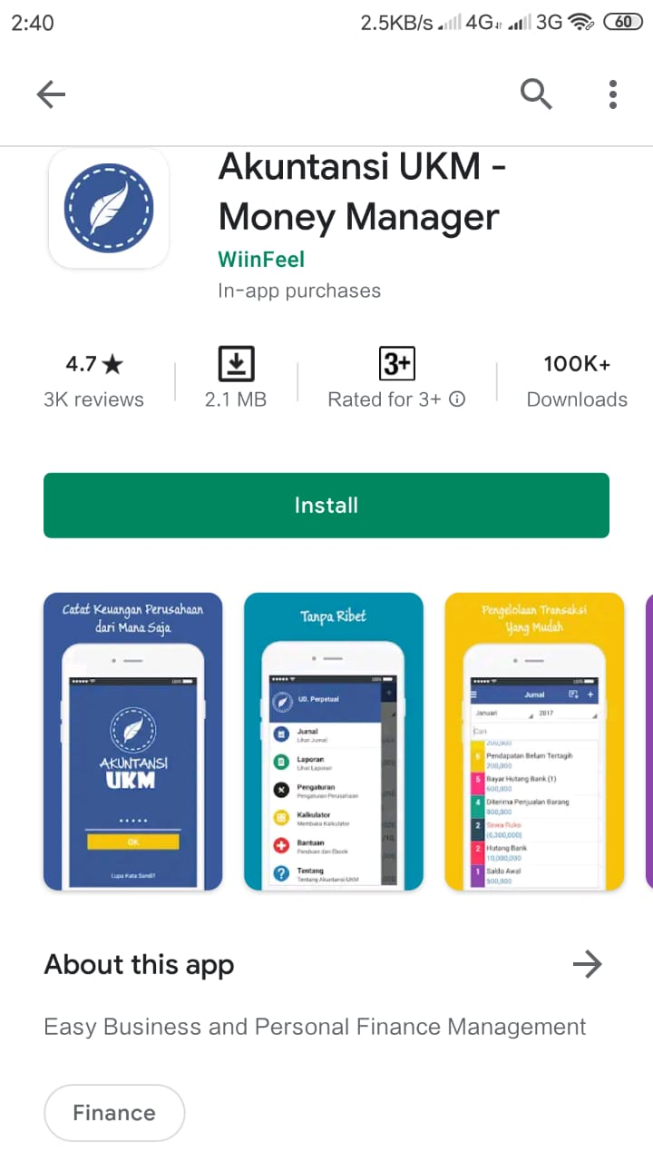
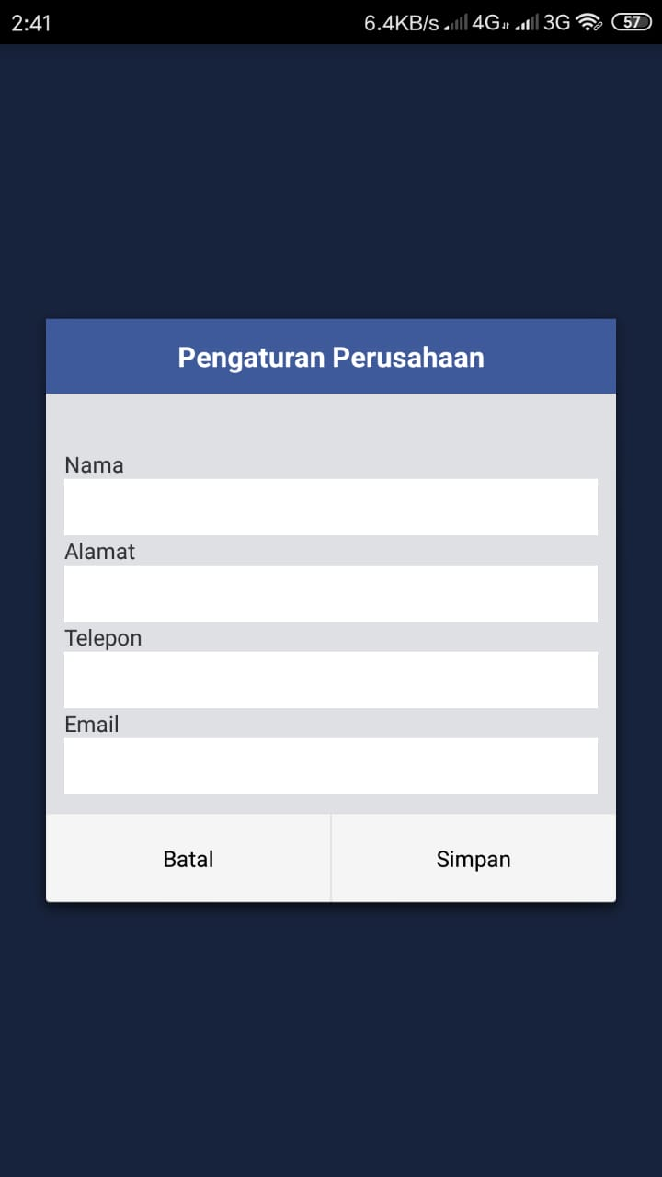

Fig 2. Initial Registration Process

The following is an explanation of the features provided by SME Accounting:
- Journal
Journals are used to enter the company's daily transactions. These transactions include purchases, sales, accounts payable and receivable, payment of expenses, etc.
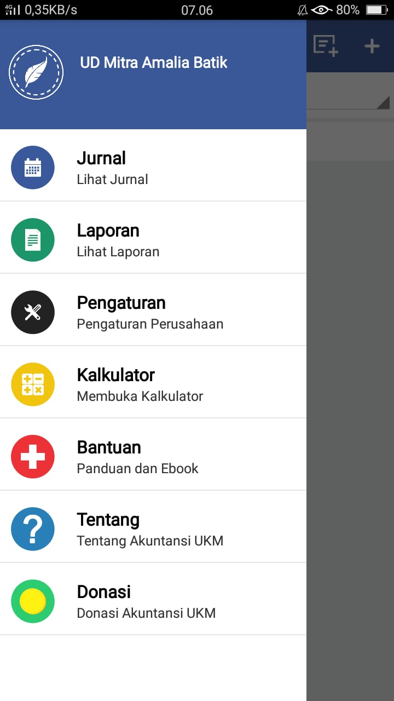
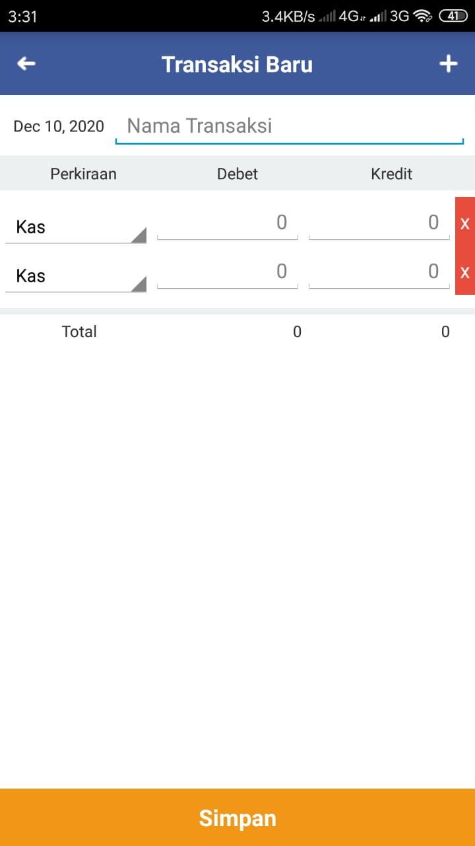

Fig 3. Business Transaction Input Process

Users can view the history of recorded transactions using the report feature by selecting a journal.
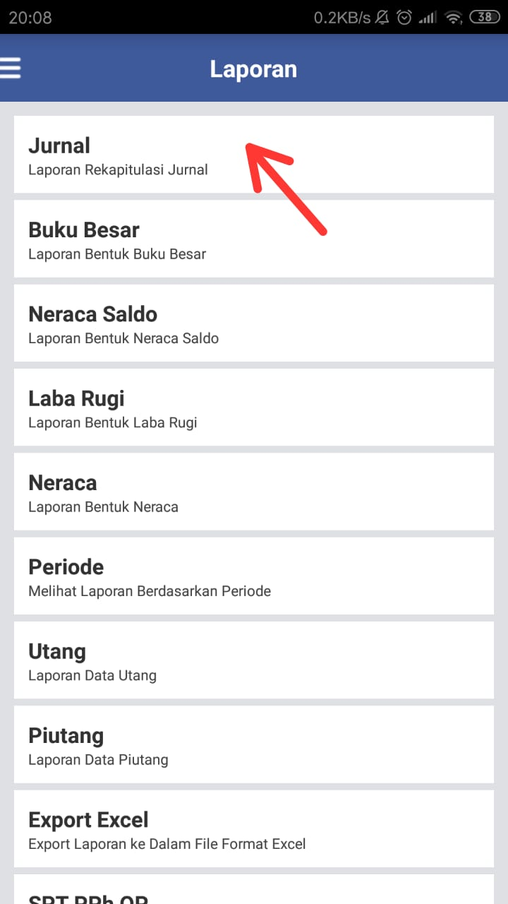
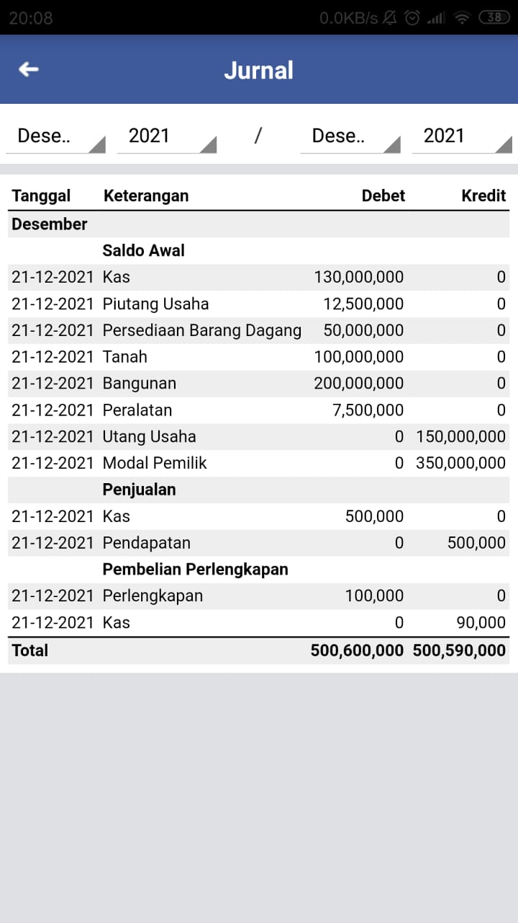
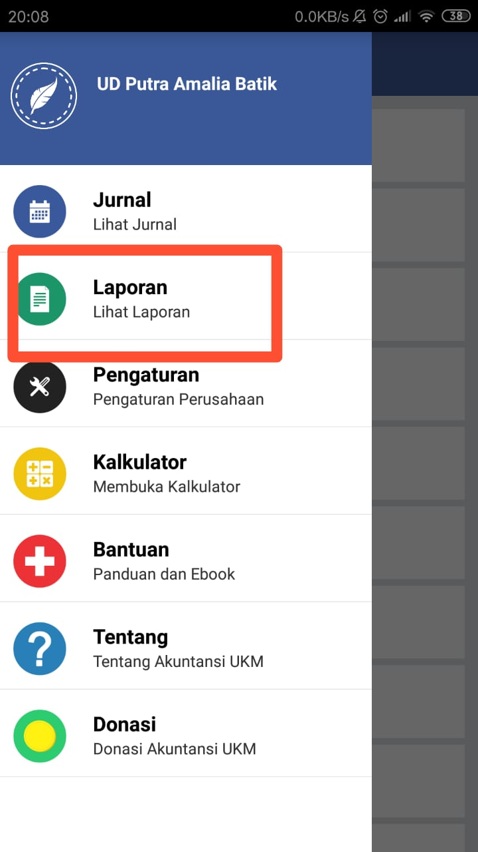
Fig 4. Journal Report

- Journal Correction
Correction Journal will be marked in red if the journal or transaction entered is not balanced. Journal correction only applies if the user uses manual journal input.
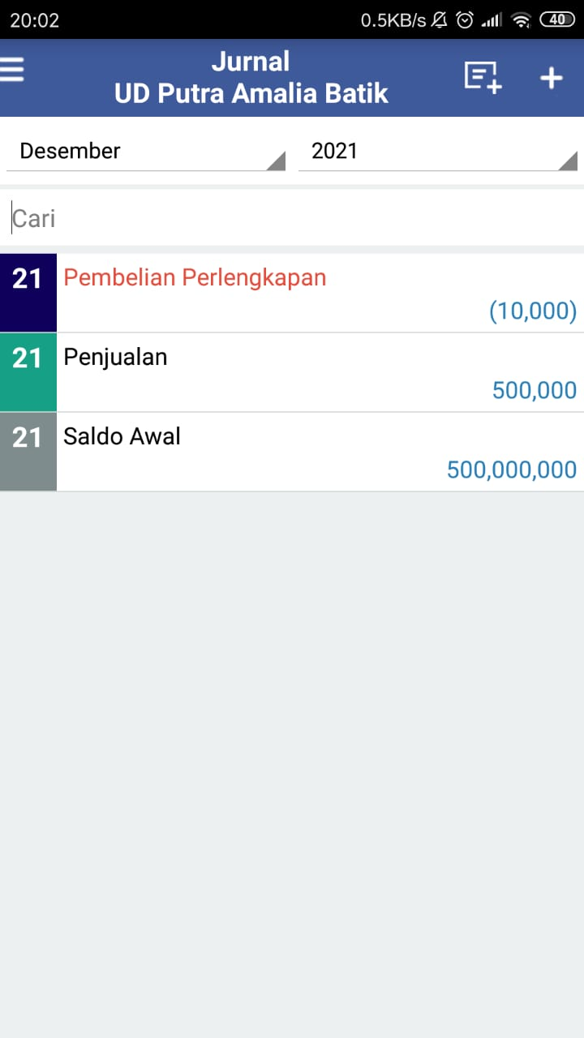
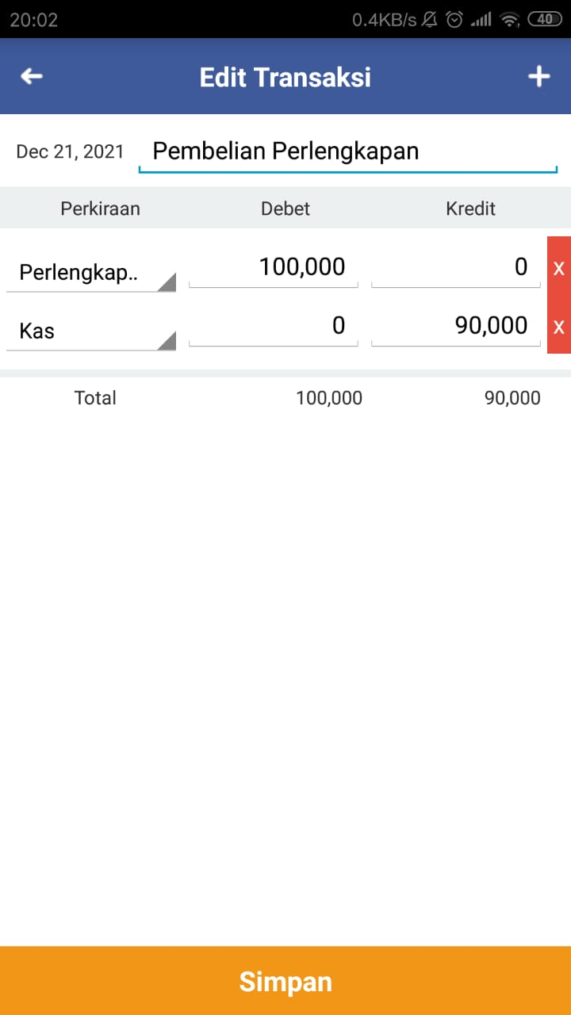

Fig 5. Journal Correction
- Ledger
The ledger contains a summary of the daily journal reports that have been inputted. All transactions entered will be grouped by account name.
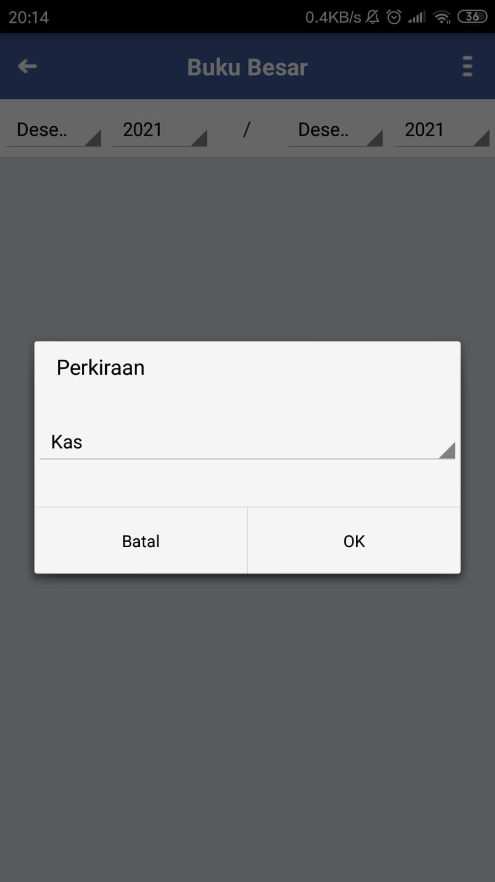
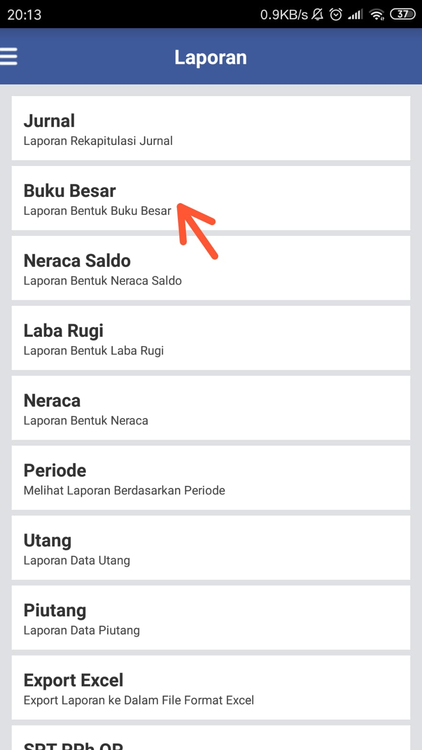
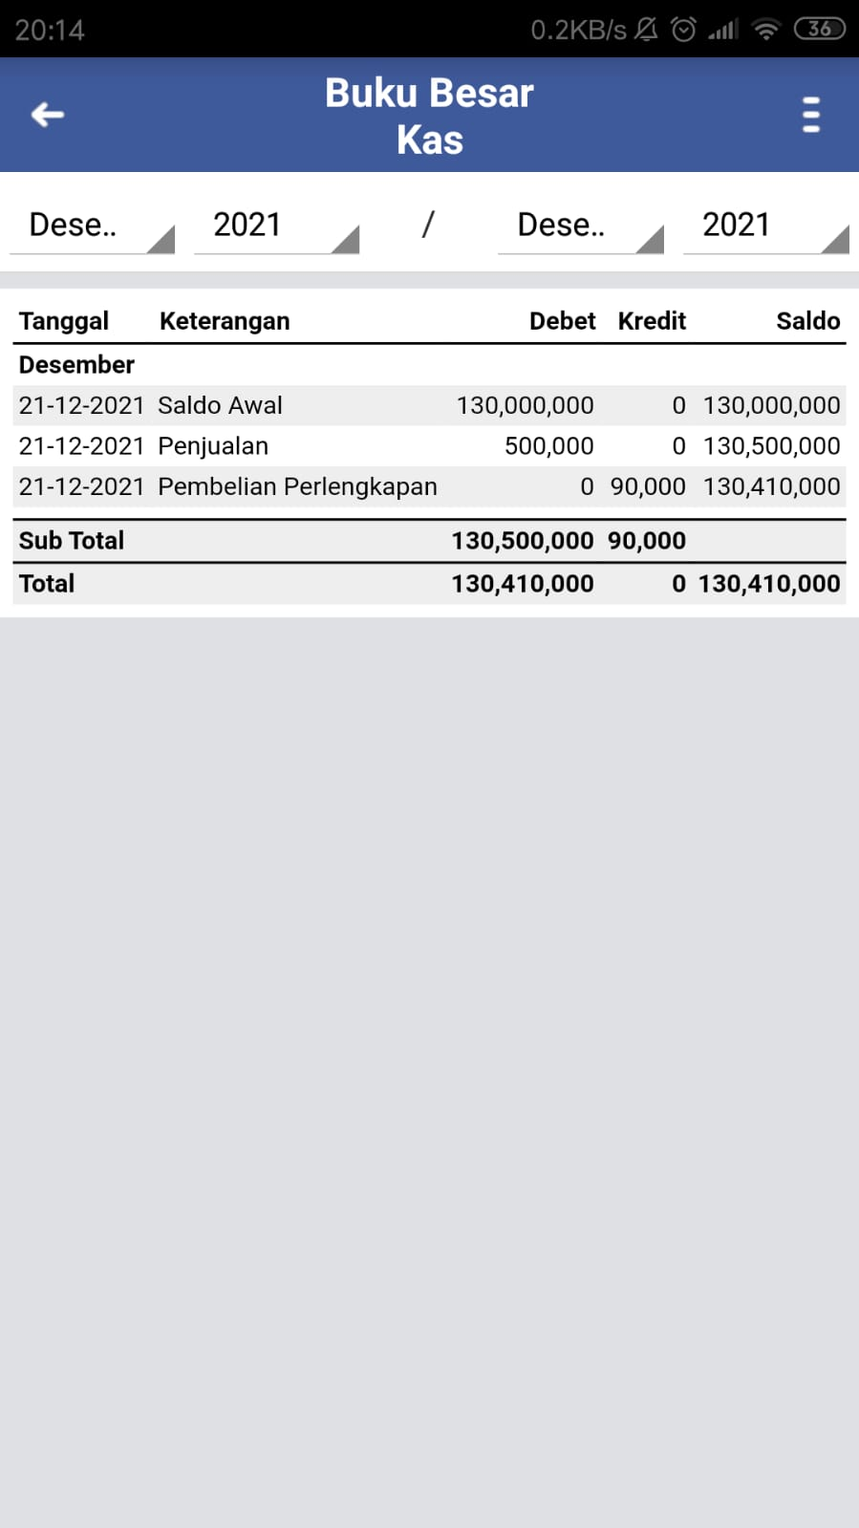
Fig 6. Ledger Report

- Trial Balance
Trial balance is a daily journal value balance report that is input. The trial balance shows the company's financial position.
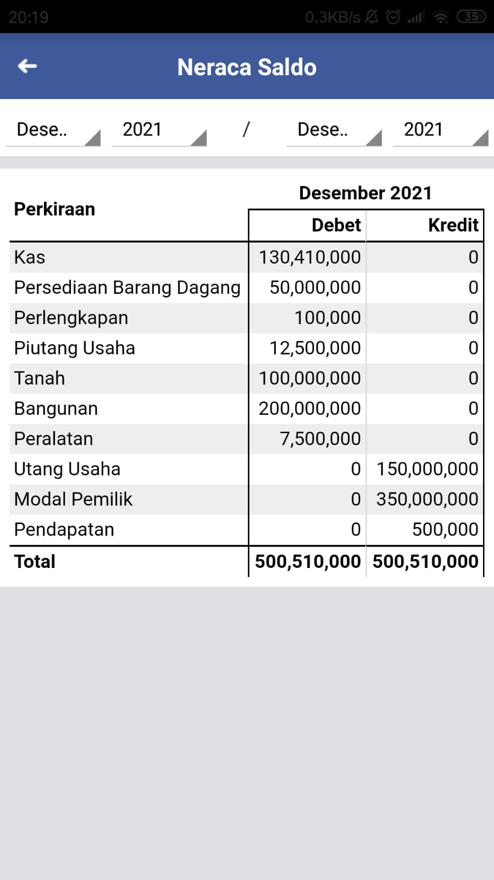
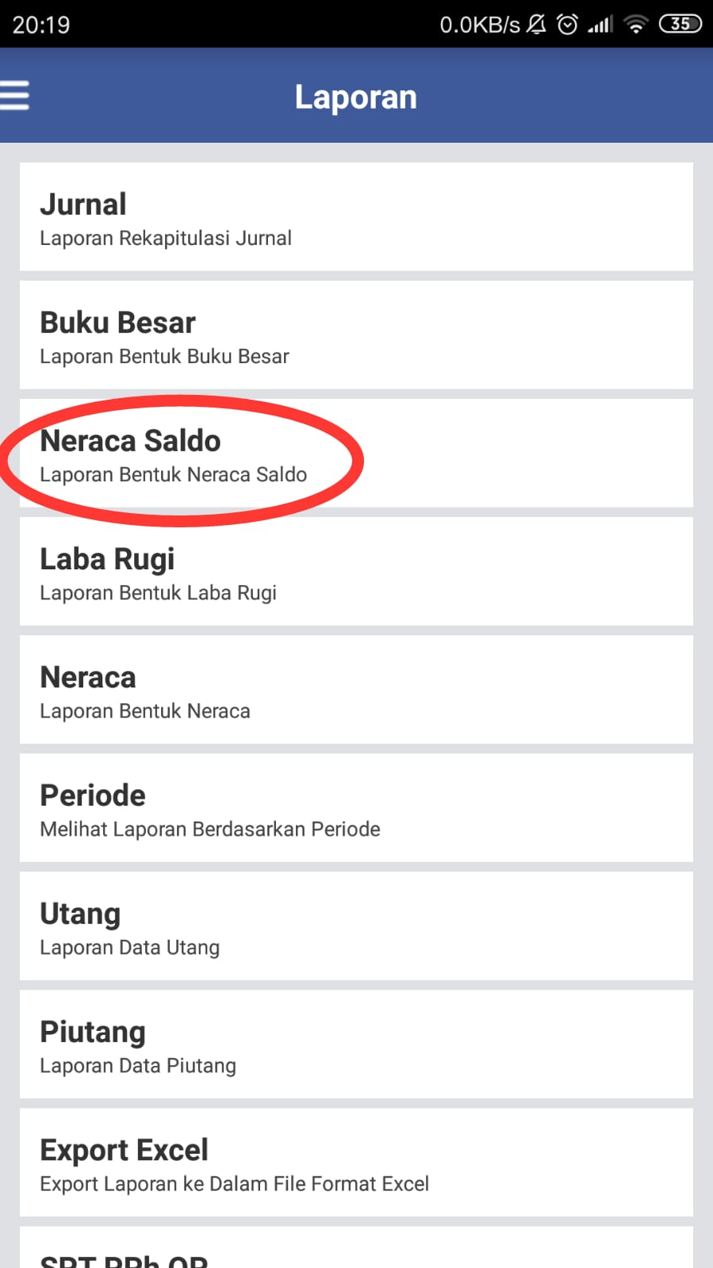

Fig 7. Trial Balance

- Income Statement
An income statement is a report that is used to view the company's profit or loss.
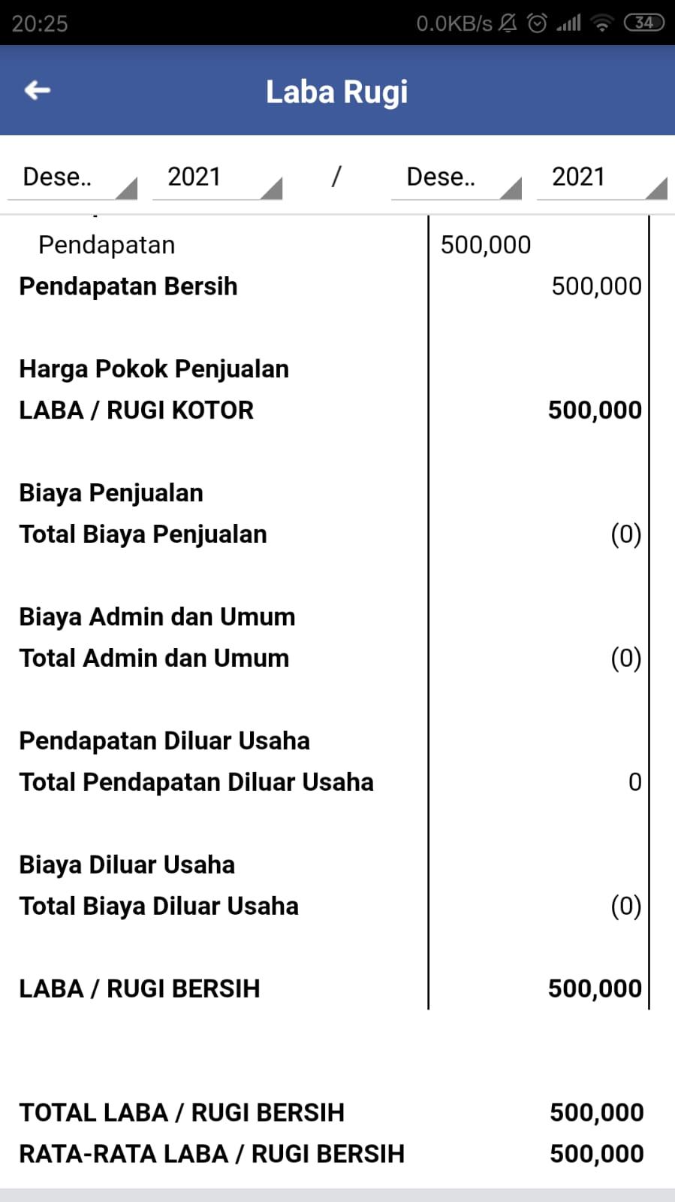
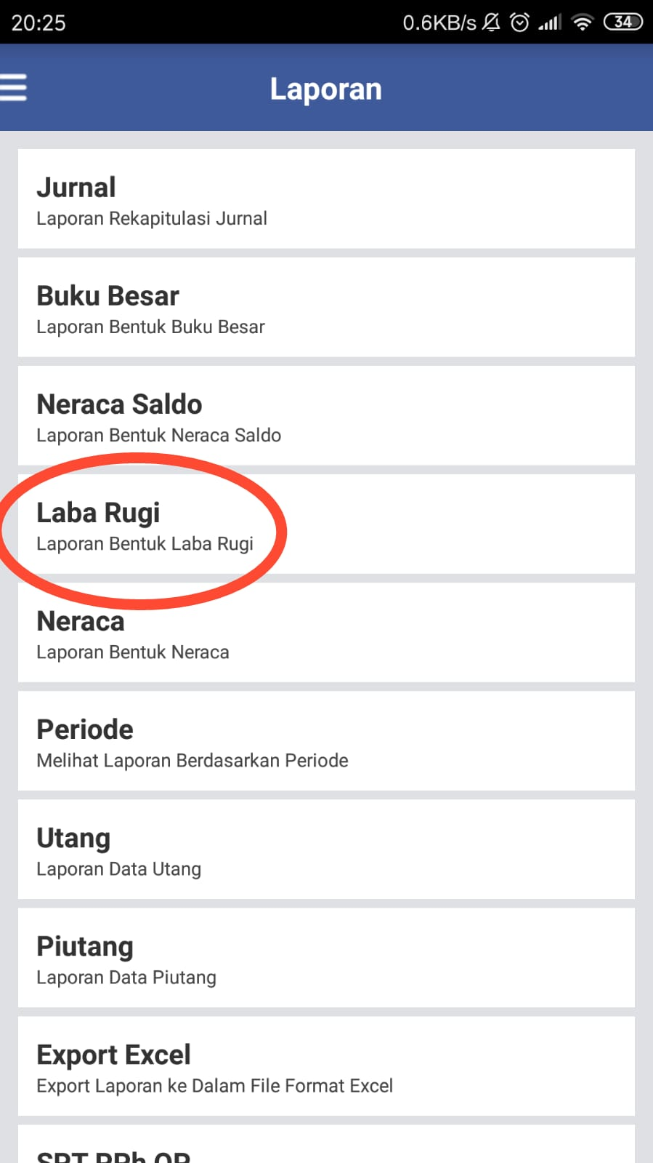

Fig 8. Income Statement

- Balance Sheet
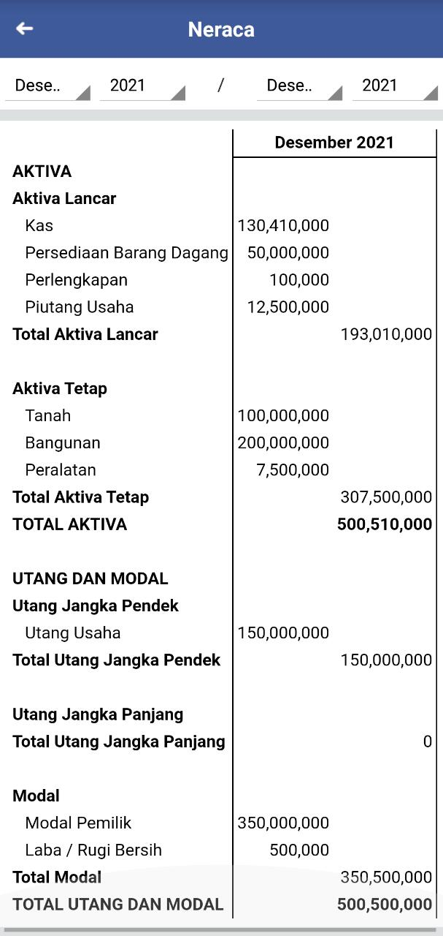
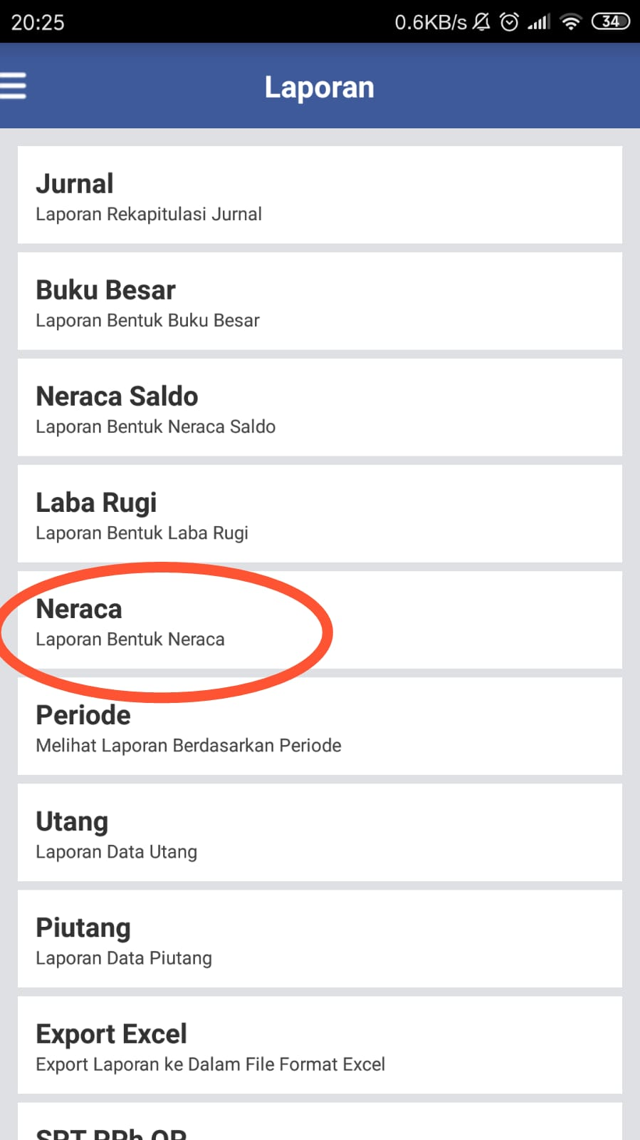
The Balance Sheet is a company's financial report as well as an automatic closing of the books.

Fig 9. Balance Sheet

- Annual SPT Report
Annual SPT report is an annual tax return (SPT) containing a tax report that must be paid.
- Export Excel
The features provided by the UKM Accounting Application are by saving reports in excel files so that they can be printed on a computer.
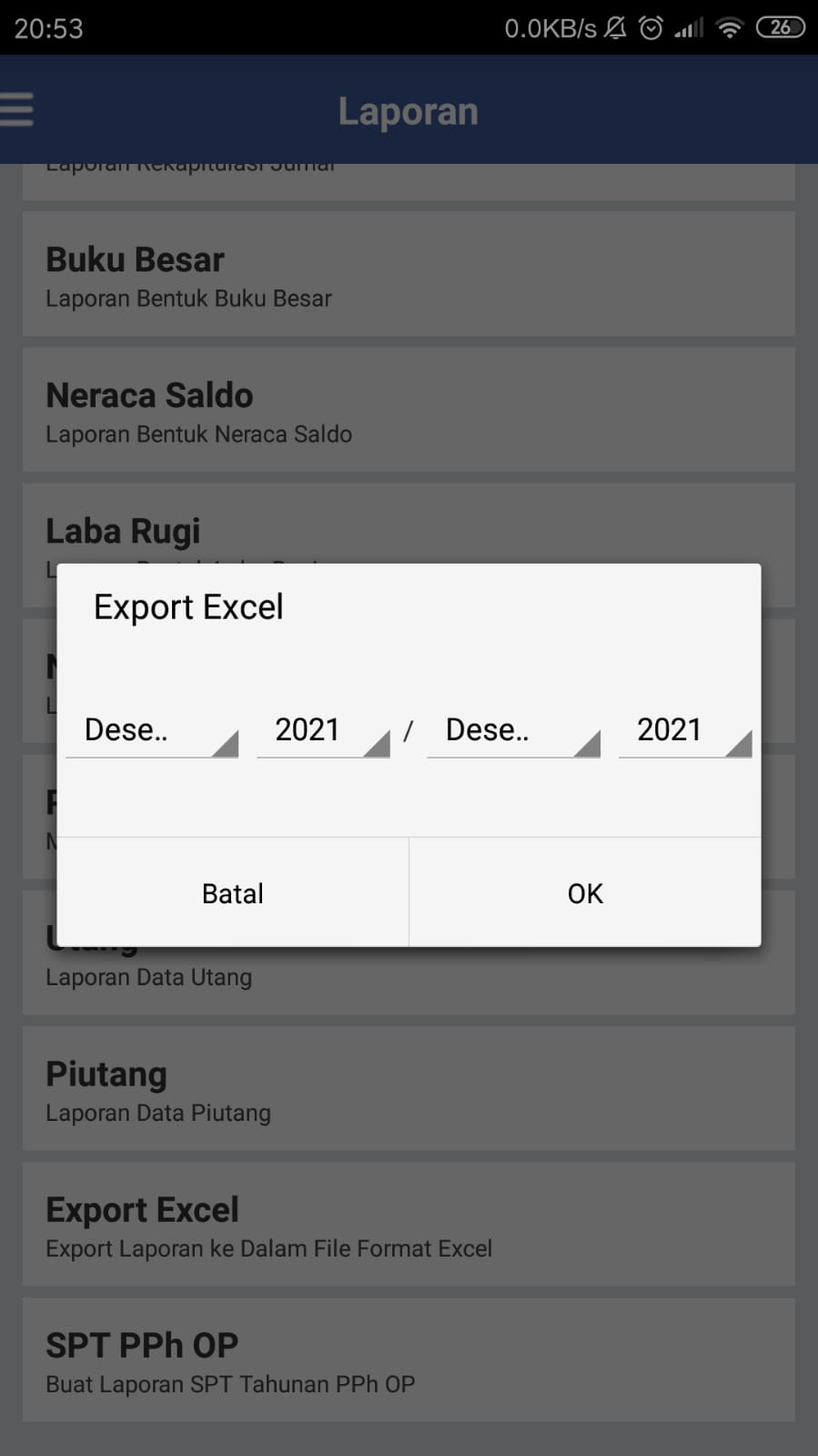
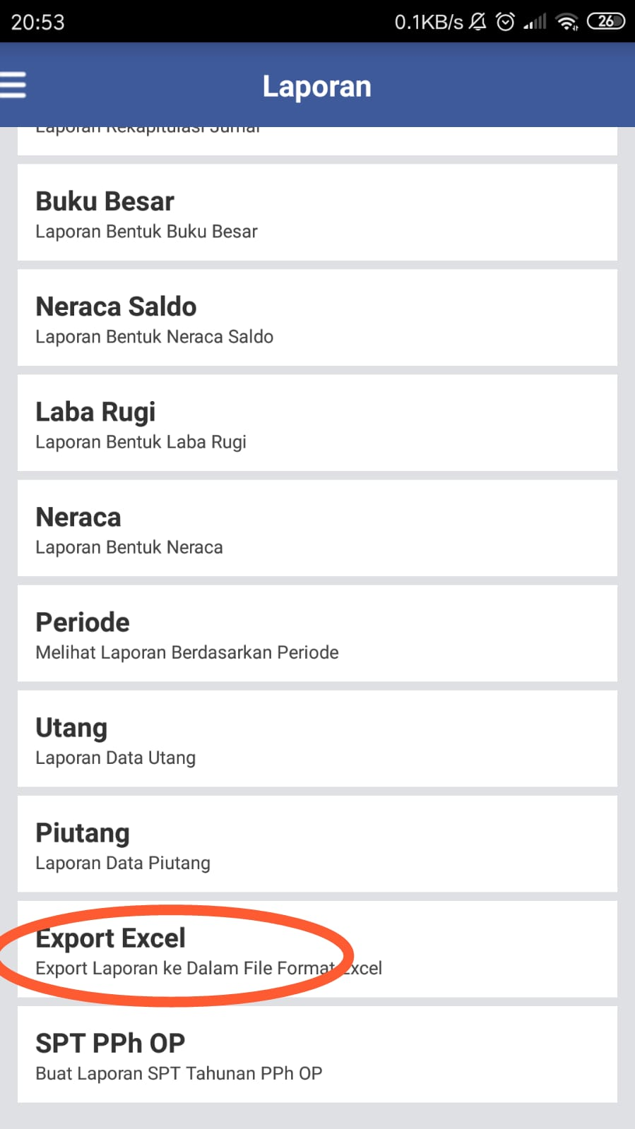

Fig 2. Export Financial Report Excel Format

- Backup & Restore
Backup & Restore is Backing up data. This feature allows users to access the web version of the SME Accounting application.
- Sync Google Drive
Google Drive Sync is backing up data to Google Drive.
- Reminder
With this feature, application users can create reminder schedules.
- Multi-User
The Multi User feature allows application users to enter multiple companies.
- Calculator
Calculator is a feature to calculate as well as calculators in general.
From the above analysis, Akuntansi UKM Application provides convenience for MSMEs in carrying out business financial bookkeeping. Business transactions in the form of purchases and sales, payables and receivables, payment of operational expenses and others, will be easier and more practical if processed using digital applications such as Akuntansi UKM application even though they are used by users, namely MSMEs such as UD Putra Amalia Batik who are unfamiliar with accounting knowledge. Users will easily monitor the company's finances because financial reports can be compiled automatically based on input transactions made, besides that, business capital will also be continuously monitored.
Some of the advantages of Akuntansi UKM application include:
- The application is easy to use at any time because it can be accessed via a smartphone so that it can provide real-time information so that it is expected to help operations move more effectively and efficiently and can find out financial position anytime and anywhere.
- It is easy to enter business transactions because Akuntansi UKM application provides facilities in the form of a quick journal to enter journals or transactions quickly using a dual input model and journal correction which will give a red mark automatically if the transactions made are not balanced.
- Provide various reports that can be downloaded in excel format so that users do not need to create financial reports manually. The reports provided include: general ledger, trial balance, income statement, balance sheet, period report, accounts payable report, accounts receivable report, Annual SPT report.
- Akuntansi UKM Application has good security quality because it provides features such as backup and restore, google drive sync, and security to lock the application so that users do not have to worry about losing data and leaking company financial information.
- Akuntansi UKM Application has several complementary features that can facilitate the operation of the application, such as: reminders, multi users, calculators, guides and ebooks, and donations for SMEs.
- Fast data processing so that recipients of information can immediately make decisions or determine company policies.
- Human resource efficiency is enhanced by the fact that just one person is required to input data into the accounting information system, after which the next procedure is carried out automatically.
Although it has many advantages, digital applications, especially Akuntansi UKM applications, also have a weakness, namely serial errors because the process of each accounting stage occurs automatically, so if an error occurs in the input process, it will result in an error in the next stage.

Acknowledgment

The author would like to thank the TIC of Politeknik Harapan Bersama committee for organizing this event and providing us with the opportunity to speak. The author also expressed gratitude to all who assisted in the preparation and completion of this paper.

References
- Amalia, M. R. (2018). Analisis Pengaruh Pelatihan, Bantuan Modal dan Cara Pengelolaan Usaha Terhadap Pendapatan Usaha Mikro Kecil dan Menengah (Studi Kasus UMKM Sentra Batik Desa Bengle Kab. Tegal). Permana, 10(1), 107–115.
- Ministry of Cooperatives and Small and Medium Enterprises. (2017). KUKM Tanpa Digitalisasi Ekonomi Akan Ketinggalan. Cooperative No.8.
- Naufalin, L. R., and Krisnaresanti, A. (2021). Analysis of Characteristics of Banyumas Batik SMEs as a Basis for Development of Digital Financial Literacy Education Model. 235–250.
- Rosalina, V., Mulyanah, and Malik, A. (2017). Electronic Customer Relationship Management (E-CRM) Modeling on Micro, Small and Medium Enterprises (MSMEs) Banten. International Journal of Computer Applications, 175(3), 28–33. https://doi.org/10.5120/ijca2017915488
- Romney, M. B., and Steinbart, P. J. (2005). Sitem Informasi Akuntansi (9th edition). Jakarta: Salemba Empat.
- Legina, X., and Sofia, I. P. (2020). Pemanfaatan Software Pembukuan Akuntansi Sebagai Solusi Atas Sistem Pembukuan Manual Pada Umkm. Jurnal Neraca: Jurnal Pendidikan Dan Ilmu Ekonomi Akuntansi, 4(2), 172. https://doi.org/10.31851/neraca.v4i2.4771
- Muafi, M. (2020). A nexus among strategic orientation, social network, knowledge sharing, organizational innovation, and MSMEs performance. Journal of Asian Finance, Economics and Business, 17(6), 327–338. https://doi.org/10.13106/jafeb.2020.vol7.no6.327
- Meilisa, R., Nopiandri, & Rosalinda, A. (2021). Penerapan Aplikasi Digital Dalam Penyusunan Laporan Keuangan Umkm Desa Tamiang. Batara Wisnu …, 1(2), 127–135. Retrieved from http://batarawisnu.gapenas-publisher.org/index.php/home/article/view/9
- Government Regulation of the Republik of Indonesia Number 7 of 2021 on Ease, Protection, and Empowerment of Cooperatives and Micro, Small and Medium Enterprises. State Gazette of the Republic of Indonesia of 2021 Number 17. Jakarta
- Suhayati, E., & Anggadini, S. D. (2009). Akuntansi Keuangan (1st edition). Yogyakarta: Graha Ilmu.
- IAI. (2016). Standar Akuntansi Keuangan Entitas Mikro, Kecil dan Menengah. Jakarta: Financial Accounting Standards Board.

