Tegal International Conference (TIC 2021)
Repurchase Intention in Terms of Service Quality Through e-Wom and Hotel Image

Heri Prabowo
Departement of Management Universitas PGRI Semarang Semarang, Indonesia
heriprabowo.se.mm@gmail.com

Sutrisno Departement of Management Universitas PGRI Semarang Semarang, Indonesia
sutrisnopgrismg@gmail.com

Soedjono
Department of Education Management Universitas PGRI Semarang
Semarang, Indonesia
soedjonosyagata@gmail.com

Abstract—This study aims to analyze the factors that can affect the intention to repurchase at the hotel. This study aims to measure the effect of service quality on repurchase intentions through hotel image and e-word of mouth. The population in this study were guests who stayed at the hotel, with a total sample of 168 respondents. Data analysis using SEM with AMOS program. The results of the analysis show that service quality has an effect on repurchase intentions through hotel image and e-word of mouth. The contribution of all variables studied in influencing repurchase intention is 78.6 percent, meaning that there are other factors that influence repurchase intention outside the variables studied.

Keywords—Service quality; electronic word of mouth; hotel image; repurchase intention

- INTRODUCTION
The hotel is an integral part of the tourism business which according to the decision of the Minister of Tourism, Post and Telecommunication is mentioned as a commercialized accommodation business by providing facilities, namely bedrooms or guest rooms, food and beverages, other supporting services such as: sports facilities, laundry facilities, and so on [1 In the current era, prospective customers in the hospitality industry are spoiled with the convenience of making hotel reservations through online travel agents (OTA). In existing online travel agent applications, prospective guests staying can see an overview of the services provided by the hotel to guests who stay by reading testimonials about their stay experiences from consumers who have used the hotel's services.
Quality services that have tangible, reliability, responsiveness, assurance and empathy dimensions [2]. The quality of service provided by the hotel and can be felt by guests who stay makes guests who stay want to return to stay at the same hotel [3]. Quality services are perceived by customers in the tourism industry as an attraction in influencing someone to come back [4]. However, there are different views about the quality of service provided by the hotel does not guarantee that the person will come back to the same hotel [5]. The quality of service obtained by the customer is expected to be able to produce information through the activities of testimonials from hotel users that are able to direct someone to make a repeat purchase or a decision to revisit the hospitality industry [6].
Providing quality service and creating superior customer value can result in high customer satisfaction, thus affecting the hotel's image. [7]. Hotels focus on creating a positive hotel image by increasing the level of comfort as a form of implementation of the quality of service provided to staying guests [8]. Creating a good hotel image provides benefits for hotel operators to encourage growth and sustainability for hotels [9]. In improving the image of the hotel, what needs to be done is to provide quality services so as to form a quality impression about the quality of service obtained by guests who have stayed [10]. Hotels that have a good, professional image are able to foster interest in staying again at the same hotel [3]. The image that is built in the hospitality industry with a positive image can influence someone to come back to the same place [11]. Based on the findings of previous studies, a model of factors that influence guests to stay again at the same hotel was developed as follows.
e-WOM

Service Quality
Repurchase Intention
Hotel Image

Fig. 1. Research model
The developed model aims to analyze whether there is an effect of service quality on electronic word of mouth and hotel image that has an impact on repurchase intention.

Copyright © 2021, the Authors. Published by Atlantis Press.

II. RESEARCH METHODS
The purpose of this study was to determine the effect of service quality on repurchase intention through electronic word of mouth and hotel image. The research was conducted using quantitative methods with data analysis using a structural equation model. Respondents in this study were guests who stayed with the criteria of these guests booking hotels through online travel agents.

III. RESULTS AND DISCUSSIONS
- Results
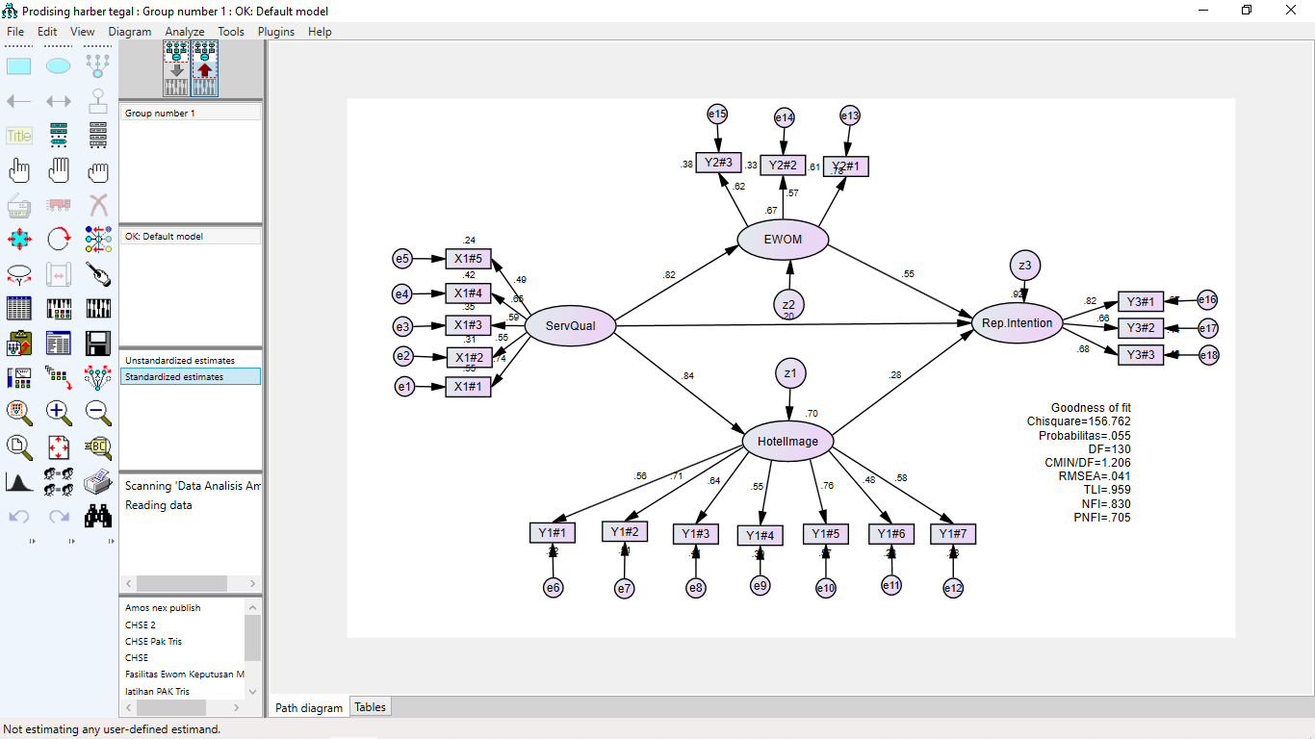

Fig. 2. SEM Analysis Using AMOS Program

TABLE I. RESULT OF MODEL TEST
Goodness of Fit Index | Cutoff Value | Result | Evaluation
X2 Chi-Square | X2 with df; 130; p: 5% = 157.610 | 156.762 | Good
Significance Probability | ≥ 0.05 | 0.055 | Good
CMIN/DF | ≤ 2.00 | 1.206 | Good
RMSEA | ≤ 0.08 | 0.041 | Good
TLI | ≥ 0.90 | 0.959 | Good
NFI | ≥ 0.90 | 0.830 | Marginal
PNFI | ≥ 0.60 ≤ 0.90 | 0.705 | Good
TABLE II. RESULT OF SEM FOR HYPOTHESIS TESTING.
Variable | Standardized Regression Weight | C.R | P | Results
ServQual → eWOM | 0.616 | 5.437 | 0.000 | Accepted
ServQual → Hotel Image | 0.839 | 5.338 | 0.000 | Accepted
eWOM → Repurchase Intention | 0.554 | 2.633 | 0.008 | Accepted
ServQual → Repurchase Intention | 0.599 | 2.733 | 0.004 | Accepted
Hotel Image → Repurchase Intention | 0.583 | 3.589 | 0.002 | Accepted
TABLE III. ANALYSIS OF DIRECT AND INDIRECT EFFECT
- Discussions
Variable | Direct Effect | Indirect Effect | Results
Service Quality on Repurchase Intention through electronic word of mouth | 0.616 | 0.690 | Accepted
Service Quality on Repurchase Intention through Hotel Image | 0.599 | 0.690 | Accepted
Based on data obtained from 168 respondents, the results of data analysis indicate that service quality affects electronic news by word of mouth. In addition to having an effect on word of mouth electronic news, service quality also affects the hotel's image. Service quality also has a direct effect on repurchase intentions. Likewise, word of mouth electronic news affects repurchase intentions, also hotel image affects repurchase intentions.
The next analysis is to analyze the effect of service quality on repurchase intentions through verbal communication and the effect of service quality on repurchase intentions through hotel image. The results showed that service quality had an effect on repurchase intention through electronic word of mouth, while service quality had an effect on repurchase intention through hotel image.

REFERENCES
  - Agus Sulastiyono, Manajemen Penyelenggaraan Hotel. Bandung; Alfabeta,2006.
  - Parasuraman, A., Zeithaml, V.A. and Berry, L.L, A Conceptual Model of Service Quality and Its Implications for Future Research. The Journal of Marketing, 49, 41-50, 1985.
  - Prabowo, H. , Astuti, W. and Respati, H, Effect of Service Quality and Brand Image on Repurchase Intention through Word of Mouth at Budget Hotels Airy Rooms. Open Journal of Business and Management, 8, 194-207, 2020.
  - Sonia Dwi Cahyanti, Sudarmiatin & Ely Siswanto, The Effect Of Service Quality And Destination Attributes On Revisit Intention Through Visitor Satisfaction At Hawai Waterpark Malang, South East Asia Journal of Contemporary Business, Economics and Law, Vol. 23, Issue 1, 2020.
  - [3] Susanto, T. W. P., Sudapet, I. N., Subagyo, H. D., & Suyono, J., The Effect of Service Quality and Price on Customer Satisfaction and Repurchase Intention (Case Study at Crown Prince Hotel Surabaya). Quantitative Economics and Management Studies, 2(5), 288-297, 2021.
  - Hamad Saleem and Naintara Sarfraz Raja, The Impact of Service Quality on Customer Satisfaction, Customer Loyalty and Brand Image: Evidence from Hotel Industry of Pakistan, Middle-East Journal of Scientific Research 19 (5): 706-711, 2014.
  - Hsin-Hui (Sunny) Hu, Jay Kandampully & Thanika Devi Juwaheer, Relationships and impacts of service quality, perceived value, customer satisfaction, and image: an empirical study, The Service IndustriesJournal, 29:2, 111-125, 2009.
  - Ali Gholipour Soleimani & Hannaneh Einolahzadeh, The influence of service quality on revisit intention: The mediating role of WOM and satisfaction (Case study: Guilan travel agencies), Cogent Social Sciences, 4:1, DOI: 10.1080/23311886.2018.1560651, 2018.
  - Cheng Boon Liat, Shaheen Mansori & Cham Tat Huei ,The Associations Between Service Quality, Corporate Image, Customer Satisfaction, and Loyalty: Evidence From the Malaysian Hotel Industry, Journal of Hospitality Marketing & Management, 23:3, 314-326, 2014.
  - Cham, Tat Huei and Easvaralingam, Yalini, Perceptions of Service Quality, Corporate Image, and Customer Loyalty in the Hotel Industry of Malaysia (October 25, 2011).
  - Cham, T. H., & Yalini, E., Perceptions of service quality, corporate image, and customer loyalty in the hotel industry of Malaysia. In The 2nd International Research Symposium in Service Management. Yogyakarta, INDONESIA (pp. 126-135)., , 2011.
  - Trung, Nguyen & Khalifa, Gamal, Impact Of Destination Image Factors On Revisit Intentions Of Hotel's International Tourists In Ba Ria-Vung Tau (Br-Vt) The Mediating Role Of Positive Word Of Mouth. 3. 98-107,,2019.
TAB I. RESULTS OF IN-DEPTH INT

