READINESS FOR RE-OPENING OF LOANS DURING COVID-19 PANDEMIC
(CASE STUDY: HOMESTAY IN GUCI TOURISM OBJECT)

Puput Dewi Anggraeni
Hospitality Study Program
Politeknik Harapan Bersama
Tegal City, Indonesia
puput.dewi@poltektegal.ac.id
Wiyanti
Hospitality Study Program
Politeknik Harapan Bersama
Tegal City, Indonesia
wiyanti@poltektegal.ac.id

Abstract— The impact of Covid-19 has dramatically affected all sectors, especially since the implementation of the large-scale social restriction system (PSBB). All businesses have been completely paralyzed, especially the tourism sector. Since the closure of the Guci Tourism Object on March 16, 2020, all homestay has been closed for quite a long time. On September 1, 2021, the Guci Tourism Object was reopened with limited conditions and accommodated thousands of visitors. Visitors are prioritized by people from Tegal Regency and are in good health. This reopening has a good impact on accommodation in Guci. For this effect, all homestays must be ready with government policies to implement cleanliness, health, security, and sustainability in the homestay environment. The purpose of this study was to determine the readiness to reopen homestay during the pandemic. The method used in this research is quantitative with descriptive analysis. The results of this research are the owners/managers of the homestays are pretty ready to reopen during the pandemic. However, there are still two things that must be considered or reviewed further. Those are Hand Washing/hand sanitizer facilities and body temperature measurement at the guest entrance.

Keywords—covid-19; homestay; readiness

Introduction
The high number of COVID-19 cases in Indonesia has caused the government to urge the public to implement social distancing, such as working from home and praying from home to stop the spread of this virus (detik.com, March 16, 2020). Since implementing the large-scale social restriction system, all businesses have been completely paralyzed, especially the tourism sector. Tourism, which in fact is a contributor to state income, has been paralyzed by this epidemic. Most of the hotels were also affected by covid-19. They suffered significant losses. The Indonesian Hotel and Restaurant Association noted that 1,642 hotels throughout Indonesia had been forced to close due to the Covid-19.
The impact of COVID-19 has also greatly affected homestays at the Guci Tourism Object. Since the closure of the Guci Tourism Object on March 16, 2020, all homestays have been in suspended for quite a long time. Starting September 1, 2021, the Guci Tourism Object will be reopened with limited conditions, which is only to accommodate one thousand visitors. Visitors are prioritized by people from Tegal Regency and are in good health. Visitors are also expected to have been vaccinated and have a non-cash payment application (Setda.tegalkab.go.id, 2021). This has a good impact on a homestay in Guci, primarily homestays. For this effect, all homestays must be ready with government policies to implement cleanliness, health, safety, and environmental sustainability in the homestay. By the Decree of the Minister of Health Number HK.01.07/Menkes/382/2020 concerning Health Protocols for the Community in Public Places and Facilities in the Context of Prevention and Control of Corona Virus Disease 2019 (Covid-19).
Hotels with good management, such as three-star hotels and above, definitely apply CHSE standards (cleanliness, health, safety, and environmental sustainability) because many consumers ask about CHSE to hotels if they will staycation at the hotel. However, unlike the homestays in the Guci Tourism Object, maybe only some are obedient to health protocols, and there are still most of them that need further research.

LITERATURE REVIEW
- Homestay
A homestay is a place of lodging or temporary rest that will be used for tourists who are vacationing in a tourist area [1].
Homestay is a place to stay for tourists with the advantage that tourists can get the opportunity to get to know the owner's family[2].

- Covid-19
In general, people have strong motivation to engage in social and physical interaction. However, the COVID-19 pandemic dramatically forced the whole world to live in a new normal. A pandemic historically generates fear of other people based on the perceived threat of pathogens. People also tend to have subjective impressions (rather than objective views on actual phenomena) of the disease threat. Therefore, it is crucial to understand how the perceived threat of COVID-19 affects various behaviors, including the preference for restaurants[3].
This pandemic is having a huge impact on real economic activity, but the extent of its actual impact remains unknown because the spread of the disease, its severity and mortality rate, suitable policy responses, and individual behavior are all uncertain[4].

- Readiness
Several things to prepare in facing the new normal are paying attention to the readiness of the owner/manager, ensuring a safe experience, rebuilding tourist trust, and confidence and implementing possible policies. When tourist lodges/homestays decide to resume operations, make sure they have trained staff to prepare and implement operational plans [5]:
Reception Room
- Healthy condition and body temperature check before receiving guests. If the body temperature is 37.3ºC and is sick, it is advised not to welcome guests and immediately conduct a health check at the nearest health service facility.
- Greet guests by way of namaste, the Indian greeting.
- Cleaning guest belongings by spraying disinfectant before entering the tourist lodge/homestay.
- Confirm guest profiles referring to the Covid-19 Risk Self-Assessment Instrument
- Inform guests about the cottage/homestay's cleanliness, health, safety, and environmental sustainability of the cottage/homestay.
- Guests to always comply with health protocols.

Guest room
- Use masks and gloves when cleaning the room.
- Change bed linen, pillowcases and blankets after each guest stays.
- Wash hands/use hand sanitizer after cleaning the room.
- Remind guests to always keep the room clean.
- Post important contact information.

Bathroom/Toilet
- Clean the bathroom/toilet with disinfectant regularly.
- Encourage guests always to keep the toilet/bathroom clean.
- Wash hands with soap after cleaning the bathroom/toilet.
- Dispose of toilet/bathroom waste at least once every two days.

Kitchen
- Clean kitchen utensils and utensils with disinfectant after use.
- Maintain a distance from other guests when working in the kitchen.
- Food processors must be in a healthy condition.
- Food processors use masks and gloves.
- Food processors wash their hands with soap before and after cooking.
- Ensure food, clean, safe, and healthy.
- Do not use the same utensils/food utensils as guests.
- Providing special guest utensils/utensils and closing guest dishes.
- Dispose of garbage regularly.

Other Rooms and Surrounding Areas of Homestay
- Clean and sanitize the yard or the area around the homestay/tourist lodge with disinfectants/other safe and appropriate cleaning fluids regularly.
- Clean and sanitize the yard or the area around the homestay/tourist lodge with disinfectants/other safe and appropriate cleaning fluids regularly.
- Wash hands with soap/use hand sanitizer before and after cleaning other rooms and the area around the homestay/tourist lodge.
- Ensure that the garbage around the homestay is disposed of regularly.

4. Tourism Object
The attraction must be a permanently established excursion destination, a primary purpose of which is to allow public access for entertainment, interest, and education, rather than being primarily a retail outlet or a venue for sports, film, or theatrical performance. It must be open to the public without prior booking and should attract day visitors or tourists [6].

METHODOLOGY
This research is quantitative with a descriptive analysis method. Quantitative research is also called positivity (positivist) which emphasizes testing theories by measuring research variables with numbers and conducting data analysis with statistics [7]. A descriptive method is a research method that describes existing phenomena, which are directly present or in the past [8].
The population in this research were homestay managers at Guci Tourism Object, amounting to 230 respondents [9]. The sample of this research is 37 respondents based on the Slovin formula and the sampling technique simple random sampling.
Table 3.1 Readiness Domain Formulation and Indicators
No | Domain | Indicator | Explanation
1 | Human Resources | Policy knowledge | Owner/Manager's understanding of government/local government policies related to Covid-19.
1 | Human Resources | Emergency knowledge | Owner/Manager's knowledge of important contact numbers, such as regional Covid-19 task forces, RT, RW, village offices, security posts, and police stations.
1 | Human Resources | Health protocol | Use of uniforms equipped with the necessary personal protective equipment.
2 | Facilities and Infrastructure | Handwashing facilities/hand sanitizer | There is a sufficient number of handwashing/hand sanitizer facilities in the reception and guest rooms.
2 | Facilities and Infrastructure | Body Temperature Checking Equipment | There are areas and equipment for checking body temperature, and the condition of owner/managers, guests and employees.
2 | Facilities and Infrastructure | Sterilization equipment | - There are special dining and drinking utensils and equipment for guests.  - Cleaning of space and equipment and utensils in the kitchen in a safe way.  - Cleaning guest bathroom/toilet.  - Change of bed linen, pillowcases, and blankets.
3 | Procedure and regulation | Traffic and crowd flow management | Past flow management rules available traffic and crowds.
3 | Procedure and regulation | Distance restriction regulations | There are rules for entering the lobby and front desk areas, set at a safe distance of at least 1 (one) meter, given a unique sign that is easy to see, or carrying out technical engineering such as installing partitions and arranging guests employee entry flows.
3 | Procedure and regulation | Body temperature check | Body temperature checks at the guest entrance. If a temperature is found to be 37.3ºC (2 reviews with a distance of 5 minutes), you will not be allowed to enter unless you have a valid Covid-19 negative/non-reactive test result.
3 | Procedure and regulation | Guest Sterilization | Cleaning of guest belongings and means of payment safely, using a safe and appropriate disinfectant/other cleaning liquid, before being brought in.
3 | Procedure and regulation | Room Sterilization | Cleaning guest rooms with disinfectant.
Source: [5]&[10]
This research instrument is questioner based on readiness domain formulation and indicators above with 13 questions and using Likert type scale measuring instrument.

RESULT AND DISCUSSION
- Respondent Profile
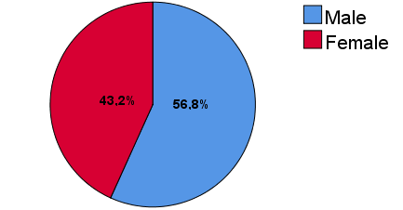

Fig. 4.1 Gender

According to the questionnaire results, 56.8% are male or 21 respondents, while female respondents amounted to 43.2% or 16 respondents.
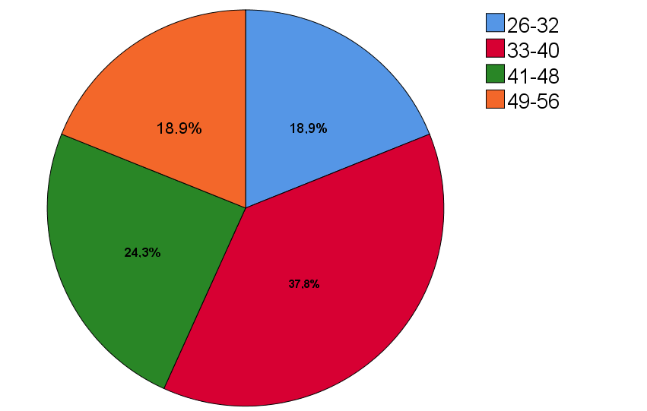

Fig. 4.2 Age

Based on the results of the questionnaire, it shows that the number of respondents aged between 26-32 years is 18.9%, aged 33-40 years are 37.8%, and aged between 41-48 years are 24.3%, while the aged 49-56 years is 18.9%.

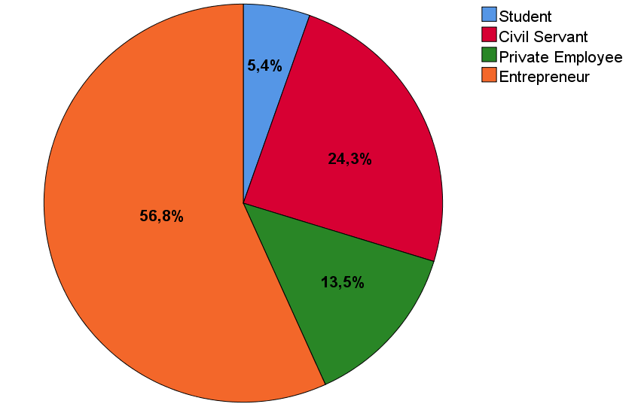

Fig. 4.3 Profession

The questionnaires that have been processed show the number of respondents who are still in school or students is 5.4%, the number of respondents who work as Civil Servants is 24.3%, and the number of respondents who work as private employees is 13. 5%, while the number of respondents who work as entrepreneurs is 56.8%.

- Questionnaire Data Analysis
The research results are seen in the question section regarding Human Resources (HR). Firstly, owners/managers must understand government/local policies related to Covid-19. Indicating that respondents strongly agree, according to questionnaire result 64.9%, and it is proven by the managers who consistently comply with all the policies set by the regional government regarding Covid-19, such as when the Guci Tourism Object is temporarily closed. All owners/managers of tourist lodges/homestays participate in implementing these policies even though there is no input at all at that time. The second question regarding managers must know important contact numbers, such as the regional Covid-19 task force, RT, RW, village offices, security posts, and police stations. 8%. Then the manager must use a complete uniform with the necessary personal protective equipment. The respondents also responded positively about this. Namely, the respondent agreed with this statement. The questionnaire results are 59.5% and evidenced by respondents who use masks when serving guests or in daily dealings with the environment around the homestay. And the last question included in the HR section, namely, the manager must comply with the health protocol. This respondent also strongly agreed and was evident from the number of respondents who were more than 50% or 54.1%.
The second part is about the existing facilities and infrastructure in the homestay. Respondent's responses about Hand Washing with Soap/hand sanitizers facilities showed promising results, namely 45.9%. Almost all homestays in Guci Tourism Object are not provided hand washing facilities on the house's terrace, and the unavailability of hand sanitizer in the reception room or guest room. It is different from the respondent's statement on cleaning guest bathrooms/toilets with disinfectants/other safe and appropriate cleaning fluids and disposing of toilet waste regularly. They stated that they agreed or 43.2%, proven when the survey researchers checked the bathrooms/toilets in several homestays with clean conditions and free of toilet waste. Respondents who agreed about owner/manager are cleaning the room and equipment in the kitchen for safety, using disinfectants/others before use and after use, and disposing of garbage regularly. The questionnaire obtained was 35.1%. It was proven by the kitchen's condition and the equipment and supplies in the homestay in a clean condition and securely closed in the furniture cupboard in the kitchen. The respondent's response to the owner/manager providing equipment and equipment for eating and drinking for guests expressly, as well as serving food/beverage (including snacks) in a closed state and served individually stated that they agreed with the results of the questionnaire by 54.1% and the availability of equipment and supplies proved it. Unique guest eating and drinking utensils are stored neatly and closed in the kitchen cupboard. Furthermore, regarding changing and washing sheets, pillowcases, and blankets after each guest use, respondents also agreed with this, as evidenced by the questionnaire results by 62.2% and the condition of the guest rooms being clean fragrant when checking into the guest rooms.
The last is regulations and procedures thing. The owner/manager's homestay must be obeyed. The first is respondents who agree that officers must always consider traffic flow and crowds by 62.2% because there are guards in front of the house at all times. Then for the measurement of body temperature at the guest entrance. If a temperature of 37.3ºC is found, they are not allowed to enter unless they have a negative/non-reactive Covid-19 test result. The results obtained are still 45.9%, or the respondent sufficiently understands the policy. The evidence is guests have not taken a body temperature measurement when a guest is coming to stay. The respondents' responses to cleaning guest belongings and payment instruments safely, using disinfectants/other cleaning liquids that are safe and appropriate, agree or 43.2%. An evident from the owner/manager, who is enthusiastic about urging guests to make non-payment. The whole room has to clean at all times must be routinely cleaned with disinfectants of 62.2% stated strongly agree, the evidenced by the periodic spraying of disinfectants which is twice a week, according to information from the Chairman of the Association of homestay in Guci Tourism Object.
From the discussion results above, there are still two things that must be considered or reviewed further regarding the means of washing hands/hand sanitizer and measuring body temperature at the guest entrance. If a temperature of 37.3ºC is found (2 checks with a distance of 5 minutes), you are not allowed to enter unless you have a negative/non-reactive Covid-19 test result that is still valid. Therefore the researcher recommends that training be held to increase readiness for reopening for owner/managers homestay during the pandemic at the Guci Tourism Object, the activity on CHSE (Cleanliness, Health, Safety, and Environmental Sustainability) by the guidelines for homestays from the Ministry of Tourism and Creative Economy [5].

CONCLUSION
The research result is the owners/managers of the homestays are pretty ready to reopen during the covid-19 pandemic because there are still two things that must be considered or reviewed further, namely regarding the facilities. Washing hands/hand sanitizer facilities and measuring body temperature at the guest entrance. If a temperature of 37.3ºC is found (2 checks with a distance of 5 minutes), you are not allowed to enter unless you have a negative/non-reactive Covid-19 test result that is still valid because the respondent only stated that the response was sufficient for these two things.

RECOMMENDATION
The suggestions for further research are this research only discusses CHSE (Cleanliness, Health, Safety, and Environmental Sustainability) from the owner/manager perspective so that further analysis can be carried out on the CHSE angle from the government's stance.

REFERENCE
[1] L. D. R. Bilqis, Irfal, and A. Mustika, “Persepsi Guru Dan Dosen Tentang Homestay Dalam Melakukan Kegiatan Wisata Edukasi Sekolah,” J. Ilm. Pariwisata, vol. 26, no. 1, pp. 33–46, 2021.
[2] V. Artina, E. Taviprawati, and A. Darsiah, “Pengaruh Fasilitas Terhadap Keputusan Menginap di Homestay Desa Cipasung, Kuningan,” J. Ilm. Pariwisata, vol. 25, no. 1, pp. 26–39, 2020.
[3] J. Kim and J. C. Lee, “Effects of COVID-19 on preferences for private dining facilities in restaurants,” J. Hosp. Tour. Manag., vol. 45, no. June, pp. 67–70, 2020, doi: 10.1016/j.jhtm.2020.07.008.
[4] H. J. Song, J. Yeon, and S. Lee, “Impact of the COVID-19 pandemic: Evidence from the U.S. restaurant industry,” Int. J. Hosp. Manag., vol. 92, p. 102702, 2021, doi: 10.1016/j.ijhm.2020.102702.
[5] Kemenparekraf, Panduan Pelaksanaan Kebersihan, Kesehatan, dan Kelestarian Lingkungan Homestay/Pondok Wisata, vol. 2019. 2020.
[6] J. Swarbrooke, The Development and Management of Visitor Attractions. Oxford: Butterworth-Heinemann, 2002.
[7] Sugiarto, T. Hendratono, and D. Sudibyo, Metodologi Penelitian Hospitaliti & Pariwisata, 1st ed. Tangerang: PT. Matana Publishing Utama, 2015.
[8] P. D. Anggraeni and T. A. Sabrina, “Analysis of Knowledge About Flour for Readiness of Pastry Practice of Students Study Program DIII Hospitality Harapan Bersama Polytechnic in Tegal,” J. Indones. Tour. Policy Stud., vol. 5, no. 1, pp. 1–7, 2020.
[9] I. Faiz, “Jumlah Villa di Guci,” Panturapost.com, 2019. [Online]. Available: https://panturapost.com/malam-tahun-baru-penginapan-di-guci-sudah-penuh-meski-tarif-naik-3-kali-lipat/.
[10] Kemenkes RI, “Keputusan Menteri Kesehatan Republik Indonesia Tentang Protokol Kesehatan Bagi Masyarakat Di Tempat Dan Fasilitas Umum Dalam Rangka Pencegahan Dan Pengendalian Corona Virus Disease 2019,” 2020.

