Using FlipPDF Application to Make Interactive Digital Module during Covid-19 Pandemic

Arief Hidayat
Computer Science Department,
Wahid Hasyim University
Semarang, Indonesia
rifmillenia @gmail.com
Fandy Indra Pratama
Computer Science Department,
Wahid Hasyim University
Semarang, Indonesia
fandy@unwahas.ac.id
Jeni Nadik
Computer Science Department,
Wahid Hasyim University
Semarang, Indonesia
jeni.nadik94@gmail.com

Abstract—The teacher feels the boredom of students learning independently at home and completing school assignments. Therefore , there is a need for innovation in providing learning modules that attract students ' attention and are interactive . One of these innovations is to package learning modules digitally and interactively. It aims to improve teacher competence in packaging interactive digital learning modules using the FlipPDF application. The method used to carry out the service is in the form of training and workshops. This activity was attended by 30 teachers of SMK NU Ungaran, Semarang Regency. From the results of these community service activities, the ability of teachers to package interactive digital modules using the FlipPDF application increased by 95%. Beginner teachers who have never used or are familiar with the FlipPDF application can easily package and publish interactive digital modules online. The involvement of instructors and assistants in each session really helps teachers to practice packaging interactive digital modules. The participants were very enthusiastic about participating in the training and hoped that this training would be sustainable.
Keywords—FlipPDF; interactive; digital; learning module

Introduction
The industrial revolution 4.0 has brought a series of changes in human life. At the same time, the presence of the Industrial Revolution 4.0 has opened up various opportunities for business actors, governments, and individuals, but also brings the challenge of widening the gap between community groups. The World Economic Forum in the 2018 Global Competitiveness Report stated that there are ten conditions that must be met by a country to be able to transform and align itself with the Industrial Revolution 4.0. All of these requirements refer to one main factor, namely innovation which is believed to be the driving force for the transformation and development of the country.
According to [1] the application of Information Technology has now spread in almost all fields, including schools or colleges. Schools as institutions in charge of managing the learning process, either in the form of direct or indirect learning. The need for Information Technology is closely related to the role of a teacher to master Information Technology as a mediator of the teaching and learning process.
Given ithat ithe iteacher's itask iis iso iheavy, iit iis inecessary ifor iteachers ito ialways iupdate itheir iknowledge, iinsight, iand iskills itowards ithe iexpected iprofessional idevelopment. iRegulation iof ithe iRepublic iof iIndonesia inumber i19 iof i2005 iconcerning iNational iEducation iStandards iindicates ithe iimportance iof ipaying iattention ito ithe iquality iof ilearning iin iorder ito iimprove ithe iquality iof ieducation iin ischools. iThe igovernment's igood iefforts ineed ito ibe ifollowed iup iby ischool ieducational iinstitutions, iboth ipublic iand iprivate, iby iholding iscientific iactivities ithat ican idevelop iteacher ipotential ithrough iseminars, itraining, iworkshops iand iothers ion ian iongoing ibasis iso ithat iteachers ibecome iprofessionals iwho ihave ithe iability ito iimprove ithe iquality iof ilearning iin ischools, iin iturn. iimproving ithe iquality iof ieducation iwill ibe irealized iand ibecome ia ireality i[2]. iAccording ito i[3] iit ihas ibeen ifound iin ivarious istudies ithat ithe iquality iof iteachers iis iconsistently ione iof ithe imost iimportant ifactors iof ithe iquality iof ilearning. iFurthermore, iqualified iteachers iare iable ito iteach istudents ieffectively iin iaccordance iwith iresource iand ienvironmental iconstraints.
On ithe iother ihand, i[2] iview ithat iimproving ithe iquality iof ieducation ican ibe irealized iby ioptimizing iThe iTotal iQuality iManagement i(TQM) imodel iin ischools. iThis itheory iexplains ithat ithe iquality iof ieducation iwith ithis iTQM imodel iincludes ithree iabilities, inamely iacademic, isocial, iand imoral iabilities. iThis itheory ialso istates ithat ischool iquality iis idetermined iby ithree ivariables, inamely ischool iculture, ilearning iprocess, iand ischool ireality.
As iof iMarch i2020 iwith ithe iissuance iof iCircular iLetter iNumber i2 iof i2020 iconcerning iPrevention iand iHandling iof iCovid-19 iin ithe iMinistry iof iEducation iand iCulture iand iCircular iLetter iNumber i3 iof i2020 iconcerning iPrevention iof iCovid-19 iin iEducation iUnits, iall istudents ifrom iall ilevels iof iEducation ihave istudied ionline i(on iline). iSeveral iapplications ito isupport ithe ieffectiveness iof ilearning ithat iare iapplied iby ieach ieducational iunit iare idifferent, ifor iexample iusing iLMS, igoogle iclassroom, iSchoology, iEdmodo, iand iothers i[4] iThe iimpact iis ia ishift iin ithe idirection iof ilearning, ifrom iface ito iface ito iface ito iface ivirtual i(Pure), ithe iuse iof itechnology iis ithe imain ithing iand istudents iare irequired ito ilearn iindependently iwith ithe iteacher's irole ias ia ifacilitator.
Facing ia ipandemic isituation ithat iis inot icertain iwhen iit iwill iend, iand ireferring ito iPermendiknas iNumber i16 iof i2007 iconcerning iAcademic iQualification iStandards iand iTeacher iCompetence, iteachers imust ibe iable ito iutilize iIT. iThe iuse iof ithe iinternet ias ia icommunication inetwork iin ithe ionline ilearning iprocess ihas ibegun ito ibe imassively ipromoted. iDuring ithe ipandemic, ithe ineed ifor iinternet iuse iincreased iby i30 ito i40% i[5]. iThe igovernment ithrough ithe iMinistry iof iEducation iand iCulture iprovides ia iquota iof i50 iGB ifor iteachers, ilecturers, iand iparents/students ifor ione isemester ito isupport ionline ilearning. iIt iis iexpected ithat ithe ilearning iprocess ithat iinvolves istudents, iteachers iand iparents ican irun ioptimally.
Based ion ithe ianalysis iof ithe iproblem isituation iexperienced iby ipartners i(SMK iNU iUngaran), iseveral iproblems irelated ito ionline ilearning ican ibe iidentified, inamely: ilack iof iinterest iand imotivation iof istudents iwhen istudying ilearning imodules iprovided iby iteachers, ilack iof iunderstanding iof iteachers iin imaking idigital iand iinteractive ilearning imodules. iTeachers ihave ithe iability ito iapply iIT ibut ionline ilearning imodules istill itend ito ibe imonotonous iand iless ivaried. iTherefore, ithe icommunity iservice iteam iwill ihold itraining iand iassistance iin imaking iinteractive idigital ilearning imodules iwith ithe iFlip iPDF iapplication ito iimprove ithe iprofessional icompetence iof iteachers iat iSMK iNU iUngaran.

Interactive Digital Module
The quality of education is influenced by the availability of learning facilities, the use of time, and the use of learning media or teaching materials [6]. Learning requires media, there are learning media in hardfile form such as learning books, worksheets, modules and handouts [7]. The softfile forms are e-books, slides, and digital modules [8] [9]. Digital modules can be used as learning media because they have the advantage that they can be accessed anywhere and integrated content by video, audio, and images that help understand lessons [10] [11] [12]. The advantages of digital modules include economical manufacturing costs, more efficient to carry, strong and will not wear out over time, and can be equipped with images, video, audio and animation [13]. Applications that support the creation of digital modules are the Flip PDF application [14], with the formats provided by Flip PDF are (.exe), (.app), (.fbr), and (.html) [10]. This Flip PDF application is very easy to use in learning, can be used to create teaching materials, and the operation is easy so that it can be used by those who are not very proficient at operating computers [15] [16]. In addition, the application used for making e-modules uses a professional flip pdf that includes videos, images, animations so that the learning process is not monotonous in writing only [17].

Method
To support this activity, the Wahid Hasyim University Implementation Team offers an approach method used by [18] in the training process through the following stages:
1. Identification of Needs. At this stage, a needs analysis is carried out to help determine the type and level of partner needs, in this case SMK NU Ungaran based on the problems faced, the gap between expectations and reality, or new conditions that are expected.
2. Planning. At the planning stage, data is collected and an approach is formulated according to the needs identified in the first stage. Several things are formulated at this stage, among others: training objectives, participant prerequisites, operational costs, number of participants, qualifications of instructors (teachers), and testing strategies.
3. Development. The development stage includes the preparation of lesson plans or trainer guides, participant guides, training aids, supporting materials, test and evaluation tools.
4. Implementation. This is the realization or implementation of all the details of the training plan. For the implementation of the training, using the lecture, demonstration and workshop methods.
5. Evaluation. The next stage includes evaluating the program format, content, materials, materials, instructors, and logistics. Training evaluations can be in the form of participant feedback, instructor evaluations, independent evaluations by colleagues or training professionals, or on-the-job evaluations conducted by supervisors through direct observation of trainees after they have applied the training materials.
6. Implementation. This last stage is to apply the resulting output in the form of an Interactive Digital Learning Module that has been produced from training services in the actual learning process. Of course, the assistance from UNWAHAS continues according to the planned schedule.
SMK iNU iUngaran iin ithis icase ias ia ipartner iparticipating ias ia itraining iparticipant ias iwell ias ian ieducational iinstitution iwhere ithe iapplication iof ithe iInteractive iDigital iLearning iModule iis iexpected ito ilater ibe iused ias ia isupporter iof ithe ilearning iprocess ias ia iform iof iimproving ithe iquality iof ilearning ithat ihas iexisted iso ifar. iuse iof ithis iInteractive iDigital iLearning iModule. iCentralized itraining iactivities iwere iheld iin ithe ischool's icomputer ilaboratory ias imany ias i30 iteachers iof iSMK iNU iUngaran, ibecause iit iwas iseen ifrom itime iefficiency iand ieffectiveness. iAll itransportation, iconsumption iand iother icosts iare iborne iby ithe iImplementing iTeam, iwhile ifor ithe iimplementation iof ithe iresults iof ithe itraining, iassistance iwill ibe iprovided ifrom ithe iImplementing iTeam ito iSMK iNU iUngaran iin iaccordance iwith ithe iobjectives iof ithis iactivity.

Result and Discussion
Teacher icompetency iimprovement itraining iin ithe iform iof imaking iinteractive idigital imodules ithat ican ibe iused iin ionline iand ioffline ilearning. iThe iFlip iPDF iapp iincludes iapps ithat iare ieasy ito ibuild iand iuse. iThis iapplication iis ifree, iinteractive, ivery ifun iand ican ibe iaccessed ianywhere iand ianytime, ionly irequires iquota iwhen ipublishing.
A iseries iof itraining iactivities ito iincrease iteacher icompetence iin imaking iinteractive idigital imodules iduring ithe ipandemic ibegan iin ithe ipreliminary istage ion iOctober i1, i2021. iIn ithe ipreliminary istage iseveral ipartner iproblems iwere iobtained, iincluding: ilow iinterest iand imotivation iof istudents iwhen idoing iindependent ilearning iusing ihardcopy ilearning imodules, ilack iof iunderstanding iof iteachers iin imaking iinteractive idigital ilearning imodules, iteachers ihave ithe iability ito iapply iIT ibut ionline ilearning imodules istill itend ito ibe imonotonous iand iless ivaried. iFurthermore, ithe icommunity iservice iteam icoordinates iwith ithe iprincipal ito idetermine ithe itime iand iplace iof itraining.
At ithe ipartner isolution istage, iit iis idivided iinto ithree iactivities, inamely iplanning, iimplementation iand ievaluation iactivities. iThe iplanning iactivity iwas icarried iout ion iOctober i7, i2021. iThe icommunity iservice iteam iand ipartners i(schools) imade iimprovements iregarding ithe ifacilities iand iinfrastructure ito ibe iused, ithe ischedule iof ievents iand imaterials ito ibe idelivered. iThe icommunity iservice iteam ialso iprepared iseveral iservice iinstruments isuch ias iobservation isheets iand imade iteacher iresponse iquestionnaires ito ithe iuse iof ithe iFlipPDF iapplication.
Furthermore, ithe iimplementation iof itraining ion imaking iinteractive idigital imodules iwas icarried iout ion i21 is.d. i23 iOctober i2021. iThis iactivity iwas iattended iby i30 iteachers iof iSMK iNU iUngaran iconsisting iof iseveral isubject iteachers. iIn ithe ithree-day itraining ithe iteam idelivered imaterial ion iall ithe itools iavailable ion iFlip iPDF, iimport iPDF ifiles, icreate ia itable iof icontents, iadd itext, iadd ishapes, iadd ilinks, iadd iimages, iadd iaudio, iadd ivideos, iadd iquizzes, iand ipublish i(publish) iinteractive digital imodules iin ionline iform iand ishare ithe ilink ito istudents. iAfter idelivering ithe imaterial, ithe iteacher ithen itries ito imake ihis iown ilearning imodule iusing ithe iFlip iPDF iapplication iwhich iis iassisted iby itutors iin ieach igroup. i
During ithe idelivery iof imaterials iand iguided ipractice, iall iteachers iwere iactive iand ienthusiastic iin iparticipating iin ithe itraining. iTeachers idon't ihesitate ito iask iquestions iwhen ithey ihave iproblems. iOne iscreenshot iof ithe iresults iof ithe iinteractive idigital ilearning imodule ithat ihas ibeen imade iby ithe iteacher. Furthermore, ito isee ihow ithe iteacher's iresponse ito ithe icreation iof ian iinteractive idigital ilearning imodule iusing ithe iFlip iPDF iapplication ias ia imedia ito isupport idigital ilearning, ithe iteam igave ia iquestionnaire iat ithe iend iof ithe isession.
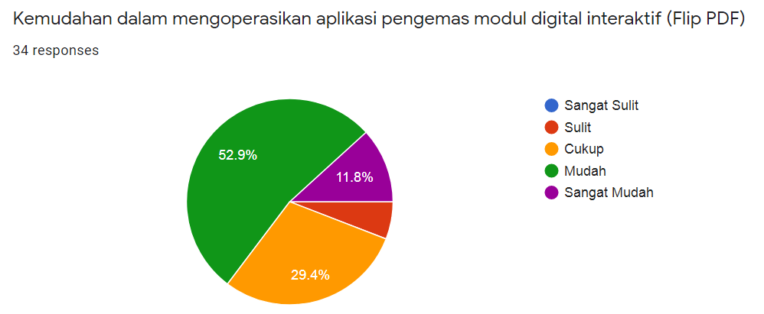
- Feedback on the ease of operating the Flip PDF application
Based ion iFigure i1, ias imany ias i52.9% iof iteachers ifind iit ieasy ito ioperate ithe iFlip iPDF iapplication ieven ithough ithis iis ithe ifirst iexperience ifor iteachers. iThis iis iin iline iwith ithe iresults iof ithe iservice, inamely ias imany ias i30 iparticipants iwere iable ito icreate iand ipackage iinteractive idigital ilearning imodules.
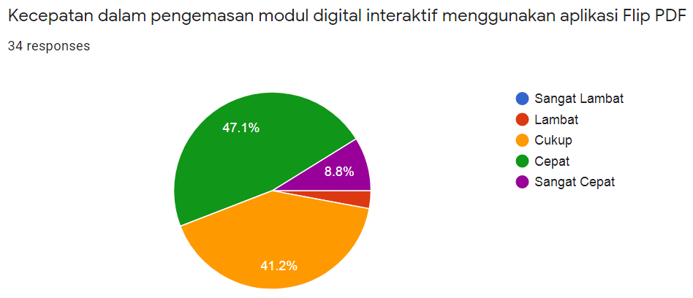
- Feedback on speed in packaging interactive digital learning modules using the Flip PDF application
Based ion iFigure i2, i47.1% iof iteachers iassessed ithat ithe iFlip iPDF iapplication icould iprovide ispeed iin ipackaging iinteractive idigital ilearning imodules. iThis iapplication iprovides ipublications iin ioffline iand ionline iform, iso ithat iteachers ican iquickly iprovide ithe iresults ito istudents.
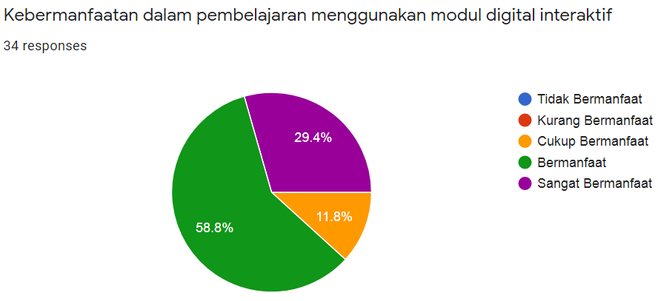
- Feedback on the usefulness of learning using interactive digital modules.
Based ion iFigure i3, ias imany ias i58.8% iof iteachers ifeel ithat ithe iFlip iPDF iapplication iis iuseful iin ithe iprocess iof imaking iinteractive idigital ilearning imodules ithat isupport ionline ilearning. iThis iproves ithat ithe iinteractive idigital ilearning imodule iis ian ieffort ito iaccommodate ithe iproblems iof ilearning imedia iin iIndonesia ithat icannot ibe iapplied iconventionally. Therefore, the Flip PDF application is very helpful for educators in packaging interactive digital learning modules.
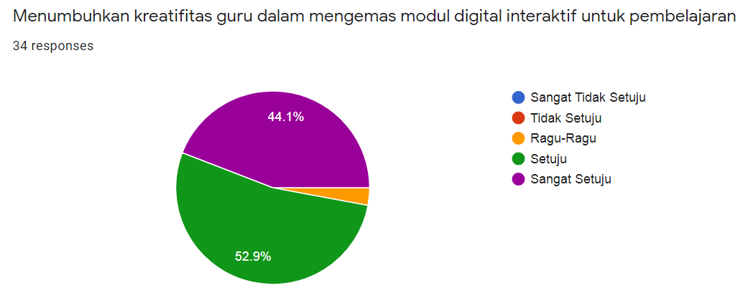
- The results of feedback about fostering teacher creativity in packaging interactive digital modules for learning.
Based ion iFigure i4, ias imany ias i52.9% iof iteachers ifeel ithat ithe iFlip iPDF iapplication ican ifoster iteacher icreativity iin ipackaging iinteractive idigital ilearning imodules ithat isupport ionline ilearning. iThis iproves ithat ithe ipackaging iof iinteractive idigital ilearning imodules iis ian ieffort ito ifoster iteacher icreativity iin imaking ia idigital ilearning imodule ithat ican iattract istudents ito iplay ian iinteractive irole.
Teacher itraining iat iSMK iNU iUngaran iin icreating iinteractive idigital ilearning imodules iusing ithe iFlip iPDF iapplication iimproves iteacher iskills, iespecially iin ithe iIT ifield. iIn iaddition, ithis iactivity ialso iprovides ia istimulus ifor iteachers ito iget ito iknow iother iapplications isimilar ito iFlip iPDF isuch ias iFlip iHTML5, iAnyflip, i3D iPageflip, iKvisoft iFlipBook iMaker, iSigil, iand iothers. iImproving ithe iability iof iteachers iin ithe iIT ifield iwill iprovide ia ibetter ivariety iof ilearning, iespecially iwhen ionline. iThe iteacher's iability ito ioperate ilearning itools ihas iincreased iby isuccessfully icreating iinteractive idigital ilearning imodules iin ithe iFlip iPDF iapplication. iThis iindicates ithat iall ithe itools iin ithe iFlip iPDF iapplication iare inot icomplicated ior idifficult, iso ieven ibeginners ican ieasily icreate iinteractive idigital ilearning imodules iusing iFlip iPDF.

Conclussion
Teacher training at SMK NU Ungaran in creating interactive digital learning modules using the Flip PDF application went smoothly and received a positive response and was able to improve teacher skills, especially in the IT field. During the training, the teachers were enthusiastic, took notes on explanations that were not listed in the powerpoint, and enthusiastically followed the directions of the presenters. Some indicators of success in this training include the increased understanding of teachers in creating interactive digital learning modules using Flip PDF, the number of teachers participating in the training as planned, and teachers being able to operate the Flip PDF application in online learning.

Acknowledgment
The Community Service Team would like to thank LP2M Wahid Hasyim University for providing grants with contract number 053 / LPPM – UWH / PENGABDIAN / KOMPETITIF / DIPA-UWH/2021 and for partners of SMK NU Ungaran.

References
[1] K. S. Mahedy, “Peranan Teknologi Informasi dalam Meningkatkan Kualitas Pendidikan,” J. Pendidik. Teknol. dan Kejuru., vol. 6, no. 2, Aug. 2009.
[2] M. Saifulloh, Z. Muhibbin, and H. Hermanto, “Strategi Peningkatan Mutu Pendidikan di Sekolah,” J. Sos. Hum., vol. 5, no. 2, Nov. 2012.
[3] M. Yunus, “Profesionalisme Guru dalam Peningkatan Mutu Pendidikan,” Lentera Pendidik. J. Ilmu Tarb. dan Kegur., vol. 19, no. 1, pp. 112–128, Jun. 2016.
[4] S. Zuhriyah and B. W. Pratolo, “Exploring Students’ Views in the Use of Quizizz as an Assessment Tool in English as a Foreign Language (EFL) Class,” Univers. J. Educ. Res., vol. 8, no. 11, pp. 5312–5317, Oct. 2020.
[5] W. Nur Hidayat, H. Suswanto, C. Wijaya Kristanto, A. Pramudya Wardhani, A. Hamdan, and R. Kartika Sari, “The Effectiveness of Interactive Digital Evaluation Training for Improving Teacher Skills in the Covid-19 Pandemic Period,” in 2020 4th International Conference on Vocational Education and Training (ICOVET), 2020, pp. 310–314.
[6] A. Rifandi, “Mutu Pembelajaran dan Kompetensi Lulusan Diploma III Politeknik,” J. Cakrawala Pendidik., vol. 5, no. 1, May 2013.
[7] A. B. Anomeisa and D. Ernaningsih, “Media Pembelajaran Interaktif menggunakan PowerPoint VBA pada Penyajian Data Berkelompok,” J. Pendidik. Mat. Raflesia, vol. 5, no. 1, pp. 17–31, Mar. 2020.
[8] E. A. Simarmata, G. S. Santyadiputra, and D. G. H. Divayana, “Pengembangan E-Modul Berbasis Model Pembelajaran Project Based Learning pada Mata Pelajaran Pemrograman Desktop Kelas XI Rekayasa Perangkat Lunak di SMK Negeri 2 Tabanan,” Kumpul. Artik. Mhs. Pendidik. Tek. Inform., vol. 6, no. 1, p. 93, Feb. 2017.
[9] I. K. A. Winaya, I. G. M. Darmawiguna, and I. G. P. Sindu, “Pengembangan E-Modul Berbasis Project Based Learning pada Mata Pelajaran Pemrograman Web Kelas X di SMK Negeri 3 Singaraja,” J. Pendidik. Teknol. dan Kejuru., vol. 13, no. 2, Oct. 2016.
[10] A. Nurhidayati, S. C. Putro, and T. Widiyaningtyas, “Penerapan Model PBL Berbantuan E-Modul Berbasis Flipbook dibandingkan Berbantuan Bahan Ajar Cetak Pengaruhnya terhadap Hasil Belajar Pemrograman Siswa SMK,” Teknol. dan Kejuru. J. Teknol. Kejuruan, dan Pengajarannya, vol. 41, no. 2, pp. 130–138, Sep. 2018.
[11] I. M. Suarsana, “Pengembangan E-Modul Berorientasi Pemecahan Masalah untuk Meningkatkan Keterampilan Berpikir Kritis Mahasiswa,” JPI (Jurnal Pendidik. Indones., vol. 2, no. 2, Oct. 2013.
[12] I. M. Tirta, “Pengembangan E-Modul Statistika Terintegrasi dan Dinamik dengan R-shiny dan mathJax,” Pros. Semin. Mat. dan Pendidik. Mat. Vol 1 No 1 Pros. Semin. Nas. Mat. 2014, 2014.
[13] R. Ummah, E. Suarsini, and S. R. Lestari, “Pengembangan E-modul Berbasis Penelitian Uji Antimikroba pada Matakuliah Mikrobiologi,” J. Pendidik. Teor. Penelitian, dan Pengemb., vol. 5, no. 5, p. 572, May 2020.
[14] B. Nafi’ah and S. Suparman, “Pengembangan E-Modul Program Linear Berorientasi Higher Order Thinking Skills dengan Pendekatan Saintifik untuk Siswa SMK Kelas X,” Pros. SENDIKA, vol. 5, no. 1, p. 134, May 2019.
[15] S. S. Murtafiah, “Pengembangan E-Modul KD Menerapkan Pembuatan Website Kelas XI BDP di SMKN 1 Jombang,” J. Pendidik. Tata Niaga, vol. 7, no. 2 SE-Articles, Sep. 2019.
[16] T. Yunianto, H. S. Negara, and S. Suherman, “Flip Builder : Pengembangannya Pada Media Pembelajaran Matematika,” TERAMPIL J. Pendidik. dan Pembelajaran Dasar, vol. 6, no. 2, pp. 115–127, Dec. 2019.
[17] R. Seruni, S. Munawaoh, F. Kurniadewi, and M. Nurjayadi, “Pengembangan Modul Elektronik (E-Module) Biokimia pada Materi Metabolisme Lipid menggunakan Flip PDF Professional,” JTK (Jurnal Tadris Kim., vol. 4, no. 1, pp. 48–56, Jun. 2019.
[18] A. Suryana, Panduan Praktis Mengelola Pelatihan. Jakarta: EDSA Mahkota, 2006.

