Design And Construction Of Street Building Earthquake Detection System Using Sw-420 Sensor And Buzzer Based On Arduino

Ulil Albab¹, Rony Darpono², Muhammad Irfan Fauzi³

^{1, 2, 3} Program Studi Teknik Elektronika, Politeknik Harapan Bersama
^{1, 2, 3} Tegal, Jawa Tengah
¹italbabz@gmail.com, ²ronydr80@gmail.com, ³muhammadirfanfauzi82@gmail.com

Abstract— Earthquakes are vibrations from the bowels of the earth that propagate to the surface due to fractures of the earth breaking and shifting violently. Tectonic earthquakes are one of the most common types of earthquakes. The larger the Richter scale generated by the earthquake, the impact will result in both immaterial and material losses. Utilization of hardware and software in the field of technology as an effort to anticipate the impact caused by the earthquake. The system design can be done by utilizing the sw-420 sensor as a vibration detector, a buzzer in the form of an alarm that emits a warning sound and Arduino as the main controller of the program. The earthquake detector is made to work when the SW-420 sensor gets a shock at 5 seconds that occurs repeatedly from 1 to 5 seconds.
Keywords : Earthquake, Anticipate, Sensor SW-420, Buzzer, Arduino

Introduction
Earthquake is one of the natural disasters in the form of vibrations on the earth's crust that occur unexpectedly in terms of time and place and cannot be avoided. Based on the process of occurrence of earthquakes, there are several types, namely volcanic earthquakes, tectonic earthquakes, artificial earthquakes, and earthquake collapses [1]. Tectonic earthquakes are one of the most dangerous types of earthquakes with a wide scope if they occur. The magnitude of the earthquake strength varies from the smallest to the largest which is measured using the Richter scale. The greater the value of the Richter scale, the effects will be fatal, such as causing damage to buildings, injuries and even fatalities. Indonesian territory is located at the confluence of three continental plates that collide with each other [2]. This is an indication that each area is prone to earthquakes.
The building is used by people to carry out various activities such as meetings, offices, performances and so on. If an earthquake occurs, especially in buildings such as buildings where there are many people in it, it will cause quite a lot of victims. From several earthquakes that have occurred, most residents are always late to save themselves to a safe place [3]. Earthquake events that can occur at any time need serious handling so that people know the early warnings quickly.
Technological developments, both hardware and software, can be used to facilitate human activities to carry out various kinds of work. By designing earthquake detection equipment early on as an effort to reduce or anticipate the impact caused when an earthquake occurs. The system design can be done by utilizing the sw-420 sensor as a vibration detector, a buzzer in the form of an alarm that emits a warning sound and Arduino as the main controller of the program.

Theory

Earthquake
An earthquake is the original vibration from within the earth, originating in the earth which then propagates to the earth's surface due to the earth's fractures breaking and shifting violently. The causes of earthquakes can be in the form of dynamics of the earth (tectonic), volcanic activity, due to falling meteors, avalanches (under sea level), nuclear bomb explosions below the surface. Tectonic earthquakes are the most common earthquakes, which are vibrations that result from rock breaking events due to the slow collision of the two plates, where the accumulated energy of the impact exceeds the strength of the rock, hence the rock below the surface.
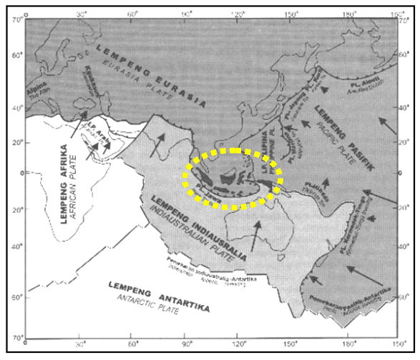
Figure 1. Kepulauan Indonesia terletak pada zona interaksi 3 lempeng bumi

Earthquakes have distinctive characteristics, namely:
- Cannot be prevented.
- The event was very sudden and shocking.
- The time of occurrence, the location of its center and its strength cannot be predicted (estimated) precisely or accurately by anyone, including earthquake experts.

Arduino
Microcontroller is a chip that functions as an electronic circuit controller consisting of a CPU (Central Processing Unit), memory, I/O (input/output), and is even equipped with an integrated ADC (Analog-to-Digital Converter). The main advantage of the microcontroller is the availability of RAM (Random Access Memory) and supporting I / O equipment so that the size of the microcontroller board becomes very compact.
Arduino can be said as a prototyping platform. In Indonesian, prototype can be interpreted as a prototype, which is a tool that can be used to produce various copyrighted works in the design stage. In fact, Arduino is not only used at the design stage, but until the finished product. We can create anything using Arduino, such as applications in the field of robotics, or other embedded system applications. Arduino provides many conveniences for users to realize their works. Arduino has been equipped with an IDE (Integrated Development Environment) system to write application programs that we create. In addition, the Arduino board has also been equipped with various facilities to make it easier for lovers or their use.
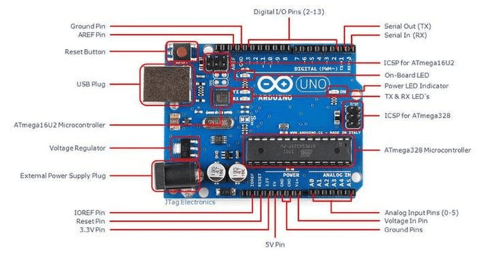
Figure 2. Arduino Uno R3

Sensor
A sensor is an equipment that functions to detect symptoms or signals originating from changes in energy such as electrical energy, physical energy, chemical energy, biological energy, mechanical energy and so on. A device that tells the control system what is actually happening is called a sensor or also known as a transducer. Most sensors work by converting some physical parameter such as temperature or position into an electrical signal. This is why a sensor is also known as a transducer i.e. a device that converts energy from one form to another.
Vibration sensor SW-420 Equipped with a breakout board which includes an LM 393 comparator and on-board potentiometer which can be adjusted for sensitivity threshold selection, and a signal indication LED.
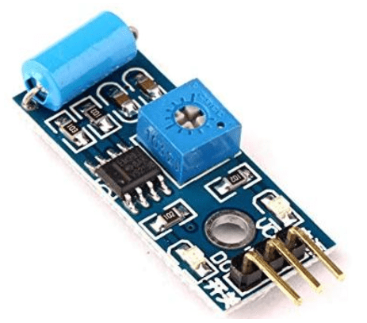
Figure 3. Sensor Vibration SW-420
How the module works:
- When there is no vibration, the vibration sensor is connected and the output value is low. The indicator light is on.
- When vibration is detected, the vibration sensor is immediately disconnected and the output value is high. The indicator light is not lit.
- The output can be directly connected to the microcontroller to detect low and high values so that it can be seen whether vibration is occurring.

Buzzer
Electric Buzzer is an electronic component that can convert electrical signals into sound vibrations. Basically the working principle of a buzzer is almost the same as a loud speaker, so the buzzer also consists of a coil attached to a diaphragm and then the coil is energized so that it becomes an electromagnet, the coil will be attracted in or out, depending on the direction of the current and the polarity of the magnet, because the coil mounted on the diaphragm, every movement of the coil will move the diaphragm back and forth so that the air vibrates which will produce sound.
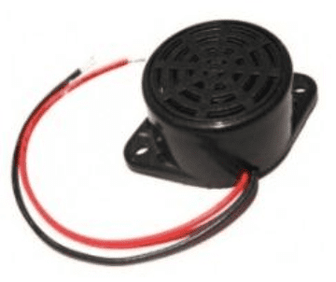
Figure 4. Buzzer

Relay
Relay is a switch (Switch) which is operated electrically and is an Electromechanical component (Electromechanical) which consists of 2 main parts, namely Electromagnets (Coil) and Mechanical (a set of Switch Contacts/Switches). Relays use the Electromagnetic Principle to drive the Switch Contacts so that with a small electric current (low power) they can conduct higher voltage electricity.
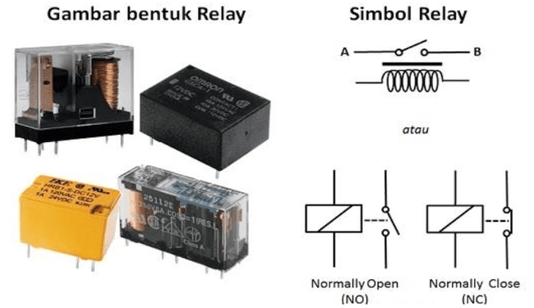

Figure 5. Relay Shapes and Relay Symbols

research methods

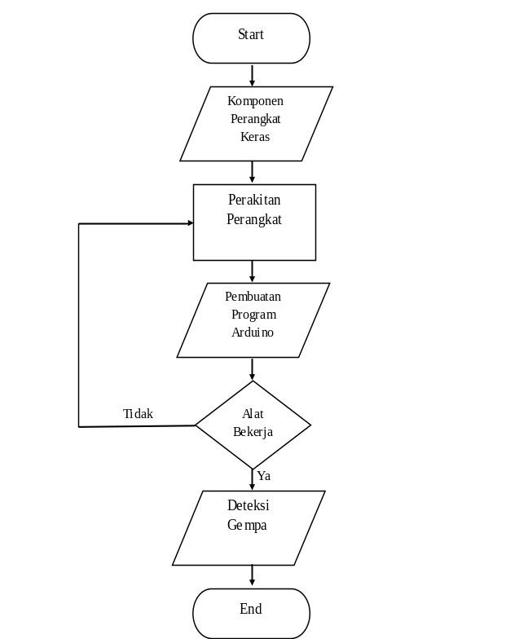

Figure 6. Research Process Flowchart

The research process that will be carried out to produce an earthquake detector is as follows:
- Gather various hardware components based on the needs needed to make earthquake detection tools such as Arduino, SW-420 Sensor, Breadboard, Buzzer, Jumper Cable and Relay.
- Connect each hardware component starting from 5v power and Arduino ground which is jumpered to the project board. Next, connect the Arduino with the SW-420 sensor, the vcc and ground pins on the SW-420 sensor are connected to the jumper project board while the data input pin on the SW-420 sensor is to digital pin 5 arduino. Followed by connecting a dual channel relay with the vcc and ground pins connected to the jumper project board and the input pins connected to Arduino digital pin 4. Next is to connect a 220V buzzer to the output of the relay where only the phase cable is connected to the relay in the NO (Normally Open) position.
- After all the components are connected to each other, the next step is to upload the Arduino program that has been made so that the device can work properly. The program in this tool is very important because all components will work if the program gives commands to these components
- To test whether the tool is working properly or not, if not, then you have to re-check the hardware and the Arduino software program.
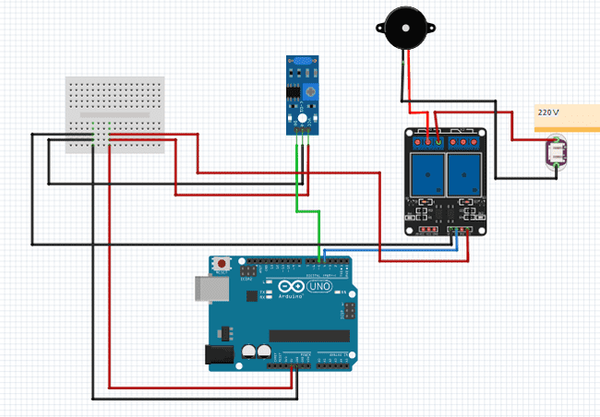
- If it is running well, the tool can detect an earthquake based on the vibration or shock it produces.
Figure 7. Component Circuit

Results
The results of the research obtained during the process of assembling the device components and making the program were testing the tool to work well based on shocks..

Earthquake Detection Tool
An earthquake detection tool by utilizing Arduino, SW-420 sensor and this relay can provide information to people around about an earthquake that occurred in the area. This tool can be implemented in several buildings which in particular have a lot of human activities in it, such as in high-rise buildings.
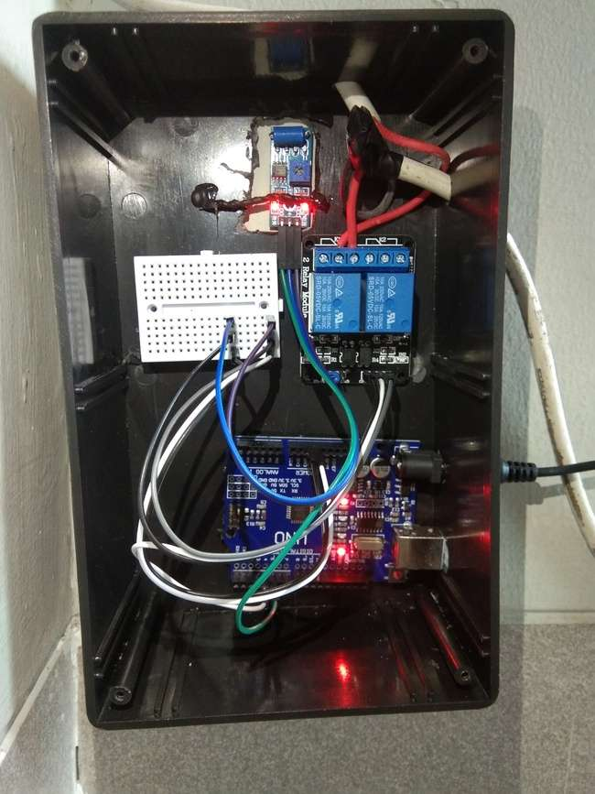
Figure 8. Earthquake Detector
In earthquake detection tools there are also programs that have been made to run properly. The Arduino program is designed so that only earthquake vibrations are detected by the sensor, earthquakes usually last 30-60 seconds, so the program takes advantage of this so that when the sensor detects a vibration and the vibration is in the 5th second, it is calculated when the new Arduino gets a voltage, the tool will work. , in addition to the 5th second, even though the sensor detects a vibration, the tool will not work, and the time will reset again at the 7th second if at the 5th second the sensor does not detect a vibration.
The power switch is used to connect or disconnect the electric current when the earthquake detector detects a shock or earthquake.
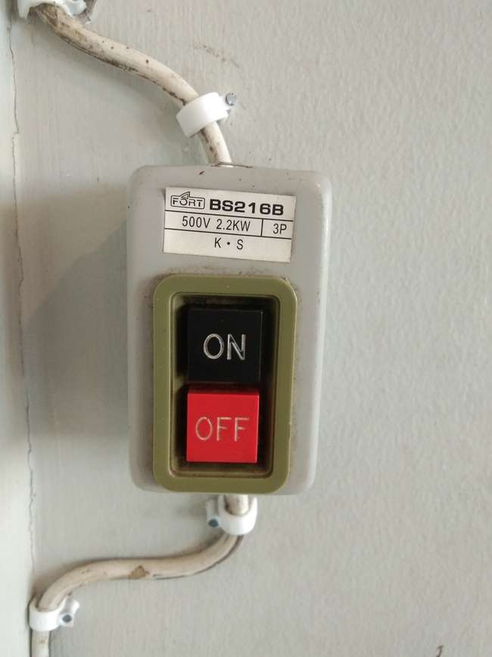

Figure 9. Power Switch
The buzzer works when the sensor on the earthquake detector detects a shock, the buzzer will get a voltage so that the buzzer will sound indicating an earthquake.
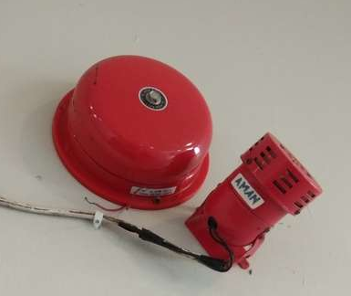

Figure 10. Buzzer

How the Tool Works
Here is how the earthquake detector works that has been made:
- This tool can work when the sensor has detected a vibration and will send data from the sensor to the Arduino.
- Arduino captures data sent by the sensor and processed by the program.
- When the data is obtained at exactly 5 seconds after the Arduino gets a voltage, the Arduino will give an order to change the relay from NO to NC. If the data obtained is not correct at 5 seconds, then this tool cannot work and the time will be reset at 7 seconds.
- If the relay is in the NC position, the buzzer will get a voltage of 220V and will make a sound.

Testing
The test of this tool is carried out on a multi-storey building that carries out a lot of human activities in it, the position of the installation of an earthquake detection device is on the wall of the building. The following are the results of the trials that have been carried out.

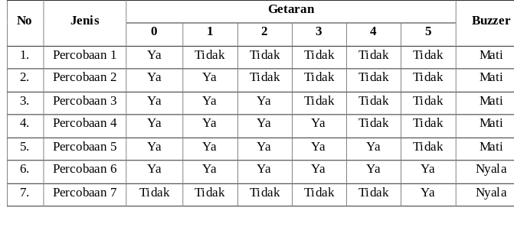
Table 1 Test Results

References
[1] Ghifari, Alif., Murti, Muhammad Ary., dan Nugraha, Ramdhan., 2018 Perancangan Alat Pendeteksi Gempa Menggunakan Sensor Getar, e-Proceeding of Engineering Vol 5 No 3 pp4028-4035.
[2] Alam, Hermansyah., Kusuma, Budhi Santri., Prayogi, M. Agus., 2020, Penggunaan Sensor Vibration Sebagai Antisipasi Gempa Bumi, Journal of Electrical Technology Vol 5 No 2 pp43-52.
[3] Santoso, Hadi., Quszaini, Ega Wahyu., dan Andriawan, Aris Heri., Alat Pendeteksi Gempa Bumi Menggunakan Sensor Accelerometer Mpu 6050 Dan Sollar Cell Sebagai Sumber Energi, Jurusan Teknik Ekektro Universitas 17 Agustus 1945 Surabaya.
[4] Fadlilah, Nuzul Imam., Arifudin, Ahmad., 2018, Pembuatan Alat Pendeteksi Gempa Menggunakan Accelerometer Berbasis Arduino, Jurnal Evolusi Vol 6 No 1 pp61-67.
[5] Witjaksana, Budi., Amal, Andi Syaiful., 2021, Penerapan Sensor Pedeteksi Dini Gempa Bumi Pada Bangunan Konstruksi, Seminar Keinsinyuran pp26-32.
[6] Nur, Arief Mustofa., 2010, Gempa Bumi, Tsunami Dan Mitigasinya, Jurnal Geografi pp66-73.
[7] Dr. Junaidi, S.Si., M.Sc., Prabowo, Yuliyan Dwi., 2018, Project Sistem Kendali Elektronik Berbasis Arduino, AURA, Gedongmeneng Bandar Lampung.
[8] Kurniawan, Ade Fadhli., 2019, Rancang Bangun Sistem Keamanan Dan Alarm Gempa Serta Kontrol Lampu Otomatis Pada Rumah Menggunakan Sms Berbasis Atmega328, skripsi, Universitas Sumatera Utara.
[9] Saleh, Muhamad., Haryanti, Munnik., 2017, Rancang Bangun Sistem Keamanan Rumah Menggunakan Relay,
Jurnal Teknologi Elektro Vol 8 No 3 pp181-186.

