Information Technology Support Model for Property Management Industry in Indonesia

Prasetya Cahya S¹, Rizqullah Fawwaz NP² and Inayatulloh¹

¹ School of Information System, Bina Nusantara University, Jakarta, Indonesia
² Graduate School of Information System-MMSI, Bina Nusantara University, Jakarta, Indonesia

Abstract. One of the main problems faced in the property management industry especially in Indonesia is limited knowledge or even ignorance of the important role of information technology and information systems in supporting and developing their business. Whereas in a world that is currently heading towards the digital industry and the trend of industry 4.0 which is on the rise, IT and IS components are needed. This paper will explain the important role of IT and IS to help understand their use, and how they can help businesses to grow in the property management industry which is increasingly competitive. The research method used in compiling this paper is in the form of observation of problems in the field. The result of this research is an Information Technology Support Model in the use of information technology to support the property management business.
- Introduction
The property industry is one of the sectors with promising growth in Indonesia. With a population of approximately 270 million people in 2019 and expected to grow every year, it will automatically increase the demand for various property sectors. Such as houses, apartments, shopping centers, to offices. [1]. Property Management industry is also becoming increasingly important for investors and property developers as well as for consumer property users. During the Covid-19 pandemic, the presence of property management on a property is increasingly needed. Consumers will always ask in advance which property management is used, whether in-house or using a property management service provider company [11]. This will indirectly affect the value of a property.

During the Covid-19 pandemic, between the beginning of 2020 and the end of 2021, the property sector experienced a stagnant and unsatisfactory condition. However, observers provide an optimistic picture that if Indonesia can get through this pandemic period, the growth of the commercial property sector is believed to be able to grow back to levels before the Covid-19 pandemic.

To bounce back from this difficult condition, property managers must be able to fix many things that previously had not received serious attention, specifically to increase efficiency and ability to compete with competitors, both new competitors, old competitors, and their substitutes. However, considering the current phenomena in the field, knowledge, and implementation of property management, especially in Indonesia, is still not optimal. Some of the problems encountered from the results of field observations for the property management industry are as follows:
- There are quite a lot of property management industry players who do not understand or have limited knowledge about the importance of using information technology and information systems for their business
- Not yet optimal use or implementation of applications that can support business processes in the property management industry
- Many business processes are still run manually
- Difficulty in getting an integrated application that can be used in the property management industry that suits your needs
- Lack of knowledge about the relationship and correlation between information technology and its application to the property management industry.

The above problem conditions can be solved by using information technology, among others by:
- Use of IT governance to know the importance of IT investment in running the property management business
- Knowledge management to be able to overcome ignorance using information technology
- Information system to be able to automate various jobs that are still done manually in running business processes in the property management industry
- Using acceptance model approaches such as TAM and UTAUT to identify and analyze factors that can affect the acceptance of an information system in the property management industry

- Literature Review
- Information System and Information Technology
Essentially, Information systems (IS) are social systems with a technical component. It is important to assess the information system's outcome. This work aims to bring together the different viewpoints, techniques, and processes involved in information system evaluation. The key contributions of previous evaluation work are discussed. The ability to learn about future projects will be enhanced by evaluating the behavior of the Information Systems production process. Both the Information Systems functionality and the realization of the anticipated benefits from the Information Systems investment are included in the successful achievement. [2]

Although they differ significantly and have important interrelationships, the terms information technology (IT), information systems (IS), and digital technology are often used interchangeably as umbrella terms for computer / software-related products and solutions. This can result in misunderstandings, trivialization of the importance of one or both terms, and feelings of overwhelming for some stakeholders outside of the IT / IS profession when it comes to the use of the term or of related terms. It is this type of misunderstanding of slippery and overlapping IT / IS-related terms that leads to some accountants underestimating or only seeing a part of the importance and value of digital technologies and digital business concepts for business management and accounting practice. This misunderstanding can lead them to also misunderstand their role in IS and digital technology issues, and to see such issues as ones that can be relegated to the IT / IS function. This misunderstanding and resultant attitudes and actions can be a risk to accountants’ careers, and even to the fates of their organizations (e.g., if it results in businesses underestimating key business risks or threats). It is crucial to delineate the boundaries between them, explain how they interrelate and interact, and explain their significance. [3]

- Property Management
Property held as an investment asset like any other investment asset is accepted to earn of return on capital employed for the holder and particularly in the case of freehold or other long-term ownership (such as long leasehold) appreciate in capital value. Property held as an operational asset serves to support the activities of the business occupying the property [12].

Property management can be interpreted as the task of a group of people or organizations with the aim of managing assets that are limited to tangible goods owned by individuals or companies, to achieve a predetermined goal [4].

The objectives of property management include:
- Managing property as an investment/business, to maximize investors’ income and capital
- Manage and implement physical aspects effectively and efficiently, to obtain optimal results
By knowing the purpose of property management, the activities in it include:
- Prepare and distribute management contracts
- Plan and take over management of a property
- Carry out maintenance and management duty of the building
- Marketing and negotiating rental prices
- Set up the billing system and management of rent
- Regulate administrative and financial systems
- Information system management

The scope of property management is quite broad, but can be grouped into two parts, namely:
- Managing property as an investment
Indicators that need to be considered to achieve property management goals as an investment include total investment, total rentable area, prediction of rental/selling prices, occupancy/sales rates, operational costs, and other costs.
- Managing property as a business
Includes marketing to get the best offer, billing rent and service fees, maintenance, financial management and reporting, monitoring property values, equipping facilities and facilities, and understanding the importance of communication and information

- Research Methodology
This research will be conducted by observing the phenomena that occurred in the field. In addition to observation, the author will also use literature studies from previous studies to support the theory that is being used.
The first step is to identify the various problems that exist in property management. These problems will then be divided into two categories, namely problems that can be solved with information technology, and problems that cannot be solved with information technology.
The latter will be ignored, while the former will be mapped with alternative solutions using information technology. The final step is to create a model for the use of information technology for property management.
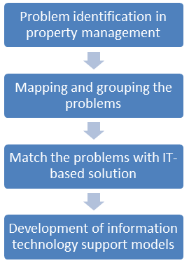
Figure 1 Research Steps

- Result and Discussion
After analyzing each of the problems encountered, it was found that there are several needs/solutions that the ERP system has not been able to offer for property management such as e-learning and IT governance. Therefore, several modules will be added to the model that is going to be built.

The model for using information technology to support the property management business will be divided into two, namely for problems related to IT solutions, and problems not related to IT solutions.
Some examples of problems that are not related to IT solutions include government regulations, bottlenecks caused by bureaucracy within the company, social factors, and others. These issues will be ignored because they are not related to the proposed IT solution.

Meanwhile, problems related to IT solutions will be divided into 8 sections, namely tenancy/client management issues, asset and preventive maintenance, marketing, excessive paperwork, complicated and inefficient finance and accounting, IT investment, human resource issue, and staff motivation.

The first problem is management issues with property’s tenant/client. Rent is one of the main incomes of a property. And to run it well, a property needs to manage them. But oftentimes, a property doesn’t know how to do it right. This is where customer relationship management (CRM) system falls into place. With CRM, property manager can manage and fulfill their client’s needs and boost their satisfaction.

The second problem is the need to manage company’s assets through asset and preventive maintenance. Other than rent, property manager also needs to keep an eye on their assets on the building. Because they count as an investment and need to be taken care of. To do this, property manager can use an asset management system. This system will data all the company’s assets, whether tangible or intangible, to monitor and manage valuable assets using a systemized approach.

The third problem is the lack of marketing activities to cover a wider market [5]. There are many cases where property management companies do not utilize IT/IS due to their ignorance of the existence of programs/applications that can help their business processes. This can be overcome by using technology in the form of e-marketing or marketing with electronic media. Besides being easy and cheap, the marketing of this model can also reach a very wide market, even to foreign countries.

The fourth problem is the excessive paperwork/printouts in the company's business processes. companies often still use manual methods in their business processes. This results in the accumulation of unnecessary paper documents, which can lead to redundancy, ineffectiveness, and a waste of time. For that, they need office automation to create, collect, store, manipulate, and relay various office information needed for accomplishing tasks.

The fifth problem is the inefficiency of the company's business processes. [7] This can be driven by many factors, such as redundant and piled data, different sections of the company using separate systems, business processes that are not generally integrated, and so on. Enterprise resource planning (ERP) is a series of modules that aim to manage and integrate various operational activities within a business. ERP can be considered as a solution to this problem because, with ERP, companies can integrate all their existing business processes.

The sixth problem is the difficulty of knowing the level of effectiveness of IT/IS investments and their relationship to the company's business development. It is easy to know how the business is developing after implementing IT. What is difficult is whether the implementation of IT has a significant effect on the developments that occur. [10] For this, companies can take advantage of IT governance.

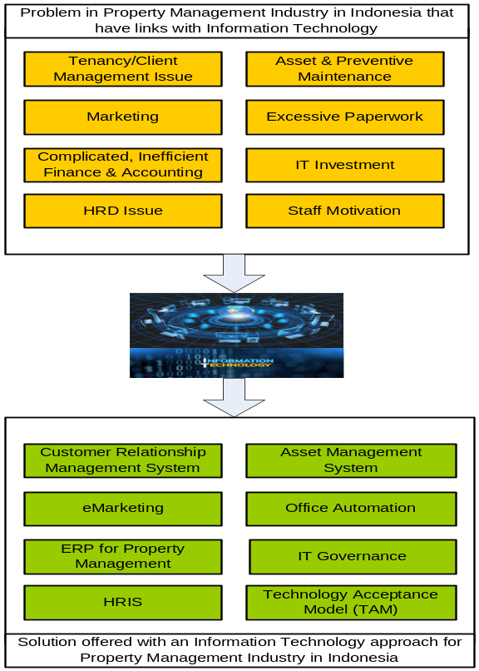
Figure 2 Mapping
Figure 2 above depicts the mapping of the solution to each problem stated in the previous section.

The seventh problem is human resource management (HR). HR does many things related to employment. Starting from looking for competent workers who have the required skills, selecting and recruiting them, how to increase their knowledge, managing the remuneration system, and others. [8] This work can be facilitated by using a human resource management system or HRIS. With HRIS, HR management can be carried out systematically and computerized.

The eighth and final problem is the low motivation for IT implementation. No matter how good the technology/system is made, it will not be useful if the user doesn’t know why and how to use it. [9] This is also the case in many property management companies. They feel that applying technology and changing their habits which were previously done manually, will increase their workload. This can be overcome by doing a technology acceptance model (TAM). With TAM, the motivation to use IT will increase.

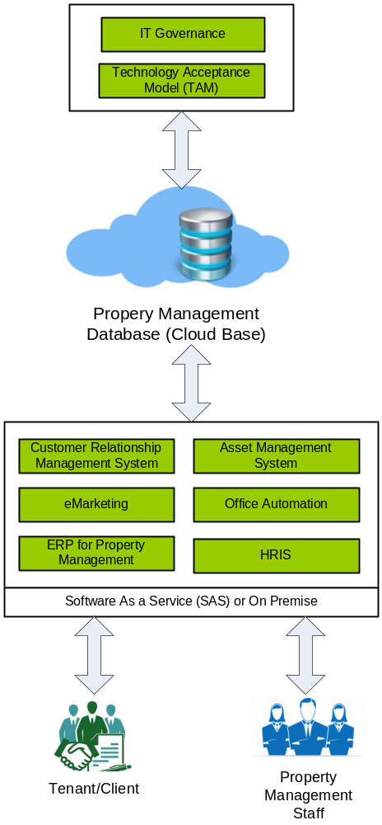
Figure 3 IT Support Model for Property Management Industry
Figure 3 above illustrates the IT support model for property management companies. The model will be divided into 4 parts, namely business continuity with the implementation of TAM which aims to encourage companies to use information technology in a sustainable manner, and IT governance to see the level of effectiveness of IT implementation. These two things do not directly intersect with the business activities of the building management company. The second part is the usage of a cloud-based property management database. The third part is customer relationship management system, asset management system, e-marketing, office automation, ERP for property management, and HRIS platform that supports the company's business activities directly. And the fourth part is the users of this model, including tenant/client, and property management staff

- Conclusion
The model of using information technology to support the business activities of property management companies presented in this paper can help property management to understand the problems in business, both those whose solutions are related to IT and those that are not related to IT. The benefit of this model is that companies can know that the application of information technology can not only be a solution to business problems but also can increase competitiveness. Many problems faced by property management companies, such as ineffective marketing activities, lack of automation, and yet to be integrated company business processes can be resolved by the implementation of information technology as described in the model presented. On the other hand, the application of this model also includes things that, although not directly related to business processes, are useful in ensuring the sustainable application of information technology and seeing its contribution to the company's business development. Such as TAM and IT governance.
- References
[1] A. Nurpita and R. Oktavia, “The Analysis of Property Loans Development in Indonesia,” Optim. J. Ekon. dan Pembang., vol. 11, no. 1, p. 123, 2021, doi: 10.12928/optimum.v11i1.3569.
[2] U. Osita-Ejikeme, “EVALUATION OF INFORMATION SYSTEMS: A REVIEW,” vol. 6, no. 10, pp. 66–81, 2020, doi: 10.46654/ij.24889849.
[3] R. Busulwa and N. Evans, “Information Systems, Strategic Information Systems, and Digital Technologies,” in Digital Transformation in Accounting, 2021, pp. 10–18.
[4] M. J. Hefferan, “Property Management and Facilities Management,” in Real Property in Australia, 2020, pp. 251–278.
[5] J. Silvers and W. O’Toole, “Marketing issues,” 2020, pp. 245–271.
[6] S. Moffett, “Knowledge management : issues, preparation and implementation.,” Sep. 2021.
[7] K. Cox, “Business Process Modelling,” 2021, pp. 19–39.
[8] P. Zhang and L. Tang, “Human resource management,” 2021, pp. 96–113.
[9] L. Wilson, “Information Systems Implementation,” 2020, pp. 267–276.
[10] S. H. Solms and R. Solms, “Information Technology Governance,” 2009, pp. 1–7.
[11] Tsai, Wei-Tek & Bai, Xiaoying & Huang, Yu. (2014). Software-as-a-service (SaaS): Perspectives and challenges. Science China Information Sciences. 57. 1-15. 10.1007/s11432-013-5050-z.
[12] Alam, Mansaf & Shakil, Kashish. (2013). Cloud Database Management System Architecture. UACEE International Journal of Computer Science and its Applications ([ISSN 2250 - 3765). 3. 27-31.

