**Fine Tuning and Comparison of**

**MobileNet, InceptionV3, and CropNet to Classify Cassava Plant Disease**

**Grady M. Oktavian**

Pradita University, Masters of Information Technology

**Abstract –** Computer Vision is a branch in Artificial Intelligence which attempts to make machines able to understand and solve problems relating to images and photos. One of the fields that offers computer vision an opportunity to contribute is plant disease detection. In sub-Saharan Africa, Cassava (*Manihot esculenta* Crantz) is widely grown and considered to be a large source of carbohydrates for human food. However, the plant is plagued with diseases which can threaten food supply for millions of people. By using computer vision, researchers attempted to create an image classification model that can tell farmers whether the plant is sick or not by taking pictures of their leaves. In this short paper, the author attempts to use transfer learning on three Convolutional Neural Network: CropNet, MobileNet, and InceptionV3 on a cassava disease dataset provided by Kaggle to compare their performance and accuracy. Turns out, transfer learning is a very effective method to quickly train a robust model with a relatively good accuracy score.

1. **Introduction**

Over 40% of Africans rely on cassava as their main source of calories, with over 145 million tons of casava harvested in 2014 [1]. For small farmers in low-income areas, growing cassava is their main occupation and considers cassava as a food security crop. Cassava is mainly chosen because the plant adapts well to the geographical and climate situation in sub-Saharan Africa (low soil fertility and irregular rainfall patterns). However, cassava farmers see a challenge as the plant is not invulnerable against diseases that might affect their crop harvest results [2]. These diseases can be diagnosed as certain patterns appear in the cassava leaves. While it is possible to have botanists or experts checking out the plants one by one to see their health, it would be a physically taxing process. Artificial intelligence technology attempts to leverage this by creating a computer vision model which can help to detect cassava diseases in real time. One of the main issues that the modelers have to face is picking the best model architecture so the model can be deployed in a robust platform which eases the usage of said model.

The task which is attempted to be performed is called image classification, in which the input image will be passed through layers in a convolutional neural network. The last layers tend to be dense layers which will finally tell us the probability of the input image belonging to a few predetermined classes [3]. The convolutional neural network architecture is used to process pictures because it allows the network to process each pixel and the relation it has with its surrounding pixels, and thus reduces the size it took to process images compared to classical machine learning frameworks which counts all pixels as feature columns. This method of processing images has led convolutional neural network to gain widespread attention and recognition in the computer vision field of study.

In this paper, the author attempts to explore, fine tune, and compare three convolutional neural networks on the cassava disease dataset. The first model is a small CNN called MobileNet, which highlights its light size and processing speed. The second model is InceptionV3 which is the currently latest version of the Inception CNN trained mainly on *ImageNet* dataset. The third model is a CNN developed by Google and TensorFlow which specifically used to tackle the cassava plant disease problem. While it can be assumed that the last model will be the most accurate, we want to see how the two more robust and general model can keep up in terms of accuracy with the highly specific model.

1. **Literary Reviews**

In this chapter, we will explore the types of diseases that may occur in casava plants. Then, we will also explore the three CNN that we are going to test.

**II. 1. Cassava Diseases**

There are four disease condition which are explored in the dataset: Cassava Mosaic Disease (CMD), Cassava Bacterial Blight (CBB), Cassava Greem Mite (CGM), and Cassava Brown Streak Disease (CBSD) [4].

Cassava Mosaic Disease are caused by virus in the genus of *Begomovirus*. These viruses are circular single-stranded DNA viruses which are transmitted by whiteflies which infect cassava plants. Cassava plants infected by CMD produces a variety of foliar symptoms that include mosaic, mottling, misshapen and twisted leaflets, and an overall reduction in size of leaves and plants. It will produce few or no tubers, which are usually harvested. The CMD is the most severe and most widespread disease in sub-Saharan Africa [5].

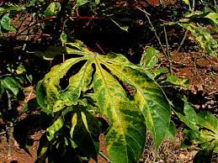

Image II.1.1. Cassava Mosaic Disease

The Cassava Bacterial Blight (CBB) is caused by the pathogen *Xanthomonas axonopodis.* This bacterium is capable of infected most members of the plant genus *Manihot*. In cassava, symptoms include blight, witting, dieback, and vascular necrosis. In leaves, it leaves an angular necrotic spotting, often with a chlorotic ring encircling the spots [6].

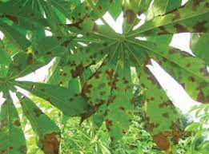

Image II.1.2. Cassava Bacterial Blight

The Cassava Green Mite (CGM) is a disease caused by the pest *Mononychellus tanajoa*. The mite pierces and sucks juices from the leaves, causing yellowing, mottling, death and leaf fall. Stems show a ‘candle stick’ effect with the loss of terminal shoots. To mitigate such mites, the options of introducing its natural enemies and/or cultivating resistant varieties of cassava [7]. If chemical control is used, it might give rise to a resistant population of mites, and the cassava natural quality might be tampered with.

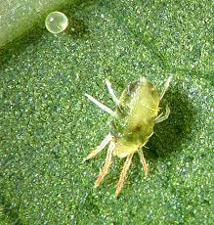

Image II.1.3. Cassava Green Mite

The Cassava Brown Streak Disease (CBSD) is a viral infection caused by the RNA virus known as *Ipomovirus*. This virus gives the cassava severe chlorosis and necrosis, giving them a yellow to brown mottled appearance. Chlorosis may be associated with the veins of leaves, spanning from the mid vein, secondary and tertiary veiins, or in blotches unconnected to veins [8].

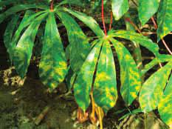

Image II.1.4. Cassava Brown Streak Disease

**II.2. Convolutional Neural Network Models**

MobileNet is the result of a deep learning research in computer vision which attempts to come up with models that can be run in embedded systems [9]. In order to reduce the number of parameters, MobileNet introduced depth-wise convolutions. The second iteration of MobileNet implements a system known as “Inverted Residual Block” to help improving the performance of the model. The main goal of MobileNet is to ensure the architecture of the network is streamlined and balanced in terms of latency and accuracy. Current MobileNet architecture is on its third iteration, in which it manages to have a 3.2% improvement in accuracy on ImageNet classification compared to MobileNet V2, while reducing latency by 20% [10].

The secret of MobileNet’s lightweight yet still competitive performance is in it’s special pooling layer which implements ‘Lite R-ASPP’ (Lite Reduced Atreus Spatial Pyramid). This system deploys the global-average pooling in similar manner compared to Squeeze-and-Excitation module, in which the model uses a large pooling kernel with large stride to save computational power, and only one 1x1 convolution in the model. MobileNet V3 applies atrous convolution to the last block of its neural network to extract denser features, and add a skip connection from low-level features to capture detailed information [11].

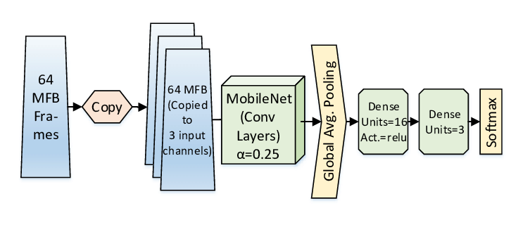

Image II.2.1. A network architecture of the MobileNet CNN.

InceptionV3 is the third version of Google’s Inception Convolutional Neural Network. InceptionV3 is trained using the ImageNet dataset on 1000 classes of images, in a total of 1 million training images. Before Inception network was created, CNNs just stack convolution layers deeper and deeper, hoping to get better performance. This does not always work, and deeper networks tend to overfit. It is also computationally intensive. To alleviate this issue, Inception network have filters with multiple sizes that operate on the same level. The network would get wider rather than deeper. Furthermore, the middle part of the network is also equipped with auxiliary classifiers in which softmax is applied to the outputs of two inception models, to compute an auxiliary loss over the same labels. The total loss function is a weighted sum of the auxiliary loss and the real loss. In further improvements to the network, filter banks in the module were expanded to remove the representational bottleneck. In the third version, RMSProp is the default optimizer, and batch normalizations are done for auxiliary classifiers [12].

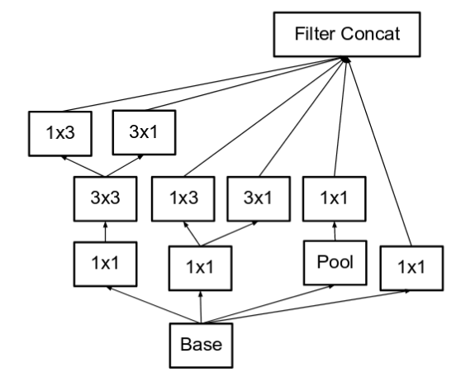

Image II.2.2. A model architecture of the Inception CNN.

CropNet is a specific CNN which is only trained on Cassava plants, and has 6 output classes: *bacterial blight, brown streak disease, green mite, mosaic disease, healthy,* or *unknown* [13]. Unlike MobileNet and InceptionV3, this model is a highly specialized model which is only designed for cassava disease detection, and passing on other images will result for them to be classified as ‘unknown’. On paper, this should make the CropNet having the best accuracy compared to our previous two models. CropNet cannot be used in other computer vision-related tasks and are not as robust as MobileNet and InceptionV3 (which can be fine tuned to a lot of cases and image datasets).

1. **Result**

The dataset that is used to fine tune and compare these three models come from Kaggle and was hosted on TensorFlow Datasets [14]. The dataset name is ‘cassava’, and consists of leaf images for the cassava plant depicting healthy and four (4) disease conditions; Cassava Mosaic Disease (CMD), Cassava Bacterial Blight (CBB), Cassava Greem Mite (CGM) and Cassava Brown Streak Disease (CBSD). Dataset consists of a total of 9430 labelled images. The 9430 labelled images are split into a training set (5656), a test set (1885) and a validation set (1889). The number of images per class are unbalanced with the two disease classes CMD and CBSD having 72% of the images.

Our models are trained for 20 epochs and the final result is then tested on validation dataset to ensure there is no information leakage. Here are the evaluation result of the training and validation process:

|  |  |  |  |
| --- | --- | --- | --- |
| Model | Size (MB) | Trainable Parameters | Validation Accuracy |
| MobileNet | 3.75 | 1 032 782 | 82.01% |
| InceptionV3 | 77 | 21 780 646 | 81.22% |
| CropNet | 15 | 15 564 502 | 87.42% |

1. **Conclusion**

Based on our training result, it is clear that CropNet is the most accurate model for cassava plant disease detection. However, we can see that more generalized models, MobileNet and InceptionV3 have good results as well. This is an important finding, because this means that fine tuning a general CNN can lead to relatively comparable results to specialized models. If there are other plant diseases that we want to monitor via CNN, rest assured that we can use MobileNet and/or InceptionV3 to help with the task.

Another important finding is that the MobileNet is a very efficient CNN – its size is the smallest and is up to 25 times smaller than InceptionV3, however it can achieve a slightly better accuracy than the bigger InceptionV3 model. This is partly because the training and testing dataset consist of relatively homogenous images (they have same dimension, same visual style, and the important object is always in the center). Perhaps, if the task is to classify more difficult images that comes in different resolution, and are less homogenous, then the complexity of the InceptionV3 can be utilized to its maximum potential.

1. **Bibliography**

[1] D. Spencer, “CASSAVA IN AFRICA: PAST, PRESENT AND FUTURE,” A review of cassava in Africawith country case studies on Nigeria, Ghana,the United Republic of Tanzania, Uganda and Benin.

[2] Di Feo, L.; Zanini, A.; Rodríguez Pardina, P.; Cuervo, M.; Carvajal-Yepes, M.; Cuellar, W. J. (2015). "First Report of Cassava common mosaic virus and Cassava frogskin-associated virus Infecting Cassava in Argentina". Plant Disease. 99 (5): 733. doi:10.1094/PDIS-10-14-1088-PDN. hdl:10568/66634

[3] Krizhevsky, A.; Sutskever, I.; Hinton, G. E. (2012). "Imagenet classification with deep convolutional neural networks" Advances in Neural Information Processing Systems. 1: 1097–1105.

[4] Cassava (manioc) | Diseases and Pests, Description, Uses, Propagation (2021)

[5] Patil B & Fauquet C (2009). Cassava mosaic geminiviruses: actual knowledge and perspectives. Molecular Plant Pathology. 10: 685–701

[6] Nukenine, E. N.; Ngeve, J. M.; Dixon, A. G. O. (2002-10-01). "Genotype × environment Effects on Severity of Cassava Bacterial Blight Disease caused by Xanthomonas axonopodis pv. manihotis". European Journal of Plant Pathology. 108 (8): 763–770. doi:10.1023/A:1020876019227. ISSN 1573-8469. S2CID 5956093.

[7] Akinlosotu TA, Leuschner K, 1981. Outbreak of two new cassava pests (Mononychellus tanajoa and Phenacoccus manihoti) in southwestern Nigeria. Tropical Pest Management, 27(2):247-250

[8] Pheneas Ntawuruhunga; James Legg (May 2007). "New Spread of Cassava Brown Streak Virus Disease and its Implications for the Movement of Cassava Germplasm in the East and Central African Region"

[9] Howard, A. G., Zhu, M., Chen, B., Kalenichenko, D., Wang, W., Weyand, T., Andreetto, M., &amp; Adam, H. (2017, April 17). MobileNets: Efficient Convolutional Neural Networks for Mobile Vision Applications. arXiv.org. https://arxiv.org/abs/1704.04861.

[10] Wang, W., Li, Y., Zou, T., Wang, X., You, J., &amp; Luo, Y. (2020, January 6). A Novel Image Classification Approach via Dense-MobileNet Models. Mobile Information Systems.

[11] Howard, A., Sandler, M., Chu, G., Chen, L.-C., Chen, B., Tan, M., Wang, W., Zhu, Y., Pang, R., Vasudevan, V., Le, Q. V., &amp; Adam, H. (2019, May 6). Searching for MobileNetV3. arXiv.org. https://arxiv.org/abs/1905.02244v1?source=post_page.

[12] Szegedy, C., Vanhoucke, V., Ioffe, S., Shlens, J., &amp; Wojna, Z. (2015, December 11). Rethinking the Inception Architecture for Computer Vision. arXiv.org.

[13] Ramcharan, A., Baranowski, K., McCloskey, P., Ahmed, B., Legg, J., &amp; Hughes, D. P. (1AD, January 1). Deep Learning for Image-Based Cassava Disease Detection. Frontiers. https://www.frontiersin.org/articles/10.3389/fpls.2017.01852/full.

[14] Makerere University AI Lab. (2021). Cassava Leaf Disease Classification. Kaggle. https://www.kaggle.com/c/cassava-leaf-disease-classification.