**Creation Design Film and Music Big Entertainment:**

**Platform Based Business Model Canvas and Enterprise Architecture**

Isra Ruddin1)*, Djarot Hindarto2), I Ketut Adi Wirayasa3), Diana4), Richardus Eko Indrajit5), Erick Dazki6)

1)2)3)4)5) Magister Technology Information, Universitas Pradita, Scientia Business Park, Jl. Gading Serpong Boulevard No.1, Tangerang, 15810, Banten, Indonesia

1)[isra.ruddin@student.pradita.ac.id](mailto:isra.ruddin@student.pradita.ac.id), 2)[djarot.hindarto@student.pradita.ac.id](mailto:djarot.hindarto@student.pradita.ac.id), 3)[diana@student.pradita.ac.id](mailto:diana@student.pradita.ac.id)

4)[eko.indrajit@pradita.ac.id](mailto:eko.indrajit@pradita.ac.id), 5) erick.dazki@pradita.ac.id

***Abstract:*** *BIG Entertainment is an application that provides entertainment in the form of music and movies like never before. Previously, applications such as Spotify only provided music as well as Netflix, Joox and Disney which only provided movies. This entertainment provides movies and music in one application. The purpose of this study is to analyze the business model canvas of the Big Entertainment application. This research uses the literature study method by collecting various scientific and relevant sources with this research. The results of this study are that BIG Entertainment service providers are trying hard to diversify their services due to variations in market trends and technological advances. On the other hand, users have also changed their listening behavior due to the occurrence of the BIG Entertainment platform. Then the service provider designs more functions to meet the needs of the users. Customization and interaction between service providers and users has not stopped. By having a service that is distinct and difficult to imitate, BIG Entertainment can make itself capable of meeting the needs of specific customers. BIG Entertainment creates a new Battlefield, there may be a new first mover advantage living better in a fierce environment. The business model includes both tangible and intangible assets for customers, they not only need the final product (music service) but also need one-stop service. BIG Entertainment can make a profit while still creating a unique and efficient business model if it integrates tangible and intangible assets successfully.*

***Key Words****: Application, Business Model Canvas, Film, Music, Entertainment*

# **INTRODUCTION**

In the last decade, the world has witnessed the development of new products, services and modern technologies that have a huge impact on today's society. Some new technologies can make our lives more convenient or more enjoyable such as blogs and e-books; Google and social networking sites (eg Facebook and Twitter); GPS, iPod and USB stick; Films and encyclopedias (ie YouTube and Wikipedia); XP operating system, WI-FI and broadband Internet; TVs and televisions (ie plasma TVs, LCD TVs, and HDTVs); and digital cameras and cell phones (Kubera, 2010).

Innovative technology is changing people's perception of the world and the way they act in it. Ease of access and use of telecommunications is provided. Regardless of the focus, whether it is communication, access to information, the mobility of one's property, or the transport of goods, it can be seen everywhere that both technical and social change are interconnected (Tully, 2003). Since no previous generation had so many tools and gadgets, innovative technologies greatly impact the daily processes among young people. Life, such as their free time activities. Today's young adults deal with everyday tasks in a completely different way than their parents' generation did (Tully, 2003).

Moreover, today's young generation is heavily influenced by technology more than other factors such as family. This creates the basis for what future societies will look like to enable scientists and professionals to understand important information from this research. Consequently, the situation described above investigates more closely the technology use of young adults in relation to their lifestyle and mobility needs (Tully, 2003). New technologies do not always promise greater efficiency or rational application but many options. Especially young people use innovative technology in their daily life as a more important convenience and joy than any other feature of electronic gadgets (Tully, 2003). As the latest technology entertainment applications are very popular entertainment tools among young adults, this raises the issue of what drives them to engage with their applications. There has to be some motivation from the user's side to use this entertainment app and they also have to get something out of it, i.e., they are most likely to get some compensation by doing so.

.

In the last decade, the world has witnessed the development of new products, services and modern technologies that have a huge impact on today's society. Some new technologies can make our lives more convenient or more enjoyable such as blogs and e-books; Google and social networking sites (eg Facebook and Twitter); GPS, iPod and USB stick; Films and encyclopedias (ie YouTube and Wikipedia); XP operating system, WI-FI and broadband Internet; TVs and televisions (ie plasma TVs, LCD TVs, and HDTVs); and digital cameras and cell phones (Kubera, 2010).

Innovative technology is changing people's perception of the world and the way they act in it. Ease of access and use of telecommunications is provided. Regardless of the focus, whether it is communication, access to information, one's property mobility, or the transportation of goods, it can be seen everywhere that technical and social change are interconnected (Tully, 2003). Since no previous generation had so many tools and gadgets, innovative technologies greatly affect the daily life processes among young people, such as their leisure time activities. Today's young adults deal with everyday tasks in a completely different way than their parents' generation did (Tully, 2003). Moreover, today's young generation is heavily influenced by technology.

More than other factors such as family. This creates the basis for what future societies will look like enabling scientists and professionals to understand important information from this research. Consequently, the situation described above investigates more closely the technology use of young adults in relation to their lifestyle and mobility needs (Tully, 2003).

New technologies do not always promise greater efficiency or rational application but many options. Especially young people use innovative technology in their daily life as a more important convenience and joy than any other feature of electronic gadgets (Tully, 2003). As the latest technology entertainment applications are very popular entertainment tools among young adults, this raises the issue of what drives them to engage with their applications. There has to be some motivation from the user's side to use the entertainment app and they also have to get something out of it, i.e., they are most likely to get some compensation by doing so.

Most academics as well as professionals identify convergence as the latest trend in the media industry. Currently, there is a great deal of convergence of wireless devices, particularly in the cellular telephone industry, along with increased mobility in the last decade (Bernabo et al., 2009). Mobile phones, especially smartphones which include mobile entertainment have forced many changes related to lifestyle, the way people work and play. Moreover, the traditional paradigm of developing entertainment and innovative technologies are often not adopted because they are new, but because they allow new users, and new services that would not be available or would be more difficult otherwise (Castells, Fernandez-Ardevol, Qiu, and Sey, 2004). It is therefore necessary to investigate the impact of investigations on leisure patterns and how certain demographic groups access entertainment from smartphones (with emphasis on frequency, shared versus individual experiences, and comparisons of past versus present affection). The most inclined and highly targeted people are technology-driven youth and technology-aware adults (Castells et al., 2004).

BIG Entertainment is an application that provides entertainment in the form of music and movies like never before. Previously, applications such as sportify only provided music as well as Netflix, Hoox and Disney which only provided movies. BIG Entertainment provides movies and music in one application. Based on the description above, the author is interested in discussing the Business Model Canvas Analysis of Big Entertainment as a Movie and Music Provider Application. The purpose of this study is to analyze the business model canvas of the Big Entertainment application.

# **METHOD**

There are two methods to approach the completion of the Enterprise Architecture proposed in this method.

2.1. Business Model Canvas is a strategy in management in the form of a visual chart consisting of 9 elements. This business model was first introduced by Alexander Osterwalder in his book entitled Business Model Generation. The model describes the Business Model Canvas for the development of platforms for film and music into a unified platform, where the platform already provides an entertainment concept that is more integrated than the two models of music and film platforms.

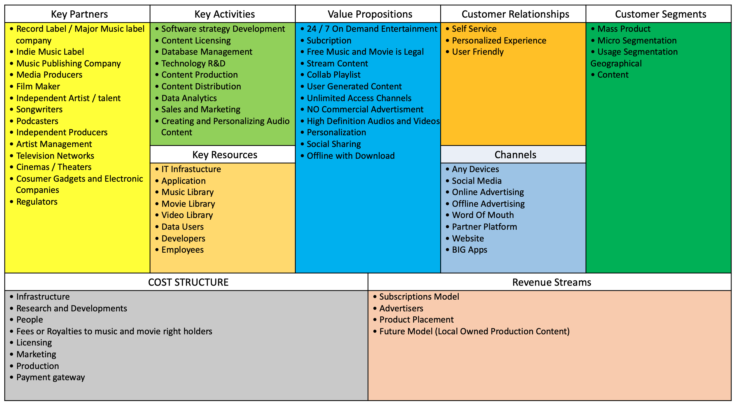

Figure 1. Business Model Canvas

2.2. Enterprise Architecture,

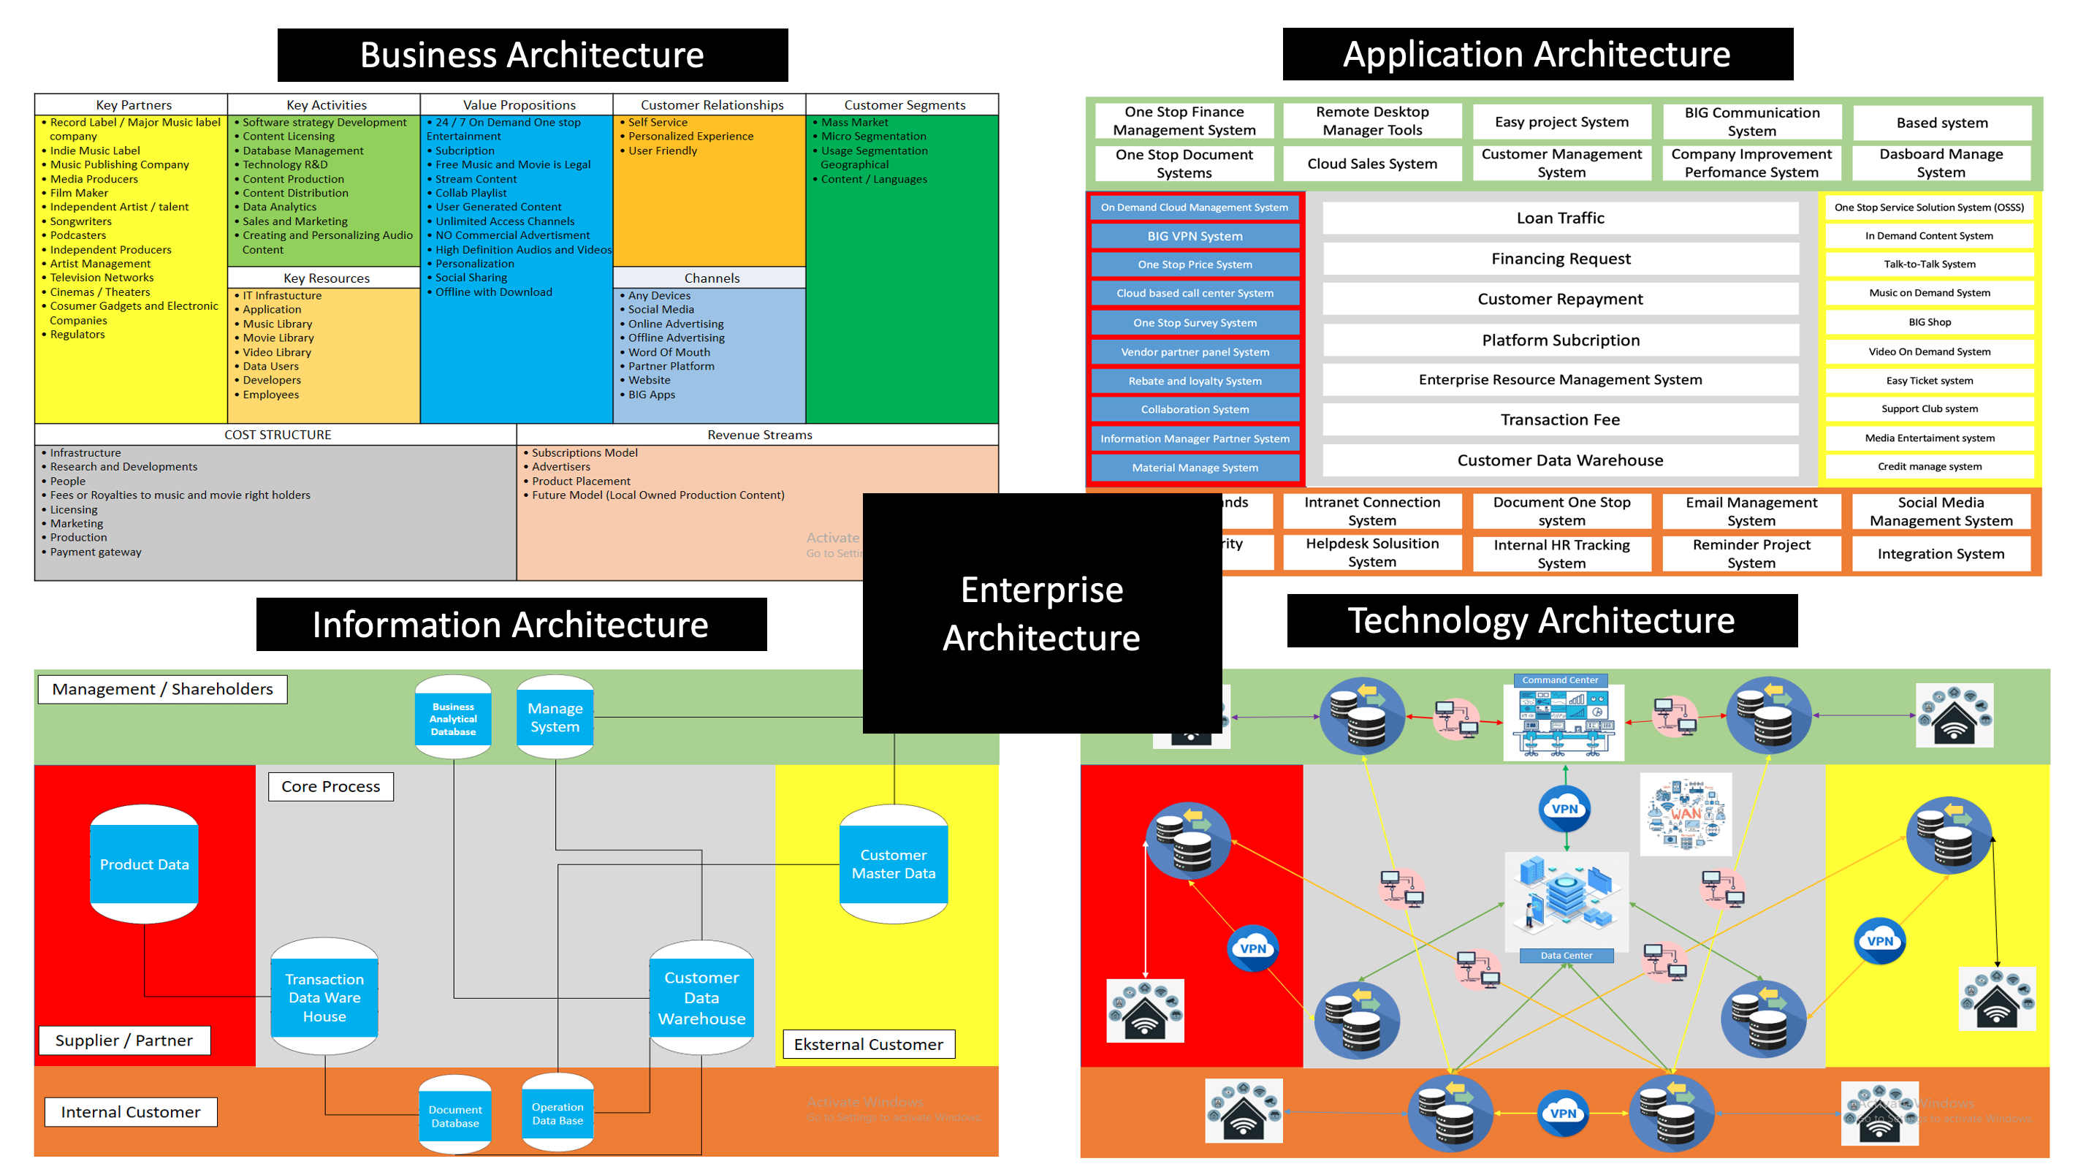

Figure 2. Enterprise Architecture

2.2.1. Application Architecture

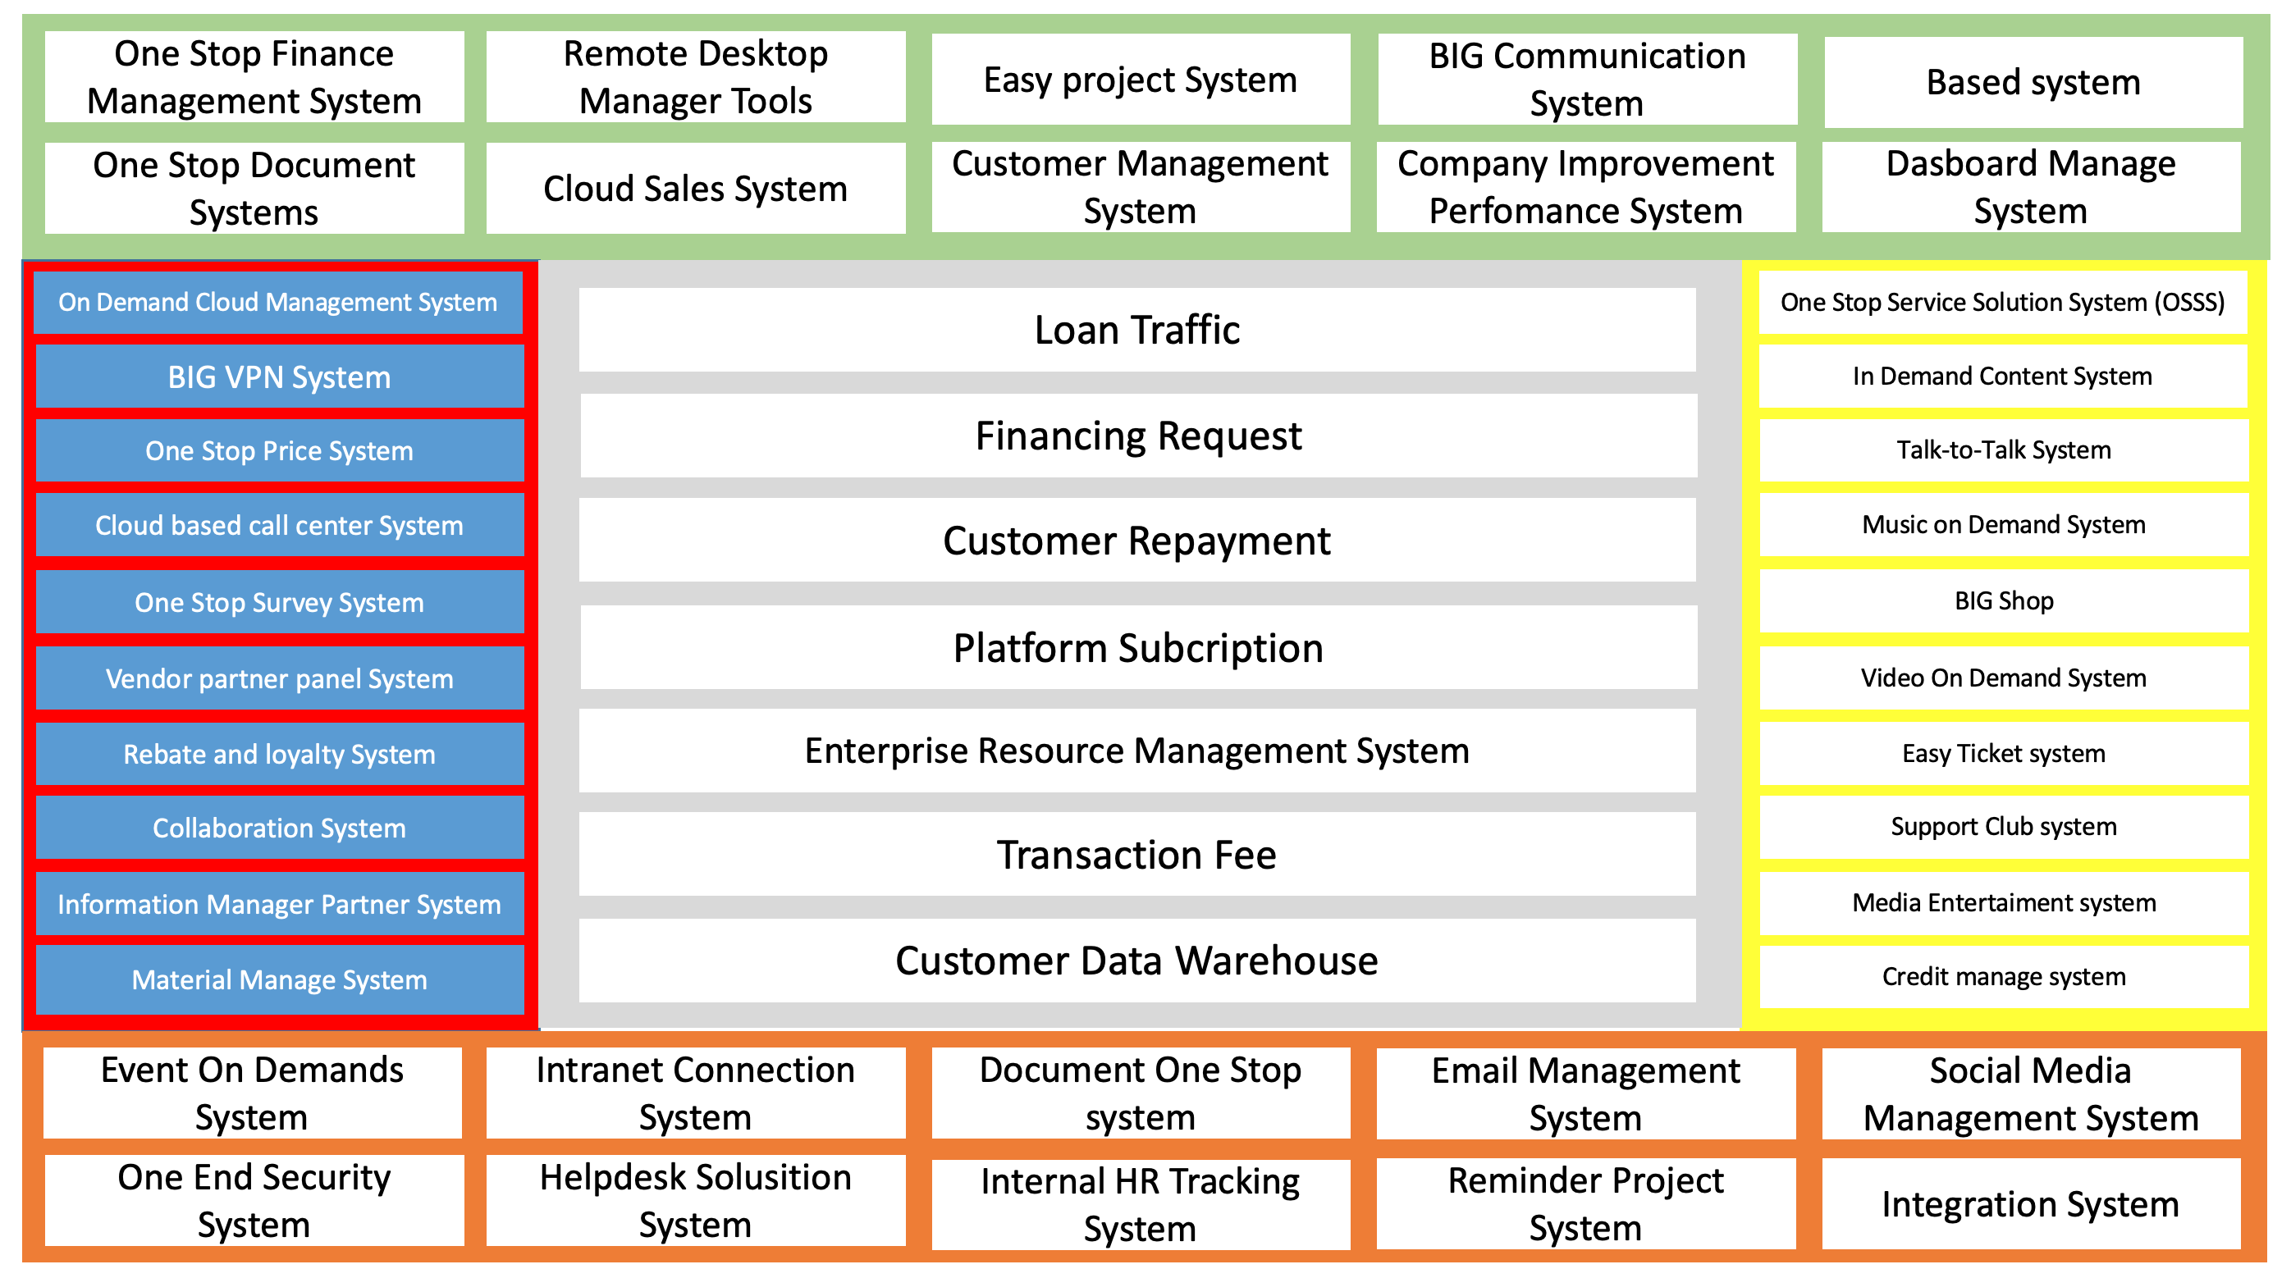

Figure 3. Application Architecture

2.2.2. Information Architecture

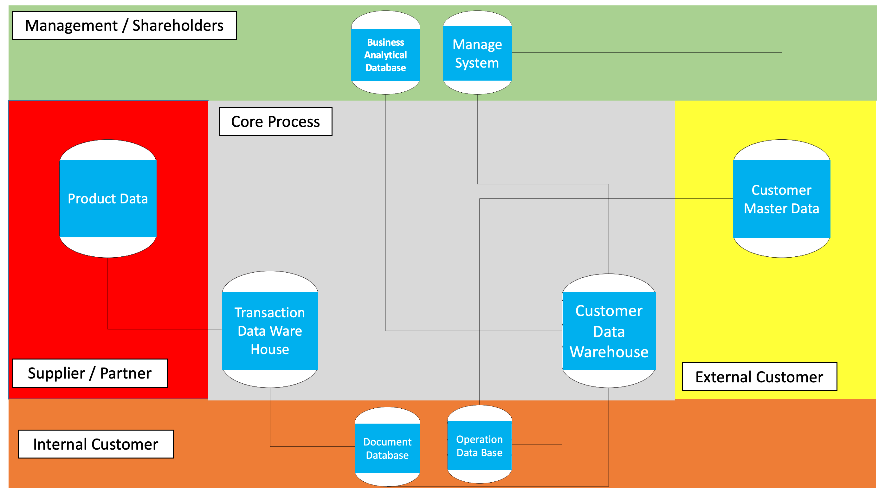

Figure 4. Information Architecture

2.2.3. Technology Architecture

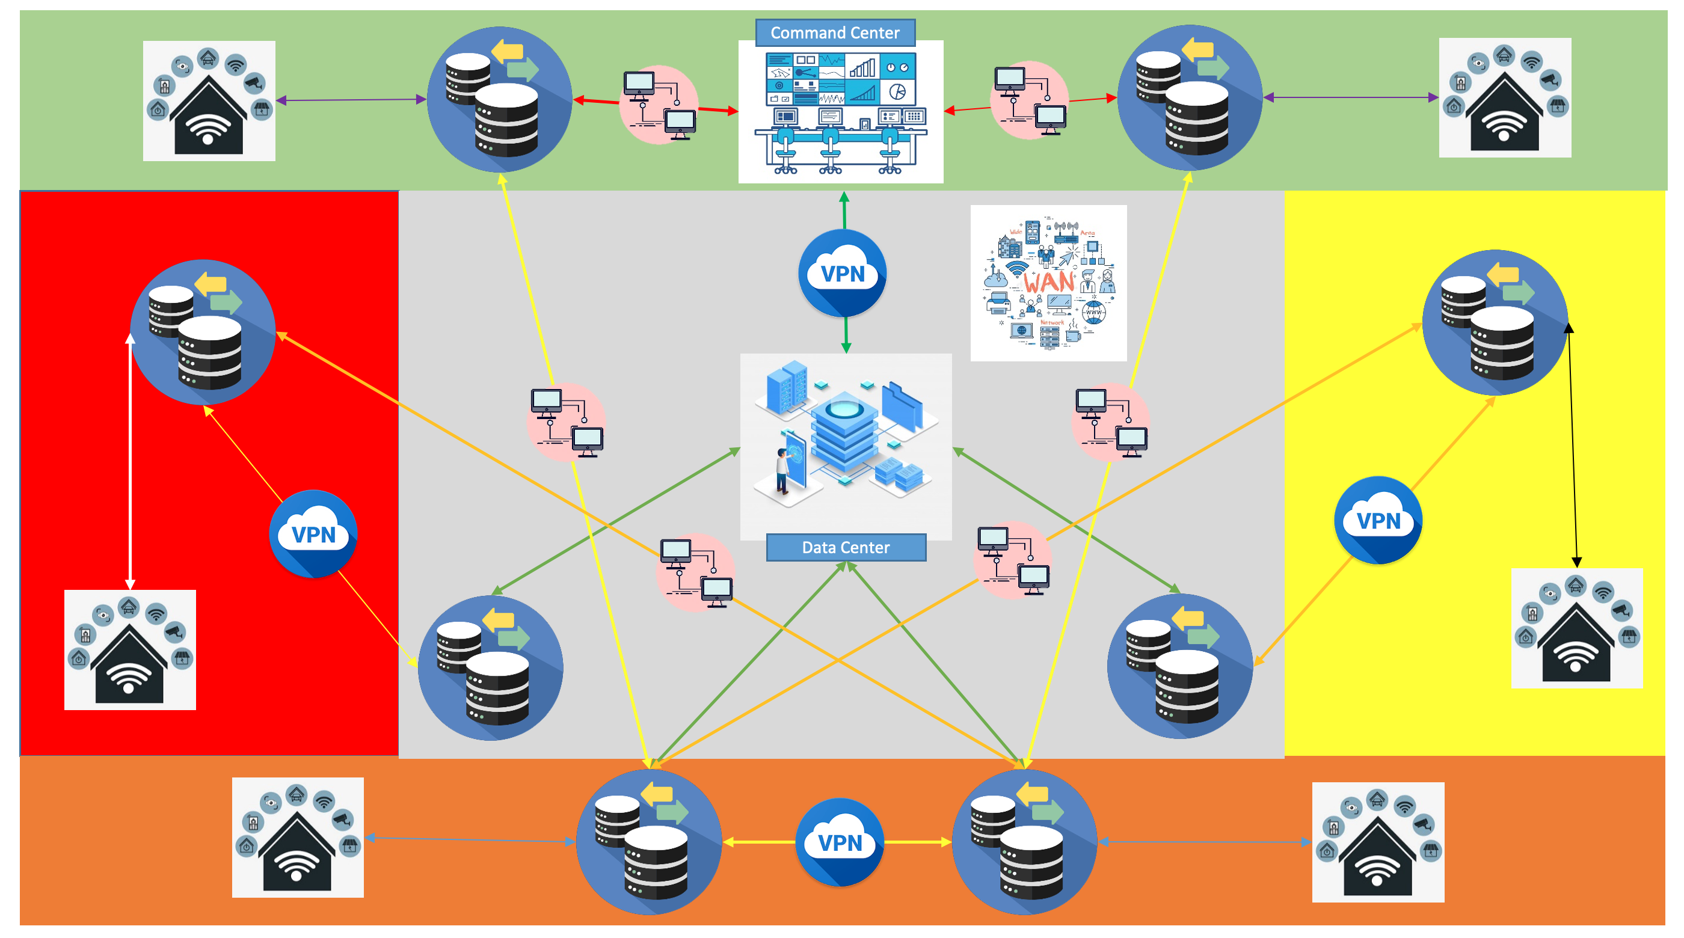

Figure 5. Technology Architecture

# 3. **RESULT**

The Zhao and Balague (2015) The development of mobile applications has presented challenges and opportunities for companies to market their brands and products through new channels; however, the branded mobile apps (branded apps) currently available in the market are far from perfect and the existing app designs don't yet have well-established mobile and social features. This study offers a systematic guideline for branded application design by identifying different levels of strategy that companies should consider. It outlines five business objectives (communication, customer relationship management, sales, product innovation, and marketing research) and identifies five types of branded applications (tool-, game-, social-, m-commerce-, and design-centric). Three functional building blocks are proposed to define how mobile features, social features, and brand mention elements should be incorporated into branded app development. Various examples of branded applications are provided to illustrate relevant best practices to guide marketers in improving the design of branded applications.

Teece (2010) states that business model innovation is the process of creating, give and get value. To get to the root of the problem, the basis of creating value in the organization is the source for designing business models. Due to the development of innovation in the field of Information Technology and electronic devices, as well as the renovation of the business model in the music and film industry, this industry has begun to rely more on the "Internet" in recent times. The Internet acts as an important resource character for delivering core value propositions in the music and film industries. An example of a typical internet business model innovation is BIG Entertainment, which provides online music and film services in Indonesia.

A basic understanding and introduction to the Business Model Canvas reviewing the history of business models shows that the brief concept of business models has been around since the 1950s. Osterwalder and Pigneur (2010). However, after the 1990s, with the disintermediation of e-commerce, and the impact of retailer virtualization, and scholars defined the term “Business Model as” the process of creating value by enterprises” Zott and Amit (2017). Gradually, business model became a popular word for business startups and investors. It builds public confidence once a company is equipped with a good business model that the company is on its way to success. There are several definitions of a business model. Timmers Timmers (1998) considered the main business model framework by embracing product flow, service flow, and information flow. Based on the definition, other characteristics in business activities can be defined under the main framework such as profit potential and source of profit receipt. Chesbrough and Rosenbloom (2002) refer to the business model as a “change process”.

A business model by their definition is the concrete performance of business logic and revenue concepts when operating a company. A business model is a story that explains how a company works. Magretta (2002). Moreover, a business model is a method and a set of assumptions that explain how a business creates and generates profits in a competitive environment. Schaltegger et al. (2016), Lumpkin and Dess (2004). Before the business model canvas became widespread, two main definition trends were identified for business models. The first and most common and widely used definition by Osterwalder et al. Osterwalder et al. (2005). They combine and compare frequently used Models and components from previous studies by Timmers (1998), Magretta (2002), and the constructed “Nine Building Block Model” cover four main areas of business: customer, product, infrastructure, and financial aspects. Soon after, they revised their model, Osterwalder and Pigneur (2010) to identify the term business model with the principles of creating, delivering, and capturing value from an organizational perspective. Meanwhile, other scholars argue in different points of view exploring business models.

The perspective of Hamel and Ruben (2000) increases profits. According to the purpose of the innovative business model should help enterprises to react to transformation environment rather than improving on traditional models. The scope of Hamel and Hamel Ruben (2000) model, named "Business Model of Enterprise Core" is the core strategy, strategic resources, customer interface, and value network. In addition, to run the business model smoothly, it is necessary to relate theory to customer benefits, configurations and company constraints. Model Shafer, Smith and Linder Shafer et al. (2005) categorize four main dimensions including strategic choice, value network, create value and capture value. Later, Johnson (2010) proposed a four-element business model framework called the "four-box framework". This model divides the business model into customer value proposition, profit formula, key resources, and key processes.

Summary and all concepts, the business model is termed as a description of the company's fundamental logic and strategic choices to create and capture value within the framework of a value network. Determine the actual consumer desires, and then set a value proposition that is relatively applicable to the company. In essence, the definitions of Johnson's (2010) four-box framework and the Osterwalder, Osterwalder and Pigneur (2010) business model canvas are similar. The difference is the derived framework. Johnson's framework is often classified as a conceptual model.

Umar et al. (2018) small and medium businesses must have a strategy to improve their competitive skills. That's because competitors want to always improve their products. If a company cannot make any changes, it will be abandoned by its competitors. The company must prepare the value of its product quality that is better than its competitors. Must have a price that is in accordance with the target market and the value of the product offered. The company must have a strategic location and can be accessed by the people who are the target market. No less important, companies must prepare product promotion techniques for themselves. Customers will feel the benefits and advantages of the product. The benefits of using a business model canvas are:

- Business can be done structurally

- The movement of the business can be faster because all the steps in developing the business have been managed on the business model canvas. One example is the company's activities have been made systematically; so that the company can run efficiently.

- Can place customers as the company's main target by providing the best value from the products offered.

With the conditions that occur, it can be concluded that the company must have its own marketing strategy that will be used as a strategy in competing with competitors. Certain strategies must be adapted to the current situation and conditions of the company and outside the company, for example, the level of prosperity of the community around the business location. Companies that are able to compete with competitors are companies that have successfully implemented their business strategies correctly.

1. **DISCUSSIONS**

The strategy used in carrying out the activities of the Business Model Canvas design with Enterprise Architecture. Implement in stages, namely by implementing in stages. The stages to be carried out are the preparation stage, the implementation stage and the evaluation stage.

The first stage is to prepare for the implementation of the design of the Business Model Canvas and Enterprise Architecture.

The second stage is to start with the implementation or implementation of the designs already in the Business Model Canvas and Enterprise Architecture.

The third stage is to evaluate from the second stage and carry out development with the concept of continuous improvement.

# **CONCLUSION**

The development of the film and music industries can be described as a mutually beneficial process. Service provider BIG Entertainment strives to diversify its services due to variations in market trends and technological advances. On the other hand, users have also changed their listening behavior due to the occurrence of the BIG Entertainment platform. Then the service provider designs more functions to meet the needs of the users. Customization and interaction between service providers and users has not stopped. By having a service that is distinct and difficult to imitate, BIG Entertainment can make itself capable of meeting the needs of specific customers. Then can build a multivariate value network by observing the transformation of customer needs.

Moreover, the BIG Entertainment industry is quite vicious. BIG Entertainment acts as a new venture on the Internet; In the new venture industry, the advancement of Internet technology usually brings global waves. But in fact, not all new business patterns of the Internet complement the advantages of globalization. BIG Entertainment needs to maintain its current advantage and make it superior, localization and mobilization. BIG Entertainment tries to provide more localization-oriented services to its customers continuously because of the unique culture of film and music products. Customer behavior is connected to the customer culture area. For newcomers, in addition to regulations and laws, an understanding of customer culture and preferences is also an important point. BIG Entertainment's diversification strategy proves the advantages and opportunities of localizing Internet services. Once a BIG Entertainment provider has enough songs, bandwidth, and hardware conditions, they still pay a lot of effort to integrate every resource they have. No problem for BIG Entertainment to face competitors such as Spotify, Netflix, Disney difficult integration. After the BIG Entertainment provider solves the problem, some businesses that seem useless in short-term operations, can bring greater industry value in long-term operations.

BIG Entertainment creates a new battlefield, there may be a new first mover advantage living better in a fierce environment. The business model includes both tangible and intangible assets for customers, they not only need the final product (music service) but also need one-stop service. BIG Entertainment can make a profit while still creating a unique and efficient business model if it integrates tangible and intangible assets successfully. Lastly, film and music are businesses, but they are also arts. In order to better share stories and productions for users, the film and music industry must delve deeper into realizing authentic user ideas. In short, users watch movies or listen to music while service providers listen to users. In order to prove if the new business model can become the future of the industry, further research is needed to input quantitative methods. In addition, this study focuses more on the adjustment of the industrial field. In short, the film and music application service industry must be more open to accepting more adaptive business models.

# **REFERENCES**

Abdullah Umar, Agung Hari Sasongko, Glory Aguzman dan Sugiharto. 2018. Business Model Canvas As A Solution For Competing Strategy Of Small Business in Indonesia. International Journal of Entrepreneurship Volume 22, Issue 1, 2018.

Afifudin, Et.al. 2012. Metodeologi Penelitian Kualitatif. Bandung: Pustaka Setia.

Arikuntoro, Suharsimi. 2006. Prosedur Penelitian Suatu Pendekatan Praktik. Jakarta : Rieneka Cipta.

Bernabo, M., Garcia-Bassets, I., Gaines, L., Knauer, C., Lewis, A., Nguyen, L., & Zolfaghari, L. 2009. Technological convergence throughout the eras: Part 2 – cellular and computers. Business Strategy Series, 10(1), 12-18.

Castells, M., Fernandez-Ardevol, M., Qiu, J., and Sey, A. 2004. The Mobile Communication Society: A cross-cultural analysis of available evidence on the social uses of wireless communication technology. International Workshop on Wireless Communication Policies and Prospects: A Global Perspective. 8-9 October, Los Angeles.

Chesbrough, H. and Rosenbloom, R. S. 2002. ‘The role of the business model in capturing value from innovation: evidence from xerox corporation’s technology spin-off companies’, Industrial and corporate change 11(3), 529–555.

Johnson, M. W. 2010. Seizing the white space: Business model innovation for growth and renewal, Harvard Business Press.

Kubera, G. 2010. Najlepsze technologie dekady. <http://technowinki.onet.pl/artykuly/najlepsze-technologiedekady,1,3169467,artykul.html>.

Lumpkin, G. T. and Dess, G. G. 2004. ‘E-business strategies and internet business models:: How the internet adds value’, Organizational Dynamics 33(2), 161–173.

Magretta, J. 2002. ‘Why business models matter?’, Harvard Business School Boston, MA pp. 86–92

Osterwalder, A. and Pigneur, Y. 2010. Business model generation: a handbook for visionaries, game changers, and challengers, John Wiley & Sons.

Osterwalder, A., Pigneur, Y. and Tucci, C. L. 2005. ‘Clarifying business models: Origins, present, and future of the concept’, Communications of the association for Information Systems 16(1), 1.

Sanusi, Anwar. 2016 Metodologi Penelitian Bisnis. Jakarta : Salemba Empat.

Sch¨afer, T., Sedlmeier, P., St¨adtler, C. and Huron, D. 2013. ‘The psychological functions of music listening’, Frontiers in psychology 4, 511.

Schaltegger, S., Hansen, E. G. and L¨udeke-Freund, F. 2016. ‘Business models for sustainability: Origins, present research, and future avenues’.

Teece, D. J. 2010. ‘Business models, business strategy and innovation’, Long range planning 43(2-3), 172– 194.

Tully, C. 2003. Growing up in Technological Worlds: How Modern Technologies Shape the Everyday Lives of Young People. Bulletin of Science Technology Society, 23(6), 444-456.

Zhao, Zhenzhen dan Balague, Christine. 2015. Designing branded mobile apps: Fundamentals and recommendations. ScienceDirect, 58, pp. 305-315.

Zott, C. and Amit, R. 2017. ‘Business model innovation: how to create value in a digital world’, GfK Marketing Intelligence Review 9(1), 18.