Analysis of the Mathematical Understanding Ability of Students Tuton Class at Statistical Method Course in the Open University

Nerru Pranuta Murnaka1*, Samsul Arifin2, Andi Mardiana Paduppai3

1 Mathematics Education Department, STKIP Surya, Tangerang.

2 Statistics Department, School of Computer Science, Bina Nusantara University, Jakarta.

1,3 Universitas Negeri Semarang

*Corresponding author: samsul.arifin@binus.edu

**Abstract.** Mathematical understanding is one of the five essential skills in learning mathematics. It is essential to develop this mathematical understanding ability to solve problems in real life by applying the mathematics they understand. This study aimed to find out how the mathematical understanding ability of Tuton students in the Statistics Method class at the Open University was determined. The sampling technique used purposive sampling. The instruments used to collect data are in the form of tests of mathematical understanding abilities and documentation. The test results were analyzed based on indicators of mathematical understanding. The results of this study indicate that the students' mathematical understanding ability is high.

1. Introduction

Mathematics is one part of the science that underlies the development of modern technology and plays an essential role in the formation of quality human resources [1–2]. Therefore, mathematics is made one of the subjects that students must study starting at the elementary school level [3–7]. By studying mathematics, students will be able to develop their mindset so that in the future they will be able to develop the ability to manage and utilize information and communication technology so that they adapt to face the development of a very fast and competitive era, especially in the 21st century and the 4.0 industrial revolution, this is as stated in Permendiknas No. 22 of 2006 [2], and Permendikbud No. 58 of 2014 [3] which states that mathematics subjects need to be given so that students are trained to think logically, analytically, systematically, critically and creatively as well as the ability to work together. Therefore, learning mathematics becomes essential in life. Given the importance of mastering mathematics, the government has set the goals of learning mathematics in schools, one of which is: understanding mathematical concepts [3, 4, 7]. In line with this, the National Council of Teachers of Mathematics NCTM (2000) also states that in learning mathematics students are required to be able to understand and be able to use procedures, concepts, and processes. From the learning objectives that have been mentioned, one of the abilities that students must have is the ability to understand.

According to Gardner [8], deep understanding is the basis of learning. Understanding is a mental process of assimilation and transformation of knowledge [8]. A person is said to have understood if he can demonstrate his understanding in two ways: he can give reasons about why and how well he can show that understanding to the public [8]. Understanding is not the end of the learning process, but understanding is seen as a tool that guides someone to understand deeply other things.

Understanding is an essential basis for thinking in solving everyday problems. In learning, the ability to understand is a part that is increasingly being considered by many academics and is a goal (goal) for all students in each subject or course [9]. Sanjaya [10] suggests that understanding is a student's ability in the form of mastery of several subject matter, but can express it again in another state that is easy to understand, provides data interpretation, and applies it according to its cognitive structure.

One part of the ability to understand is the ability to understand concepts. The ability to understand mathematical concepts is the ability of students to re-express what has been communicated to them through writing and apply it to solving simple mathematical problems that are relevant to the concepts being studied [6,11,12]. Meanwhile, according to Jihad and Haris [12], the ability to understand mathematical concepts is the ability of students to carry out working procedures (algorithms) appropriately using the concepts learned. Neglecting the ability to understand good concepts will make students know or remember, but students can also express a mathematical idea in other forms. Students will also be able to apply one or more concepts in solving specific problems.

To measure the ability to understand students' mathematical concepts, an indicator of the ability to understand mathematical concepts is needed. The hands of the ability to understand mathematical concepts listed in Permendikbud No. 58 of 2014 [3] are as follows: 10 Restate the concepts that have been studied; 2) Classify objects based on whether or not the requirements that make up the concept are met; 3) Identify the properties of the idea; 4) Apply the concept logically; 5) Provide examples or non-examples of the concepts studied; 6) Presenting ideas in various forms of mathematical representation (tables, graphs, diagrams, pictures, sketches, or mathematical models); 7) Using, utilizing, and selecting work procedures or algorithms in solving problems.

Distance Education or Distance Learning (DL) is a breakthrough in education; it is different from conventional education. According to Warsita [13], distance education is an open education with a relatively tight structured learning program and a learning pattern without face-to-face or separation between and training participants. Distance education also involves the media in delivering knowledge (knowledge) to students and requires students to learn independently. Perry & Rumble [14] mentions that Distance Education (PJJ) is an instructional activity, which does not require a physical presence in class.

Distance Education was first developed in the United States, France, Germany, and England in the mid-1800s. In 1840, Sir Isac Pitman taught distance learning using letters. And in the 1980s, International Correspondence Schools (ICS) build a "home-study course" lecture method, which was due to security in that era. Meanwhile, in Indonesia, distance education was first introduced in Indonesia Indonesia through the opening of the Open University (UT) in 1984. Based on the description of the problem above, this study aims to determine and analyze the ability to understand students' mathematical concepts in online tutorial activities for statistical methods courses.

1. Methods

This research is qualitative research using the descriptive method. Through qualitative research, researchers can identify subjects and feel what they experience in everyday life. According to Sugiyono [14], qualitative research produces descriptive data that aims to obtain a complete picture of a thing in detail from a phenomenon and according to someone who will be examined. Data obtained

will be more complete and meaningful so that the objectives of the research will be achieved. The subjects in this study were students who took part in online tutorial activities for class 07 statistical methods. The sampling technique was carried out using purposive sampling.

The ability to understand students' concepts is assessed based on the indicators of the ability to understand mathematical concepts contained in Permendikbud No. 58 of 2014 [3], namely 1) restating the concepts that have been studied; 2) applying the concept logically; 3) provide examples or non-examples of the concepts studied; 4) use, utilize and have working procedures or algorithms in solving problems. The criteria for assessing the ability to understand mathematical concepts can be seen in the following table:

**Table 1.** Guidelines for Scoring Ability to Understand Mathematical Concepts

|  |  |  |
| --- | --- | --- |
| **Understanding**  **Indicator Concept** | **Description** | **Score** |
| Restate the concepts that have been learned | Blank answer | 0 |
| Unable to restate the concept | 1 |
| Can restate the idea but still a lot of errors | 2 |
| Can restate the argument but not yet correct | 3 |
| Can restate concepts appropriately | 4 |
| Apply concepts logically | Blank answer | 0 |
| Unable to apply concepts logically | 1 |
| Can apply concepts logically but not yet correctly, and there are still many mistakes. | 2 |
| Can apply concepts logically but incomplete | 3 |
| Can apply concepts logically appropriately | 4 |
| Give an example or not an example of the concept being studied | Blank answer | 0 |
| Unable to provide examples or non-examples of the concept being studied | 1 |
| Can provide examples or non-examples of the concepts studied but are not correct, and there are still many mistakes | 2 |
| Can provide examples or non-examples of the concepts studied but are incomplete | 3 |
| Can provide examples or non-examples of the concepts studied correctly | 4 |
| Using, utilizing, and having working procedures or algorithms in solving problems | Blank answer | 0 |
| Not using, utilizing, and having procedures or working algorithms to solve problems is not correct, and there are still many errors. | 1 |
| Can use, utilize, and have working procedures or algorithms in solving problems, but there are still many errors. | 2 |
| Can use, utilize, and have procedures or working algorithms in solving problems but are not complete | 3 |
| Can use, utilize, and have procedures or working algorithms in solving problems logically appropriately | 4 |

To calculate the Percentage of the result score of the ability to understand mathematical concepts, the following formula is used:

|  |  |
| --- | --- |
| **Score** = | Description: *x* = Percentage of students' correct answer scores *a* = Correct answer score *b* = Maximum score that can be achieved |

Furthermore, the Percentage of the score obtained is then interpreted to determine how high the students' ability to understand mathematical concepts is according to Gita, et.al [7]. The following table of Score Interpretation Criteria is below:

**Table 2.** Guidelines for Scoring Ability to Understand Mathematical Concepts

|  |  |  |
| --- | --- | --- |
| No | Percentage | Level of Understanding |
| 1 | 0% ≤ *score* < 20% | Not much |
| 2 | 20% ≤ *score* < 40% | Not enough |
| 3 | 40% ≤ *score* < 60% | Enough |
| 4 | 60% ≤ *score* < 80% | Good |
| 5 | 80% ≤ *score* ≤ 100% | Very good |

1. Results and Discussion

The subjects in this study were open university students who took online tutorials for statistical methods courses, as many as 50 students. This study aimed to analyze the ability to understand students' mathematical concepts in completing introductory statistics courses. The problems given to the students were as many as four description questions, each of which contained several indicators of understanding mathematical concepts. The following is a summary table of the percentage of students' mathematical concept understanding abilities, namely:

**Table 3.** Summary of Mathematical Concept Understanding Ability

|  |  |  |  |
| --- | --- | --- | --- |
| No | Indicator | Percentage | Criteria |
| 1 | Restate the concepts that have been learned | 86,76% | Very good |
| 2 | Apply concepts logically | 98,48% | Very good |
| 3 | Give an example or not an example of the concept being studied | 84,70% | Very good |
| 4 | Using, utilizing, and having working procedures or algorithms in solving problems | 78,64% | Good |
|  | Total | 87,15% | Very good |

The percentage of students' ability to understand mathematical concepts as a whole is 87.15%. Therefore, understanding students' mathematical concepts in online tutorial activities for statistical methods courses is very good. Next, analyze pictures of student answers on solving questions related to student answers

1. **Indicator: Restate the concept that has been learned**

Question No. 1 : An electrical company manufactures light bulbs usually spread by a mean of 800 hours and a standard deviation of 40 hours. Calculate the probability that a bulb will reach its lifespan:

1. More than 820 hours
2. Between 778 and 834 Hours

From the analysis of student answers, a score of 86,76% means that for the first indicator, students' ability to restate a concept is categorized as very good. The following is a description of students' abilities in the first indicator for question number 1

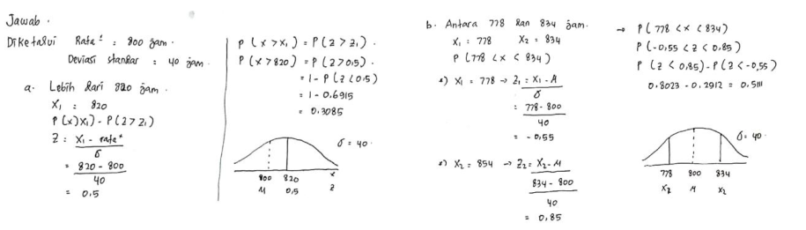

**Figure 1.** The correct answer for question number 1

In question number 1, students are expected to restate a concept. Figure 1 is one of the students' answers that meet these indicators. The answer shows that students have been able to restate a concept with correctly, and students' answers are complete. Students are also able to restate concepts in their language. Based on the answers, it can be said that students are able to restate a concept.

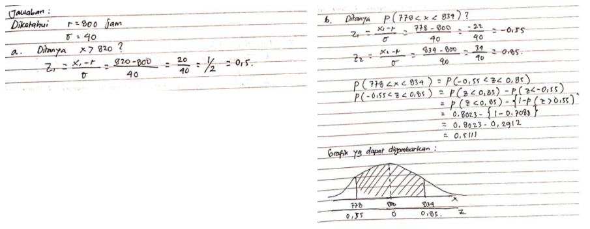

**Figure 2. Wrong answer for question number 1**

Figure 2 is one of the wrong answers. In answering point A, the student is still wrong because it is incomplete, while point B is correct. This shows that students have been able to restate a concept, but there are still a few errors. This error occurs because students think that the answer to point A that stopped is only that, even though there should still be a continuation. This shows that students have been able to restate a concept, but it is still not right. Figure 3 also shows the answers from students who have been able to restate a concept but are incomplete.

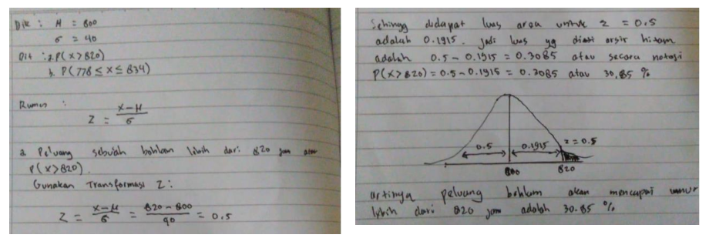

**Figure 3. Wrong answer for question number 1**

In Figure 3, it can be seen that students only do point A, while point B has not been done at all. From point A, it can be seen that the students understand the problems that are asked and can answer them correctly.

1. **Indicator: Applying the concept logically**

Question No. 2: A car brand can withstand the road shock test with a probability of, calculate:

a) exactly 2 of the four tested parts will not fail?

b) at most, 3 out of 4 tested parts will not be damaged?

c) At least 3 out of 4 tested parts will not be damaged?

From the results of the analysis of student answers for the second indicator, a score of 98.48% means that students' ability to apply concepts logically is categorized as very good. The following describes students' abilities in the second indicator for question number 2.

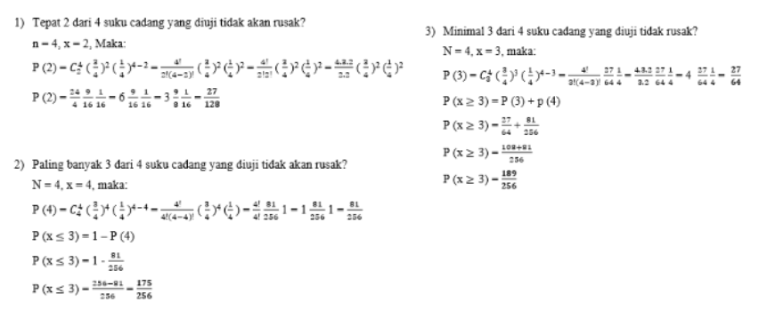

**Figure 4. The correct answer for question number 2**

In question number 4, students are expected to apply the concept logically. Figure 4 is one of the students' answers that meet these indicators. The answer shows that students can apply concepts logically with correct, and students' answers are complete. Students are also able to communicate their answers in their own language. Based on the answers, it can be said that students are able to apply the concept logically.

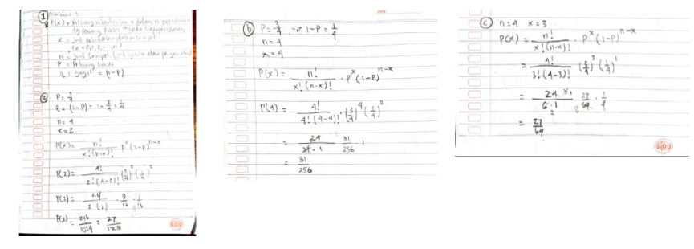

**Figure 5.** The wrong answer for question number 2

Figure 5 is one of the wrong answers. In answering point A, the student is correct, while in points B and C the student's answer is still wrong. This shows that students can apply the concept logistically, but there are still a few errors. This error occurs because students think that the answers to points B and C stop at that, even though there should still be a continuation. This shows that the steps written by the students are correct, but the answers are still incomplete. So students can apply the concept logistically, but it is still not right. The following are also answers from students who can apply the concept logistically.

1. **Indicator: Gives an example or not an example of the concept being studied**

Question No.3 : What causes the independent sample case to arise?, give an example?

From the results of the analysis of student answers for the third indicator, a score of 84.70% means that the ability of students to provide examples or not examples of concepts that are categorized as very good. The following is a description of students' abilities in the third indicator for question number 3.

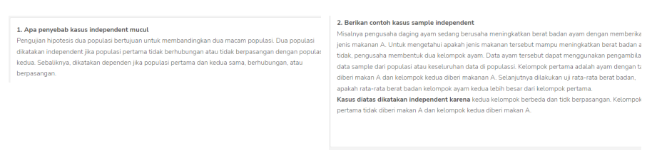

**Figure 6.** The correct answer for question number 3

In question number 3, students are expected to provide examples or not examples of the concepts being studied. Figure 6 is one of the students' answers that meet these indicators. In the explanation, it can be seen that students are able to provide examples or not examples of the concepts being studied, and students' answers are complete. Students can also communicate their answers in their own language. The answer can be said that students are able to provide examples or not examples of the concepts being studied.

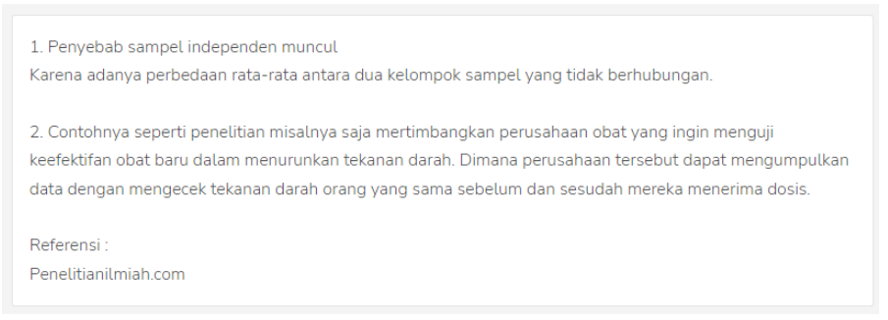

**Figure 7.** The wrong answer for question number 3

Figure 7 is one of the wrong answers. Students are still wrong in giving examples related to the concepts being studied. For example, even though students already understand the definition of independent events, they can also explain the explanation in their own language. Figure 7, that has not provided an example or not an example of the concept being studied.

1. **Indicators: Using, utilizing, and having procedures or working algorithms in solving problems**

Question No. 4: a family has 4 children and what is observed is the sex of the children based on their birth order. Let A be the event that the family has at least 2 sons and B be the event that the second child is a boy and the third is a girl.

Calculate : a) P(A)

b) P (B)

c) P(A∩B)

d) The probability that there will be at least two boys if it is known that the second child is a boy and the third child is a girl?

From the results of the analysis of student answers for the fourth indicator, a score of 78.64% means that students' ability to use, utilize, and have procedures or working algorithms in solving problems is categorized as very good. The following describes students' abilities on the fourth indicator for question number 4.

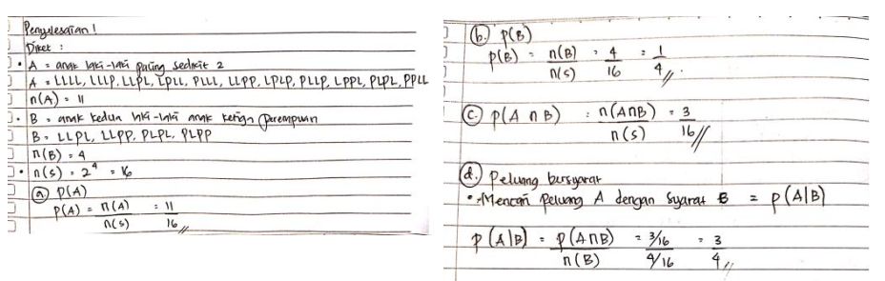

**Figure 8.** The correct answer for question number 4

In question number 4, students are expected to use, utilize, and have procedures or working algorithms in solving problems. Figure 8 is one of the students' answers that meet these indicators. In the answers, it can be seen that students are able to use, utilize, and have procedures or working algorithms in solving problems related to the material being studied, and students' answers are complete. Students are also able to communicate their answers in their own language. Based on the answers, it can be said that students are able to use, utilize, and have procedures or working algorithms in solving related problems being studied.

|  |  |
| --- | --- |
|  |  |

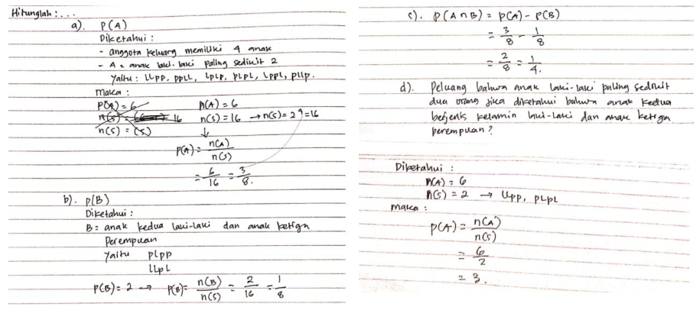

**Figure 9. Wrong answer for question number 4**

In question number 4, students are expected to be able to use, utilize, and have procedures or working algorithms in solving problems. Figure 9 is one of the students' answers that meet these indicators. In the answers, it can be seen that students are able to use, utilize, and have procedures or working algorithms in solving problems related to the material being studied, and students' answers are complete. Students are also able to communicate their answers in their own language. Based on the answers, it can be said that students use, utilize, and have procedures or working algorithms in solving related problems being studied.

From the description above, it can be concluded that understanding the concept of students' mathematical problems in solving math problems related to basic statistics courses is already very good. Or in other words, students' ability to understand mathematical concepts is very good.

1. Conclusion

Based on the results of the research and discussion above, it is obtained a score of the first indicator is 86.76% which is categorized as very good, for the score on the indicator, the second is 98.48% which is categorized as very good, for the score on the indicator the third is 84.70% which is categorized as very good, and finally the score on the fourth indicator is 78.64% which is categorized as good. From this description, it can be concluded that the score of students who can understand mathematical concepts in the statistical method course reaches 87.15% which is included in the very good category. Or it can be concluded that the students' ability to understand mathematical concepts related to statistical methods courses is in good condition.

The reasons why some students still make mistakes are: seen in the first indicator, that students are able to restate a concept using their own language but the answer is still incomplete. There may be student misconceptions. Whereas understanding the concept is very important for student development, because if students have understood the concept correctly then students can solve the problems that exist. This is in accordance with the indicators of understanding mathematical concepts, namely students must be able to restate concepts that have been studied, apply concepts logically, provide examples or non-examples of concepts studied, use, utilize, and have procedures or working algorithms in solving problems. To overcome this, students should be trained more to be able to develop their ability to understand concepts.

**References**

1. Suherman, E., Turmudi, Suryadi, D., Herman, T., Suhendra, Prabawanto, S., . . . Rohayati, A. (2003). *Common Textbook: Strategi Pembelajaran Matematika Kontemporer*. Bandung: MIPA UPI
2. Tarigan, S., Murnaka, N. P., & Arifin, S. (2021, April). Development of teaching material in mathematics “Sapta Maino Education” on topics of plane geometry. In *AIP Conference Proceedings* (Vol. 2331, No. 1, p. 020003). AIP Publishing LLC.
3. Depdikbud. (2014). Peraturan Menteri Pendidikan dan Kebudayaan Republik Indonesia Nomor 58 Tahun 2014 Tentang Kurikulum 2013 Sekolah Menengah Pertama dan Madrasah  
   Tsanawiyah. *Berita Negara Republik Indonesia. Menteri Pendidikan dan Kebudayaan Republik Indonesia. Jakarta.*
4. Depdiknas. (2006). *Permendiknas No. 22/2006: Standar Isi untuk Satuan Pendidikan Dasar dan Menengah.* Jakarta: BNSP.
5. Sugiarti, R., Murkana, N. P., Erlangga, E., Adicita, R., & Pinandita, S. (2021). Learning model of municipal students. *Cypriot Journal of Educational Sciences*, *16*(4), 1765-1775.
6. Suwarno, and Nerru Pranuta. M. (2019). Education 4.0: Technology Integration In Calculus Course. *International Journal Of Scientific & Technology Research*. Vol. 8, Issue 08, August 2019.
7. Gita, A., Murnaka, N. P., & Sukmawati, K. I. (2018). Penerapan Model Pembelajaran Conceptual Understanding Procedures (CUPS) sebagai Upaya Mengatasi Miskonsepsi Matematis Siswa. *Journal of  
   Medives, 2*(1), 65-76
8. Gardner, H. (1999). *Intelligence Reframed : multiple Intelligence for 21th century.* USA: Basic Book.
9. Stylianides, A. J. & Stylianides, G. J. (2007)*.* Learning Mathematics with Understanding: A Critical Consideration of the Learning Principle in the Principles and Standards for School Mathematics. *The Montana Mathematics Enthusiast*, 4 (1), 3-114.
10. Sanjaya, W. (2013). *Perencanaan dan Desain Sistem Pembelajaran*. Jakarta: Kencana Prenadamedia.
11. Kilpatrick, J., Jane, & Findell, B. (2001). *Adding It Up: Helping Children  
    Learn Mathematics*. Washington: National Academy Press.
12. Jihad, A. & Haris, A. (2013). *Evaluasi Pembelajaran*. Bantulg: Multi  
    Pressindo
13. Warsita, B. (2013). Perkembangan definisi dan kawasan teknologi pembelajaran serta perannya dalam pemecahan masalah pembelajaran. *Kwangsan*, *1*(2), 286943.
14. Sugiyono. 2015. *Metode Penelitan Pendidikan (Pendekatan Kuantitatif, Kualitatif, dan R&D).* Bandung: Alfabeta.
15. Perry, W., & Rumble, G. (1987). *A Short Guide to Distance Education*. International Extension College, Office D, Dales Brewery, Gwydir Street, Cambridge CB1 2LJ, England (2.50 pounds).