Study of Pulp and Paper Making Characteristic Produces from Sago Fiber Waste

T D Maurila1, H D Rahmayanti1, S Ardiani1\*, N Hastuti2, and D A Indrawani2

1Graphic Engineering Department, Politeknik Negeri Media Kreatif, Indonesia

2Pusat Penelitian dan Pengembangan Hasil Hutan, Bogor, Indonesia

\*Corresponding author: septiaardiani@polimedia.ac.id

**Abstract.** This study is about the characterization of pulp and paper from sago fiber waste. The process of its has several stages: preparing solution, sago fiber analysis, pulping process, and printing process. The required solutions are NaOH solution (technical), 10% BaCl2 solution, 0.1 N HCl solution, 60% ethanol solution, phenolphthalein indicator solution, 1% starch indicator solution, sindur methyl indicator solution of NaOH titration, borax solution, Na₂S solution (technical), and THIO solution (1 N; 0.1 N). The pulping process is carried out by inserting sago fiber and solutions into a rotary digester machine for 4 hours (170oC). Then, it removed after 24 hours and dried by spinner machine. Characterizations on the sample include: chemical and physical properties, mechanical properties, and optical properties. The result shows that sago fiber waste can be used as raw material for paper. The value of its are grammage of 62 g/m2, thickness of 0.1294 mm, water absorption capacity of 627.27 g/m2, water content of 9.83%, ash content of 26.26%, pH of 7.9, tensile strength of 14.22 MD and 13.33 CD, brightness of 19.8%, and opacity 22.78. The pore diameter of the paper is 4.608 nm.

1. Introduction

According to Indonesia Packaging Federation, the performance of the packaging industry in Indonesia is projected to grow around 6 percent in 2020 from the realized value in 2019 of IDR 98.8 trillion. Judging from the materials used, the most widely circulated packaging is 44% flexible packaging, 28% paperboard packaging, 14% rigid plastic packaging, and 14% other materials (Jelita, 2020).

With the second highest percentage after flexible packaging, it is certain that there is a lot of industry demand for paperboard packaging. According to ISO 536: 2019, paperboard is a material made of paper weighing more than 200 g/m2. Paper is made from pulp, either organic pulp, synthetic pulp, or the rest of paper production (recycled). The high use of cardboard packaging is expected to continue to increase over time, in line with human needs which are also always increasing. This will pose a challenge to the domestic paper production capability because the potential for conventional fiber raw materials (natural forest wood) is increasingly scarce. Therefore, this research is needed on alternative non-wood paper raw materials, one of which is sago tree fiber.

Indonesia has high potential of sago, even more than 50% of the world's sago, which is around 5.5 million ha and 90% of that area is in Papua Province, which is 4.7 million ha (Ahmad et al, 2017: 115). Sago has a higher productivity level than other carbohydrate-producing crops, such as sweet potatoes, rice, and corn. The potential for sago production per year can even reach up to 220 million tons (Bantacut, 2020: 189).

The sago industry in Indonesia ranges from small industry to large industry, with high production, so by that the by-product will also be high. Management of by-products from the sago industry is still lacking and it is necessary to utilize this to reduce environmental impacts and produce value-added products (Bantacut, 2020: 190). Untreated sago fiber waste based on dry weight of materials containing starch, cellulose, hemicellulose, and lignin with their respective contents (58%, 23%, 9.25%, 3.9%) (Winarni, 2019: 44). The cellulose content in the sago fiber waste can be an alternative raw material for paper other than wood. It is hoped that with the research on sago fiber waste as an alternative non-wood paper raw material, it can provide wider options in the future for the utilization of sago fiber waste, as well as an alternative non-wood paper alternative raw material option which can later be used as an alternative packaging material.

1. Methods

In this study, paper was made by sago fiber waste. The paper manufacturing process has several stages: preparing solution, sago fiber analysis, pulping process, and printing process. The required solutions are NaOH solution (technical), 10% BaCl2 solution, 0.1 N HCl solution, 60% ethanol solution, phenolphthalein indicator solution, 1% starch indicator solution, sindur methyl indicator solution of NaOH titration, borax solution, Na₂S solution (technical), and THIO solution (1 N; 0.1 N). After the required solutions have been prepared, the concentration of the cooking solution that will be used for pulp and paper production is determined using sago fiber. Analysis of sago fiber was carried out to determine fiber requirements during pulping process. The water content of sago fiber was calculated by weighing the dry weight of the air, then oven at 105°C for 2x24 hours. Furthermore, the oven-dried sago fiber was weighed to determine its oven-dry weight (BKO).

In the pulping process, the sago fiber is cooked into pulp by inserting the sago fiber, and the solution into a rotary digester machine (Figure 2(A)) for 4 hours at 170oC. After Then, the pulp is removed after 1x24 hours. After removal, the pulp is washed, and dried with a spinner machine. When the pulp is dry, it is then prepared for analysis which will then prepare for the needs for printing paper sheets. Then the pulp is printed, after the pulp is printed and has become paper, then the paper characterization is carried out to determine the feasibility of paper made from sago fiber.

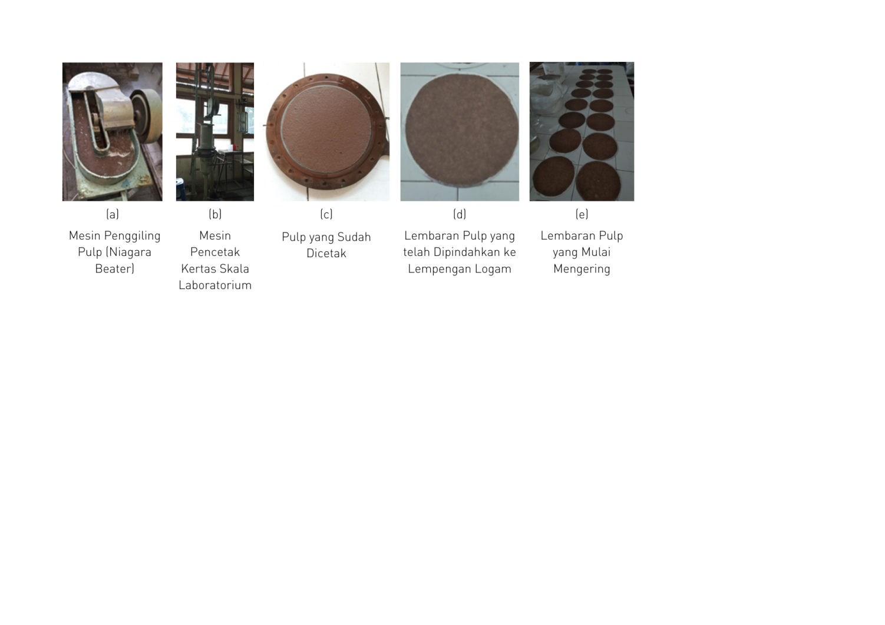

(E)

(D)

(C)

(B)

(A)

**Figure 1.** Paper printing (A) Milling with a niagara beater, (B) Laboratory scale paper printing machine, (C) Printed pulp (D) Pulp sheets that have been transferred to metal plates (E) Pulp sheets that are starting to dry.

Several characterizations have been employed such as physical and mechanical properties, optical properties and chemical properties. The physical and mechanical properties tested includes grammage, thickness, water absorption capacity, water contain, ash contain, pore diameter, and tensile strength (Figure 2(A)). The optical properties tested includes brightness, and opacity. The optical of the sample was tested using a Yante data tools, as shown in Figure 2(B). The BET test was used to determine the pore diameter of the fiber, pore volume, and pore area. SEM was used to determine the appearance of the fiber.

|  |  |  |  |
| --- | --- | --- | --- |
| (A)  C:\Users\Talitha DM\Downloads\Proses Pembuatan Larutan Pemasakan (4).png | (B) | C:\Users\Talitha DM\Downloads\IMG_20210531_144027.jpg  (C) |  |

**Figure 2.** (A) A rotary digester machine, (B) Optical test, dan (C) Tensile strength test

1. Results and Discussion

Paper based on sago fiber waste is made by preparing raw materials for pulping, namely sago fiber and pulping solution. Basically, the pulping process is a process of separating fiber from raw materials containing fiber by mechanical, chemical or a combination of both. The main purpose of pulping is to separate the cellulose (fibers). There are several methods for pulping which is a process of separating cellulose from its binding compounds, especially lignin, namely mechanically, semichemically and chemically (Audina, 2015:5). In the manufacture of pulp for this study uses mechanical pulping using a rotary digester machine. Initially this process was developed by E.G. Kellen (Sulasmita, 2015:6). In this process, the wood is crushed into mud.

Pulp analysis was carried out by analyzing the water content, the resulting pulp immersion and the kappa number. The results of the pulp analysis are shown in Table 1. Analysis of the raw material pulp for sago fiber was conducted to determine the potential utilization of sago fiber as an alternative to pulp from non-wood materials. Kappa number is the number of ml of 0.1 N KMnO4 used by 1 gram of oven-dried pulp under standard conditions. The kappa number is used to indicate the amount of lignin remaining after the cooking process, and also to determine the level of maturity or the degree of delignification and whitening power of the ripened pulp.

**Table 1**. The results of the pulp analysis

|  |  |
| --- | --- |
| **Parameter** | **Hasil** |
| Alkaline Residual | 7,71 % |
| Alkaline Consumtion | 15,04 % |
| Residual Alkaline | 0,96 % |
| Wet Water Content | 64 % |
| Dry Water Content | 177,99 % |
| Soak Content | 50,81 % |
| Kappa Number | 33,68 |

Prior to the printing process, the water requirements and pulp requirements are calculated. Grammage made is 60 g/m2. The number of papers made is 30 sheets. From the calculation results, it is found that the need for pulp for paper printing is 423.56 grams. With water needed is 9.5 liters.

The pulp is milled with a niagara beater to smooth and break the fibers so that it is easy for the molding process. The printing process is done manually with a laboratory scale printing equipment. After printing, the pulp sheet is transferred to a metal plate to facilitate drying. Figure 1(D) shows a sample of dark colored sago fiber-based paper. This is because the process of making sago fiber-based paper without going through a bleaching or bleaching process so that the resulting color is still natural. The pulp sheets that have been transferred to metal plates are left to dry indoors, so that there is no external dirt adhering to the wet pulp sheets.

* 1. *Characterization of Paper*

The physical, mechanical, optical, and chemical characteristics of paper based on sago fiber waste are shown in Table 2.

**Table 2**. The results of paper characterization

based on sago fiber waste

|  |  |
| --- | --- |
| **Parameter** | **Hasil** |
| Grammage | 62.05 g/m2 |
| Tickness | 0.1294 mm |
| Water absorption | 627.27 g/m2 |
| Tensile strength | MD:14.22 N CD:13.33 N |
| Elong | MD:4.02%  CD:4.22% |
| Water content | 9.75 % |
| Ash content | 27.2% |
| pH | 7.9 |
| Brighness | 19.865% |
| Opacity | 22.778% |
| Pore diameter | 4.608 nm |
| Pore volume | 0.580 m3/g |
| Pore surface area | 76.99 m2/g |

Measurement of material resistance can be calculated based on what is the maximum stress that a material can withstand when pulled or pulled, before the material breaks. Stress is the term used when the applied force is expressed relative to the cross-sectional area (Rahmayanti et al., 2019:32). The tensile strength between MD and CD has a difference based on the direction of attraction. MD is greater than CD because the tensile strength of MD is parallel to the fiber direction. While the CD is smaller because it crosses or is perpendicular to the direction of the paper fibers. This is also influenced by the presence of bonds between fibers and between paper/pulp particles. CD is easier to break because there are only bonds between fibers.

Paper acidity (pH) is the concentration of hydrogen ions with a paper extract solution. Low acidity on paper will cause prints to dry for a long time, resulting in print transmission, faded print colors, thus affecting the quality of print production, especially for packaging printing (Wasono dan Bowo, 2008). The results of the pH testing of sago fiber-based paper are shown in Table 2. The test was carried out twice with each paper weight of 2.0062 g and 2.0128 g at room temperature of 30.2oC. The pH value meets the criteria for printing paper. The minimum pH criteria for printing paper is 4.9 (Muchtar et al, 1998). This shows that sago fiber-based paper has the potential as an alternative packaging material in the future.

From the results of testing the water content of paper, it shows the water content of 9.75%. The water content in the paper more or less affects the tear resistance of a paper (Iyus, 2008). The higher the water content, the higher the humidity. At high humidity, the tear strength will decrease due to interference with the bonds between the fibers in the paper caused by water (Ariyani and Hidayati, 2012:15). The results of testing the ash content of sago fiber-based paper showed an ash content of 27.20%. Ash is an organic substance left over from the combustion of an organic material. The size of the ash content indicates a lot or less air voids on the paper (Ariyani and Hidayati, 2012:15). The smaller the value of the ash content, the more air voids and the stronger the absorption. The value of ash content also affects the dust scale. High ash content will affect the high value of the dust scale on the paper. With a high ash content, the dust scale is even higher. A good dusting scale is on a scale of 1-2. If it is greater than 2 then the paper quality will be poor due to the occurrence of white spots (Mucktar et al, 1998).

In the paper brightness test, the value is 19.865%. The low brightness value is because the paper has not been bleached. In addition, the composition of the excess NaOH solution can also cause yellowing of the paper because the increase in the NaOH solution makes the paper fibers more degraded and the lignin content decreases (Felicity et al, 2009:8). The results of the sago fiber-based opacity test showed that it was 22.778%. The opacity value of sago fiber-based paper is still low. For further research, the opacity value can be increased in several ways, such as setting grammage, grinding, base pressing, filler material and the type of fiber itself. The higher the grammage, the higher the opacity value.

* 1. *SEM and BET Analysis*

The surface morphology analysis of sago fiber-based paper at a magnification of 250x is shown in Figure 3. The results of SEM analysis clearly show that the size of paper based on sago fiber waste is 20 µm.

C:\Users\Talitha DM\Downloads\KULIAH\Praktik Industri\kertas serat sagu 250x.tif

**Figure 3**. Microscopic structure of paper based on sago fiber with SEM magnitude 250x

Paper porosity testing has been carried out using the BET tool. In the BET test, data on pore diameter and volume were obtained, as well as the specific surface area of ​​sago fiber-based paper. The test results using BET are shown in Table 2.

1. Conclusion

Paper packaging has been successfully made from sago fiber waste using mechanical pulping method. The physical, mechanical, optical, and chemical characteristics of paper based on sago fiber waste are meet with the characteristic of paper packaging. The BET analysis shows that the paper has 4.608 nm of pore diameter, 0.580 m3/g of pore volume, and 76.99 m2/g of pore surface area.

**References**

1. Ahmad, F., Bintoro, M. H., Supijatno, S. (2017). Morphology and Production of Some Sago Palm Accessions in Iwaka, Mimika District, Papua Province. *Buletin Palma*, *17*(2), 115-126.
2. Ariyani, S. B., & Hidayati, H. (2012). Utilization of Durian Skin as Raw Materials of Art Paper. Biopropal Industri, 3(1).
3. Audina, G. R. (2015). Pembuatan Pulp Dari Serabut Kelapa Muda menggunakan Metode Organosolv (Doctoral dissertation, Politeknik Negeri Sriwijaya).
4. Bantacut, Tajuddin dkk. (2020). Suplemen Bahan Webinar: Pembangunan Sagu Terpadu dan Berkelanjutan. Dewan Guru Besar: Institut Pertanian Bogor.
5. Felicity, F., & Elyani, N. (2009). Kekuatan Tarik, Noda, Opasitas dan Derajat Putih Kertas Pada Proses Daur Ulang Kertas Koran.1-12
6. ISO 536: 2019 Paper and Board-Determination of grammage
7. Iyus. 2008. Studi Pemanfaatan Limbah Kertas Karton menjadi Pengemas Telur. Thesis. Universitas Gadjah Mada. Yogyakarta.
8. Jelita, Insi Nantika. (2020). Pasar Digital Genjot Industri Kemasan. Dalam Media Indonesia Senin 30 November 2020. Jakarta
9. Muchtar, E., et al. (1998). Pedoman Pengujian Kertas dan Tinta. Pusat Grafika Indonesia. Jakarta.
10. Rahmayanti, H. D., Munir, R., Sustini, E., & Abdullah, M. (2019). Karakterisasi Sifat Mekanik Benang Wol dan Benang Kasur. Jurnal Fisika, 9(1), 28-36
11. Sulasmita, D. D. (2015). Pengaruh Proses Acetosolv dalam Pembuatan Pulp dengan Sabut Kelapa Muda (Doctoral dissertation, Politeknik Negeri Sriwijaya).
12. Wasono and Bowo, A. (2008). Teknik Grafika dan Industri Grafika. Jakarta
13. Winarni, I., Waluyo, T. K., Komarayati, S. (2019). Pembuatan Bioetanol dari Empulur dan Limbah Serat Sagu dengan Metode Kimiawi dan Enzimatis. *Jurnal Penelitian Hasil Hutan*, *37*(1), 43-50