Force-Displacement Analysis of MacPherson Type L Suspension Spring for Electic City Car Using Finite Element Method

S S Budi, A B Hendrawan, I Saputra, R Ismail

Department Of Mechanical Engineerng, Politeknik Harapan Bersama, Indonesia

Department of Mechanical Engineering, Universitas Diponegoro

*Corresponding author: seti08405@gmail.com

**Abstract.** MacPherson suspension is widely used because of its simple mechanism. However, the side load that appears is a weakness of the MacPherson suspension. The purpose of this study is to reduce the load that arises from the side using MacPherson type L suspension. This study used several stages, namely the L type model and using finite element method software. The suspension is pressed down and at the top of the suspension spring will be seen the force that arises on the x, y, and z axes to simulate the side loads that arise on the top of the spring. The formula is based on analysis and the L type coil spring is designed taking into account the effect of the design variable on the force axis. The FEM simulation results show that the side loads on the springs towards the x and y axes whose values are close to zero are the most stable springs.

1. Introduction

Based on the trend, the means of transportation is very important because not only it can reduce noises, it can also reduce pollution, especially on cars. Electric cars are developing rapidly and are also used to reduce depencency to fossil fuels and provide energy [1]. Electric vehicles or cars are made to facilitate vehicle performance, time efficiency, and driving comfort [2]. One of the structural components that play an important role in a car is the suspension [3]. Of the several types of suspension, there are two types, namely double wishbone and MacPherson. Aside of being expensive, the double wishbone suspension began to be abandoned by the manufacturer and switched to the Macperson type. In addition to being easy to use, it has simple form, and it also has tilt angle to the shock absorber axis line which aims to reduce the suspension which results in driving comfort [4][5].

The springs used in MacPherson suspensions usually have an abnormal direction of motion (displacement) on the x, y, and z axes, which is a characteristic of it [6]. However, the lateral force (FQ) applied to the upper damping rod will cause components friction in the upper mount [7], as shown in Figure 1. Moreover, the MacPherson model does not have an upper arm, so the upper mount is integrated into the body. It causes vibrations due to the friction between the road and forward wheels to the body, especially the upper mounted components. Side loads can be reduced by minimizing the direction and displacement of forces caused by the x and y axes. Therefore MacPherson suspension is very important to reduce side loads [2]. The purpose of this research is to find the right type L spring suspension for electric car vehicles. The type L suspension was simulated using ANSYS software by applying pressure to the coil [8][9]. The spring suspension was simulated with the same length but different shapes and coils. The FEM simulation was clamped at the bottom and the three models had a direction about the z-axis as well as the magnitude of the forces and displacements that occured during the running simulation.

1. 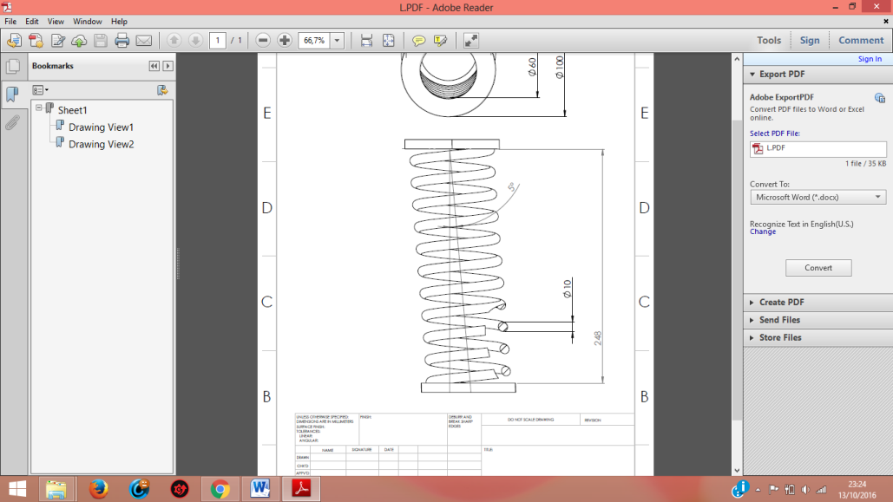 (b)

**Figure 1.** (a) Type L coil spring shape at free height (b) Force on suspension that produces side force

1. Methods

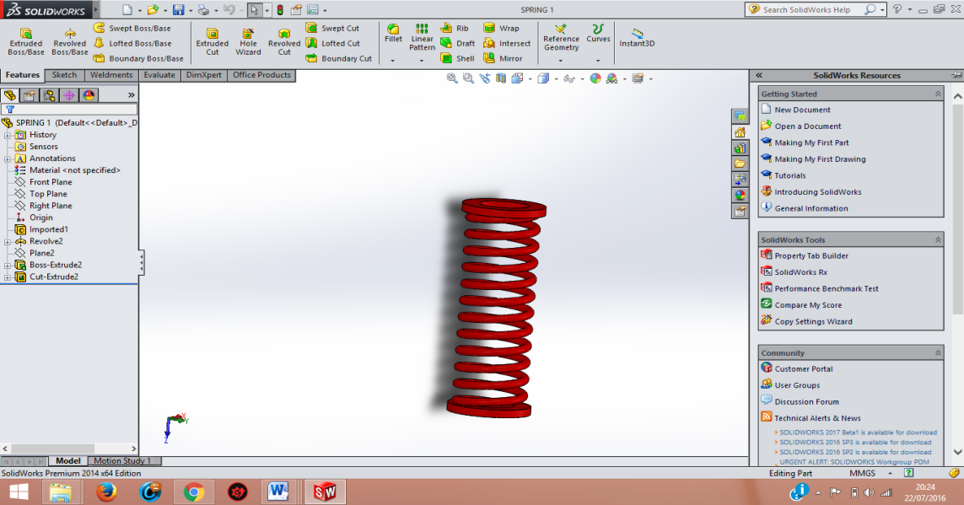

Clamped

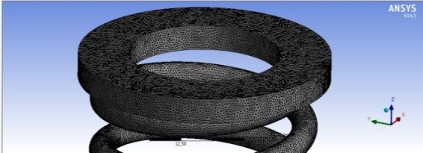

**Figure 2 (a).** Spring tipe L suspension dimension and clamped position (b) Meshing on spring

The spring dimension for the outer diameter is 100 mm, the coil diameter is 10 mm, and the spring length is 268 mm. In this study, the length of each spring coil is the same which is 268 mm. What differs them is coil 11, 12, 13. The material consists of ST 37 steel, and the material properties are shown in Table 1.

.Table 1

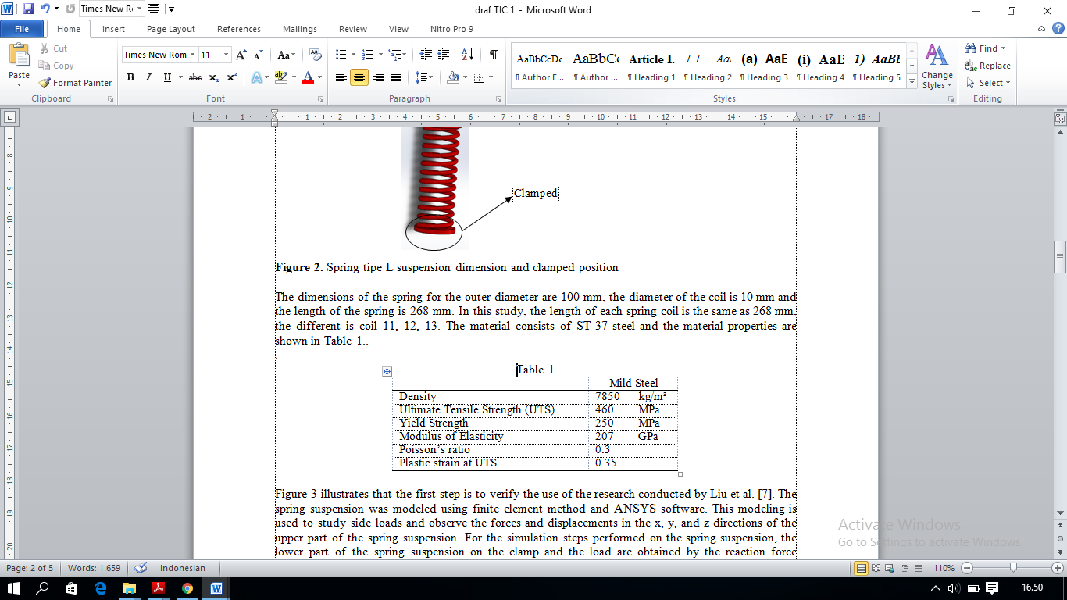

The first step was to verify using the research of Liu, et al. [7] used in this study, the ANSYS modeling using finite element method simulation. Modeling the top of the spring suspension about the x, y, and z axes was done to study side loads, observe forces, and displacements. The simulation steps carried out on the suspension spring, the bottom of the suspension spring on the clamp, and the load obtained the reaction force received by the suspension spring, as shown in Figure 3. From the determination of the load following the study where the spring that experienced displacement due to loading (per mm) it was known the amount and the direction of the emerging style. Spring displacement measured up to 250 mm.

Make geometry model

Result

ANSYS Simulation:

\

Validation

**Figure 3.** Analysis process of Tipe L spring modeling

1. Results and Discussion

Before the research was conducted, it was validated by Liu, et al [7]; repetition comparisons were made, showed that the FEM simulation showed a difference of less than 10% as shown in Figure 4.

Force (N)

**Figure 4.** Simulation comparation

**Type L spring 11 Coils**

Figure 5(a) above shows a simulation of a Type L 11 coil. During a displacement of 50 mm of the suspension spring, the forces and displacements in the direction of x, y, and z can be seen, as shown in Figure 5(b). The force received by the suspension spring during the displacements of 100 mm, 150 mm, 200 mm, and 250 mm were used to determine the displacement that occured in each axle. FEM modeling was done using a tetrahedral mesh with 5727 nodes and 2180 elements.

From the simulation of the Type L suspension spring using 11 turns of the spring, it showed that the displacement of the suspension spring increased, the force towards the z-axis was greater, and the force towards the x and y axes was close to zero, as shown in Figure 5(b) . Based on the linear spring analysis shown in Figure 5(a), using 11 coil springs with a displacement of 50 mm, the force towards the z-axis was 0.79 N, the force towards the x-axis was 118.72 N, and the force towards the x-axis was The y direction was N. During a displacement of 250 mm the force in the direction of the z-axis was 5600.9 N, in the direction of the x-axis was 0.46 N and in the direction of the y-axis is 593.79 N

1. 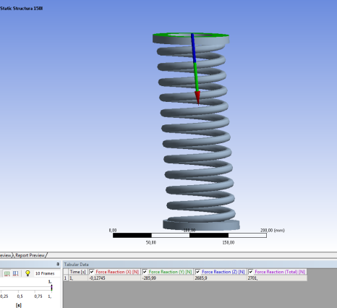 (b)

Force (N)

Displacemet (mm)

**Figure 5.** The force of tipe L 11 coils spring during 50 mm displacement (b) Simulation results on the spring suspension of Tipe L 11 coils

**Type L spring 12 Coils**

A Type L spring with 12 coils during the FEM simulation results is shown in Figure 6(a) and the graph of the simulation results for the displacement that occurs in the coils is shown in Figure 6(b).

1. 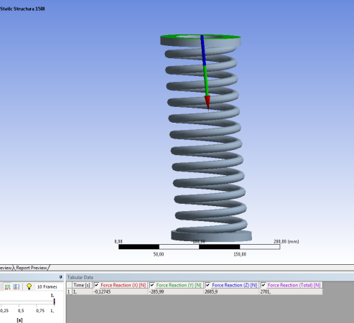b (b)

Force (N)

Displacement (mm)

**Figure 6**. The force of Type L 12 coils spring during 50 mm displacement (b) The simulation results on the coils suspension of Type L 12 coils

From the simulation results that carried out on the Type L spring, it showed that the displacement of 50 mm about the x, y, and z axes on the L 12 threaded spring, the magnitude of the direction of the force on the x, y, and z axes of the 50 mm displacement were 0.43 N; 24.9 N; and 952.38 N. The displacement of 250 mm on the threaded spring 12 produces a force in the x, y, and z directions were 2.18 N; 124.6 N; and 4761.9 N.

**Type L spring 13 Coils**

1. The same simulation was also carried out on a Type L spring with coils number 13. The following are the simulation results at a displacement of 150 mm as shown in Figure 7(a). The graph of the simulation results is shown in Figure 7(b).

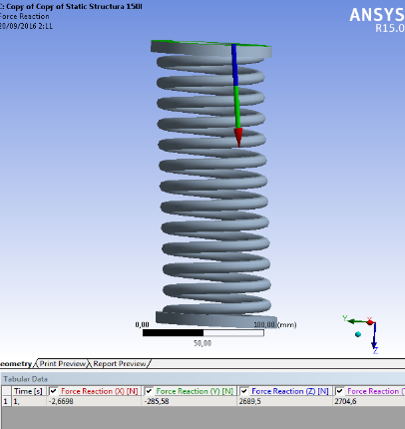

Force (N)

Displacement (mm)

**Figure 7.** The force of Type L 13 coils spring during 50 mm displacement (b) The simulation results on the spring suspension of Type 13 coils

The simulation results on the threaded spring Type L 13 also show a higher force value at a displacement of 50 mm for the x, y and z axes where 0.89 N; 95.192 N; and 896.49 N. When a displacement of 250 mm occurs, the simulated forces for the x, y, and z axes are 4.45 N, respectively; 475.96 N; and 4482.5 N.

1. Conclusion

Based on the simulation results of the L type coil spring suspension, the L 11 helical spring could withstand the force better in the z-axis direction, and the L 13 helical spring had the least force. For the x-axis direction, the L12 type coil suspension had the largest spring force, and the L11 type rotary spring was the smallest, and in the y-axis direction the L-type spring coil had the least amount of spring force, and the L type 12 coil springs was the least. The results of the spring suspension simulation showed that the forces generated were small on the x and y axes (close to zero), so that the resulting side load was reduced. Of the three simulated springs, the simulation showed the effect of the number of turns. The more turns the spring had, the less side load occured. This situation can be seen from the simulation results compared. A spring with a coil of type L 13 had the least force on the x and y axes. However, the ability to withstand the force (increase or decrease) in the z-axis direction was owned by a 12-winding L type spring, and the ability to withstand the force on the displacement reached 4482.5 N. The excellent ability to withstand the force in the z-axis direction means that the spring could reduce the yaw indication. (swing). The most crucial matter is the right combination, so that the suspension, especially the springs, could control the direction of the vehicle's motion.

**References**

[1] D.C. Robert, and L.W. Robert, *Vehicle Design and Stability*, *The ROV Manual* (Butterworth-Heinemann, London, 2014), pp 107-120.

[2] A. Makhrojan, S. S. Budi, J. Jamari, A. Suprihadi and R. Ismail, “Strenght Analysis of Monocoque Frame Construction in an Electric City Car Using Finite Element Method,” in *Joint International Confererence on* *Electric Vehicular Technology and Industrial, Mechanical, Electrical, and Chemical Engineering-2015,* IEEE Conference Proceedings, pp. 275-279.

[3] K. Watanabe, M. Tamura, K. Yamaya, and T. Kunoh, J. of Mat. Process. Tech. Letters **111**, 132-134 (2001).

[4] J. Reimpell, *Automotive Chasis,* (Butterworth Heinemann, London, 2001), pp 10-14.

[5] Y. I. Ryu, D. O. Kang, S. J. Heo, H. J. Yim and J. I. Jeon, J. of Mech. Sci. and Tech. Letters **24**, 351-356 (2010).

[6] M. Mitsuhiro, JSAE review. Letters **20**, 471-477 (1999).

[7] J. Liu, D. J. Zhuang, F. Yu and L. M. Lou, Int. J. of Auto. Tech. Letters **9**, 29-35 (2008)

[8] S S Budi, A Suprihadi, A Makhrojan, R Ismail, and J Jamari1. “The Effect of Linear Spring Number at Side Load of McPherson Suspension in Electric City Car” *ln joint international Conference on Engineering Science and Nanotechnology 2017*, AIP Conference Proceeding, pp. 275-281

[9] S Cho, H Yeon, H Kim and CW Kim, “Design of end coil angular position and centerline shape of C-type side load coil spring for reducing side load of MacPherson strut suspension” *Journal of Mechanical Science and Technology 35 (3) 2021*