The Influence of *SAVI* problem based and Mathematical Disposition on the student achievement of SMK Dynamics

Tegal City.

Danuri

Universitas Negeri Semarang

Semarang, Indonesia

Nuryadi

Universitas Mercu Buana Yogyakarta

Yogyakarta, Indonesia

M. Taufik Qurohman Politeknik Harapan Bersama

Tegal, Indonesia

[taufikqurohman87@gmail.com](mailto:taufikqurohman87@gmail.com)

***Abstract*—** **Research of problem based SAVI (Somatis, Auditori Visual, Intelektually) on mathematical creative thinking skills, mathematical problem solving abilities, and mathematical dispositions. The study was conducted from June to October 2021. The results of this study showed that students who followed learning with problem-based SAVI had better mathematical creative thinking skills than students who followed conventional learning. The results of learning device development are as follows: (1) learning devices developed valid according to validators, with an average validation score of 3.25 with the highest score of 4; (2) the device is said to be practical because the positive student response with a score of 83.92 and the teacher's ability to manage learning with a score of 4.41 is very high; (3) use of SAVI model learning devices** **Mathematical Disposition-based is effective, characterized by the achievement: (a) students achieve completion individually and classical, (b) the ability to solve mathematical problems in the classroom that uses the SAVI model based on Mathematical Disposition is better than the ability to solve mathematical problems in the classroom with conventional methods, (c) The existence of influence together - the character of independence and problem-solving skills to the problem. Mathematical problem solving ability by 80.7%.**

***Keywords—SAVI, mathematical problem-solving skills, mathematical disposition, Learning Achievement***

1. INTRODUCTION

Mathematics has special characteristics, namely the entire object of abstract study,[19] stating that mathematical characteristics are deductive, logical, as a formal system of number symbols, abstract structures, symbolism, and is a collection of human reason propositions, or basic science and thinking activities. Learning mathematics is a high mental activity, with regard to abstract ideas and must be carried out continuously in a logical order. According to [7], character is a pattern, be it thoughts, attitudes, or actions that are attached to a person very strongly and difficult to eliminate. Character is the character, character, morals, personality of a person formed from the internalization of various virtues that are believed and used as a basis for the way of view, thinking, behaving and acting[1]. Character education is a conscious effort in developing one's personality and is used as a foundation for perspective, thinking, behaving, and acting. And in this study contains the affective aspect of independence which is one of the 18 characters used in the 2013 curriculum.

The study concluded that the need for vigilance when concluding that cognitive dependence/field independence affects lexical knowledge in the absence of tests for possible interactions between other variables. And including gender differences that can affect vocabulary knowledge. In the same way, understanding the effective role of the cognitive and gender aspects of students will enable teachers and researchers to design appropriate materials and activities to help students improve their lexical competence. Next on the research from [12] In the advanced research process, the researchers must still show that cognitive ability does correlate with the tendency to avoid some rational thinking biases, in particular the tendency to display denominator abandonment, probability of matching rather than maximizing, belief bias, and matching biases on the task of selecting 4 cards then presenting a framework for predicting when cognitive abilities will and will not correlate. With a rational tendency to think. The results of subsequent studies are[4] the results of this study provide an understanding that field independence correlates more positively with the success of test takers in understanding IELTS listening. compared to those that depend on the field. More specifically, field independency correlated more significantly with fill in the gap questions, i.e., form completion, note completion and sentence completion tasks compared to field-dependent test takers. The dependence of the cognitive style field, however, correlated more significantly with multiple choice and question matching compared to the cognitive style of field independence. Then the next review is the result of research [5] which provides quite interesting research results, namely the structure of adaptive e-learning systems based on technology by considering the factors that make up independence. Experiments conducted at 3 Ukrainian universities have shown that the use of developed mathematical and information technology models makes it possible to improve academic performance significantly and to reduce the frequency of rejection from independent student work using an e-learning environment. And the next one is to provide a related view of quantitative research results where analysis of the principle component followed by varimax rotation reveals two factors that account for 62% of variance. The first factor consists of three social cognition tests and the second of two tasks that tap into the ability to make representations of oneself and others that integrate more informedness. The first factor is uniquely correlated with negative symptoms, and the second is uniquely correlated with social function.

According to [9] that aspects used in using cognitive learning outcomes contain 6 levels: remembering, understanding, applying, analyzing, assessing and creating. Then the percentage results for the cognitive domain contained in student book problems can provide provisions to train and encourage the level of learning development. So from some definitions and problems it is very interesting to take the common thread related to cognitive aspects, independence, and mathematical learning. Problems that often arise in learning, especially linear program materials, including: (1) the patterns and teaching methods used are still more with lecture methods; (2) The media and learning resources used are still very limited, both in terms of quality and quantity. Therefore, students tend to find it difficult to understand linear program material so that the student success rate on this material is relatively low. Based on the facts, then looking at the data on the average daily replay of linear program material in the last three years in class XI SMK Tegal City Dynamics did not increase based on the experience of teachers during teaching class XI Automotive, with the analysis of daily repeat values conducted on students of class XII Automotive Year 2021/2022 student success in achieving completion is 54% much lower than the previous year in the previous year in the 2021/2022 school year. Which reached 62.5%, and currently KKM mathematics in SMK Dynamics of Tegal City in the 2021/2022 school year is 78 which is still the same as the previous year and 2 years ago in the 2012/2013 study year KKM mathematics is 75. Based on the observations and information above, in an effort to improve students' problem-solving skills, research is conducted by trying to apply a learning model that involves all the senses possessed by students, namely the SAVI learning model (Somatic, Auditory, Vizualisation, Intellectualy). SAVI learning is learning that involves emotions, the whole body, all the senses, and all the depth and breadth of the person, respecting the learning style of another individual by realizing that people learn in different ways. Because the use of the 2013 curriculum prioritizes attitude or character education, one of which is independence and all learning is also directed to contextual learning methods so that the savi learning model is appropriate when used mathematical disposition approach that emphasizes and relates learning to everyday life.

Meier in [2], states that learning does not automatically improve by telling the child to stand up and move. However, combining physical movement with intellectual activity and the use of all senses can have a major effect on learning. Such a learning model is called the SAVI Model. The elements are easy to remember, namely: (1) Somatic: Learning by moving and doing, (2) Auditory: Learning by speaking and hearing, (3) Visual: Learning by observing and describing, (4) Intellectual: Learning by solving problems and reflecting. SAVI learning can be planned with groups/individuals in four stages: (1) Preparatory stage, (2) Delivery Stage, (3)Training Stage, (4) Performance stage of results.

Problem solving in mathematical learning is an approach strategy and at the same time as a goal to be achieved. Problem solving as an approach to learning. While according to Polya [3] there are two problems, namely: 1. problems to find, can be theoretical or practical, abstract or concrete, including puzzles. The main part of a problem is as follows: a) What is it looking for? b) How is the data known?; c) What are the conditions?; These three main parts are the foundation for being able to solve this type of problem. 2. The problem with proving is showing that a question is right, wrong or both. So it is necessary to do further research related to Somatic Learning Auditory Visual Intellectual, mathematical problem solving skills, mathematical disposition and Learning Achievement.

II. RESEARCH METHODS

This research is classified in the type of development research, namely the development of mathematical learning devices. The devices developed are syllabus, Learning Implementation Plan, student book (SB), Student Worksheet (SW), and Problem Solving Ability Test (PSAT).

The Four-D model was suggested by Siyasailam Thiagarajan, Dorothy S. Semmel, and Melvyn I. Semmel. This model consists of 4 stages of development, namely Define, Design, Develop, and Disseminate or adapted into a 4 D model, namely defining, designing, development, and deployment in bustang. Modifications are included 3 steps / stages, namely defining (define), design (design), development (develop), while the stage of dissemination (disseminate) is not done. The stages that are done are: This research is classified in the type of development research, namely the development of mathematical learning devices. The devices developed are syllabus, Learning Implementation Plan, student book (BS), Student Worksheet, and Problem Solving Ability Test Problem Solving Ability Test (PSAT). Before carrying out an experiment, it is necessary to know the initial condition of the control class with the experimental class. The data needed to determine this condition uses pre-test scores. The data calculated the normality test, the homogeneity test and the average similarity test.

After the design of the learning device is made, the learning device is requested by an expert validator consisting of 5 validators. The practicality of learning devices can be determined from the student response, namely student responses about the implementation of learning using SAVI model learning devices. Learning tools are said to be practical if the average of respondents gives a minimal assessment of the "agree"[14] category. Learning is said to be effective if after experiencing the learning process with a device developed using the SAVI model if (1) students complete classical in the experimental class that more than 75% of students get a score of more than or equal to 78 with an average of more than or equal to 78; (2) Problem-solving skills and independence during the learning process affect Problem Solving Ability Test (PSAT); (3) The results of the experimental class problem solving ability test (PSAT) are better than the control class. So to measure the effectiveness of learning outcomes, statistically completed tests, influence tests, and comparative tests against research variables.

III. RESULTS AND DISCUSSIONS

The research was conducted from June 2021 to October 2021, starting from the preparation of proposals to the preparation of a full report. In its implementation took the research object of class XI Automotive at SMK Dynamics of Tegal City. After validating the instrument of the Mathematical Problem Solving Capability Test, the researcher conducted a test instrument test of problem-solving ability, then analyzed the problem solving ability test (PSAT) problem item through a test of validity, reliability, difficulty level and different power of the problem instrument. Based on the analysis of problem solving ability test (PSAT) instrument trial data. For validation results from validators on device development, syllabus, learning implementation plan, student books, student worksheet, and Math Problem Solving Ability Tests problem solving ability test (PSAT) are presented on the recapitulation table of validator values against device development such as Table 1.

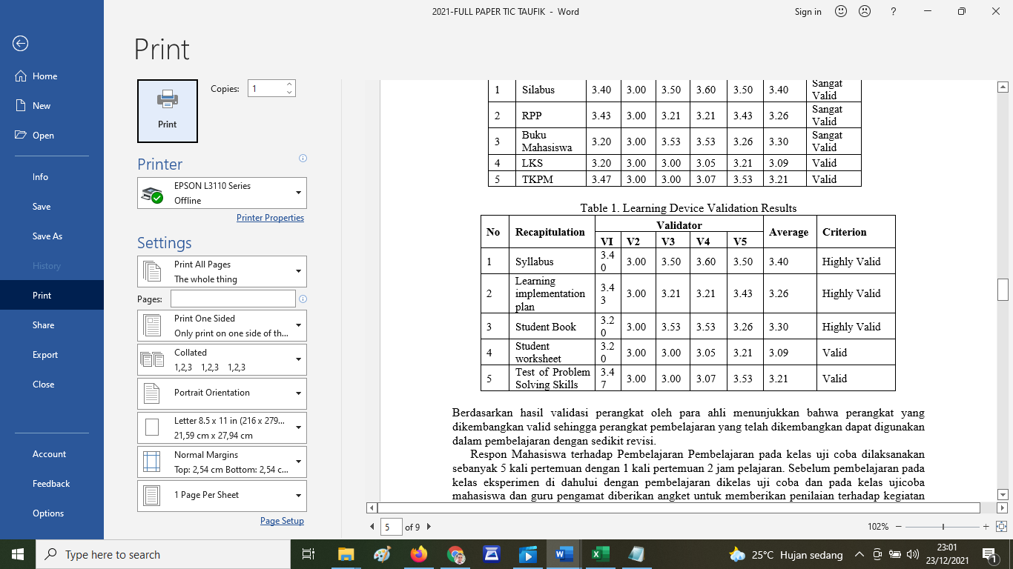

Based on the results of device validation by experts show that the developed device is valid so that learning devices that have been developed can be used in learning with little revision. Student response to Learning Learning in the trial class was carried out as many as 5 meetings with 1 meeting of 2 hours of lessons. Before learning in the experimental class first with learning in the trial class and in the trial class students and observer teachers are given a questionnaire to provide an assessment of the learning activities carried out and learning tools developed. Incoming responses are used to assess the practicality of the device being developed.

Research results data are used to determine the effectiveness of using SAVI-based learning devices and models of Mathematical Disposition in the learning process. The level of effectiveness is measured through statistical tests: (1) tests of completion of mathematical problem-solving skills, (2) average differences tests (appeals), (3) influence tests, and (4) improvement tests. The great influence of character independence and problem-solving skills on mathematical problem-solving abilities is described in Table 2.

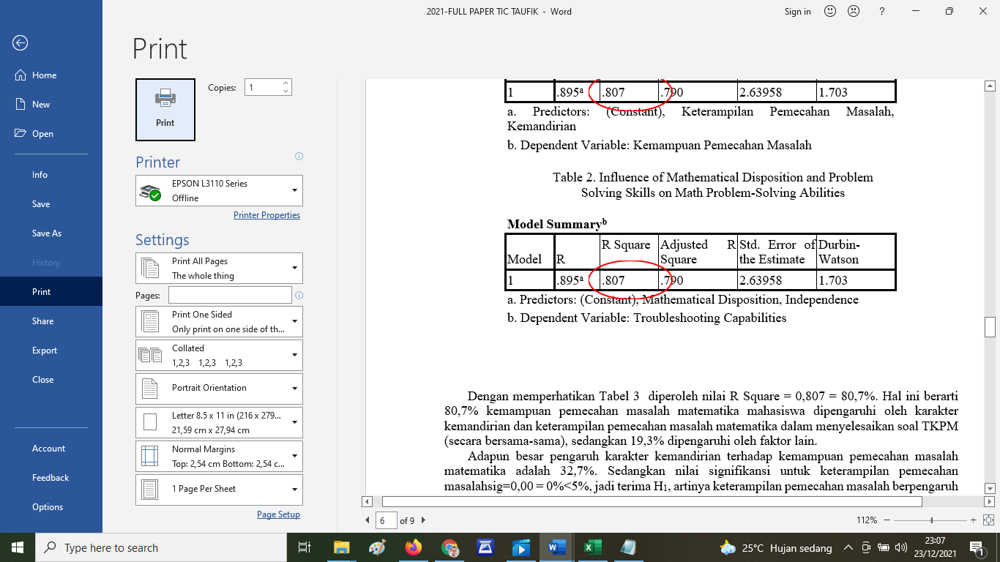

With a close eye on Table 2 obtained the value of R Square = 0.807 = 80.7%. This means that 80.7% of students math problem-solving abilities are influenced by the character of independence and math problem solving skills in solving problem solving ability test (PSAT) problems (together), while 19.3% are influenced by other factors. The magnitude of the influence of independence character on the ability to solve mathematical problems is 32.7%. While the significance value for problem-solving skills sig = 0.00 = 0%<5%, so accept H1, meaning problem solving skills affect mathematical problem solving skills. The large influence of problem-solving skills on math problem-solving skills is 74%.

The results of the test improve the ability to solve mathematical problems to find out the improvement of the ability to solve math problems students in the test class of devices and control classes based on the values at the beginning and end of learning can be done with the following hypothesis formulation. Because tcount = 9.16>1,658 = t_tabel H0 was rejected in other words H1 was accepted, so the average difference in post test scores and pre test scores of students' math problem-solving skills in the classroom with mathematical disposition-based SAVI learning tools and models was more than the average difference in post test scores and pre test scores of students' math problem solving skills in classes with conventional learning, then to find out the increase using the gain test. By using the gain test obtained an average score of 0.7 shows an increase in students in the experimental class is relatively high and in the control class by using the gain test obtained an average score of 0.6 shows an increase in students in the control class is relatively low.

Development of mathematical learning tools developed as described earlier, namely Syllabus, Learning Implementation Plan, student worksheet, Student Book, and Problem Solving Skills Test. During the trial, revisions were carried out in accordance with the input of parties related to the trial process so that the final prototype was obtained. The results of the development of the SAVI model learning device based on Mathematical Disposition, before being directly tested in classes that are treated first are limited class trials whose results are obtained in the form of data observation of teacher abilities and student response questionnaires to obtain practicality data.

From the results of the analysis of data obtained shows the ability of teachers to manage the classroom well and the student's response to positive learning. This suggests that the learning device developed can be directly tested in a trial class. Good and positive results obtained from the observation of the teacher's ability and student response questionnaire showed that the learning device can be said to have met practical criteria. Discussion of effectiveness tests before being tested for effectiveness, prerequisite tests are carried out to test whether classes that get treatment and classes that do not get treatment are normal and homogeneous or not. Based on the results of calculations from problem solving ability test (PSAT) value acquisition data before learning, it can be concluded that the data comes from a normal distributed population and the variance of both homogeneous classes.

The influence test is done with the help of SPSS, namely regression test. The results of a simple regression test of the character of independence to problem solving ability show that the character of independence affects the ability of problem solving. The next simple regression test also showed that problem-solving skills affected students' problem-solving abilities. Double regression tests performed showed that the character of independence and problem-solving skills both affected students' problem-solving abilities. This shows that the character of independence and problem-solving skills have a good (positive) influence on students' problem-solving abilities.

The process of developing learning devices in this research has gone through the validation, revision, field trials in students, until finally obtained the final draft of a valid learning device. Furthermore, the trial of learning devices has also provided results, namely: (1) student KPM variables achieve completion classically or individually, (2) there is a positive influence of independence character variables and problem-solving skills together on students' problem-solving abilities, (3) the average class that gets better treatment than the average class that does not get treatment (4) there is an increase in the ability to solve students' lazy. Based on the ability of the four criteria means that the trial of the learning device of the SAVI model based on Mathematical Disposition has resulted in an effective learning process.

IV. CONCLUSION

Based on the results and discussions that have been outlined, the following conclusions were obtained: (1) Using a 3-D development model generated mathematical learning devices with SAVI models based on Mathematical Disposition of Automotive CLASS XI linear program materials consisting of Syllabus, learning implementation plan, BS, student worksheet, and problem solving ability test (PSAT). Because the learning device developed has been through the validation process and declared valid by people who are experts / experts in their fields, the learning tools developed in this research are valid. (2) The use of SAVI model learning devices based on Mathematical Dispositions charged with character education is expressed practical, (3) Linear program material learning using SAVI model learning devices based on Mathematical Disposition is declared effective, namely : (a) The ability to solve mathematical problems achieves completion both individually and classically, in other words students who are treated with KKM 78 completed individually. Then based on classical completion calculations obtained the conclusion that students complete classically or the percentage of students who achieve KKM scores of more than 75%, (b) The ability to solve students' mathematical problems with learning SAVI model based on Mathematical Disposition is higher than the ability to solve mathematical problems students with conventional learning, (c) There is a positive influence of the character of independence and problem-solving skills on the ability to solve math problems. solving mathematical problems. So that the character of independence and problem-solving skills affect math problem solving skills by 80.7%.

REFERENCES

* 1. Depdiknas. (2008). Panduan Analisis Butir Soal. Jakarta: Departemen Pendidikan Nasional. Dirjen Manajemen Pendidikan Dasar dan Menengah, Direktorat Pembinaan Sekolah Menengah Atas.
  2. Fauzan, A., & Yerizon, Y. (2013). Pengaruh Pendekatan Disposisi Matematis dan Kemandirian Belajar Terhadap Kemampuan Matematis Siswa. Prosiding SEMIRATA 2013, 1(1).
  3. Hudojo, H. (2001). Pengembangan Kurikulum Matemátika dan Pembelajaran Matemátika. Malang: Universitas Negeri Malang.
  4. Khodadady, E., & Zeynali, S. (2012). Field-dependence/independence cognitive style and performance on the IELTS listening comprehension. International Journal of Linguistics, 4(3), 622-635.
  5. Lavrov, E., Logvinenko, V., Siryk, O., & Kyzenko, V. (2021, March). Method for assessing the information content of factors forming the cognitive independence of students. In Journal of Physics: Conference Series (Vol. 1840, No. 1, p. 012066). IOP Publishing.
  6. Lysaker, P. H., Gumley, A., Luedtke, B., Buck, K. D., Ringer, J. M., Olesek, K., ... & Dimaggio, G. (2013). Social cognition and metacognition in schizophrenia: evidence of their independence and linkage with outcomes. Acta Psychiatrica Scandinavica, 127(3), 239-247.
  7. Murni, M. (2021). MANAJEMEN PENDIDIKAN KARAKATER. Intelektualita, 6(02).
  8. Niroomand, S. M., & Rostampour, M. (2014). The Impact of Field Dependence/Independence Cognitive Styles and Gender Differences on Lexical Knowledge: The Case of Iranian Academic EFL Learners. Theory & Practice in Language Studies, 4(10).
  9. Phua, D. H., & Tan, N. C. (2013). Cognitive aspect of diagnostic errors. Ann Acad Med Singapore, 42(1), 33-41.
  10. Prayito. (2011). “Pengembangan Perangkat Pembelajaran Matematika Humanistik Berbasis Kontruktivisme Berbantuan E-Learning Materi Segitiga Kelas VII”. Aksioma, Volume 2. No 2. Hal 1-9.
  11. Rochmad. (2012). “Desain Model Pengembangan Perangkat Pembelajaran Matematika”. Kreano, Volume 3 No. 1. Hal 59-72.
  12. Stanovich, K. E., & West, R. F. (2008). On the relative independence of thinking biases and cognitive ability. Journal of personality and social psychology, 94(4), 672.
  13. Suciati, I. (2020). Penggunaan Metode “Perang Mental Matematika” dengan Menggunakan Media Kartu Pecahan Pada Materi Penjumlahan Bilangan Pecahan. Guru Tua: Jurnal Pendidikan dan Pembelajaran, 3(1), 35-42.
  14. Sugiyono. (2006). Statistika untuk Penelitian. Bandung: Alfabeta.
  15. Suherman, Erman, dkk. (2003). Common Text Book (Edisi Revisi). Strategi Pembelajaran Matematika Kontemporer. Bandung: Universitas Pendidikan Indonesia (UPI).
  16. Sukestiyarno. (2016). Olah Data Penelitian Berbantuan SPSS. Universitas Negeri Semarang.
  17. Trianto. (2007). Model-model Pembelajaran Inovatif Berorientasi Konstruktivistik Konsep, Landasan, Teoritis, dan Implementasinya. Jakarta: Prestasi Pustaka Publiser.
  18. Uno, H B dan Mohamad, N. (2012). Belajar dengan Pendekatan Pailkem. Jakarta: Bumi Aksara.
  19. Yeni, E. M. (2015). Kesulitan belajar matematika di sekolah dasar. Jurnal Pendidikan Dasar (JUPENDAS), 2(2).