Implementation of fuzzy logic-based smart rice fields

Mohammad. Humam, Abdul Basit, Amirullah Hillal

Diploma 3 Computer Engineerin, Politeknik Harapan Bersama Tegal

* [humam@poltektegal.ac.id](mailto:humam@poltektegal.ac.id), [elangputih286@gmail.com](mailto:elangputih286@gmail.com), [alelibra39@gmail.com](mailto:alelibra39@gmail.com)

**Abstract.** Rice fields have a strategic function because they are the main food providers for the population. Indonesia. And the conversion of rice fields tends to experience an increase that makes the emergence of New problems because agricultural land will be replaced with the housing sector or factories. From the thing, Therefore, it is necessary to make modern rice fields means that the planting and harvesting process does not have to be done. in a large rice field. As for the components used such as the microcontroller wemos D1 R1, groundhog sensor, DHT sensor, RTC sensor, also, fan, and pump. And also the results of his research. obtained from the test results that are declared successful, in the form of the implementation of fuzzy logic with rule-based on microcontrollers with soil moisture and DHT sensor inputs, and as a fan and pump output and with fuzzy sets included in the form of fast, medium, old, and fertilization scheduling with RTC sensor. With the addition of technology, it is expected that modern farmers will get more effective. in carrying out a plant monitoring and care system.

1. Introduction

Rice fields have a strategic function because they are the main food supply for the Indonesian population. Data on the raw area of rice fields for all of Indonesia shows that about 41% is found in Indonesia. Java and about 59% are located outside Java (BPS, 2018) with the area of rice fields that exist will be very unfortunate if the utilization of Ricefields is not optimized by farmers.

The rice field is the land that Used to plant some plants that can be consumed, both continued all year round or in turns. The term rice field is not a term. taxonomy, but it is a general term Just like forest land, land plantations, farmland, and so on [1].

Raw area data of rice fields for the whole of Indonesia is 8.1 million ha, about 43% It is located in Java, and about 57% is in Java. outside Java (Directorate General of Infrastructure and Facilities) Agriculture, 2012). With the increase in the number of people and the increasing need for land to various sectors, conversion of rice fields tends to increase, in others. new rice field printing party (extensively) experiencing a slowdown (Sutomo, et al., 2004). Quantity aspect, accessibility, safety (food safety), and Distribution is important element in food security (Suryana, 2005).

On the island of Java due to land conversion, rice fields

the standard tends to decrease in extent, It's the same with outside Java. As a result of the conversion of rice fields Which happens naturally and is difficult to avoid, the development of rice fields in The room should be intensified. Deceleration expansion coupled with insistence against the conversion of rice fields to the development of other sectors leads to widespread The raw rice fields are decreasing.

The reduction of raw rice fields will disrupt the national food sector. Most rice fields outside Java (especially new opening rice fields) are difficult to match the rice fields. on the island of Java. The number of workers in the sector limited farming, low mastery of agricultural technology by farmers, and its limitations Labor in the agricultural sector is constr in their effort to increase production food in Indonesia. Improvement efforts Food production through land clearing New rice fields cannot be fully expected to succeed in the short term. Thus, the function of rice fields in Java island is expected to be the source of Food productivity will be replaced with The development sector will eventually result in decreased productivity and quality of food products of the archipelago.

From the above problems, it is necessary. there are efforts to create land areas New rice fields for effectiveness and quality food production, by utilizing The empty area that is good in the room Or outside the room. So that the food sector The national area does not depend on the area. raw rice fields are getting more and more years. Replaced by the development sector. residential areas and factories and infrastructure Another government.

In farming, farmers need to think to Take care of the plant in the form of watering and moisture stability plant, providing fertilizer on a scheduled basis according to the plant so that productivity and the effectiveness of farmers are increasing. Deep Planning requires logic. Thinking instead of controlling the work of farmers By adding smart systems Using fuzzy logic as reasoning the logic of thinking farmers, to facilitate farmers in work because the management of rice fields It's in automatic condition. Reason Fuzzy logic is necessary. used as a controller on various tools, such as air conditioning and machinery wash. This logic tends to be more practical to use because it is simple, easy to understand, flexible, and better and frugal. Fuzzy logic itself is One form of artificial intelligence (Artificial Intelligence or AI).

Therefore, it needs to be implemented a fuzzy-based smart rice field smart system logic. With a smart system, Fuzzy logic-based rice fields are expected to be more optimizing the performance of farmers because Can control the state of the rice field automatically. This research aims to implement an intelligent system of automatic control on smart rice fields based on fuzzy logic.

1. Methods

One of the methodologies for designing Software systems is models. waterfall (Daryanto, 2011). Research Methods It contains a few things:

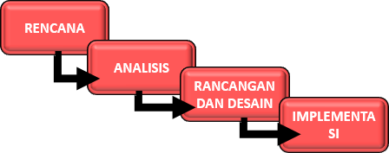

**Figure 1**. The flow of research procedures

In Figure 1. Explaining flow research procedures on System Implementation Smart Smart Rice Fields Based fuzzy logic, from plan to analysis to design and design to implementation.

1. Results and Discussion
2. Plan / Planning

The plan or plan is The first step in researching By collecting data and observing farmers in monitoring rice fields. The plan will be made of a product. Design Smart Rice Fields Using Wemos D1 R1 Based Website, by implementing Fuzzy logic into the system of the product aforementioned.

1. Analysis

The analysis contains the initial steps of data collection, drafting of the creation of Smart Rice Field Design products Using Wemos D1 R1 Based Website, as well as data analysis and Record any hardware and software Which will be used in the manufacture this system. Data obtained by research from an existing journal.

1. Design

System planning is a stage. development after system analysis Done. Design Smart Rice Fields Using Wemos D1 R1 Based Websites use flowchart for flow tool work. This plan will Require software and logic methods. Fuzzy will be used to give commands to the system.

1. Implementation

The results of this study will be tested. Try in real-time to assess how many good products Design Smart Sawah Using Wemos D1 R1 Based The website, which has been created as well. correct when there is an error That's what happened. Then the results of the test Try it will be implemented.

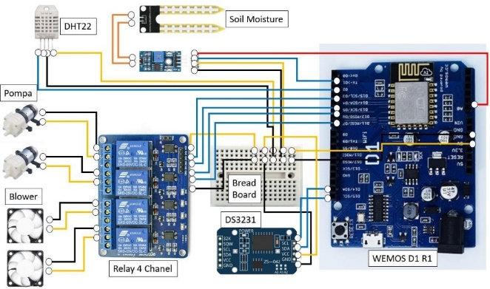

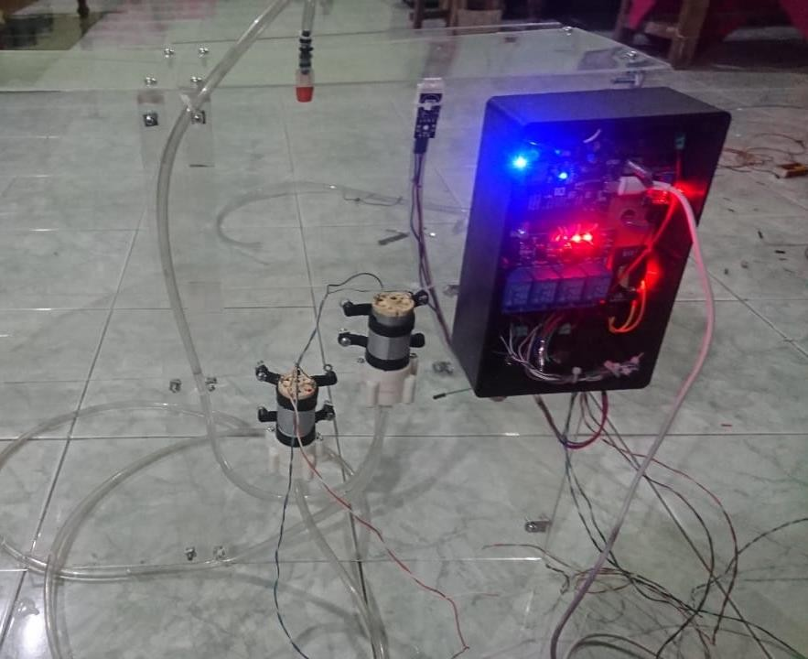

**Figure 2** Soil Sensor, DHT 22 On Prototype

The component box contains a 4 channel relay, wemos D1R1, RTC module, 12V DC Adapter Connector, and 12V DC Pump. The use of soil moisture sensors to find out the humidity level, while for DHT 22 to find out the humidity level and temperature in the prototype design.

1. Fuzzy Tsukamoto Implementation (Manual Calculation)

This implementation will continue the previous step in chapter 4. After establishing fuzzy variables, fuzzy sets, membership functions, and fuzzy rule bases, the next step is to determine the values a and z in the fuzzy inference system to determine the result of the value in the defuzzification step. As for the explanation of the steps of the workmanship as follows:

For example here will calculate inference from the soil moisture variable.

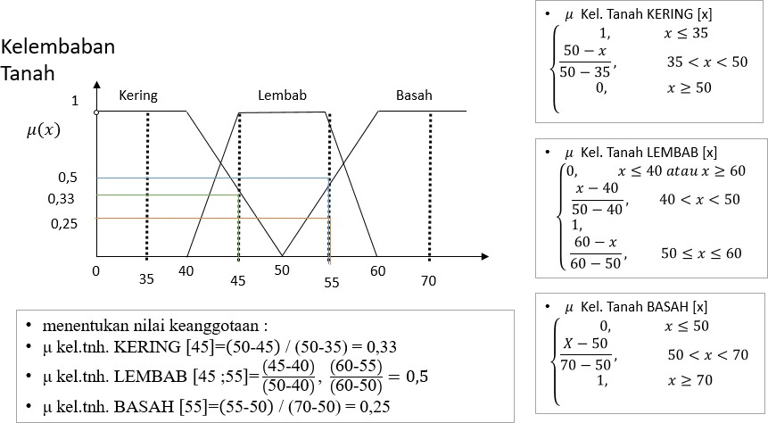

**Figure 3** Variable Inference of Soil Moisture is a step in determining the membership value in each

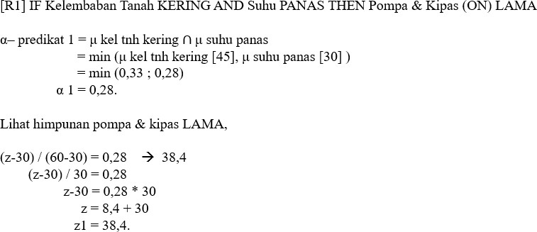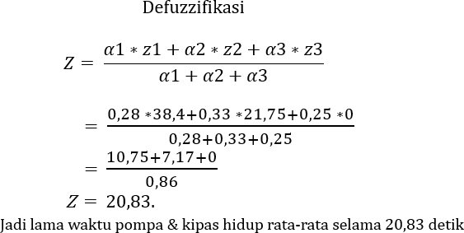soil moisture set based on the formula, as well as apply to determine the membership value of other variables. Then next is the step to determine the value of α and z, using the MIN function, by taking each rule base as a reference for its formulation. For example, it will choose the rule base/rule to 1 [R1].

1. The inference rule base b. defuzzification

**Figure 4** The inference rule base is the step of determining the values α1 and z1, by adding the MIN function to determine the lowest α value and determining the value z by using the pump and fan set formula. And the determination of the value applies also to other base rules. Then the next step is to determine the defuzzification value of each α and z value that has been obtained.

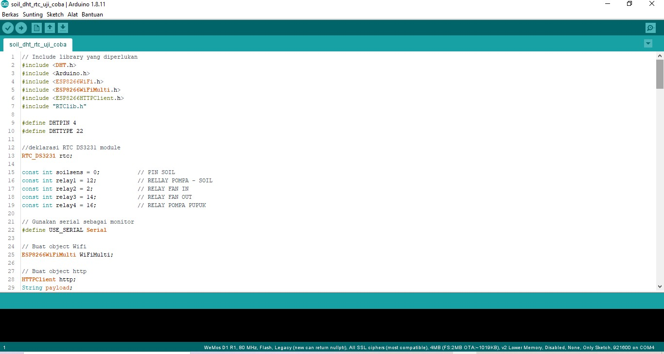Software implementation This requires software to manage the program code used This system is an Arduino application. IDEA. As for the explanation of the steps Code the program as follows :

**Figure 5** Fuzzy Logic Coding display on Arduino IDE, contains sensor/microcontroller library, input pin definition, declaration of connecting commands and transmission of sensor data to the database using an ESP8266 module, and implementation of fuzzy rule base on looping if else in void loop(), to the determination of fertilization schedule.

(a) (b) (c)



**Figure 6**, In figure (a), contains a page monitoring on smart information system which displays the temperature data. Image (b) contains a monitoring page on the smart information system of the rice field that displays soil moisture data. In image (c) Load the monitoring page on the smart information system of the rice field that displays air humidity data.

**Test Results**

At this stage of testing is something that is done to determine the results of the system created, whether the software is running properly and smoothly, has no error problems on the system, and is as expected or not.

Table Smart Rice Field Smart System Testing Results

|  |  |  |  |  |
| --- | --- | --- | --- | --- |
| No | Kind  Testing | Testing Criteria | Result  Testing | Information |
| 1. | *Rule base [R1]* | If the soil moisture value is dry and the temperature is hot, then the pump and fan live for a long time between 30-60 seconds | Pumps and fans live for a long time | Succeed |
| 2. | *Rule base [R2]* | If the soil moisture value is moist and the temperature is normal, then the pump and live fans in a fast time between 0-30 seconds | Pumps and fans live in quick time | Succeed |
| 3. | *Rule base [R3]* | When the soil moisture value is wet and the temperature is cold, then the pump and fan die | Pumps and fans off | Succeed |
| 4. | Fertilization scheduling | First set the scheduling time, and when the time has come, then the pump is on in 10 second | The pump lives on at the specified time | Successful delay time difference of 30 seconds |

1. Conclusion

Based on the results of research, analysis, design, and implementation of the system that has been done, and based on the formulation and limitations of existing problems, it can be taken several conclusions including the following:

1. Implementation of fuzzy logic in the design of smart rice fields based on the website is useful as an automatic controller that can do watering, fertilization automatically based on the rules made. System implementation is applied to software called Arduino IDE that can send commands to each sensor and microcontroller.

2. From the test results, the system is successful and able to work according to soil moisture conditions and temperature based on the rules made.

**References**

1. R. A. GHANI, “Kajian Agihan C Organik Tanah Pada Budidaya Tanaman Padi Sawah di Kecamatan Sokaraja Kabupaten Banyumas.” Universitas Jenderal Soedirman, 2019.
2. R. Noviandy, R. R. Yacoub, and E. D. Marindani, “SISTEM PENGENDALIAN KELEMBABAN PADA BUDIDAYA TANAMAN SAWI,” J. Tek. Elektro Univ. Tanjungpura, vol. 2, no. 1.
3. N. Firmawati, “Rancang Bangun Sistem Penyemprot Tanaman Otomatis Berdasarkan Waktu dengan Real Time Clock (RTC) dan Ultrasonik Serta Notifikasi Via SMS,” J. ILMU Fis. Univ. ANDALAS, vol. 11, no. 2, pp. 62– 71, 2019.
4. H. S. Utama, “RANCANG BANGUN ALAT PEMBERIAN PUPUK CAIR BIBIT MELON OTOMATIS DENGAN SISTEM PENJADWALAN MENGGUNAKAN ARDUINO SEVERINO DAN SOLENOID VALVE,” pp. 1–7, 2016.
5. R. Boki, S. Statiswaty, and S. Subardin, “Sistem Pendukung Keputusan Penentuan Calon Guru Berprestasi Menggunakan Metode Fuzzy Tsukamoto ‘Studi Kasus: SMP Negeri 5 Kendari,’” semanTIK, vol. 2, no. 2, 2016
6. S. Kusumadewi, Artificial Intelligence (Teknik dan Aplikasinya). Graha Ilmu, 2003
7. A. Suryadi, “Perancangan aplikasi game edukasi menggunakan model waterfall,” J. Petik, vol. 3, no. 1, pp. 8–13, 2017.
8. Wijayanto, Rizky and Hermawan, Arif (2018) *SISTEM PENGENDALI IRIGASI PERTANIAN DESA NGUKEN BERBASIS WIRELESS.* Tugas Akhir thesis, University of Technology Yogyakarta.
9. AHMAD NIF’AN, 11111100111 (2016) PURWARUPA KENDALI KANAL IRIGASI SAWAH TERJADWAL BERBASIS MIKROKONTROLER ATMEGA328. Prodi. Teknik Informatika, Fakultas Teknik Universitas PGRI Yogyakarta.
10. AHMAD NIF’AN, 11111100111 (2016) *PURWARUPA KENDALI KANAL IRIGASI SAWAH TERJADWAL BERBASIS MIKROKONTROLER ATMEGA328.* Prodi. Teknik Informatika, Fakultas Teknik Universitas PGRI Yogyakarta.