**MANAGEMENT**

**GUEST PERSPECTIVE OF MANAGEMENT PERFORMANCE ON BUDGET HOTEL AT SHAH ALAM MALAYSIA**

**Ahmad Pitra1, Ahmad Al-battat1, Revita Desi2, Agnemas Yusuf2**

***1 : Management & Science University,*** *University Drive, Off Persiaran Olahraga, Section 13, 40100 Shah Alam, Selangor Darul Ehsan, Malaysia*

***2 : Jakarta Global University,*** *Jl. Boulevard Grand Depok City, Tirtajaya, Kec. Sukmajaya, Kota Depok, Jawa Barat 16412, Indonesia*

**Abstract**

In the current economic, the nation’s tourism industry recorded a positive tourist arrivals growth of **+4.8%** for the January-May 2019 period, registering a total of **10,954,014** tourist arrivals compared to **10,454,447** in the same period last year (*Tourism Malaysia*). Shah Alam is part of the good destination in Malaysia, in this place more than 184 hotels ready to stay. Therefore, businesses must always consider competitive strategies in maintaining customer satisfaction in order to create customer loyalty. Consistency in quality service, cost, Restaurant, room Design, Public Area have a significant positive correlation with Guest satisfaction. The purpose of this paper is to propose a conceptual model of the factors that influence the Guest Satisfaction of "budget hotel’’ in Shah Alam, Malaysia, which was built based on extensive review of journals marketing and existing theories. This article provides two benefits: first, the theory expands knowledge and strengthens understanding of the factors that influence Guest Satisfaction. Second, contributions to managerial concepts, papers this is to be a resource for decision makers in maintaining the sustainability of their hotel business.

Keyword : Guest Perspective, Hotel Budget

1. **Introduction**

According by UNWTO 2012, Foreign tourist arrivals (tourists) around the world through the 1.035 billion, is an increase of 4.0% from the previous year. Southeast Asia received 80.4 million foreign tourists visiting with 7% growth per year (Arrivals, 2013). Malaysia in 2009 received a visit of 23.6 million foreign tourists with a total income of 16.7 billion dollars equal to Rp 225.45 trillion or equivalent to 10.2% of Malaysian GDP (Ooi, Hooy, & Som, 2013).

To meet the needs of hotel for foreign tourists whose numbers continue to increase each year, the number of hotels also continues to grow-up. The hotel industry is also following the changing need for hotel in the global community. The development of hospitality when viewed historically, in the era of the 1660 ago, hotel visitors have the perspective that the service must be with luxury in room facilities, a good swimming pool and restaurant / cafe with luxury food. At that time five-star hotels such as Hilton and Wilson were built to answer the need for luxury lodging at the time (Jayawardena, 2013). The growth of hotels in Asia including Malaysia for both business and leisure has also increased rapidly. The Asian hotel approach changed from an emphasis on luxury aspects to an emphasis on "technology" and "human intensive" and most importantly on the human intensive aspect was the price of the room (Lim & Kimes, 2012). Some hotel visitors now tend not to be solely interested in luxury or star classification, but rather prioritize the need for standard overnight services and entertainment while traveling.

Global Recognition Timeline, Malaysia are proud of many achievements. Tourism Malaysia and its many iterations over the years have received many awards and recognition. Malaysia proudest moments:

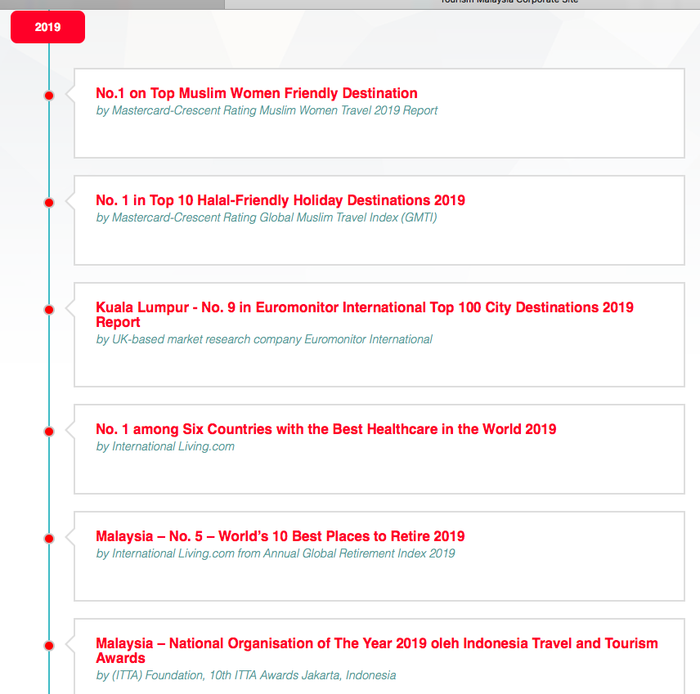  
Tourism Malaysia

Above six achievement, that has supported by the hotel services. It is not only coming from hotel four star or Five-star hotel, but it includes budget hotel. Furthermore, in every management hotel has targeted that guest will be satisfied during stay in hotel itself even in budget hotel. According by Ahmad Al-Battat 2018, factor guest satisfied is looking of Room Design, Restaurant, Public area, cost as well as service quality by the officer. Throughout this journal will be expand knowledge about budget hotel by the perspective guest based on visitor to have stayed at the budget hotel.

According by Karina Dwi Kusumastuty 2018, a budget hotel is a hotel without restaurant or banquet facilities, with the services and facilities offered for this hotel fairly simple. But in the past 10 years, services and facilities have evolved, and currently types of budget hotel facilities can include business centers, fitness rooms, guest laundry facilities, pantry kitchens, indoor or outdoor pools and whirl pools, and small meeting rooms. Budget hotels are increasingly trending due to high occupancy. Besides being practical and efficient, this hotel does not require a lot of high maintenance costs for swimming pools and ballrooms, which are usually charged to consumers in the room rate.

**2. Literature Review**

2.1 Room Design

The room design consists of sleeping rooms for guests stay overnight, equipped with facilities for bedrooms, toilets, corridors, elevators, and other equipment. Hotels as a business service industry and serve guests in the form of goods and services. In terms of appearance, the hotel industry product consists of two parts, as follow: (Abdul Wahid 2018)

a. Tangible Product: Hotel products that can be clearly seen, touched, or directly seen in the form of objects, such as bedrooms, food, drinks, etc. inside of the room. some of the hotel that are not focus what guest need during stay at hotel, it is basic should be provided in the room such as Drinking water, towel, Qiblat position as well as prayer mates. Hereinafter, some of the budget hotel that are not provided space for pray in the room. as Malaysia is Muslim country the basic of Tangible should be prepared for guest.

b. Intangible Product: Hotel products that are not clearly visible, but very influential on the value or quality of Tangible products, for example ambience, tranquility, tranquility, cleanliness, etc.

2.2 Menu restaurant

Increasing competition for consumer satisfaction as its main goal. No exception in culinary businesses that start from small scale such as stalls and cafe tents of medium-scale food businesses such as restaurants and cafes to large-scale food businesses such as restaurants in star hotels. The restaurant business is currently one of the most popular businesses. This can be proven from the many new restaurants that have sprung up in recent years. Each restaurant tries to accentuate their uniqueness, both in the style of presentation and in the menu provided. As budget hotel, the management can be proposing the simple breakfast, lunch and dinner for the guest with lower price. The restaurant more help for guest staying in hotel, sometimes the guest didn’t have time to go out for buying the food (Tjiptono dalam Sari, 2012)

2.3 Public Area

Public areas are the common places and facilitates accessible to in house guest and non-resident guest. Guest requires common areas to meet, sit and carry other activities. The place comes under the are lobby, restaurants, bars, banquets, and other Food and Beverage Outlets. Public area cleaning is the most important and challenging task for hotel / hospitality housekeeping. According by BNG Hotel management, Public area consist of:

1. Entrance– Guest get their 1st impression of hotel from the entrance lobby. Entrances which are not cleaned and maintained daily, it will become unpleasant for the guest due to heavy traffic and exposure. The maintenance and cleaning of the entrance and the door is important. So proper and daily cleaning is required in this area.

2. Lobbies- These are the common meeting points of the guest near the reception. Many lobbies are carpeted while others are hard flooring. Floors in the lobbies need to be cleaned frequently., since these are spaces where guest interact., relax etc.

3. Front office- Housekeeping department is responsible for this Public area cleaning and maintaining of front office because front office is the face of the hotel. So daily cleaning of the department is required. Mopping of the floor, dusting of the furniture and fixture and vacuuming of carpets are essentials.

4. Elevators- Elevators must be cleaned at the time of day when it is least used. The necessary boards indicating the cleaning is carried out must be displayed promptly. Elevators doors are made of steel. In steel door shows lots of grease marks from finger easily.

5. Stair case- Stair case should be cleaned when there is less traffic. While cleaning of staircase care should be taken that dart and dust do not fall down words.

6. Guest corridors- While cleaning of the corridors necessary boards indicating the public area cleaning is carried on must be displayed prominently. Carpets in the corridors should be vacuumed daily.

2.4 Cost

The purpose of Budget Hotels is to provide standard accommodation at affordable prices. The main difference between luxury hotels and budget hotels is the intensity of contact between staff and guests. Budget hotels are only done when checking in and checking out so staff costs can be minimized. Hotels like this are sought after by business travelers, who are increasingly numerous in Indonesia. Budget hotels are also sought after by both domestic and foreign tourists. And if seen from the essence of the hotel itself is offering a comfortable stay for guests with a variety of facilities and rooms that are quite spacious. However, budget hotels have less spacious rooms and also limited service, including facilities and staff numbers. It is necessary to organize a good space to create an efficient design so that it still considers the comfort of guests despite having limited facilities and the number of staffs. (Karina Dwi Kusumastuty 2018)

1. **Research Methodology**

Total of sample for this journal is 100 respondents that have been collected. The data collected it was organised and analysed by a computer programme called Stastical Package for Social Science (SPSS) was used. Data was analysed by using descriptive statistic. Frequency tables were drawn and from these the data was presented in pie diagrams and bar graphs.

1. **Finding** 
   1. **Respondent Profile**

|  |  |  |  |  |
| --- | --- | --- | --- | --- |
| Items | | Frequency | Percent | Cumulative Percent |
| **Gender** | Male | 44 | 44 | 49.3 |
| Female | 56 | 56 | 100.0 |
| **Language** | Malay | 53 | 53 | 53.6 |
| English | 29 | 29 | 81.2 |
| Mandarin | 18 | 18 | 91.3 |
| **Level of Education** | No formal education | 4 | 4 | 5.8 |
| High school or equivalent | 23 | 23 | 24.6 |
| Vocational /technical school | 9 | 9 | 36.2 |
| College | 33 | 33 | 69.6 |
| Bachelor's degree | 27 | 27 | 94.2 |
| Master's degree | 2 | 2 | 97.1 |
| Professional degree (MD,JD,ETC) | 1 | 1 | 98.6 |
| Others | 1 | 1 | 100.0 |
| **Marital Status** | Single | 51 | 51 | 59.4 |
| Married | 33 | 33 | 92.8 |
| Divorced | 14 | 14 | 98.6 |
| Widowed | 2 | 2 | 100.0 |

*Table 1.1 Respondents Profile*

* 1. **Room Design**

***Pie 1.1 Room Design***

The pie chart above showed that room design in the budget hotel in Shah Alam is satisfied with total of *Good Average* is 46% as well as *Excellent* 36%. From this research that are only one respondent not satisfied from 100 respondents.

* 1. **Menu Restaurant**

***Pie 1.2 Menu Restaurant***

According by Tjiptono Sari, 2012 ‘’ *Increasing competition for consumer satisfaction as its main goal. No exception in culinary businesses that start from small scale such as stalls and cafe tents of medium-scale food businesses such as restaurants and cafes to large-scale food businesses such as restaurants in budget hotels.’’*

Based on the above statement, budget hotel in Shah Alam still facing this issue because it is so many budget hotels not provide for the food & Beverage. Furthermore, result from the respondent 4% is *Poor* as well as 7% is *Below Average*.

* 1. **Public Area**

***Pie 1.3 Public Area***

According by BNG Hotel management, *‘’Public area cleaning is the most important and challenging task for hotel / hospitality housekeeping’’.*  Hotel budget in Shah Alam is very ood to maintain the cleaning, based on the result that *Average* is 14%, *Good Average* is 57%, and *Excellent* is 28%. The statement from BNG Hotel Management is answered by this result that Hotel budget in Shah Alam has good keep Cleaning by the Housekeeping department.

* 1. **Cost**

***Pie 1.4 Cost***

According by Karina Dwi Kusumastuty 2018, *‘’ The purpose of Budget Hotels is to provide standard accommodation at affordable prices.’’* The price for the budget hotels in Shah Alam is really cheap based on feedback from respondents. Furthermore, the result is to answer statement from Karina Dwi Kusumastuty 2018.

1. **Conclusion**

This research report will be able to improve existing theories and practices in relation to that factors that influence guest satisfaction. Thus, improve work performance of the employees within an organization, particularly into the hospitality and hotel industry. All the variable above is the Influencing guest satisfaction from budget hotel. Through this journal, Management from budget hotel highest possibility to propose some simple restaurant (Food & Beverage) to increase valuable rating of the hotel. Beside of that, the company can get additional income from restaurant itself.

**Reference**

1. Ahmad Al-battat (2019). I*ntroducing the Practices of Shariah-Compliant Hotel (Sch) In Shah Alam.* ISSN(e): 2411-9458, ISSN(p): 2413-6670Vol. 5, Issue. 4, pp: 990-998, 2019URL: <https://arpgweb.com/journal/journal/7D>
2. BNG Hotel management 2018, [*https://www.bngkolkata.com/public-area-cleaning/*](https://www.bngkolkata.com/public-area-cleaning/)
3. Jayawardena, C. (Chandi). (2013). *Trends in the international hotel industry. Worldwide Hospitality and Tourism Themes,* 5(2), 151–163. <http://doi.org/10.1108/17554211311314100>
4. Karina Dwi Kusumastuty 2018. [*http://eprints.undip.ac.id/42182/1/Document1.pdf*](http://eprints.undip.ac.id/42182/1/Document1.pdf)
5. Lim, L. K. S., & Kimes, S. E. (2012). *Technology- and human-intensiveness in room ratesetting: A study of four styles among Asia-Pacific hotels. Journal of Revenue and Pricing Management.* <http://doi.org/10.1057/rpm.2012.29>
6. Ooi, C. A., Hooy, C. W., & Som, A. P. M. (2013). *Tourism crises and state level tourism demand in Malaysia. International Journal of Business and Society*, 14(3), 376–389.  
   Tjiptono dalam Sari, 2014. Praktik Riset Perilaku Konsumen. CAPS (Center Of Academic Publishing Service. Jl. Cempaka Putih No 8 Yogyaka
7. Tourism Malaysia 2019. *https://www.tourism.gov.my/global-recognitions/2019*