Use of Psidium guajava and Citrus aurantifolia as Peel-Off Masks

Rosaria Ika Pratiwi1 Wilda Amananti2

1Pharmacy Study Program, Politeknik Harapan Bersama, Mataram Street, Tegal, Jawa Tengah, Indonesia

*Corresponding author : [rosariaikapratiwi45@gmail.com](mailto:rosariaikapratiwi45@gmail.com)

**Abstract.** Peel-off masks have been developed as a face care cosmetic preparation in liquid form. Guava fruit (Psidium guajava) contains flavonoids that are effective in removing acne and clearing blackheads. Lime (Citrus aurantifolia) contains flavonoids used as a skin rejuvenator. This study aims to identify the flavonoid compounds contained in guava (Psidium guajava) and lime (Citrus aurantifolia) and the best concentration as a peel-off mask preparation. The research design made three peel-off mask formulas, each formula carried out three replications, statistical analysis using one-way ANOVA. Comparison of lime and guava in formula I (5%:9%), formula II (7%:7%), formula III (9%:5%), while the additives have the same concentration. Based on the research results, guava and lime contain flavonoid compounds which are indicated by the formation of an orange-red colored solution through the addition of concentrated ethanol, concentrated HCl, and magnesium. The formula I, II, and III have a pH of 5, the density of formula I (1.033 g/ml), formula II (1.031 g/ml), and formula III (1.030 g/ml). The viscosity of formula I (1,723 cP), formula II (1,311 cP), and formula III (1,292 cP). The homogeneity test on formulas I, II, and III was homogeneous and there was no precipitate. It was concluded that guava and lime contain flavonoid compounds, and the best concentration as a peel-off mask preparation was formula II.

**Keywords** : Psidium guajava; Citrus aurantifolia; Peel-Off Masks

1. Introduction

Masker Peel-off masks have been developed as a topical application of facial and neck care cosmetics [1]. Peel-off is applied to form a thin elastic layer [2], used for 15-20 minutes even some peel-off masks are used overnight for better results [3]. The active substances and additives in the mask can penetrate the skin and supply the needed substances in a short time [4]. Peel-off functions to clean, moisturize, shrink pores and remove dead skin cells deposited in the stratum corneous so that the skin becomes more elastic [5]. Peel-off is useful for removing blackheads, tightening the skin, relaxing facial muscles, preventing wrinkles, and as a refresher [6].

Skin is the outermost covering of the human body that protects it from environmental influences. Some indications of aging on the skin include wrinkles, black spots on the face, dry skin, and loss of fat, resulting in the skin losing its smoothness [7]. All of these symptoms require treatment to slow the loss of natural collagen [8]. The ability of the skin to repair itself continues to decline and collagen will decrease so that the skin loses its elasticity [9]. Treatment using antioxidants is a strategy to prevent premature aging. Polyphenol compounds are one of the most anti-aging substances because they can prevent oxidation reactions on the skin [10]. Antioxidants are commonly used in skin care products to protect the skin from free radicals [11].

Natural sources of plants have been used for centuries in Indonesia to treat various health problems. Currently, one of the plants that are widely cultivated as phytopharmaceutical is guava (Psidium guajava) [12]. Guava plants (Psidium guajava) are widely distributed throughout the world, especially in tropical countries, including Indonesia [13]. This plant has biological activities including antidiarrheal, antimicrobial, antioxidant, hepatoprotective, anti-allergic, antispasmodic, anti-diabetic, anti-inflammatory, and antitussive [14]. Guava fruit contains nutrients, vitamins, and antioxidant compounds [15], while guava leaves contain flavonoids, alkaloids, triterpenoids, tannins, and essential oils [16]. The flavonoids and essential oils contained in the guava plant have antimicrobial properties so that they can be used as anti-acne [17].

Citrus plants are grown all over the world and the plant is consumed as fresh fruit, but in some countries such as Brazil and the United States parts of the plant are marketed in the form of concentrated juice or through the pasteurization process [18]. Lime fruit (Citrus aurantifolia) is used for lemonade, mixed drinks, bottled juices, and carbonated drinks. Lime fruit is also used as a flavoring and cosmetic preparation [19]. This fruit contains potassium, iron, phosphorus, calcium, vitamin C, niacin, riboflavin, B2, thiamin, B1, vitamin A, crude fiber, carbohydrates, fat, and protein [20]. The skin of the fruit contains essential oils which are used in the perfume chemical industry, while in the health sector it is used as an antioxidant [21]. Orange juice contains saponins and flavonoids, namely hesperidin (hesperetin 7-rutinoside), tangeretin, naringin, eriocitrin, and eriocitrocide [22]. Lime fruit is generally used by industry to produce lime juice and lime powder [23].

This study combines guava and lime fruit to obtain an optimal therapeutic effect as a peel-off preparation used for facial treatments. The purpose of this study was to identify the flavonoid compounds contained in guava (Psidium guajava) and lime (Citrus aurantifolia) and the best concentration as a peel-off mask preparation.

1. Materials and Methods
   1. *Materials*

The materials used are guava fruit, lime fruit, propylene glycol, nipagin, nipasol, aquadest, 96% ethanol, magnesium, concentrated HCl, pH paper.

* 1. *Study Design*

Experimental research design made three peel-off mask formulas, each formula three replications. This study consisted of three stages, namely the first stage of identification of flavonoids in guava and lime juice, the second stage of making peel-off mask preparations, and the third stage of evaluating pH, specific gravity, viscosity, and homogeneity of peel-off masks.

1. Identification of flavonoids

0.5 g of the sample was added with 10 ml of aquadest then heated, filtered, and 1 ml of the filtrate was taken, then added with 1 ml of 96% ethanol, 0.1 g of magnesium, and 10 ml of concentrated HCl. Flavonoids in guava and lime are indicated by the formation of orange to red color [24].

1. Making Peel-Off Masks

Nipagin and nipasol were added with 2 drops of 96% ethanol, added propylene glycol, and stirred continuously until dissolved. The juice of the guava fruit is added little by little, the juice of the lime, and aquadest is added to a volume of 30 ml.

1. Evaluation
2. pH

Take a sample of a peel-off mask, put it on litmus paper, observe the color change that occurs, the color is compared with the indicator.

1. Density

The clean and dry pycnometer was weighed, the sample was put in the pycnometer at a temperature of 25°C, allowed to stand until a temperature of 20°C, the temperature was set back to 25°C. Weigh the pycnometer and peel-off mask sample, record the weighing results and calculate the density.

c. Viscosity

The peel-off mask sample was inserted by a viscometer to the specified limit, pulled the sample using filler to the upper limit, calculated the time required for the sample to drop to the lower limit using a stopwatch, and calculated the peel-off mask viscosity.

d. Homogeneity

The peel-off mask was put in a 10 ml test tube and observed using a sodium lamp and a black cloth background. The test is carried out by observing the preparation including particles or deposits in the preparation made. If there are no solid particles or deposits, the preparation is said to be homogeneous.

* 1. *Statistical Analysis*

The measurement of the significant difference between the formula or the concentration of guava and lime juice with different densities and viscosity was carried out by using one-way ANOVA statistical analysis.

1. Results and Discussion
   1. *Identification of flavonoids*

The results of the screening test showed that guava and lime fruit contained flavonoid secondary metabolites (Table 1).

Table 1. Phytochemical Screening of Guava and Lime Fruit Flavonoids

|  |  |  |  |
| --- | --- | --- | --- |
| **Fruit Type** | **Reagent** | **Color Change** | **Results** |
| Guava | 0.5 g sample + 10 ml aquadest + heat + filter and take 1 ml filtrate + 1 ml 96% ethanol + 0.1 g magnesium + 10 ml concentrated HCl | Orange - Red | (+) Flavonoids |
| Lime Fruit | 0.5 g sample + 10 ml aquadest + heat + filter and take 1 ml filtrate + 1 ml 96% ethanol + 0.1 g magnesium + 10 ml concentrated HCl | Orange – Red | (+) Flavonoids |

The flavonoid test used the Wilstater method by adding concentrations of Mg and HCl into the sample. The addition of HCl aims to hydrolyze flavonoids into aglycones through the hydrolysis of O-glycosyl. The glycosyl is replaced by H+ from the acid due to its electrophilic nature. Reduction with concentrated Mg and HCl produces orange or red-colored complex compounds which are flavonoid derivatives including flavonols, flavanones, flavanonols, and xanthones. Flavonoids are phenolic compounds widely distributed in plants and have pharmacological properties such as antimicrobial and exogenous antioxidants [25][26].

*3.2. Making Peel-Off Masks*

The characterization of peel-off masks is shown (Table 2):

Table 2. Peel-Off Mask Characterization

|  |  |  |  |  |  |
| --- | --- | --- | --- | --- | --- |
| **Component** | **Concentration (%)** | | | | |
| **Formula** | | | **Standard** | **Literature** |
| **I** | **II** | **III** |
| Guava juice (*Psidium guajava*) | 9 | 7 | 5 | - | - |
| Lime juice (*Citrus aurantifolia*) | 5 | 7 | 9 | - | - |
| Propilenglikol | 12 | 12 | 12 | <15 | [27] |
| Nipagin | 0,2 | 0,2 | 0,2 | 0,02-0,3 | [27] |
| Nipasol | 0,05 | 0,05 | 0,05 | 0,01-0,06 | [27] |
| Aquadest | Ad 30 ml | Ad 30 ml | Ad 30 ml | - |  |

The three formulas had the same concentration of propylene glycol, nipagin, and nipasol, but the concentrations of the active substances from guava and lime juice were different in each formula.

* 1. *Evaluation*

1. pH Test

Table 3. pH Test

|  |  |
| --- | --- |
| **Formula** | **pH** |
| I | 5 |
| II | 5 |
| III | 5 |

The pH test results showed that the different concentrations in the three formulas had a constant pH of 5 and had met the skin pH requirements. The pH of topical preparations should be in the skin pH range of 4.5 – 6.5, this is due to avoid skin irritation [28]. The more acidic or alkaline a substance is, the greater the damage caused to the skin, such as dry skin, cracks, sensitive skin, and easy infection [29]. The pH of the preparation can change during storage, this is because the carbohydrates contained in the preparation can be digested by microorganisms so that it will undergo a complex reaction so that it will form alcohol and carbon dioxide [30].

1. Density

Table 4. Density Test

|  |  |
| --- | --- |
| **Formula** | **Density (g/ml)** |
| I | 1,033 |
| II | 1,031 |
| III | 1,030 |

The results of the density test showed that formula I had the highest density (1.033), followed by formula II (1.031), and formula III (1.030). This density is influenced by the atomic mass of a compound such as water, glycerin, bio-resin ratio, temperature, and time [31]. Formula I concentration of guava juice is higher than lime juice, guava contains essential oils, resins, and oxalic acid compounds, besides the content of vitamin C, pectin, and fiber is higher than lime [32]. resulted in the density of formula I being higher than that of formulas II and III.

Table 5. Peel-Off Mask Density ANOVA Test

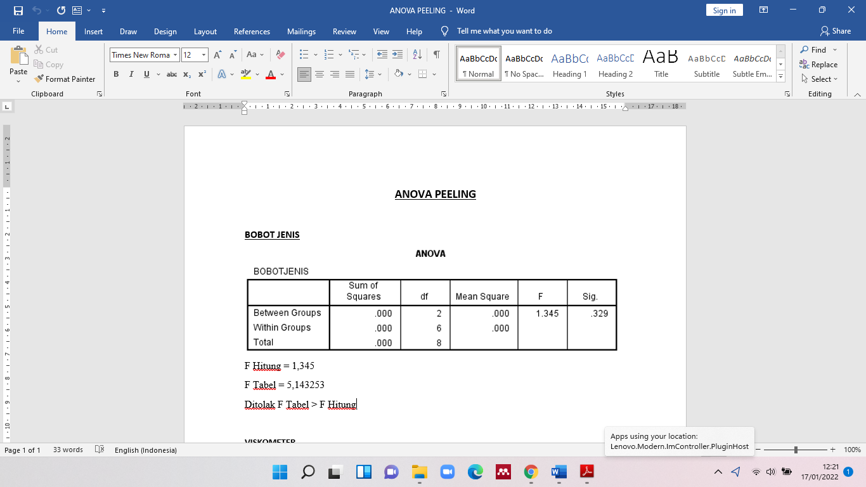

The results of the ANOVA test showed that the different concentrations of guava and lime juice did not affected the density of the peel-off mask preparation with a significance value of p = 0.329 (p>0.05).

1. Viscosity

Table 6. Viscosity Test

|  |  |
| --- | --- |
| **Formula** | **Viscosity (cP)** |
| I | 1,723 |
| II | 1,311 |
| III | 1,292 |

The results of the viscosity test showed that formula I had the highest viscosity (1,723 cP), followed by formula II (1,311 cP), and formula III (1,292). Guava contains a lot of carbohydrates, in water carbohydrates will form a gel through a helical structure due to hydrogen and ionic bonds so that there is an increase in viscosity. The viscosity of a liquid is a measure of its resistance to flow, the higher the viscosity the greater the resistance [33]. Formula I concentration of guava juice is higher than lime juice, so the higher the increase in gelling agent which causes the viscosity of the preparation to increase [34] and it is increasingly difficult to pour from the container. Formula II concentration of guava juice is the same as lime juice so it has a lower viscosity which makes the preparation easier to pour from the container. Formula III concentration of guava juice is lower than lime juice so it has the lowest viscosity which makes the preparation very runny. The best formula in this peel-off mask preparation is formula II which has ideal viscosity with the same concentration of guava and lime juice.

Table 7. Peel-Off Mask Density ANOVA Test

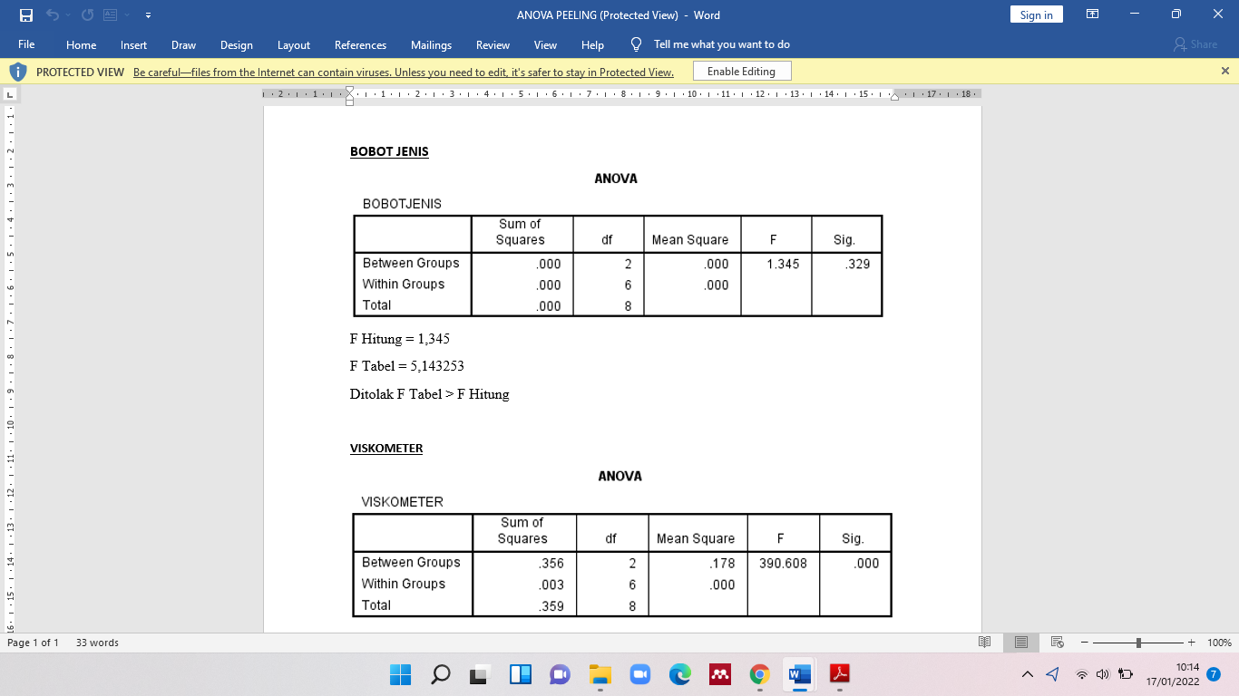

The results of the ANOVA test showed that the different concentrations of guava and lime juice affected the viscosity of the peel-off mask preparation with a significance value of p = 0.00 (p<0.05).

1. Homogeneity

Table 8. Peel-Off Mask Homogeneity

|  |  |
| --- | --- |
| **Formula** | **Homogeneity** |
| I | Homogeneous and no sediment |
| II | Homogeneous and no sediment |
| III | Homogeneous and no sediment |

The results of the homogeneity test showed that the three peel-off mask formulas were homogeneous and there were no deposits or particles so that they met the product requirements.

1. **Conclusion**

Based on the research results, guava fruit (Psidium guajava) and lime (Citrus aurantifolia) contain flavonoid compounds, and the best concentration as a peel-off mask preparation is formula II.

1. Acknowledgment

The author would like to thank the Pharmacy Study Program which has provided the facilities, equipment, and chemicals needed, laboratory staff, and LPPM Harapan Bersama Polytechnic which has provided funding.

**References**

[1] Yeom G, Yun DM, Kang YW, Kwon JS, Kang IO, and Kim SY. 2010. Clinical Efficacy of Facial Masks Containing Yoghurt and Opuntia HumifusaRaf.(F-YOP). *J Cosmet Science*. **5** L505

[2] Rahmawanty D, Yulianti N, and Fitriana M. 2015. Formulation and Evaluation the Peel-Off Face Mask Contains Quercetin with Variations Concentrations of Gelatin and Glycerin. *Med Farm*. **12** L17

[3]Budiman A, Aulifa DL, Kusuma ASW, Kurniawan IS, and Sulastri A. 2017. Peel-off gel Formulation from Black Mulberries (*Morus nigra*) Extract as Anti-Acne Mask. *National Journal of Physiology, Pharmacy and Pharmacology*. **7** L987

[4] Kulkarni SV, Gupta A, and Bhawsar S. 2019. Formulation and Evaluation of Activated Charcoal Peel Off -Mask *International Journal of Pharmacy Research & Technology*. **9** L44

[5] Grace F, Dariska C, Sowmya KV, Suganya K, and Shanmuganathan S. 2015. Preparation and Evaluation of Herbal Peel-Off Face Mask. *Am J PharmTech*. **4** L333.

[6] Vieira RP, Fernandes AR, Kaneko TM, Consiglieri VO, Pinto CA, and Pereira CS. 2009. Physical and Physicochemical Stability Evaluation of Cosmetic Formulations Containing Soybean Extract Fermented by *Bifidobacterium animalis*. *Braz J Pharm Sci*. **3** L515.

[7] Melfa F, Siragusa D, Caruso D, Lo Faro C, Nicoletti GF, and Rauso R. 2020. At-home Cosmeceutical Application and Outpatient Treatments: A 3D Stepwise Facial Rejuvenation Approach*. Maced J Med* *Sci*. **8** L1041

[8] Syakri S, Ismail I, Amal NM, Masjidi NA, and Tahir KA. 2021. Characterization and Anti-aging Tests of Peel-Off Gel Masks Made from Ethanolic Extract of Yarrow (*Achillea millefolium*). *Macedonian Journal of Medical Sciences*. **9** L1156

[9] Cadet J, Douki T, Pouget JP, Ravanat JL, and Sauvaigo S. 2001. Effects of UV and Visible Radiations on Cellular DNA. *Curr Probl Dermatol*. **29** L62

[10] Shanbhag S, Nayak A, Narayan R, and Nayak UY. 2019. Anti-Aging and Sunscreens: Paradigm Shift in Cosmetics. *Adv Pharm Bull*. **9** L348

[11] Ginting M, Fitri K, Leny L, and Lubis BK. 2020. Clay Mask Formulation and Anti Aging Effectiveness from Ethanol Extract of Yellow Potato (*Solanum tuberosum* L.). *J Dunia Farm*. **4** L68

[12] Nugraha ASPA and Keller. 2011. Revealing Indigenous Indonesian Traditional Medicine: Anti-Infective Agents. *Natural Product Communications*. **6** L1953

[13] Sudira IW, Merdana IM, Qurani SN. 2019. Preliminary Phitochemical Analysis of Guava Leaves (*Psidium guajava L*.) as Antidiarrheal in Calves. *Advances in Tropical Biodiversity and Environmental Sciences*. **3** L21

[14] Sanda, KA, Grema, Geidam, Bukar-Kolo. 2011. Pharmacological Aspects of Psidium guajava: An Update. *International Journal of Pharmacology*. **7** L316

[15] Puspaningtyas AR. 2012. Evaluation of the Effect of Red Guava (*Psidium guajava*) Fruit Extract on Tyrosinase Activity by Spectrophotometry, *International Current Pharmaceutical Journal*. **1** L92

[16] Agustina EF, Andiarna N, Lusiana R, Purnamasari MI, and Hadi. 2018. Identification of Active Compounds from Guava Leaf Extract (*Syzygium aqueum*) with Comparison of Several Solvents in the Maceration Method. *Biotropic*. **2** L108

[17] Maysarah H, Apriani, and Misrahanum. 2016. Antibacterial Activity Test Ethanol Extract of White and Red Flesh From Guava Leaf (*Psidium* *guajava.* L) Againts *Staphylococcus* *aureus* and *Escherichia coli.* *Jurnal Natural*. **16** L51

[18] Vand SH and Abdullah TL. 2019. Identification and Introduction of Thornless Lime (*Citrus aurantifolia*) in Hormozgan, Iran. *Indian Journal of Science and Technology*. **5** L1

[19] Ahmad IK. 2007. Citrus, Genetics, Breeding and Biotechnology. *CABI, Cambridge USA*. pp 370

[20] Reuther E, Batcheler LD, and Webber HJ. 1967. The Citrus Industry. *Division of Agricultural*Sciences. **1** L431

[21] Asmah N, Suniarti DF, Margono1 A, Mas'ud ZA, and Bachtiar EW. 2020. Identification of Active Compounds in Ethyl Acetate, Chloroform, and N-Hexane Extracts from Peels of *Citrus* *aurantifolia* from Maribaya West Java, Indonesia*. Journal of Advanced Pharmaceutical Technology & Research.* **11** L107

[22] Aprioku JI and Briggs OE. 2018. *Citrus aurantifolia* (Lime) Juice Negatively Influences Estrous Cycle of Wistar Rats. *IOSR J Pharm*. **8** L38

[23] Abrahimy Y, Vand H, Shokrollah. 2004. Comparison of Minab Lime, Rodan Lime and Persian Lime Cultivars on Different *Citrus rootstocks* in Minab Hormozgan, Iran*. Iran Citrus Research Institute - ICRI*. http:// www.agrisis.org

[24] Ministry of Health of the Republic of Indonesia. 1977. Indonesian Materia Medika Volume I. Ministry of Health of the Republic of Indonesia, Jakarta

[25] Hu Y, Xu J, and Hu Q. 20013. Evaluation of Antioxidant Potential of *Aloe vera* (*Aloe barbadensis* Miller) Ext Racts. *J. Agriculture and Food Chemistry****.* 51** L7788

[26] Kuber BR, Lakshmi MR, Deepika E, and Yamini P. 2013. Phytochemical Screening Invitro Antibacterial and Antioxidant Activity of the *Psidium guajava* Root Bark*. Int . J. Curr. Microbiol. App. Sci*. **2** L238

[27] Rowe. 2009. Handbook of Pharmaceutical Excipient. American: Pharmaceutical Press

[28] Prakash C, Bhargava P, Tiwari S, Majumdar B, and Bhargava RK. 2017. Skin Surface pH in Acne Vulgaris: Insights from an Observational Study and Review of the Literature. *J Clin Aesthet* Dermatol. **10** L*33*

[29] Latifah F and Iswari R. 2013. Handbook of Cosmetic Science. *Gramedia Pustaka Utama Jakarta*

[30] Massel, Alexander, and Corredig, 2014. The Colloidal Behavior of Pectin Containing Water in Oil Emulsions as a Function of Emulsifier Concentration. *Food Biophys.***10** L57

[31] Kažys and Rekuvienė. 2011. Viscosity and Density Measurement Methods for Polymer Melts. pp 66

[32] Tampedje. 2016. Test the Antibacterial Effect of Guava Leaf Extract Seeds (*Psidium guajava* Linn.) on Colony Growth *Streptococcus* Mutants. *J Scientific Pharmacy-UNSRAT*. 5 L222

[33] Sinko PJ. 2011. Martin Pharmacy Physics and Pharmaceutical Sciences. 5th ed. *EGC Press Jakarta*

[34] Setyawati Y, Aladin A, Wiyani L, Modding B. 2018. Evaluation of Viscosity and pH on Emulsions of Virgin Coconut Oil Beverages. *IOP Conf. Series: Earth and Environmental Science*. p. 175.