**Smart City Readiness Analysis Using Ministry of Communications and Informatics Smart Readiness Model: Case Study Purworejo Regency**

**M R K Pratama1*, L M Hasani2, A Gandhi3, Y Ruldeviyani4**

1234Faculty of Computer Science, University of Indonesia

* E-mail : muhammad.ridho03@ui.ac.id

**Abstract**. Amidst the rapid expansions of technology, several cities throughout the globe are competing in becoming the forefront in implementing smart cities. As a form of government assistance on smart city development, a proclaimed program of “100 Smart City Movement” is initiated in 2017. Purworejo Regency became one of the cities or regencies selected in the said program in 2021. The aim of this research is to analyze the readiness of Purworejo Regency in its smart city development effort. Readiness analysis is conducted based on the Smart Readiness Model of Ministry of Communications and Informatics. Data collection is conducted in several methods, namely, focus group discussion along with relevant local government agencies on each smart city dimension. Furthermore, secondary data collection is conducted by collecting mid-term development plan (RPJMD) documents, local government agencies’ strategical design document, and sectoral statistic document. These data are mapped based on three parameters on the Smart Readiness Model, which consists of enabler, driver, and mediator. According to the data analysis result, it’s concluded that generally, Purworejo Regency has a good readiness, although there’s still room for improvements. The improvement recommendations consist of providing local government regulation regarding smart city development; allocating the proper budget for smart city development; providing smart city initiatives, which accommodate disaster management and mitigation, as well as providing interoperable development planning information systems and ICT management optimization related to incident handling governmental data.

1. **Introduction**

Amidst the rapidly growing technological expansion, many cities throughout the globe are competing to be the best and forefront in the implementation of a smart city. According to IESE Cities in Motion Index 2020[1], several cities like London, New York, Paris, Tokyo, Reykjavik, Copenhagen, Berlin, Amsterdam, Singapore, and Hong Kong are on the top ten cities that possess the greatest smart city implementation on the world. The said ranking is based on the assessment of nine aspects, namely economy, human resources, social cohesion, environment, governance, urban planning, international projection, technology, as well as mobility and transportation. In ASEAN scope, Singapore, according to IESE Cities in Motion Index 2020 [1], is on the 9th rank, the highest in ASEAN regional. Consequently, the city ranking was followed by Kuala Lumpur at 106th, Bangkok at 112th, Ho Chi Minh City at 127th, Jakarta at 133th, and lastly Manila at 165th.

According to analysis results from Kearney [2], by 2025, the digital revolution may alter the daily life in ASEAN, with lesser frequent cash usage, cities are getting smarter and safer to live in. Additionally, based on Kearney's [2] analysis, several cities in Indonesia such as Jakarta, Surabaya, and Denpasar are included in the ASEAN smart cities plan that incorporates several dimensions, namely smart energy, smart environment, smart transport, smart IT, smart buildings, and smart healthcare dimensions.

As the form of governmental support on smart city development in Indonesia, Ministry of Communications and Informatics initiated the movement of Towards 100 Smart Cities, which first started in 2017. In 2021, there are 48 regencies chosen for this program [3]. Purworejo Regency is one of the selected regencies in this program.

Prior to the execution of smart cities development in Purworejo Regency, there’s a need for a readiness analysis of smart city development to map the regional potential and identify the issues encountered by Purworejo Regency, which are relevant to smart cities development. This is in line with Reichental’s statement[4] who defined smart cities as cities where people and governments are able to respond to the challenges confronted and are able to formulate solutions by understanding the advantages and disadvantages possessed.

This research was conducted with the aim to assess the readiness of Purworejo Regency in developing the regional smart cities. Therefore, the research questions that will be answered in this study are formulated as follows: How’s the readiness of Purworejo Regency to develop a regional smart city reviewed on the aspects comprised in the Ministry of Communications and Informatics Smart Readiness Model?

This article is classified into four parts, namely (1) Introduction; (2) Theoretical Foundation; (3) Research Methodology; (4) Outcomes and Discussions; as well as (5) Conclusions. The explanations related to the said theoretical foundations are presented in the next section.

1. **Literature Review**
   1. *Smart Readiness*

Referring to the definition stated by the Ministry of Communications and Informatics [5], what is intended by smart readiness is the preparedness of a region in applying various aspects of smart cities in its development process. The region should be able to enhance its readiness level on three main parameters, namely enablers, mediators, and drivers.

Enabler parameters refer to the primary foundation of a regional readiness, namely its natural potential. Driver parameters refer to the aspects that encompass structures, infrastructures, and superstructures that may support the enabler parameters. Additionally, mediator parameters refer to an important role in guiding the smart cities development. Mediators comprise of tradition, innovation, and interaction aspects. The three parameters illustration of smart city readiness may be seen in Figure 1.

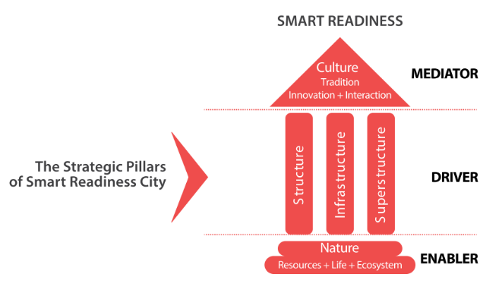

**Figure 1**. Smart Readiness Model of Ministry of Communications and Informatics

Source: adaptation from [5]

* 1. *Smart City*

A smart city is a collection of responses that harness the technology against demands, challenges, and complexities in the enhancement of living standards in urban areas [4]. The implemented smart city in a region may be utilized to overcome public issues and improve sustainable regional development. This can be attained by increasing human and social resources, as well as harnessing natural and economic resources through technology-based solutions and innovations [6]. Various technologies can be combined in the development of smart cities, such as the Internet of Things, big data, social media, and cloud computing technology [7]. Security, mobility, scalability, latency, and deployment aspects are also required to be considered in smart city development particular region [8].

In the particular regional development, smart cities can be developed based on six dimensions, namely smart economy, smart people, smart governance, smart mobility, smart environment, and smart living [9], which represented in Figure 2.

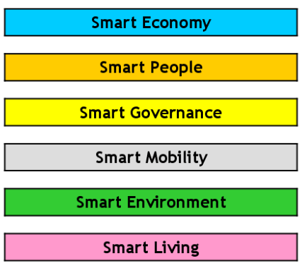

**Figure 2**. Smart City Dimension Mapping

Source: adaptation form [9]

The definition of the said dimensions is described as follow:

A smart economy refers to the region’s competitiveness according to the approaches on business aspects, development and research costs, entrepreneurial prospects, and the economic role of a city in domestic and international markets [10]. Moreover, the smart economy is also connected to smart business [11].

Smart people refer to the social interaction quality, cultural awareness, the extent of community education, as well as the level of community participation [10]. It’s also essential for people to possess an open mind, be able to adapt to environmental changes, be creative, and be able to partake in every transformation process of the city [12].

Smart governance refers to participation on a governmental level. In a transparent governance system, the public may contribute to decision-making, and the presence of ICT can facilitate people to access data related to city management [10]. The government's success in the implementation of smart cities depends on the provision of urban services, channels, smart mobile services, and network integration to the community [13][14]. In order to stimulate public participation, government information systems and related services can be integrated with relevant stakeholders and various other government organizations [15]. Consequently, for sustainable governance in the smart cities context, the prerequisite for cloud-based information systems is pivotal [16].

Smart mobility refers to the efficiency of the transportation system and guarantees people to easily access public transportation. The aim is to enhance the mobility efficiency of people, goods, and vehicles in urban environments [10]. Furthermore, it also refers to the proper traffic regulation [17]. A smart environment refers to resource management as well as sustainable development planning. The city’s appearance can be polished by reducing pollution and emissions, along with various efforts to preserve the environment [10].

Smart living refers to enhancing people's life quality and improving the environment [18]. The public may easily access healthcare services, electronica-assisted health management, and be offered diversity to social services [10].

In the version of Ministry of Communications and Informatics [5], smart city dimension mapping emerges to possess some resemblances to Giffinger’s version [9], yet in some ways there are differences. Mapping these dimensions comprise smart governance, smart branding, smart economy, smart living, smart society, and smart environment, which represented in Figure 3.

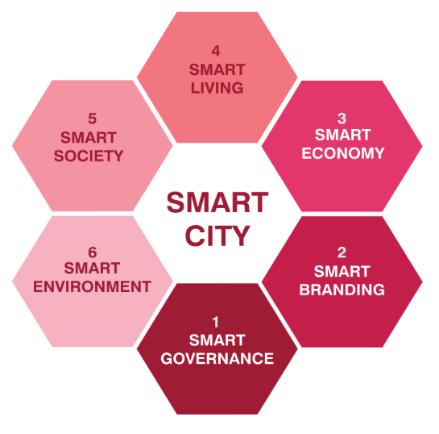

**Figure 3**. Smart City Dimension Mapping

Source: adaptation from [5]

1. **Research Methodology**

In conducting the research, qualitative approaches are used. The preliminary stage starts by conducting background analysis, including trends related to smart city development in various regions of the world. Once the background and development trends have been identified, the next is formulating the research question.

Following the background analysis, proceed with the data collection stage. Data collection and interpretation related to existing data are carried by conducting a focus group discussion, along with the relevant local government agencies in each smart city dimension. Aside from conducting a focus group discussion, a secondary data collection process is carried out from mid-term development plan documents (RPJMD), strategic design documents of the local government agencies, and sectoral statistical documents. The data collected will be mapped in three smart readiness parameters comprised of enablers, drivers, and mediators along with each aspect embedded in it. The research flow represented in Figure 4.

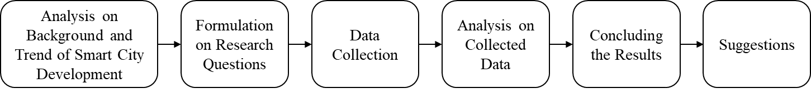

**Figure 4**. A flow diagram of research

1. **Outcomes and Discussions**

From the data collection along with the interpretation carried on a focus group discussion session with the relevant local government agencies in each smart city dimension, the following results are acquired:

1. *Readiness on Natural Aspect*

In the nature aspect, the highlighted point in readiness is related to the disaster potential. According to the data from the National Disaster Management Agency (BNPB) 2019 [19], Purworejo Regency has a disaster risk index of 150.64. Some of the potential natural disasters that possess a high potential class in Purworejo Regency, among others: floods, earthquakes, tsunamis, landslides, and, droughts [19]. A summary of the readiness on the natural aspect can be seen in Table 1.

**Table 1**. Readiness on a natural aspect

|  |  |
| --- | --- |
| **Interpretation** | **Summarized Issues** |
| **Sub-aspect: disaster potential** | |
| Medium. | The need for accommodation for disaster mitigation and post-disaster recovery. |

1. *Readiness on Structural Aspect*

In the structural aspect, the highlighted point is the readiness related to human resources, government resources, and the financial capacity of the existing region in Purworejo Regency. A summary of the of readiness on the structural aspect can be seen in Table 2.

**Table 2**. Readiness on a structural aspect

|  |  |
| --- | --- |
| **Interpretation** | **Summarized Issues** |
| **Sub-aspect: human resource quality** | |
| Good enough, yet still need improvement. | The need to supervise the existed digital startup or software developer communities in the region. |
| The need to establish a partnership with college institutions and ICT vendors. |
| The need for law enforcement optimization to suppress the number of law violations. |
| **Sub-aspect: government resource quality** | |
| Good enough, yet still need improvement. | The need for ICT management optimization. |
| The need to record the number of regional ICT volunteers and ICT resources in a government agency. |
| The need to establish a partnership with ICT vendors. |
| **Sub-aspect: regional financial capacity** | |
| Medium. | The need for regional income improvement. |
| The need to optimize the budget absorption. |
| The need for a specific budget allocation for the smart city initiative. |

1. *Readiness on Infrastructural Aspect*

In the infrastructural aspect, the highlighted point is the readiness related to regional physical infrastructure, regional digital infrastructure, and regional social infrastructure in Purworejo Regency. A summary of the readiness on the infrastructural aspects can be seen in Table 3.

**Table 3**. Readiness on an infrastructural aspect

|  |  |
| --- | --- |
| **Interpretation** | **Summarized Issues** |
| **Sub-aspect: physical regional infrastructure** | |
| Good enough, yet still need improvement. | The need to improve the condition of the regency’s road infrastructure and traffic signs, specifically the one related to the proximity to Yogyakarta International Airport and Borobudur Authority Agency. |
| The need to record the pedestrian facilities condition in order to assess and improve the quality of the regency’s road infrastructure. |
| **Sub-aspect: digital regional infrastructure** | |
| Good enough. | There’s a need to increase the availability of regional electricity supply, due to the number of monthly power outages as of July 2021 being around four to six times. |
| **Sub-aspect: social regional infrastructure** | |
| Good enough, yet still need improvement. | The need to optimize the utilization of community’s learning activities centers at a village level and regional public libraries as one of the socialization and education channels regarding smart city initiatives. |
| The available halls and communal rooms can be used as a means for the socialization of smart city initiatives. |

1. *Readiness on Superstructural Aspect*

In the superstructural aspect, the highlighted point is the readiness related to regional policies and regional agencies in the development of smart cities in Purworejo Regency. A summary of the readiness on superstructural aspects can be seen in Table 4.

**Table 4**. Readiness on a superstructural aspect

|  |  |
| --- | --- |
| **Interpretation** | **Summarized Issues** |
| **Sub-aspect: regional policies** | |
| Good enough, yet still need improvement. | The need to stipulate local regulations and regional head regulations that specifically regulate smart city masterplans. |
| The need to make use of the evaluation mechanism and performance appreciation to the apparatus and organizations that excel in implementing smart city programs. |
| **Sub-aspect: regional agencies** | |
| Good enough. | A smart city council and the regional managing team of smart city have been established. |

1. *Readiness on Cultural Aspect*

In the cultural aspect, the highlighted point is the readiness related to regional community organizations, which may contribute to the development of regional smart cities in Purworejo Regency. A summary of the readiness of cultural aspects can be seen in Table 5.

**Table 5**. Readiness on a cultural aspect

|  |  |
| --- | --- |
| **Interpretation** | **Summarized Issues** |
| **Sub-aspect: regional citizen organization** | |
| Good enough. | The need to establish partnerships with college institutions as well as non-governmental and smart cities supporting forums in smart city initiatives planning and implementation. |
| The need for Community Information Group (KIM) activation and fostering the partnerships with the group in implementation of smart city initiatives. |

1. **Conclusion**

According to the result of the focus group discussion, Purworejo Regency has proper readiness, especially in its regional digital infrastructure, governmental institutions, or regional community organization. Although in some other aspects, there’s room for improvements, for the better readiness of Purworejo Regency in smart city development. Several notes on further improvement are summarized into the following points:

* The need for governmental regulation that specifically regulates the development of the smart city.
* The necessity of a specific budget allocation to fund the initiative of the smart city.
* The need of improvement on Regional Income and budget absorption optimization.
* The necessity of smart city initiatives that accommodate disaster mitigation and post-disaster recovery.
* The need for ICT optimization, specifically the one related to incident handling SOP, may threaten governmental data integrity, and information system availability of an interoperable regional design planning.

It’s expected that the ongoing smart city development in Purworejo Regency may participate in the realization of regional development vision and mission, which is manifested in the 2021-2026 Mid-Term Development Plan of Purworejo Regency, as well as elevate the general living standards of citizens in Purworejo Regency.

1. **Bibliography**

[1] IESE, IESE Cities in Motion Index. 2020.

[2] Kearney, *The ASEAN Digital Revolution*. 2015.

[3] Ditjen Aplikasi Informatika Kementerian Komunikasi dan Informatika, “*Lewat Enam Pilar Utama Kominfo Berupaya Hadirkan 100 Smart City*,” 2021. https://aptika.kominfo.go.id/2021/09/lewat-enam-pilar-utama-kominfo-berupaya-hadirkan 100-smart-city/.

[4] J. Reichental, *Smart Cities for Dummies*. Wiley and Sons, 2020.

[5] Kementerian Komunikasi dan Informatika, “*Guideline Masterplan Smart City Kemenkominfo 2021*.” 2021.

[6] V. Fernandez-Anez, “*Stakeholders Approach to Smart Cities: A Survey on Smart City Definitions*,” Lect. Notes Comput. Sci. (including Subser. Lect. Notes Artif. Intell. Lect. Notes Bioinformatics), vol. 9704, pp. 157–167, 2016, doi: 10.1007/978-3-319-39595-1_16.

[7] A. de M. Del Esposte et al., “*Design and Evaluation of a Scalable Smart City Software Platform with Large-Scale Simulations*,” Futur. Gener. Comput. Syst., vol. 93, pp. 427–441, 2019, doi: 10.1016/j.future.2018.10.026.

[8] A. Elsaeidy, K. S. Munasinghe, D. Sharma, and A. Jamalipour, “*Intrusion Detection in Smart Cities Using Restricted Boltzmann Machines*,” J. Netw. Comput. Appl., vol. 135, no. September 2018, pp. 76–83, 2019, doi: 10.1016/j.jnca.2019.02.026.

[9] R. Giffinger, “*Smart Cities: Ranking of European Mid-Sized Cities*,” Cent. Reg. Sci. Vienna UT, no. October, p. 28, 2007, [Online]. Available: https://ec.europa.eu/digital-agenda/en/smart cities.

[10] C. Colldahl, S. Frey, and J. E. Kelemen, “*Smart Cities: Strategic Sustainable Development for an Urban World*,” p. 63, 2013.

[11] P. Johnson, M. E. Iacob, M. Välja, M. van Sinderen, C. Magnusson, and T. Ladhe, “*A Method for Predicting the Probability of Business Network Profitability*,” Inf. Syst. E-bus. Manag., vol. 12, no. 4, pp. 567–593, 2014, doi: 10.1007/s10257-014-0237-4.

[12] J. An et al., “*Toward Global IoT-Enabled Smart Cities Interworking Using Adaptive Semantic Adapter*,” IEEE Internet Things J., vol. 6, no. 3, pp. 5753–5765, 2019, doi: 10.1109/JIOT.2019.2905275.

[13] G. Cledou, E. Estevez, and L. Soares Barbosa, “*A Taxonomy for Planning and Designing Smart Mobility Services*,” Gov. Inf. Q., vol. 35, no. 1, pp. 61–76, 2018, doi: 10.1016/j.giq.2017.11.008.

[14] K. J. Fietkiewicz, A. Mainka, and W. G. Stock, “*eGovernment in Cities of the Knowledge Society. An Empirical Investigation of Smart Cities’ Governmental Websites*,” Gov. Inf. Q., vol. 34, no. 1, pp. 75–83, 2017, doi: 10.1016/j.giq.2016.08.003.

[15] G. Viale Pereira, M. A. Cunha, T. J. Lampoltshammer, P. Parycek, and M. G. Testa, “*Increasing Collaboration and Participation in Smart City Governance: a Cross-Case Analysis of Smart City Initiatives*,” Inf. Technol. Dev., vol. 23, no. 3, pp. 526–553, 2017, doi: 10.1080/02681102.2017.1353946.

[16] H. L. Truong and S. Dustdar, “*A Survey on Cloud-Based Sustainability Governance Systems*,” Int. J. Web Inf. Syst., vol. 8, no. 3, pp. 278–295, 2012, doi: 10.1108/17440081211258178.

[17] J. L. Galán-García, G. Aguilera-Venegas, and P. Rodríguez-Cielos, “*An Accelerated-Time Simulation for Traffic Flow in a Smart City*,” J. Comput. Appl. Math., vol. 270, pp. 557–563, 2014, doi: 10.1016/j.cam.2013.11.020.

[18] H. Yeh, “*The Effects of Successful ICT-Based Smart City Services: From Citizens’ Perspectives*,” Gov. Inf. Q., vol. 34, no. 3, pp. 556–565, 2017, doi: 10.1016/j.giq.2017.05.001.

[19] Badan Nasional Penanggulangan Bencana, “*Indeks Risiko Bencana*,” 2019. http://inarisk.bnpb.go.id/irbi/kabupaten.