EXPERT’S EVALUATION RESULTS OF ANDROID BASED FOOD SAFETY VIRTUAL LABORATORY

Dimas Bayu Pinandoyo and Yeni Nurhasanah

Politeknik Negeri Media Kreatif

dimas.pinandoyo@polimedia.ac.id

**Abstract**. In term of E-Learning, simulation tools to increase the effectiveness of online study is needed. Android based Food Safety Virtual Laboratory developed to fulfil the need. Laboratory developed using Unity Engine with click and drag interaction. Experts from Art Culinary Department and Media and Design Department of POLIMEDIA given the opportunity to try the developed laboratory to evaluate the content and effectiveness of the laboratory. Evaluation conducted using Focused Group Discussion Methods. Experts considered the laboratory needed to improve the color and background. Color wise, it should use cool colors to give futuristic impression. Classics colors should be avoided and empty space background should be avoided. Content wised the laboratory already covered the subject needed. The interaction was simple and simplify the learning process so the subject can be understood easily. It was suggested that a pop up should be added to inform the name of every tool so it can be more new users friendly.

*Keyword: Food Safety; Virtual Laboratory; E-Learning*

1. Introduction

Digitalization was one of promoting factors for disruptions era. E-learning or online learning was one of the digitalization in education. It promised a lot of benefits, but need good structures to support it. Unfortunately, in Indonesia supporting facilities for E-Learning still very limited [1].

Food safety described as subject that learn procedures to ensure the food consumes by consumers were save to be consumed. Five basic principles of it were (1) Keep it’s safe, (2) Grow it safe, (3) Keep it safe, (4) Knows what’s safe, and (5) Team up for food safety. The broad principles require food safety to be mastered not only by food technicians, but also those work in production, handling, packaging, processing until serving of food [2]. Any development to support the study of food safety will give impact especially in E-Learning.

Development of virtual laboratories had been conducted to support E-learning. In Saudi Arabia, Virtual Science Laboratory had been conducted since 2018 and claimed to be more interesting, fun, and beneficial compared to conventional laboratory [3]. Virtual laboratory deemed to be more economic since every student can practice the subject of their study individually and repeat as much as they want to ensure they understand the subject they studied [4]. Application of Science Technology Engineering and Mathematic (STEM) Virtual Laboratory proofed to be more effective in increasing the cognitive ability of the students compared to conventional laboratory. It also more convenience since students can adept to various situation so that the study could be done in many places and times [5]. Virtual Laboratory packed in game form, or virtual laboratory game based learning was very effective in improving self-learning motivation of students [6]. Virtual laboratory in form of game also proved to be a good alternative to study and practice entrepreneurship subject in Gadjah Mada University [7]. Android based virtual laboratory found increasing the mark output for history subject in IKIP Budi Utomo Malang [8]. Android based Chemical Virtual Laboratory found effectively increasing the understanding of chemistry subject for students in primary school [9]. Linguistic Android based Virtual Laboratory increased the average mark of 11th grade students of SMK Muhamadiyah Kota Bogor for respective subject [10].

Considering the importance of Food Safety, development of Virtual Laboratory for Food Safety was needed to be initiated. Virtual laboratory developed using android based because android was the broadest operation system used by cellphone consumers [11]. In this study, virtual laboratory designed with game-based environment. Study process packaged in multimedia and interaction aspects.

1. Research Methods

Research conducted using Focus Group Discussion. Four experts were chosen from Politeknik Negeri Media Kreatif namely expert in subject of Food Quality Management, expert in subject of Nutrition, expert in Multimedia, and lastly expert of Graphic Design. To keep the discussion a scoring board was used to give the satisfaction mark regarding the material that been evaluated. Scoring system developed using Likert chart with 5 grade described as bellow,

Table I. Likert Score

|  |  |
| --- | --- |
| **Score** | **Criteria** |
| 1 | Very unsatisfied |
| 2 | Unsatisfied |
| 3 | Neutral |
| 4 | Satisfied |
| 5 | Very Satisfied |

Subject of the discussion were (1) The Material/contents delivered in virtual laboratory, (2) Visual Communication of virtual laboratory, (3) Assets design of the virtual laboratory, (4) Effectivity of virtual laboratory to deliver of education.

**3. Results and Discussion**

* 1. Results

From the analysis, the result found was shown below,

Table II. Expert’s score for Android Based Food Safety Virtual Laboratory

|  |  |  |
| --- | --- | --- |
| No | Subject | Score |
| 1 | Material/ Contents | 4.5 |
| 2 | Visual Communication | 5.0 |
| 3 | Assets Design | 4.0 |
| 4 | Effectivity | 5.0 |
|  | Overall Score | 4.625 |

Material/Content wise, the virtual laboratory got 4.5 from 5 scale. It can be interpreted that the material/contents already covering subject needed based on core competencies or basic competencies of students. Visual communication got 5.0 from 5 scale. The assets and interaction in virtual laboratory could delivered the subject properly to its users. Assets Design got 4.0 from 5 scale. The assets design already represents the actual condition of laboratory and pleased the eyes of the users. Expert’s scored 5 out of 5 for the effectivity of virtual laboratory. This was based how the virtual laboratory could deliver material so well that event people without basic knowledge of food safety could understood the subject. Overall score of the virtual laboratory was 4.625 means the performance was above satisfactory.

* + 1. Discussion

Contents/material covered in food safety android based virtual laboratory developed using scheme system adopted by vocational education in Indonesia. Referred to the basic competence and core competence in that scheme, the materials were chosen. The facilities and infrastructure found in vocational institution also taken as a consideration. Unfortunately, the funding to develop the virtual laboratory was very limited, so that not every material could be covered in virtual laboratory. But considering other facilities can be found during offline study, experts decided that the materials/contents already covered what students need. Coliform detection was basic analysist for contaminant detection to ensure food safety, while hygiene was basic skill to be a basic level food handler.

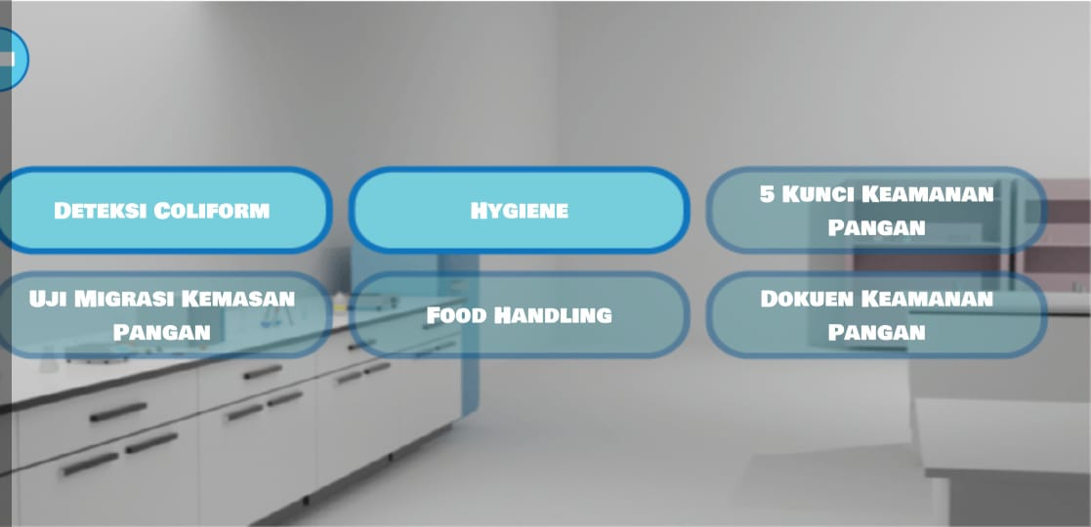

Fig. 1. Materials covered in Virtual Laboratory

The results of FGD was in accordance with the found of Al-Ghazali *et al*., mentioned that hygiene was basic but essential knowledge to ensure food product safe to be consumed. Hygiene was compulsory knowledge for restaurant’s food handler in Muscat, Oman [12]. Hygiene not just needed by restaurant’s food handlers, but also for food handlers in hospitals [13]. Coliform detection and hygiene was required for public university students in developing country [14].

Visual communication should be designed properly to ensure the audio visual media could deliver the knowledge effectively to users. Concept wise, the virtual developed using casual based learning game genre. The interaction chosen were drag and click interaction. Information about the subject was provided in every user interfaces. Expert mentioned that visual communication was very satisfying because it could deliver messages and education material in every subject. When needed, a tutorial video also can be played in “help” option.

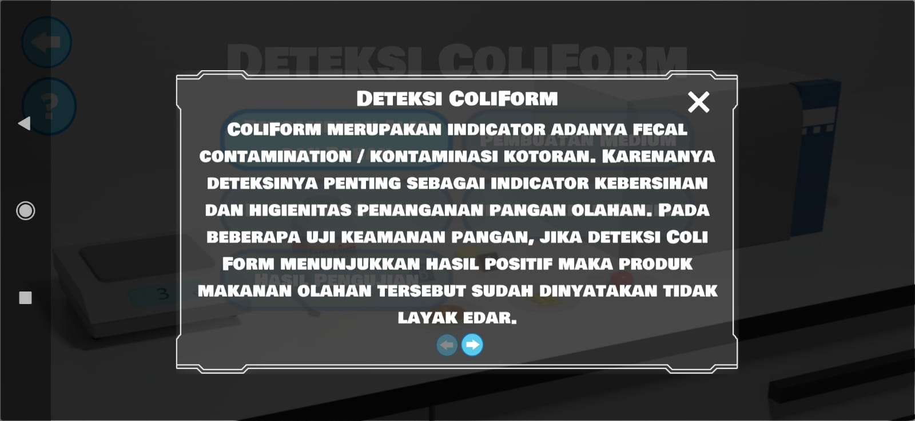

Fig. 2. Information in user interface section of virtual laboratory

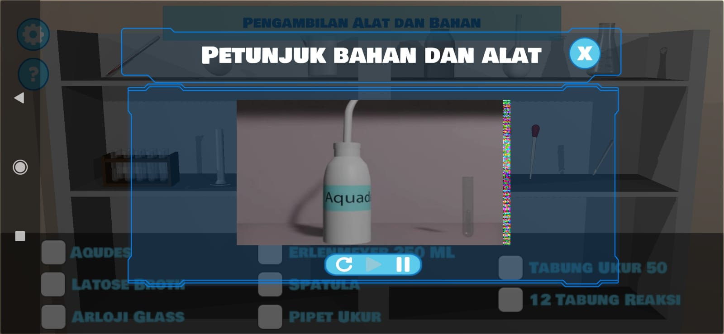

Fig. 3. Tutorial video in help section of virtual laboratory

Audio visual was the key of succeed in virtual laboratory. It was the key to improve the learning performance in virtual laboratory [15]. It was also the key for the effectivity of virtual laboratory [16]. Good audio visual in virtual laboratory allowed users experienced practical and realistic learning process [17].

Design wise, virtual laboratory developed using simple, hygienic, and futuristic. Assets developed using cool colours. Background developed using assets represents the actual laboratory and audit field. Expert considered that color wise, it should use cool colors to give futuristic impression. Classics colors and empty space background should be avoided. But expert from nutrition background mentioned that the colors used in the virtual lab already represent the formal and serious situation inside the laboratory. Thus, asset design deemed as satisfying (score 4) by the experts.

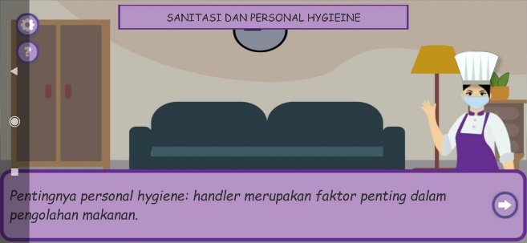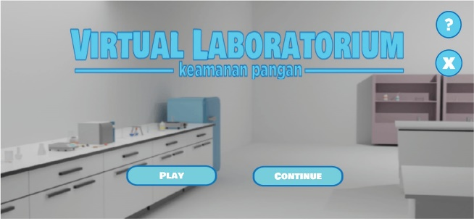

Fig. 4. Overall assets design of virtual laboratory

To test the efficiency of the virtual laboratory, expert tried the application. They found that they can understand the materials given in virtual laboratory although they did not have food safety background. Pre-test and post test results of students who tried the application also presented during the discussion. It was showed that from 25 students, the average mark increase significantly after using the virtual laboratory from 30 to 70. T test analysis found that there was a significant difference for student after using the virtual laboratory. Based on this, the expert describe that the virtual laboratory was very effective in increasing the knowledge of users.

Table. III. T Test Analysis of Students Average Mark

|  |  |
| --- | --- |
| Sample | 25 |
| DF | 24.00 |
| Critical Limit | 0.05 |
| T. Tabel | 2.063898562 |
| Mean 1 | 2.88 |
| Mean 2 | 9.28 |
| Mean difference | * 6.4 |
| SD Difference | 2.236067977 |
|  |  |
| T count | -14.31083506 |
| The difference | There’s significant difference |
|  | H0 rejected |

4. Conclusions

The virtual laboratory developed overall more than satisfactory. It was very effective to increase the knowledge of food safety for the users. However, it still needed improvement especially in term of colors and background. Content wised the laboratory already covered the subject needed. The interaction was simple and simplify the learning process so the subject can be understood easily.

References

1. Basar A.P., “Problematika pembelajaran jarak jauh pada masa pandemi Covid-19S,”Jurnal Ilmiah Pendidikan, vol 2, no. 1, pp. 208-218, 2021.
2. FAO, “A guide to world food safety day 2021,” <https://www.fao.org/3/cb3404en/cb3404en.pdf> (acessed on 12th Deecember 2021).
3. Ambusaidi, A., Al Musawi, A., Al-Balushi, S. and Al-Balushi, K., “The impact of virtual lab learning experiences on 9th grade students’ achievement and their attitudes towards science and learning by virtual lab,” Journal of Turkish Science Education, vol. 15, no. 2, pp.13-29. 2018.
4. Aljuhani, K., Sonbul, M., Althabiti, M. and Meccawy, M.,” Creating a Virtual Science Lab (VSL): the adoption of virtual labs in Saudi schools,” Smart Learning Environments, vol. 5, no. 1, p.16. 2018.
5. Gutiérrez-Carreón, G., Jorba, J., Peña-Gomar, M.C. and Daradoumis, T.,” A Study on the effectiveness of an undergraduate online teaching laboratory with semantic mechanism from a student perspective,” Journal of Information Technology Education: Innovations in Practice, vol. 19, no. 1, pp.137-155, 2020.
6. Akour, Mohammed, Hiba Alsghaier, and Samah Aldiabat., "Game-based learning approach to improve self-learning motivated students." International Journal of Technology Enhanced Learning, vol. 12, no. 2, pp: 146-160, 2020
7. Hidayat, Rahmat., "Game-Based Learning: Academic Games sebagai Metode Penunjang Pembelajaran Kewirausahaan," Buletin Psikologi, vol. 26, no. 2, pp: 71-85, 2018.
8. Arsyad, M.N. and Lestari, D.E.G., “Efektifitas penggunaan media mobile learning berbasis Android terhadap hasil belajar mahasiswa IKIP Budi Utomo Malang,” Agastya: Jurnal Sejarah Dan Pembelajarannya, vol. 10, no. 1, pp.89-105. 2020.
9. Herga, N.R., Čagran, B. and Dinevski, D., “Virtual laboratory in the role of dynamic visualisation for better understanding of chemistry in primary school,” Eurasia Journal of Mathematics, Science and Technology Education, vol. 12, no. 3, pp.593-608, 2016.
10. Jannatan, J.A. and Madjid, T.A., “Efektifitas media pembelajaran interaktif berbasis android mata pelajaran bahasa indonesia untuk kelas XI SMA Muhammadiyah Kota Bogor. Prosiding Teknologi Pendidikan, vol. 1, no. 1, pp.149-157, 2018.
11. Sheikh, A.A., Ganai, P.T., Malik, N.A. and Dar, K.A., “Smartphone: Android Vs IOS,” The SIJ Transactions on Computer Science Engineering & its Applications (CSEA), vol. 1, no. 4, pp.141-148, 2013.
12. Al-Ghazali, Maryam, M., Al-Bulushi, I., Al-Subhi, L., Rahman, M. S., and Al-Rawahi, Al., "Food Safety Knowledge and Hygienic Practices among Different Groups of Restaurants in Muscat, Oman," International Journal of Food Science, vol. 2020, pp.1-8, 2020.
13. Teffo, Lesiba A., and Frederick T. Tabit., "An assessment of the food safety knowledge and attitudes of food handlers in hospitals," BMC public health, vol. 20, no. 1, pp: 1-12, 2020.
14. Serrem, Kevin, Csaba Bálint Illés, Charlotte Serrem, Bridget Atubukha, and Anna Dunay. "Food safety and sanitation challenges of public university students in a developing country." Food Science & Nutrition, vol. 9, no. 10, pp:1-11, 2021.
15. Minda, Andrea Amalia, and Gilbert-Rainer Gillich. "The Role of Virtual Laboratories in Improving Students Learning Performance," Analele Universităţii “Eftimie Murgu” Reşiţa*,* vol. 25*,* no. 1, pp: 43-51, 2018.
16. Hamed, Ghadeer, and Ahmad Aljanazrah, "The effectiveness if using virtual experiments on students’ learning in the general physics lab," Journal of Information Technology Education: Research, vol. 19, pp: 977-996, 2020.
17. García-Vela, M. T., et al., "Teaching rock mechanics using Virtual Reality: laboratory practices and field trips during the confinement of the Coronavirus COVID-19 in Ecuador, Bolivia, and Spain." *IOP Conference Series: Earth and Environmental Science*. Vol. 833. No. 1. IOP Publishing, 2021.