Social Distance Monitoring System for COVID-19 using CNN Algorithm

**Muhammad Fikri Hidayattullah1*, Dega Surono Wibowo2, M. Galih Fikran Syah3, Yustia Hapsari4\***

123Department of Informatic Engineering, Polytechnic of Harapan Bersama, Indonesia

4Department of Digital Business, Pancasakti University, Indonesia

*Corresponding author: [fikri@poltektegal.ac.id](mailto:fikri@poltektegal.ac.id), [yustia.hapsari@gmail.com](mailto:yustia.hapsari@gmail.com)

**Abstract.** The Covid-19 pandemic is not going away. Even today, the government continues to implement the policy for the Enforcement of Community Activity Restrictions (PPKM). One of the activities that community members can do to suppress the spread of Covid-19 is to comply with health protocols. In addition to the health protocols for wearing masks and washing hands, another protocol that is heavily emphasized to be implemented in public places is social distancing. However, this social distancing activity in some places is still often not complied with. Based on these conditions, this study will develop a model that is able to automatically observe the activities of people who obey and violate social distancing rules. The model developed in this study has two main stages. First, the detection of human objects using the CNN algorithm. Second, calculate the proximity between objects. If it is under the threshold value, it will be considered a violation. The resulting model was tested on several images and resulted in varying accuracy.

1. Introduction

Covid-19 has become a global pandemic since it first emerged in December 2019 in Wuhan [1]. This pandemic has not ended until today. Strict health protocols continue to be implemented [2] by governments in various countries. One form of the health protocol is in the form of instructions to maintain social distance when interacting with other people. Social distancing activities are believed to be able to reduce the spread of Covid-19 [3]. However, the reality that occurs in the field is that there are still very many community members who have not obeyed the rules of social distancing [4]. Generally, these social distancing rules will be implemented if there are parties who carry out direct monitoring.

Convolutional Neural Network (CNN) algorithm is a deep learning algorithm that works by taking input images and combining them with filters or kernels to extract features [5]. The NxN image is convoluted with the fxf filter and this convolution operation learns the same features on the entire image [6]. CNN was first proposed by LeCUn and used for handwriting recognition [7]. This algorithm can achieve optimal results when implemented in the fields of image recognition, scene recognition, semantic segmentation, and edge detection [8]. Technically, the application of the CNN algorithm has also been realized in the form of a framework, such as TensorFlow for example. So that it can be easily implemented to build a smart application.

The phenomenon of disobedience to members of the public in complying with social distancing rules can be monitored automatically using computer vision-based intelligent system technology. This application can apply the CNN algorithm to monitor human movement and calculate proximity by health protocols. Members of the public who violate social distancing rules will automatically be able to be detected.

This study aims to build an automatic detection prototype that can monitor violations of social distancing health protocols. The application prototype that will be built has not yet recognized the identity of the violator but is limited to detecting human movements that do not comply with social distancing rules.

1. CNN Algorithm

Convolutional Neural Network (CNN) algorithm is one of the Deep Learning algorithms that is widely used for computer vision work [9]. The basis of the CNN algorithm is a neural network. CNN can receive input in the form of images, determine any aspect or object in an image that the machine can use to learn to recognize images, and distinguish one image from another [10]. CNN architecture is somewhat similar to the pattern of connections of neurons or nerve cells in the human brain. CNN is inspired by the Visual Cortex, which is the part of the brain responsible for processing information in visual form. With such an architecture, CNN can be trained to understand the details of an image better [11]. That way, CNN can capture the spatial and temporal dependencies in an image after you provide the relevant filters.

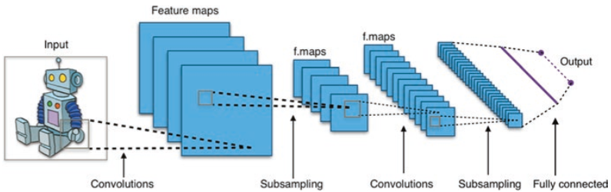

**Figure 1.** CNN algorithm process

1. Methods

The first step to monitor social distancing activities is to detect human objects. In the human detection process, the CNN algorithm is used. In this research, the CNN algorithm is implemented into the YOLO v3 framework. Therefore, the dataset training stage is not carried out because human object detection is already available in the YOLO framework. After the human object has been detected by the built model, the next step is to calculate the proximity between the objects. If the proximity distance exceeds the threshold for social distancing rules, the model will state that there are no violations. If it is less than the minimum limit, a violation will be declared. After that the accuracy of the model will be calculated.

**Figure 2.** Research methodology of social distance monitoring system for COVID-19 using the CNN algorithm

Video Streaming

People Detection using CNN

Calculate Distance Between People

Under Threshold?

Violation

Not Violation

Measurement Accuracy

1. Results and Discussion

The model that was built was tested in real time on several objects of the human crowd. The crowd detected as violating social distance will be given a blue bounding box. Meanwhile, those who are detected as not violating will be given a green bounding box. The ideal distance between the camera and the detected object is in the range of 1 – 1.5 meters.

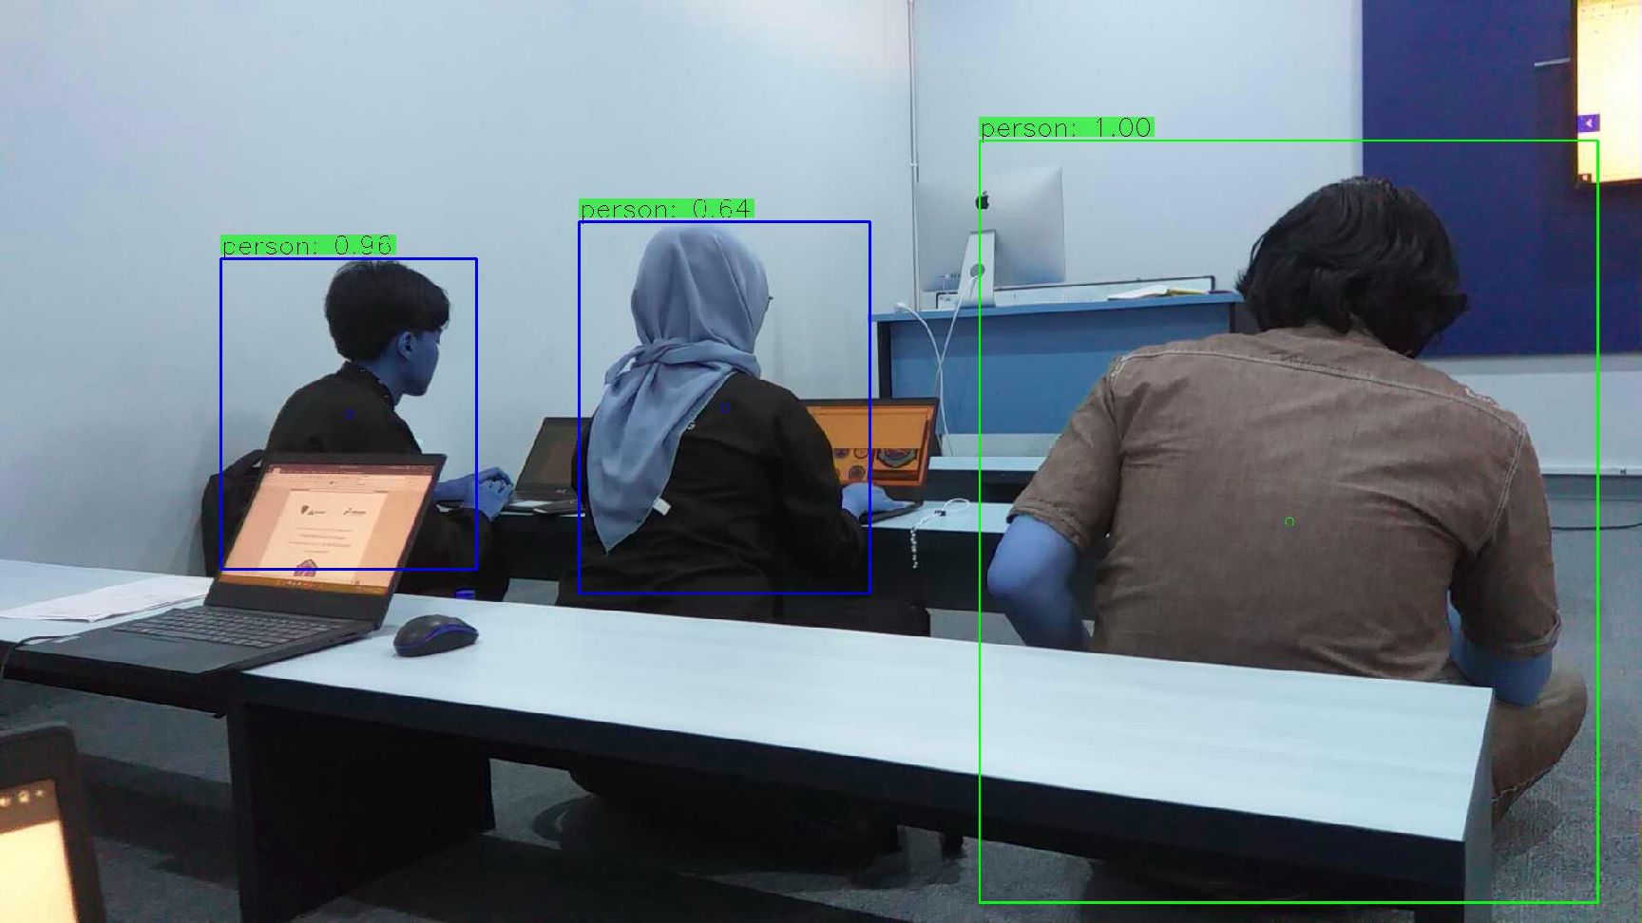

**Figure 3**. The blue bounding box indicates a violation of social distance, while the green bounding box indicates compliance with the social distance rules.

The detection result will experience an error if the distance of the camera with the object is too far or above 2 meters. Because the detector model is designed based on the distance between the pixel values of human objects. The offending object has a distance value under 700 pixels. Meanwhile, if the distance between objects is above 700 pixels, it will be considered not to have committed a violation. Objects that actually comply with social distancing rules will be deemed to have committed a violation if detected from a considerable distance. Because the captured human object is reduced in size and results in a low distance of the obtained pixel value.

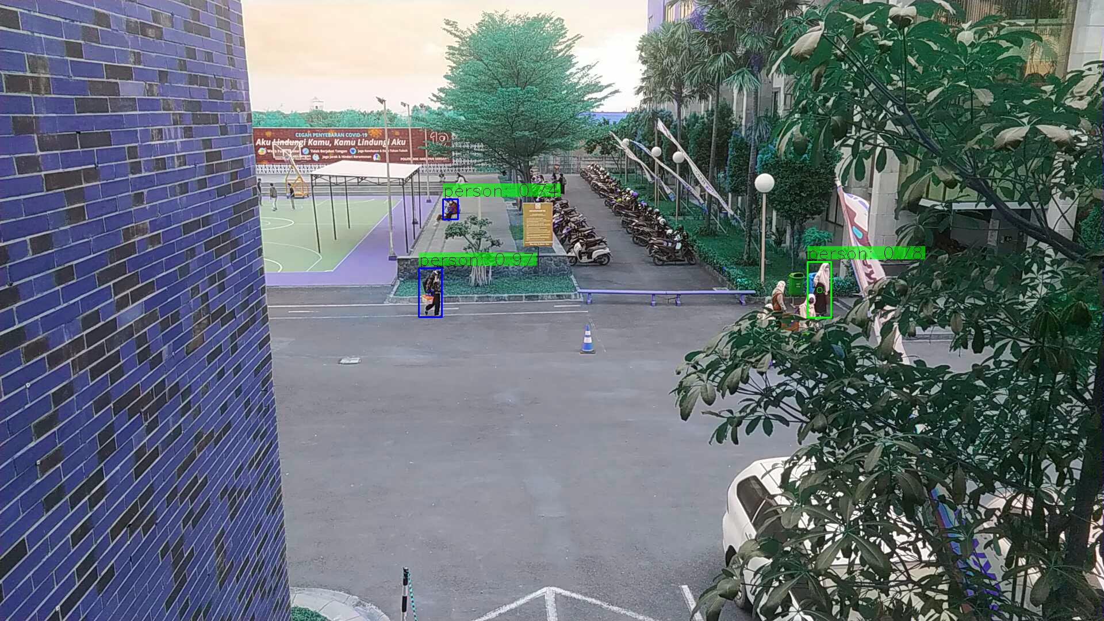

**Figure 4**. Images taken at a distance of over 5 meters.

The detection results in Figure 4. indicate a social distance violation. In fact, in real terms, the distance between humans who are detected as violating the minimum limit for social distancing rules. This happens because the distance between human objects accumulated by the model is below the threshold value. This kind of detection error is called a false positive (FP).

Detection errors will also occur if between human objects are not in a straight line position, but are in a position facing back and forth. Although in real between objects do not violate.

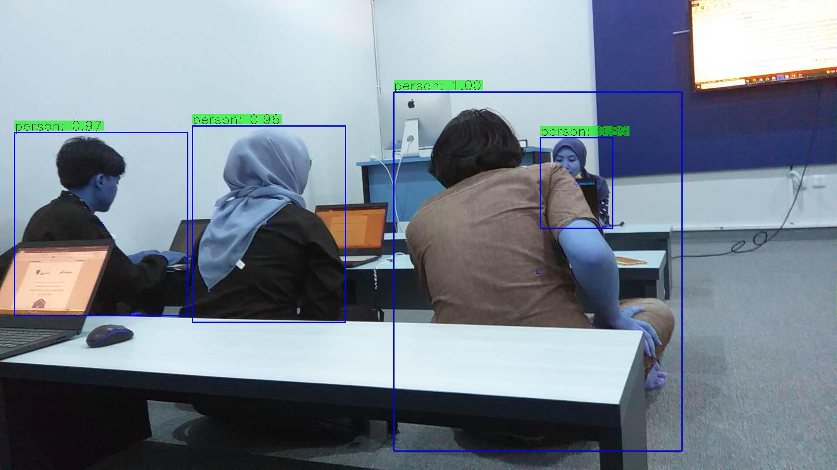

**Figure 5**. Human objects marked with a red mark are considered to have violated social distance. Even though in reality he did not commit a violation.

The detection error shown in Figure 5. is caused by the model calculating the proximity distance horizontally. The model assumes the objects marked in red are in a straight line plane with parallel positions. Though in real it is not so. Therefore, the calculation of the proximity of the pixel values between objects is below the threshold value.

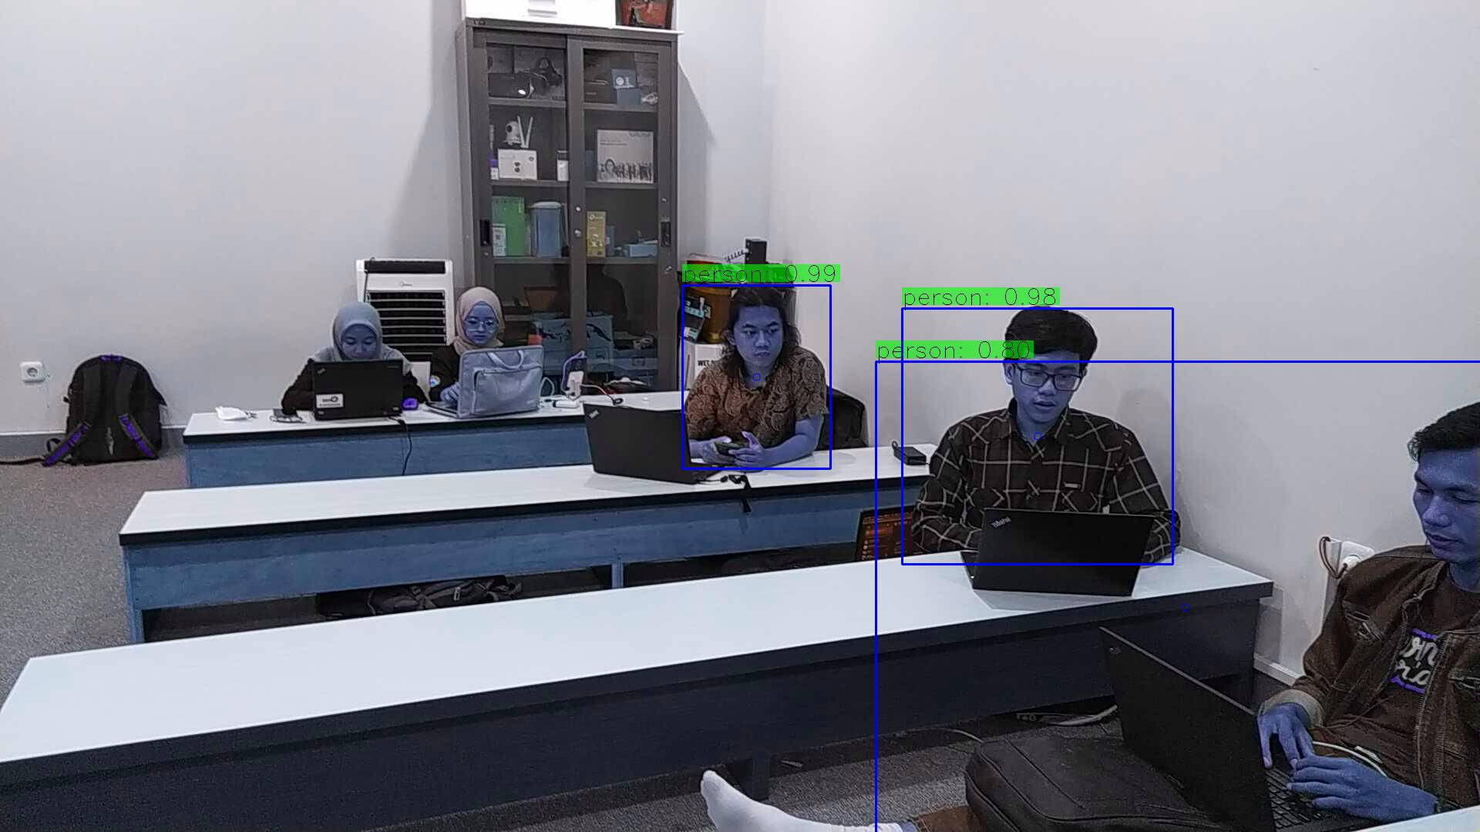

**Figure 6**. False positive detection

The developed model also still shows inaccuracies in detecting objects. Figure 6. shows the existence of two human objects that were not detected by the model.

The detection results will calculate the accuracy value with the formula:

where TP stands for the number of true positive; FP stands for the number of false positive; TN stands for the number of true negative; FN stands for the number of false negative.

**Table 1**. Calculation of the accuracy of each detected image

|  |  |  |
| --- | --- | --- |
| Image | Accuracy | Description |
| Figure 3 | 100% | Although the accuracy value is very high, the shooting position is not facing straight towards the object. It is also very possible the occurrence of false positive and false negative errors. |
| Figure 4 | 20% | The distance of the camera with objects that are too far causes a high rate of false positives and false negatives. |
| Figure 5 | 75% | Detection errors in the form of false negatives are caused because the model reads human objects in a straight vertical position. |
| Figure 6 | 60% | The model failed to detect two human objects. |

After testing in real time according to the ideal distance, the results obtained for an accuracy value of 99.3%, precision 98.8%, recall 99.9% and F1-Score 99.3%.

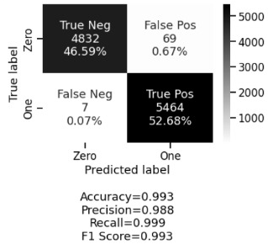

**Figure 7.** Test Results

1. Conclusion

The ability of the CNN algorithm to detect human objects can be said to be quite high. Although in some tests it still has not succeeded in detecting human objects. The model developed in this study can detect human objects that obey and violate social distance rules at a distance of less than 2 meters. Errors in detecting social distance violations are caused because the camera is too far from the object and also because the detected object is not in a straight vertical line.

References

[1] M. Ciotti, M. Ciccozzi, A. Terrinoni, W. C. Jiang, C. Bin Wang, and S. Bernardini, “The COVID-19 pandemic,” *Crit. Rev. Clin. Lab. Sci.*, vol. 57, no. 6, pp. 365–388, 2020.

[2] F. D. A. Pinasti, “Analisis Dampak Pandemi Corona Virus Terhadap Tingkat Kesadaran Masyarakat dalam Penerapan Protokol Kesehatan,” *Wellness Heal. Mag.*, vol. 2, no. 2, pp. 237–249, 2020.

[3] J. A. Lewnard and N. C. Lo, “Scientific and ethical basis for social-distancing interventions against COVID-19,” *Lancet Infect. Dis.*, vol. 20, no. 6, pp. 631–633, 2020.

[4] I. W. Sukawana and I. made Sukaraja, “Gambaran Kepatuhan Masyarakat Mawang Kelod dalam Menerapkan Protokol Pencegahan COVID-19 di Tempat Umum Bulan September 2020,” *Community Publ. Nurs.*, vol. 9, no. 2, pp. 204–210, 2021.

[5] R. Chauhan, K. K. Ghanshala, and R. C. Joshi, “Convolutional Neural Network (CNN) for Image Detection and Recognition,” *ICSCCC 2018 - 1st Int. Conf. Secur. Cyber Comput. Commun.*, pp. 278–282, 2018.

[6] M. D. Zeiler and R. Fergus, “Visualizing and Understanding Convolutional Networks,” in *Analytical Chemistry Research*, vol. 12, 2014, pp. 818–833.

[7] Y. LeCun *et al.*, “Backpropagation applied to digit recognition,” *Neural computation*, vol. 1, no. 4. pp. 541–551, 1989.

[8] M. Coskun, A. Ucar, O. Yildirim, and Y. Demir, “Face recognition based on convolutional neural network,” *Proc. Int. Conf. Mod. Electr. Energy Syst. MEES 2017*, vol. 2018-Janua, pp. 376–379, 2017.

[9] B. Benjdira, T. Khursheed, A. Koubaa, A. Ammar, and K. Ouni, “Car Detection using Unmanned Aerial Vehicles: Comparison between Faster R-CNN and YOLOv3,” *2019 1st Int. Conf. Unmanned Veh. Syst. UVS 2019*, pp. 1–6, 2019.

[10] R. Zhao, X. Niu, Y. Wu, W. Luk, and Q. Liu, “Optimizing CNN-based object detection algorithms on embedded FPGA platforms,” *Lect. Notes Comput. Sci. (including Subser. Lect. Notes Artif. Intell. Lect. Notes Bioinformatics)*, vol. 10216 LNCS, no. 1, pp. 255–267, 2017.

[11] M. Heidari, S. Mirniaharikandehei, A. Z. Khuzani, G. Danala, Y. Qiu, and B. Zheng, “Improving the performance of CNN to predict the likelihood of COVID-19 using chest X-ray images with preprocessing algorithms,” *Int. J. Med. Inform.*, vol. 144, no. June, p. 104284, 2020.