**DRAINAGE ANALYSIS BY APPLYING THE RATIONAL METHOD ON FLOOD DISCHARGE**

**Adam Safitri,Yunita Rosdiana Dewi, Nono Carsono, Lia Amaliah**

Civil Engineering Study Program - Sekolah Tinggi Teknologi Cirebon

Email: [adam@sttcirebon.ac.id](mailto:adam@sttcirebon.ac.id)

**ABSTRACT**

*The construction of the Kuningan East Ring Road is the construction of a new road that aims to relieve congestion by dividing continuous traffic on the 7.2 KM Cirebon-Kuningan road.* *To anticipate the occurrence of puddles on the road, road facilities in the form of drainage are needed.* *This study was carried out in four stages, namely site surveys, problem identification, data collection, and data analysis. Data obtained were in the form of primary data and secondary data which were then analyzed according to the needs of the study. For the hydrological analysis, rainfall data were acquired from two rainfall stations, namely Lame Dam Station in Ciniru Village and Linggarjati Station, for a span of 10 years from 2012 to 2021. Calculation of the maximum rainfall area applied the Algebraic Average Method, with obtained average rainfall for the last 10 years being 978 mm. Furthermore, the analysis of rainfall intensity using the Mononobe Equation attained result of 84.199 mm/hour. The analysis of flood discharge using the Rational Method obtained a design flood discharge of 0.187 m³. Meanwhile, the channel planning and cross section used U-Ditch DS 3 with dimensions of 1.10 m x 1.25 m and a channel capacity of 0.580 m³/second. Based on the calculation results, it can be concluded that the channel capacity is greater than the design flood discharge. Thus, the drainage planning requirements have been met.*

***Keywords: Road drainage, planning, Kuningan East Ring Road***

**INTRODUCTION**

In general, drainage has the meaning of disposing or draining water (rainwater, waste water, or groundwater) to a predetermined disposal site by means of gravity or using a pumping system (Nugrahedi and Saputra, 2014). According to Pane *et al.* (2016), there are two functions of road drainage, namely: (1) to reduce the possibility of a decrease in the carrying capacity of the subgrade due to the increase in water content that exceeds the optimum water content as a result of the seepage of rainwater into the subgrade through the pores of the road pavement or the rise of groundwater to the surface, and (2) to minimize the possibility of damage to the road pavement as a result of submersion of the road pavement by puddles of rainwater. This can lead to changes in land use functions which have an impact on the decrease in the catchment areas (Rahmawati, R and Kurniani, 2017). In addition, heavy rainfall can cause puddles on the road if the rainwater runoff is not well received by the existing drainage system (Susilowati, 2017). Thus, it can be said that generally both surface drainage and subsurface drainage are made with the intention of saving road pavement layers and subgrades from the adverse effects of water. The drainage planning analysis includes (Kafi *et al.,* 2017):

1. Calculation of rainfall using the Algebraic Method
2. Analysis of rainfall intensity applying the Mononobe Method
3. Rainfall data were obtained from two rainfall stations, namely Lame Dam Station in Ciniru Village and Linggarjati Station
4. Channel cross-section using U-Ditch DS 3

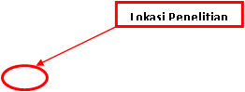

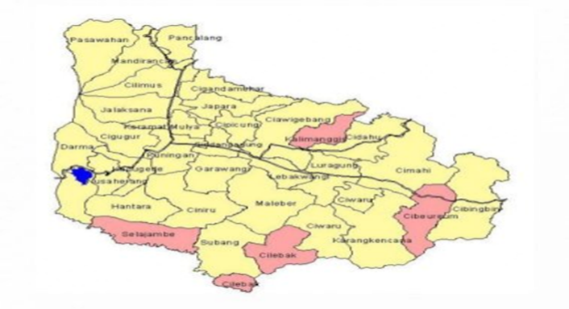

### **Figure 1** Map of Kuningan Regency (Central Bureau of Statistics of Kuningan Regency, 2021, processed)

**THEORETICAL FRAMEWORK**

Drainage has the meaning of disposing, draining, dumping, or diverting water. In general, drainage is defined as a series of water structures that function to reduce and/or remove excess water from an area or land so that the land can be used optimally. The drainage system is often found in other buildings such as culverts, siphons, water bridges (aqueducts), spillways, sluice gates, drop structures, reservoir ponds, and pumping stations.

Road drainage planning criteria include:

1. Area to be drained
2. Maximum estimated rain
3. The slope of the surrounding area as well as possible drainage and disposal (geomorphology/ the shape of the ground surface)
4. Subgrade characteristics, including the tendency to erode other soils
5. Percentage of groundwater
6. The average elevation above groundwater level
7. Minimum depth required to protect drainage pipes from traffic loads

The formulas used are:

Rational Formula

Q = C.I.A

= (1/3,6) . C.I.A...............m³/sec

= 0.278 . C.I.A................m³/sec

A = Flow area (m²)

I = Average rainfall intensity (mm/hour)

C = Flow rate

Burkli–Ziegler Formula

Q = C.I.A . (S/A) 0.25

S = Average slope of the land surface

Empirical Formula

t = 0.00013 L0.77/ S0.385 .............(hour)

KIRPICH Formula

LI.15/7700.H0.385..............(hour)

Where:

L = Distance from the farthest place to the drainage channel (feet)

H = Height difference between the farthest place and the drainage channel (feet)

S= H/L = Mean slope of the flow area

t = 0.0195 (L/(S) 0.5) 0.077 ..........(minute)

However, the generally used formulas are:

t = L/V.....(hour)

and V = 72.(H/L) 0.5

The Manning formula for open channels

v = (1.49/n) R2/3 S1/2

Q = (0.00061/n) D8/3 S1/2

**Channel Dimensions**

The dimensions of the channel must be able to flow the design discharge. In other words, the discharge flowed by the channel (Qs) must be equal to or greater than the design discharge (QT). To measure the flow velocity in the channel, the Manning formula was used.

……………………….

Where:

V = Flow velocity in the channel

*n* = Manning coefficient

R = Hydraulic radius (m)

P = Wetted perimeter of the channel (m)

As = Cross-sectional area of the channel (m²)

S1 = Slope of the channel

**Table 1** Manning Coefficient

|  |  |  |
| --- | --- | --- |
| **No.** | **Type of Channel** | **Manning Coefficient** |
| 1 | Steel | 0.011-0.014 |
| 2 | Corrugated Steel | 0.021-0.030 |
| 3 | Cement | 0.010-0.013 |
| 4 | Concrete | 0.011-0.015 |
| 5 | Cemented Rubble | 0.017-0.030 |
| 6 | Wood | 0.010-0.014 |
| 7 | Brickwork | 0.011-0.015 |
| 8 | Asphalt | 0.013 |

*Source: Suripin, 2004*

The measurement of the slope of the channel was obtained through the formula:

S = ………………………………….

Where:

S = Slope of the channel base

t2 = Highest elevation of the channel (m)

t1 = Lowest elevation of the channel (m)

**Hydrological Analysis**

The frequency analysis of hydrologic data is related to the magnitude of extreme events in connection with the frequency of their occurrence through the application of probability distribution (Waskitaningsih, 2012). The analyzed hydrologic data is assumed to be independent, randomly distributed, and stochastic.

Log-Pearson Type III Method

The statistical parameters used in the Log-Pearson Type III distribution are:

1. Design Rainfall

Average value:

Standard Deviation:

Asymmetry Coefficient:

Where:

Log X = Logarithmic value of X with a return period of Y years

Log = Average value of Log X

Sd = Standard deviation

K = Frequency factor

Cs = Skewness coefficient

1. Regional Rainfall

This method is based on a weighted average. Each rain gauge has an area of influence that is formed by drawing axes perpendicular to the connecting line between two rain gauge posts (Safitra, Diana, & Sholihah, 2018). This method is used when the distribution of rain in the reviewed area is uneven.

..

Where:

A = Area

R = Average rainfall of the area

RA,RB,..,Rn = Rainfall in the post

1,2,....,n AA,AB,..,An = Area of influence of Post 1,2,....,

1. Rainfall Intensity

Rainfall intensity is the total amount of rain that falls during the period where the water is concentrated.

The Mononobe formula is used when short-term rainfall data is not available and only daily rainfall data is available.

2/3 ..............

Where:

I = Rainfall intensity (mm/hour)

R24 = Maximum daily rainfall (mm)

Tc = Time of concentration (hour)

1. Time of Concentration

Time of concentration is the time required for water to flow from the most distant point in the flow area to a specified control point downstream of a channel.

1. Inlet Time

It is the time required for water to reach the nearest channel, formulated as:

.........................

Where:

*t0* = Runoff time to channel (minute)

*L* = Length of flow path over land surface (m)

*n* = Manning’s roughness coefficient

*S* = Slope of the land

1. Conduit Time

It is the time required for water to flow along the channel to a specified control point downstream, formulated as:

t_d = Ls/(60 v) .........................

Where:

td = Runoff time on the channel from one point to another (minute)

Ls = Length of the land path to the channel (m),

v = Flow rate in the channel (m/sec)

1. Rainwater Runoff Discharge

Rainwater discharge or runoff discharge is when the intensity of rain falling in a watershed exceeds the infiltration capacity (Suharmadi, 2011). After the infiltration rate is met, the water will fill the basins on the ground. After the basins are full, then the water will flow over the ground. Rainwater discharge can be calculated using the following formula (Oktavia, 2018):

Runoff Discharge Formula:

Q = 0.278 . I .C . A .......................

Where:

Q = Runoff water flow (m3/sec)

C = Runoff coefficient (by default)

I = Rainfall intensity (mm/hour)

A = Drainage area (ha)

0.278 = Constant

The amount of rainwater discharge in an area must be drained immediately so as not to cause puddles. To do so, a channel that can hold and drain the water to a water reservoir is required.

1. Design

Square

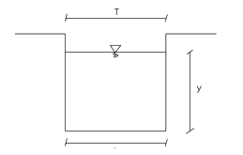

**Figure 2** Square Channel

Where:

Area (A) = b.y

Wetted perimeter (P) = b+2y

Hydraulic Radius (R) =

Peak Width (T) = b

Hydraulic Depth (D) = y

Cross-sectional Factor (Z) =

**Table 2** Allowable Water Flow Velocity

|  |  |  |
| --- | --- | --- |
| Side Gutter Material | Allowable Water Flow Velocity (m/sec) | Slope of Side Gutter (%) |
| Fine sand | 0.45 | 0- 5 |
| Sandy clay | 0.50 | 0- 5 |
| Alluvial silt | 0.60 | 0- 5 |
| Fine gravel | 0.75 | 0- 5 |
| Sturdy clay | 0.75 | 5- 10 |
| Solid clay | 1.10 | 5- 10 |
| Coarse gravel | 1.20 | 5- 10 |
| Big stones | 1.50 | 5- 10 |
| Cemented rubble | 1.50 | 10 |
| Concrete | 1.50 | 10 |
| Reinforced concrete | 1.50 | 10 |

*Source: SNI03-3424-1994*

U-Ditch Concrete is a channel of reinforced concrete with a U-shaped cross section and can also be covered. It is generally used as drainage or irrigation channel (Lubis, 2012). The height of this open channel may vary according to the needs in the field or the desired channel elevation. U-Ditch cover is a concrete material that functions as a cover for drainage channels which is very practical in the installation stage that does not take a long time, thus accelerating the work schedule on the project.

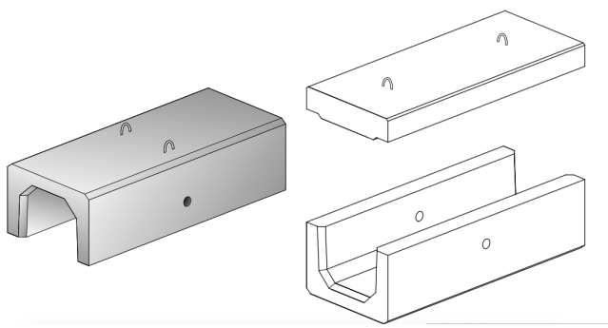

**Figure 3** Standard Dimensions of U-Ditch Concrete

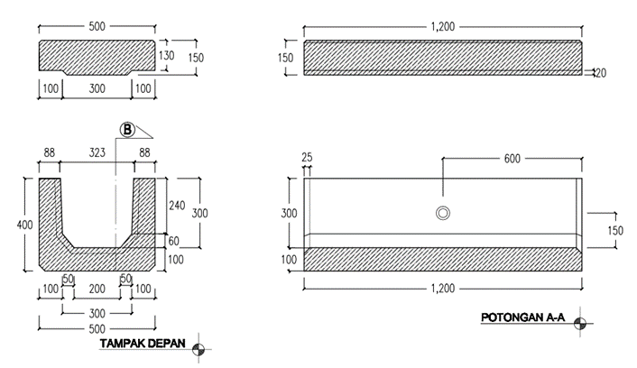

**Figure 4** U Ditch cover and cross section details

**RESEARCH METHOD**

Data collection is the stage to determine the solving of a problem scientifically. In planning the drainage of the Kuningan East Ring Road, there were types and methods of data collection needed.



**Figure 5** Research Procedure Flowchart

Secondary data is supporting data in a planning and gained not through direct observation in the field. The secondary data of this study included:

1. Topographic maps
2. Hydraulic data
3. Rainfall data

The secondary data were obtained from the collection of documents related to the primary data. Documents used as secondary data were written or compiled by other people. In this study, there were several sources used as a reference/guideline, including:

1. Road Design Engineer Module-07 Department of Public Works on Fundamentals of Road Drainage Planning in 2005
2. Specifications for Drainage Works of the Ministry of Public Works and Housing in 2016
3. General Specifications of the Ministry of Public Works and Housing regarding Road Drainage in 2016
4. Road Surface Drainage Planning Module by Adiwijaya, (2016)

**DISCUSSION**

* Hydrological Analysis

The data needed in the hydrological analysis was rainfall data obtained from the Department of Water Resources Management for the Cimanuk–Cisanggarung River Basin using two rainfall stations, namely the Lame Dam Station in Ciniru Village, the Regional Technical Implementation Unit (UPTD) for the Cilimus Region and Linggarjati Station, UPTD for the Cilimus Region. Data collection was carried out in a span of 10 years, namely from 2012 to 2021.

**Table 3** Calculation Results of the Regional Annual Maximum Rainfall

|  |  |  |  |
| --- | --- | --- | --- |
| **Year** | **Lame St.**  **(mm)** | **Linggarjati St.**  **(mm)** | **Maximum Average Rainfall (mm)** |
| **2012** | 73 | 121 | 97 |
| **2013** | 125 | 147 | 136 |
| **2014** | 65 | 115 | 90 |
| **2015** | 95 | 73 | 84 |
| **2016** | 34 | 78 | 56 |
| **2017** | 70 | 102 | 86 |
| **2018** | 82 | 109 | 95.5 |
| **2019** | 175 | 155 | 165 |
| **2020** | 67 | 75 | 71 |
| **2021** | 92 | 103 | 97.5 |
| **∑** | | | **978** |

Source: 2021 Calculation

In determining the frequency distribution of rainfall, Normal Distribution, Log Normal, Log-Pearson Type III, and Gumbel were used.

**Table 4** Normal Distribution Frequency Analysis

|  |  |  |  |  |
| --- | --- | --- | --- | --- |
| No. | Year | Rainfall  (Xi) (mm) | Xi - X | (Xi - X)2 |
| 1 | 2019 | 165 | 67.2 | 4515.84 |
| 2 | 2013 | 136 | 38.2 | 1459.24 |
| 3 | 2021 | 97.5 | - 0.3 | 0.09 |
| 4 | 2012 | 97 | - 0.8 | 0.64 |
| 5 | 2018 | 95.5 | - 2.3 | 5.29 |
| 6 | 2014 | 90 | - 7.8 | 60.84 |
| 7 | 2017 | 86 | -11.8 | 139.24 |
| 8 | 2015 | 84 | -13.8 | 190.44 |
| 9 | 2020 | 71 | -26.8 | 718.24 |
| 10 | 2016 | 56 | -41.8 | 1745.24 |
| N = 10 Ʃ | | 978 | 0.00 | 8835.1 |

Source: 2021 Calculation

In calculating the normal distribution, the average rainfall value and standard deviation were needed, namely:

1. Average Rainfall ()
2. Standard Deviation (S)
3. Coefficient of Variation (Cv)
4. Skewness Coefficient (Cs)
5. Kurtosis Coefficient (Ck)

To determine the value of the Gaussian Elimination Variable frequency factor, the following formula was used:

In the 2, 5, 10, 20, and 50 return periods, the calculations were:

From the above calculations, the following graph was obtained:

Source: 2021 Calculation

**Figure 6** Normal Distribution Rainfall Graph

**Runoff Coefficient (C)**

In road drainage study, the runoff coefficient (C) used was the channel planning guideline set by the Department of Public Works in SNI 03-3424-1994 concerning Road Surface Drainage Planning Procedures, then the runoff coefficient (C) obtained for the relationship between ground surface conditions was as follows:

1. L1 = Asphalt pavement (width 7m) : Coefficient C = 0.70
2. L2 = Shoulder (width 1m) : Coefficient C = 0.65
3. L3 = Curb (width 1 m) : Coefficient C = 0.40

To determine the area of the watershed for the highway, it is taken by calculating the length of the 1350 m drainage channel as follows:

1. Asphalt pavement A1 = 7 m x 1,350 m = 9,450 m²
2. Shoulder A2 = 1 m x 1,350 m = 1,350 m²
3. Curb A3 = 1 m x 1,350 m = 1,350 m²

Overall area = 9,450 m²+1,350 m² + 1,350 m² = 12,150 m²

Furthermore, the determination of the combined coefficient (Cw) can be calculated as follows:

Cw = 0.661

Time of concentration is the time taken for rainwater to fall at the start point of the upstream channel to the downstream point of the channel, by first calculating the slope from upstream to downstream.

Calculating the slope of the channel:

= 0.049 ~ 0.05 %

Note:

S = Slope of the channel base

t1 = Starting point elevation (m)

t2 = End point elevation (m)

L = Channel length

Calculating the Inlet Time

Note:

= Time of concentration (minute)

= Inlet time (minute)

= Conduit time (minute)

= Farthest point distance (m)

= Channel length (m)

= Coefficient of drag

= Slope

= Average water velocity (m/sec)

0.70

0.69

* Rainfall Intensity Analysis

The time of rainfall greatly affects the size of the rainfall intensity. Based on the obtained daily rainfall data, the calculation of rainfall intensity used the Mononobe formula as follows:

2/3

Note:

= Rainfall Intensity (mm/hour)

= Maximum Daily Rainfall (mm/hour)

= Time of Concentration (hour)

The intensity of rainfall was calculated using the maximum daily rainfall for a 10 year return period using the Log-Pearson Type III method to find out the design discharge to be used and to determine road drainage channels. The calculation was as follows:

2/3

* Calculation of Design Flood Discharge (Qr)

In calculating the design flood discharge, the rational method on flood discharge with a return period of 10 years was used. The previous calculations found the runoff coefficient (C) value of 0.661, the rainfall intensity (I) value with a return period of 10 years of 84.199 mm/hour, and the flow area of 12,150 m².

* Hydraulic Analysis

Hydraulic analysis was carried out to determine whether the drainage system was technically planned in accordance with the technical requirements. This analysis included the calculation of channel capacity and channel planning. Channel planning was adapted to field conditions. However, since there was no existing channel at the research site, the type and shape of the channel was planned as follows:

* Drainage Planning Design

There were numerous considerations in planning the dimensions of the channel. In addition to adjusting to field conditions, the capacity of the channel for maximum flood discharge must also be considered. In planning the drainage of the Kuningan East Ring Road, U-Ditch Concrete was chosen as the channel material due to the limited availability of land. Besides, considering that the road will be accessed by heavy vehicles, the use of U-Ditch Concrete will make it stronger to withstand the load. However, in the planning, it is necessary to consider which type of U-Ditch is appropriate in order to be able hold and drain water properly. The comparison of the types of U-Ditch to be planned is shown in Table 5.

**Table 5** Comparison of Planned U-Ditch Dimensions

|  |  |  |  |  |
| --- | --- | --- | --- | --- |
| Type of U-Ditch | Outside Height | Depth | Surface Width | Cross-sectional area  (m²) |
| U-Ditch DS 1 | 0.50 | 0.40 | 0.40 | 0.16 |
| U-Ditch DS 2 | 0.87 | 0.80 | 0.60 | 0.48 |
| U-Ditch DS 3 | 1.25 | 1.10 | 0.80 | 0.88 |

Source: 2021 Calculation

Based on the comparison of U-Ditch dimensions above, it can be calculated which type of U-Ditch to be used in the Kuningan East Ring drainage channel. The calculation was as follows:

1. U-Ditch DS 1

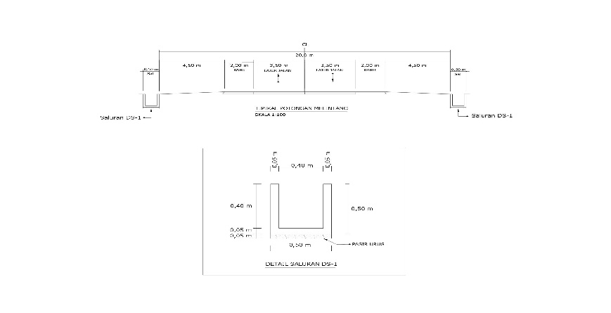

**Figure 7** Dimensions of Square Design Channel (U-Ditch DS 1)

1. Shape of channel = Square (U-ditch DS 1)
2. Channel length = 1,350 m

Based on previous calculations, the design channel depth was:

1. Depth (h) = 0.40 m
2. Surface width (b) = 0.40 m
3. Surface area (A) = 0.40 x 0.40

= 0.16 m²

1. Manning (n) coefficient = 0.016 (Manning Table)
2. Slope of channel base (S) = 0.0005
3. Hydraulic radius (R) = 0.13

In determining the Hydraulic Radius (R), the values of the cross-sectional area and wetted perimeter are needed. The cross-sectional area (A) and wetted perimeter (P) values were obtained from the following formula:

P = perimeter = b+2h

= 0.40 + 2(0.40)

= 1.20 m

Then, the value of the Hydraulic Radius (R) can be calculated as follows:

Design Qs = V x A

= 0.41 x 0.16

= 0.065 m³/sec

1. U-Ditch DS 2

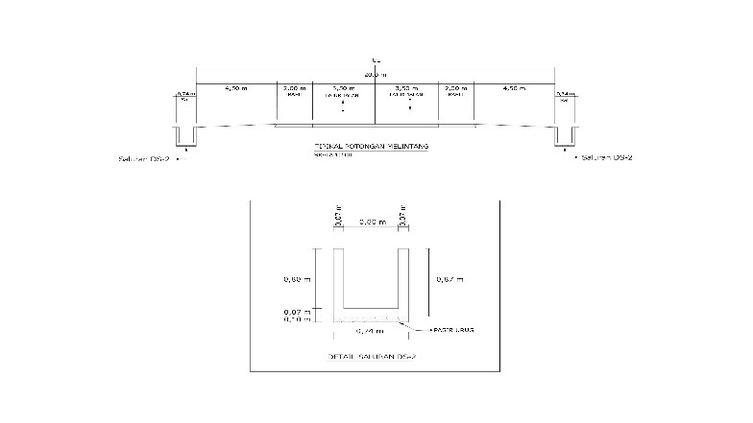

**Figure 8** Dimensions of Square Design Channel (U-Ditch DS 2)

1. Shape of channel = Square (U-ditch DS 2)
2. Channel length = 1,350 m

Based on previous calculations, the design channel depth was:

1. Depth (h) = 0.80 m
2. Surface width (b) = 0.60 m
3. Surface area (A) = 0.80 x 0.60

= 0.48 m²

1. Manning (n) coefficient = 0.016 (Manning Table)
2. Slope of channel base (S) = 0.0005
3. Slope of channel base (R) = 0.22

In determining the Hydraulic Radius (R), the values of the cross-sectional area and wetted perimeter are needed. The cross-sectional area (A) and wetted perimeter (P) values were obtained from the following formula:

P = perimeter = b+2h

= 0.60 + 2(0.80)

= 2.20 m

Then, the value of the Hydraulic Radius (R) can be calculated as follows:

Design Qs = V x A

= 0.56 x 0,48

= 0.268 m³/sec

1. U-Ditch DS 3

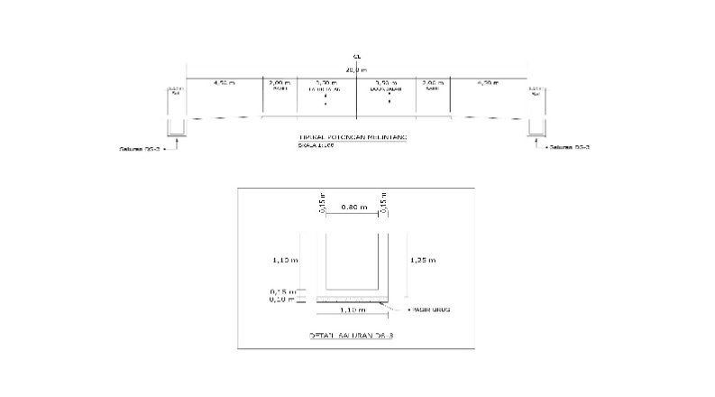

**Figure 9** Dimensions of Square Design Channel (U-Ditch DS 3)

1. Shape of channel = Square (U-Ditch DS 3)
2. Channel length = 1,350 m

Based on previous calculations, the design channel depth was:

1. Depth (h) = 1.10 m
2. Surface width (b) = 0.80 m
3. Surface area (A) = 1.10 x 0.80

= 0.88 m²

1. Manning (n) coefficient = 0.016 (Manning Table)
2. Slope of channel base (S) = 0.0005
3. Slope of channel base (R) = 0.29

In determining the Hydraulic Radius (R), the values of the cross-sectional area and wetted perimeter are needed. The cross-sectional area (A) and wetted perimeter (P) values were obtained from the following formula:

P = perimeter = b+2h

= 0.80 + 2(1.10)

= 3.00 m

Then, the value of the Hydraulic Radius (R) can be calculated as follows:

Design Qs = V x A

= 0.66 x 0.88

= 0.580 m³/sec

**CONCLUSION**

The Chi Square test was used to determine the order of distribution equations. By using the significance of DK = 1 and (α) = 0.05, the critical Chi Square value of X2 = 3.841 was obtained. From the results of the above calculations, X2 count = 2 < X2 table = 3.841 was obtained, meaning that the distribution meets the requirements. In calculating the design flood discharge, the rational method on flood discharge with a return period of 10 years was used. The previous calculations found the runoff coefficient (C) value of 0.661, the rainfall intensity (I) value with a return period of 10 years of 84.199 mm/hour, and the flow area of 12,150 m². In the selection of U-Ditch DS 3, it is concluded that Qd (DS3) > Qs (DS2), > Qs (DS1), namely 0.580 m³/sec > 0.268 m³/sec > 0.065 m³/sec. Therefore, a square channel (U-Ditch DS3) was chosen by considering the cross-sectional area factor; this channel was proven to be capable of draining more water. The design discharge caused by the magnitude of the hydrological rainfall intensity (Qr) can be held and distributed according to the hydraulic capacity (Qs). Therefore, it can be concluded that:

Hydrological Qr = 0.278 .C .I . A

= 0.187 m³/sec

Hydraulic Qs = Design V x A

= 0.66 x 0.88

= 0.580 m³/sec

**REFERENCES**

Kafi, A. A. *et al.* (2017). ' Perencanaan Sistem Drainase Pada Pengembangan Bandara Ahmad Yani Semarang' (Drainage System Planning in the Development of Ahmad Yani Airport Semarang). *Jurnal Karya Teknik Sipil*, 7(1), p. 39–49.

Lubis, A. H. (2012). 'Analisa Intensitas Curah Hujan Maksimum terhadap Kemampuan Drainase Perkotaan (Studi Kasus Drainase Jalan Sisingamangaraja Kota Sibolga)' (Analysis of Maximum Rainfall Intensity on Urban Drainage Capability (Case Study of Sisingamangaraja Street Drainage, Sibolga City)), (1).

Nugrahedi, S. A. and Saputra, A. (2014). 'Perencanaan Sistem Drainase Kali Kendal' (Kendal River Drainage System Planning), *Jurnal Karya Teknik Sipil*, 3(4), p. 1043–1055.

Oktavia, S. R. (2018). 'The Effect of Cylindrical and Triangular Pillars on Changes in Water Levels at Channel Bends'. *Engineering Journal*, 22(2), p. 131-140

Pane, Y. F. *et al.* (2016). 'Perencanaan Drainase Jalan Raya Semarang (Pelatihan Transmigrasi Dan Penyandang Cacat Jateng)' Semarang Highway Drainage Planning (Training for Transmigration and People with Disabilities in Central Java), *Jurnal Karya Teknik Sipil*, 5, p. 179–189.

Rahmawati, E., R, A. W. and Kurniani, D. (2017). 'Pengembangan Drainase Sistem Polder Sungai Sringin' (Sringin River Polder Drainage System Development), *Jurnal Karya Teknik Sipil*, 6(1), p. 282–291.

Suharmadi, U. H. (2011). 'Kajian Model Long And Short-Term Runoff (LST) dan Implementasinya untuk Menghitung Debit Banjir' (Study of Long And Short-Term (LST) Runoff Model and Its Implementation for Calculating Flood Discharge), *Cauchy*, 1(4), p. 187. doi: 10.18860/ca.v1i4.1797.

Susilowati, & Hapsari, A. R. (2017). ' Kajian Kapasitas Tampungan Drainase Di Perumahan Puri Perwata Teluk Betung Timur Bandar Lampung' (Study of Drainage Storage Capacity in Puri Perwata Housing, East Teluk Betung, Bandar Lampung), *Jurnal Teknik Sipil* 8(2), p. 1081–1092.

Waskitaningsih, N. (2012). ' Kearifan Lokal Masyarakat Sub-Sistem Drainase Bringin Dalam Menghadapi Banjir' (Community Local Wisdom of Bringin Drainage Sub-System in Facing Flood), *Jurnal Pembangunan Wilayah & Kota*, 8(4), p. 383. doi: 10.14710/pwk.v8i4.6495.